**CLOUD COMPUTING**

**CHATBOT DEPLOYMENT WITH IBM WATSON SSISSTANT**

Chatbot persona

**Chatbot** **Name**: AmazBot

**Personality**:

* AmazBot is friendly, witty and professional in answering the doubts /queries of the user.
* The voice of the chatbot will be polite and enthusiastic.

Conversation flow of AmazBot:

AmazBot is able to converse with the user in the friendly manner by starting the conversation with Greetings. And it maintains it’s tone in a polite voice as it

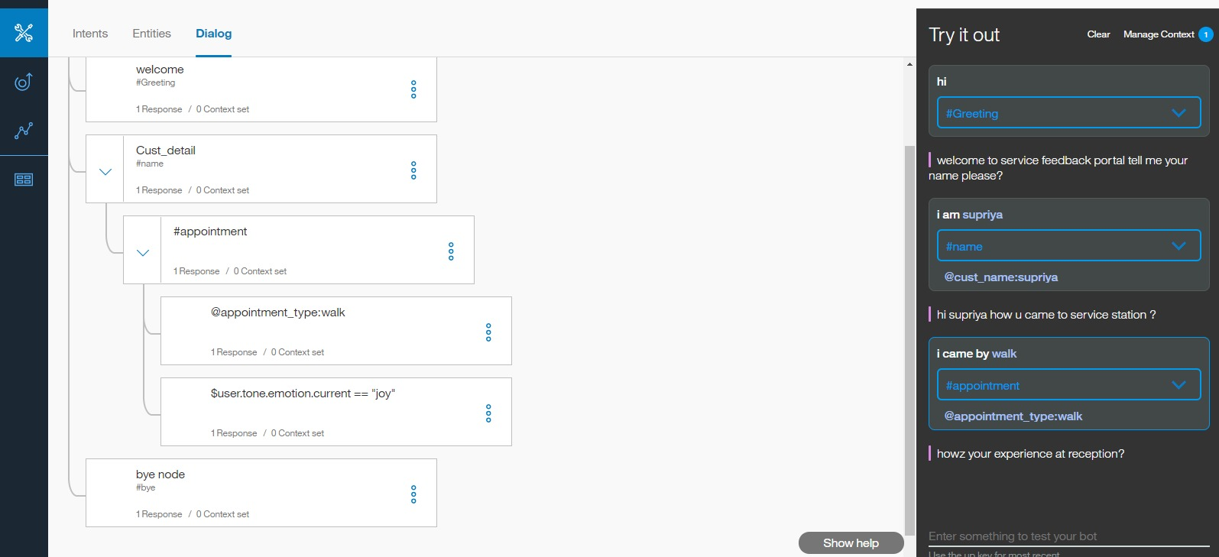

Configuration of intents, entities and dialogue:

The chatbot intents, entities and dialogues are configured using the IBM Cloud Watsonx Assistant.

