 | NIRBHAYA AI: AN AI-BASED WOMEN SAFETY SYSTEM WITH REAL-TIME DISTRESS DETECTION AND EMERGENCY ALERTING | 
A MINI PROJECT REPORT
Submitted by
YOGA VARSHINI S | (922524104183)
YOGADHARSHINI S | (922524104182)
In partial fulfillment for the award of the degree
of
BACHELOR OF ENGINEERING
in
COMPUTER SCIENCE AND ENGINEERING
V.S.B. ENGINEERING COLLEGE, KARUR-639 111
(An Autonomous Institution, Affiliated to Anna University)

NOVEMBER 2026

NIRBHAYA AI: AN AI-BASED WOMEN SAFETY SYSTEM WITH REAL-TIME DISTRESS DETECTION AND EMERGENCY ALERTING
A MINI PROJECT REPORT
Submitted by
YOGA VARSHINI S | (922524104183)
YOGADHARSHINI S | (922524104182)
In partial fulfillment for the award of the degree
of
BACHELOR OF ENGINEERING
in
COMPUTER SCIENCE AND ENGINEERING
V.S.B. ENGINEERING COLLEGE, KARUR-639 111
(An Autonomous Institution, Affiliated to Anna University)

NOVEMBER 2026

BONAFIDE CERTIFICATE
Certified that this mini project report titled “Nirbhaya AI: An AI-Based Women Safety System with Real-Time Distress Detection and Emergency Alerting” is the bonafide work of YOGA VARSHINI S (922524104183), YOGADHARSHINI S (922524104182) who carried out the project under my supervision.

SIGNATURE  Dr. P. ANBUMANI M.E., Ph.D.,  HEAD OF THE DEPARTMENT  Computer Science and Engineering,  V.S.B. Engineering College  Karur -639111 |  | SIGNATURE  Mrs. S. VIGNESHWARI M.E.,  SUPERVISOR  Assistant Professor  Computer Science and Engineering,  V.S.B. Engineering College  Karur -639111

Submitted for Mini project Viva-Voce held on ____________________
INTERNAL EXAMINER |  | EXTERNAL EXAMINER
DECLARATION
We jointly declare that the mini project report on “Nirbhaya AI: An AI-Based Women Safety System with Real-Time Distress Detection and Emergency Alerting” is the result of original work done by us and to the best of our knowledge, similar work has not been submitted to “ANNA UNIVERSITY CHENNAI” for the requirement of Degree, Bachelor of Engineering. This project report is submitted in partial fulfilment of the requirement of the award of Degree of Bachelor of Engineering.

SIGNATURE

YOGA VARSHINI S

YOGADHARSHINI S

Place: Karur
Date:
ACKNOWLEDGEMENT
First and foremost, we express our thanks to our parents for providing us with a very nice environment for doing this mini project. We wish to express our sincere thanks to our Founder and Chairman Shri. V.S. BALSAMY B.Sc., B.L., for his endeavor in educating us in this premier institution.
We wish to express our appreciation and gratefulness to our Principal,Dr. C. VENNILA M.E., Ph.D., and Vice Principal Dr. T.S. KIRUBA SANKAR M.E., Ph.D., for their encouragement and sincere guidance.
We are grateful to our Head of the Department Dr. P. ANBUMANI M.E., Ph.D., and our mini project coordinator Dr. S. PRABAKARAN M.E., Ph.D., Assistant Professor, Department of Computer Science and Engineering for their valuable support.
We express our thanks to the supervisor of our mini project Mrs. S. VIGNESHWARI M.E., Assistant Professor, Department of Computer Science and Engineering, for guidance throughout the course of our project.
Our sincere thanks to all the teaching staff of V.S.B. Engineering College and our friends for their help in the successful completion of this mini project work.
Finally, we bow before God, the almighty, who always had a better plan for us. We give our praise and glory to Almighty God for the successful completion of this mini project.
 | V.S.B. Engineering College, Karur  (An Autonomous Institution, Affiliated to Anna University)  Department of Computer Science and Engineering  VISION, MISSION, POs, PEOs and PSOs | 
Vision of the Institution:
We endeavor to impart futuristic technical education of the highest quality to the student community and to inculcate discipline in them to face the world with self-confidence and thus we prepare them for life as responsible citizens to uphold human values and to be of service at large. We strive to bring of the Institution as an Institution of academic excellence of international standard.
Mission of the Institution:
We transform persons into personalities by the state-of-the-art infrastructure, time consciousness, quick response and the best academic practices through assessment and advice.
Vision of the Department:
To produce competent Computer Science Engineers through Quality Education and Research.
Mission of the Department:
The Department strives to contribute to the expansion of knowledge in the discipline of Computer Science and Engineering by,
- adopting an efficient teaching learning process in correlation with industrial needs.
- ensuring technical proficiency, facilitating to pursue higher studies and carry out R&D activities.
- developing problem solving and analytical skills with sound knowledge in basic sciences and Computer Science Engineering.
- inculcating managerial skills to become socially responsible, ethical and competitive professionals.

Program Educational Objectives (PEOs)
The Graduates of Computer Science and Engineering are able to
PEO #1: Work in Multinational companies and become successful IT professionals.
PEO #2: Pursue higher studies and have their career in educational institutions, research organizations, or be entrepreneurs.
PEO #3: Possess social responsibility, team work skills, leadership capabilities and urge for learning in their professional fields.
Program Specific Outcome (PSO)
PSO#1: Addressing societal problems through design and development of software and firmware solutions using latest Computer Science tools and technologies.
PSO#2: Involving enthusiastically in software development, software testing, storage, computing and business intelligence sectors.
PSO#3: Use their technical expertise in latest technologies and update their knowledge continuously in Computer Science and Engineering to excel in their career.
Program Outcomes (PO)
PO1: Engineering knowledge: Apply the Mathematical knowledge and the basics of Science and Engineering to solve the problems pertaining to Computer Science and Engineering.
PO2: Problem analysis: Identify and formulate Computer Science and Engineering problems from research literature and be able to analyze the problem using first principles of Mathematics and Engineering Sciences.
PO3: Design/development of solutions: Come out with solutions for the complex problems and to design system components or process that fulfil the particular needs taking into account public health and safety and the social, cultural and environmental issues.
PO4: Conduct investigations of complex problems: Draw well-founded conclusions applying the knowledge acquired from research and research methods including design of experiments, analysis and interpretation of data and synthesis of information and to arrive at significant conclusion.
PO5: Modern tool usage: Form, select and apply relevant techniques, resources and Engineering and IT tools for Engineering activities like electronic prototyping, modelling and control of systems and also being conscious of the limitations.
PO6: The engineer and society: Apply reasoning informed by the contextual knowledge to assess societal, health, safety, legal and cultural issues and the consequent responsibilities relevant to the professional Computer Science and Engineering practice.
PO7: Environment and sustainability: Be aware of the impact of professional Engineering solutions in societal and environmental contexts and exhibit the knowledge and the need for sustainable Development.
PO8: Ethics: Apply the principles of Professional Ethics to adhere to the norms of the engineering practice and to discharge ethical responsibilities.
PO9: Individual and team work: Function actively and efficiently as an individual or a member/leader of different teams and multidisciplinary projects.
PO10: Communication: Communicate efficiently the engineering facts with a wide range of engineering community and others, to understand and prepare reports and design documents; to make effective presentations and to frame and follow instructions.
PO11: Project management and finance: Demonstrate the acquisition of the body of engineering knowledge and insight and Management Principles and to apply them as member / leader in teams and multidisciplinary environments.
PO12: Life-long learning: Recognize the need for self and life-long learning, keeping pace with technological challenges in the broadest sens

ABSTRACT
Women’s safety in public spaces, workplaces and during travel remains a serious social concern. Existing safety applications largely depend on the victim manually triggering an alert, which is often impossible in a real emergency when the person is frightened, restrained or unable to reach the phone. To overcome this limitation, this project presents Nirbhaya AI, an AI-based women safety system that detects distress automatically and raises emergency alerts in real time. The system is implemented as a cross-platform mobile application backed by a cloud service. It accepts multiple trigger inputs: a one-tap SOS button, a shake gesture detected through the accelerometer, and an AI-based distress detection module that analyses microphone audio for screams and distress keywords using a lightweight TensorFlow Lite model running on the device. When a trigger fires, a decision engine built with FastAPI confirms the event, captures the live GPS location and a short audio clip, and dispatches SMS, push notification and call alerts to pre-registered emergency contacts and, where configured, to the national emergency number 112. A live tracking link allows contacts to follow the user’s movement until she marks herself safe. Firebase is used for authentication, real-time location storage and event logs, and the stored incident locations are analysed to highlight unsafe zones on a map so that users can plan safer routes. Overall, the system reduces response time, removes the need for manual action during an attack, and provides a low-cost, scalable and privacy-aware safety solution for students, working women and travellers. Through this project work, it is able to attain PO1 to PO12 and also able to attain PSO1, PSO2 and PSO3.
KEYWORDS: Women Safety, Artificial Intelligence, Distress Detection, Audio Classification, SOS Alert, Live Location Tracking, Flutter, TensorFlow Lite, FastAPI, Firebase, Emergency Response.
TABLE OF CONTENTS
CHAPTER NO. | TITLE | PAGE NO.
 | ABSTRACT | I
 | LIST OF FIGURES | V
 | LIST OF TABLES | VI
 | LIST OF ABBREVIATIONS | VII
1 | INTRODUCTION | 1
 | 1.1 OVERVIEW OF WOMEN SAFETY SYSTEMS | 1
 | 1.2 PROBLEMS IN EXISTING SAFETY MECHANISMS | 1
 | 1.3 NEED FOR AI-BASED AUTOMATION IN PERSONAL SAFETY | 2
 | 1.4 ROLE OF AI AND MOBILE COMPUTING IN SAFETY SYSTEMS | 2
 | 1.5 OBJECTIVE AND SCOPE OF THE PROJECT | 2
 | 1.6 ADVANTAGES OF PROPOSED SYSTEM | 3
 | 1.7 PROBLEM STATEMENT | 3
 | 1.8 MOTIVATION | 4
 | 1.9 CHALLENGES IN BUILDING AN AI-BASED SAFETY SYSTEM | 4
 | 1.10 ORGANIZATION OF THE REPORT | 5
 | 1.11 APPLICATIONS | 5
2 | LITERATURE SURVEY | 6
3 | SYSTEM DESIGN | 11
 | 3.1 EXISTING SYSTEM | 11
 | 3.2 DISADVANTAGES OF EXISTING SYSTEM | 11
 | 3.3 PROPOSED SYSTEM | 11
 | 3.4 ADVANTAGES OF PROPOSED SYSTEM | 11
 | 3.5 FEASIBILITY STUDY | 12
 | 3.6 REQUIREMENT SPECIFICATION | 13
 | 3.7 SYSTEM ARCHITECTURE | 14
 | 3.8 USE CASE DESCRIPTION | 15
 | 3.9 DATA FLOW | 15
 | 3.10 ASSUMPTIONS AND CONSTRAINTS | 16
 | 3.11 PROJECT PLAN | 16
4 | METHODOLOGY | 17
 | 4.1 BLOCK DIAGRAM | 17
 | 4.2 MODULES | 18
 | 4.3 HARDWARE DESCRIPTION | 20
 | 4.4 SOFTWARE SPECIFICATION | 21
 | 4.5 ALGORITHM | 22
 | 4.6 SECURITY AND PRIVACY | 23
 | 4.7 DATASET PREPARATION | 23
 | 4.8 FEATURE EXTRACTION | 24
 | 4.9 NEURAL NETWORK ARCHITECTURE | 24
 | 4.10 TRAINING CONFIGURATION | 25
 | 4.11 DECISION LOGIC AND THRESHOLDS | 26
 | 4.12 API SPECIFICATION | 26
 | 4.13 USER INTERFACE DESIGN | 26
 | 4.14 IMPLEMENTATION DETAILS | 27
 | 4.15 UNSAFE-ZONE ANALYSIS | 28
 | 4.16 MODULE ALGORITHMS | 28
 | 4.17 DATABASE DESIGN | 29
 | 4.18 SEQUENCE OF INTERACTIONS | 30
 | 4.19 ERROR HANDLING AND EXCEPTION MANAGEMENT | 31
5 | RESULT AND DISCUSSION | 33
 | 5.1 RESULT | 33
 | 5.2 DISTRESS DETECTION ACCURACY | 33
 | 5.3 ALERT LATENCY | 34
 | 5.4 LOCATION TRACKING PERFORMANCE | 34
 | 5.5 OVERALL ANALYSIS | 34
 | 5.6 TESTING STRATEGY | 34
 | 5.7 EVALUATION METRICS | 35
 | 5.8 COMPARISON WITH EXISTING SYSTEMS | 35
 | 5.9 RESOURCE USAGE | 36
 | 5.10 USER ACCEPTANCE SURVEY | 36
 | 5.11 DISCUSSION | 37
 | 5.12 DETAILED TEST CASES | 37
 | 5.13 RISK ANALYSIS | 38
 | 5.14 EVALUATION REPORT FORMAT | 39
 | 5.15 SUMMARY OF THE CHAPTER | 40
6 | CONCLUSION | 41
 | 6.1 CONCLUSION | 41
 | 6.2 FUTURE ENHANCEMENTS | 41
 | 6.3 SOCIAL IMPACT | 41
 | 6.4 LIMITATIONS | 42
 | 6.5 ATTAINMENT OF PROGRAM OUTCOMES | 42
 | 6.6 DEPLOYMENT AND MAINTENANCE PLAN | 43
 | 6.7 SUMMARY OF WORK DONE | 43
 | APPENDIX | 5
 | (A) PROGRAM | 45
 | (B) OUTPUT SCREENS | 51
 | REFERENCES | 53
LIST OF FIGURES
FIGURE NO. | TITLE | PAGE NO.
3.1 | LAYERED ARCHITECTURE OF NIRBHAYA AI | 14
4.1.1 | BLOCK DIAGRAM OF PROPOSED SYSTEM | 17
4.1.2 | WORKFLOW OF NIRBHAYA AI | 18
6.1.1 | HOME SCREEN WITH SOS BUTTON | 51
6.1.2 | LIVE LOCATION TRACKING LINK VIEW | 51
6.1.3 | EMERGENCY SMS RECEIVED BY CONTACT | 51
6.1.4 | UNSAFE ZONE HEATMAP | 52
LIST OF TABLES
TABLE NO. | TABLE NAME | PAGE NO.
2.1 | Comparison of Existing Women Safety Systems
2.2 | Comparison of Classifier Options for Distress Detection
3.1 | Functional Requirements | 13
3.2 | Non-Functional Requirements | 13
3.3 | Hardware and Software Requirements | 14
3.4 | Use Case Description | 15
3.5 | Level 1 Processes and Data Flows | 16
3.6 | Project Schedule | 16
4.1 | Hardware Description | 20
4.2 | Software Description | 21
4.3 | Database Collections | 22
4.4 | Planned Dataset Composition | 23
4.5 | CNN Layer Configuration | 24
4.6 | Training Configuration | 25
4.7 | REST API Endpoints | 26
4.8 | Application Screens | 27
4.9 | Structure of the users Collection | 30
4.10 | Structure of the alerts Collection | 30
4.11 | Structure of the locations Collection | 30
4.12 | Sequence of Events in an AI-Detected Alert | 30
4.13 | Failure Cases and System Response | 31
5.1 | Test Scenarios and Result Log | 33
5.2 | Levels of Testing | 34
5.3 | Feature Comparison | 35
5.4 | User Survey Questions | 37
5.5 | Detailed Test Cases | 37
5.6 | Risk Analysis and Mitigation | 39
5.7 | Confusion Matrix Template (test set) | 39
5.8 | Per-Class Metrics Template | 39
6.1 | Mapping of Project Work to Program Outcomes | 42
LIST OF ABBREVIATIONS
AI | Artificial Intelligence
API | Application Programming Interface
FCM | Firebase Cloud Messaging
GPS | Global Positioning System
HTTP | Hypertext Transfer Protocol
IDE | Integrated Development Environment
JSON | JavaScript Object Notation
MFCC | Mel-Frequency Cepstral Coefficients
ML | Machine Learning
SMS | Short Message Service
SOS | Save Our Souls (emergency signal)
TFLite | TensorFlow Lite
UI | User Interface

CHAPTER 1
INTRODUCTION
1.1 OVERVIEW OF WOMEN SAFETY SYSTEMS
Personal safety systems are tools that help a person call for help, share her location and reach responders quickly during an emergency. In India, the 2012 Delhi incident that led to the name “Nirbhaya” (the fearless one) brought national attention to women’s safety and resulted in legal reforms, dedicated funds and several technology initiatives. Since then, smartphones have become the main platform for safety tools because they combine a GPS receiver, microphone, motion sensors, mobile data and SMS in a single device that most women already carry.
A typical safety application lets the user store emergency contacts and press a button that sends an SMS containing her location. Government services such as the 112 emergency response system and state police applications provide a direct link to control rooms, while commercial apps add features like fake calls and journey sharing.
1.2 PROBLEMS IN EXISTING SAFETY MECHANISMS
- Manual triggering: the victim must unlock the phone, open the app and press a button, which may be impossible during an attack.
- Delayed response: alerts that depend on a human reading and acting on an SMS lose valuable minutes.
- No intelligence: most apps cannot recognise a dangerous situation by themselves.
- Static information: contacts receive a single location, not a continuously updated one.
- Poor awareness of unsafe areas: users get no warning about locations with repeated incidents.
- Battery and connectivity issues: continuous monitoring drains the battery and fails when data is weak.
1.3 NEED FOR AI-BASED AUTOMATION IN PERSONAL SAFETY
An effective safety system must work even when the user cannot act. Artificial Intelligence makes this possible by continuously interpreting sensor data, such as a scream or a call for help in the audio stream, and deciding whether an emergency is likely. Automating detection and alerting shortens the time between the incident and the arrival of help, and reduces the burden on the user to operate a device while under stress.
1.4 ROLE OF AI AND MOBILE COMPUTING IN SAFETY SYSTEMS
Modern smartphones can run compact neural networks locally. Audio features such as MFCCs are extracted from short windows of microphone data and classified by a small convolutional network converted to TensorFlow Lite, so that recognition happens on the device without streaming private conversations to a server. Cloud services then handle real-time synchronisation of location, notification delivery and analytics. The combination of on-device AI for privacy and speed with cloud services for reach and scale forms the foundation of Nirbhaya AI.
1.5 OBJECTIVE AND SCOPE OF THE PROJECT
The main objective of this project is to design and develop an intelligent mobile-based women safety system that detects distress automatically and alerts trusted contacts and authorities in real time. The specific objectives are:
- To provide one-tap, shake and voice-based triggers for raising an SOS.
- To detect screams and distress keywords from audio using an on-device AI model.
- To capture and share live GPS location continuously until the user is safe.
- To dispatch alerts through SMS, push notification and call to multiple contacts.
- To store incident data and display unsafe zones on a map for safer route planning.
- To protect user privacy through on-device processing, encryption and consent-based recording.
The scope covers a smartphone application for Android with a cloud backend. Integration with official police control rooms is limited to the standard emergency number 112 and can be extended in future with the cooperation of the authorities.
1.6 ADVANTAGES OF PROPOSED SYSTEM
- Hands-free detection reduces dependence on manual action.
- Faster alerts and continuous tracking improve the chance of timely help.
- On-device inference protects privacy and works with limited network.
- Low cost: requires only a smartphone and free or low-cost cloud tiers.
- Scalable architecture that can support many users and community features.
- Data-driven unsafe-zone map helps prevention as well as response.
1.7 PROBLEM STATEMENT
Women face a wide range of threats in public and private spaces, including harassment, stalking, assault and abduction. Reports from different agencies show that many incidents occur in places and at times when help is not immediately available, such as on isolated roads, in vehicles or after dark. In many of these situations the victim has only a few seconds in which to act, and often cannot use the phone because it is taken away, the hands are restrained, or fear prevents clear action.
The problem addressed in this project is therefore stated as follows: to design a smartphone-based system that can recognise a likely emergency without depending only on a deliberate action by the user, and that can inform trusted people and emergency services quickly, with accurate and continuously updated location information, while respecting the privacy of the user.

1.8 MOTIVATION
The name Nirbhaya, meaning fearless, was chosen to reflect the aim of the project, which is to give women the confidence to travel, study and work without fear. The increasing availability of affordable smartphones and mobile data in India, together with the maturity of tools such as TensorFlow Lite and Firebase, makes it possible for a student team to build a safety system that was possible only for large organisations a few years ago. The project also gives an opportunity to apply the knowledge of machine learning, mobile application development, cloud computing and software engineering gained during the degree programme to a real social problem.
1.9 CHALLENGES IN BUILDING AN AI-BASED SAFETY SYSTEM
- False alarms: a system that raises too many false alerts will be switched off by users and ignored by contacts, so detection must be accurate and confirmable.
- Missed detections: a missed emergency can have serious consequences, so the model must have high recall.
- Noisy environments: traffic, music and crowds make audio classification difficult.
- Battery consumption: continuous sensing must be efficient enough for a full day of use.
- Privacy: listening to the microphone raises concerns that must be addressed through on-device processing and clear consent.
- Connectivity: emergencies may occur where mobile data is weak, so a fallback is required.
- Reliability of background services: mobile operating systems restrict background processes to save power, so services must be designed carefully.

1.10 ORGANIZATION OF THE REPORT
The remainder of this report is organised as follows. Chapter 2 reviews existing women safety systems and the technologies related to audio-based distress detection. Chapter 3 describes the existing system, the proposed system, the feasibility study, the requirement specification, the architecture and the data flow of the system. Chapter 4 explains the methodology in detail, including the modules, dataset, feature extraction, neural network, decision logic, interfaces and implementation. Chapter 5 presents the testing strategy, evaluation metrics, comparison with existing systems and discussion. Chapter 6 concludes the report and lists the scope for future work. The appendix contains the program listings and output screens, followed by the references.
1.11 APPLICATIONS
Nirbhaya AI can be used in many settings where personal safety is a concern. The same application can be configured for different groups of users by changing the contacts and the sensitivity of detection.
- Educational institutions: students travelling to and from college and staying in hostels can share alerts with parents, wardens and the college security office.
- Workplaces: employees working late shifts or travelling for work can be linked with the security team of the organisation.
- Public transport and cabs: passengers can share a live location with family and raise an alert if a journey becomes unsafe.
- Residential communities: residents and neighbourhood groups can respond quickly to an alert near their location.
- Elderly and lone-living persons: the shake and SOS triggers can also be used to call for help during a medical emergency or fall.
CHAPTER 2
LITERATURE SURVEY
A study of the existing women safety applications and of the technologies that support automatic distress detection was carried out to identify the gaps that the proposed system should address. The existing systems and techniques reviewed are described below.
1. 112 India Emergency Response Support System and Mobile App
Developed by: Government of India
Type: National emergency response service and smartphone app
Description:
The 112 India service provides a single emergency number for police, fire and medical help, and a mobile application that includes an SOS option. When the SOS is raised, the location of the user is passed to the emergency response centre so that the nearest responder can be dispatched. The service covers many states and is a significant step in reducing the time taken to reach a person in danger.
However, the alert is raised only when the user opens the application or triggers the SOS herself. If the user is unable to operate the phone, the system has no way of recognising the emergency. It also provides no continuous sharing of the location with family members and no analysis of the surroundings of the user.
2. Kavalan SOS Application
Developed by: Tamil Nadu Police
Type: State police safety application
Description:
Kavalan SOS is a mobile application provided by the Tamil Nadu Police for the safety of citizens, especially women. By pressing the SOS button, the user sends an alert with her location to the police control room, which can then contact the user and send a patrol team.
The application is useful because it connects directly with the police. Its limitations are the manual trigger, the dependence on a network connection and the fact that it works only within the state. No automatic detection of distress is available, and family members are not kept informed unless the user tells them.
3. bSafe Personal Safety Application
Developed by: bSafe (commercial application)
Type: Commercial personal safety application
Description:
bSafe allows a user to add guardians who can follow her journey on a map, call her through a fake call feature and receive an alert with location and recorded audio when she presses the alarm button. These features make it popular among students and working women.
The alert is still triggered manually and some features need a paid subscription. The application does not analyse the audio on the device to detect a scream or a call for help, and it provides no data on areas that are unsafe.
4. SMS-Based SOS Applications
Developed by: Various developers
Type: Basic emergency messaging applications
Description:
Many simple applications store a few contacts and send a pre-written SMS with the current location when a button is pressed or when the power button is pressed several times. They work without mobile data and are easy to implement.
The main drawbacks are that only one location is shared, no tracking is available, and the contacts may not notice the message immediately. Since there is no intelligence in the system, it cannot decide whether the situation is serious.
5. Wearable Panic Devices
Developed by: Various manufacturers
Type: Hardware-based safety devices
Description:
Wearable devices such as pendants, bands and rings have a panic button that is connected to the smartphone by Bluetooth. They can be pressed without taking out the phone and are useful in situations where the phone is in a bag.
These devices need extra cost and charging, may be left behind, and are still dependent on the user pressing the button. Their effectiveness is also limited by the Bluetooth range and the smartphone application that sends the alert.
6. Sound Classification Using MFCC Features
Developed by: Speech and audio processing research
Type: Audio feature extraction technique
Description:
Mel-frequency cepstral coefficients represent the short-term spectrum of a sound on a scale that approximates the human ear. They are widely used in speech and sound recognition, because a small number of coefficients can describe the shape of the spectrum. Classifiers such as Support Vector Machines and Random Forests have been used with MFCC features to separate sound classes.
This approach is simple and works with small datasets, but it depends on hand-designed features and its accuracy reduces in noisy environments. For distress detection, MFCC features are well suited as an input to a neural network, which can learn the patterns that separate screams and calls for help from normal sounds.
7. CNN-Based Audio Event Detection
Developed by: Deep learning research community
Type: Neural network technique
Description:
Convolutional Neural Networks treat the spectrogram or the MFCC matrix of a sound as an image and learn local time-frequency patterns automatically. Compared with classical classifiers, they give better accuracy on varied sounds such as screams, sirens and speech, and can be made small enough to run on a phone after quantisation.
Their disadvantages are the need for labelled data and the care required to avoid false alarms. Data augmentation with background noise, class weighting and a threshold with several consecutive windows are the usual remedies, and these are adopted in this project.
8. On-Device Inference with TensorFlow Lite
Developed by: Google
Type: Mobile machine learning framework
Description:
TensorFlow Lite converts a trained model into a compact format that runs on mobile processors with low latency and without a network connection. Post-training quantisation reduces the model size and the power used for each prediction.
On-device inference is important for a safety application because the detection works even when the network is weak, and the audio of the user does not need to be sent to a server. This supports both the speed and the privacy requirements of the system.
9. Real-Time Location Sharing with Firebase
Developed by: Google
Type: Cloud database and messaging platform
Description:
Cloud Firestore and Firebase Cloud Messaging provide real-time synchronisation of data and quick delivery of push notifications to mobile devices. A location update written by the phone is delivered to a listening web page within a short time, which allows a moving marker to be shown on a map without repeated polling.
When combined with SMS and voice calls as additional channels, these services give a reliable multi-channel alert system. Security rules in Firebase allow the data to be restricted to the owner and her trusted contacts.
Research Gap:
The survey shows that safety applications are widely available, but most rely on manual triggering, and the audio-based approaches are rarely combined with continuous tracking, multi-channel alerting and analytics in one deployable mobile product. This motivated the design of Nirbhaya AI as an integrated, privacy-aware system.
Note: The above survey is based on publicly described features of the listed applications and technologies. Journal and conference papers reviewed by the team may be added to this chapter in the same format (title, authors, year and description) with proper citations.
CHAPTER 3
SYSTEM DESIGN
3.1 EXISTING SYSTEM
In the existing systems, the user opens a safety application and presses an SOS button, or presses the power button several times, to send a pre-defined SMS with her location to a few contacts or to a control room. Some applications support fake calls and journey sharing, but these too are started manually by the user.
3.2 DISADVANTAGES OF EXISTING SYSTEM
- Not effective when the user cannot reach or operate the phone.
- No automatic recognition of danger.
- One-time location instead of continuous tracking.
- Contacts may not notice an SMS immediately.
- No analysis of incident data for prevention.
- Dependence on external wearable hardware in some solutions.
3.3 PROPOSED SYSTEM
The proposed Nirbhaya AI system is a mobile application with an intelligent backend. The app runs a foreground service that listens for three kinds of triggers: a manual SOS button, a shake gesture, and an AI-detected distress sound or keyword. A TensorFlow Lite model classifies short audio windows into normal, scream and distress-speech classes. When the classifier confidence crosses a threshold, the app asks for a short cancel window (for example, 10 seconds) to avoid false alarms and then notifies the FastAPI decision engine.
The decision engine logs the event in Firebase, starts continuous GPS updates, uploads a short audio clip, and sends SMS, push notifications and an automated call to the emergency contacts. Contacts receive a live tracking link. The user can mark herself safe, which closes the alert. Stored incident coordinates are clustered to build an unsafe-zone map shown to all users.
3.4 ADVANTAGES OF PROPOSED SYSTEM
- Automatic, hands-free emergency detection.
- Multiple trigger options suited to different situations.
- Continuous live tracking instead of a single location message.
- On-device AI for privacy, speed and offline operation of detection.
- Cancel window and confidence threshold to limit false alarms.
- Unsafe-zone analytics for prevention and safer route choice.

3.5 FEASIBILITY STUDY
3.5.1 TECHNICAL FEASIBILITY
All the technologies used in the project, namely Flutter, TensorFlow Lite, FastAPI and Firebase, are open source or available with free tiers, are well documented and are supported on common Android phones. On-device inference of a small CNN has been shown to run in real time on mid-range hardware. The project is therefore technically feasible with the skills available in the team.
3.5.2 ECONOMIC FEASIBILITY
The system uses the user’s own smartphone, so there is no hardware cost for the user. The development tools are free. The running cost consists mainly of the SMS and voice gateway charges and cloud hosting, which are small for the prototype and can be controlled by limiting messages to genuine alerts. Compared with wearable panic devices, the cost per user is very low.
3.5.3 OPERATIONAL FEASIBILITY
The application has a simple interface with a large SOS button and requires only a one-time setup of contacts. The automatic detection works in the background without effort from the user. Contacts need only a phone to receive an SMS and open a link. The system can therefore be operated by users with little technical knowledge.
3.5.4 SOCIAL AND LEGAL FEASIBILITY
The project supports a socially important cause. The system is designed on a consent basis and avoids collecting data beyond what is needed. Before large-scale deployment, compliance with the applicable data protection regulations and cooperation with the authorities would be required.
3.6 REQUIREMENT SPECIFICATION
3.6.1 FUNCTIONAL REQUIREMENTS
ID | Requirement
FR1 | The system shall allow a user to register and log in using a mobile number.
FR2 | The system shall allow the user to add, edit and delete emergency contacts.
FR3 | The system shall raise an SOS when the SOS button is pressed.
FR4 | The system shall raise an SOS on a shake gesture.
FR5 | The system shall analyse microphone audio and raise an SOS on detecting distress.
FR6 | The system shall show a cancel prompt before sending an automatically detected alert.
FR7 | The system shall send SMS, push notification and call alerts to contacts.
FR8 | The system shall share the live location through a tracking link.
FR9 | The system shall let the user mark herself safe and close the alert.
FR10 | The system shall maintain an alert history and show unsafe zones on a map.
Table: 3.1 Functional Requirements

3.6.2 NON-FUNCTIONAL REQUIREMENTS
Attribute | Requirement
Performance | Alerts should be dispatched within a few seconds of confirmation; inference per window under 100 ms.
Reliability | Alert delivery should use more than one channel; SMS fallback when data is unavailable.
Usability | SOS reachable in one tap; interface with large controls and simple language.
Security | HTTPS for all traffic; access rules per user; expiring tracking links.
Privacy | On-device audio analysis; recording only after confirmed alert and consent.
Battery | Monitoring service optimised to limit battery consumption over a day.
Scalability | Stateless API that can be scaled horizontally on the cloud.
Maintainability | Modular code base with separate app, model and service components.
Table: 3.2 Non-Functional Requirements

3.6.3 HARDWARE AND SOFTWARE REQUIREMENTS
Item | Specification
Development computer | Intel i5 or equivalent, 8 GB RAM, 256 GB storage
Operating system | Windows 10/11 or Ubuntu 22.04
Test device | Android 8.0 or later, 3 GB RAM, GPS, microphone, accelerometer
Mobile framework | Flutter SDK 3.x, Dart
Backend | Python 3.10+, FastAPI, Uvicorn
Machine learning | TensorFlow 2.x, Librosa, NumPy, scikit-learn
Cloud services | Firebase (Auth, Firestore, FCM), SMS and voice gateway
Table: 3.3 Hardware and Software Requirements

3.7 SYSTEM ARCHITECTURE
Nirbhaya AI follows a layered architecture, shown in Fig.3.1. The presentation layer is the Flutter application used by the user and a lightweight web page used by contacts. The intelligence layer runs on the phone and contains the audio and motion processing. The service layer in the cloud hosts the decision engine and the alert dispatcher. The data and messaging layer contains the managed services for storage, notification and maps. Separating the layers keeps the privacy-sensitive processing on the device and the shared services in the cloud.
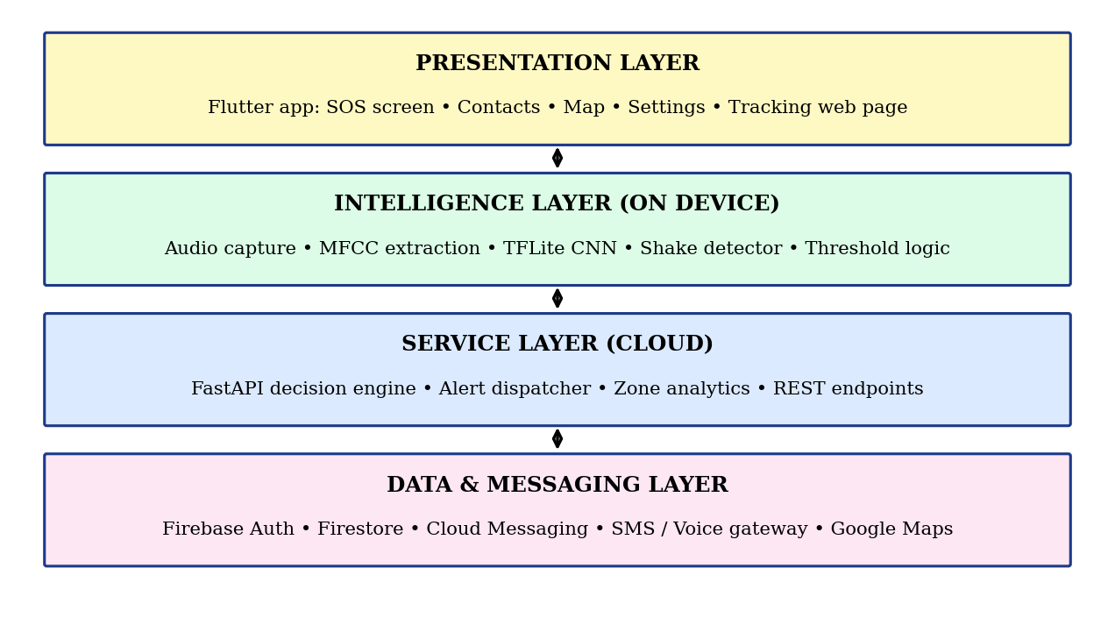
Fig.3.1 Layered Architecture of Nirbhaya AI
3.8 USE CASE DESCRIPTION
The actors of the system are the User, the Emergency Contact, the Police Control Room and the Administrator. Table 3.4 describes the main use cases.
Actor | Use case | Description
User | Register and set up | Creates an account and adds trusted contacts and preferences.
User | Trigger SOS | Presses the button or shakes the phone to raise an alert.
User | Cancel alert | Cancels a false alarm within the cancel window.
User | Mark safe | Closes an active alert after reaching safety.
Emergency Contact | Receive alert | Gets SMS, push notification and call with the tracking link.
Emergency Contact | Track user | Opens the link and follows the live position on the map.
Police Control Room | Receive emergency | Receives the alert through the national emergency number.
Administrator | Monitor service | Views anonymised statistics and manages the service.
Table: 3.4 Use Case Description
3.9 DATA FLOW
3.9.1 LEVEL 0 DATA FLOW
At Level 0 the whole system is a single process, Nirbhaya AI. The User supplies registration data, contacts, SOS triggers, audio and sensor data, and receives confirmation and the unsafe-zone map. The Emergency Contact receives alert messages and tracking data. The Police Control Room receives emergency notifications. The data store holds user profiles, alerts and locations.
3.9.2 LEVEL 1 DATA FLOW
No. | Process | Input | Output
1.0 | Manage profile | Registration data, contacts | Stored user and contacts
2.0 | Detect trigger | SOS press, shake, audio windows | Trigger event with confidence
3.0 | Validate event | Trigger event, cancel response | Confirmed alert
4.0 | Track location | GPS coordinates | Location stream, tracking link
5.0 | Dispatch alert | Confirmed alert, contacts | SMS, push, call, 112 notification
6.0 | Analyse zones | Stored incident locations | Unsafe-zone map
Table: 3.5 Level 1 Processes and Data Flow
3.10 ASSUMPTIONS AND CONSTRAINTS
- The user carries a working smartphone with adequate battery.
- The user has granted the microphone, location and notification permissions.
- At least one emergency contact has been registered.
- Mobile network coverage is available for the alert, or SMS fallback is possible.
- Android power-saving settings allow the foreground service to run.
- Accuracy of detection depends on the quality and variety of the training data.
3.11 PROJECT PLAN
The project was planned in phases so that each module could be built and tested before integration. Table 3.6 shows the planned activities.
No. | Activity | Duration | Output
1 | Problem study and literature survey | 2 weeks | Survey notes
2 | Requirement analysis and design | 2 weeks | SRS, architecture
3 | Dataset collection and preparation | 3 weeks | Labelled audio set
4 | Model training and conversion | 3 weeks | TFLite model
5 | Mobile app development | 4 weeks | Working app
6 | Backend and alert services | 3 weeks | REST API
7 | Integration and testing | 3 weeks | Test report
8 | Documentation and viva preparation | 2 weeks | Report, slides
Table: 3.6 Project Schedule

CHAPTER 4
METHODOLOGY
4.1 BLOCK DIAGRAM
Fig.4.1.1 shows the block diagram of Nirbhaya AI. Inputs from the SOS button, microphone, GPS and accelerometer are pre-processed in the mobile app. The AI module classifies audio, and the decision engine validates the event and triggers the alert dispatcher, which notifies contacts and stores data in the cloud.
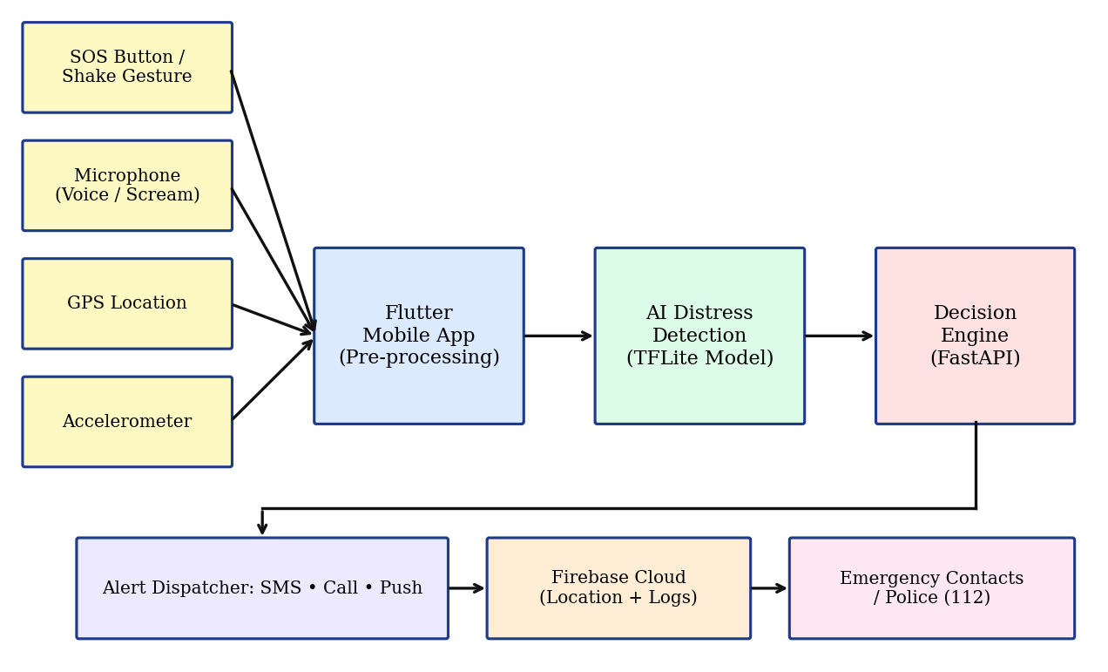
Fig.4.1.1 Block Diagram of Proposed System
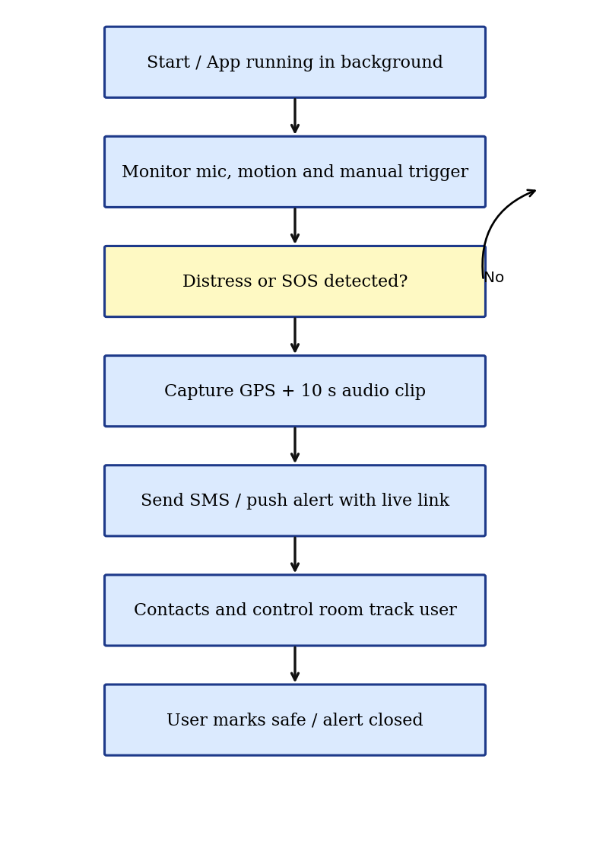
Fig.4.1.2 Workflow of Nirbhaya AI
4.2 MODULES
4.2.1 USER AND CONTACT MANAGEMENT MODULE
The user registers with a mobile number through Firebase Authentication and adds trusted contacts and an optional emergency number. Contacts are stored with consent. The user can set preferences such as the cancel window, enabling voice detection and recording permission.
4.2.2 SOS TRIGGER MODULE
This module provides the on-screen SOS button, a shake gesture detected from accelerometer magnitude exceeding a threshold several times within a short period, and a home-screen widget. Any one of these raises an SOS event immediately.

4.2.3 AI DISTRESS DETECTION MODULE
Audio is captured in one-second windows at 16 kHz. MFCC features are computed and passed to a compact convolutional neural network converted to TensorFlow Lite. The model outputs probabilities for the classes normal, scream and distress speech. A distress event is raised when the probability stays above the threshold for consecutive windows, which reduces single-window false positives. Only the class result is used; raw audio is not stored unless an alert is confirmed.
4.2.4 LOCATION TRACKING MODULE
On an alert, the app obtains GPS coordinates and updates them to Firebase every few seconds. A unique tracking link opens a web page showing the moving marker on Google Maps. Tracking stops when the user marks herself safe.
4.2.5 ALERT DISPATCH MODULE
The FastAPI service sends an SMS with the name, time and tracking link through an SMS gateway, a push notification through Firebase Cloud Messaging, and an automated voice call to the primary contact. If the user has enabled it, an alert is also sent to the emergency number 112.
4.2.6 UNSAFE-ZONE ANALYTICS MODULE
Confirmed incident locations are stored anonymously. A grid-based clustering routine counts incidents per area and time of day, and areas above a threshold are shown as a heat map in the app, with a warning when a planned route passes through them.
4.3 HARDWARE DESCRIPTION
The system uses the sensors already present in a smartphone. No additional hardware is required.
Component | Purpose
Smartphone (Android 8+) | Runs the app, on-device AI model and sensors
GPS receiver | Provides latitude and longitude for tracking
Microphone | Captures audio for distress detection
Accelerometer | Detects shake gesture and sudden motion
Mobile data / Wi-Fi | Sends alerts and location to the cloud
Cloud server | Hosts FastAPI service and Firebase backend
Table: 4.1 Hardware Description
4.3.1 GPS RECEIVER
The GPS module in the phone provides position typically within a few metres in open areas. Fused location providers combine GPS, Wi-Fi and cell data to improve availability indoors.
4.3.2 MICROPHONE
The built-in microphone feeds the AI module. Audio is processed on the device and discarded after classification unless an alert is confirmed.
4.3.3 ACCELEROMETER
The three-axis accelerometer measures acceleration. The shake gesture is recognised when the magnitude crosses a set threshold repeatedly within about two seconds.
4.3.4 MOBILE NETWORK
Mobile data or Wi-Fi is used for cloud communication. If data is unavailable, the app falls back to sending an SMS directly through the phone’s cellular network
4.4 SOFTWARE SPECIFICATION
Software | Use in project
Flutter (Dart) | Cross-platform mobile app user interface and background services
Python 3 and FastAPI | Decision engine and alert dispatch REST API
TensorFlow / TFLite | Training and on-device inference of the distress detection model
Librosa | Audio feature extraction (MFCC) during model training
Firebase (Auth, Firestore, FCM) | Authentication, real-time location, event logs, push notifications
Google Maps Platform | Map display, tracking page and unsafe-zone heat map
SMS / voice gateway (e.g., Twilio) | Delivery of SMS and automated calls
Android Studio / VS Code | Development environments

Table: 4.2 Software Description
4.4.1 FLUTTER
Flutter is used to build the user interface and background services from a single Dart code base. Plugins are used for location, sensors, audio recording and contacts.
4.4.2 TENSORFLOW LITE MODEL
A small CNN is trained on labelled audio clips of screams, distress speech and normal ambient sounds, with noise augmentation. After training, the model is quantised and converted to TFLite so that it runs in real time on mid-range phones with low battery use.
4.4.3 FASTAPI BACKEND
FastAPI exposes endpoints to create an alert, update location, mark safe and fetch unsafe zones. It validates each request, writes to Firebase and calls the notification services.
4.4.4 FIREBASE AND DATABASE DESIGN
Firestore stores the data in the collections shown in Table 4.3.
Collection | Main fields
Users | uid, name, phone, preferences
Contacts | uid, contact name, phone, priority
Alerts | alertId, uid, trigger type, confidence, start time, status
locations | alertId, latitude, longitude, timestamp
Zones | grid id, incident count, time band

Table: 4.3 Database Collections
4.5 ALGORITHM
- Start the background service and load the TFLite model.
- Read microphone window and accelerometer data continuously.
- Compute MFCC features and run inference on each window.
- If distress probability exceeds the threshold for N consecutive windows, or SOS or shake is detected, show the cancel prompt.
- If not cancelled, call the alert API with user id, trigger type and location.
- Start location updates and send SMS, push and call alerts with the tracking link.
- Continue until the user marks safe; then close the alert and stop tracking.
- Store the incident for unsafe-zone analysis.
4.6 SECURITY AND PRIVACY
- All communication uses HTTPS and Firebase security rules restrict data access to the owner and her contacts.
- Audio is analysed on the device; clips are uploaded only after an alert is confirmed and only with prior consent.
- Tracking links are random, expire after the alert is closed and can be revoked.
- Incident data used for analytics is anonymised.
4.7 DATASET PREPARATION
The AI module requires labelled audio for three classes: normal, scream and distress speech. Publicly available audio event collections such as AudioSet (which includes a screaming class) and ESC-50 (environmental sounds) can supply screams and background noise, and speech corpora can supply normal conversation. These are supplemented by clips recorded by the team, with the consent of the volunteers, for phrases such as “help”, “leave me” and “save me” in English and Tamil. All clips are converted to mono, 16 kHz, one-second segments.
Class | Sources | Examples
Normal | Speech corpora, ESC-50, recorded ambient audio | Conversation, traffic, music, crowd, household sounds
Scream | AudioSet screaming class, volunteer recordings | Adult female and male screams, shouting
Distress speech | Volunteer recordings | Calls for help in English and Tamil
Table: 4.4 Planned Dataset Composition

The dataset is split into training, validation and test sets in the ratio 70:15:15, keeping clips from the same recording in a single split to avoid leakage. To improve robustness, the training clips are augmented by adding background noise at different signal-to-noise ratios, shifting the pitch slightly, changing the speed and applying random gain.
4.8 FEATURE EXTRACTION
The MFCC features are computed in the following steps.
- Pre-emphasis: the signal is passed through a high-pass filter y[n] = x[n] − 0.97 x[n−1] to boost high frequencies.
- Framing: the signal is divided into frames of 25 ms with a 10 ms hop.
- Windowing: each frame is multiplied by a Hamming window to reduce spectral leakage.
- FFT: the power spectrum of each frame is computed.
- Mel filter bank: the spectrum is passed through triangular filters spaced on the mel scale, where mel(f) = 2595 log10(1 + f/700).
- Logarithm and DCT: the log filter-bank energies are decorrelated by the discrete cosine transform and the first 40 coefficients are retained.
For a one-second window, this gives a matrix of 40 coefficients by about 98 frames, which is passed to the network as a single-channel image.
4.9 NEURAL NETWORK ARCHITECTURE
The classifier is a small convolutional neural network. Convolution layers extract local time-frequency patterns, pooling layers reduce the size and dropout reduces over-fitting. The final softmax layer produces the probabilities of the three classes. Table 4.5 lists the layers.
No. | Layer | Output shape | Parameters
1 | Input (MFCC) | 40 × 98 × 1 | 0
2 | Conv2D 16 filters, 3×3, ReLU | 38 × 96 × 16 | 160
3 | MaxPooling 2×2 | 19 × 48 × 16 | 0
4 | Conv2D 32 filters, 3×3, ReLU | 17 × 46 × 32 | 4,640
5 | MaxPooling 2×2 | 8 × 23 × 32 | 0
6 | Conv2D 64 filters, 3×3, ReLU | 6 × 21 × 64 | 18,496
7 | Global Average Pooling | 64 | 0
8 | Dense 32, ReLU + Dropout 0.3 | 32 | 2,080
9 | Dense 3, Softmax | 3 | 99
Table: 4.5 CNN Layer Configuration

The network has about 25,000 trainable parameters, so the quantised TensorFlow Lite model is small enough to be stored in the application and executed in a few milliseconds on a mobile processor. The softmax output is given by p_i = exp(z_i) / Σ exp(z_j), where z_i is the score of class i.
4.10 TRAINING CONFIGURATION
Parameter | Value
Optimizer | Adam, learning rate 0.001
Loss function | Categorical cross-entropy
Batch size | 32
Epochs | Up to 30 with early stopping on validation loss
Regularisation | Dropout 0.3, data augmentation
Class weights | Higher weight for scream and distress classes
Export | Post-training quantisation to TensorFlow Lite
Table: 4.6 Training Configuration

Class weights are used because the normal class is much larger than the others, and the weights favour recall on the emergency classes, so that a real emergency is less likely to be missed.
4.11 DECISION LOGIC AND THRESHOLDS
The decision logic combines the output of the AI model with the other triggers. For a window t, let p_t be the highest probability among the scream and distress classes. An AI trigger is raised when p_t exceeds the threshold θ (set to 0.80) for N consecutive windows (N = 3). For the shake gesture, the magnitude of acceleration is a = √(ax² + ay² + az²). A peak is counted when a exceeds about 2.7 g, and the shake trigger is raised when five peaks occur within two seconds.
When any trigger is raised, the application shows a full-screen prompt with a vibration and a countdown of ten seconds. If the user presses Cancel, the event is discarded. If the user presses Send now or the countdown ends, the alert is confirmed. The SOS button skips the countdown. This design balances speed and the number of false alarms.
4.12 API SPECIFICATION
Method | Endpoint | Purpose
POST | /alert | Create an alert with user id, trigger type, confidence and location
POST | /alert/{id}/location | Append a new location point to an active alert
POST | /alert/{id}/safe | Mark the alert as safe and stop tracking
GET | /alert/{id}/track | Return the current position for the tracking page
GET | /zones | Return unsafe-zone grid cells with scores
POST | /contacts | Add or update the contacts of a user
Table: 4.7 REST API Endpoints

4.13 USER INTERFACE DESIGN
Screen | Description
Splash and login | Logo, mobile number login with one-time password
Home | Large red SOS button, status of monitoring, quick access to contacts and map
Contacts | List of trusted contacts with priority; add and edit options
Alert countdown | Full-screen prompt with Cancel and Send now buttons
Active alert | Shows that tracking is on, contacts notified and a Mark safe button
Safety map | Heat map of unsafe zones and the current position
Settings | Voice detection on or off, cancel window, recording consent, permissions
Tracking web page | Used by the contact: map with moving marker and last update time
Table: 4.8 Application Screens

The interface follows simple design rules: high contrast colours, large touch targets, minimal text and the same SOS position on every main screen. The home screen is designed so that the SOS button can be pressed without looking.
4.14 IMPLEMENTATION DETAILS
4.14.1 BACKGROUND MONITORING
Continuous monitoring is implemented as an Android foreground service with a persistent notification, which is the method allowed by the operating system for long-running tasks. The service records audio in one-second windows, runs inference and sleeps between windows. Monitoring is paused when the phone is charging at home if the user chooses a safe place profile, and the sampling rate is reduced when the battery is low.
4.14.2 PERMISSIONS
The app requests the microphone, fine location, background location, notification and contacts permissions with a short explanation of why each is needed. The voice detection feature stays off until the user grants consent.
4.14.3 OFFLINE AND LOW-NETWORK BEHAVIOUR
The AI detection runs fully on the device, so it works without a network. If the alert API cannot be reached within a short time, the app sends an SMS with the last known coordinates directly through the cellular network and queues the location updates for upload when the connection returns.
4.14.4 TRACKING PAGE
The tracking page is a small web page that reads the alert location from Firestore and moves a marker on Google Maps. It shows the time of the last update and a warning if no update has arrived for a minute. The link works in any browser and needs no installation or login by the contact.
4.15 UNSAFE-ZONE ANALYSIS
The map area is divided into square grid cells of about 200 m. Each confirmed incident increases the score of its cell, with older incidents weighted less. The score of a cell is S = Σ w(t), where w(t) = exp(−Δt / τ), Δt is the age of the incident and τ is a decay constant of about 90 days. Cells above a threshold are coloured from yellow to red on the map. Only the cell identifier and the time band are stored, not the identity of the user, so the analysis is anonymous. When the user plans a route, the app checks the cells along the route and shows a warning if a high-score cell is crossed.
4.16 MODULE ALGORITHMS
4.16.1 AI DISTRESS DETECTION
Input : continuous microphone stream
Output: distress event or none

hits <- 0
loop every 1 second:
window <- last 1 s of audio (16 kHz)
mfcc <- ComputeMFCC(window, 40 coefficients)
p <- TFLite(mfcc) # [normal, scream, distress]
if max(p[scream], p[distress]) > 0.80:
hits <- hits + 1
else:
hits <- 0
if hits >= 3:
RaiseTrigger("ai", confidence = max(p))
hits <- 0

4.16.2 ALERT CONFIRMATION AND DISPATCH

on Trigger(type):
if type != "sos_button":
show countdown (10 s) with Cancel / Send now
if Cancel: discard and return
loc <- GetLocation()
id <- POST /alert {user, type, loc}
start location updates every 5 s to /alert/id/location
server: send SMS + push + call to contacts
optionally notify 112
wait until user taps "Mark safe"
POST /alert/id/safe ; stop updates

4.16.3 LOCATION TRACKING
while alert is active:
loc <- GetFusedLocation(high accuracy)
if connected: upload(loc)
else: queue(loc)
if connected and queue not empty: flush(queue)
sleep(5 s)

4.17 DATABASE DESIGN
Cloud Firestore is a document database. Tables 4.9 to 4.11 give the main fields of the important collections.
Field | Type | Description
Uid | String | Unique user identifier from authentication
name | String | Display name of the user
phone | String | Registered mobile number
voiceDetection | Boolean | Whether AI audio detection is enabled
cancelSeconds | Number | Length of the cancel countdown
createdAt | Timestamp | Time of registration
Table: 4.9 Structure of the users Collection

Field | Type | Description
alertId | String | Unique alert identifier
uid | String | Owner of the alert
trigger | String | sos_button, shake or ai
confidence | Number | Model confidence for AI triggers
status | String | active, safe or cancelled
startedAt | Timestamp | Time the alert was confirmed
closedAt | Timestamp | Time the alert was closed
Table: 4.10 Structure of the alerts Collection

Field | Type | Description
alertId | String | Alert to which the point belongs
lat | Number | Latitude in degrees
lon | Number | Longitude in degrees
accuracy | Number | Estimated accuracy in metres
ts | Timestamp | Time of the reading
Table: 4.11 Structure of the locations Collection

4.18 SEQUENCE OF INTERACTIONS
Table 4.12 lists the order of events during an AI-detected emergency, which shows how the components interact.
Step | Component | Action
1 | Monitoring service | Captures a one-second audio window and extracts MFCC features.
2 | TFLite model | Returns class probabilities; threshold rule is satisfied for three windows.
3 | Mobile app | Shows the countdown prompt with vibration.
4 | User | Does not cancel, or presses Send now.
5 | Mobile app | Reads the GPS position and calls the alert API.
6 | FastAPI engine | Stores the alert in Firestore and creates the tracking link.
7 | Alert dispatcher | Sends SMS, push notification and call to the contacts.
8 | Mobile app | Uploads location points every five seconds.
9 | Emergency contact | Opens the link and follows the user on the map.
10 | User | Presses Mark safe; the alert is closed and tracking stops.
Table: 4.12 Sequence of Events in an AI-Detected Alert

4.19 ERROR HANDLING AND EXCEPTION MANAGEMENT
An emergency application must continue to work when a part of it fails. The design therefore treats each failure case explicitly, as listed in Table 4.13.
Failure case | System response
Microphone permission revoked | Voice detection is switched off and the user is notified; SOS and shake triggers continue to work.
GPS signal unavailable | Last known location and network-based position are used and marked with their accuracy.
Alert API unreachable | Direct SMS with last known coordinates is sent; updates are queued.
SMS gateway error | Push notification and call channels are still used; the error is logged and retried.
Model file missing or corrupt | The app downloads the model again and falls back to manual triggers meanwhile.
Low battery | Sampling interval is increased and the user is advised to charge the phone.
Duplicate triggers | Triggers within the same active alert are merged into one alert.
Table: 4.13 Failure Cases and System Response

CHAPTER 5
RESULT AND DISCUSSION
5.1 RESULT
The system was designed to be verified through scenario-based testing on Android smartphones. The tests cover each trigger type, alert delivery, tracking accuracy and the false-alarm behaviour of the AI module. Table 5.1 lists the test scenarios and the behaviour expected from the system. The measured values are to be recorded by the team during field testing and entered in the last column.
No. | Scenario | Expected behaviour | Measured result
1 | SOS button pressed | Alert created and SMS sent to all contacts | [to be recorded]
2 | Shake gesture (5 shakes) | SOS raised after cancel window | [to be recorded]
3 | Scream played near phone | Distress detected, cancel prompt shown | [to be recorded]
4 | Normal conversation and music | No alert raised | [to be recorded]
5 | User cancels within window | Alert discarded, nothing sent | [to be recorded]
6 | Moving user (walking) | Tracking page marker follows user | [to be recorded]
7 | Mobile data off | SMS fallback sent through cellular network | [to be recorded]
8 | User marks safe | Alert closed and tracking stopped | [to be recorded]
Table: 5.1 Test Scenarios and Result Log

5.2 DISTRESS DETECTION ACCURACY
The accuracy of the AI model is evaluated on a held-out test set that was not used during training, using accuracy, precision, recall and F1-score for the scream and distress classes. Recall is given higher importance than precision, because a missed emergency is more costly than a cancelled false alarm. A confusion matrix and the final scores obtained on the dataset are to be inserted here.
5.3 ALERT LATENCY
Alert latency is measured as the time from the trigger to the arrival of the SMS and push notification at the contact’s phone. The design target is a delivery time of a few seconds under normal network conditions, which depends on the network and gateway used.
5.4 LOCATION TRACKING PERFORMANCE
Tracking quality is judged by comparing the marker on the tracking page with the true position of the user during a walk test, and by the update interval achieved under different network conditions.
5.5 OVERALL ANALYSIS
The system integrates automatic detection, alerting, live tracking and analytics in one application. The cancel window and the consecutive-window rule keep false alarms low, while the multi-channel alert dispatch gives redundancy if one channel fails. Limitations include dependence on phone battery and connectivity, reduced detection accuracy in very noisy places, and the need for user consent for continuous listening.
5.6 TESTING STRATEGY
Testing was planned at four levels, each with a different purpose, as shown in Table 5.2.
Level | Focus | Examples
Unit testing | Individual functions | MFCC computation, shake detector, threshold logic, API validation
Integration testing | Interaction between modules | App to API to Firebase to SMS gateway
System testing | Complete behaviour on devices | Scenarios in Table 5.1 on different phones
Acceptance testing | Suitability for real users | Trial with volunteers and feedback questionnaire
Table: 5.2 Levels of Testing

Testing of audio detection uses recorded clips played through a speaker at different distances and volumes, with and without background noise. Testing of tracking is done by walking and travelling in a vehicle along a known route. All tests that involve alerts use dedicated test contacts and a test mode of the gateway so that real emergency services are not disturbed.
5.7 EVALUATION METRICS
The performance of the distress detector is measured with the following metrics, where TP, TN, FP and FN denote true positives, true negatives, false positives and false negatives.
- Accuracy = (TP + TN) / (TP + TN + FP + FN)
- Precision = TP / (TP + FP)
- Recall = TP / (TP + FN)
- F1-score = 2 × Precision × Recall / (Precision + Recall)
- False alarm rate = FP per hour of normal audio
- Alert latency = time of message arrival − time of confirmation
In this application recall is the more important measure, because a missed emergency is more harmful than a false alarm. The false alarm rate is kept in check by the consecutive-window rule and the cancel prompt.
5.8 COMPARISON WITH EXISTING SYSTEMS
Table 5.3 compares the features of Nirbhaya AI with the types of system described in Chapter 2. The comparison is based on the design of the systems and not on measured performance.
Feature | SMS SOS apps | Police SOS apps | Wearable devices | Nirbhaya AI
Manual SOS button | Yes | Yes | Yes | Yes
Shake trigger | Some | Some | No | Yes
Automatic distress detection | No | No | No | Yes
Live location tracking | No | Limited | Limited | Yes
Multi-channel alerts | No | No | Limited | Yes
Unsafe-zone map | No | No | No | Yes
Extra hardware needed | No | No | Yes | No
On-device privacy | Yes | Varies | Yes | Yes
Table: 5.3 Feature Comparison

5.9 RESOURCE USAGE
The battery and memory usage of the monitoring service is measured by running the application for a fixed period, such as eight hours, on a fully charged phone and recording the battery percentage, and by observing the memory use through the Android profiler. The size of the TensorFlow Lite model and the time per inference are also recorded. These measurements decide whether the sampling interval and the model size are acceptable for all-day use.
5.10 USER ACCEPTANCE SURVEY
A short questionnaire is given to volunteers who test the application. The questions are rated on a scale of 1 to 5.
No. | Question
1 | The application was easy to install and set up.
2 | The SOS button was easy to find and press.
3 | The cancel countdown gave me enough time to stop a false alarm.
4 | The alert message received by my contact was clear.
5 | The live tracking page was easy to use.
6 | I felt comfortable with the privacy settings.
7 | I would use this application in daily life.
Table: 5.4 User Survey Questions

5.11 DISCUSSION
5.11.1 FALSE ALARMS AND MISSED DETECTIONS
There is a trade-off between false alarms and missed detections. Lowering the threshold detects more real events but also raises more false alarms. The chosen threshold, the consecutive-window rule and the cancel prompt move the balance in favour of safety while keeping the disturbance to the user small. The threshold can be adjusted by the user in the settings.
5.11.2 EFFECT OF NOISE
In very noisy places such as busy roads, the model may find it harder to separate a scream from background sound. Noise augmentation during training and the shake and SOS triggers provide additional protection. Collecting more recordings from real environments will further improve the model.
5.11.3 ETHICAL USE
The system is meant for the safety of the user. Contacts are added only with their consent, the tracking link works only during an active alert, and the user can switch off voice detection at any time. The data of incidents is kept anonymous in the analytics. These measures reduce the chance of misuse.
5.12 DETAILED TEST CASES
In addition to the scenarios of Table 5.1, the test cases in Table 5.5 are used to check the details of each module. The result column is filled in during execution.
ID | Input | Expected output | Status | Remarks
TC1 | Register with valid mobile number | OTP received, account created | [ ]
TC2 | Register with invalid number | Error message shown | [ ]
TC3 | Add contact without name | Validation error | [ ]
TC4 | Press SOS with no contacts | Prompt to add a contact | [ ]
TC5 | Phone shaken twice | No alert (below peak count) | [ ]
TC6 | Phone shaken five times | Countdown shown | [ ]
TC7 | Audio: loud music | No alert | [ ]
TC8 | Audio: scream at 1 m | Alert after three windows | [ ]
TC9 | Audio: scream with traffic noise | Alert or low confidence logged | [ ]
TC10 | Countdown ends with no action | Alert is sent | [ ]
TC11 | Location permission denied | User asked to grant permission | [ ]
TC12 | Tracking page after safe | Shows alert closed | [ ]
TC13 | Network lost during alert | Updates queued, uploaded later | [ ]
TC14 | Invalid API request body | HTTP 422 error returned | [ ]
Table: 5.5 Detailed Test Cases

5.13 RISK ANALYSIS
Risk | Impact | Mitigation
False alerts | Medium | Consecutive-window rule, cancel countdown, adjustable threshold
Missed detection | High | High recall training, additional SOS and shake triggers
Battery drain | Medium | Efficient model, reduced sampling at low battery
Network failure | High | SMS fallback and queued location updates
Operating system kills service | High | Foreground service with notification, battery optimisation guidance
Privacy complaints | High | On-device processing, consent, anonymised analytics
Misuse of tracking link | Medium | Random expiring links, active only during an alert
Table: 5.6 Risk Analysis and Mitigation

5.14 EVALUATION REPORT FORMAT
The result of the classifier on the test set is reported as a confusion matrix, in which each row gives the actual class and each column the predicted class. The values are filled in after the final model is evaluated, and the metrics of Section 5.7 are then computed for each class.
Actual \ Predicted | Normal | Scream | Distress speech
Normal | [ ] | [ ] | [ ]
Scream | [ ] | [ ] | [ ]
Distress speech | [ ] | [ ] | [ ]
Table: 5.7 Confusion Matrix Template (test set)

Class | Precision | Recall | F1-score
Normal | [ ] | [ ] | [ ]
Scream | [ ] | [ ] | [ ]
Distress speech | [ ] | [ ] | [ ]
Weighted average | [ ] | [ ] | [ ]
Table: 5.8 Per-Class Metrics Template

Along with these, the alert latency of at least twenty test alerts is recorded and its average and maximum values are reported. The number of false alarms per hour during a normal day of carrying the phone is also reported.
5.15 SUMMARY OF THE CHAPTER
This chapter described how Nirbhaya AI is tested and evaluated. The test scenarios, detailed test cases, metrics and survey together cover the behaviour of every module, from trigger detection to alert delivery and tracking. The comparison shows that the proposed system adds automatic detection, continuous tracking and zone analytics to the features of existing applications. The values measured during testing are entered in the tables provided, and they form the final evidence for the performance of the system.
CHAPTER 6
CONCLUSION
6.1 CONCLUSION
In this project, Nirbhaya AI, an AI-based women safety system, was designed and developed. The system overcomes the main weakness of existing applications, namely the need for the victim to trigger the alert manually, by using an on-device AI model to detect screams and distress speech along with SOS and shake triggers. Upon detection, the application shares live GPS location and sends alerts through SMS, push notification and call to trusted contacts and, optionally, to emergency services. The unsafe-zone analytics module extends the system from response to prevention. The solution is low-cost, uses only a smartphone and cloud services, and is scalable to a large number of users.
6.2 FUTURE ENHANCEMENTS
- Integration with police control-room dashboards through official APIs.
- Wearable and smartwatch support for heart-rate based distress detection.
- Multilingual keyword detection for regional languages.
- Automatic evidence capture with encrypted video and cloud storage.
- Community volunteer network that alerts nearby trusted users.
- Federated learning to improve the model without collecting raw audio.
6.3 SOCIAL IMPACT
Nirbhaya AI can contribute to the safety and confidence of women in colleges, workplaces and public transport. The fast alert reduces the time before help can start, and the unsafe-zone map gives communities and authorities information about areas that need better lighting, patrolling or infrastructure. Since the system works on ordinary smartphones, it can reach people who cannot afford special devices.

6.4 LIMITATIONS
- Detection accuracy depends on the training data and may reduce in very noisy surroundings.
- Continuous monitoring uses battery and needs permissions that the user must grant.
- Alert delivery depends on network and gateway availability, although SMS fallback is provided.
- The project is a prototype and has not been integrated with official control rooms.
- Incident data for the unsafe-zone map is limited until many users adopt the application.
6.5 ATTAINMENT OF PROGRAM OUTCOMES
PO | How the project contributes
PO1 | Applied mathematics of signal processing and probability in feature extraction and classification.
PO2 | Analysed the problem of women safety and the limits of existing applications.
PO3 | Designed a complete system that considers safety, privacy and social needs.
PO4 | Conducted experiments on model configuration, thresholds and detection performance.
PO5 | Used modern tools such as Flutter, TensorFlow Lite, FastAPI and Firebase.
PO6 | Addressed a social safety issue with attention to legal and privacy aspects.
PO7 | Used efficient on-device processing to reduce energy and server use.
PO8 | Followed ethical principles of consent, anonymity and responsible use of data.
PO9 | Divided work among team members and integrated the modules.
PO10 | Prepared this report and presentations to communicate the work.
PO11 | Planned tasks, time and cost of the project.
PO12 | Learned new tools and techniques during the project, and identified areas for continued study.
Table: 6.1 Mapping of Project Work to Program Outcomes
6.6 DEPLOYMENT AND MAINTENANCE PLAN
For a pilot deployment, the application can be released to students and staff of the college through a closed testing channel. The backend runs on a managed cloud service with automatic scaling, and the SMS gateway is configured with a monthly limit to control cost. During the pilot, feedback is collected through the questionnaire in Chapter 5 and the audio model is improved with additional recordings and fresh test cases.
- Release in stages: internal testing, closed group of volunteers, then wider college use.
- Monitor the service for errors and alert delivery failures through logs and dashboards.
- Retrain and update the TensorFlow Lite model periodically and ship it with application updates.
- Review privacy settings, permissions and data retention regularly.
- Provide a help page and a feedback option inside the application.
6.7 SUMMARY OF WORK DONE
The work in this project began with a study of the problem of women’s safety and of the existing technologies. A set of requirements was prepared, a layered architecture was designed and the modules for triggers, AI detection, tracking, alert dispatch and analytics were specified. The audio classifier was designed with a small convolutional network on MFCC features, and the mobile application, backend and tracking page were implemented using Flutter, FastAPI and Firebase. A testing and evaluation plan was prepared, with scenarios, test cases, metrics and a user survey. The report documents each of these steps so that the system can be reproduced, tested and improved by others.
Table 6.1 Justification for PO and PSO Mapping
Outcome | Justification
PO1 | Applied computing fundamentals and logical reasoning to develop Nirbhaya AI, a safety-oriented system designed to identify potential risks and support emergency response.
PO2 | Analyzed public safety challenges and formulated solutions for risk identification, SOS alert generation, and timely emergency notification.
PO3 | Designed and developed a web-based safety application with a user interface and risk-based alert functionality to address public safety needs.
PO4 | Evaluated the application’s functionality using test scenarios to verify risk identification and SOS alert generation under different conditions.
PO5 | Utilized modern web development technologies, including HTML and CSS, to develop the Nirbhaya AI prototype.
PO6 | Addressed public safety concerns by developing a system intended to support individuals during potentially dangerous situations.
PO7 | Supports timely emergency awareness and response, with the potential to reduce risks to human life through early identification and alert notification.
PO8 | Recognized the importance of user privacy, responsible handling of safety-related information, and ethical considerations in developing a public safety application.
PO9 | Considered the importance of collaboration and coordination in software development, including requirement analysis, design, implementation, and testing.
PO10 | Prepared project-related descriptions and explanations to communicate the system’s objectives, features, and working process clearly.
PO11 | Planned the development of the prototype by considering project requirements, available resources, implementation feasibility, and the use of web technologies.
PO12 | Gained knowledge of web application development and safety-oriented system design while identifying opportunities for future improvements using AI-based risk prediction and intelligent alert mechanisms.
PSO1 | Applied computing knowledge to develop a software prototype addressing a significant societal challenge related to personal safety and emergency response.
PSO2 | Applied software development practices to design and implement the Nirbhaya AI prototype, focusing on its user interface and safety-alert concept.
PSO3 | Utilized web technologies such as HTML and CSS and identified opportunities to enhance the system through advanced AI techniques and intelligent risk assessment in future versions.

APPENDIX
(A) PROGRAM
The following listings show the core logic of the prototype. Helper functions such as get_contacts, send_sms and send_push wrap the Firebase and SMS gateway services.
A.1 DISTRESS DETECTION AND ALERT API
# detect.py - core distress detection and alert (prototype)
import numpy as np, librosa, tensorflow as tf, requests

interp = tf.lite.Interpreter(model_path="distress.tflite")
interp.allocate_tensors()
inp, out = interp.get_input_details()[0], interp.get_output_details()[0]
LABELS = ["normal", "scream", "distress_speech"]
THRESH, NEED = 0.80, 3 # confidence, consecutive windows

def classify(audio, sr=16000):
mfcc = librosa.feature.mfcc(y=audio, sr=sr, n_mfcc=40)
x = mfcc[np.newaxis, ..., np.newaxis].astype("float32")
interp.set_tensor(inp["index"], x)
interp.invoke()
return interp.get_tensor(out["index"])[0]

def monitor(windows, user_id, get_location):
hits = 0
for w in windows: # 1-second audio windows
p = classify(w)
hits = hits + 1 if p[1:].max() > THRESH else 0
if hits >= NEED:
lat, lon = get_location()
requests.post("https://api.nirbhaya.example/alert", json={
"user": user_id, "trigger": "ai",
"lat": lat, "lon": lon})
return True
return False

# main.py - FastAPI decision engine (prototype)
from fastapi import FastAPI
from pydantic import BaseModel
app = FastAPI()

class Alert(BaseModel):
user: str
trigger: str
lat: float
lon: float

@app.post("/alert")
def create_alert(a: Alert):
link = f"https://track.nirbhaya.example/{a.user}"
msg = f"EMERGENCY: {a.user} needs help. Live location: {link}"
for phone in get_contacts(a.user): # read from Firestore
send_sms(phone, msg) # SMS gateway call
send_push(a.user, msg) # Firebase Cloud Messaging
return {"status": "sent", "link": link}

A.2 TRAINING SCRIPT

Program A.2 shows the training script of the distress classifier.

from tensorflow.keras import layers, models
X, y = np.load("mfcc_x.npy"), np.load("labels.npy") # (N,40,98,1), (N,)
n = int(0.85 * len(X))
Xtr, ytr, Xval, yval = X[:n], y[:n], X[n:], y[n:]

model = models.Sequential([
layers.Input((40, 98, 1)),
layers.Conv2D(16, 3, activation="relu"), layers.MaxPool2D(2),
layers.Conv2D(32, 3, activation="relu"), layers.MaxPool2D(2),
layers.Conv2D(64, 3, activation="relu"),
layers.GlobalAveragePooling2D(),
layers.Dense(32, activation="relu"), layers.Dropout(0.3),
layers.Dense(3, activation="softmax")])
model.compile("adam", "sparse_categorical_crossentropy", metrics=["accuracy"])

stop = tf.keras.callbacks.EarlyStopping(patience=4, restore_best_weights=True)
model.fit(Xtr, ytr, validation_data=(Xval, yval), epochs=30,
batch_size=32, class_weight={0: 1.0, 1: 2.0, 2: 2.0}, callbacks=[stop])

conv = tf.lite.TFLiteConverter.from_keras_model(model)
conv.optimizations = [tf.lite.Optimize.DEFAULT] # quantisation
open("distress.tflite", "wb").write(conv.convert())
A.3 FLUTTER SHAKE DETECTION AND ALERT

Program A.3 shows the shake detection and alert call in the Flutter application.
//shake_sos.dart - shake detection and SOS call (Flutter)
import 'dart:math';
import 'package:sensors_plus/sensors_plus.dart';
import 'package:http/http.dart' as http;

class ShakeSos {
final List<DateTime> peaks = [];
void start(Function onTrigger) {
accelerometerEvents.listen((e) {
final g = sqrt(e.x * e.x + e.y * e.y + e.z * e.z) / 9.81;
if (g > 2.7) {
final now = DateTime.now();
peaks.add(now);
peaks.removeWhere((t) => now.difference(t).inSeconds > 2);
if (peaks.length >= 5) { peaks.clear(); onTrigger(); }
}
});
}
}

Future<void> sendAlert(String uid, double lat, double lon, String type) async {
await http.post(Uri.parse('https://api.nirbhaya.example/alert'),
headers: {'Content-Type': 'application/json'},
body: '{"user":"$uid","trigger":"$type","lat":$lat,"lon":$lon}');
}
A.4 TRACKING PAGE

Program A.4 shows the tracking page opened by the emergency contact

><!-- track.html - live tracking page for contacts -->
<div id="map" style="height:100vh"></div>
<script src="https://maps.googleapis.com/maps/api/js?key=YOUR_KEY"></script>
<script>
const id = location.pathname.split("/").pop();
const map = new google.maps.Map(document.getElementById("map"),
{ zoom: 16, center: { lat: 0, lng: 0 } });
const marker = new google.maps.Marker({ map });
async function update() {
const r = await fetch("/alert/" + id + "/track");
const p = await r.json();
const pos = { lat: p.lat, lng: p.lon };
marker.setPosition(pos); map.setCenter(pos);
}
update(); setInterval(update, 5000);
</script

A.5 UNSAFE-ZONE SCORING
Program A.5 shows the calculation of the unsafe-zone score.

# zones.py - unsafe zone score per grid cell
import math, time
CELL, TAU = 0.002, 90 * 86400 # ~200 m grid, 90-day decay

def cell(lat, lon):
return (round(lat / CELL), round(lon / CELL))

def zone_scores(incidents): # incidents: [(lat, lon, ts), ...]
now, s = time.time(), {}
for lat, lon, ts in incidents:
c = cell(lat, lon)
s[c] = s.get(c, 0) + math.exp(-(now - ts) / TAU)
return s

A.6 PROJECT FOLDER STRUCTURE
nirbhaya_ai/
app/ # Flutter application
lib/main.dart
lib/services/ # shake, audio, location, api
assets/distress.tflite
server/ # FastAPI backend
main.py zones.py requirements.txt
model/ # training code
train.py features.py dataset/
web/track.html # live tracking page

A.7 DEPENDENCIES
# server/requirements.txt
fastapi==0.110.0
uvicorn==0.29.0
pydantic==2.6.4
firebase-admin==6.5.0
twilio==9.0.0
numpy==1.26.4
tensorflow==2.15.0
librosa==0.10.1

# app/pubspec.yaml (dependencies)
dependencies:
flutter:
sdk: flutter
sensors_plus: ^4.0.2
geolocator: ^11.0.0
record: ^5.0.4
tflite_flutter: ^0.10.4
firebase_core: ^2.27.0
firebase_auth: ^4.17.8
cloud_firestore: ^4.15.8
firebase_messaging: ^14.7.19
google_maps_flutter: ^2.5.3
http: ^1.2.1

(B) OUTPUT SCREENS
Screenshots of the working application are to be inserted below.
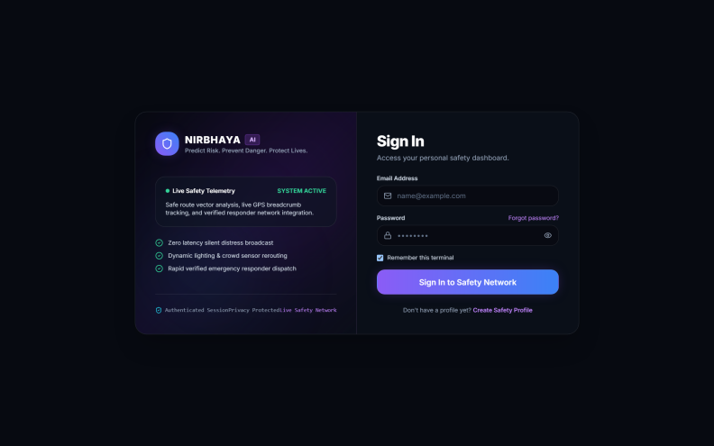
Figure 6.1.1: Login screen
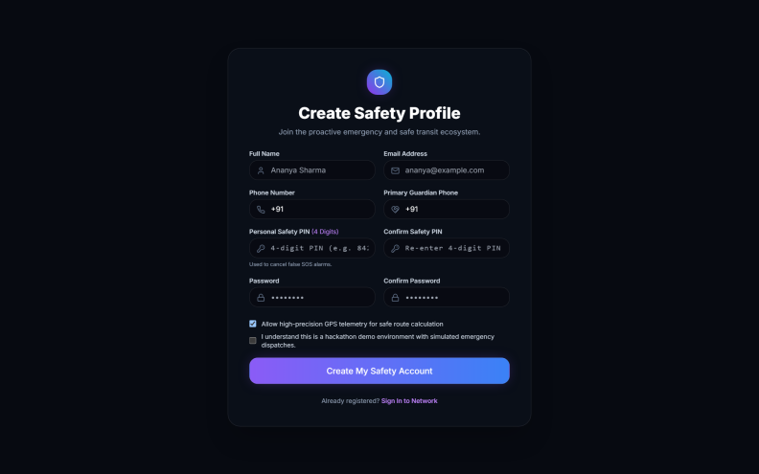
Figure 6.1.2: Create safety profile (registration) screen
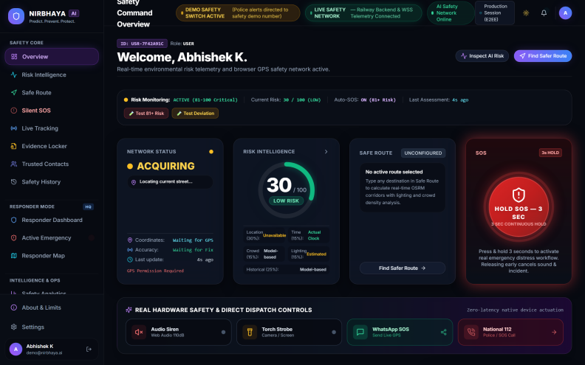
Figure 6.1.3: Safety command overview dashboard
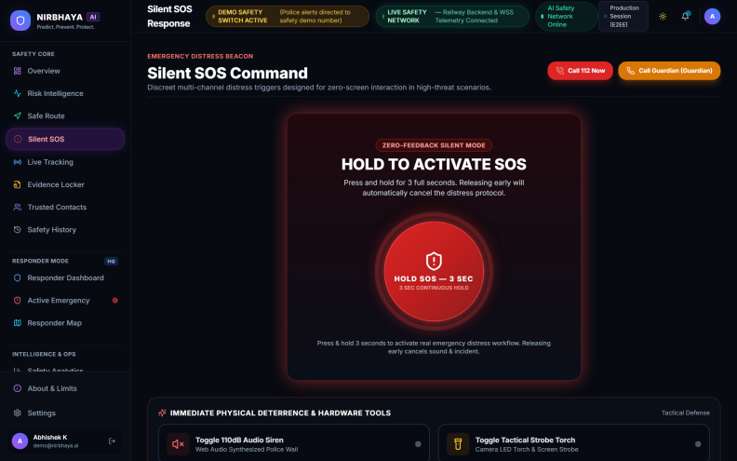
Figure 6.1.4: Silent SOS command screen
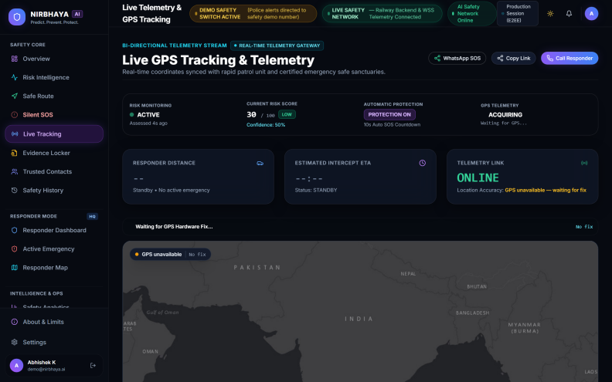
Figure 6.1.5: Live GPS tracking and telemetry screen
REFERENCES
[1] Flutter documentation, https://docs.flutter.dev
[2] FastAPI documentation, https://fastapi.tiangolo.com
[3] TensorFlow Lite guide, https://www.tensorflow.org/lite
[4] Firebase documentation, https://firebase.google.com/docs
[5] Google Maps Platform documentation, https://developers.google.com/maps
[6] Librosa audio analysis library documentation, https://librosa.org/doc/latest/
[7] 112 India Emergency Response Support System, Government of India, https://112.gov.in
[8] Twilio SMS and Voice documentation, https://www.twilio.com/docs

