WEEK 0
NAME: YOGADHARSHINI N K
ROLL NO: 241801324
Q1: Calculate Area and Perimeter
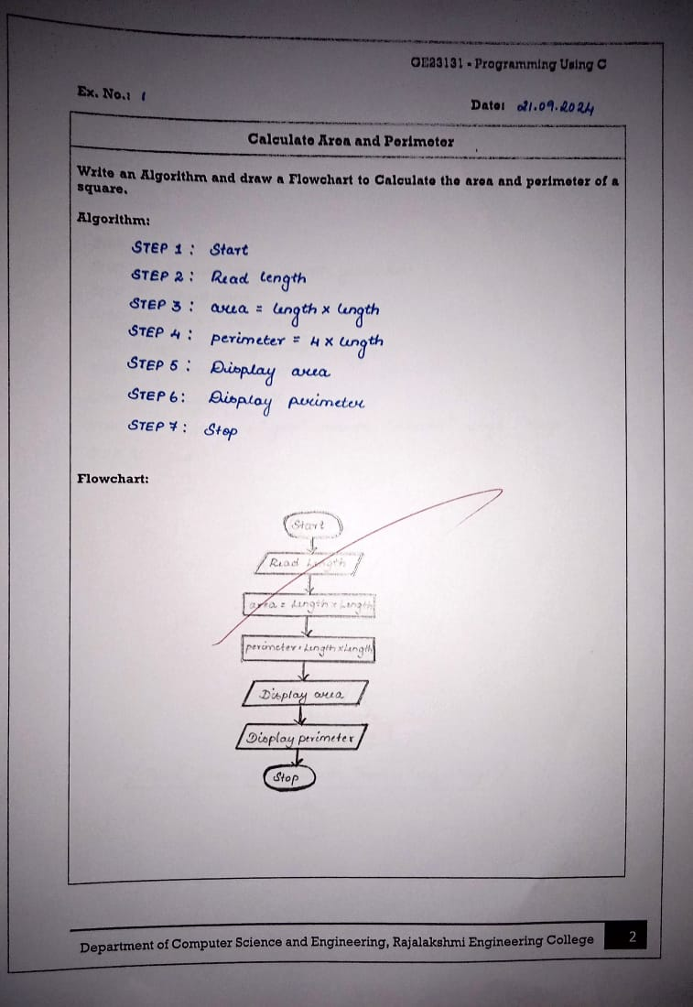
Q2: Days to Year Conversion
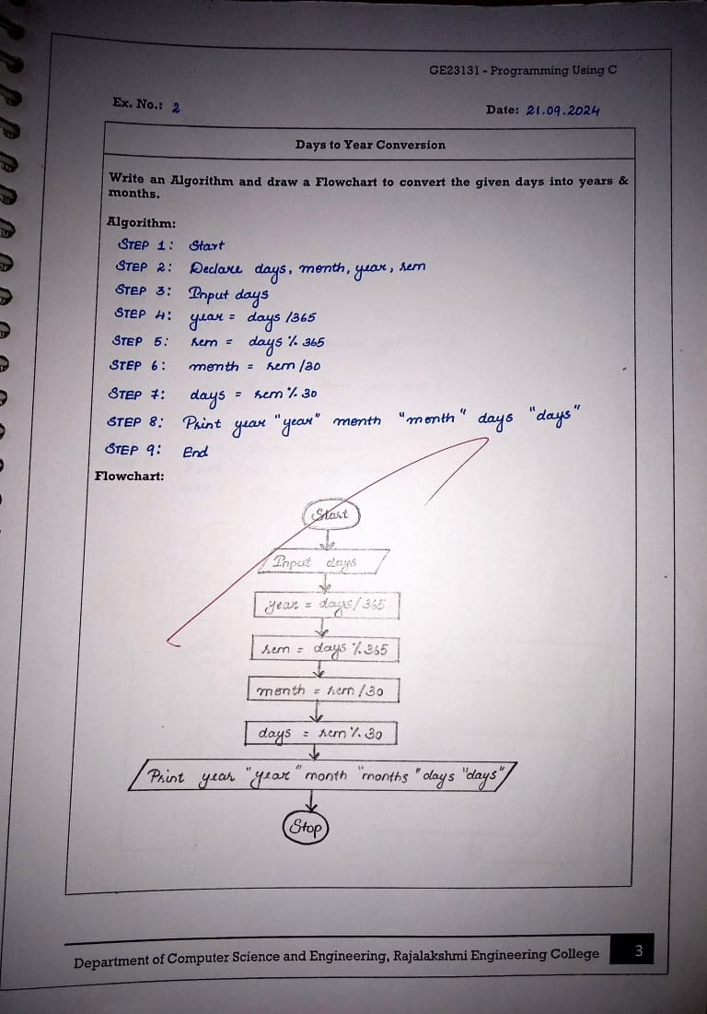
Q3: Prime Number
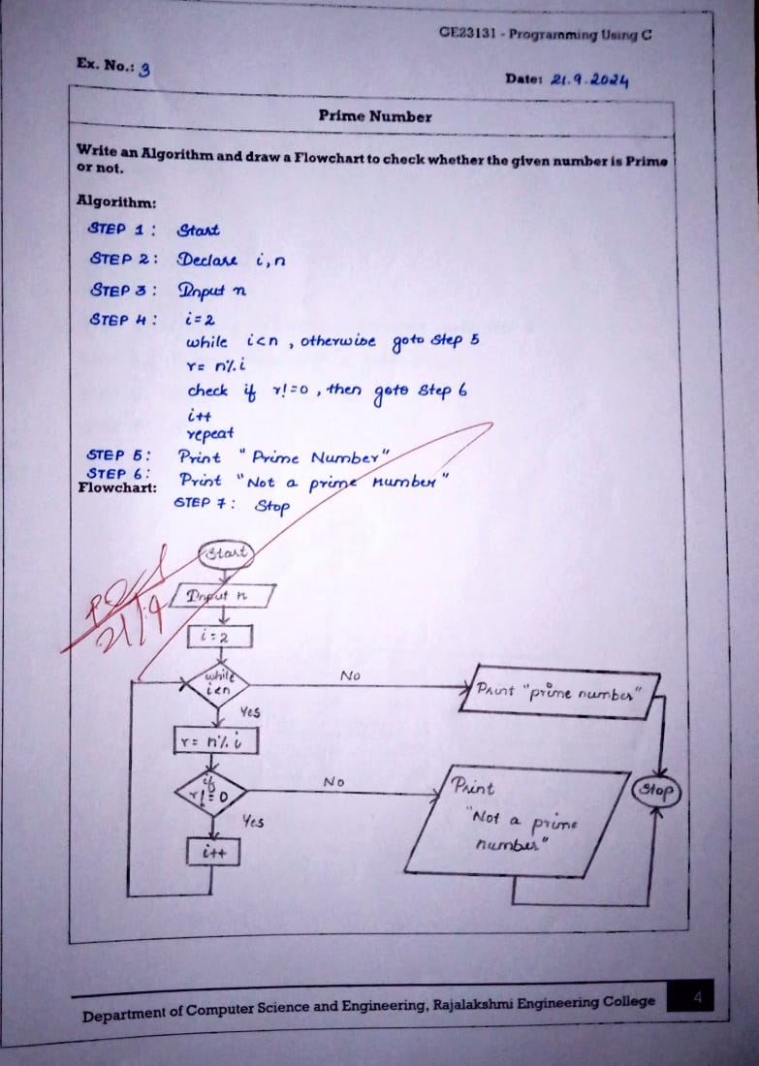
Q4: Leap Year
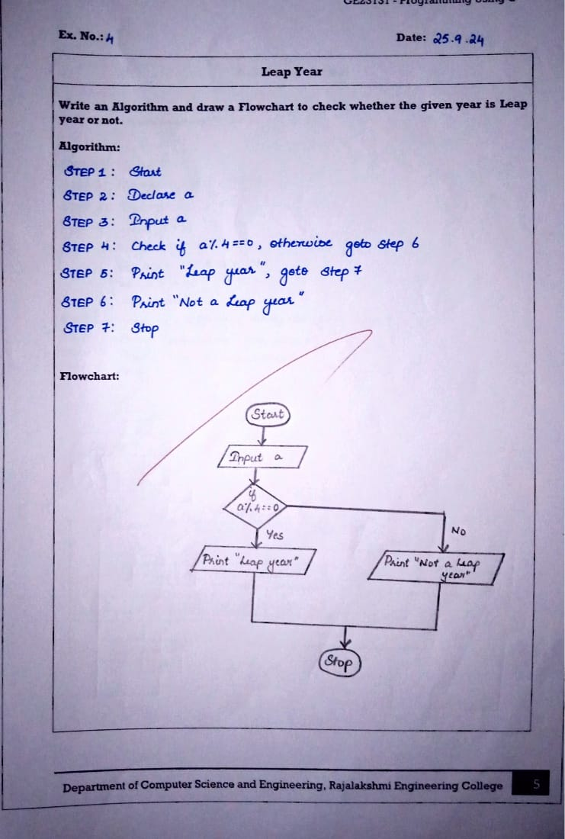
Q5: Palindrome Number
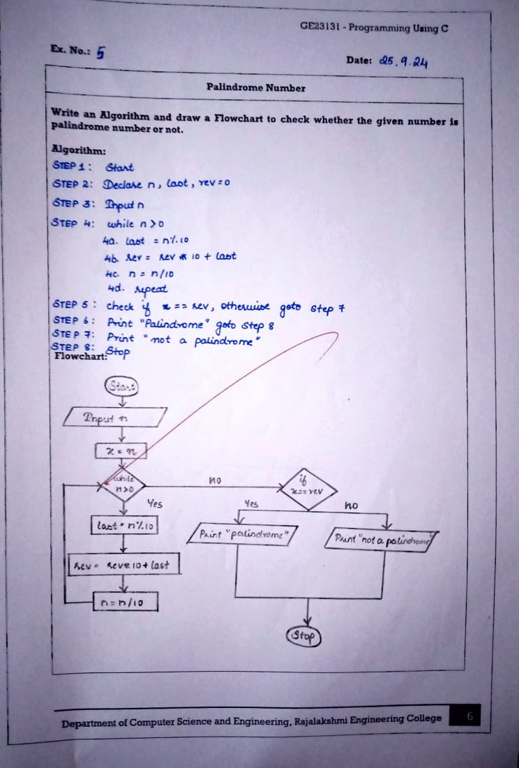
Q6: Sum of Digits