Week-05-01
Practice Session-Coding
ROLL NO: 241801324
NAME: Yogadharshini N K
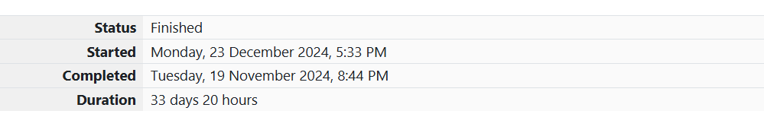
Q1) Write a program that prints a simple chessboard. Input format: The first line contains the number of inputs T. The lines after that contain a different value for size of the chessboard Output format: Print a chessboard of dimensions size * size. Print W for white spaces and B for black spaces. Sample Input: 2 3 5 Sample Output: WBW BWB WBW WBWBW BWBWB WBWBW BWBWB WBWBW.
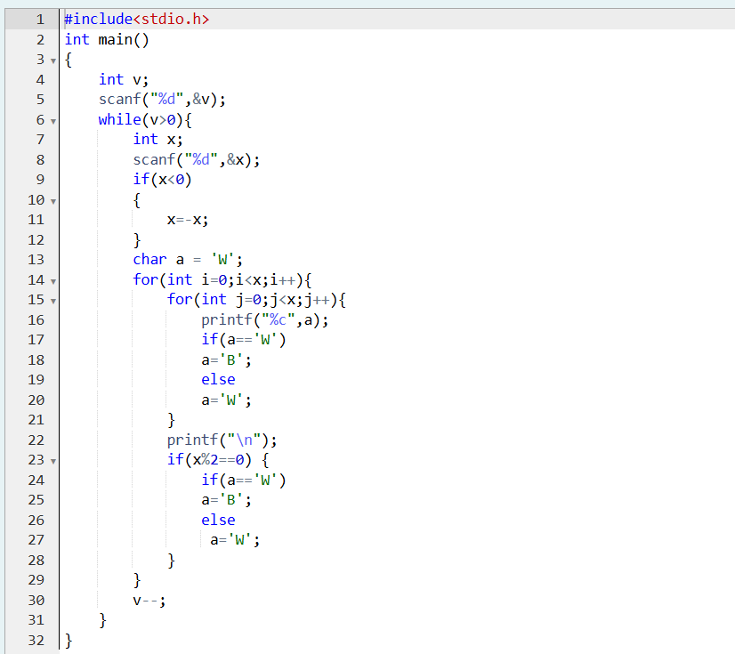
OUTPUT:
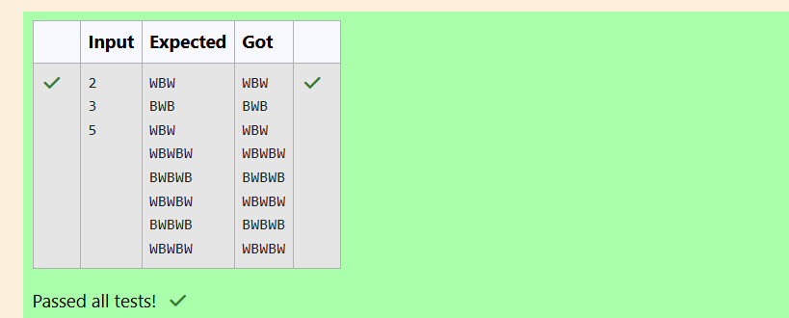
Q2) Let’s print a chessboard! Write a program that takes input: The first line contains T, the number of test cases Each test case contains an integer N and also the starting character of the chessboard Output Format Print the chessboard as per the given examples Sample Input: 2 2 W 3 B Sample Output: WB BW BWB WBW BWB.
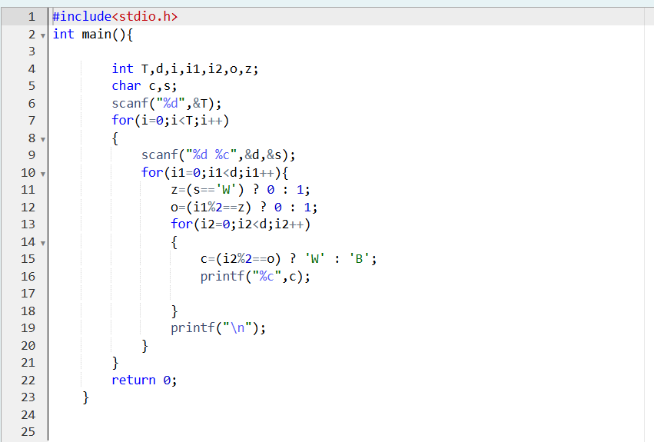
OUTPUT:

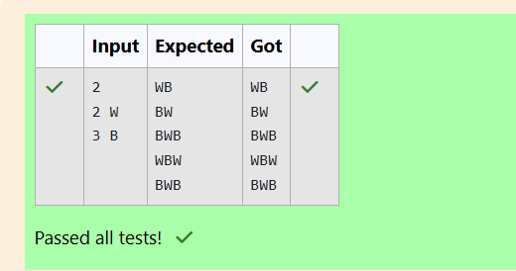
Q3) Decode the logic and print the Pattern that corresponds to given input. If N= 3 then pattern will be: 10203010011012 **4050809 ****607 If N= 4, then pattern will be: 1020304017018019020 **50607014015016 ****809012013 ******10011 Constraints: 2 <= N <= 100 Input Format First line contains T, the number of test cases, each test case contains a single integer N Output Format First line print Case #i where i is the test case number, In the subsequent line, print the pattern Sample Input 3 3 4 5 Sample Output Case #1 10203010011012 **4050809 ****607 Case #2 1020304017018019020 **50607014015016 ****809012013 ******10011 Case #3 102030405026027028029030 **6070809022023024025 ****10011012019020021 ******13014017018 ********15016. 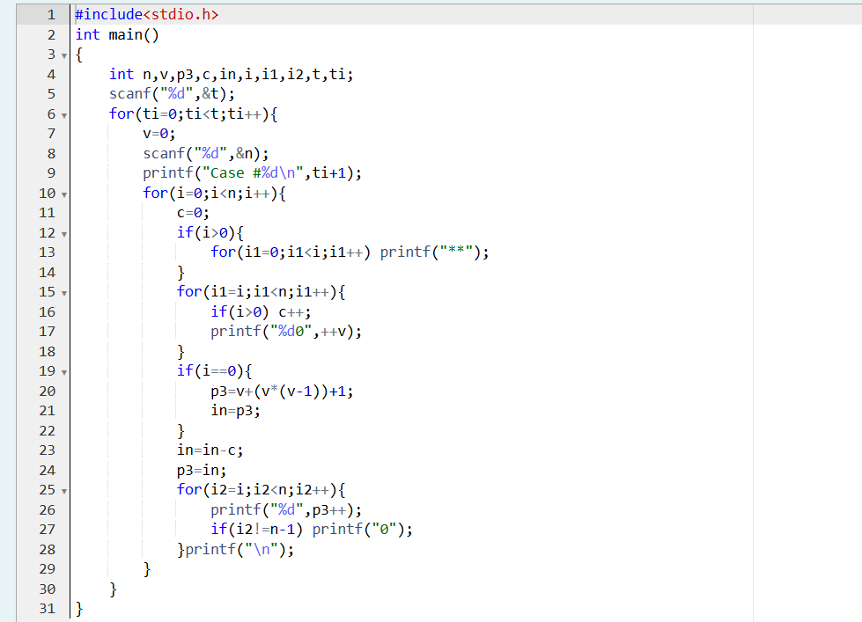
OUTPUT:
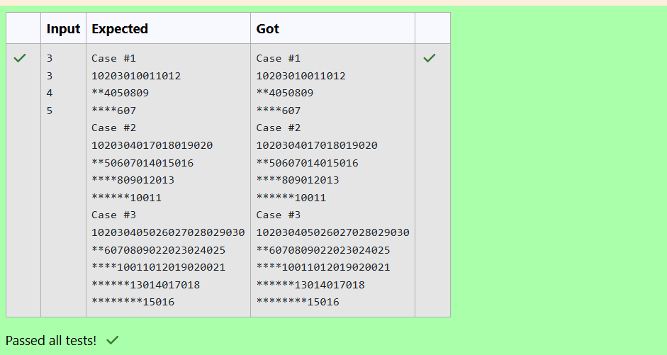
Week-05-02
Practice Session-Coding
ROLL NO: 241801324
NAME: Yogadharshini N K
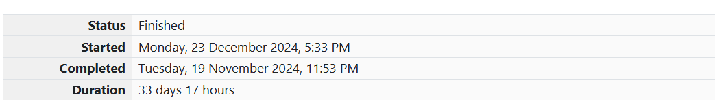
Q1) The k-digit number N is an Armstrong number if and only if the k-th power of each digit sums to N. Given a positive integer N, return true if and only if it is an Armstrong number. Note: 1 <= N <= 10^8 Hint: 153 is a 3-digit number, and 153 = 1^3 + 5^3 + 3^3. Sample Input: 153 Sample Output: true Sample Input: 123 Sample Output: false Sample Input: 1634 Sample Output: true.
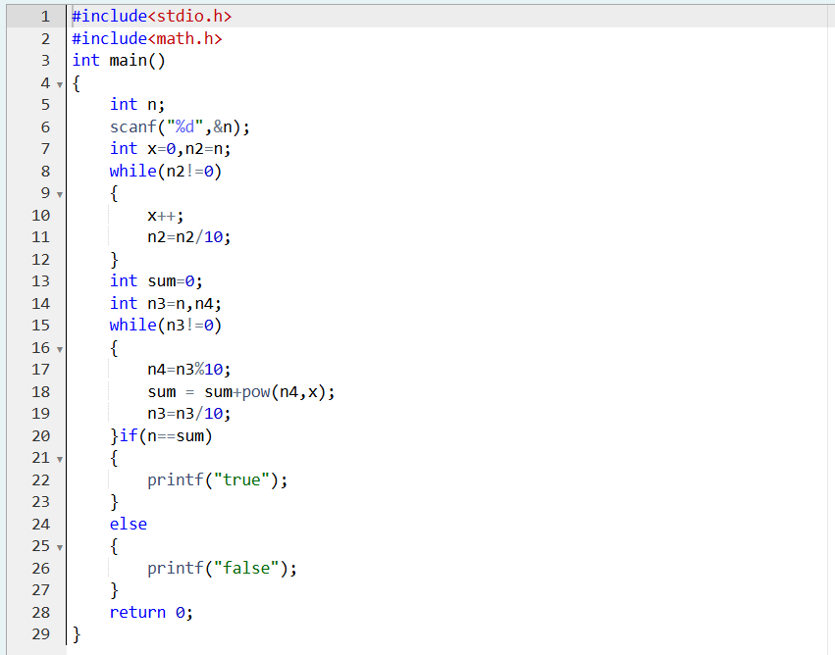
OUTPUT:
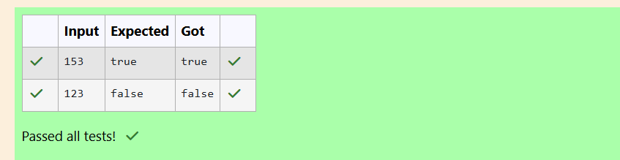
Q2) Take a number, reverse it and add it to the original number until the obtained number is a palindrome. Constraints 1<=num<=99999999 Sample Input 1 32 Sample Output 1 55 Sample Input 2 789 Sample Output 2 66066.
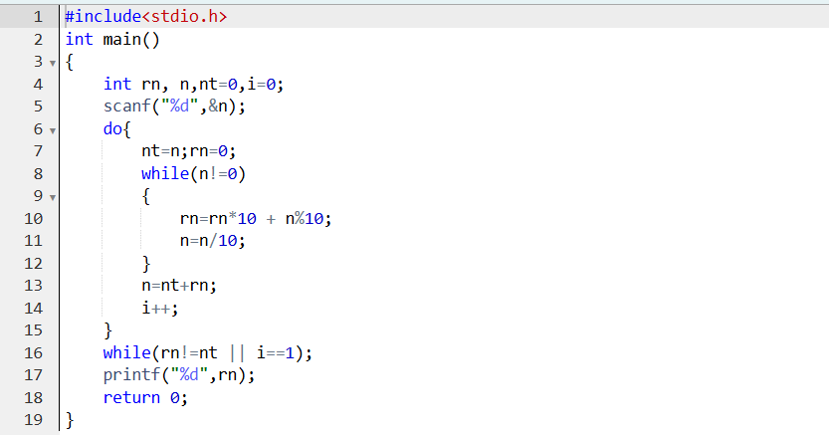
OUTPUT:
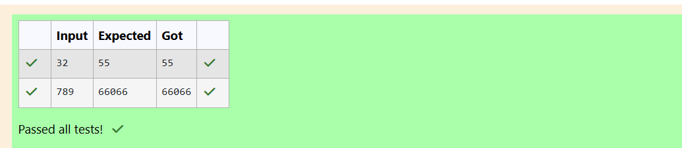
Q3) A number is considered lucky if it contains either 3 or 4 or 3 and 4 both in it. Write a program to print the nth lucky number. Example, 1st lucky number is 3, and 2nd lucky number is 4 and 3rd lucky number is 33 and 4th lucky number is 34 and so on. Note that 13, 40 etc., are not lucky as they have other numbers in it. The program should accept a number 'n' as input and display the nth lucky number as output. Sample Input 1: 3 Sample Output 1: 33.
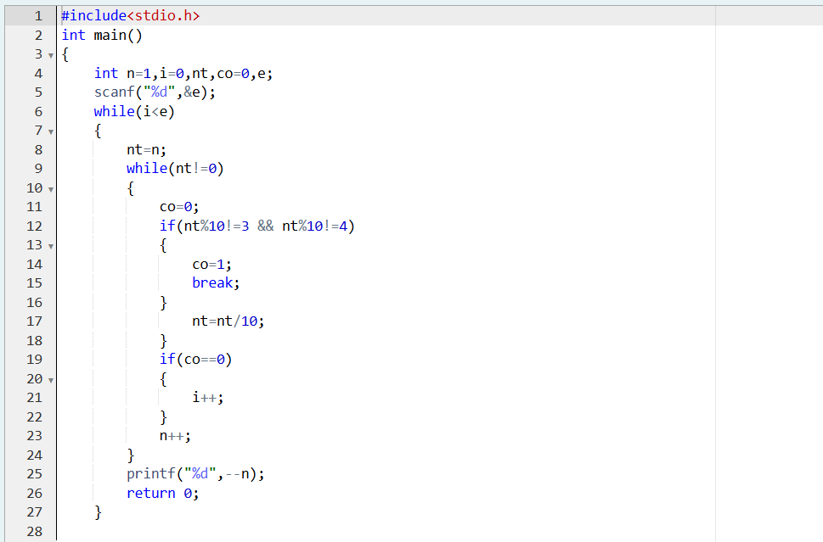
OUTPUT:
