WEEK O
NAME: YOGADHARSHINI N K
ROLL NO: 241801324
Q1-CALCULATE AREA AND PERIMETER
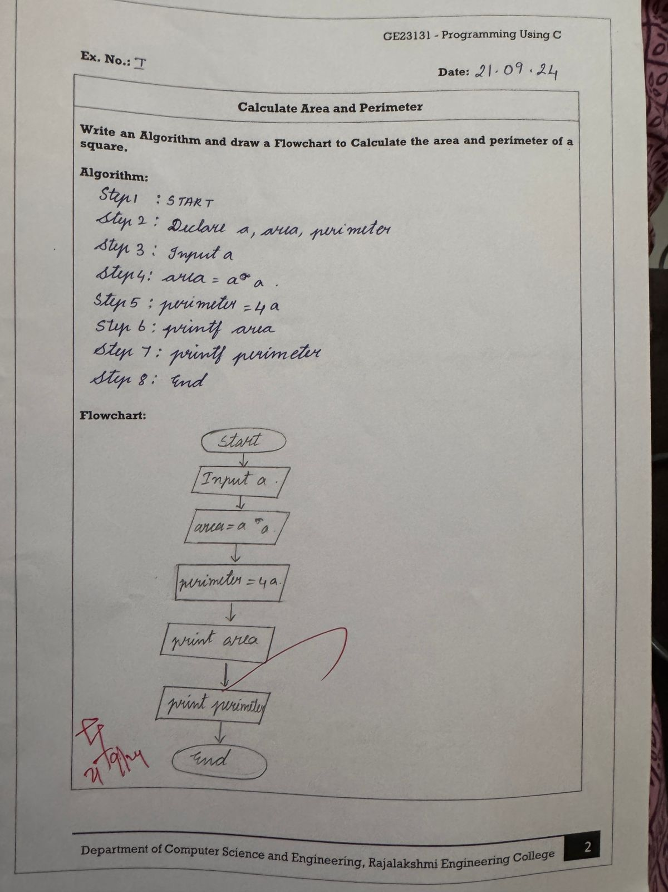

Q2-DAYS TO YEAR CONVERSION

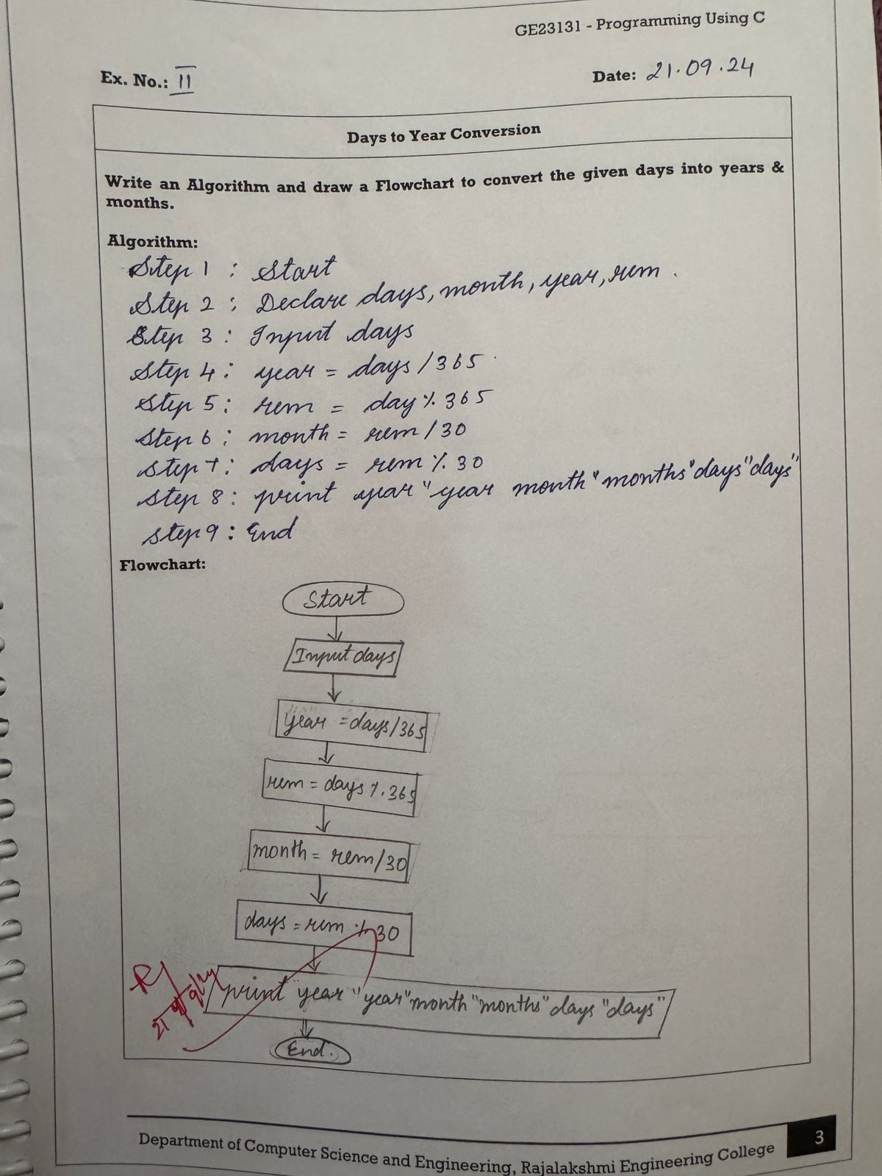
Q3-PRIME NUMBER
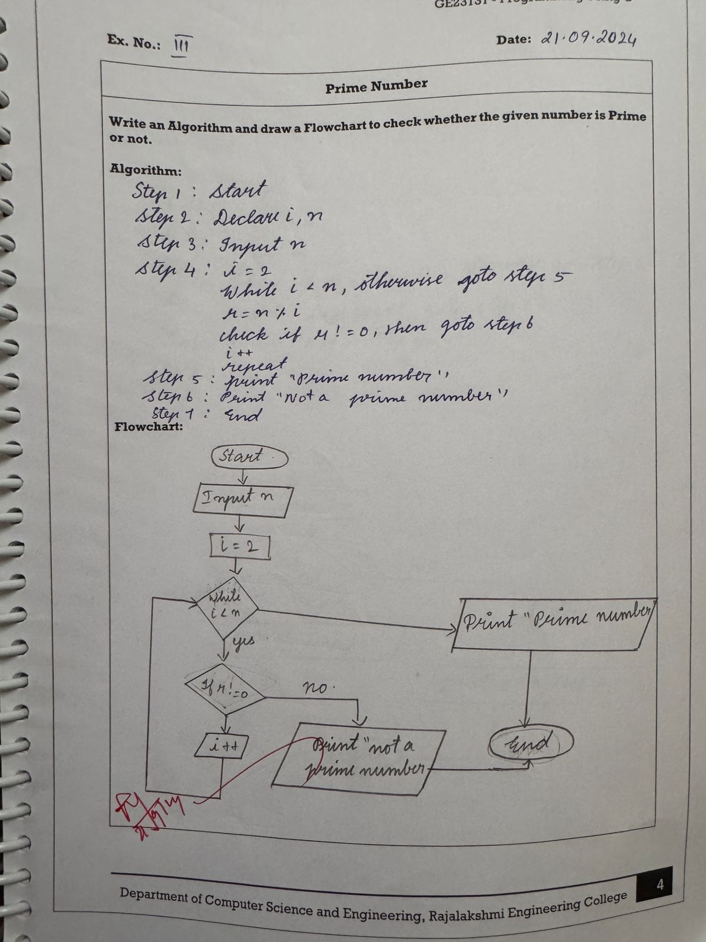

Q4-LEAP YEAR

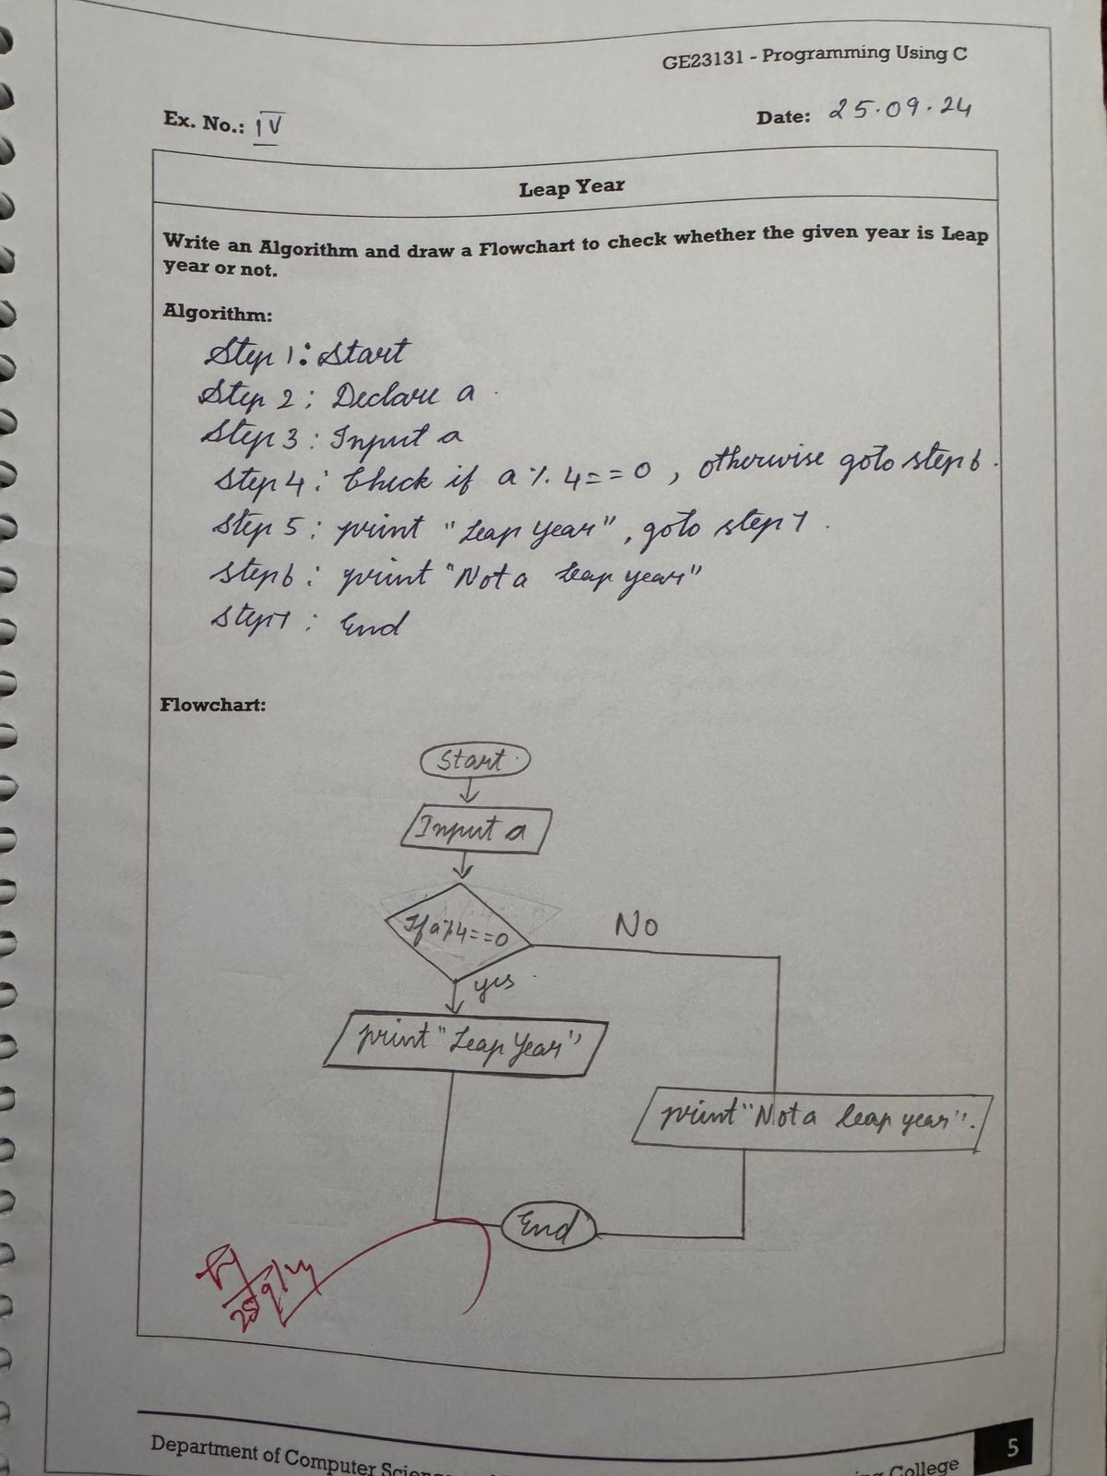
Q5-PALINDROME NUMBER
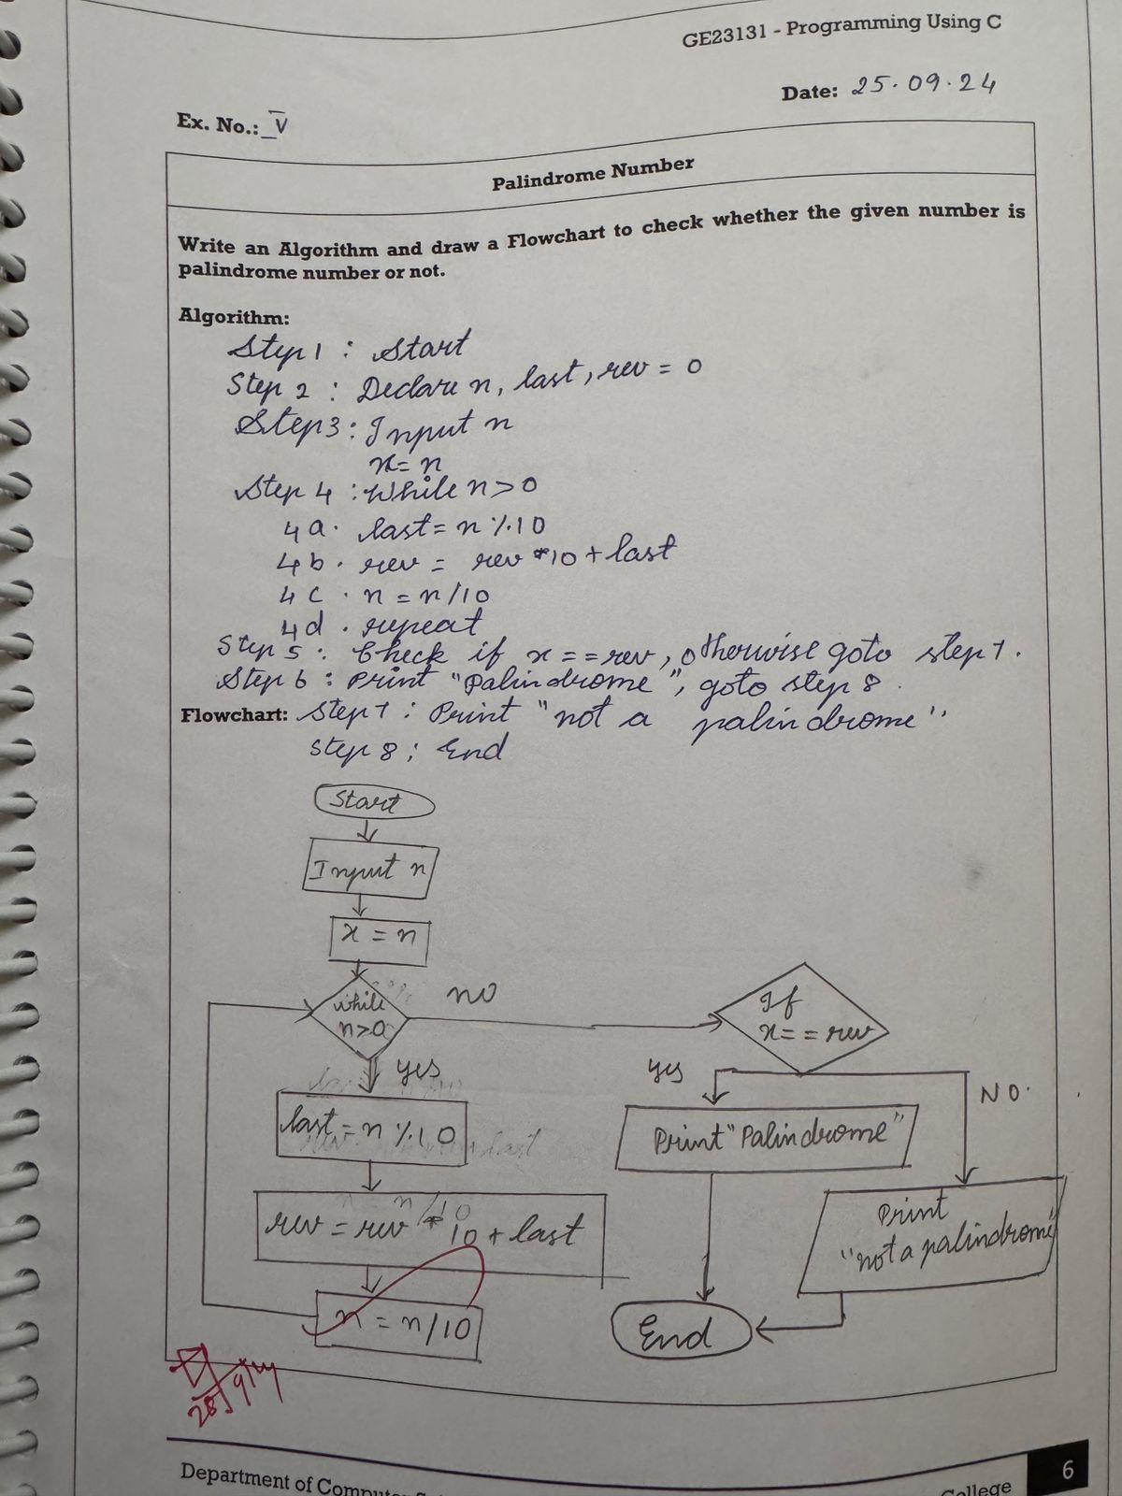

Q6-SUM OF DIGITS
