RAJALAKSHMI ENGINEERING COLLEGE

(Autonomous)

RAJALAKSHMI NAGAR, THANDALAM, CHENNAI-602105



LABORATORY RECORD NOTEBOOK
CS23432 – SOFTWARE CONSTRUCTION

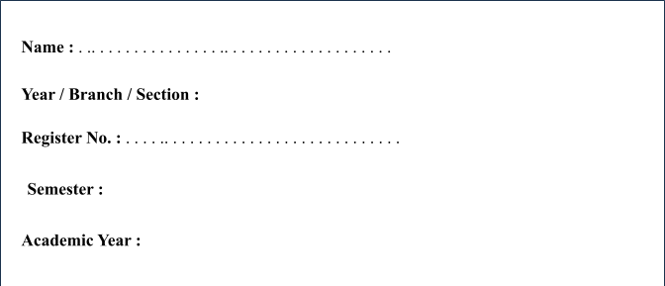

RAJALAKSHMI ENGINEERING COLLEGE
[AUTONOMOUS]
RAJALAKSHMI NAGAR, THANDALAM – 602 105

BONAFIDE CERTIFICATE

Name : . . . . . . . . . . . . . . . . . . . . . . . . . . . . . . . . . . . . . . . . . . . . . .


Academic Year : Semester : 04 Branch : AIDS

Register No.

Certified that this is the Bonafide record of work done by the above student in the
CS23432 – SOFTWARE CONSTRUCTION during the year 2025 - 2026.

Signature of the Faculty In- charge

Submitted for the Practical Examination held on . . . . . . . . . . . . . . . . . .

Internal Examiner External Examiner

RAJALAKSHMI ENGINEERING COLLEGE
(An Autonomous Institution affiliated to Anna University) DEPARTMENT OF ARTIFICIAL INTELLIGENCE AND DATA SCIENCE
Subject: CS23432-Software Construction Reg No: 241801328
Name: ZAINA RAHEEN A.P

S NO | DATE | EXPERIMENTS | QR CODE | SIGN
1 |  | Study of DevOps | 
2 |  | Problem Statement | 
3 |  | Creation of DevOps Organization | 
4 |  | Epic, Feature , user story creation for Library Management System | 
5 |  | Sprint and Poker Planning | 

6 |  | Class Diagram | 
7 |  | Sequence Diagram | 
8 |  | Architecture Diagram | 
9 |  | Usecase Diagram | 
10 |  | ER Diagram | 
11 |  | Test plan and Test case | 
12 |  | Load Testing | 

