Question 1:
vehicle_maintence_scheduler screenshot

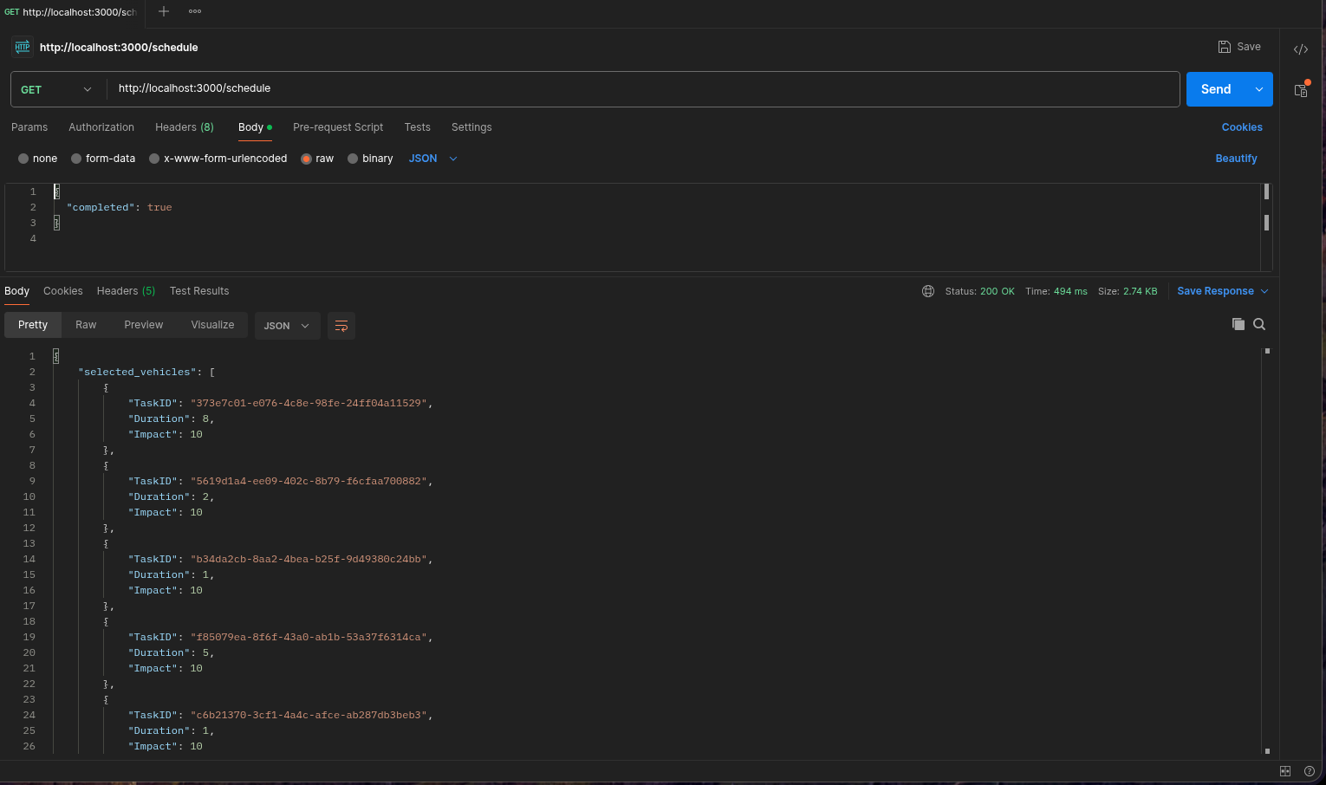
Question 2:

Campus Notification Screenshot

