**SMART PARKING**

**Definition:**

Smart parking refers to an advanced system that uses technology and data-driven solutions to optimize the process of finding and managing parking spaces. It typically involves sensors, cameras, mobile apps, and algorithms to enhance the efficiency of parking operations. Smart parking systems aim to reduce congestion, save time, and improve the overall parking experience for both drivers and parking facility operators.

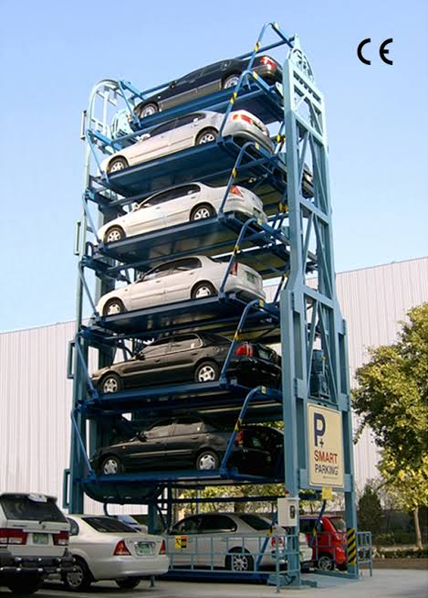

**DESIGN THINKING :**

**Objective:**

* The objective of smart parking systems is to efficiently manage and optimize parking spaces in urban areas by using technology to achieve the following goals:
* Reduce Traffic Congestion: Smart parking systems help drivers find available parking spaces quickly, reducing the time spent circling for parking and alleviating traffic congestion.
* Improve User Experience: These systems enhance the overall parking experience for users by providing real-time information about available spaces and enabling convenient payment methods.
* Maximize Space Utilization: Smart parking aims to make the most of available parking spaces by efficiently allocating them and ensuring that they are used to their full capacity.
* Reduce Environmental Impact: By reducing the time spent searching for parking, smart parking systems help reduce carbon emissions and promote environmental sustainability.
* Increase Revenue for Operators: Operators can optimize pricing, manage parking demand effectively, and generate additional revenue through smart parking solutions.
* Enhance Safety and Security: Smart parking systems often incorporate features like surveillance cameras and lighting to enhance the safety and security of parking facilities.
* Data Analysis: Collecting data on parking usage can help city planners and operators make informed decisions about parking policies, infrastructure development, and future urban planning.
* Overall, the objective of smart parking is to make urban parking more efficient, convenient, and sustainable for both users and operators

**Iot sensors :**

IoT sensors in smart parking systems play a crucial role in efficiently managing parking spaces. Here are some common types of IoT sensors used:

* Ultrasonic Sensors: These sensors detect the presence of a vehicle by sending out sound waves and measuring the time it takes for them to bounce back. They are typically installed on the ceiling or walls of parking spaces.
* Magnetic Sensors: Magnetic sensors detect the presence of a vehicle by measuring changes in the magnetic field caused by the presence of a metal object (like a car). They are often embedded in the ground.
* Infrared Sensors: These sensors use infrared light to detect the presence of a vehicle. They are installed on the ground or on posts and can detect both the presence and size of a vehicle.
* Camera-Based Sensors: High-resolution cameras can be used to visually monitor parking spaces. Advanced image processing algorithms can analyze the images to determine if a space is occupied or vacant.
* Wireless Communication Sensors: Sensors equipped with wireless communication capabilities, such as Wi-Fi or cellular, can transmit data about parking space availability in real-time to a central server or a mobile app.
* Smartphone Apps: While not traditional sensors, smartphone apps can also be part of a smart parking system. They allow users to check for available parking spaces and make reservations.
* Environmental Sensors: Some smart parking systems incorporate environmental sensors to measure factors like air quality, temperature, and noise levels in parking areas.
* RFID (Radio-Frequency Identification) Sensors: RFID tags on vehicles can be read by sensors at entry and exit points to track when a vehicle enters and leaves the parking facility.
* These sensors work together to monitor parking space occupancy, provide real-time data to drivers, and enable efficient management of parking resources. They can help reduce traffic congestion, save time for drivers, and improve the overall parking experience.

**Real time trasport information platform:**

A real-time transport information platform in a smart parking system would provide up-to-the-minute information about transportation options and parking availability. This platform could include features such as:

* Parking Availability: Real-time updates on available parking spaces within the smart parking facility, helping drivers find parking quickly.
* Public Transportation Integration: Information about nearby public transportation options, including bus and train schedules, routes, and real-time updates on arrivals and departures.
* Traffic Updates: Live traffic data and congestion alerts to help drivers plan their routes and avoid traffic jams.
* Navigation Assistance: Turn-by-turn navigation to guide drivers to their chosen parking spot or public transportation stop.
* Payment Integration: Integration with payment systems for parking fees and public transportation fares, allowing for seamless transactions.
* Parking Reservation: The ability to reserve parking spaces in advance, ensuring availability upon arrival.
* Mobile App Access: A mobile app that provides all of these features and allows users to access the platform from their smartphones.
* Sustainability Information: Information about eco-friendly transportation options, such as electric vehicle charging stations or bike-sharing programs.
* Emergency Notifications: Alerts and notifications for emergency situations or unexpected disruptions in transportation services.
* Overall, a real-time transport information platform in a smart parking system aims to enhance the overall parking and transportation experience, reduce congestion, and promote sustainable transportation options.

**Integration approach :**

Integrating various components in a smart parking system involves connecting different technologies and systems to work together seamlessly. Here’s an approach to integration in smart parking:

* Define Objectives: Clearly define the objectives of your smart parking system. Understand what you want to achieve, such as optimizing parking space usage, improving user experience, or increasing revenue.
* Select Key Components: Identify the key components and technologies you want to integrate, such as sensors, cameras, payment systems, and mobile apps.
* Standardize Protocols: Ensure that the components you choose use standardized communication protocols, such as MQTT, RESTful APIs, or WebSocket, to enable data exchange.
* Centralized Control: Implement a central control system or software platform that can manage and monitor all components. This could be a cloud-based solution or an on-premises server.
* Data Aggregation: Collect data from various sensors and devices, such as occupancy sensors, access control systems, and payment gateways. Use data aggregation techniques to consolidate information in a unified format.
* Real-Time Data Processing: Implement real-time data processing to analyze and act on the incoming data. For example, detect available parking spaces, calculate parking fees, and update signage.
* User Interface: Create user-friendly interfaces for both administrators and end-users. Mobile apps and web portals can provide real-time parking availability, reservation options, and payment features.
* Payment Integration: Integrate secure payment gateways to facilitate seamless transactions for users. Ensure compliance with payment industry standards for security.
* Security Measures: Implement robust security measures to protect data and systems from cyber threats and unauthorized access. Encryption and authentication are essential.
* Scalability: Design the system to be scalable so that it can accommodate future expansions and increasing numbers of users and devices.
* Testing and Validation: Thoroughly test the integrated system to ensure it meets the defined objectives and functions correctly. Conduct testing for various scenarios and edge cases.
* User Training: Provide training for administrators and end-users to ensure they can effectively use the smart parking system.
* Maintenance and Support: Establish a maintenance plan to regularly update software, firmware, and security measures. Provide ongoing support to address any issues or improvements.
* Feedback Loop: Continuously gather feedback from users and administrators to make necessary improvements and updates to the system.
* Compliance: Ensure compliance with relevant regulations and standards, such as data privacy laws and accessibility requirements.
* Partnerships: Collaborate with local authorities, transportation agencies, and third-party service

**CONCLUSION:**

In conclusion, smart parking systems represent a significant advancement in urban infrastructure and transportation management. These systems leverage technology to enhance the parking experience for both drivers and city planners. Here are some key takeaways:

* Improved Efficiency: Smart parking systems optimize parking space utilization, reducing congestion and making it easier for drivers to find parking quickly.
* Reduced Environmental Impact: By minimizing the time spent searching for parking, smart parking systems can help reduce fuel consumption and emissions, contributing to environmental sustainability.
* Enhanced User Experience: Mobile apps and real-time data provide users with convenience and a seamless parking experience, including reservations, payments, and navigation.
* Data-Driven Decision-Making: Smart parking generates valuable data on parking patterns and usage, enabling city planners to make informed decisions regarding urban development and traffic management.
* Integration Potential: Smart parking can be integrated with other smart city initiatives, such as public transportation systems, to create a holistic urban mobility ecosystem.
* Revenue Generation: Municipalities and parking facility operators can increase revenue through efficient pricing models and reduced operational costs.
* Challenges Remain: Challenges include the cost of implementation, security concerns, and ensuring accessibility for all users.
* Future Growth: As technology continues to advance, smart parking systems will likely evolve to incorporate innovations like autonomous vehicles and predictive analytics.

Overall, smart parking systems play a crucial role in addressing urban mobility challenges and creating more sustainable, user-friendly cities. They are a part of the broader movement towards smart cities that aim to leverage technology for the benefit of residents and the environment.