727721EUIT185-YOGASELVAN

CA-2

Question-1

package com.ca2.Ca2;

import org.openqa.selenium.By;

import org.openqa.selenium.WebDriver;

import org.openqa.selenium.chrome.ChromeDriver;

import org.openqa.selenium.chrome.ChromeOptions;

import org.testng.annotations.Test;

import io.github.bonigarcia.wdm.WebDriverManager;

public class Q1 {

@Test

public void f() throws InterruptedException{

ChromeOptions co=new ChromeOptions();

co.addArguments("--remote-allow-origins=*");

WebDriverManager.chromedriver().setup();

WebDriver driver=new ChromeDriver(co);

driver.get("https://www.trivago.in/");

driver.manage().window().maximize();

String currtitle=driver.getTitle();

System.out.println(currtitle);

String exptitle="trivago.in - Compare hotel prices worldwide";

if(currtitle.equals(exptitle)) {

System.out.println("Title get Matched");

}

else {

System.out.println("Title not get Matched");

}

Thread.sleep(3000);

driver.findElement(By.xpath("//*[@id=\"input-auto-complete\"]")).click();

Thread.sleep(3000);

driver.findElement(By.xpath("//*[@id=\"suggestion-list\"]/ul/li[1]/div/div")).click();

Thread.sleep(3000);

driver.findElement(By.xpath("//*[@id=\"__next\"]/div[1]/div[1]/section/div[2]/div[3]/div/div[2]/div/div/div/div[2]/div/div[1]/div[2]/button[24]/time")).click();

Thread.sleep(3000);

driver.findElement(By.xpath("//*[@id=\"__next\"]/div[1]/div[1]/section/div[2]/div[3]/div/div[2]/div/div/div/div[2]/div/div[1]/div[2]/button[26]/time")).click();

Thread.sleep(3000);

driver.findElement(By.xpath("//*[@id=\"__next\"]/div[1]/div[1]/section/div[2]/div[3]/div/div[2]/div/div/div[1]/div/div[1]/div[1]/div/button[2]")).click();

Thread.sleep(3000);

driver.findElement(By.xpath("//*[@id=\"__next\"]/div[1]/div[1]/section/div[2]/div[3]/div/div[2]/div/div/div[1]/div/div[1]/div[3]/div/button[2]")).click();

Thread.sleep(3000);

driver.findElement(By.xpath("/html/body/div[1]/div[1]/div[1]/section/div[2]/div[3]/div/div[2]/div/div/div[1]/div/div[2]/div[2]/input")).click();

Thread.sleep(3000);

driver.findElement(By.xpath("//*[@id=\"__next\"]/div[1]/div[1]/section/div[2]/div[3]/div/div[2]/div/div/div[2]/div/button[2]")).click();

}

}

**OUTPUT:**

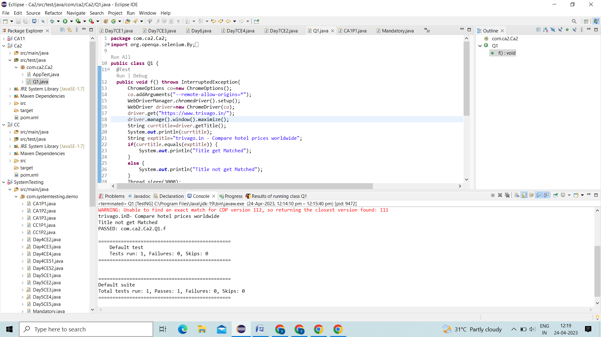

**QUESTON-2**

@Test

  public void Q2() throws InterruptedException {

   Thread.sleep(3000);

   driver.findElement(By.xpath("//*[@id=\"sorting-selector\"]")).click();

   Thread.sleep(3000);

   driver.findElement(By.xpath("//*[@id=\"sorting-selector\"]/option[3]")).click();

   Thread.sleep(3000);

   String txt1=driver.findElement(By.xpath("//*[@id=\"__next\"]/div/div[1]/main/div[3]/div[1]/div/div[3]/div/div/ol/li/div/article/div[2]/div[1]/section/h2/button/span")).getText();

  System.out.println(txt1);

  Thread.sleep(3000);

  String txt2=driver.findElement(By.xpath("//*[@id=\"__next\"]/div/div[1]/main/div[3]/div[1]/div/div[3]/div/div/ol/li/div/article/div[2]/div[2]/div[1]/div/div[3]/div[1]/div/p")).getText();

  System.out.println(txt2);

  Thread.sleep(3000);

  driver.findElement(By.xpath("//*[@id=\"sorting-selector\"]")).click();

  Thread.sleep(3000);

  driver.findElement(By.xpath("//*[@id=\"sorting-selector\"]/option[6]")).click();

  Thread.sleep(3000);

  String txt3=driver.findElement(By.xpath("//*[@id=\"__next\"]/div/div[1]/main/div[3]/div[1]/div/div[3]/div/div/ol/li/div/article/div[2]/div[1]/section/h2/button/span")).getText();

  System.out.println(txt3);

  Thread.sleep(3000);

  String txt4=driver.findElement(By.xpath("//*[@id=\"__next\"]/div/div[1]/main/div[3]/div[1]/div/div[3]/div/div/ol/li/div/article/div[2]/div[2]/div[1]/div/div[3]/div[1]/div/p")).getText();

  System.out.println(txt4);

  String txt5=driver.findElement(By.xpath("//*[@id=\"__next\"]/div/div[1]/main/div[3]/div[1]/div/div[2]/div[1]/div[2]/div[2]/div/div/div[1]/span[2]/strong")).getText();

  System.out.println("Stay Found : " + txt5);

  Thread.sleep(3000);

  String txt6=driver.findElement(By.xpath("//*[@id=\"__next\"]/div/div[1]/main/div[3]/div[1]/div/div[3]/div/div/ol/li/div/article/div[2]/div[2]/div[1]/div/div[3]/div[1]/div/p")).getText();

  System.out.println("Booking site Searched : "+txt6);

}

QUESTON-3

@Test

  public void Q3() throws InterruptedException {

   String txt1=driver.findElement(By.xpath("//*[@id=\"search\"]/div[1]/div[1]/div/span[1]/div[1]/div[3]/div/div/div/div/div/div/div/div[2]/div/div/div[1]/h2/a/span")).getText();

  System.out.println(txt1);

  String txt2=driver.findElement(By.xpath("//*[@id=\"search\"]/div[1]/div[1]/div/span[1]/div[1]/div[4]/div/div/div/div/div/div/div/div[2]/div/div/div[1]/h2/a/span")).getText();

  System.out.println(txt2);

  String txt3=driver.findElement(By.xpath("//*[@id=\"search\"]/div[1]/div[1]/div/span[1]/div[1]/div[5]/div/div/div/div/div/div[2]/div/div/div[1]/h2/a/span")).getText();

  System.out.println(txt3);

  String txt4=driver.findElement(By.xpath("//*[@id=\"search\"]/div[1]/div[1]/div/span[1]/div[1]/div[6]/div/div/div/div/div/div[2]/div/div/div[1]/h2/a/span")).getText();

  System.out.println(txt4);

  String txt5=driver.findElement(By.xpath("//*[@id=\"search\"]/div[1]/div[1]/div/span[1]/div[1]/div[7]/div/div/div/div/div/div[2]/div/div/div[1]/h2/a/span")).getText();

  System.out.println(txt5);

  driver.findElement(By.xpath("//*[@id=\"sorting-selector\"]/option[3]")).click();

  String currentprice=driver.findElement(By.xpath("//*[@id=\"__next\"]/div/div[1]/main/div[3]/div[1]/div/div[3]/div/div/ol/li/div/article/div[2]/div[2]/div[1]/div/div[3]/div[1]/div/p")).getText();

  String expectedprice="[trivago.in](http://trivago.in/) - Compare hotel prices worldwide";

  System.out.println(currentprice);

  if(currentprice.equals(expectedprice)) {

   System.out.println("price Matched");

  }

  else {

   System.out.println("price not Matched");

  }

  driver.findElement(By.xpath("//*[@id=\"__next\"]/div/div[1]/main/div[3]/div[1]/div/div[3]/div/div/ol/li/div/article/div[2]/div[2]/div[1]/div/div[3]/div[2]/button/span/span[1]")).click();

  driver.findElement(By.xpath("//*[@id=\"contentContainer\"]/div[3]/ol/li[1]/div[2]/a/div/div[2]/div")).click();

  driver.findElement(By.xpath("//*[@id=\"hotelNavBar\"]/div/ul/li[2]/button/span")).click();

  driver.findElement(By.xpath("//*[@id=\"ChildRoom-Ch8I2vnABhACIA4ojuUhMARAAUoJN0QxTl8xMDBQUJgFEgIIARoGEAIoBDAB\"]/div/div[4]/div[2]/div/div[1]/button/div")).click();

  WebElement txtBoxl=driver.findElement(By.xpath("//*[@id=\"Fullname\"]"));

  txtBoxl.sendKeys("Yogaselvan");

  }

  @BeforeClass

  public void beforeClass() {

   ChromeOptions co = new ChromeOptions();

   co.addArguments("--remote-allow-origins=*");

   WebDriverManager.chromedriver().setup();

   driver = new ChromeDriver(co);

   driver.get("<https://www.trivago.in/>");

   driver.manage().window().maximize();

  }

  @AfterClass

  public void afterClass() {

// driver.close();

}

}

