**DOCUMENT**

PostgreSQL Setup with Docker

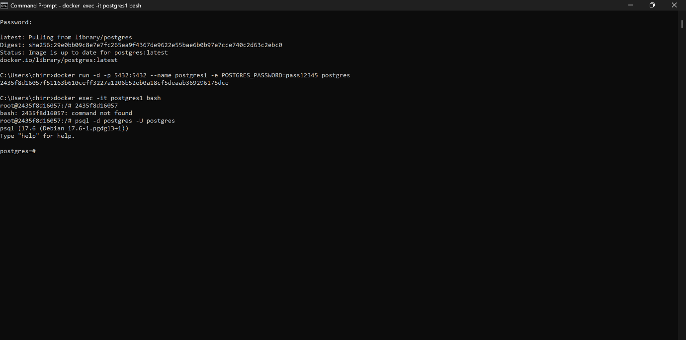

Build a Python Web App with Docker Compose in code environments (e.g., VS Code)

requirements.txt

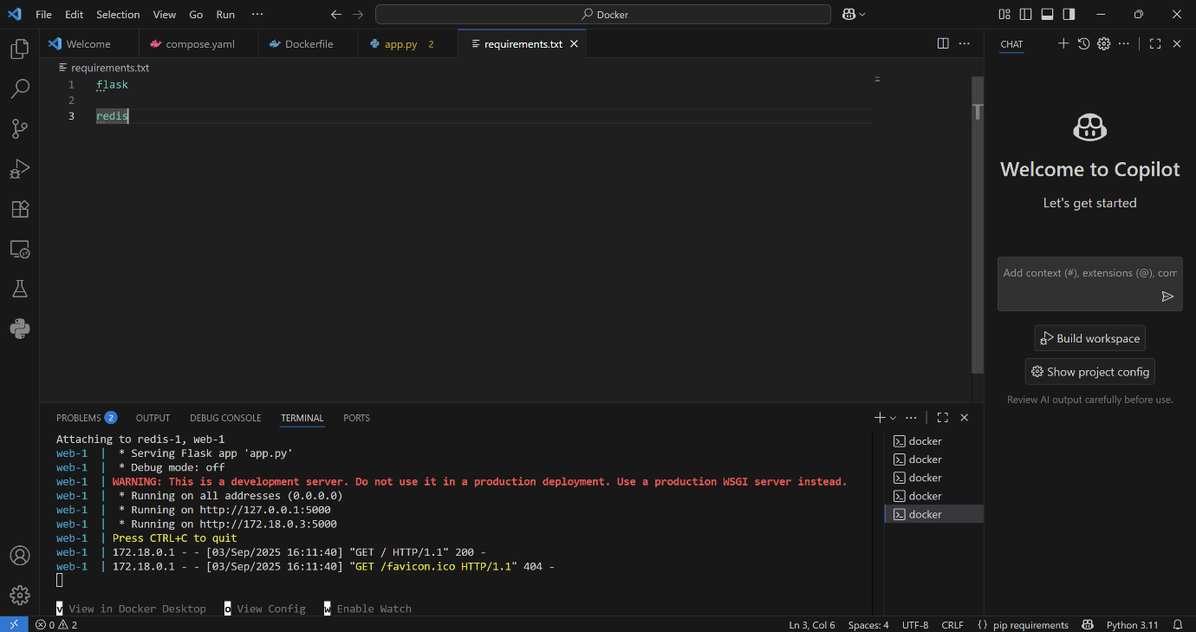

app.py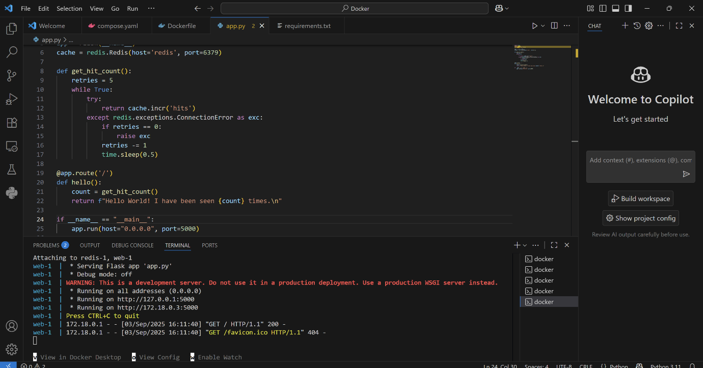

Dockerfile

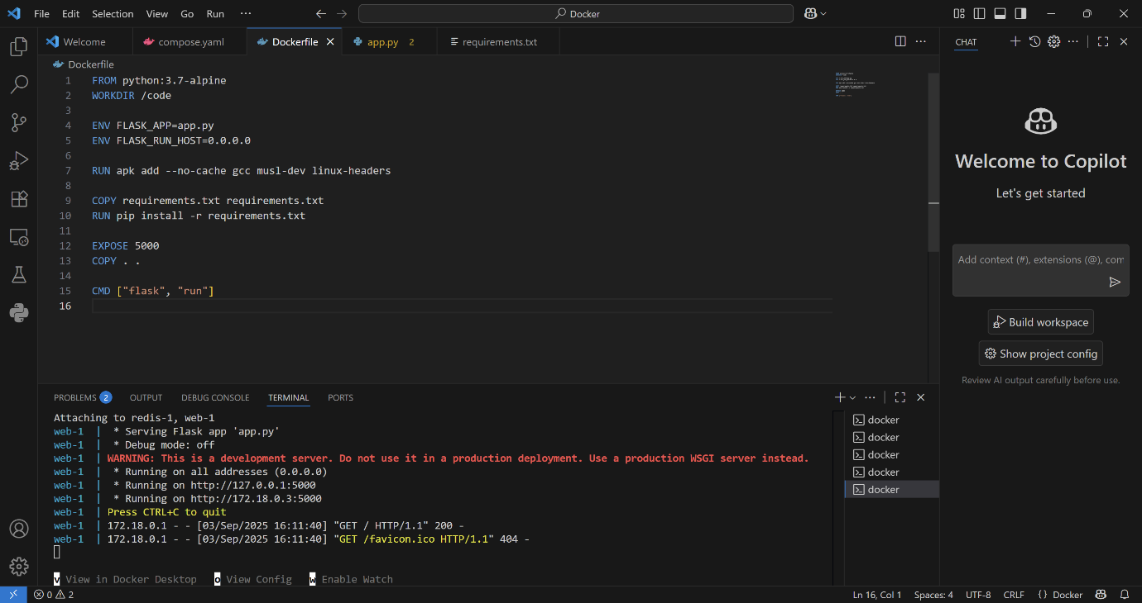

compose.yaml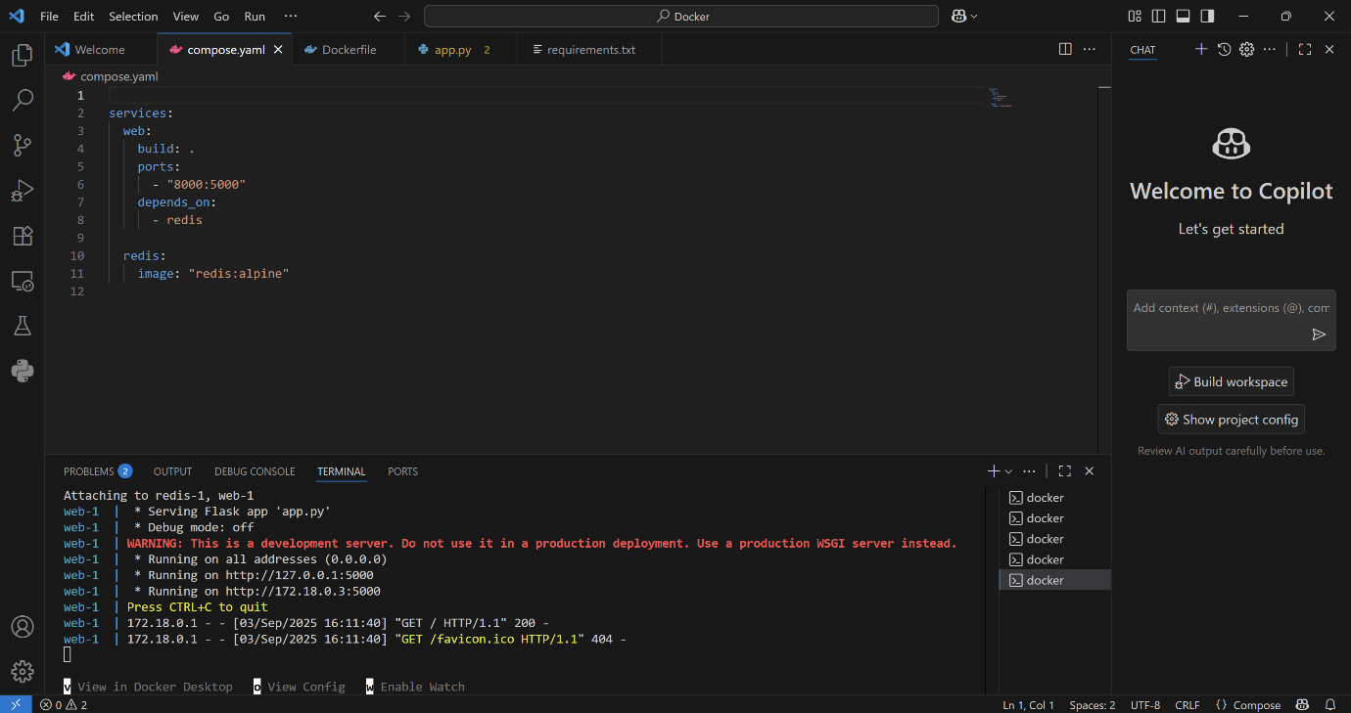

Terminal

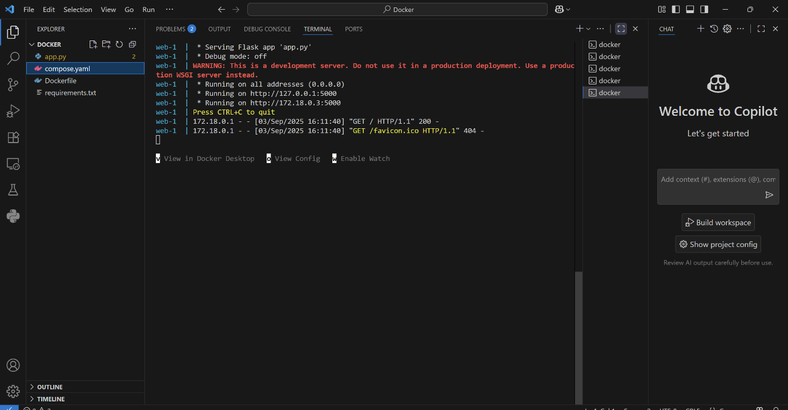

**OUTPUT OBTAINED AFTER THE HANDS ON:**

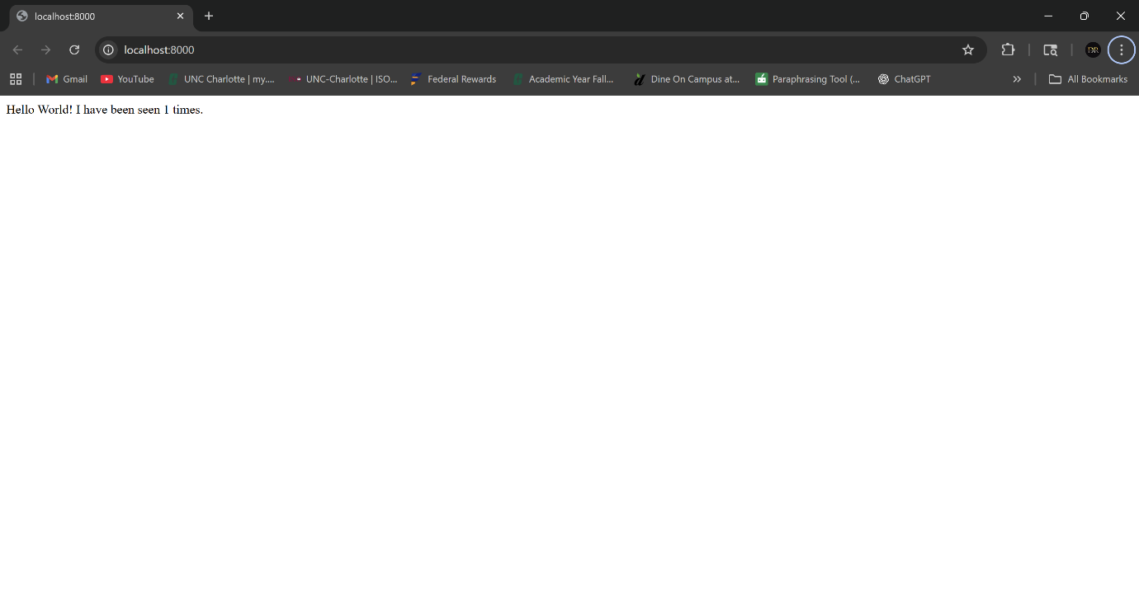

**Docker desktop app showing the containers:**

