B.Tech. BCSE497J - Project-I

ADAPTIVE PORTFOLIO OPTIMIZATION IN DYNAMIC FINANCIAL MARKETS

Submitted in partial fulfillment of the requirements for the degree of

Bachelor of Technology

in

Computer Science and Engineering (Artificial Intelligence and Machine Learning)

by

23BAI0002 | YOGDEEP BENCHIMATH
23BAI0014 | ANUSHKA MISHRA
23BAI0044 | MEHUL ARORA

Under the Supervision of
Dr. Arti Tiwari
[Designation of the guide]
School of Computer Science and Engineering (SCOPE)


October 2026

DECLARATION

We hereby declare that the project entitled ADAPTIVE PORTFOLIO OPTIMIZATION IN DYNAMIC FINANCIAL MARKETS submitted by us, for the award of the degree of Bachelor of Technology in Computer Science and Engineering to VIT is a record of bonafide work carried out by us under the supervision of Dr. Arti Tiwari.
We further declare that the work reported in this project has not been submitted and will not be submitted, either in part or in full, for the award of any other degree or diploma in this institute or any other institute or university.

Place : Vellore
Date :
Signature of the Candidates
Yogdeep Benchimath (23BAI0002)
Anushka Mishra (23BAI0014)
Mehul Arora (23BAI0044)

CERTIFICATE

This is to certify that the project entitled ADAPTIVE PORTFOLIO OPTIMIZATION IN DYNAMIC FINANCIAL MARKETS submitted by Yogdeep Benchimath (23BAI0002), Anushka Mishra (23BAI0014) and Mehul Arora (23BAI0044), School of Computer Science and Engineering, VIT, for the award of the degree of Bachelor of Technology in Computer Science and Engineering, is a record of bonafide work carried out by them under my supervision during Fall Semester 2026-2027, as per the VIT code of academic and research ethics.

The contents of this report have not been submitted and will not be submitted either in part or in full, for the award of any other degree or diploma in this institute or any other institute or university. The project fulfills the requirements and regulations of the University and in my opinion meets the necessary standards for submission.

Place : Vellore
Date :

Signature of the Guide
Dr. Arti Tiwari

Examiner(s)

[Name of the Head of the Department]
B.Tech. Computer Science and Engineering (Artificial Intelligence and Machine Learning)
ACKNOWLEDGEMENTS

We thank the management of Vellore Institute of Technology (VIT) for the opportunity to take up this project and for the academic environment in which we could carry it out.

We are grateful to Dr. Jaisankar N, Dean of the School of Computer Science and Engineering (SCOPE), for the support and encouragement the school has given us during our studies.

We thank [Name of the Head of the Department], Head of the [Department Name], for the guidance and support given to us while we worked on this project.

We are especially thankful to our project guide, Dr. Arti Tiwari, for the guidance, time and feedback that shaped this project.

Thank you all for your contributions and support.

Yogdeep Benchimath
Anushka Mishra
Mehul Arora

TABLE OF CONTENTS
Sl.No | Contents | Page No.
 | Abstract | xii
1. | INTRODUCTION | 1
 | 1.1 Background | 1
 | 1.2 Motivations | 1
 | 1.3 Scope of the Project | 2
2. | PROJECT DESCRIPTION AND GOALS | 3
 | 2.1 Literature Review | 3
 | 2.2 Research Gap | 3
 | 2.3 Objectives | 4
 | 2.4 Problem Statement | 5
 | 2.5 Project Plan | 5
3. | TECHNICAL SPECIFICATION | 7
 | 3.1 Requirements | 7
 | 3.1.1 Functional | 7
 | 3.1.2 Non-Functional | 8
 | 3.2 Feasibility Study | 8
 | 3.2.1 Technical Feasibility | 8
 | 3.2.2 Economic Feasibility | 8
 | 3.2.3 Social Feasibility | 9
 | 3.3 System Specification | 9
 | 3.3.1 Hardware Specification | 9
 | 3.3.2 Software Specification | 10
4. | DESIGN APPROACH AND DETAILS | 11
 | 4.1 System Architecture | 11
 | 4.2 Design | 12
 | 4.2.1 Data Flow Diagram | 12
 | 4.2.2 Use Case Diagram | 13
 | 4.2.3 Class Diagram | 14
 | 4.2.4 Sequence Diagram | 15
5. | METHODOLOGY AND TESTING | 18
 | 5.1 Module Description | 18
 | 5.1.1 Data Acquisition and Preprocessing | 18
 | 5.1.2 Regime Detection with a Hidden Markov Model | 20
 | 5.1.3 Length-Invariant Shape and Transformer Encoder | 20
 | 5.1.4 Reference Corpus and HDBSCAN | 21
 | 5.1.5 Similarity Scoring and the Comparison Report | 21
 | 5.1.6 Allocation Strategies | 22
 | 5.1.7 Backtest Engine and Evaluation Metrics | 23
 | 5.1.8 Dashboard | 24
 | 5.2 Testing | 25
 | 5.2.1 Approach and Test Environment | 25
 | 5.2.2 Functional (API) Tests | 26
 | 5.2.3 Unit Tests | 27
 | 5.2.4 Model Validation Protocol | 27
 | 5.2.5 Defects Found and Fixed | 28
6. | PROJECT DEMONSTRATION | 29
 | 6.1 Running the Application | 29
 | 6.2 Portfolio Backtest Tab | 29
 | 6.3 Regime Detection Tab | 30
 | 6.4 About Tab | 32
7. | RESULT AND DISCUSSION (COST ANALYSIS AS APPLICABLE) | 34
 | 7.1 Regime Detection | 34
 | 7.2 Historical-Pattern Comparison | 34
 | 7.2.1 Example Reports | 34
 | 7.2.2 Embedding Space | 35
 | 7.2.3 Leakage-Controlled Evaluation | 36
 | 7.2.4 Unseen Crises | 37
 | 7.3 Walk-Forward Allocation Backtests | 37
 | 7.3.1 Criterion-Wise Analysis | 40
 | 7.4 Statistical Analysis | 41
 | 7.5 Ablation Study | 41
 | 7.6 Comparison with Existing Methods | 43
 | 7.7 Cost Analysis | 43
 | 7.8 Discussion | 44
 | 7.9 Limitations | 44
8. | CONCLUSION | 46
 | 8.1 Future Work | 46
9. | REFERENCES | 48
 | APPENDIX A: SAMPLE CODE | 50

List of Figures
Figure No. | Title | Page No.
2.1 | Four-month project work plan | 6
4.1 | Layered architecture of the Adaptive Portfolio Optimizer | 11
4.2 | Data flow diagram, level 0 (context diagram) | 12
4.3 | Data flow diagram, level 1 | 12
4.4 | Use case diagram | 13
4.5 | Class diagram of the back end | 14
4.6 | Sequence diagram of a historical-pattern comparison | 15
4.7 | Sequence diagram of a portfolio backtest | 16
5.1 | Transformer shape encoder and the decoder used only for training | 21
5.2 | Historical-pattern comparison pipeline | 22
5.3 | Walk-forward protocol: training on the pre-crisis segment, evaluation through the crisis | 23
6.1 | Portfolio Backtest tab for the 2008 crisis | 30
6.2 | Regime Detection tab for SPY, 2019 to 2021, with the comparison loading | 31
6.3 | Regime Detection tab with the comparison report for the COVID-19 window | 32
6.4 | About and tech stack tab | 33
7.1 | HMM regimes on SPY for (a) the dot-com bust, (b) the 2008 crisis and (c) the COVID-19 crash | 34
7.2 | Query paths (solid) against the nearest reference windows (dashed) | 35
7.3 | Corpus embeddings colored by label: (a) PCA and (b) t-SNE of the 965 vectors | 35
7.4 | Embedding ablation under blocked cross-validation | 37
7.5 | Confusion matrix of the trained-Transformer classifier under blocked cross-validation | 37
7.6 | Portfolio value of the three strategies in the four settings | 39
7.7 | Out-of-sample Sharpe ratio, maximum drawdown and volatility | 39
7.8 | Adaptive-policy weights over time (seed 42) | 40
7.9 | Out-of-sample Sharpe ratio of the adaptive policy across six seeds; dashed lines are the baselines | 42

List of Tables
Table No. | Title | Page No.
1.1 | Scope of the project | 2
2.1 | Literature review of recent adaptive portfolio optimization studies | 3
2.2 | Research gaps, proposed focus and status | 4
2.3 | Sustainable Development Goals addressed | 5
2.4 | Project plan with task durations | 6
3.1 | Functional requirements | 7
3.2 | Non-functional requirements | 8
3.3 | Resources and costs | 9
3.4 | Hardware used for development and testing | 9
3.5 | Software stack | 10
4.1 | REST endpoints of the back end | 12
5.1 | Backtest settings and crisis definitions | 18
5.2 | Descriptive statistics of each asset over each backtest window (252 trading days per year) | 19
5.3 | Hyper-parameters used in the experiments | 24
5.4 | Functional tests of the REST API | 26
5.5 | Unit tests of the analytics modules | 27
5.6 | Defects found during development and testing | 28
7.1 | Comparison report output for five example queries | 34
7.2 | Blocked, purged 5-fold cross-validation of event identification | 36
7.3 | Leave-one-event-out: share of the unseen crisis' windows predicted as crisis-like | 37
7.4 | Out-of-sample performance of the three strategies (policy seed 42) | 37
7.5 | Best strategy per criterion and setting on the test segment | 40
7.6 | Paired stationary-bootstrap intervals for the test-segment Sharpe ratio difference | 41
7.7 | Allocator ablation: test-segment results, mean ± standard deviation over six seeds | 41
7.8 | Capability comparison with the reviewed studies | 43
7.9 | Computing cost of the main operations | 44
8.1 | Objectives and outcomes | 46

List of Abbreviations

AD Adaptive (strategy)
API Application Programming Interface
CI Confidence Interval
CNN Convolutional Neural Network
CPU Central Processing Unit
CSV Comma-Separated Values
DDPG Deep Deterministic Policy Gradient
DFD Data Flow Diagram
DRL Deep Reinforcement Learning
EM Expectation-Maximization
ES Evolution Strategies
ETF Exchange-Traded Fund
EW Equal-Weight (strategy)
FFN Feed-Forward Network
FR Functional Requirement
GAT Graph Attention Network
GELU Gaussian Error Linear Unit
GFC Global Financial Crisis
GLD SPDR Gold Shares (ETF)
GPU Graphics Processing Unit
HDBSCAN Hierarchical Density-Based Spatial Clustering of Applications with Noise
HMM Hidden Markov Model
HTTP Hypertext Transfer Protocol
IEEE Institute of Electrical and Electronics Engineers
JSON JavaScript Object Notation
k-NN k-Nearest Neighbors
LOEO Leave-One-Event-Out
LSTM Long Short-Term Memory
MACD Moving Average Convergence Divergence
MDD Maximum Drawdown
MLP Multi-Layer Perceptron
MV Mean-Variance (strategy)
NFR Non-Functional Requirement
PCA Principal Component Analysis
PPO Proximal Policy Optimization
QQQ Invesco QQQ Trust (Nasdaq-100 ETF)
REST Representational State Transfer
RL Reinforcement Learning
RSI Relative Strength Index
SDG Sustainable Development Goal
SLSQP Sequential Least Squares Programming
SMA Simple Moving Average
SPY SPDR S&P 500 ETF Trust
SR Sharpe Ratio
t-SNE t-distributed Stochastic Neighbor Embedding
TLT iShares 20+ Year Treasury Bond ETF
TO Turnover
TRL Technology Readiness Level
UI User Interface
VIX CBOE Volatility Index
VUSTX Vanguard Long-Term Treasury Fund

Symbols and Notations

r_{t} Daily log return of an asset on day t
P_{t} Adjusted closing price on day t
σ_{t} 20-day annualized rolling volatility
d_{t} Drawdown from the 60-day rolling peak
z_{t} Hidden regime state on day t (bull, bear or crisis)
A State transition matrix of the HMM
μ_{j}, σ_{j} Mean and standard deviation of the features in HMM state j
X̃ Length-invariant 40 by 3 shape of a price window
c_{τ}, v_{τ}, g_{τ} Cumulative return, rolling volatility and running drawdown at point τ of a window
d_{model} Hidden size of the Transformer (32)
Q, K, V Query, key and value matrices of self-attention
d_{k} Dimension of the attention keys
f_{θ}, g_{φ} Encoder and decoder of the autoencoder
L Reconstruction loss
z 16-dimensional embedding of a window
ℓ Label of a corpus window (dot-com, GFC, COVID-19 or normal)
k Number of nearest neighbors (8)
s_{ℓ} In-class spacing of label ℓ
m_{ℓ} Mean distance to the k nearest windows of label ℓ
π_{ℓ} Gaussian-kernel similarity to label ℓ
p_{ℓ} Local purity of label ℓ among the 15 nearest windows
C_{ℓ} Match confidence for label ℓ
w_{k} Portfolio weight vector at rebalance k
s_{k} State vector given to the adaptive policy
W₁, W₂, b₁, b₂ Weights and biases of the policy network
θ Flattened parameters of the policy
ε_{i} Gaussian perturbation of the parameters in evolution strategies
σ, α Perturbation scale (0.1) and step size (0.05) of evolution strategies
F̂_{i} Rank-normalized reward of perturbation i
R(θ) Training reward of the policy
SR Sharpe ratio
MDD Maximum drawdown
TO_{k} Turnover at rebalance k
V Portfolio value
c Proportional transaction cost (5 basis points)
r_{f} Annual risk-free rate (2 percent)
Δ Difference in Sharpe ratio between two strategies

ABSTRACT
Portfolio managers allocate money with models that assume the market will behave tomorrow as it did in the sample used to fit them. Markets do not behave that way. The dot-com bust, the 2008 financial crisis and the COVID-19 crash each changed volatility, correlation and drawdown patterns within weeks, and static strategies such as mean-variance optimization react slowly. This project asks two practical questions. Does a chosen period of market data resemble one of those three crises, and does an allocation policy that knows the current market regime do better than simple benchmarks?
We built a working web application, with a FastAPI back end and a React dashboard, that answers both questions on real daily prices from Yahoo Finance. A three-state Gaussian hidden Markov model labels each trading day as bull, bear or crisis without being given crash dates. For the comparison, any price window is turned into a 40-point, three-channel shape (cumulative return, short-term volatility and running drawdown), encoded into a 16-dimensional vector by a small Transformer encoder, and scored against a reference corpus of 965 labelled windows from the three crises and from calm periods. HDBSCAN is used to examine how the corpus clusters. The report shows the closest historical event, a confidence value, an overlay with the nearest real window, and a normal-regime baseline when no crisis matches. For allocation, we trained a small neural policy with evolution strategies and compared it with equal-weight and rolling mean-variance portfolios in walk-forward backtests that include a 5 basis point cost.
The system passed 21 functional and unit tests, and the models were evaluated with leakage-controlled validation. The matcher separates crisis-like from normal periods, finding 48.8 percent of crisis windows with a 1.0 percent false alarm rate, and it flags crises it never saw in training in 53 to 93 percent of their windows. It cannot reliably say which crisis a period resembles (balanced accuracy 0.39 against a chance level of 0.25), and the trained Transformer did no better than an untrained one or seven summary statistics. The adaptive allocator did not beat mean-variance in three of four settings. Its one apparent win came from an invalid train and test split that produced a constant gold position, and every Sharpe ratio difference had a bootstrap interval that included zero. We report these results as they are, together with the diagnostics that exposed them. The project is at technology readiness level 3 and relates to Sustainable Development Goals 8 and 9.

CHAPTER 1
INTRODUCTION

1.1 Background
Prices in a financial market do not follow one fixed pattern. A calm year, a slow bear market and a sudden crash each have their own level of volatility, and assets that usually move independently tend to fall together when a crisis arrives [1]. Three episodes from the last twenty-five years show how different these events can be. In the dot-com bust (March 2000 to October 2002) the Nasdaq-100, which we follow through the QQQ fund, lost about 78 percent of its value over two and a half years. In the 2008 global financial crisis (October 2007 to March 2009) the S&P 500 fell by about 57 percent from peak to trough. The COVID-19 crash was far shorter: the S&P 500 dropped roughly 34 percent between 19 February and 23 March 2020 and then recovered faster than in any earlier bear market.
Most portfolio construction still starts from the mean-variance framework of Markowitz [2], which picks asset weights from the average returns and covariances observed in a past window. Those estimates are noisy, and when the market changes character the window is already out of date. DeMiguel and co-authors [3] found that splitting money equally across assets, the 1/N rule, is hard to beat out of sample, which tells us how little the estimated inputs can be trusted. Two lines of research try to fix this. Regime-switching models [4][5] let the data choose between a few market states, and reinforcement learning [6][7] lets an agent learn an allocation rule directly from prices.
This project sits where those ideas meet. We built a web application that takes live price data, labels the current market regime, compares any period the user selects with the three crises above, and tests whether an adaptive allocation rule beats simple benchmarks. During development we made the comparison with past crises the central feature, because it answers a question people ask in practice ("does this look like 2008?") and can be checked against evidence.

1.2 Motivations
Several things pushed us toward this topic.
• People reason about the present by analogy with past crises, but the analogy is usually informal. A tool can say how close a period is to each known crisis, on what evidence, and can say plainly when it resembles none of them.
• Static allocation rules assume stable market conditions. The reviewed papers (Table 2.1) report that adaptive methods do better, but few of them include transaction costs, repeat the training with several random seeds or guard against information leaking from the test period. We wanted to see how much of the claimed gain survives a stricter test.
• Free daily price data now goes back decades, which makes it possible to study all three crises with the same code and to run the application on live data.
• The project let us combine time series modelling, deep learning, clustering, numerical optimization and web development in one system, which is how such tools are built outside the classroom.

1.3 Scope of the Project
The project covers daily data for liquid exchange-traded funds and a few other instruments. It delivers a back end, a dashboard and an evaluation of the models behind them. Table 1.1 lists what the work includes and what it leaves out.
Table 1.1 Scope of the project.
Within the scope | Outside the scope
Daily adjusted close prices from Yahoo Finance, fetched live and cached | Intraday, tick-level or order-book data
Three historical case studies: dot-com bust, 2008 financial crisis, COVID-19 crash | Other crises such as 1987, 1998 or 2022, and non-US markets
Unsupervised regime labelling with a three-state hidden Markov model | Using the regime label as a trading signal or forecast
Comparison of any window of at least 20 trading days with the case studies, using a Transformer encoder and HDBSCAN | Predicting future prices or returns
Long-only portfolios of three or four assets, rebalanced every 21 trading days with a 5 basis point cost | Short selling, leverage, derivatives, taxes and a liquidity or market-impact model
Walk-forward backtests, bootstrap intervals, seed and feature ablations | Live or paper trading with real money
A browser dashboard that runs on a single machine | Multi-user deployment, authentication and cloud hosting

The work is a proof of concept at technology readiness level 3, as set out in Section 2.3. It is an educational and research tool. Nothing in the application or in this report is investment advice.

CHAPTER 2
PROJECT DESCRIPTION AND GOALS

2.1 Literature Review
We began with four recent studies on adaptive portfolio optimization, listed in Table 2.1. All four report that an adaptive reinforcement learning agent does better than static allocation, but they differ in architecture, assets and how much they say about costs and interpretability.
Table 2.1 Literature review of recent adaptive portfolio optimization studies.
Paper | Objective | Methodology | Pros and cons | Findings
Zhang (2025), GAT multi-agent DRL [8] | Adapt to time-varying asset correlations | Graph attention network with three specialized RL agents | High returns; high complexity | Outperforms mean-variance and equal-weight
DRL-APO framework (2025) [9] | Adaptive optimization for dynamic markets | CNN-LSTM encoder with PPO policy gradient | Captures temporal patterns; price-only inputs | More adaptive than static models
RL-APM / DDPG (2025) [10] | Real-time single-stock allocation | DDPG agent with technical indicators (SMA, RSI, MACD) | Continuous control; ignores costs and liquidity | Improves on static baselines
Regime-aware RL (2025) [11] | Regime-adaptive, explainable allocation | Transformer-PPO and LSTM with regime detection | Best returns; LSTM more interpretable | Regime context improves stability

Beyond these four, we read the work our methods rest on. Markowitz [2] gave the mean-variance framework, and Sharpe [12] defined the return-to-risk ratio we use to score portfolios. DeMiguel et al. [3] compared fourteen optimized strategies with equal weighting and found that none consistently beat it, so we use both as baselines.
For regimes, Hamilton [4] introduced Markov-switching models for series whose behavior changes between states, and Ang and Bekaert [5] showed that such regimes matter for asset allocation. Hidden Markov models [13] are the standard way to fit these states without labels, and we use the hmmlearn implementation [14].
Reinforcement learning for trading goes back to Moody and Saffell [6]. Jiang et al. [7] applied deep networks to portfolio management, and DDPG [15] and PPO [16] are the usual training algorithms in the papers above. Salimans et al. [17] showed that evolution strategies, which estimate a gradient from the rewards of randomly perturbed parameters, can train policies without back-propagation. We chose evolution strategies for the allocator because they need no automatic differentiation and finish training in seconds on a laptop.
The Transformer [18] relies on self-attention instead of recurrence. Zerveas et al. [19] showed that Transformer encoders can learn representations of multivariate time series without labels, and we follow that idea at a small scale. HDBSCAN [20][21] clusters points of varying density and marks sparse points as noise, which suits the question of whether a window belongs to any known group at all. We use the scikit-learn implementation [22].

2.2 Research Gap
Comparing the four studies shows four gaps, summarized in Table 2.2 together with the focus we gave each one and how far the finished project went.
Table 2.2 Research gaps, proposed focus and status.
Gap area | Limitation in existing work | Proposed focus of this work | Status in this project
Model adaptivity | Most RL models assume a single asset or a simplified setting and ignore transaction costs and liquidity constraints | Multi-asset framework with transaction costs and liquidity in the reward function | Multi-asset and transaction costs done; liquidity not modelled
Regime awareness | Static mean-variance and early RL models do not detect or respond to shifting regimes in real time | Explicit regime-detection module feeding the allocation decision | Done with an HMM; ablation shows no consistent gain from it
Risk-adjusted evaluation | Many studies report returns without risk-adjusted benchmarking across varied conditions | Backtests with Sharpe ratio, maximum drawdown and volatility-based metrics | Done, plus seeds, bootstrap intervals and ablations
Interpretability versus performance | High-performing deep RL models such as Transformer-PPO give up interpretability, which limits adoption | Balance predictive performance with explainable decision outputs | Regime view and comparison report are explainable; the allocation policy is not

A fifth gap emerged while reviewing the material. None of the studies offers a way to compare an arbitrary market period with named past crises and report how strong the resemblance is. We added that as a feature, and it became the part of the project we evaluated most carefully.

2.3 Objectives
The aim set out at the first review was to design and evaluate an adaptive portfolio optimization framework that reallocates assets in response to market regime shifts and improves risk-adjusted returns over traditional static strategies. The framework should reduce reliance on the fixed distributional assumptions of mean-variance models, support real-time data-driven rebalancing validated by backtesting on historical multi-asset data, and be benchmarked and interpretable enough for portfolio managers and researchers to use. The objectives were:
1. Develop an adaptive allocation model for multi-asset portfolios (proposed as a deep reinforcement learning model).
2. Integrate real-time market regime detection to trigger dynamic portfolio reallocation.
3. Incorporate transaction costs and liquidity constraints into the reward function for realistic decisions.
4. Benchmark against static strategies (mean-variance and equal-weight) using Sharpe ratio, drawdown and returns.
5. Validate robustness across bull, bear and volatile market regimes using historical financial data.

Two further objectives were added during development:
• Build a historical-pattern comparison that shows whether a chosen period follows the same trend as the dot-com bust, the 2008 crisis or the COVID-19 crash, using a Transformer encoder and HDBSCAN, and gives a normal-regime baseline when no crisis matches.
• Package everything as a working web application that uses live market data and explains its output.

Sustainable Development Goals. The project was mapped to SDG 8 and SDG 9 [23]. Table 2.3 states how, and the link is indirect: the work is a research prototype and does not itself change any economic outcome.
Table 2.3 Sustainable Development Goals addressed.
Goal | Connection to the project
SDG 8: Decent work and economic growth | Clear, evidence-based risk tools help investors and fund managers avoid large losses in crises, which supports stable economic activity. The tool is free and runs on a laptop.
SDG 9: Industry, innovation and infrastructure | The project applies machine learning to financial infrastructure and releases the code and evaluation scripts as open source for other researchers.

Expected outcomes. A conference paper or a journal article indexed in Scopus. A full manuscript with the complete evaluation has been prepared for that purpose.
Technology readiness level. The project is assigned TRL 3, analytical and experimental proof of concept [24]. The regime detection and adaptive rebalancing functions were validated through simulation on historical multi-asset data. They have not been tested in a live trading or production environment. The target for future work is TRL 4 to 5, validation in a relevant environment with live or paper-traded data.

2.4 Problem Statement
Traditional portfolio models such as mean-variance optimization and static allocation assume fixed market conditions. Real markets are non-stationary and move between regimes, so these models adapt slowly when volatility and correlations change. We therefore study two connected problems on daily multi-asset price data.
• Historical-analogue comparison. Given any symbol and date range of at least 20 trading days, decide whether the price path resembles the dot-com bust, the 2008 crisis, the COVID-19 crash or an ordinary period. Report the evidence: a similarity confidence, a chart overlay with a real historical window, the return, volatility and drawdown of the period, its regime composition, and a normal-regime baseline when nothing matches.
• Regime-aware allocation. Decide whether a policy that observes regime probabilities and asset momentum and volatility improves risk-adjusted performance over equal-weight and rolling mean-variance portfolios when it is trained only on data before a crisis and evaluated through the crisis and recovery, with transaction costs included.

2.5 Project Plan
The four-month plan presented at the first review (17 August 2026) has six tasks that overlap in time. Figure 2.1 shows the schedule and Table 2.4 gives the week of each task.
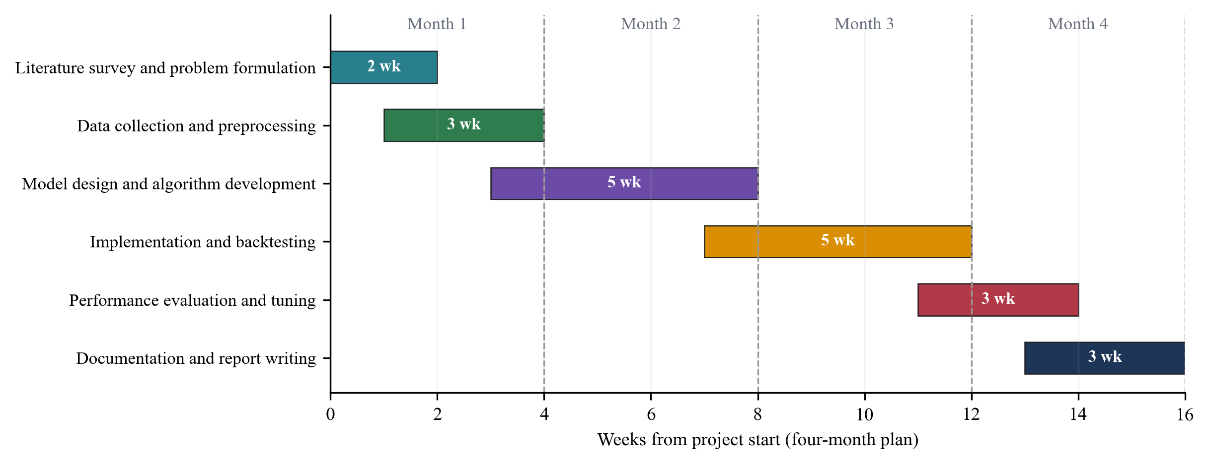
Figure 2.1 Four-month project work plan.
Table 2.4 Project plan with task durations.
No. | Task | Start (week) | Duration (weeks) | End (week)
1 | Literature survey and problem formulation | 0 | 2 | 2
2 | Data collection and preprocessing | 1 | 3 | 4
3 | Model design and algorithm development | 3 | 5 | 8
4 | Implementation and backtesting | 7 | 5 | 12
5 | Performance evaluation and tuning | 11 | 3 | 14
6 | Documentation and report writing | 13 | 3 | 16

CHAPTER 3
TECHNICAL SPECIFICATION

3.1 Requirements

3.1.1 Functional
Table 3.1 lists what the system must do and where each requirement is implemented.
Table 3.1 Functional requirements.
ID | Requirement | Implemented by
FR1 | Show live quotes for SPY, QQQ, GLD, TLT, BTC-USD and the VIX index in a ticker ribbon | GET /api/market/live; TickerRibbon
FR2 | Fetch daily history for any symbol and range, cache it, retry on failure, and fall back to labelled synthetic data for the three case studies if the feed is unreachable | market_data.py; synthetic_fallback.py
FR3 | Classify each trading day of a symbol and range as bull, bear or crisis and plot the result over the price | GET /api/regimes/history; RegimeExplorer
FR4 | Report the current regime of a symbol with its probability | GET /api/regimes/current
FR5 | Compare a window of at least 20 trading days with the dot-com, 2008 and COVID-19 events and a normal baseline, returning confidence, overlay path, statistics and written insights | GET /api/regimes/compare; event_matcher.py
FR6 | Offer an auto-detect mode and a mode that scores the window against one chosen event | event_id parameter; EventComparisonReport
FR7 | Run a backtest of Equal-Weight, Mean-Variance and Adaptive strategies for a case study or for custom assets and dates | POST /api/backtest; engine.py
FR8 | Let the user set rebalance frequency, cost in basis points, and the training generations and population of the adaptive policy | BacktestRequest schema
FR9 | Display value curves, a metrics table (total and annualized return, volatility, Sharpe, maximum drawdown, Calmar) and allocation weights over time | BacktestPanel
FR10 | Flag results that come from synthetic fallback data | synthetic_data field in the response
FR11 | Validate inputs and return clear error messages for missing dates, short windows, unknown case studies and unreachable data | main.py exception handling
FR12 | Describe the method and the technology stack inside the application | AboutPanel

3.1.2 Non-Functional
Table 3.2 Non-functional requirements.
Attribute | Requirement | Measured or observed
Performance | A comparison on a cached matcher should feel instant; a backtest should finish within a few seconds to tens of seconds | Comparison about 0.1 s after the one-time matcher build of about 25 s; backtest 8 to 17 s
Reliability | A rate limit or outage at the data provider must not stop the demonstration | Retry with back-off, 15-minute disk cache, labelled synthetic fallback
Reproducibility | Reported numbers must be repeatable | Fixed seeds; experiment scripts and saved outputs in paper/
Usability | One page with three tabs, no sign-up and no API key | Single-page React dashboard, dark theme
Interpretability | Output should show its evidence | Overlay with a real historical window, written insights, confidence with stated basis
Portability | Run on a common developer machine | macOS tested; Python 3.12 and Node 22; no GPU needed
Maintainability | Separate concerns so that a model can be replaced | Packages: data, ml, backtest; about 3,200 lines in total
Security and privacy | No personal data and no secrets | Only public market data is fetched; no accounts. Cross-origin access is open because the tool is meant for local use
Scalability | Single-user use | In-memory caches in one process; not built for many concurrent users

3.2 Feasibility Study

3.2.1 Technical Feasibility
Every component we needed exists as mature open-source software: scikit-learn and hmmlearn for the hidden Markov model and HDBSCAN, PyTorch for the Transformer encoder, SciPy for the mean-variance optimizer, FastAPI for the service layer and React for the interface. The Transformer is small (32 hidden units, two layers) and the reference corpus has under a thousand windows, so training takes seconds on a CPU. The whole pipeline, including a full set of experiments, ran on a single Apple M3 laptop with 8 GB of memory. The part that was less certain was data access: Yahoo Finance rate-limited our early requests, and we solved it with a direct client, caching and a labelled fallback (Section 5.2.5).

3.2.2 Economic Feasibility
The project needed no cash outlay. Table 3.3 lists the resources and what each cost.
Table 3.3 Resources and costs.
Resource | Source | Cost
Development machine (Apple M3, 8 GB) | Already owned by a team member | No additional cost
Python 3.12, FastAPI, PyTorch, scikit-learn, hmmlearn, SciPy, pandas, NumPy | Open-source licences | Free
Node.js, React, Vite, Recharts, axios | Open-source licences | Free
Daily market data | Yahoo Finance public chart endpoint, no API key | Free
Hosting | Local machine at 127.0.0.1 | Free
GPU or cloud compute | Not used | None
Team effort | Three students over 16 weeks (Section 2.5) | Student time

A production service would add recurring costs for a licensed real-time data feed, hosting and monitoring. We did not estimate those because the project is not meant for production at this stage.

3.2.3 Social Feasibility
The tool helps students and analysts see how today's market compares with past crises, and it is open about its limits. That openness matters socially: a confident-looking score can lead a user to risk money they cannot afford to lose. The dashboard therefore labels its output as illustrative and not predictive, shows when data is synthetic, and states the confidence value with the evidence behind it. The application collects no personal data. The main risk is misuse of the output as investment advice, which the interface and this report both discourage.

3.3 System Specification

3.3.1 Hardware Specification
Table 3.4 Hardware used for development and testing.
Component | Specification
Processor | Apple M3, 8 cores
Memory | 8 GB unified memory
Storage | Under 1 GB for the code, dependencies and cached price files
GPU | Not required; the Transformer runs on the CPU
Network | Internet access for Yahoo Finance (the case studies also run offline on cached or synthetic data)
Client | Any current desktop browser

3.3.2 Software Specification
Table 3.5 Software stack.
Layer | Software | Version
Operating system | macOS | 26.6.2
Language (back end) | Python | 3.12.7
Web framework | FastAPI with Uvicorn; Pydantic | 0.115.6; 0.34.0; 2.10.4
Numerical computing | NumPy, pandas, SciPy | 1.26.4, 2.2.3, 1.13.1
Machine learning | scikit-learn (HDBSCAN, PCA, t-SNE, k-NN), hmmlearn, PyTorch | 1.5.2, 0.3.3, 2.5.1
Front end | React, Vite, Recharts, axios | 19.2, 8.2, 3.10, 1.20
Runtime (front end) | Node.js | 22
Data source | Yahoo Finance chart endpoint, called through curl | n/a

The requirements file also lists the yfinance package, but the code does not use it. The data client talks to the Yahoo chart endpoint directly so that retries and caching are under our control.

CHAPTER 4
DESIGN APPROACH AND DETAILS

4.1 System Architecture
The application has four layers, shown in Figure 4.1. The React dashboard runs in the browser and talks to a FastAPI service over eight REST endpoints. The service calls the analytics layer, which holds the hidden Markov model, the pattern matcher, the adaptive allocator and the backtest engine. The data layer fetches prices from Yahoo Finance, stores them in a CSV cache and, for the three case studies only, can fall back to a synthetic series calibrated to each crisis. The matcher is built once per server process, which takes about 25 seconds, and is reused afterwards. Backtest results are cached by a hash of their settings.
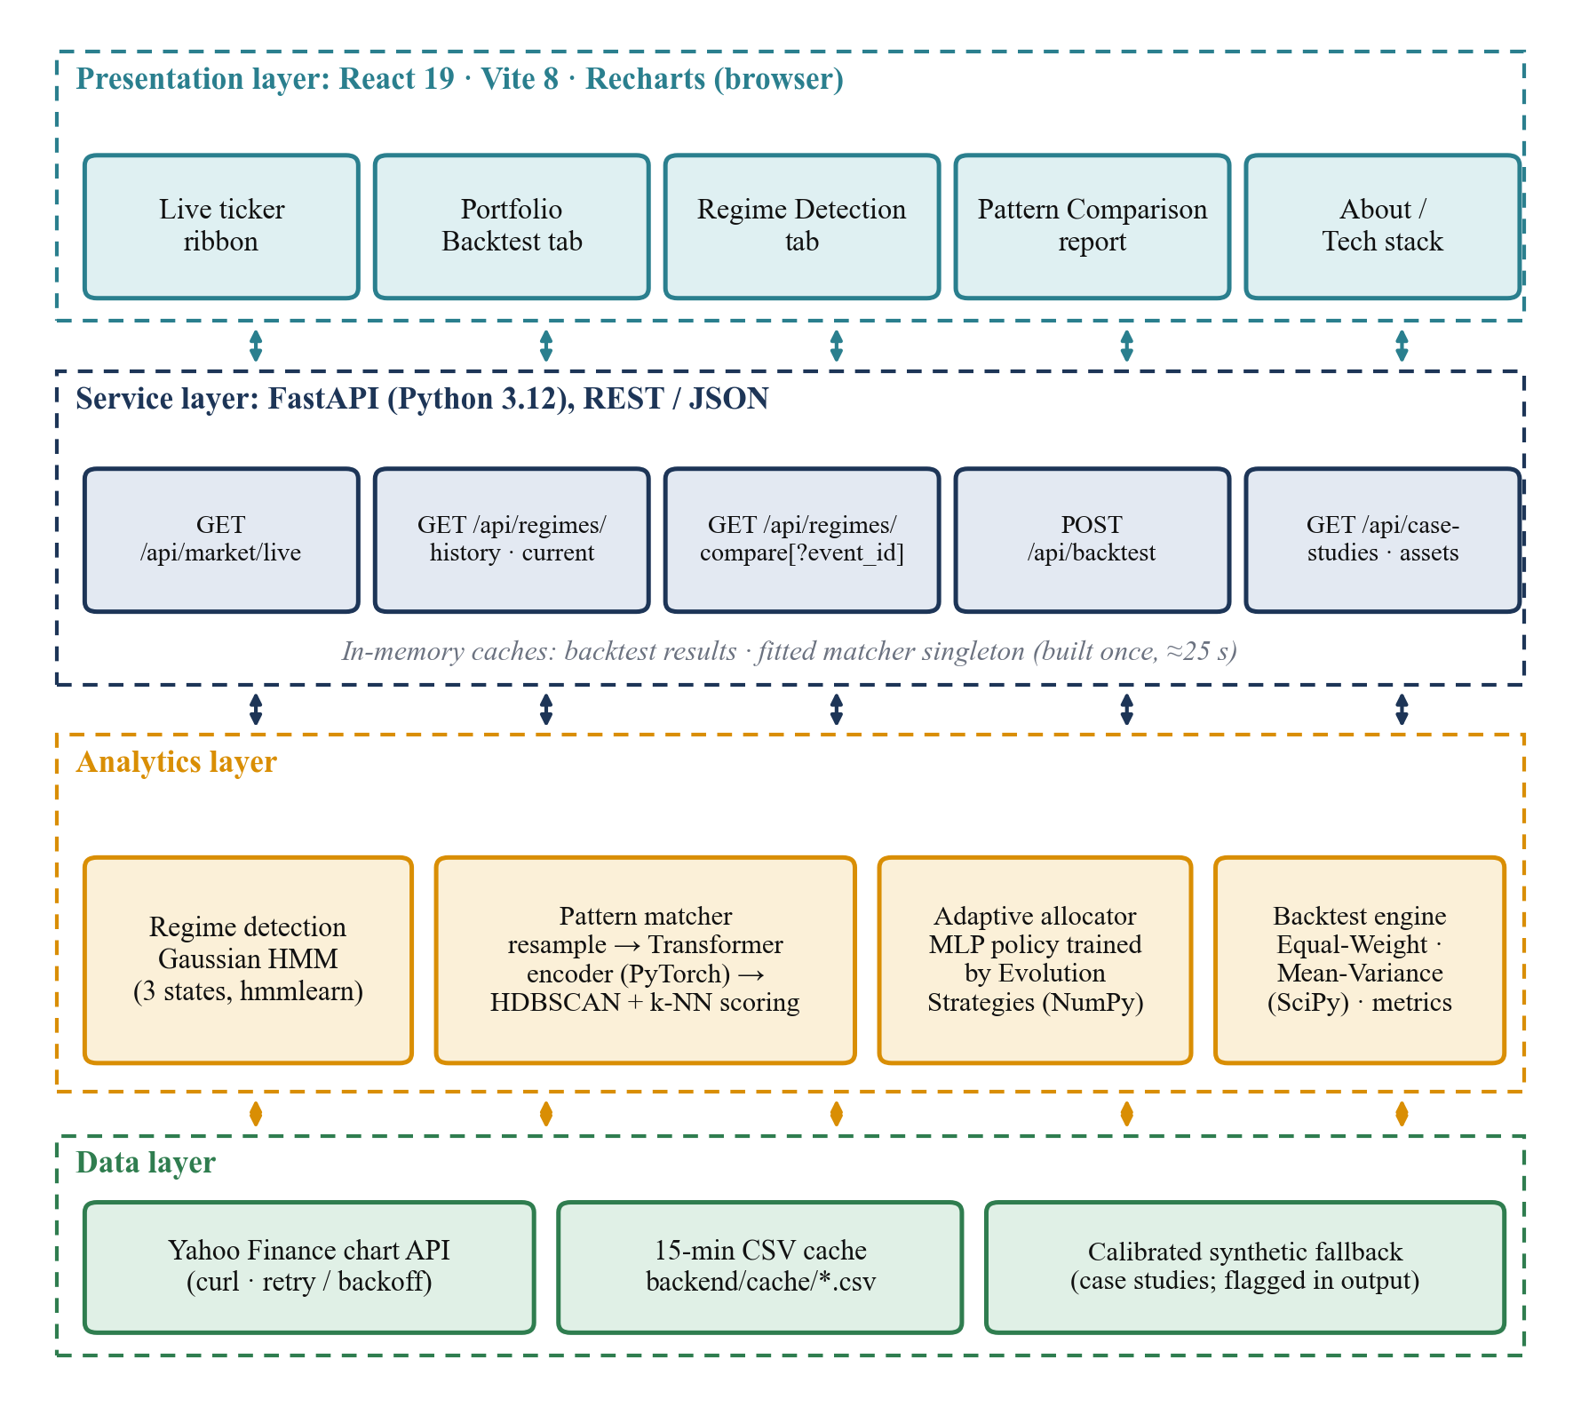
Figure 4.1 Layered architecture of the Adaptive Portfolio Optimizer.
Table 4.1 REST endpoints of the back end.
Method and path | Purpose | Main parameters
GET /api/health | Liveness check | none
GET /api/case-studies | Definitions of the three crises (dates, assets, description) | none
GET /api/assets/default | Default four-asset universe (SPY, QQQ, GLD, TLT) | none
GET /api/market/live | Latest quotes for the ticker ribbon | none
GET /api/regimes/current | Current regime and probabilities of a symbol | symbol, lookback_days
GET /api/regimes/history | Daily regime labels and probabilities | symbol, start, end
GET /api/regimes/compare | Historical-pattern comparison report | symbol, start, end, event_id (optional)
POST /api/backtest | Walk-forward backtest of three strategies | case_study or assets, start, end, rebalance_freq, cost_bps, es_generations, es_population

4.2 Design

4.2.1 Data Flow Diagram
Figure 4.2 is the context diagram. The user sends a symbol, a date range and optional settings, and receives charts, a comparison report and backtest results. Yahoo Finance is the only external data source.
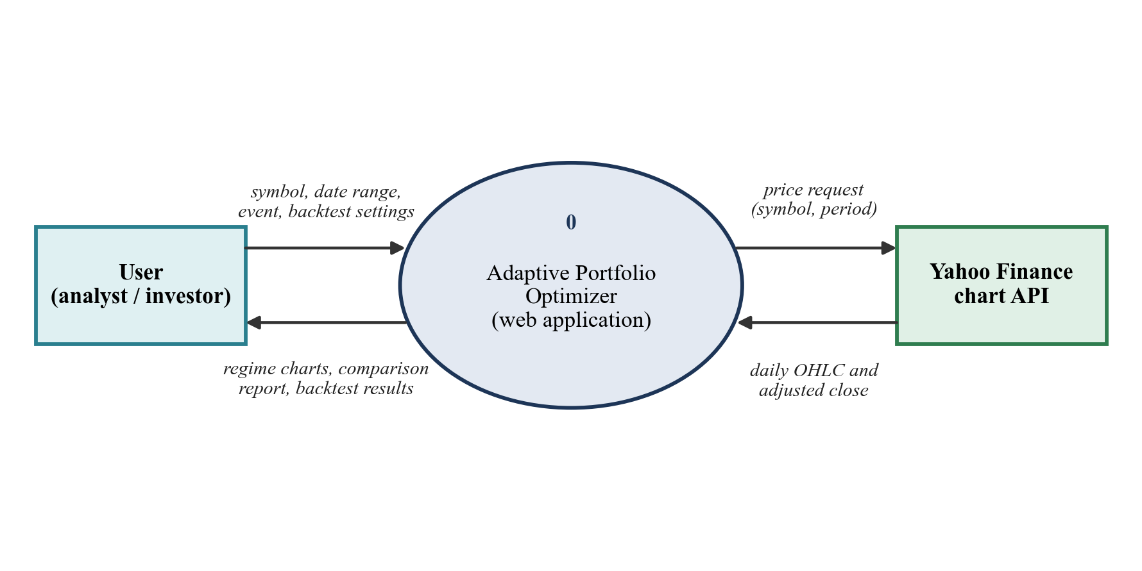
Figure 4.2 Data flow diagram, level 0 (context diagram).
Figure 4.3 breaks the system into five processes. Process 1.0 acquires and cleans prices and writes them to the price cache (D1). Process 2.0 fits the hidden Markov model and returns regime labels. Process 3.0 compares a window with the reference corpus and the fitted matcher stored in D2. Process 4.0 runs the backtest and keeps finished results in D3. Process 5.0 is the dashboard, which collects the user's input and presents all outputs.
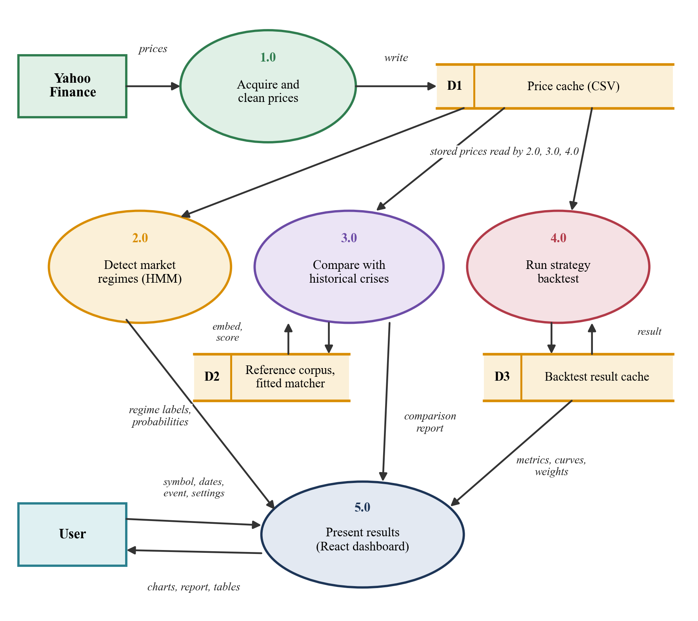
Figure 4.3 Data flow diagram, level 1.

4.2.2 Use Case Diagram
Figure 4.4 shows the two actors. The user can view the market ribbon and regime charts, compare a date range with historical crises (optionally targeting one event), read the report, run backtests and inspect their allocations. Yahoo Finance is a secondary actor that supplies prices to the use cases that need them. The most important use case is the comparison: the user picks a symbol and dates, optionally clicks one of the three event buttons, and receives a verdict with its evidence.
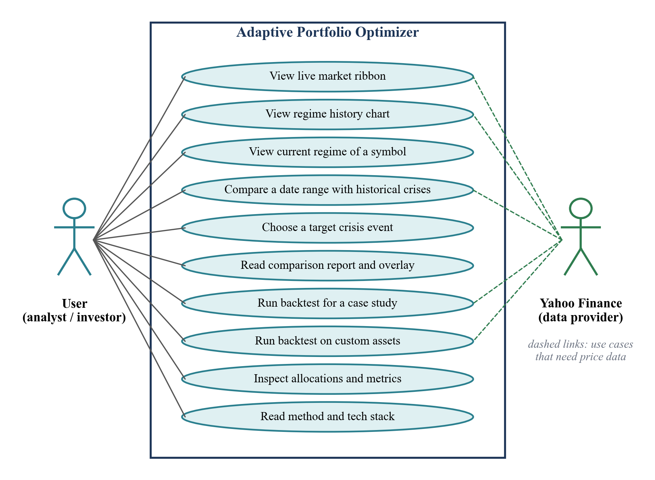
Figure 4.4 Use case diagram.

4.2.3 Class Diagram
Figure 4.5 shows the main data structures and modules of the back end. The API module receives a BacktestRequest and calls the market data, regime, matcher and backtest modules. A Matcher object bundles the encoder, the scaling constants, the list of CorpusWindow records, their embeddings and the cluster summaries. PolicyNet is the small neural policy used by the adaptive strategy, and ShapeAutoencoder wraps the ShapeEncoder with a decoder that is used only for training.
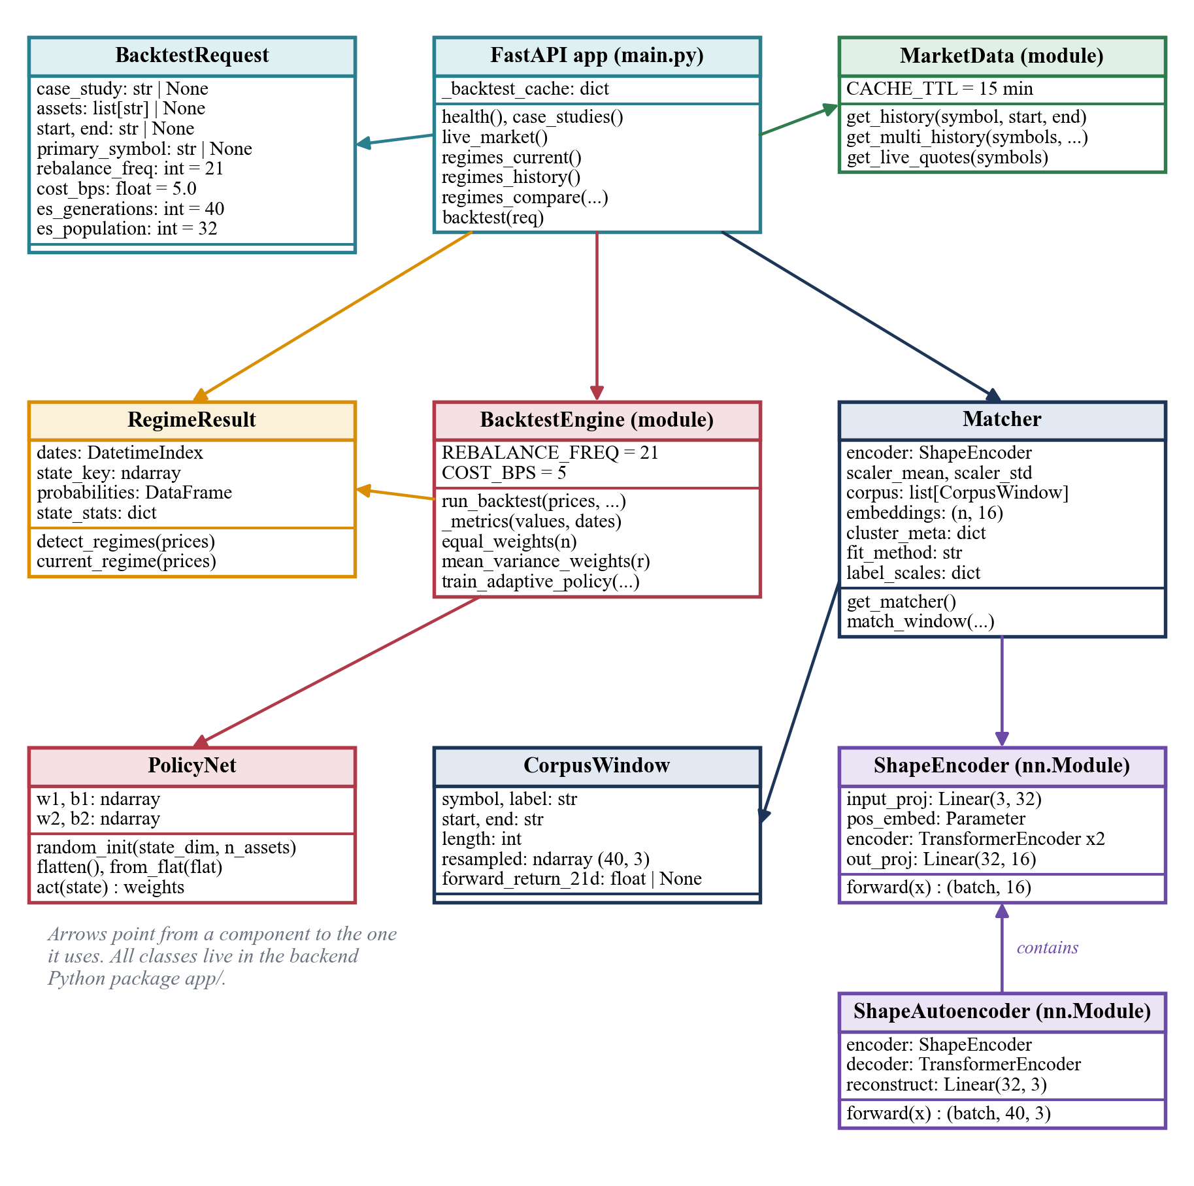
Figure 4.5 Class diagram of the back end.

4.2.4 Sequence Diagram
Figure 4.6 follows one comparison request. The dashboard calls the compare route, which hands the work to the matcher. The matcher gets prices through the data layer, converts the window into a 40 by 3 shape, asks the Transformer for an embedding, scores the labels and returns a report that the dashboard draws.
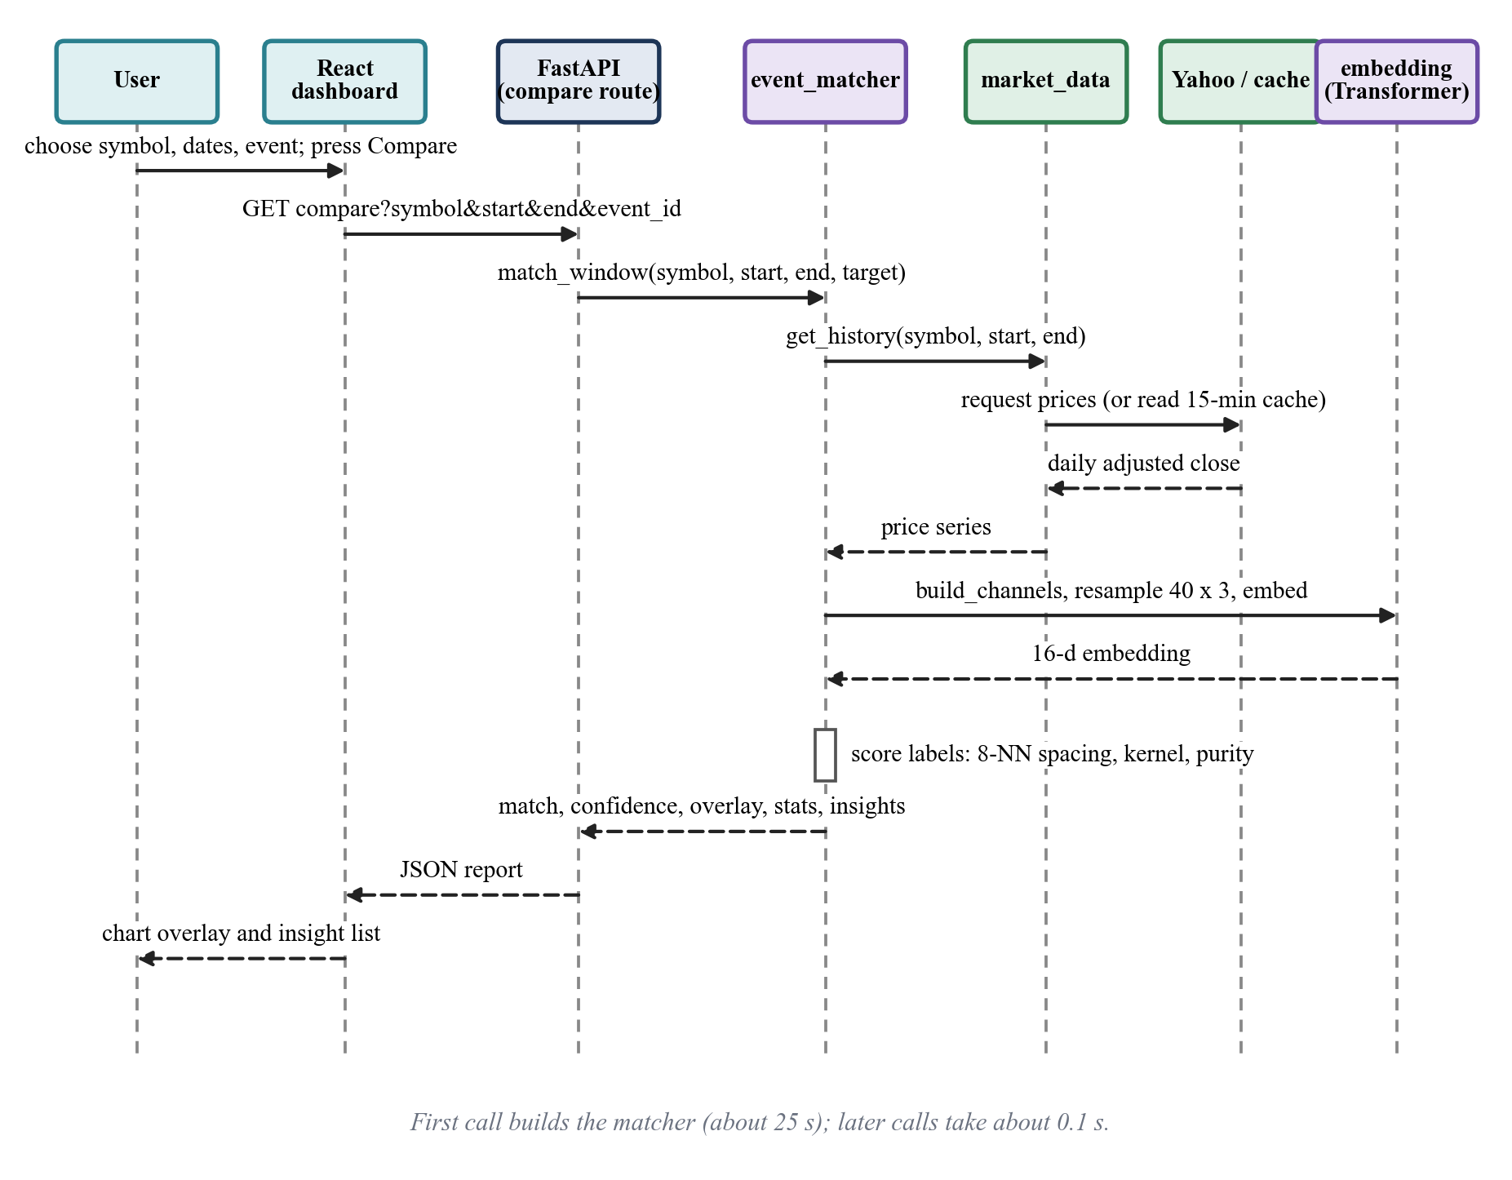
Figure 4.6 Sequence diagram of a historical-pattern comparison.
Figure 4.7 shows a backtest. After checking its cache, the service loads the price panel, fits the regime model on the primary symbol, trains the adaptive policy on the pre-crisis segment only, simulates the three strategies with the same rebalance dates and cost, and returns values, weights and metrics.
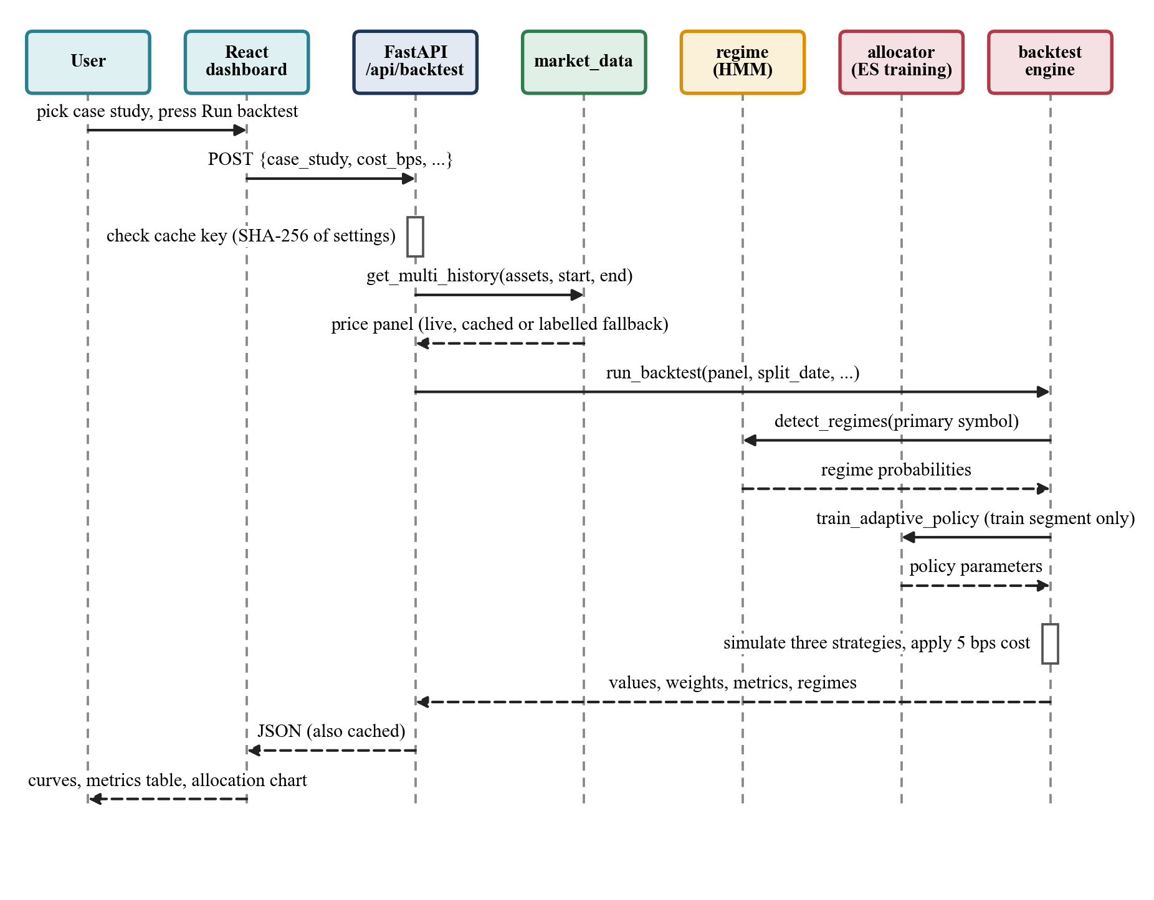
Figure 4.7 Sequence diagram of a portfolio backtest.

CHAPTER 5
METHODOLOGY AND TESTING
This chapter describes the modules of the system in the order data flows through them, and then the tests used to check the software and the models. Results are reported in Chapter 7.

5.1 Module Description

5.1.1 Data Acquisition and Preprocessing
All results use real daily adjusted close prices from the Yahoo Finance chart interface [25]. The client in market_data.py calls the endpoint through curl with explicit start and end timestamps. Yahoo's default "max" range quietly returns roughly monthly bars for long histories, so explicit timestamps are needed to get daily data. Failed requests are retried with back-off, and every response is cached on disk for 15 minutes. If the feed cannot be reached, the three case studies can run on a synthetic series calibrated to the size of each crisis, and the response carries a flag so the dashboard can say so. No result in this report used the synthetic fallback.
Table 5.1 defines the three crises and the four backtest settings. The dot-com setting appears twice. The version labelled "as deployed" uses gold futures (GC=F), whose Yahoo history only begins in August 2000, after the crisis had started. The "corrected" version replaces them with the Treasury fund VUSTX, which has a long history, so that a real pre-crisis training period exists (Section 7.3).
Table 5.1 Backtest settings and crisis definitions.
Setting | Assets | Data window | Trading days | Crisis window | Train / test days
Dot-com (as deployed) | SPY, QQQ, GC=F | 2000-08-31 to 2003-12-31 | 829 | 2000-03-10 to 2002-10-09 | 30 / 799
Dot-com (corrected) | SPY, QQQ, VUSTX | 1999-06-02 to 2003-12-31 | 1153 | 2000-03-10 to 2002-10-09 | 196 / 957
2008 GFC | SPY, QQQ, GLD, TLT | 2006-01-04 to 2010-12-31 | 1258 | 2007-10-09 to 2009-03-09 | 443 / 815
COVID-19 | SPY, QQQ, GLD, TLT | 2019-01-03 to 2021-12-31 | 756 | 2020-02-19 to 2020-04-07 | 283 / 473

Table 5.2 Descriptive statistics of each asset over each backtest window (252 trading days per year).
Setting | Asset | Period | N | Ann. return | Ann. volatility | Max drawdown
Dot-com (as deployed) | SPY | 2000-08-30 to 2003-12-31 | 830 | -7.3% | 22.3% | -47.3%
Dot-com (as deployed) | QQQ | 2000-08-30 to 2003-12-31 | 830 | -26.1% | 44.5% | -80.5%
Dot-com (as deployed) | GC=F | 2000-08-30 to 2003-12-31 | 830 | 13.5% | 14.7% | -15.2%
Dot-com (corrected) | SPY | 1999-06-01 to 2003-12-31 | 1154 | -2.0% | 21.9% | -47.5%
Dot-com (corrected) | QQQ | 1999-06-01 to 2003-12-31 | 1154 | -7.0% | 44.8% | -83.0%
Dot-com (corrected) | VUSTX | 1999-06-01 to 2003-12-31 | 1154 | 8.7% | 9.5% | -12.8%
2008 GFC | SPY | 2006-01-03 to 2010-12-31 | 1259 | 1.9% | 24.9% | -55.2%
2008 GFC | QQQ | 2006-01-03 to 2010-12-31 | 1259 | 6.2% | 25.3% | -53.4%
2008 GFC | GLD | 2006-01-03 to 2010-12-31 | 1259 | 21.2% | 23.1% | -29.4%
2008 GFC | TLT | 2006-01-03 to 2010-12-31 | 1259 | 4.9% | 14.5% | -26.6%
COVID-19 | SPY | 2019-01-02 to 2021-12-31 | 757 | 25.9% | 21.9% | -33.7%
COVID-19 | QQQ | 2019-01-02 to 2021-12-31 | 757 | 37.8% | 24.9% | -28.6%
COVID-19 | GLD | 2019-01-02 to 2021-12-31 | 757 | 12.1% | 15.3% | -18.8%
COVID-19 | TLT | 2019-01-02 to 2021-12-31 | 757 | 8.6% | 16.3% | -21.3%

For the pattern comparison we built a reference corpus of 965 labelled windows. They come from the three case studies (QQQ for the dot-com bust, SPY for the other two) and from four calm periods: SPY in 2003 to 2006, 2012 to 2015 and 2016 to 2019, and QQQ in 2012 to 2015. The corpus holds 679 normal, 105 dot-com, 101 GFC and 80 COVID-19 windows.
Prices from different assets are aligned on shared trading dates, and daily simple returns are computed for the backtests. For regime detection, each day is described by three features: the log return, the 20-day annualized volatility and the drawdown from the 60-day rolling peak.
 | 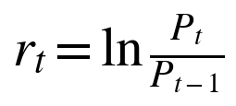 | (5.1)

 | 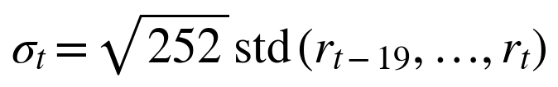 | (5.2)

 | 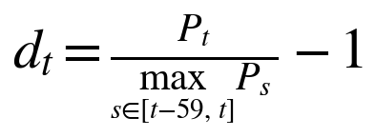 | (5.3)

The features are standardized before the model is fitted.

5.1.2 Regime Detection with a Hidden Markov Model
A three-state Gaussian hidden Markov model with diagonal covariance [13] is fitted by expectation-maximization (300 iterations, seed 7) on the standardized features. Each state has its own mean and variance for the three features, and a transition matrix describes how likely the market is to move between states.
(5.4)

State numbers are arbitrary, so we name the states afterwards from their statistics. The state with the highest average volatility is Crisis. Of the other two, the one with the higher average return is Bull and the other is Bear. The model never sees crash dates. Its posterior probabilities are used by the dashboard and as part of the state of the adaptive allocator.

5.1.3 Length-Invariant Shape and Transformer Encoder
The comparison has to treat a 33-day crash and a 600-day bear market on equal terms. For a window of n trading days we compute three channels from the window's own start: cumulative return, a 5-day rolling annualized volatility, and the running drawdown. Each channel is linearly interpolated onto 40 equally spaced points of a normalized time axis, so every window becomes a 40 by 3 array.
 | 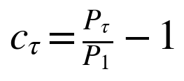 | (5.5)

 | 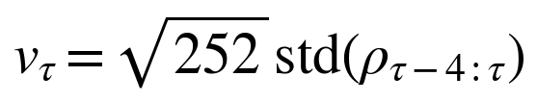 | (5.6)

 | 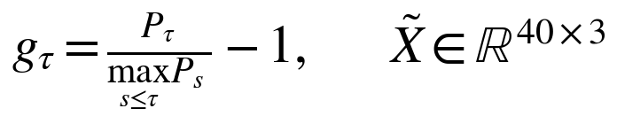 | (5.7)

Here ρ stands for the daily returns inside the window. The channels are standardized with means and standard deviations computed over the corpus.
A small Transformer encoder [18] maps the 40 by 3 array to a 16-dimensional embedding (Figure 5.1). A linear layer lifts each time step to 32 dimensions and a learned positional embedding is added. Two encoder layers with four attention heads and a 64-unit feed-forward block (GELU activation [26], layer normalization [27]) follow. The 40 outputs are averaged and a last linear layer produces the 16 values. Self-attention is the scaled dot product of Vaswani et al.:
 | 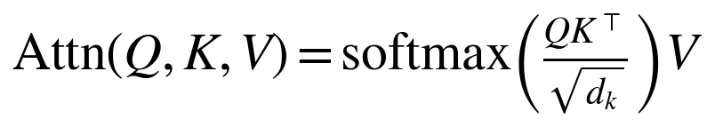 | (5.8)

The encoder is trained without labels as an autoencoder. A decoder of the same size rebuilds the 40 by 3 array from the embedding, and training minimizes the squared reconstruction error with Adam [28] (learning rate 0.002, 120 full-batch epochs) in PyTorch [29]. The decoder is thrown away after training.
 | 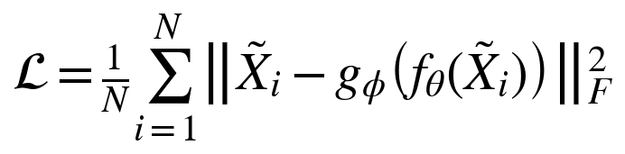 | (5.9)

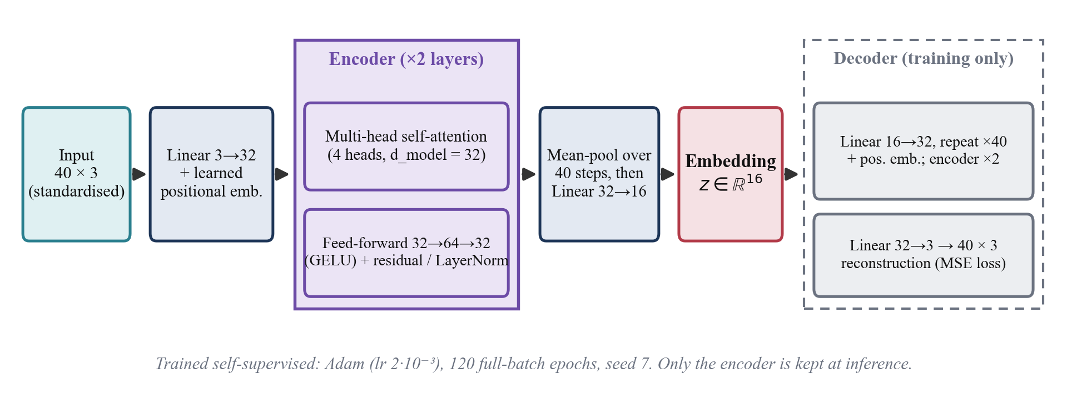
Figure 5.1 Transformer shape encoder and the decoder used only for training.

5.1.4 Reference Corpus and HDBSCAN
Overlapping windows are cut from each source series at 21 lengths between 10 and 600 trading days, with a stride of max(3, length/5) days. A window gets an event label if the crisis covers at least half of the window, or if the window contains at least 80 percent of the crisis and is no longer than four times its length. The second rule exists because the COVID-19 crash lasted only 33 trading days, so most windows that contain it are longer than the crash itself. Windows that overlap a crisis by 5 to 50 percent are dropped as ambiguous, and the rest are labelled normal. Each event class is capped at 120 windows and the normal class at 2.5 times the event total. The cap is stratified by window length, so a large number of short windows does not push out the rarer long ones.
HDBSCAN [20][21] is run on the embeddings over a grid of nine settings of minimum cluster size and minimum samples. We choose the setting that gives each event its own cluster with a majority of at least 60 percent, with high purity and little noise, and that avoids splitting into many small clusters. On the deployed corpus it finds 3 clusters. We use the clustering to inspect the structure of the corpus. The final score does not rely on cluster centers, because the center of an irregular density cluster can lie in empty space, and about 16 percent of the corpus is classed as noise that no center describes.

5.1.5 Similarity Scoring and the Comparison Report
For a query embedding z and a label ℓ, let N_{k}(z) be the k = 8 corpus windows nearest to z that carry label ℓ, and let s_{ℓ} be the typical in-class spacing, the 75th percentile over the label's windows of the mean distance to their eight nearest same-label neighbors. The distance score m_{ℓ} is turned into a similarity by a Gaussian kernel, and a purity term p_{ℓ} measures how many of the 15 nearest windows overall carry the same label, weighted by inverse distance.
 | 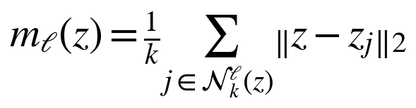 | (5.10)

 | 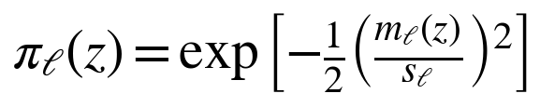 | (5.11)

 | 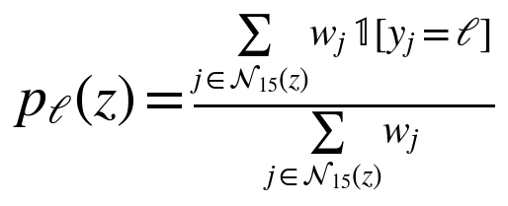 | (5.12)

 | 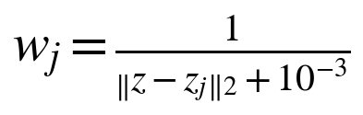 | (5.13)

 | 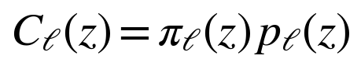 | (5.14)

In targeted mode the user picks an event and the confidence C_{ℓ} is reported for that event. In auto mode the label with the highest C_{ℓ} wins. A match requires m_{ℓ} ≤ 1.4 s_{ℓ} and C_{ℓ} ≥ 0.20, and in auto mode the winner must not be the normal class and must have p_{ℓ} above 0.6. If these conditions fail, the report says that no crisis resembles the period and gives the normal-regime confidence instead. Every report also contains the nearest same-label real window for the overlay, the annualized return, volatility and maximum drawdown of the period, the share of bull, bear and crisis days from the HMM, and the average 21-day forward return of the nearest same-label windows as a historical baseline. Figure 5.2 gives the whole pipeline.
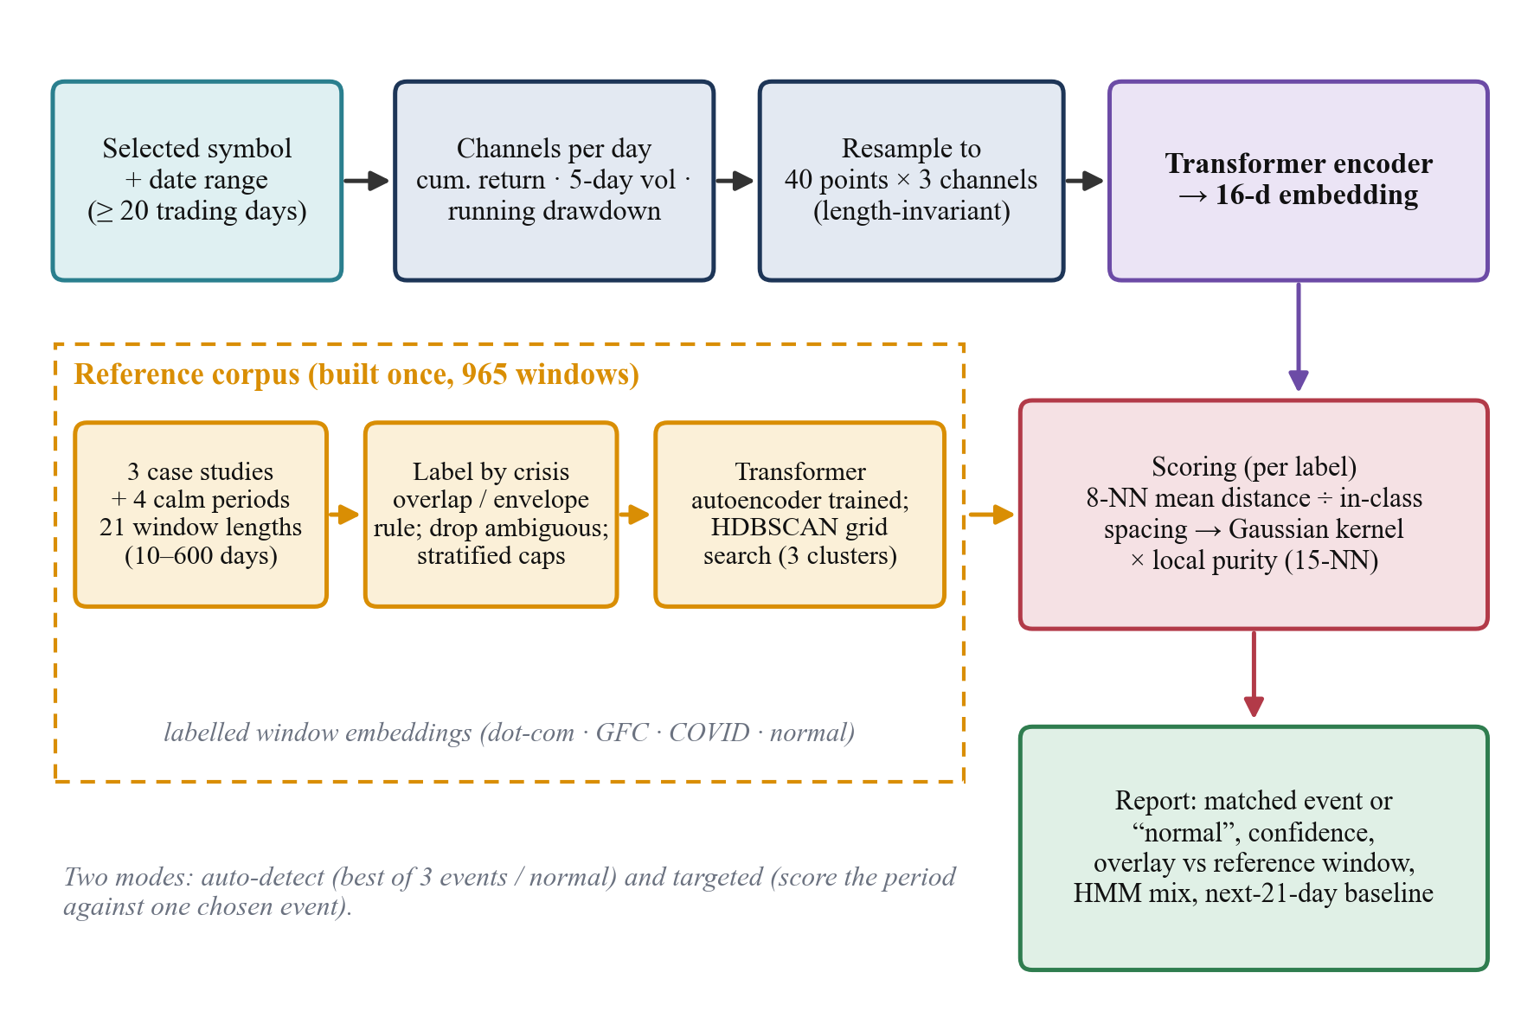
Figure 5.2 Historical-pattern comparison pipeline.

5.1.6 Allocation Strategies
Three strategies are compared on the same rebalance dates (every 21 trading days) and with the same proportional cost of 5 basis points on turnover.
• Equal-Weight holds 1/N of each asset.
• Mean-Variance maximizes the Sharpe ratio of a long-only, fully invested portfolio using the previous 63 trading days, solved with sequential least squares programming. If the solver fails it falls back to equal weights.
• Adaptive is a small neural policy. Its input is the state s_{k}: the three regime probabilities, and the 21-day momentum and 21-day annualized volatility of every asset. A hidden layer of 16 tanh units and a softmax output give long-only weights.

(5.15)

The policy is trained with evolution strategies [17]. In each of 40 generations, 32 antithetic Gaussian perturbations of the parameter vector (σ = 0.1) are scored by simulating the policy through the training segment. The rewards are rank-normalized and the parameters move along the reward-weighted perturbation direction with a step of 0.05. The reward subtracts a drawdown penalty and a turnover penalty from the Sharpe ratio, which is how transaction costs enter the objective.
 | 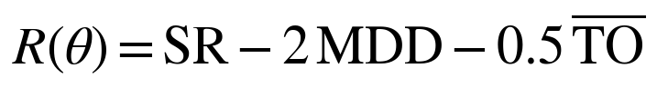 | (5.16)

 | 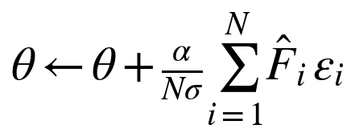 | (5.17)

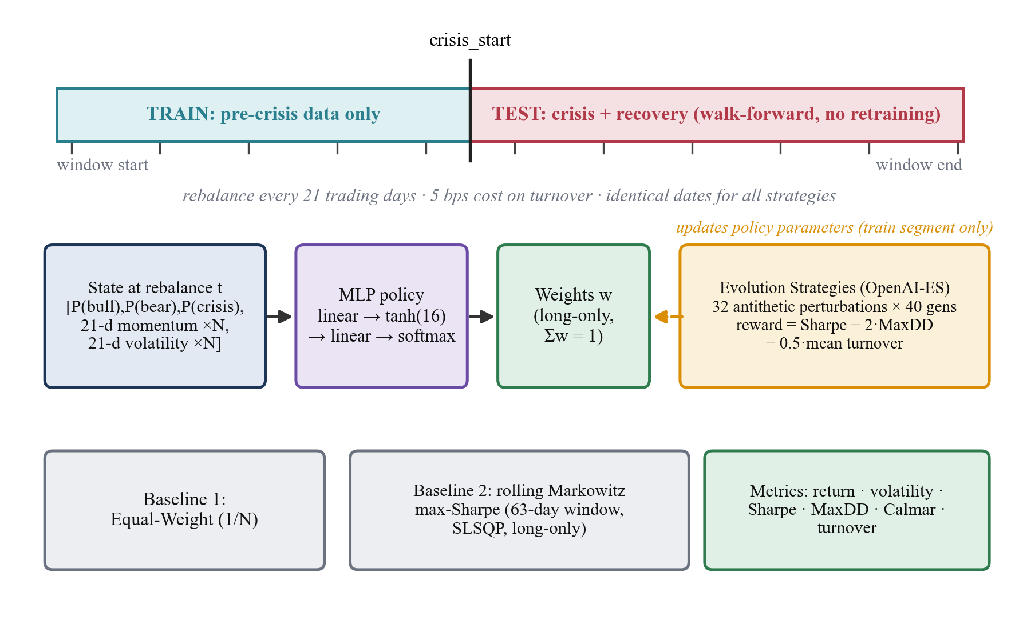
Figure 5.3 Walk-forward protocol: training on the pre-crisis segment, evaluation through the crisis.

5.1.7 Backtest Engine and Evaluation Metrics
The engine splits each setting at the crisis start. The adaptive policy and the 63-day look-back of the mean-variance strategy only ever use data before the date being decided. The test segment runs from the crisis start to the end of the data window. With daily portfolio returns r and portfolio value V, the metrics are:
 | 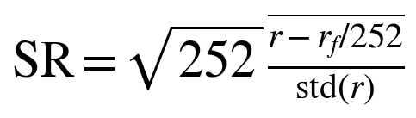 | (5.18)

 | 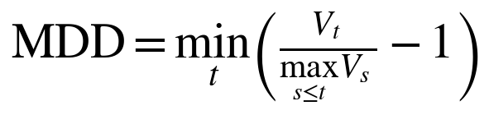 | (5.19)

 | 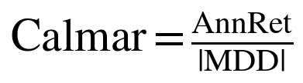 | (5.20)

 | 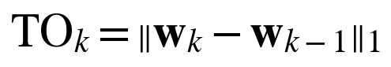 | (5.21)

 | 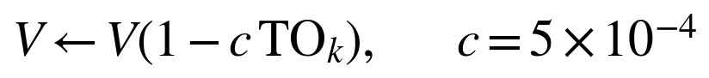 | (5.22)

 | 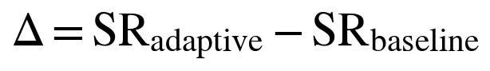 | (5.23)

The risk-free rate is 2 percent a year. Total return, annualized return, annualized volatility and mean turnover are also reported. For the matcher, the event classes are much smaller than the normal class, so we report balanced accuracy (the mean recall over the four classes, with a chance level of 0.25) and macro-F1, together with the crisis recall (the share of event windows predicted as some event) and the false-alarm rate (the share of normal windows predicted as an event). Plain accuracy is given only for completeness, since always answering "normal" already scores 70 percent.

5.1.8 Dashboard
The React interface has three tabs. Portfolio Backtest lets the user choose a case study, runs the backtest and draws the value curves, the metrics table and the allocation chart. Regime Detection draws the price with colored regime bands for any symbol and range, and below it the Historical Pattern Comparison report with its overlay chart, key figures and written insights. About describes the method and the stack. A ticker ribbon at the top polls the live quotes. The charts use Recharts, and a request counter in the regime explorer ignores answers to outdated requests. Table 5.3 collects the hyper-parameters of all modules.
Table 5.3 Hyper-parameters used in the experiments.
Component | Setting
HMM | 3 states, diagonal covariance, 300 EM iterations, seed 7; features: log return, 20-day volatility, 60-day drawdown
Shape | 40 points by 3 channels; windows of 10 to 600 days (21 lengths); stride max(3, length/5)
Transformer | d_{model} 32, 4 heads, 2 layers, feed-forward 64 (GELU), learned positions, mean pooling, 16-d output; Adam, learning rate 0.002, 120 epochs
Corpus | Event cap 120 per class (length-stratified); normal cap 2.5 times the events; 50 percent overlap or 80 percent coverage rule
HDBSCAN | 9-point grid on minimum cluster size and minimum samples; the score favors one majority cluster per event, high purity, low noise
Scoring | k = 8 same-label neighbors; Gaussian kernel on spacing s; purity over 15 nearest; match if m ≤ 1.4 s and C ≥ 0.20
Backtest | Rebalance every 21 trading days; cost 5 bps on turnover; risk-free rate 2 percent; 252 trading days a year
Mean-Variance | 63-day window, long-only maximum Sharpe (SLSQP), equal-weight fallback
ES policy | 16 tanh hidden units; 32 antithetic perturbations by 40 generations; σ 0.1; step 0.05; reward SR - 2 MDD - 0.5 turnover

5.2 Testing

5.2.1 Approach and Test Environment
The project has no earlier automated test suite, so for this report we wrote a test script (paper/scripts/run_tests.py) with 21 test cases and ran it on the development machine described in Section 3.3. The API cases call the real routes through FastAPI's test client with live Yahoo data, so they also check the data path. The unit cases check numerical properties of single modules. Every case was run once and the observed result was recorded; all 21 passed.

5.2.2 Functional (API) Tests
Table 5.4 Functional tests of the REST API.
ID | Test case | Expected result | Observed result | Result
TC01 | GET /api/health | HTTP 200 | HTTP 200; body holds a status field | Pass
TC02 | GET /api/case-studies | three case studies | HTTP 200; ids dotcom, gfc and covid | Pass
TC03 | GET /api/assets/default | default four-asset universe | HTTP 200; assets SPY, QQQ, GLD, TLT | Pass
TC04 | GET /api/market/live | at least one live quote | HTTP 200, 6 quotes | Pass
TC05 | GET /api/regimes/current (SPY) | regime label, probabilities sum to 1 | HTTP 200; regime bear, probabilities sum to 1.000 | Pass
TC06 | GET /api/regimes/history (SPY 2007-2010) | aligned arrays, states in {bull, bear, crisis} | HTTP 200; 988 daily labels, states bear, bull and crisis present | Pass
TC07 | Compare without start and end dates | HTTP 400 | HTTP 400, start and end are required | Pass
TC08 | Compare window of 6 trading days | HTTP 400 (window too short) | HTTP 400; message says the window is too short and gives the count (7 trading days) | Pass
TC09 | Compare COVID-19 window, targeted at covid | matched, event covid | HTTP 200; matched, event covid, confidence 0.59 | Pass
TC10 | Compare calm 2013-2015 window, auto mode | no crisis match | HTTP 200; no crisis matched, normal regime | Pass
TC11 | Compare with an invalid ticker | HTTP 400 or 502 | HTTP 502; message says Yahoo returned no data for that symbol | Pass
TC12 | POST /api/backtest with unknown case study | HTTP 400 | HTTP 400; message names the unknown case study | Pass
TC13 | POST /api/backtest, COVID-19 case study | HTTP 200 with three strategies | HTTP 200; response holds strategies, metrics for the test and full periods, regimes and the split date | Pass

5.2.3 Unit Tests
Table 5.5 Unit tests of the analytics modules.
ID | Test case | Expected result | Observed result | Result
TC14 | Backtest weights are fully invested | each rebalance row sums to 1 | 108 rebalance rows checked; largest deviation of a weight sum from 1 is 1.0e-04 (rounding in the output) | Pass
TC15 | Higher cost lowers net return | return at 0 bps above return at 50 bps | Mean-Variance final value 1.705 at 0 bps vs 1.367 at 50 bps (start 1.0) | Pass
TC16 | Resampling is length invariant | (40, 3) for any window length | (40, 3) for windows of 33, 120 and 600 days | Pass
TC17 | Equal-weight and mean-variance weights | sum to 1, long-only | equal-weight sum 1.0000; mean-variance sum 1.0000 with minimum weight 0.0000 | Pass
TC18 | Adaptive policy output and parameter round trip | softmax weights, lossless flatten | softmax weights sum to 1.0000 with minimum 0.016; flatten and rebuild give identical output | Pass
TC19 | HMM crisis state has highest volatility | crisis = max volatility state | mean volatility: crisis 0.543, bear 0.220, bull 0.131 | Pass
TC20 | Reference corpus and embedding size | 965 windows, 16-d embeddings | embeddings of shape (965, 16); 679 normal, 105 dot-com, 101 GFC and 80 COVID-19 windows; 3 HDBSCAN clusters | Pass
TC21 | Matcher is deterministic | identical confidence on repeat | two identical queries gave confidence 0.5912 both times | Pass

TC15 compares the final value of the Mean-Variance strategy in the 2008 setting at 0 and at 50 basis points of cost. TC19 uses the SPY history from 2007 to 2010 and checks that the state named Crisis really is the highest-volatility state, which holds by construction but guards against a regression in the relabelling code.

5.2.4 Model Validation Protocol
The software tests say nothing about whether the models are any good, so we designed four further experiments. Their results are in Chapter 7.
• Blocked, purged cross-validation of the matcher. Within each label the windows are sorted by start date and cut into five contiguous blocks. Any training window that overlaps in calendar time with a test window is removed, and the encoder is retrained on the training windows only. Ordinary shuffled cross-validation would be misleading here, because neighboring windows share most of their days.
• Leave-one-event-out. Train on two crises plus normal windows, purge anything overlapping the held-out crisis, and check whether the unseen crisis is flagged as any crisis class rather than normal.
• Embedding ablation. The same 8-nearest-neighbor classifier is run on the trained Transformer, an untrained random Transformer, the raw 120-value shape, a 16-component PCA of it, and seven hand-made summary statistics. If the trained Transformer does not beat the others, it adds nothing.
• Allocator ablation and bootstrap. Six seeds, four settings and three variants (full, no regime information, untrained policy), plus a paired stationary bootstrap [30] (5,000 resamples, mean block length 10 days) of the Sharpe ratio difference between the adaptive policy and each baseline.

5.2.5 Defects Found and Fixed
Table 5.6 Defects found during development and testing.
Issue | Symptom | Cause | Fix
Data rate limiting | Early requests to Yahoo returned HTTP 429 in bursts | Default client and repeated requests for the same history | Direct curl client with a browser-like user agent, retries with back-off, 15-minute disk cache, labelled synthetic fallback
Coarse history | Long histories came back as roughly monthly bars | Yahoo's "max" range coarsens the interval | Explicit start and end timestamps in every request
Stale chart | The regime chart sometimes showed the previous selection | Older responses arrived after newer ones and overwrote them | Request counters in the regime explorer ignore outdated answers; load functions take explicit arguments
Shape mismatch | Dot-com queries were compared with a corpus built from a different symbol | Corpus used SPY while the shape of the event is clearest in QQQ | A shape_symbol field in the case-study configuration, used by both
Invalid dot-com split | The adaptive policy held 100 percent gold in every period | GC=F history starts in August 2000, leaving 30 training days | Documented as a failed setting; corrected setting uses VUSTX with 196 training days
Run-to-run drift | COVID-19 adaptive Sharpe moved from 0.85 to 1.05 with the same code and seed | Small revisions in refreshed Yahoo data change the HMM fit | Not removable; reported with seed ranges (Section 7.5)

CHAPTER 6
PROJECT DEMONSTRATION

6.1 Running the Application
The project needs Python 3.12 and Node.js, and it needs no API key. From the project folder one script installs the dependencies on first use and starts both servers.
./run.sh
# back end: http://127.0.0.1:8000 (interactive API docs at /docs)
# dashboard: http://127.0.0.1:5173

The first comparison after the server starts takes about 25 seconds, because the matcher trains the encoder and builds the corpus. The page says so while it waits. Later comparisons take about a tenth of a second.

6.2 Portfolio Backtest Tab
The user picks one of the three case studies and presses Run Backtest. Figure 6.1 shows the 2008 crisis. The upper chart gives the value of one unit invested in each strategy. The dashed line marks the end of the adaptive policy's training data and the red band is the crisis window. Below the chart, the metrics table can switch between the out-of-sample segment and the full period, and the last panel stacks the weights the adaptive policy chose at each rebalance. In this run the policy moved almost entirely into long Treasuries (TLT) in late 2008.
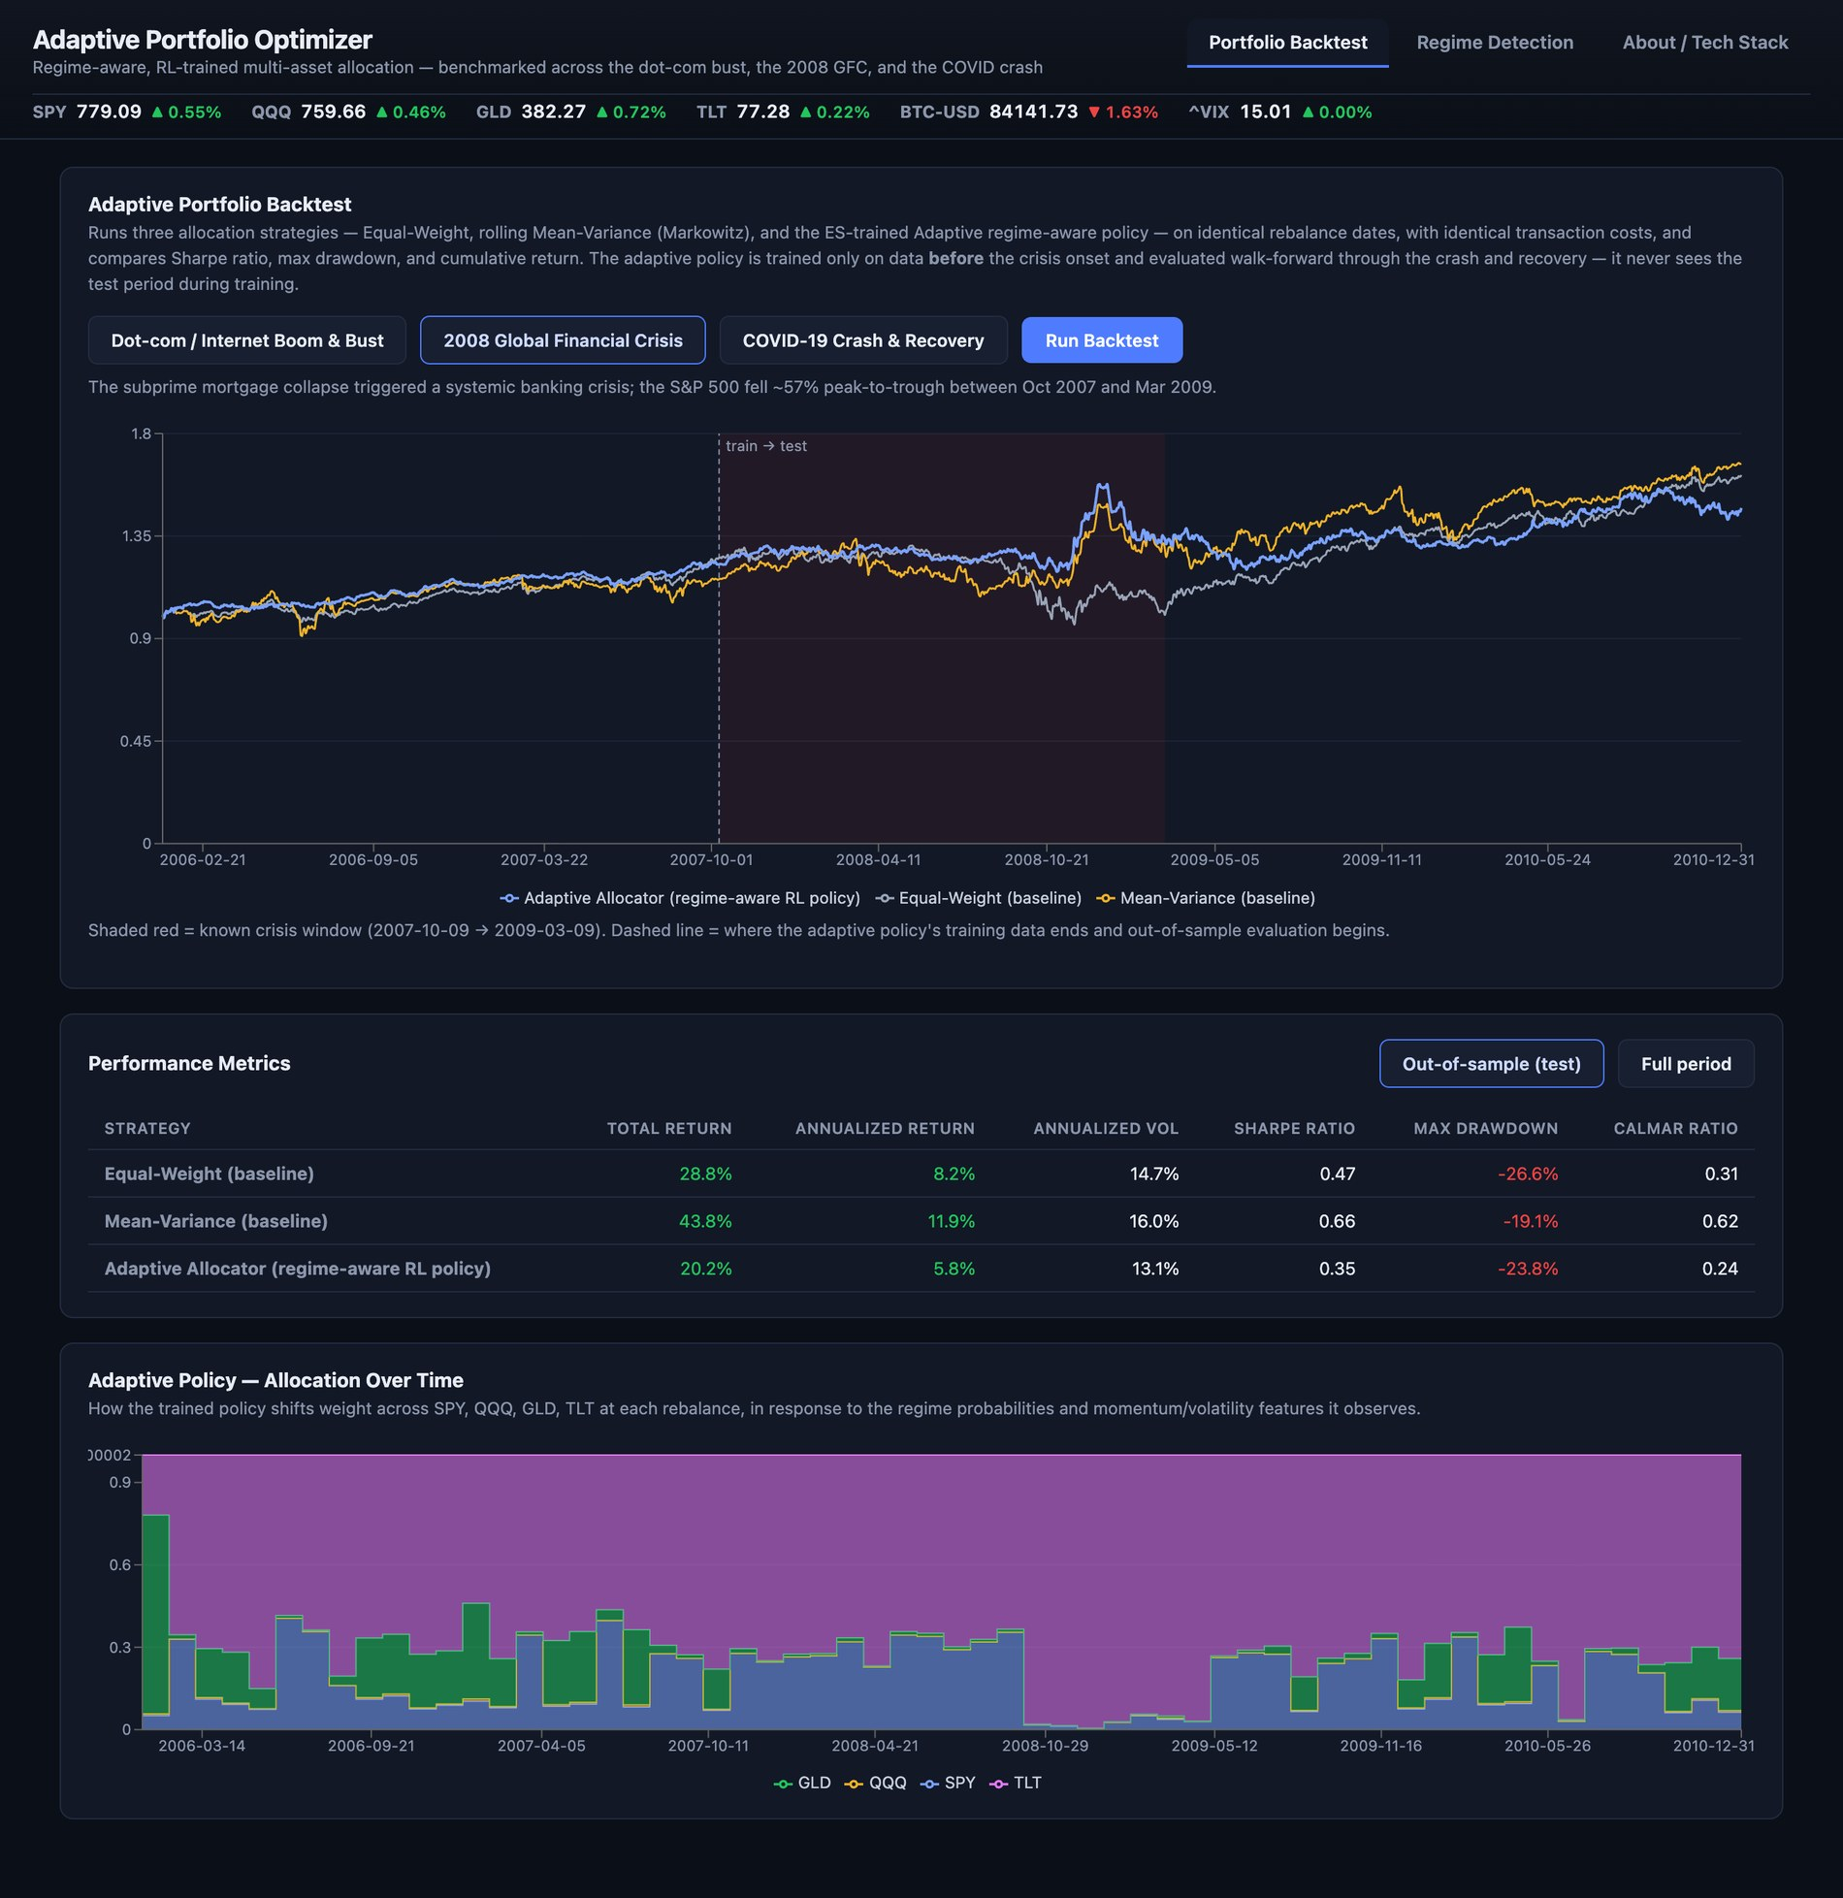
Figure 6.1 Portfolio Backtest tab for the 2008 crisis.

6.3 Regime Detection Tab
The upper panel colors each trading day of the chosen symbol and range by regime. Figure 6.2 shows SPY from 2019 to 2021. The red band is the COVID-19 crash and amber and green bands alternate before and after it. The panel beneath is the Historical Pattern Comparison. In this capture it is still computing, which is what the user sees on the first comparison after startup.
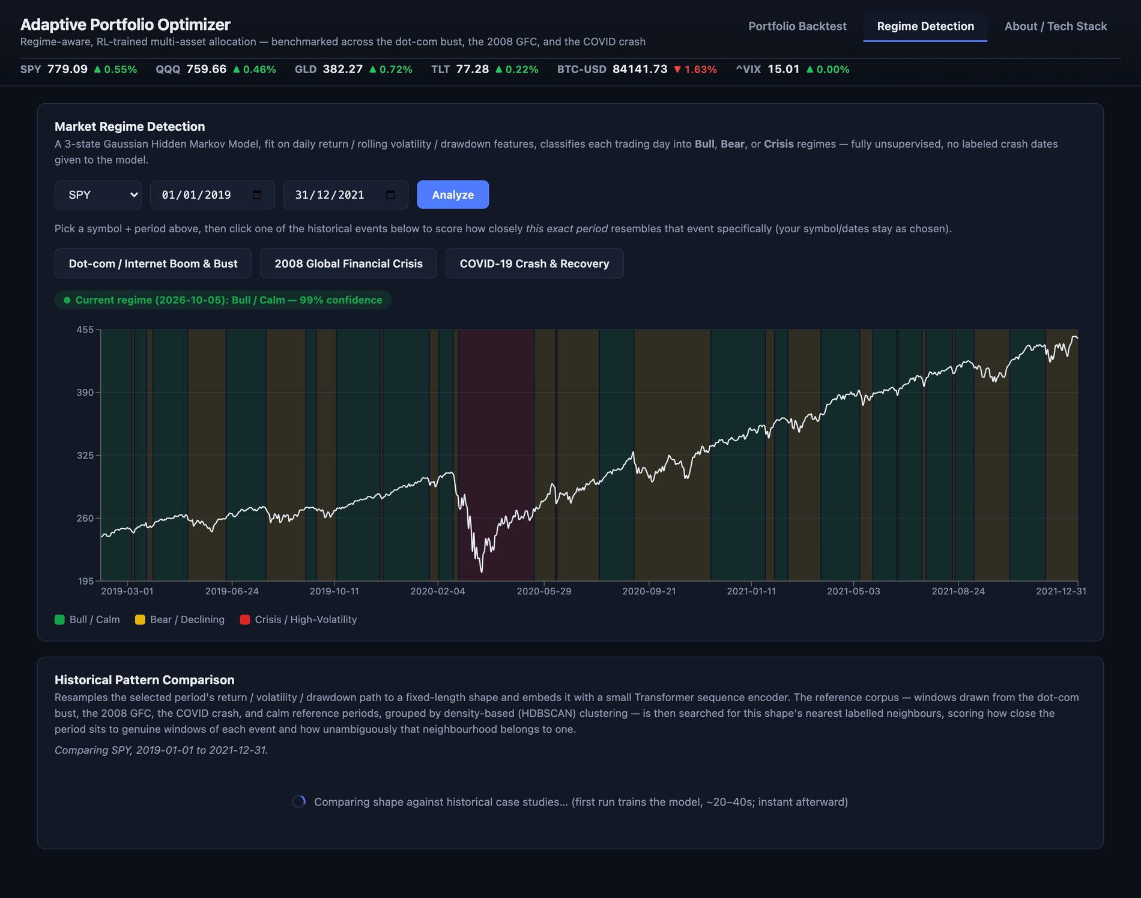
Figure 6.2 Regime Detection tab for SPY, 2019 to 2021, with the comparison loading.
When the user selects the dates 15 January to 15 May 2020 and clicks the COVID-19 button, the report in Figure 6.3 appears. The 85-trading-day window is judged to closely resemble the COVID-19 crash with 59 percent confidence. The overlay chart draws the selected period (blue) against a real COVID-19 reference window (purple, dashed). Four figures sit under it: annualized return of -32.1 percent, annualized volatility of 51.9 percent, a maximum drawdown of -33.7 percent and the match confidence. The written insights state that the HMM labelled 32 percent of the days Bull, 38 percent Bear and 29 percent Crisis, and that similar historical windows were followed by an average 21-day return of +5.2 percent (standard deviation 3.2 percent, 8 windows). The footer reminds the reader that the analysis is illustrative and not investment advice.
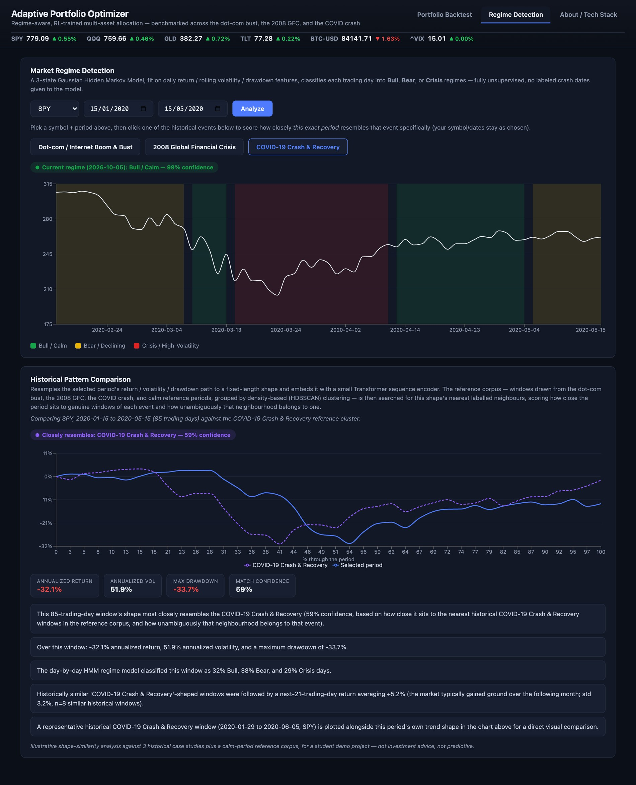
Figure 6.3 Regime Detection tab with the comparison report for the COVID-19 window.
If a period matches no event, the same panel states that the period tracks none of the three crises, shows the confidence for the normal class and gives the normal-regime baseline in place of an event overlay. The 2013 to 2015 SPY window is an example (Section 7.2).

6.4 About Tab
The About tab in Figure 6.4 explains what the application does, lists the stack, walks through the pipeline and states the scope limits. One thing in it is out of date: its description of the match step still mentions nearest cluster centers, whereas the final scoring uses the nearest labelled windows (Section 5.1.5).
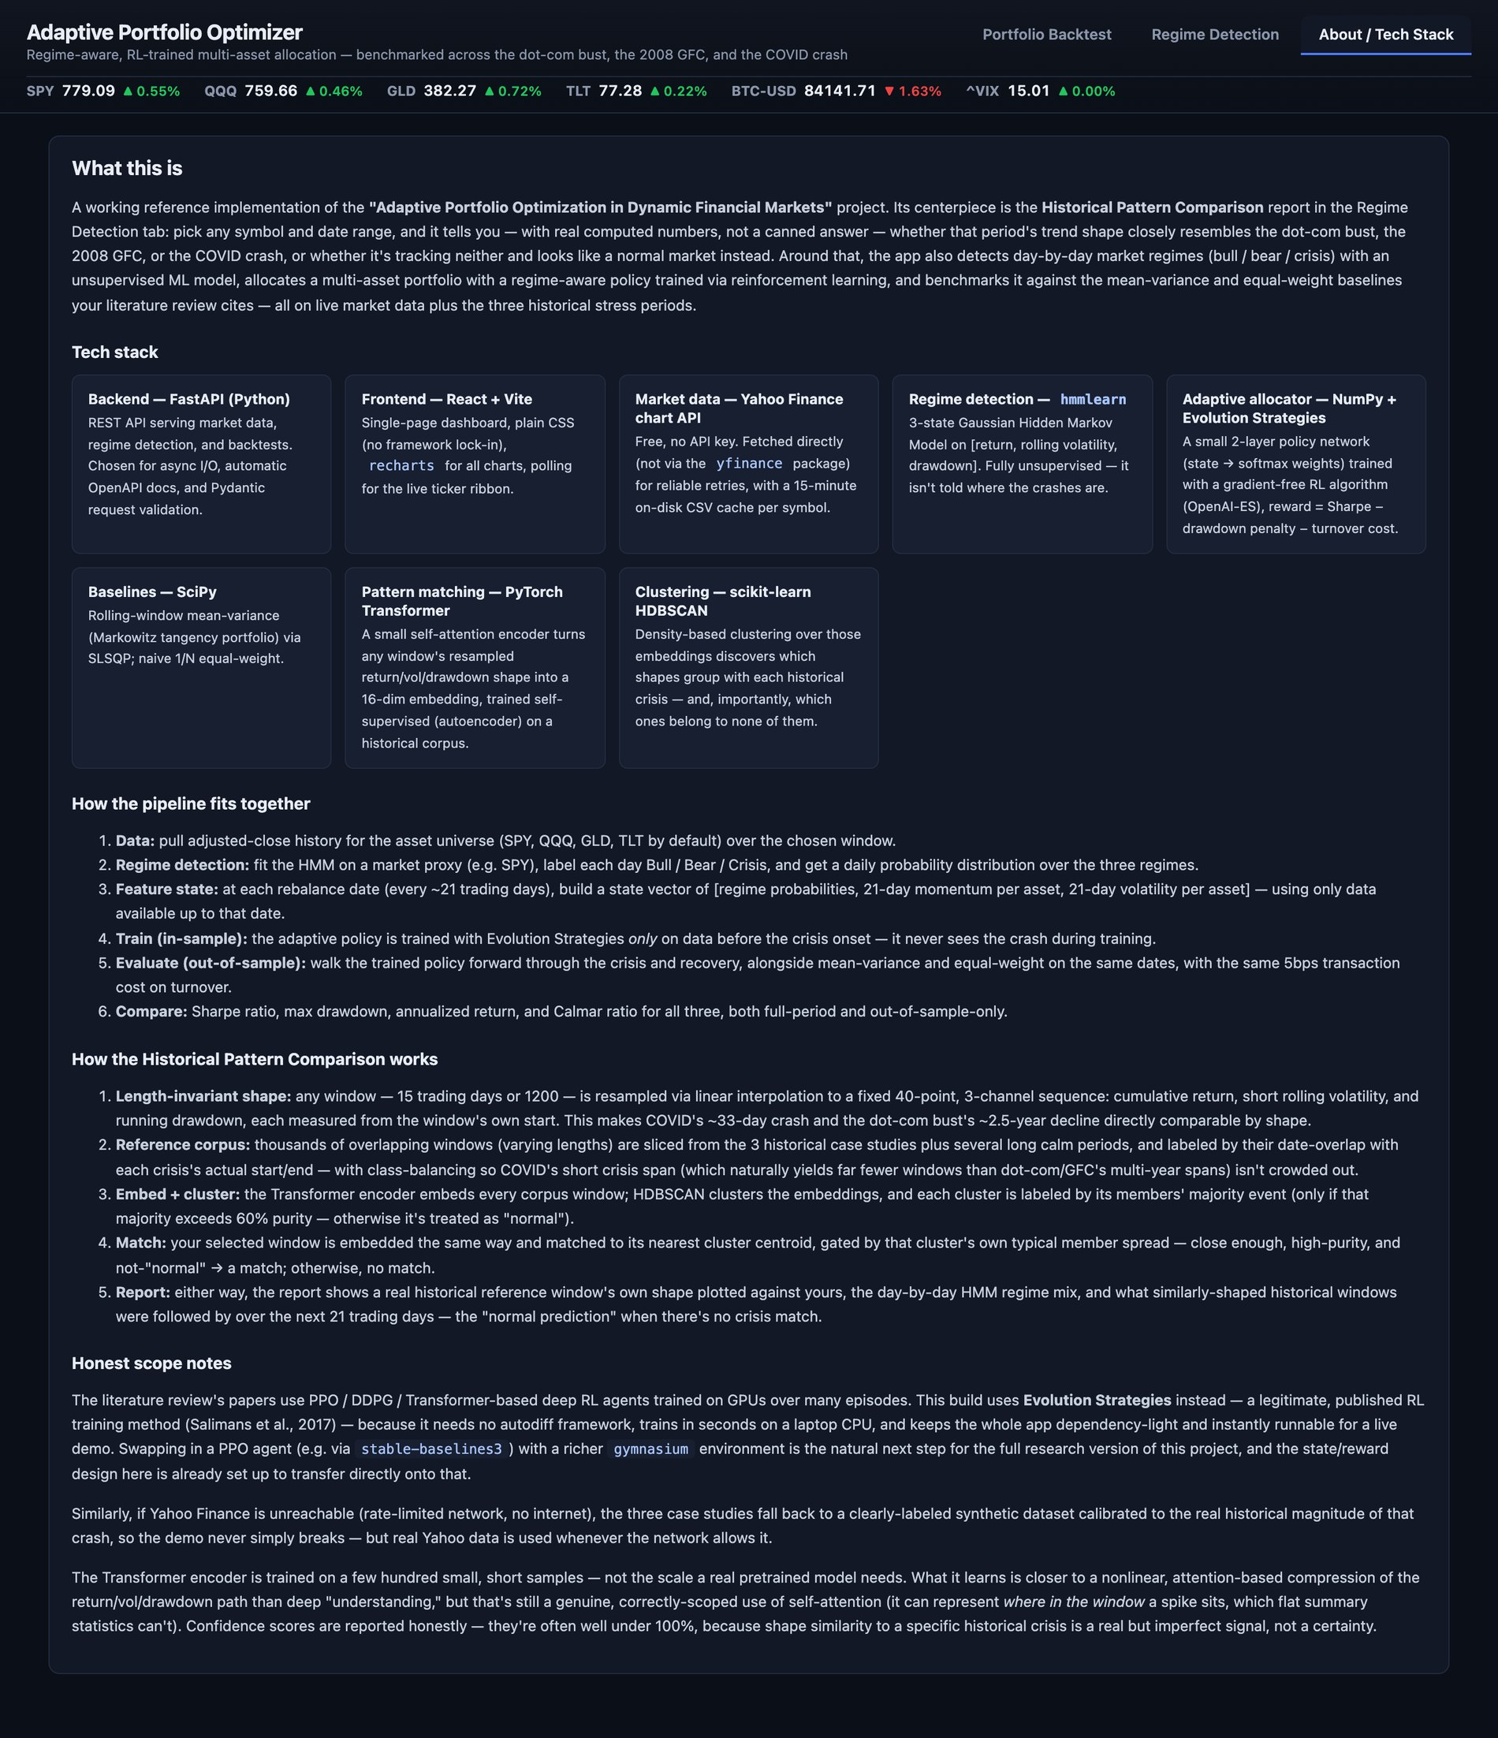
Figure 6.4 About and tech stack tab.

CHAPTER 7
RESULT AND DISCUSSION (COST ANALYSIS AS APPLICABLE)

7.1 Regime Detection
The unsupervised HMM marks the long turbulent stretches of all three crises as Crisis (Figure 7.1). The red band covers the 2008 and 2009 collapse, the low of October 2002 and the March 2020 crash, and the model was never told these dates. Crisis days are a minority of each window (19, 14 and 8 percent), and Bear states fill the slower phases before and after. In calm periods the labels flip between Bull and Bear more often, so we treat the HMM as a descriptive overlay and an input to the allocator, not as a trading signal.
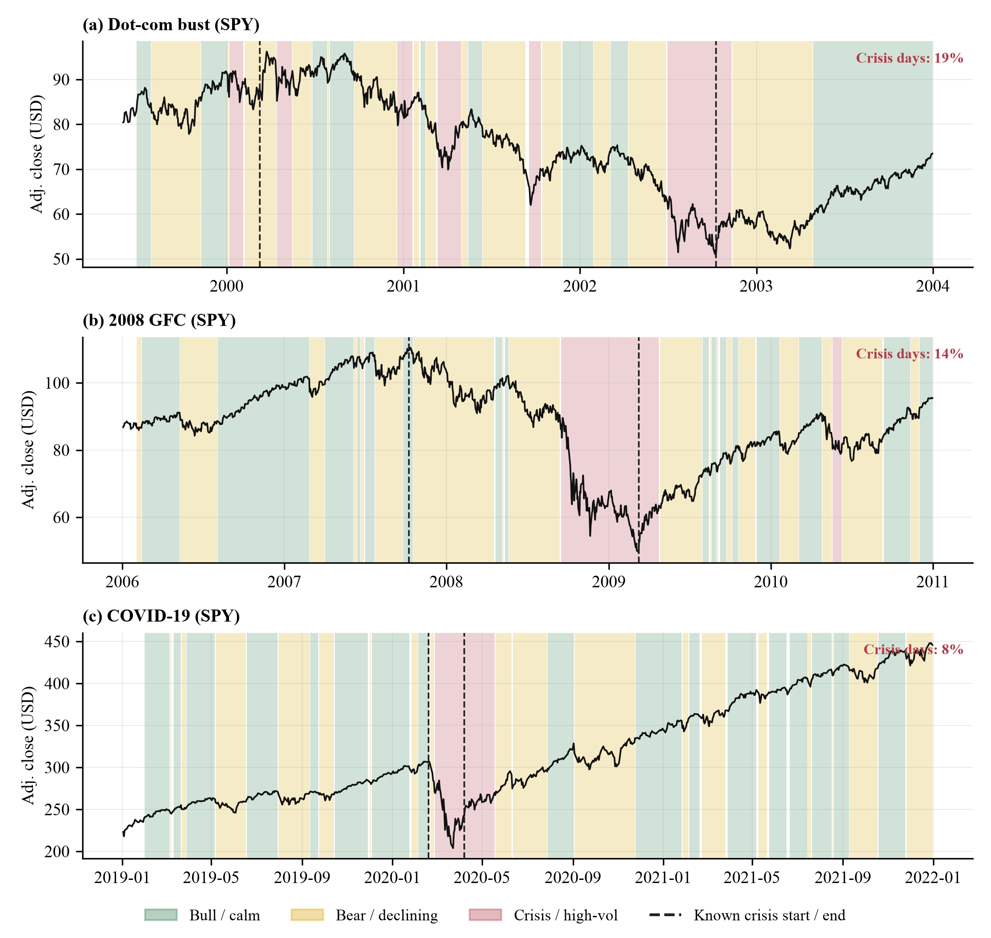
Figure 7.1 HMM regimes on SPY for (a) the dot-com bust, (b) the 2008 crisis and (c) the COVID-19 crash.

7.2 Historical-Pattern Comparison

7.2.1 Example Reports
Table 7.1 and Figure 7.2 show the report for five queries. The three crisis windows are matched to their own events with confidences of 59% (COVID-19), 72% (2008) and 89% (dot-com). The 2013 to 2015 period and the most recent months are labelled normal. These queries overlap the periods that were used to build the corpus, so the matches are partly circular. They show what the report looks like, and the cross-validation below measures how well the method generalizes.
Table 7.1 Comparison report output for five example queries.
Query | Symbol and range | Days | Result (confidence) | Ann. return | Max DD | HMM bull / bear / crisis | Next-21d baseline
COVID-19 crash window | SPY 2020-01-15 to 2020-05-15 | 85 | covid (59%) | -32.1% | -33.7% | 32% / 38% / 29% | 5.2%
2008 GFC window | SPY 2008-01-02 to 2009-06-30 | 377 | gfc (72%) | -24.4% | -51.9% | 57% / 28% / 15% | 3.1%
Dot-com bust window | QQQ 2000-03-01 to 2002-10-01 | 649 | dotcom (89%) | -46.0% | -82.4% | 41% / 34% / 25% | -1.3%
Calm 2013-2015 | SPY 2013-01-01 to 2015-12-31 | 756 | normal (66%) | 14.0% | -11.9% | 57% / 37% / 6% | 0.3%
Recent 2026 window | SPY 2026-03-01 to 2026-10-05 | 151 | normal (77%) | 23.5% | -7.7% | 68% / 17% / 15% | 0.9%
Crisis rows are scored in targeted mode against the matching event, the other two in auto mode. The last column is the mean 21-day forward return of the nearest same-label reference windows.
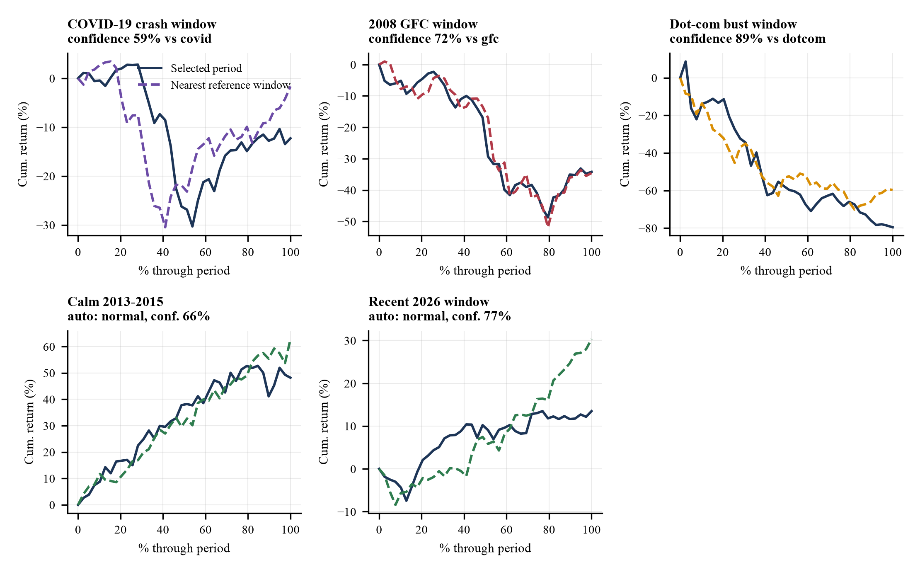
Figure 7.2 Query paths (solid) against the nearest reference windows (dashed).

7.2.2 Embedding Space
Figure 7.3 projects the 16-dimensional embeddings to two dimensions. Normal windows form the dense bulk. Event windows occupy a separate but overlapping region in which dot-com, 2008 and COVID-19 windows are mixed. That mixing is what we would expect if a crash followed by a recovery has a similar shape in every crisis.
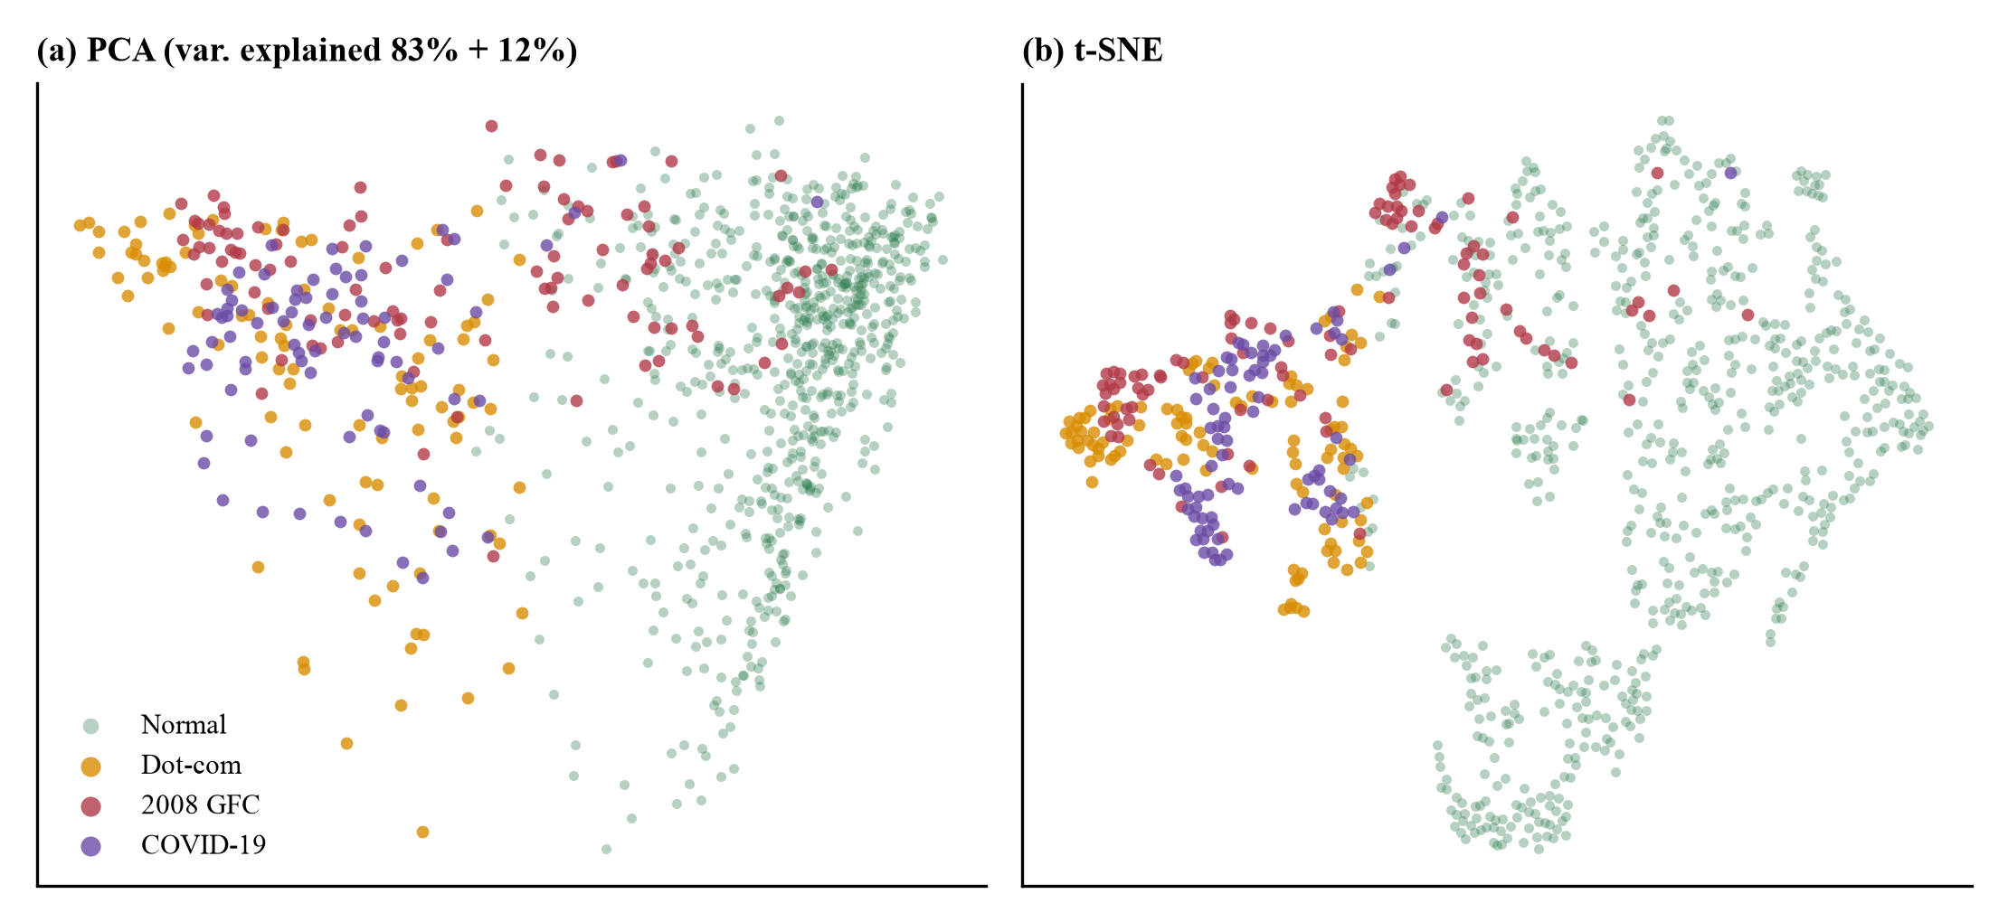
Figure 7.3 Corpus embeddings colored by label: (a) PCA and (b) t-SNE of the 965 vectors.

7.2.3 Leakage-Controlled Evaluation
Table 7.2 gives the blocked cross-validation. All variants reach about 75 to 76 percent accuracy, but almost all of it comes from the normal class, which has 99 percent recall. The trained Transformer reaches a balanced accuracy of 0.39 against a chance level of 0.25. Dot-com windows are recognized in 54% of cases, while 2008 and COVID-19 windows almost never are (recall 2% and 0%). The confusion matrix in Figure 7.5 shows that they are mostly assigned to dot-com or to normal. Telling crisis from normal works better: 49% of event windows are predicted as some crisis, with a false-alarm rate of 1.0%. So on unseen time blocks the representation captures "crisis-like" but not "which crisis".
Table 7.2 Blocked, purged 5-fold cross-validation of event identification.
Features (8-NN) | Balanced acc. | Macro-F1 | Accuracy | Crisis recall | False alarm | Recall dot-com / 2008 / COVID / normal
Transformer (trained) | 0.389 ± 0.006 | 0.353 ± 0.005 | 75.8% | 48.8% | 1.0% | 54% / 2% / 0% / 99%
Transformer (untrained) | 0.389 ± 0.009 | 0.355 ± 0.005 | 75.9% | 46.6% | 0.9% | 54% / 2% / 0% / 99%
Raw shape (120-d) | 0.367 ± 0.000 | 0.339 ± 0.000 | 75.0% | 42.7% | 0.7% | 46% / 2% / 0% / 99%
PCA-16 of raw shape | 0.372 ± 0.000 | 0.342 ± 0.000 | 75.1% | 44.1% | 0.9% | 48% / 2% / 0% / 99%
Summary statistics (7-d) | 0.378 ± 0.000 | 0.339 ± 0.000 | 75.2% | 51.7% | 1.2% | 51% / 1% / 0% / 99%
Mean ± standard deviation over three encoder seeds for the two Transformer variants; the other variants are deterministic. Chance balanced accuracy is 0.25.
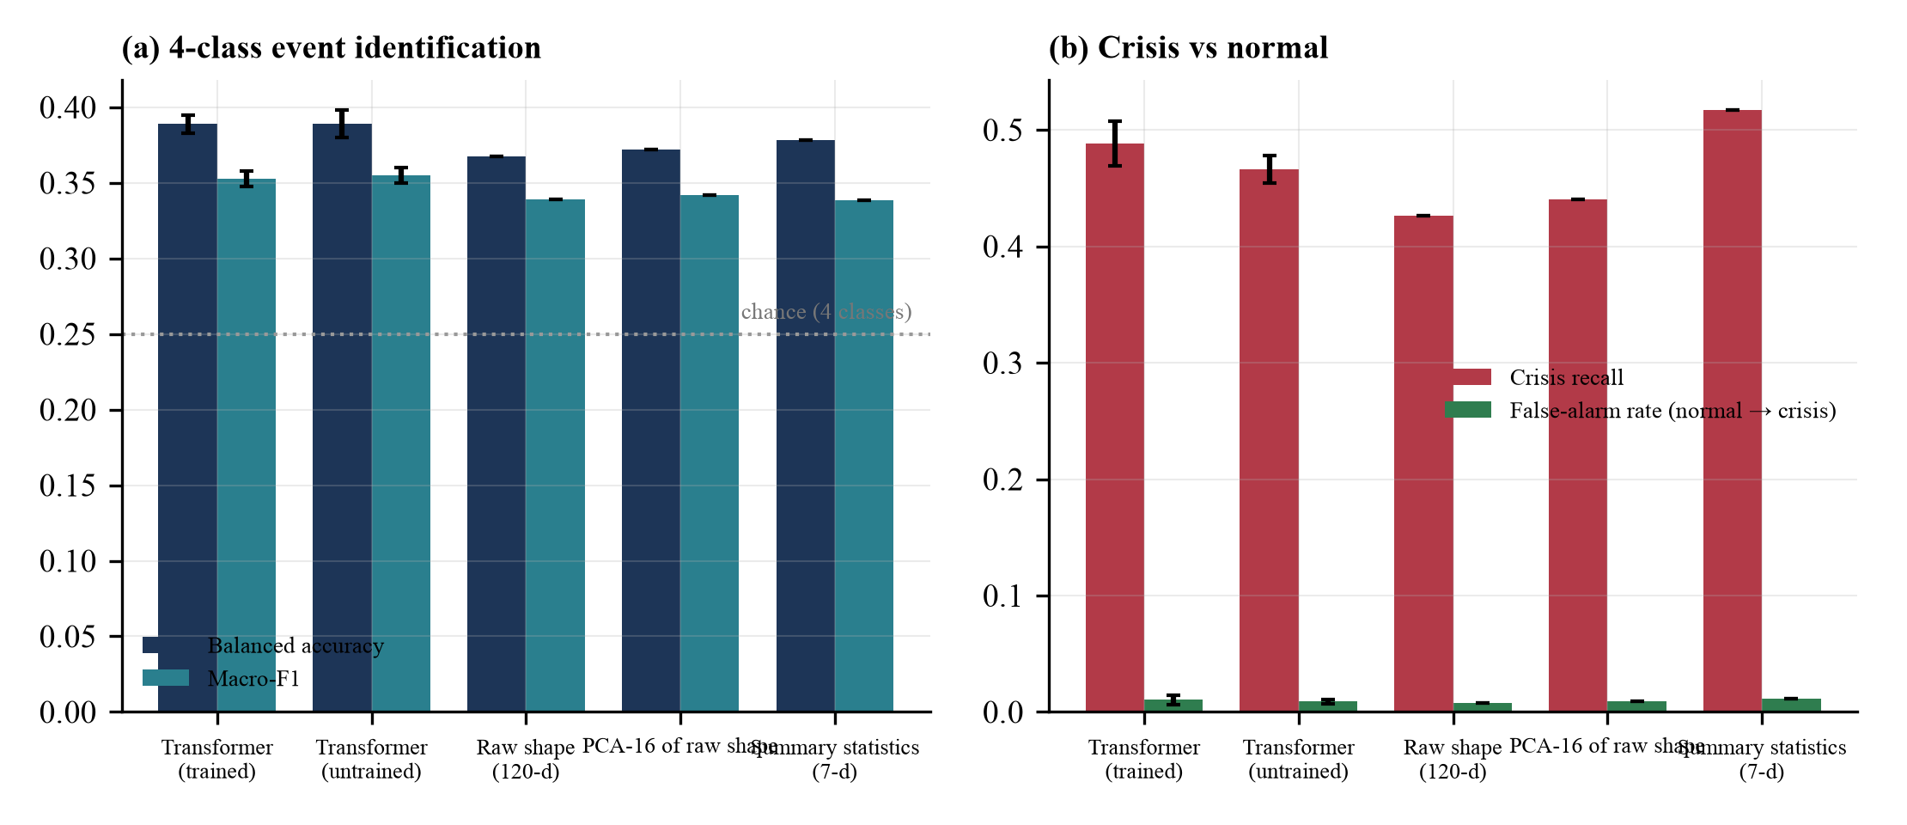
Figure 7.4 Embedding ablation under blocked cross-validation.
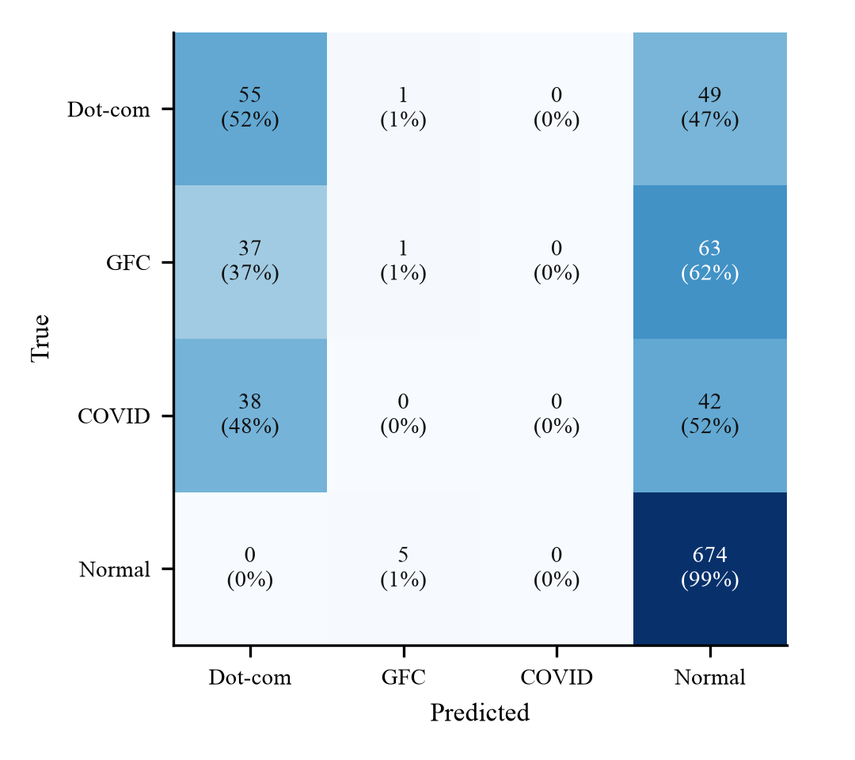
Figure 7.5 Confusion matrix of the trained-Transformer classifier under blocked cross-validation.

7.2.4 Unseen Crises
In leave-one-event-out tests (Table 7.3) the trained encoder flagged 90% of dot-com windows, 53% of 2008 windows and 93% of COVID-19 windows as crisis-like, although no window of that crisis was available for training. The 2008 crisis was a slow decline whose short sub-windows look like ordinary periods, which explains why it is the hardest. The result supports using the tool to ask whether a period looks like a crisis in general.
Table 7.3 Leave-one-event-out: share of the unseen crisis' windows predicted as crisis-like.
Held-out event | Test | Train | Transformer (trained) | Transformer (untrained) | Raw shape | PCA-16 | Summary stats
Dot-com | 105 | 808 | 90% | 96% | 85% | 85% | 90%
2008 crisis | 101 | 799 | 53% | 51% | 51% | 51% | 53%
COVID-19 | 80 | 853 | 93% | 82% | 82% | 88% | 96%

7.3 Walk-Forward Allocation Backtests
Table 7.4 and Figure 7.6 to Figure 7.7 give the out-of-sample results. The picture is mixed and depends heavily on the experimental design.
Dot-com as deployed. The adaptive portfolio reaches a Sharpe ratio of 0.84 and a maximum drawdown of -15.2%, ahead of both baselines. That result is not real. Its weights are 100 percent gold at all 40 rebalances and its turnover is zero. The gold futures series starts in August 2000, so the training segment is only 30 trading days and the policy collapses to a buy-and-hold gold position, which happened to rise.
Dot-com corrected (SPY, QQQ and VUSTX, 196 genuine pre-crisis training days). Now the adaptive policy loses badly, with a Sharpe ratio of -0.43 and a maximum drawdown of -73.2%. A policy trained in the bubble years concentrates in QQQ and then flips between QQQ and bonds (Figure 7.8).
2008 crisis. Mean-variance has the best Sharpe ratio (0.66). The adaptive policy has the lowest volatility (13.1%) but not the shallowest drawdown. COVID-19. Mean-variance leads again (1.15), and the adaptive policy (1.04) is close to equal-weight (1.03).
Table 7.4 Out-of-sample performance of the three strategies (policy seed 42).
Setting | Strategy | Total return | Ann. return | Ann. vol. | Sharpe | Max DD | Calmar | Turnover
Dot-com (as deployed) | Equal-Weight | -10.4% | -3.4% | 20.9% | -0.16 | -43.0% | -0.08 | 0.00
 | Mean-Variance | 52.6% | 14.3% | 20.3% | 0.66 | -17.7% | 0.81 | 0.90
 | Adaptive (ES) | 52.6% | 14.3% | 14.8% | 0.84 | -15.2% | 0.94 | 0.00
Dot-com (corrected) | Equal-Weight | -20.7% | -5.9% | 21.2% | -0.28 | -46.5% | -0.13 | 0.00
 | Mean-Variance | 43.4% | 10.0% | 13.7% | 0.61 | -25.2% | 0.39 | 0.50
 | Adaptive (ES) | -60.5% | -21.7% | 41.6% | -0.43 | -73.2% | -0.30 | 0.57
2008 GFC | Equal-Weight | 28.8% | 8.2% | 14.7% | 0.47 | -26.6% | 0.31 | 0.00
 | Mean-Variance | 43.8% | 11.9% | 16.0% | 0.66 | -19.1% | 0.62 | 0.75
 | Adaptive (ES) | 20.2% | 5.8% | 13.1% | 0.35 | -23.8% | 0.24 | 0.27
COVID-19 | Equal-Weight | 34.6% | 17.2% | 14.4% | 1.03 | -15.4% | 1.11 | 0.00
 | Mean-Variance | 40.1% | 19.7% | 14.9% | 1.15 | -12.4% | 1.58 | 0.72
 | Adaptive (ES) | 33.9% | 16.8% | 13.9% | 1.04 | -13.1% | 1.28 | 0.72
The row with the highest Sharpe ratio in each setting is in bold. Turnover is the mean weight change per monthly rebalance; equal-weight targets never change, so it reports 0.
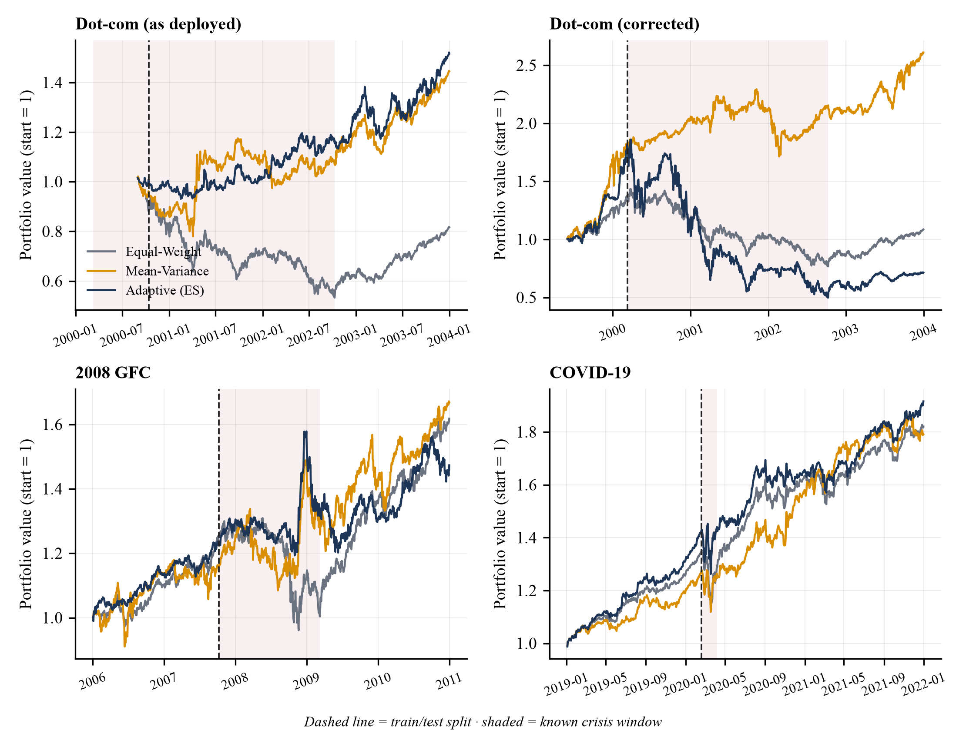
Figure 7.6 Portfolio value of the three strategies in the four settings.
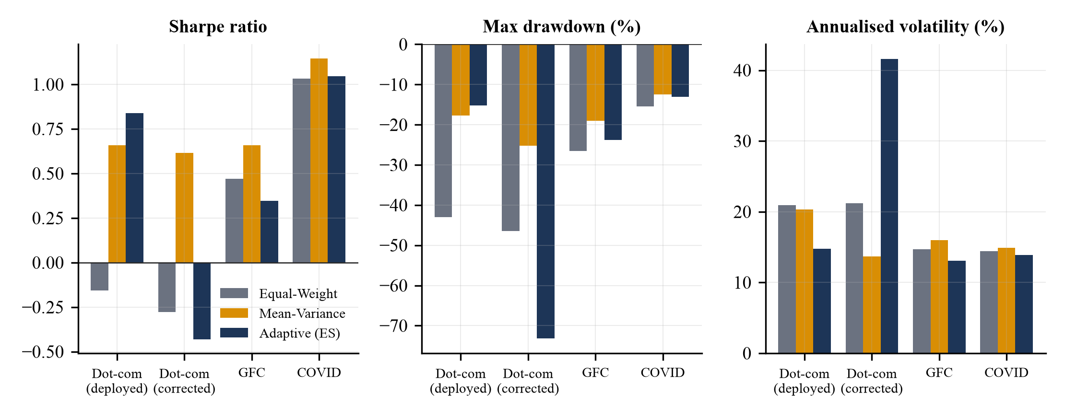
Figure 7.7 Out-of-sample Sharpe ratio, maximum drawdown and volatility.
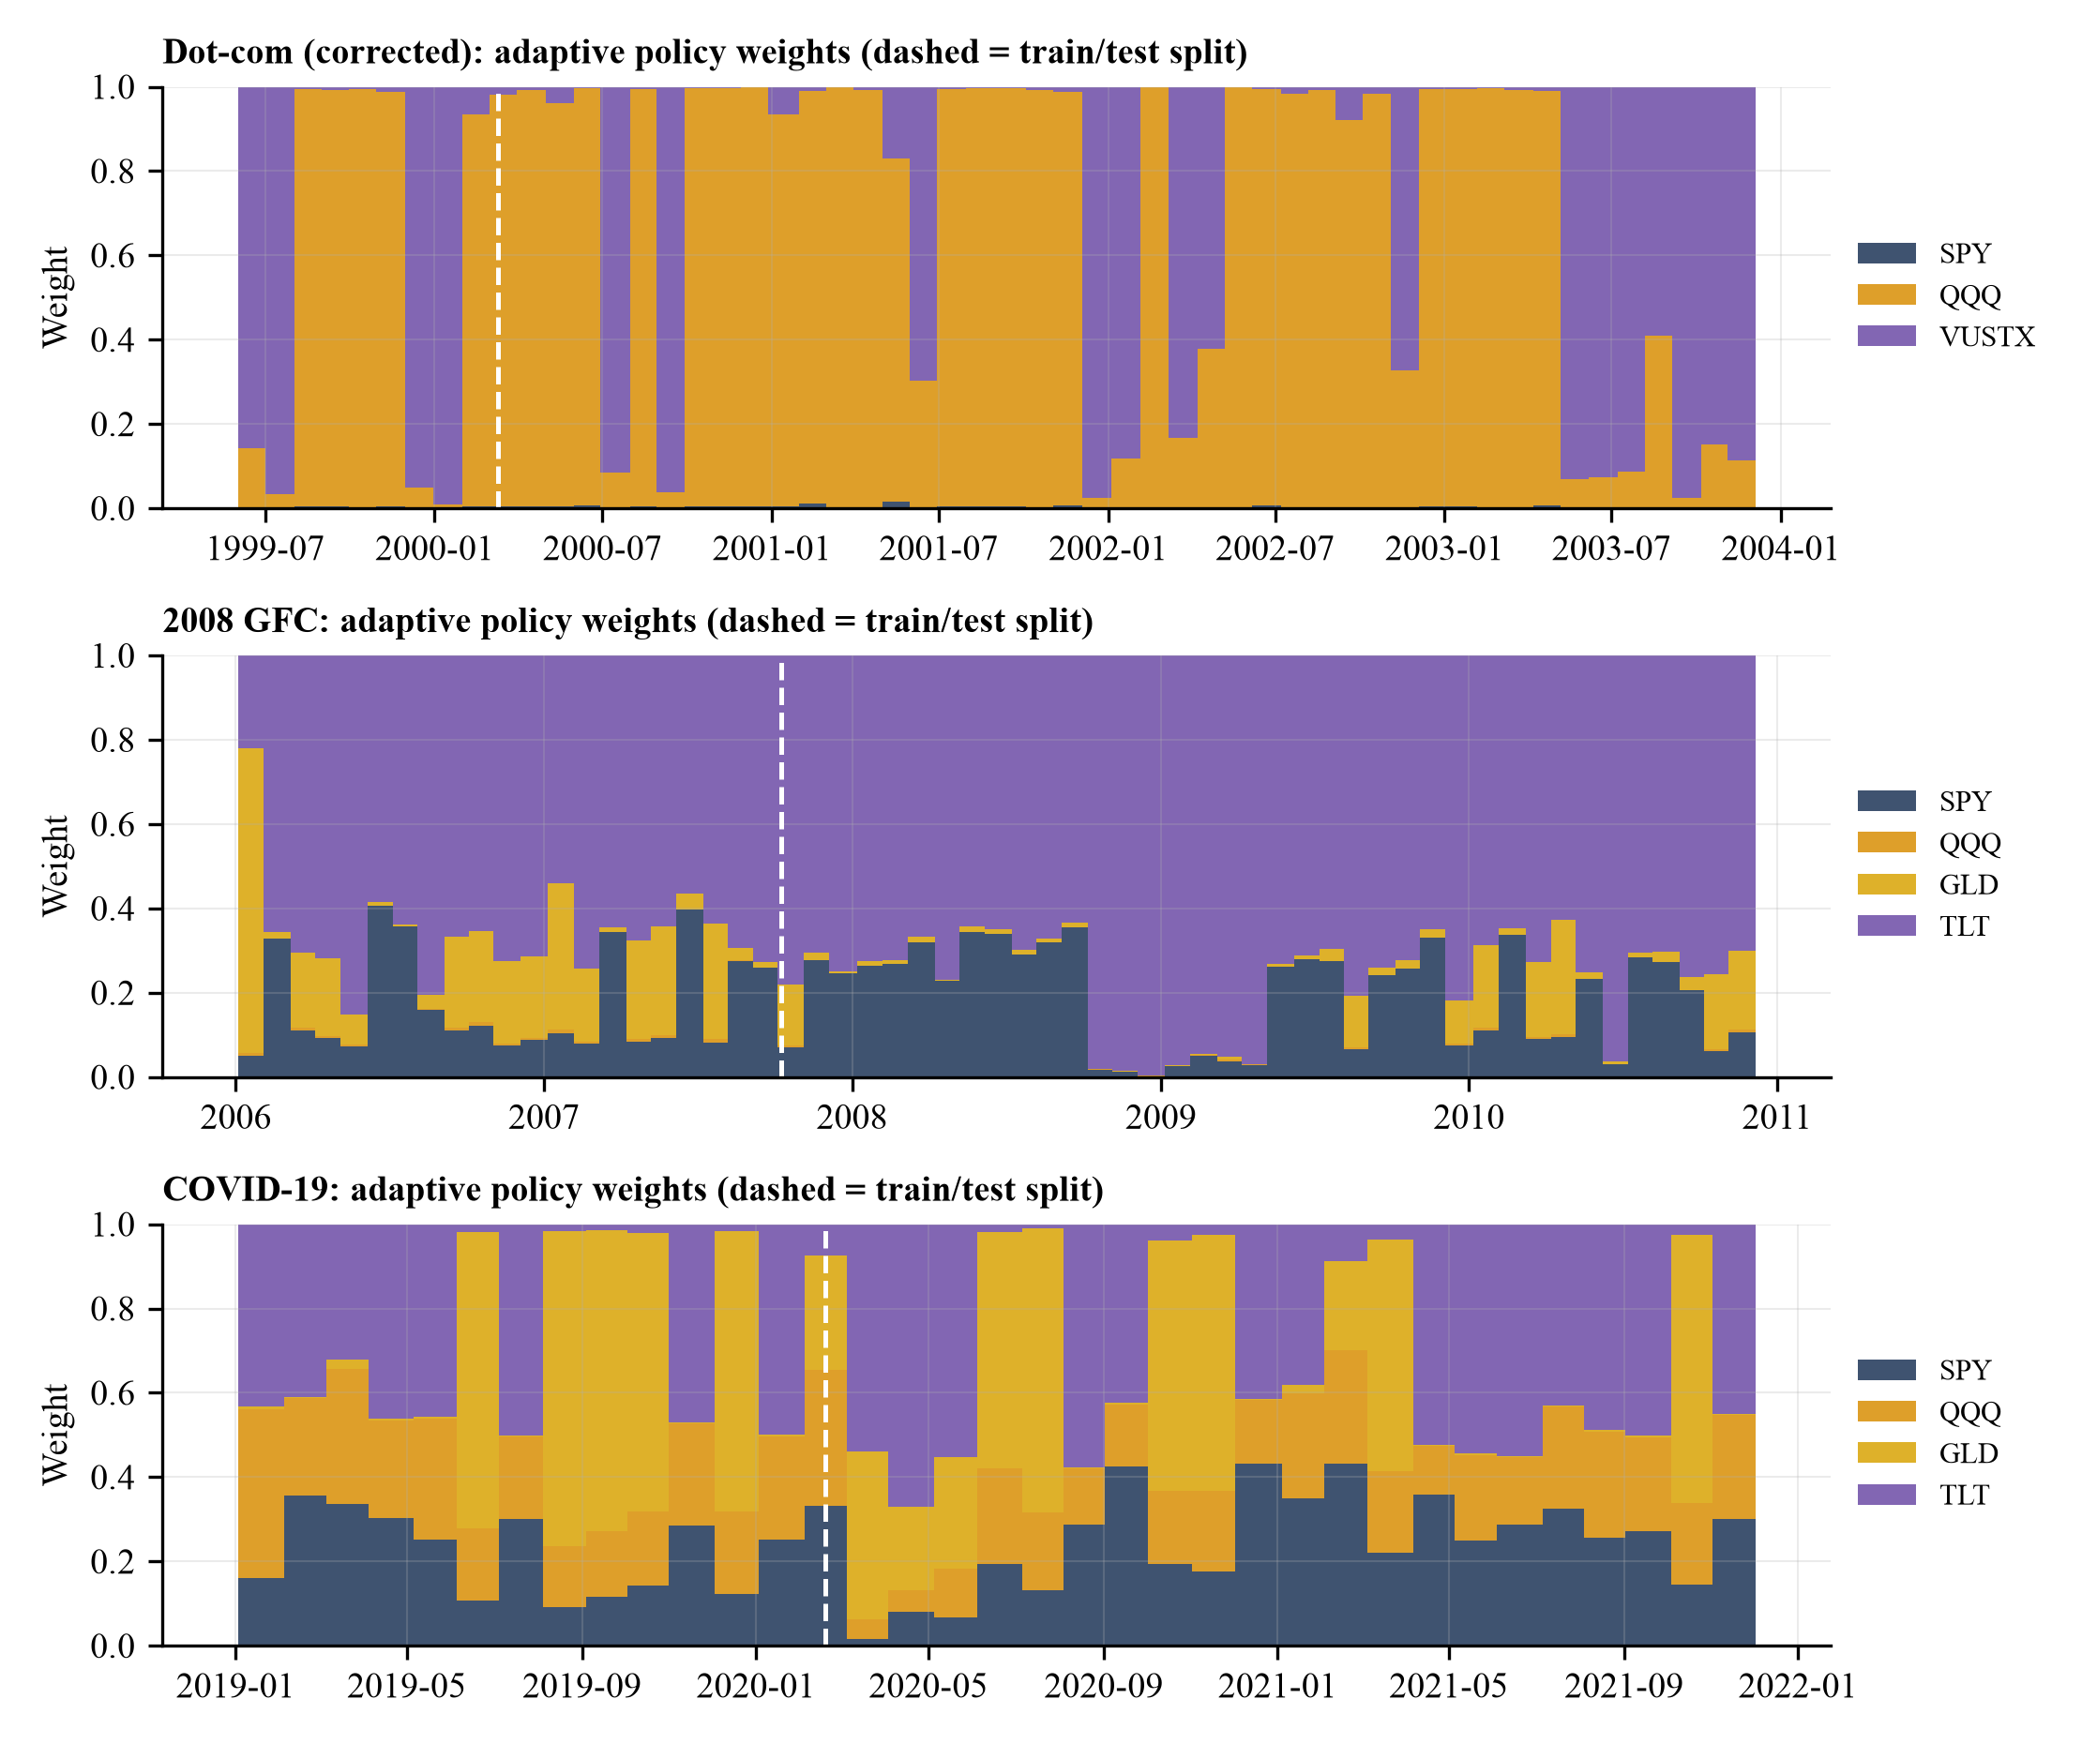
Figure 7.8 Adaptive-policy weights over time (seed 42).

7.3.1 Criterion-Wise Analysis
Table 7.5 Best strategy per criterion and setting on the test segment.
Criterion | Dot-com (as deployed) | Dot-com (corrected) | 2008 GFC | COVID-19
Total return | AD | MV | MV | MV
Annualized volatility (lowest) | AD | MV | AD | AD
Sharpe ratio | AD | MV | MV | MV
Max drawdown (shallowest) | AD | MV | MV | MV
Calmar ratio | AD | MV | MV | MV
EW is Equal-Weight, MV is Mean-Variance, AD is Adaptive.
Mean-variance is best on return, Sharpe ratio, Calmar ratio and drawdown in three of the four settings. The adaptive policy has the lowest volatility in three settings, which is the quantity its reward penalizes through the drawdown and turnover terms, but Section 7.5 shows that this does not hold across seeds. Equal-weight is never best and has the deepest drawdown in three of four settings, yet it is the cheapest to run, with no optimization and no change in target weights.

7.4 Statistical Analysis
Table 7.6 Paired stationary-bootstrap intervals for the test-segment Sharpe ratio difference.
Setting | Adaptive minus | Sharpe difference | 95% bootstrap CI | P(difference ≤ 0)
Dot-com (as deployed) | vs Mean-Variance | +0.17 | [-0.77, +1.19] | 0.36
 | vs Equal-Weight | +0.91 | [-0.46, +2.28] | 0.10
Dot-com (corrected) | vs Mean-Variance | -1.04 | [-2.27, +0.16] | 0.95
 | vs Equal-Weight | -0.15 | [-0.53, +0.22] | 0.79
2008 GFC | vs Mean-Variance | -0.31 | [-1.45, +0.72] | 0.72
 | vs Equal-Weight | -0.13 | [-1.47, +1.15] | 0.60
COVID-19 | vs Mean-Variance | -0.10 | [-0.94, +0.77] | 0.59
 | vs Equal-Weight | +0.02 | [-0.84, +0.79] | 0.51

Every interval contains zero. With test segments of 473 to 957 daily returns, none of the observed Sharpe ratio differences can be told apart from zero in either direction, so neither the dot-com "win" nor the other "losses" should be read as evidence about the method. Differences between seeds are a larger effect than most of the differences between strategies (Section 7.5). The standard deviation of balanced accuracy across encoder seeds is at most 0.009, so the matcher results are stable even though the allocator results are not. We report eight comparisons without a multiplicity correction. Since no interval excludes zero, a correction would not change any conclusion.

7.5 Ablation Study
Table 7.7 and Figure 7.9 give the mean and standard deviation of the test-segment results over six seeds. Removing the regime features does not change the outcome in any consistent direction. The 2008 Sharpe ratio drops slightly and the COVID-19 one rises, both within one standard deviation. A more telling result is that the untrained random policy matches or beats the trained one in the 2008 and COVID-19 settings (Sharpe 0.59 against 0.36 and 1.02 against 0.90), and has lower volatility in COVID-19 (14.1 against 19.2 percent). Training by evolution strategies on the short pre-crisis segment overfits and does not carry over to the crisis. In the as-deployed dot-com setting the trained variants give identical results for every seed because they all converge to the same constant gold portfolio.
Table 7.7 Allocator ablation: test-segment results, mean ± standard deviation over six seeds.
Setting | Strategy or variant | Sharpe | Ann. volatility | Max drawdown | Seeds with lowest volatility
Dot-com (as deployed) | Equal-Weight | -0.16 | 20.9% | -43.0% | n/a
 | Mean-Variance | 0.66 | 20.3% | -17.7% | n/a
 | Adaptive (full) | 0.84 ± 0.00 | 14.8% ± 0.0% | -15.2% ± 0.0% | 100%
 | Adaptive (no regime) | 0.84 ± 0.00 | 14.8% ± 0.0% | -15.2% ± 0.0% | 100%
 | Adaptive (untrained) | -0.27 ± 0.03 | 26.9% ± 2.7% | -54.3% ± 4.4% | 0%
Dot-com (corrected) | Equal-Weight | -0.28 | 21.2% | -46.5% | n/a
 | Mean-Variance | 0.61 | 13.7% | -25.2% | n/a
 | Adaptive (full) | -0.42 ± 0.08 | 41.3% ± 3.0% | -76.5% ± 5.9% | 0%
 | Adaptive (no regime) | -0.45 ± 0.06 | 41.4% ± 2.8% | -77.5% ± 4.8% | 0%
 | Adaptive (untrained) | -0.37 ± 0.05 | 27.5% ± 3.4% | -59.8% ± 6.3% | 0%
2008 GFC | Equal-Weight | 0.47 | 14.7% | -26.6% | n/a
 | Mean-Variance | 0.66 | 16.0% | -19.1% | n/a
 | Adaptive (full) | 0.36 ± 0.23 | 13.9% ± 3.5% | -25.1% ± 8.6% | 67%
 | Adaptive (no regime) | 0.30 ± 0.19 | 15.9% ± 3.7% | -29.7% ± 8.7% | 33%
 | Adaptive (untrained) | 0.59 ± 0.16 | 14.1% ± 0.9% | -24.1% ± 0.4% | 50%
COVID-19 | Equal-Weight | 1.03 | 14.4% | -15.4% | n/a
 | Mean-Variance | 1.15 | 14.9% | -12.4% | n/a
 | Adaptive (full) | 0.90 ± 0.12 | 19.2% ± 3.5% | -21.5% ± 7.1% | 0%
 | Adaptive (no regime) | 0.97 ± 0.13 | 19.6% ± 2.5% | -21.4% ± 5.1% | 0%
 | Adaptive (untrained) | 1.02 ± 0.05 | 14.1% ± 0.8% | -14.0% ± 0.1% | 33%
Baselines are deterministic. The last column is the share of seeds in which the adaptive variant has lower volatility than both baselines.
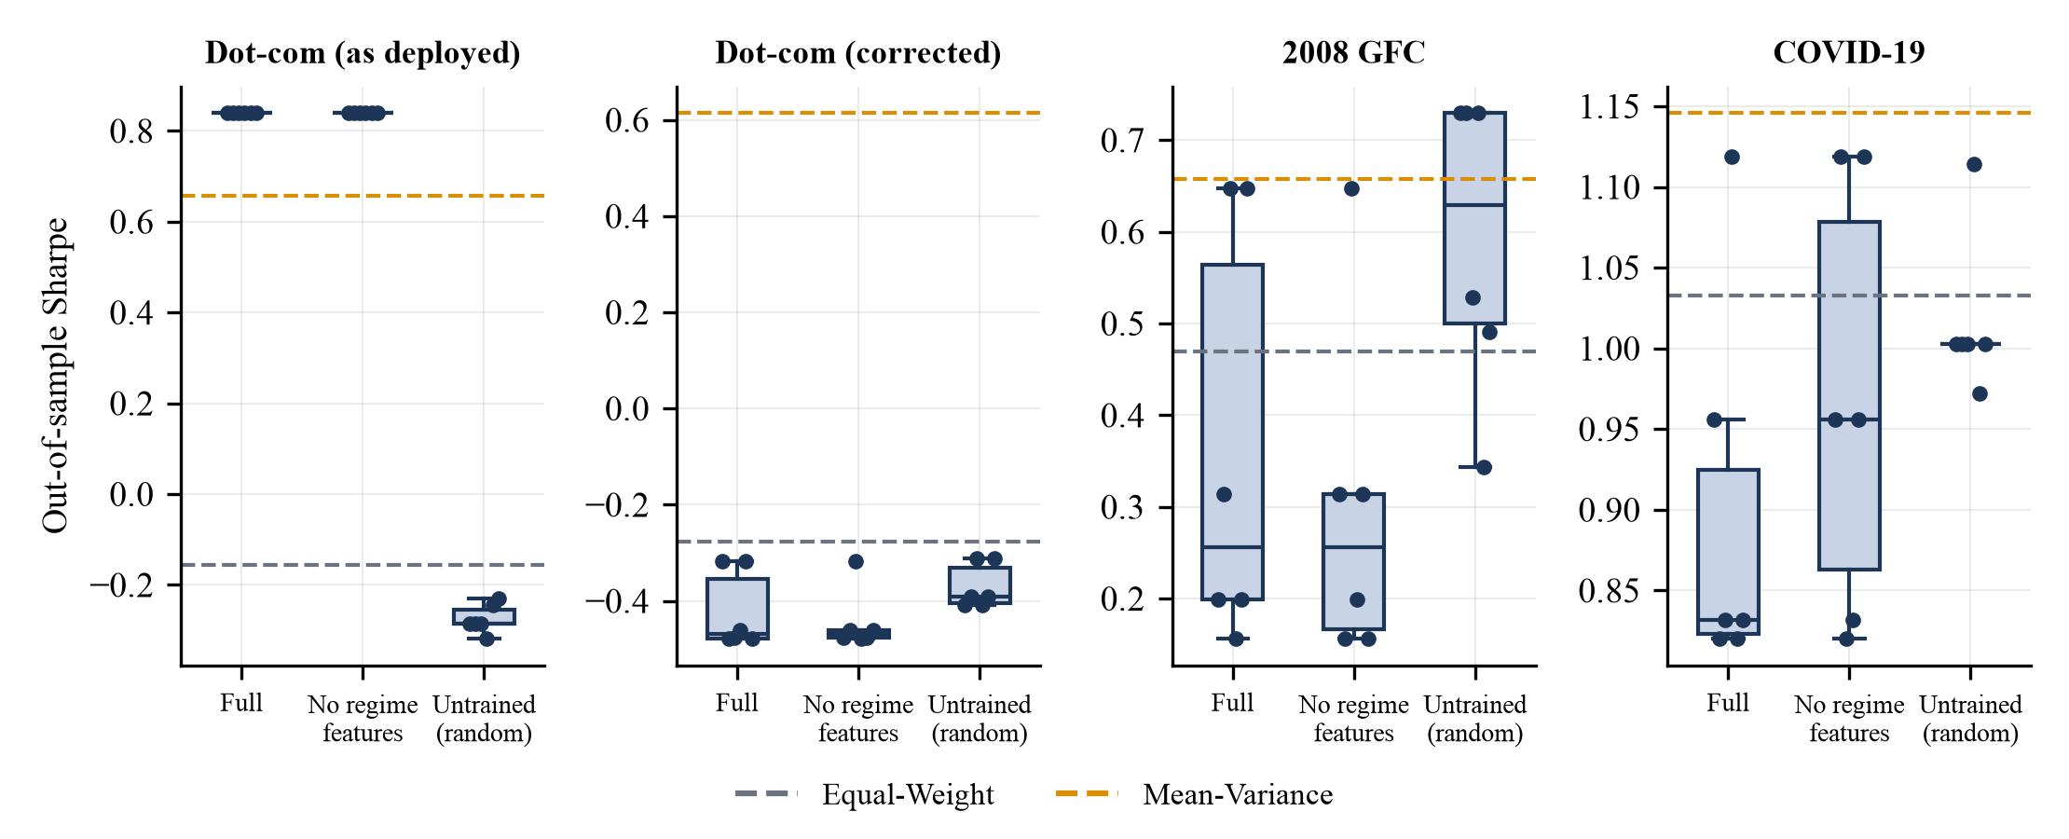
Figure 7.9 Out-of-sample Sharpe ratio of the adaptive policy across six seeds; dashed lines are the baselines.
For the matcher, replacing the trained Transformer with an untrained one, the raw shape, PCA or seven summary statistics changes balanced accuracy by at most 0.022 (Table 7.2). The leave-one-event-out rates (Table 7.3) are similar: summary statistics are highest for COVID-19 (96 against 93 percent for the trained encoder), the untrained encoder is highest for dot-com (96 against 90 percent), and the trained encoder is above the raw features for dot-com and COVID-19. The useful signal sits in the resampled shape itself, and at this data scale the Transformer neither adds to it nor removes any of it.

7.6 Comparison with Existing Methods
A number-for-number comparison with the four reviewed studies is not possible. They use different data, assets, periods and costs, and their code and data were not available to us. We therefore compare against equal-weight and mean-variance under one protocol, and compare capabilities with the reviewed approaches in Table 7.8, using only the properties that those studies report.
Table 7.8 Capability comparison with the reviewed studies.
Capability | Mean-Variance / 1/N | Zhang (GAT) | DRL-APO | RL-APM | Regime-aware RL | This work
Multi-asset allocation | Yes | Yes | Yes | No (single stock) | Yes | Yes (3 to 4 assets)
Explicit regime detection | No | Not reported | No | No | Yes | Yes (HMM)
Transaction costs in objective | No | Not reported | Not reported | Ignored | Not reported | Yes (turnover and 5 bps)
Historical-analogue comparison | No | No | No | No | No | Yes (Transformer and HDBSCAN)
Interpretable output | Yes | Low | Low | Medium | Medium (LSTM) | Yes (report and overlay)
Leakage-controlled, multi-seed evaluation | n/a | Not reported | Not reported | Not reported | Not reported | Yes
Reported to beat static baselines | n/a | Yes (reported) | Yes (reported) | Yes (reported) | Yes (reported) | No (this report)
"Not reported" means the literature review did not record the property, not that the study lacks it.
The difference lies in scope and in how the results are reported. The application adds an explainable comparison and an evaluation with seeds, ablations and leakage controls. It does not show that its allocator beats the baselines.

7.7 Cost Analysis
The monetary cost of the project was nil (Section 3.2.2). Table 7.9 gives the computing cost on the development laptop. Training and scoring are cheap because the Transformer and the corpus are small.
Table 7.9 Computing cost of the main operations.
Operation | Time on Apple M3 (CPU)
Build the matcher (train encoder, embed 965 windows, HDBSCAN grid), once per server start | about 25 s
One comparison request after the matcher exists | about 0.1 s
One backtest including HMM fit and 40 ES generations | 8 to 17 s

The trading cost inside the backtests is modelled at 5 basis points of turnover. Mean-Variance trades heavily (0.75 per rebalance in 2008, 0.72 in COVID-19), and pays for it in return relative to a frictionless run. TC15 in Table 5.5 confirms that a higher cost lowers net return.

7.8 Discussion
• Regimes can be found without labels, but the label is not a forecast. The HMM recovers the turbulent phases of all three crises. Its day-level states are noisy, and removing them from the allocator's input made no consistent difference.
• Shape similarity detects crises and cannot yet name them. Once windows are reduced to normalized shapes, the three crises look alike, so telling them apart on held-out blocks fails while crisis against normal works with few false alarms. The confidence in the report is closeness to a family of crash shapes. It is not the probability that the period is that event.
• The Transformer is not where the signal comes from. An untrained encoder, the raw shape and seven summary statistics do as well. With under a thousand strongly overlapping windows this is expected, and the encoder acts close to a fixed random projection that preserves distances.
• The adaptive allocator did not beat simple baselines. Mean-variance is the strongest or near strongest in three of four settings, and apparent wins were fragile.
• The experimental design can decide the conclusion. Swapping gold futures for a bond fund in the dot-com setting turned the best strategy into the worst.

7.9 Limitations
• Three crises and four calm periods give 965 overlapping windows with a large normal class. Blocked purging reduces the dependence between windows but cannot remove it, and other crises (1987, 1998, 2022) were not tested.
• The example queries in Table 7.1 overlap the corpus; only the blocked and leave-one-event-out results measure generalization.
• Evolution strategies replace the PPO and DDPG agents of the literature, with a small state, 40 generations and short training segments. The negative result applies to this implementation and says little about deep reinforcement learning in general. Only long-only portfolios of three or four assets were studied, with one cost assumption and no liquidity or market-impact model, which was one of the original objectives.
• The as-deployed dot-com setting is invalid and is kept only to document the diagnosis. The corrected setting uses a mutual fund as a proxy for bonds, and each test segment contains a single crisis.
• Results move slightly when Yahoo refreshes its data, as the COVID-19 case showed. The endpoint is unofficial and may change, and adjusted prices are revised retroactively.

CHAPTER 8
CONCLUSION
We built and evaluated a web application that compares any market period with the dot-com bust, the 2008 crisis and the COVID-19 crash. It combines a length-invariant shape representation, a Transformer encoder and nearest-neighbor scoring over an HDBSCAN-structured corpus with an HMM regime view and a walk-forward allocation workbench. The evaluation gives a clear but modest result. The comparison separates crisis-like from normal periods (crisis recall 49% at a 1.0% false-alarm rate) and recognizes unseen crises as crisis-like. It cannot say which crisis a period resembles, and neither the trained Transformer nor the regime-aware allocator beat simpler alternatives.
Table 8.1 compares the outcome with the objectives from Section 2.3.
Table 8.1 Objectives and outcomes.
Objective | Outcome | Status
1. Adaptive allocation model for multi-asset portfolios | Implemented as an evolution-strategies policy rather than PPO or DDPG; works on 3 to 4 assets | Partly met
2. Real-time regime detection to trigger reallocation | HMM regimes feed the policy state; ablation shows no consistent benefit | Met, benefit not shown
3. Transaction costs and liquidity in the reward | Turnover cost and drawdown in the reward; no liquidity model | Partly met
4. Benchmark against mean-variance and equal-weight | Sharpe, drawdown, return, volatility and Calmar reported, with bootstrap intervals | Met
5. Robustness across bull, bear and volatile regimes | Four settings, six seeds and ablations; no consistent advantage found | Met, result negative
6. Historical comparison with Transformer and HDBSCAN | Working report with overlay, statistics and baseline; evaluated with leakage controls | Met
7. Working web application on live data | Eight endpoints, three-tab dashboard, 21 of 21 tests passed | Met

We regard the diagnostics as useful results in their own right: the invalid split that produced a constant gold portfolio, the untrained-encoder and untrained-policy controls, and the seed and bootstrap analysis.

8.1 Future Work
• Extend the corpus to more crises and markets, and cross-validate by whole event instead of by window.
• Replace the single-crisis labels by a continuous severity score, and add shape descriptors that keep the original duration so that fast and slow crashes can be told apart.
• Pre-train the encoder on a much larger set of unlabelled windows, or try contrastive objectives, before claiming any benefit from attention.
• Implement PPO and DDPG agents under the same protocol with longer training windows, rolling retraining, policy regularization and a cost and liquidity model.
• Add automated tests to the repository and make the dot-com configuration valid by default.
• Move toward TRL 4 and 5 with paper trading on live data, and evaluate the dashboard with real users.

CHAPTER 9
REFERENCES
[1] R. Cont, "Empirical properties of asset returns: Stylized facts and statistical issues," Quant. Finance, vol. 1, no. 2, pp. 223-236, 2001.
[2] H. Markowitz, "Portfolio selection," J. Finance, vol. 7, no. 1, pp. 77-91, 1952.
[3] V. DeMiguel, L. Garlappi, and R. Uppal, "Optimal versus naive diversification: How inefficient is the 1/N portfolio strategy?," Rev. Financ. Stud., vol. 22, no. 5, pp. 1915-1953, 2009.
[4] J. D. Hamilton, "A new approach to the economic analysis of nonstationary time series and the business cycle," Econometrica, vol. 57, no. 2, pp. 357-384, 1989.
[5] A. Ang and G. Bekaert, "International asset allocation with regime shifts," Rev. Financ. Stud., vol. 15, no. 4, pp. 1137-1187, 2002.
[6] J. Moody and M. Saffell, "Learning to trade via direct reinforcement," IEEE Trans. Neural Netw., vol. 12, no. 4, pp. 875-889, Jul. 2001.
[7] Z. Jiang, D. Xu, and J. Liang, "A deep reinforcement learning framework for the financial portfolio management problem," arXiv:1706.10059, 2017.
[8] B. Zhang, "Graph attention-based heterogeneous multi-agent deep reinforcement learning for adaptive portfolio optimization," Sci. Rep., vol. 15, 2025.
[9] "Deep reinforcement learning for adaptive portfolio optimization in dynamic financial environments," Appl. Artif. Intell. Comput. Syst., 2025.
[10] "Reinforcement learning for single-stock portfolio optimization in equity markets," Int. J. Comput. Intell. Syst., Springer, 2025.
[11] "Adaptive and regime-aware RL for portfolio optimization," arXiv:2509.14385, 2025.
[12] W. F. Sharpe, "The Sharpe ratio," J. Portf. Manag., vol. 21, no. 1, pp. 49-58, 1994.
[13] L. R. Rabiner, "A tutorial on hidden Markov models and selected applications in speech recognition," Proc. IEEE, vol. 77, no. 2, pp. 257-286, 1989.
[14] "hmmlearn: Hidden Markov models in Python, with scikit-learn like API." [Online]. Available: https://github.com/hmmlearn/hmmlearn. Accessed: Oct. 2026.
[15] T. P. Lillicrap et al., "Continuous control with deep reinforcement learning," in Proc. Int. Conf. Learn. Represent. (ICLR), 2016.
[16] J. Schulman, F. Wolski, P. Dhariwal, A. Radford, and O. Klimov, "Proximal policy optimization algorithms," arXiv:1707.06347, 2017.
[17] T. Salimans, J. Ho, X. Chen, S. Sidor, and I. Sutskever, "Evolution strategies as a scalable alternative to reinforcement learning," arXiv:1703.03864, 2017.
[18] A. Vaswani et al., "Attention is all you need," in Adv. Neural Inf. Process. Syst., vol. 30, 2017, pp. 5998-6008.
[19] G. Zerveas, S. Jayaraman, D. Patel, A. Bhamidipaty, and C. Eickhoff, "A transformer-based framework for multivariate time series representation learning," in Proc. 27th ACM SIGKDD Conf. Knowl. Discov. Data Min., 2021, pp. 2114-2124.
[20] R. J. G. B. Campello, D. Moulavi, and J. Sander, "Density-based clustering based on hierarchical density estimates," in Adv. Knowl. Discov. Data Min. (PAKDD), LNCS 7819, 2013, pp. 160-172.
[21] L. McInnes, J. Healy, and S. Astels, "hdbscan: Hierarchical density based clustering," J. Open Source Softw., vol. 2, no. 11, p. 205, 2017.
[22] F. Pedregosa et al., "Scikit-learn: Machine learning in Python," J. Mach. Learn. Res., vol. 12, pp. 2825-2830, 2011.
[23] United Nations, "Transforming our world: The 2030 Agenda for Sustainable Development," Resolution A/RES/70/1, 2015.
[24] J. C. Mankins, "Technology readiness levels: A white paper," NASA Office of Space Access and Technology, 1995.
[25] Yahoo Finance, "Historical market data (chart API)." [Online]. Available: https://finance.yahoo.com. Accessed: Oct. 2026.
[26] D. Hendrycks and K. Gimpel, "Gaussian error linear units (GELUs)," arXiv:1606.08415, 2016.
[27] J. L. Ba, J. R. Kiros, and G. E. Hinton, "Layer normalization," arXiv:1607.06450, 2016.
[28] D. P. Kingma and J. Ba, "Adam: A method for stochastic optimization," in Proc. Int. Conf. Learn. Represent. (ICLR), 2015.
[29] A. Paszke et al., "PyTorch: An imperative style, high-performance deep learning library," in Adv. Neural Inf. Process. Syst., vol. 32, 2019, pp. 8024-8035.
[30] D. N. Politis and J. P. Romano, "The stationary bootstrap," J. Am. Stat. Assoc., vol. 89, no. 428, pp. 1303-1313, 1994.

APPENDIX A: SAMPLE CODE

A.1 Transformer shape encoder (ml/embedding.py)
class ShapeEncoder(nn.Module):
"""(batch, 40, 3) -> (batch, 16) embedding via a small Transformer encoder."""

def __init__(self):
super().__init__()
self.input_proj = nn.Linear(3, D_MODEL)
self.pos_embed = nn.Parameter(torch.randn(1, WINDOW_POINTS, D_MODEL) * 0.02)
layer = nn.TransformerEncoderLayer(
d_model=D_MODEL, nhead=N_HEADS, dim_feedforward=D_MODEL * 2,
dropout=0.0, batch_first=True, activation="gelu",
)
self.encoder = nn.TransformerEncoder(layer, num_layers=N_LAYERS)
self.out_proj = nn.Linear(D_MODEL, EMBED_DIM)

def forward(self, x: torch.Tensor) -> torch.Tensor:
h = self.input_proj(x) + self.pos_embed
h = self.encoder(h)
pooled = h.mean(dim=1)
return self.out_proj(pooled)

A.2 Length-invariant shape (ml/embedding.py)
def build_channels(prices: pd.Series) -> np.ndarray:
"""
In-window-only features -- no external lookback required, so this is
safe to call on corpus slices as short as ~15 trading days (unlike
regime.py's _build_features, which needs 20-60 days of PRIOR context).

Returns an (n_days, 3) array: [cumulative return from window start,
short rolling annualized vol, running drawdown from window start].
"""
prices = prices.astype(float)
cum_return = (prices / prices.iloc[0] - 1.0).values

daily_ret = prices.pct_change().fillna(0.0)
roll_vol = daily_ret.rolling(SHORT_VOL_WINDOW, min_periods=1).std().fillna(0.0)
* np.sqrt(252)
roll_vol = roll_vol.values

running_max = prices.cummax()
drawdown = (prices / running_max - 1.0).values

return np.column_stack([cum_return, roll_vol, drawdown]).astype(np.float32)

def resample_to_fixed(channels: np.ndarray, n_points: int = WINDOW_POINTS) ->
np.ndarray:
"""Per-channel linear interpolation onto n_points along a normalized [0,1]
x-axis."""
n_days = channels.shape[0]
if n_days == 1:
return np.repeat(channels, n_points, axis=0)
src_x = np.linspace(0.0, 1.0, n_days)
dst_x = np.linspace(0.0, 1.0, n_points)
out = np.empty((n_points, channels.shape[1]), dtype=np.float32)
for c in range(channels.shape[1]):
out[:, c] = np.interp(dst_x, src_x, channels[:, c])
return out

A.3 Label scoring (ml/event_matcher.py)
def _score_label(query_emb: np.ndarray, matcher: "Matcher", label: str) -> dict:
"""
Score how strongly this query resembles `label`, using the actual
labelled corpus windows rather than any cluster summary -- so HDBSCAN
noise points (~16% of the corpus, belonging to no cluster at all) still
contribute, instead of being invisible to the score.

match_dist is the mean distance to the MATCH_K nearest windows CARRYING
that label; it's expressed in units of that label's own in-class
spacing (_label_scales), then passed through a Gaussian kernel. That
calibrates the way a reader expects: a query sitting well inside the
spacing genuine members keep from each other reads ~0.9, one sitting at
exactly the typical spacing reads ~0.6, and one 2-3x outside decays to
~0.1 and below.
"""
dists = np.linalg.norm(matcher.embeddings - query_emb, axis=1)
same_label_idxs = np.array([i for i, w in enumerate(matcher.corpus) if w.label
== label])
k = min(MATCH_K, len(same_label_idxs))
nearest_same = same_label_idxs[np.argsort(dists[same_label_idxs])[:k]]

match_dist = float(dists[nearest_same].mean())
scale = matcher.label_scales[label]
proximity = float(np.exp(-0.5 * (match_dist / scale) ** 2))
purity = _local_purity(query_emb, matcher, label)

fwd = [matcher.corpus[i].forward_return_21d for i in nearest_same
if matcher.corpus[i].forward_return_21d is not None]
return {
"label": label,
"confidence": proximity * purity,
"purity": purity,
"match_dist": match_dist,
"typical_dist": scale,
"nearest_idx": int(nearest_same[0]),
"neighbour_idxs": nearest_same,
"forward_return_21d_mean": float(np.mean(fwd)) if fwd else None,
"forward_return_21d_std": float(np.std(fwd)) if fwd else None,
"forward_return_21d_n": len(fwd),
}

A.4 Mean-variance weights and adaptive policy (ml/allocator.py)
def mean_variance_weights(returns_window: pd.DataFrame, risk_free_daily: float =
0.0) -> np.ndarray:
"""
Max-Sharpe (tangency) portfolio over a trailing window of daily returns,
long-only, fully invested. Falls back to equal-weight if the optimizer
fails or the window is degenerate (e.g. all-zero variance).
"""
n = returns_window.shape[1]
mean_ret = returns_window.mean().values
cov = returns_window.cov().values
cov += np.eye(n) * 1e-6 # numerical stability

def neg_sharpe(w):
port_ret = w @ mean_ret
port_vol = np.sqrt(w @ cov @ w)
if port_vol < 1e-9:
return 0.0
return -(port_ret - risk_free_daily) / port_vol

cons = ({"type": "eq", "fun": lambda w: np.sum(w) - 1.0},)
bounds = tuple((0.0, 1.0) for _ in range(n))
x0 = equal_weights(n)
result = minimize(neg_sharpe, x0, method="SLSQP", bounds=bounds, constraints=cons,
options={"maxiter": 200, "ftol": 1e-9})
if not result.success or np.any(np.isnan(result.x)):
return x0
w = np.clip(result.x, 0, None)
total = w.sum()
return w / total if total > 1e-9 else x0

class PolicyNet:
"""Minimal 2-layer MLP: state -> tanh(hidden) -> softmax(weights). Pure numpy."""
w1: np.ndarray
b1: np.ndarray
w2: np.ndarray
b2: np.ndarray

@classmethod
def random_init(cls, state_dim: int, n_assets: int, hidden: int = 16, rng=None)
-> "PolicyNet":
rng = rng or np.random.default_rng()
scale1 = np.sqrt(2.0 / state_dim)
scale2 = np.sqrt(2.0 / hidden)
return cls(
w1=rng.normal(0, scale1, size=(state_dim, hidden)),
b1=np.zeros(hidden),
w2=rng.normal(0, scale2, size=(hidden, n_assets)),
b2=np.zeros(n_assets),
)

def flatten(self) -> np.ndarray:
return np.concatenate([self.w1.ravel(), self.b1.ravel(), self.w2.ravel(),
self.b2.ravel()])

def shapes(self):
return self.w1.shape, self.b1.shape, self.w2.shape, self.b2.shape

@classmethod
def from_flat(cls, flat: np.ndarray, state_dim: int, n_assets: int, hidden: int
= 16) -> "PolicyNet":
i = 0
w1 = flat[i:i + state_dim * hidden].reshape(state_dim, hidden); i +=
state_dim * hidden
b1 = flat[i:i + hidden]; i += hidden
w2 = flat[i:i + hidden * n_assets].reshape(hidden, n_assets); i += hidden *
n_assets
b2 = flat[i:i + n_assets]
return cls(w1, b1, w2, b2)

def act(self, state: np.ndarray) -> np.ndarray:
h = np.tanh(state @ self.w1 + self.b1)
logits = h @ self.w2 + self.b2
logits = logits - logits.max()
exp = np.exp(logits)
return exp / exp.sum()

A.5 Evolution strategies training loop (ml/allocator.py)
def train_adaptive_policy(returns: pd.DataFrame, regime_proba: pd.DataFrame,
rebalance_idxs: list[int],
cost_bps: float = 5.0, hidden: int = 16, generations: int
= 40,
population: int = 32, sigma: float = 0.1, lr: float = 0.05,
seed: int = 42) -> PolicyNet:
"""
Train the adaptive allocation policy with a standard OpenAI-ES update:
perturb the parameter vector with antithetic Gaussian noise, weight each
perturbation by its (rank-normalized) reward, and step in that direction.
Runs entirely on the TRAIN segment of the backtest window (see engine.py)
so evaluation on the TEST segment is genuinely out-of-sample.
"""
rng = np.random.default_rng(seed)
n_assets = returns.shape[1]
state_dim = 3 + n_assets * 2 # regime probs + momentum + vol per asset
theta = PolicyNet.random_init(state_dim, n_assets, hidden, rng).flatten()

if len(rebalance_idxs) < 2:
return PolicyNet.from_flat(theta, state_dim, n_assets, hidden)

for gen in range(generations):
noise = rng.normal(0, 1, size=(population // 2, theta.size))
noise = np.concatenate([noise, -noise], axis=0) # antithetic sampling
rewards = np.empty(noise.shape[0])
for i in range(noise.shape[0]):
candidate = theta + sigma * noise[i]
rewards[i] = _simulate_policy(candidate, state_dim, n_assets, hidden,
returns, regime_proba, rebalance_idxs,
cost_bps)["reward"]
ranks = rewards.argsort().argsort().astype(float)
std_reward = (ranks - ranks.mean()) / (ranks.std() + 1e-9)
theta = theta + (lr / (noise.shape[0] * sigma)) * (noise.T @ std_reward)

return PolicyNet.from_flat(theta, state_dim, n_assets, hidden)

A.6 Comparison route (main.py)
def regimes_compare(
symbol: str = "SPY", start: str | None = None, end: str | None = None,
event_id: str | None = None,
):
if not start or not end:
raise HTTPException(status_code=400, detail="start and end are required")
try:
return event_matcher.match_window(symbol, start, end, target_event=event_id)
except ValueError as exc:
raise HTTPException(status_code=400, detail=str(exc)) from exc
except md.MarketDataError as exc:
raise HTTPException(status_code=502, detail=str(exc)) from exc
except Exception as exc:
logger.exception("regimes_compare failed")
raise HTTPException(status_code=500, detail=str(exc)) from exc

A.7 Commands to reproduce the experiments
./run.sh # API and dashboard
backend/.venv/bin/python paper/scripts/exp_backtest.py # backtests, bootstrap
backend/.venv/bin/python paper/scripts/exp_ablation.py # allocator ablation
backend/.venv/bin/python paper/scripts/exp_matcher.py # matcher CV and LOEO
backend/.venv/bin/python paper/scripts/run_tests.py # 21 test cases

