HCL GUVI, IITM RESEARCH PARK, THARAMANI, CHENNAI, 600113

DATA SCIENCE COURSE

MINI PROJECT REPORT

TOPIC

SALES MANAGEMENT SYSTEM

Submitted by

YOGESWARAN P N

BATCH CODE: DS-S-WD-T-B154

Under the Guidance of
Mr. VIGNESH P – PROJECT CO-ORDINATOR

DECLARATION

I hereby declare that the project titled "Sales Intelligence Hub" is a genuine work carried out by me. This project was developed to provide an integrated solution for multi-branch sales management and business intelligence.
I further declare that the code, database design, and documentation submitted herewith are my original work, and to the best of my knowledge, it has not been submitted previously for the award of any degree, diploma, or other similar titles in any other University or Institution.
All resources, libraries, and external tools used during the development of this project have been appropriately acknowledged and used in accordance with their respective licenses.

Station: Chennai
Date: 18/04/2026

Name : Yogeswaran P N
Batch Code : DS-S-WD-T-B154
Course Name : Data Science
Institution Name : HCL GUVI
TABLE OF CONTENT

CHAPTER | TOPICS | PAGE NO
01 | ABSTRACT | 01
02 | INTRODUCTION | 02
03 | SYSTEM REQUIREMENTS  3.1HARDWARE  REQUIREMENTS  3.2 SOFTWARE  REQUIREMENTS | 03
04 | TECHNOLOGIES USED | 04
05 | DATASET | 05
06 | USE CASE | 06
07 | SOURCE CODE | 07
08 | PROJECT OUTPUT | 57
09 | CONCLUSION | 60
10 | FUTURE ENHANCEMENT | 61

ABSTRACT

In the modern business landscape, managing sales operations across multiple branches presents significant challenges, including fragmented data, delayed reporting, and inconsistencies in payment tracking. The **Sales Intelligence Hub** is a comprehensive Business Intelligence (BI) and management solution designed to bridge these gaps. Developed using **Python**, **Streamlit**, and **MySQL**, the system provides a centralized platform for real-time sales monitoring, automated financial tracking, and granular branch management.
The project features a multi-tiered **Role-Based Access Control (RBAC)** system, allowing Super Admins to oversee global performance while providing Branch Admins with localized management tools. Key functionalities include an **Executive Dashboard** with interactive Key Performance Indicators (KPIs), dynamic data visualizations for trend analysis, and a specialized **Payment Tracking System** that automates balance calculations through database-level triggers.
By integrating robust data processing with a high-performance, responsive user interface, the Sales Intelligence Hub transforms raw sales data into actionable business insights. The system not only streamlines administrative workflows but also enhances decision-making accuracy, improves collection efficiency, and provides a scalable foundation for growing retail and service-oriented enterprises.

2. INTRODUCTION
In today’s data-driven business environment, the ability to monitor and analyze sales performance in real-time is no longer a luxury but a necessity for sustainable growth. Organizations with multiple branches often struggle with "data silos," where information is scattered across different locations, making it difficult for management to get a unified view of the business. The **Sales Intelligence Hub** was developed to address these specific challenges by providing a centralized, high-performance Business Intelligence (BI) dashboard. The primary goal of this project is to create a seamless interface where sales transactions, customer data, and payment histories from various branches are consolidated into a single MySQL database. By leveraging **Streamlit** for the frontend and **Python** for the analytical backend, the system offers an intuitive way to track Key Performance Indicators (KPIs) such as total revenue, collection efficiency, and product-wise sales distribution.

The scope of the project extends beyond simple data entry; it includes:

- **Financial Integrity**: Ensuring accurate balance tracking through automated database triggers.
- **Strategic Insights**: Providing visual trends that help managers identify peak sales periods and best-selling products.
- **Operational Efficiency**: Streamlining the payment recording process to reduce manual errors and overhead.

By transforming raw transactional data into meaningful visual analytics, the Sales Intelligence Hub empowers business owners to make informed, data-backed decisions. Whether it is identifying underperforming branches, managing pending customer collections, or optimizing inventory based on sales trends, this tool serves as a "command center" for modern sales management.

3. SYSTEM REQUIREMENTS

To ensure the Sales Intelligence Hub runs efficiently, the following minimum hardware and software configurations are required:
3.1. Software Requirements
- Operating System: Windows 10/11, macOS, or any Linux distribution.
- Python Version: Python 3.8 or higher.
- Database: MySQL Server 8.0 or higher.
- Web Browser: Google Chrome, Mozilla Firefox, or Microsoft Edge (Latest versions).
- Libraries:
  - Streamlit (Web UI)
  - Pandas (Data Processing)
  - Plotly (Visualizations)
  - MySQL-Connector (Database connection)
3.2. Hardware Requirements
- Processor: Dual-Core 2.0GHz or higher (Intel Core i3 / AMD Ryzen 3 minimum).
- Memory (RAM): 4.0 GB minimum (8.0 GB recommended for optimal performance).
- Disk Space: At least 500 MB of free space (for application code and local database storage).
- Internet Connectivity: Required for the initial installation of Python libraries.

4. TECHNOLOGIES USED:
The system is built using a modern open-source technology stack focused on performance and scalability:
- Python: The core programming language used for all business logic, data processing, and integration.
- Streamlit: A powerful Python framework used to build the interactive web dashboard and user interface.
- MySQL: A robust relational database management system (RDBMS) used for secure and organized data storage.
- Pandas: A high-performance library used for data manipulation, cleaning, and transformation.
- Plotly: Used to create interactive, professional-grade charts and data visualizations.
- Custom CSS: Integrated into Streamlit for a premium, modern design aesthetic (Glassmorphism and Dark Mode support).
- MySQL Connector: Facilitates seamless communication between the Python application and the MySQL database.
- Specialized Library (FPDF): Used to generate professional PDF sales reports directly from the dashboard.

5. DATASET:
The Sales Intelligence Hub relies on four primary datasets that work together to manage sales and branch performance. These datasets are initially stored in CSV format and then imported into the MySQL database:
- Branches Dataset: Includes a list of all physical branch locations along with their names and the managers assigned to oversee them.
- Users Dataset: Contains the login credentials, email addresses, and access levels (Super Admin or Branch Admin) for all system users.
- Customer Sales Dataset: The core of the system, tracking every transaction. It records customer names, mobile numbers, product names, total sale amounts, and the current status (Open/Closed).
- Payment Splits Dataset: A detailed history of all payments made toward specific sales. This dataset allows the system to track partial payments and calculate the remaining balances automatically.

6. USE CASE:
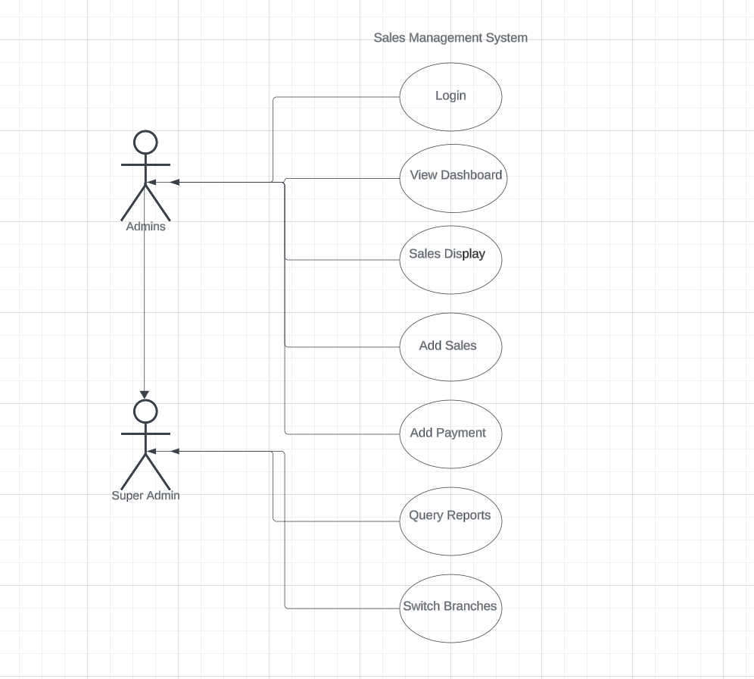

7.SOURCE CODE:

7.1.dashboard/streamlit_app.py (The Presentation Layer):

import sys
import os
sys.path.append(os.path.abspath(os.path.join(os.path.dirname(__file__), '..')))

import streamlit as st
from datetime import date

from app.queries import (
get_sales,
add_sale,
check_login,
get_kpis,
get_branch_sales,
get_payment_analysis,
get_branch_list,
update_sale,
delete_sale,
get_sale_by_id,
record_payment,
get_sales_trend,
get_product_performance,
get_status_analysis,
get_recent_activity,
execute_custom_query,
)
import plotly.express as px
import plotly.graph_objects as go
import io

def init_page():
st.set_page_config(
page_title="Sales Intelligence Hub",
page_icon="📊",
layout="wide",
initial_sidebar_state="expanded"
)

def inject_dashboard_css():
st.markdown(
"""
<style>
@import url('https://fonts.googleapis.com/css2?family=Inter:wght@300;400;500;600;700;800&display=swap');

/* Global App Background */
.stApp {
background-color: #f8fafc;
}

/* General block padding */
.block-container {
padding: 2.5rem 4rem !important;
max-width: 1400px !important;
}

/* Sidebar Styling */
[data-testid="stSidebar"] {
background-color: #ffffff;
border-right: 1px solid #e2e8f0;
box-shadow: 2px 0 10px rgba(0,0,0,0.02);
}

[data-testid="stSidebarNav"] span {
font-family: 'Inter', sans-serif !important;
font-weight: 500;
}

/* Metric Cards */
[data-testid="stMetric"] {
background: #ffffff;
border: 1px solid #e2e8f0;
border-radius: 12px;
padding: 1.5rem;
box-shadow: 0 4px 6px -1px rgba(0, 0, 0, 0.05), 0 2px 4px -1px rgba(0, 0, 0, 0.03);
transition: all 0.3s cubic-bezier(0.4, 0, 0.2, 1);
position: relative;
overflow: hidden;
}
[data-testid="stMetric"]:hover {
box-shadow: 0 10px 15px -3px rgba(0, 0, 0, 0.08), 0 4px 6px -2px rgba(0, 0, 0, 0.04);
transform: translateY(-4px);
border-color: #3b82f6;
}
[data-testid="stMetricValue"] {
color: #0f172a;
font-weight: 800;
font-size: 28px;
font-family: 'Inter', sans-serif;
letter-spacing: -0.02em;
}
[data-testid="stMetricLabel"] {
color: #64748b;
font-size: 13px;
font-weight: 600;
text-transform: uppercase;
letter-spacing: 0.05em;
margin-bottom: 8px;
font-family: 'Inter', sans-serif;
}

/* Accent strip to metrics */
[data-testid="stMetric"]::before {
content: "";
position: absolute;
top: 0; left: 0; right: 0;
height: 4px;
background: linear-gradient(90deg, #3b82f6, #8b5cf6);
}

/* Buttons */
.stButton > button {
border-radius: 8px !important;
border: 1px solid #cbd5e1 !important;
background-color: #ffffff !important;
color: #000000 !important;
transition: all 0.2s ease;
font-weight: 600;
font-family: 'Inter', sans-serif;
}
.stButton > button:hover {
border-color: #3b82f6 !important;
color: #3b82f6 !important;
box-shadow: 0 4px 6px -1px rgba(59, 130, 246, 0.1) !important;
}

/* Form Submit Buttons */
[data-testid="stFormSubmitButton"] button {
background: linear-gradient(135deg, #3b82f6 0%, #2563eb 100%) !important;
color: white !important;
border: none !important;
font-weight: 600 !important;
border-radius: 8px !important;
box-shadow: 0 4px 6px -1px rgba(37, 99, 235, 0.2) !important;
padding: 0.75rem 2rem !important;
transition: all 0.2s ease !important;
letter-spacing: 0.025em;
}
[data-testid="stFormSubmitButton"] button:hover {
box-shadow: 0 10px 15px -3px rgba(37, 99, 235, 0.3) !important;
transform: translateY(-2px);
}

/* Inputs */
.stTextInput input, .stSelectbox div[data-baseweb="select"], .stNumberInput input, .stDateInput input {
border-radius: 8px !important;
border: 1px solid #cbd5e1 !important;
background-color: #ffffff !important;
color: #000000 !important;
box-shadow: 0 1px 2px 0 rgba(0, 0, 0, 0.03) !important;
padding: 0.6rem 1rem;
font-family: 'Inter', sans-serif;
transition: all 0.2s ease;
font-size: 15px;
}

/* Force dropdown text and options to black */
.stSelectbox div[data-baseweb="select"] div, div[data-baseweb="popover"] ul li {
color: #000000 !important;
background-color: #ffffff !important;
}

.stTextInput input:focus, .stSelectbox div[data-baseweb="select"]:focus, .stNumberInput input:focus, .stDateInput input:focus {
border-color: #3b82f6 !important;
box-shadow: 0 0 0 3px rgba(59, 130, 246, 0.2) !important;
}

/* Tabs Styling */
[data-testid="stTabs"] button {
border-radius: 8px 8px 0 0;
padding-bottom: 1rem;
padding-top: 1rem;
font-weight: 600;
color: #64748b;
font-family: 'Inter', sans-serif;
font-size: 15px;
}
[data-testid="stTabs"] button[aria-selected="true"] {
border-bottom: 3px solid #3b82f6 !important;
color: #2563eb !important;
}

/* Data Editor background */
[data-testid="stDataFrame"] {
border-radius: 12px;
overflow: hidden;
border: 1px solid #e2e8f0;
box-shadow: 0 4px 6px -1px rgba(0, 0, 0, 0.05);
background: white;
}

/* Headings and generic text */
h1, h2, h3, h4, h5, h6, label, p, span, div {
font-family: 'Inter', sans-serif !important;
color: #000000 !important;
}
h3 {
font-weight: 700;
letter-spacing: -0.02em;
}

/* Chart backgrounds */
.js-plotly-plot {
background: white;
border-radius: 12px;
padding: 1rem;
border: 1px solid #e2e8f0;
box-shadow: 0 4px 6px -1px rgba(0, 0, 0, 0.03);
}
</style>
""",
unsafe_allow_html=True
)

def init_session_state():
if "logged_in" not in st.session_state:
st.session_state.logged_in = False
if "user" not in st.session_state:
st.session_state.user = None
if "status_message" not in st.session_state:
st.session_state.status_message = ""

def format_currency(value):
return f"₹ {value:,.2f}" if value is not None else "₹ 0.00"

def show_login():
css_code = """
<style>
@import url('https://fonts.googleapis.com/css2?family=Inter:wght@400;500;600;700&display=swap');

/* Hide sidebar and top header completely for login page */
[data-testid="stSidebar"] { display: none; }
[data-testid="stHeader"] { display: none; }

/* App Background */
.stApp {
background: linear-gradient(135deg, #f0f4f8 0%, #e2e8f0 100%) !important;
font-family: 'Inter', sans-serif !important;
}

/* Position container to center */
.block-container {
padding: 0 !important;
max-width: 1000px !important;
margin-top: 8vh !important;
background: rgba(255, 255, 255, 0.95) !important;
backdrop-filter: blur(12px) !important;
box-shadow: 0 25px 50px -12px rgba(0, 0, 0, 0.15), 0 0 0 1px rgba(255, 255, 255, 0.5) inset !important;
border-radius: 20px !important;
overflow: hidden !important;
}

/* Column padding */
[data-testid="stColumn"]:nth-of-type(1), [data-testid="column"]:nth-of-type(1) {
padding: 4.5rem 5rem !important;
display: flex;
flex-direction: column;
justify-content: center;
}
[data-testid="stColumn"]:nth-of-type(2), [data-testid="column"]:nth-of-type(2) {
padding: 0 !important;
}

/* Remove default stForm styling */
[data-testid="stForm"] {
background: transparent !important;
border: none !important;
box-shadow: none !important;
padding: 0 !important;
margin: auto;
}

/* Typography */
h2.login-text {
color: #0f172a !important;
font-weight: 800;
margin-bottom: 2.5rem !important;
font-family: 'Inter', sans-serif;
font-size: 34px !important;
letter-spacing: -0.025em;
}

/* Input boxes */
[data-testid="stTextInput"] div div input {
background-color: #f8fafc !important;
border: 1px solid #cbd5e1 !important;
border-radius: 10px !important;
color: #0f172a !important;
padding: 14px 16px !important;
box-shadow: inset 0 2px 4px 0 rgba(0, 0, 0, 0.02) !important;
font-size: 15px;
font-family: 'Inter', sans-serif;
transition: all 0.2s ease;
}

[data-testid="stTextInput"] div div {
background-color: transparent !important;
border: none !important;
border-radius: 0 !important;
box-shadow: none !important;
}

[data-testid="stTextInput"] div div:focus-within input {
border-color: #3b82f6 !important;
box-shadow: 0 0 0 3px rgba(59, 130, 246, 0.2) !important;
background-color: #ffffff !important;
}

/* Submit Button */
[data-testid="stFormSubmitButton"] button {
background: linear-gradient(135deg, #3b82f6 0%, #2563eb 100%) !important;
border-radius: 10px !important;
width: 100% !important;
padding: 0.9rem 1rem !important;
border: none !important;
margin-top: 2rem !important;
transition: all 0.3s ease;
box-shadow: 0 4px 6px -1px rgba(37, 99, 235, 0.3), 0 2px 4px -1px rgba(37, 99, 235, 0.15) !important;
}

[data-testid="stFormSubmitButton"] button p {
color: white !important;
font-weight: 700 !important;
font-size: 16px !important;
letter-spacing: 0.03em;
font-family: 'Inter', sans-serif;
}

[data-testid="stFormSubmitButton"] button:hover {
box-shadow: 0 10px 15px -3px rgba(37, 99, 235, 0.4), 0 4px 6px -2px rgba(37, 99, 235, 0.2) !important;
transform: translateY(-2px);
}

/* Placeholder text */
::placeholder {
color: #94a3b8 !important;
opacity: 1 !important;
}

/* Reset Markdown p color */
[data-testid="stMarkdownContainer"] p {
color: #64748b;
font-size: 14px;
font-family: 'Inter', sans-serif;
}
</style>
"""
st.markdown(css_code, unsafe_allow_html=True)

col1, col2 = st.columns([1, 1.2])

with col1:
with st.form("login_form"):
st.markdown("<h2 class='login-text'>Login</h2>", unsafe_allow_html=True)

username = st.text_input("Username", placeholder="Email or UserName", key="login_username", label_visibility="collapsed")
password = st.text_input("Password", type="password", placeholder="Password", key="login_password", label_visibility="collapsed")

forgot_pwd_html = "<div style='text-align: right; margin-top: -12px; margin-bottom: 5px;'><a href='#' style='color: #3b82f6; font-size: 13px; text-decoration: none; font-weight: 500;'>Forgot Password?</a></div>"
st.markdown(forgot_pwd_html, unsafe_allow_html=True)

st.checkbox("Remember me", key="login_remember")

submitted = st.form_submit_button("LOGIN", use_container_width=True)

signup_html = "<div style='text-align: center; margin-top: 25px; font-size: 14px; color: #64748b;'>New Member? <a href='#' style='color: #3b82f6; text-decoration: none; font-weight: 600;'>Sign up Now</a></div>"
st.markdown(signup_html, unsafe_allow_html=True)

if submitted:
user = check_login(username.strip(), password.strip())
if user:
st.session_state.logged_in = True
st.session_state.user = user
st.session_state.status_message = "Welcome back!"
st.rerun()
else:
st.error("Invalid email or password.")

with col2:
right_panel_html = '<div style="position: relative; height: 100%; min-height: 600px; display: flex; align-items: center; justify-content: center; background: linear-gradient(135deg, #1e3a8a 0%, #3b82f6 100%); overflow: hidden;"><div style="position: absolute; right: -15%; top: -15%; width: 60vw; height: 60vw; background: radial-gradient(circle, rgba(255,255,255,0.08) 0%, transparent 60%); border-radius: 50%;"></div><div style="position: absolute; left: -10%; bottom: -10%; width: 40vw; height: 40vw; background: radial-gradient(circle, rgba(255,255,255,0.05) 0%, transparent 60%); border-radius: 50%;"></div><div style="position: relative; z-index: 10; background: rgba(255, 255, 255, 0.1); backdrop-filter: blur(16px); border: 1px solid rgba(255,255,255,0.2); padding: 50px 40px; box-shadow: 0 25px 50px -12px rgba(0,0,0,0.25); border-radius: 20px; width: 80%; text-align: center;"><svg width="80" height="80" viewBox="0 0 24 24" fill="none" stroke="white" stroke-width="1.5" stroke-linecap="round" stroke-linejoin="round" style="margin-bottom: 25px; filter: drop-shadow(0px 4px 6px rgba(0,0,0,0.1));"><polyline points="23 6 13.5 15.5 8.5 10.5 1 18"></polyline><polyline points="17 6 23 6 23 12"></polyline></svg><h3 style="color: white; margin: 0 0 15px 0; font-family: \'Inter\', sans-serif; font-size: 28px; font-weight: 800; letter-spacing: -0.03em; line-height: 1.2;">Sales Intelligence Hub</h3><p style="color: rgba(255,255,255,0.9); font-size: 15px; line-height: 1.6; margin: 0; font-weight: 400;">Transforming data into actionable insights with smarter business tracking and centralized management.</p></div><div style="position: absolute; bottom: 40px; z-index: 10; display: flex; gap: 10px;"><div style="width: 32px; height: 6px; background: white; border-radius: 3px; box-shadow: 0 2px 4px rgba(0,0,0,0.1);"></div><div style="width: 32px; height: 6px; background: rgba(255,255,255,0.3); border-radius: 3px;"></div></div></div>'
st.markdown(right_panel_html, unsafe_allow_html=True)

def show_logout():
st.sidebar.markdown("<br>", unsafe_allow_html=True)
if st.sidebar.button("🔒 Secure Logout", use_container_width=True, type="primary"):
st.session_state.clear()
st.rerun()

def display_header(user):
st.markdown(f"""
<div style='background: white; padding: 30px 40px; border-radius: 16px; box-shadow: 0 4px 6px -1px rgba(0, 0, 0, 0.05), 0 2px 4px -1px rgba(0, 0, 0, 0.03); margin-bottom: 35px; border-left: 6px solid #3b82f6; display: flex; justify-content: space-between; align-items: center;'>
<div>
<h1 style='margin:0 0 8px 0; font-size: 32px; color: #0f172a; font-weight: 800; letter-spacing: -0.03em; font-family: "Inter", sans-serif;'>Sales Intelligence Hub</h1>
<p style='margin: 0; color: #64748b; font-size: 16px; font-weight: 400; font-family: "Inter", sans-serif;'>Smarter sales monitoring for branches and payments system</p>
</div>
<div style='background: #f0fdf4; color: #166534; padding: 8px 16px; border-radius: 20px; font-weight: 600; font-size: 14px; border: 1px solid #bbf7d0; font-family: "Inter", sans-serif;'>
<span style='display:inline-block; width:8px; height:8px; background:#22c55e; border-radius:50%; margin-right:6px;'></span> System Active
</div>
</div>
""", unsafe_allow_html=True)

col1, col2, col3 = st.columns([1, 1, 1.5])

with col1:
st.metric("User Profile", f"{user['username']}")
with col2:
display_role = st.session_state.user['role']
st.metric("System Role", f"{display_role.replace('_', ' ').title()}")
with col3:
if user["role"] == "super_admin":
scope_label = "All Branches"
else:
if "branch_name" in user and user["branch_name"]:
scope_label = user["branch_name"]
else:
branches = get_branch_list()
found_name = next((b["branch_name"] for b in branches if b["branch_id"] == user["branch_id"]), None)
scope_label = found_name if found_name else f"Branch {user.get('branch_id')}"
st.session_state.user["branch_name"] = scope_label

st.metric("Access Scope", scope_label)

if st.session_state.status_message:
st.success(st.session_state.status_message)
st.session_state.status_message = ""

def apply_chart_style(fig):
fig.update_layout(
plot_bgcolor="rgba(0,0,0,0)",
paper_bgcolor="rgba(0,0,0,0)",
font_family="Inter",
font_color="#0f172a",
margin=dict(l=80, r=20, t=50, b=100),
legend=dict(
orientation="h",
yanchor="bottom",
y=-0.4,
xanchor="center",
x=0.5,
font=dict(size=11)
),
hovermode="x unified",
hoverlabel=dict(
bgcolor="white",
font_size=12,
font_family="Inter",
bordercolor="#e2e8f0"
)
)
fig.update_yaxes(
title_standoff=25,
showgrid=True,
gridcolor="#f1f5f9",
zeroline=False
)
fig.update_xaxes(
showgrid=False,
zeroline=False,
tickangle=-45,
categoryorder="category ascending"
)
return fig

def render_overview(user, start_date=None, end_date=None, product_filter=None):
st.markdown("""
<div style='display: flex; align-items: center; gap: 10px; margin-bottom: 20px;'>
<div style='width: 4px; height: 24px; background: #3b82f6; border-radius: 2px;'></div>
<h3 style='margin: 0;'>Executive Summary</h3>
</div>
""", unsafe_allow_html=True)

total_sales, total_received, total_pending, sale_count = get_kpis(user, start_date, end_date, product_filter)

# Advanced KPIs
collection_rate = (total_received / total_sales * 100) if total_sales > 0 else 0
aov = (total_sales / sale_count) if sale_count > 0 else 0

metric_cols = st.columns(5)
metric_cols[0].metric("Total Sales", format_currency(total_sales))
metric_cols[1].metric("Total Received", format_currency(total_received))
metric_cols[2].metric("Total Pending", format_currency(total_pending), delta=f"-{format_currency(total_pending)}", delta_color="inverse")
metric_cols[3].metric("Collection Rate", f"{collection_rate:.1f}%")
metric_cols[4].metric("Avg Order Value", format_currency(aov))

st.markdown("<br>", unsafe_allow_html=True)

# Main Dashboard Body
main_col, activity_col = st.columns([2.5, 1])

with main_col:
# 1. Sales Trend Area Chart
st.markdown("#### 📈 Sales Revenue Trend")
df_trend = get_sales_trend(user, start_date, end_date, product_filter)
if not df_trend.empty:
fig_trend = px.area(
df_trend,
x="sale_date",
y="daily_sales",
color_discrete_sequence=["#3b82f6"],
labels={"sale_date": "Date", "daily_sales": "Revenue (₹)"}
)
fig_trend.update_traces(
line_width=3,
fillcolor="rgba(59, 130, 246, 0.1)",
hovertemplate="<b>Date:</b> %{x}<br><b>Revenue:</b> ₹%{y:,.2f}<extra></extra>"
)
apply_chart_style(fig_trend)
fig_trend.update_xaxes(type='category')
st.plotly_chart(fig_trend, use_container_width=True, theme=None, config={'displayModeBar': False})
else:
st.info("No trend data available for this range.")

with activity_col:
st.markdown("#### ⚡ Recent Activity")
df_activity = get_recent_activity(user)
if not df_activity.empty:
for _, row in df_activity.iterrows():
with st.container():
st.markdown(f"""
<div style='background: white; padding: 12px; border-radius: 8px; border: 1px solid #f1f5f9; margin-bottom: 10px; border-left: 3px solid #3b82f6;'>
<div style='font-size: 11px; color: #64748b; font-weight: 600; text-transform: uppercase;'>{row['date']}</div>
<div style='font-size: 14px; font-weight: 700; color: #0f172a; margin: 2px 0;'>{row['customer']}</div>
<div style='display: flex; justify-content: space-between; align-items: center;'>
<span style='font-size: 12px; color: #3b82f6; font-weight: 600;'>{row['product']}</span>
<span style='font-size: 13px; font-weight: 700; color: #10b981;'>₹{row['gross_sales']:,.0f}</span>
</div>
</div>
""", unsafe_allow_html=True)
else:
st.info("No recent activity.")

st.markdown("<br>", unsafe_allow_html=True)

# 2. Key Performance Breakdowns
chart_cols = st.columns(3)

with chart_cols[0]:
if user["role"] == "super_admin":
st.markdown("#### 🏢 Sales by Branch")
df_branch = get_branch_sales(user, start_date, end_date, product_filter)
if not df_branch.empty:
fig_branch = px.bar(
df_branch,
x="branch_name",
y="total_sales",
color="total_sales",
color_continuous_scale=["#93c5fd", "#3b82f6"],
labels={"branch_name": "Branch", "total_sales": "Sales"}
)
apply_chart_style(fig_branch)
fig_branch.update_coloraxes(showscale=False)
fig_branch.update_traces(
marker_line_width=0,
marker_pattern_shape="",
hovertemplate="<b>%{x}</b><br>Sales: ₹%{y:,.2f}<extra></extra>"
)
st.plotly_chart(fig_branch, use_container_width=True, theme=None, config={'displayModeBar': False})
else:
st.info("No branch sales data.")
else:
st.markdown("#### 📈 Sales Status Analysis")
df_status = get_status_analysis(user, start_date, end_date, product_filter)
if not df_status.empty:
fig_status = px.pie(
df_status,
names="status",
values="total_value",
hole=0.7,
color="status",
color_discrete_map={"Open": "#f59e0b", "Close": "#10b981"},
labels={"status": "Status", "total_value": "Revenue"}
)
apply_chart_style(fig_status)
fig_status.update_traces(
textposition='inside',
textinfo='percent',
marker=dict(line=dict(color='#FFFFFF', width=2)),
hovertemplate="<b>%{label}</b><br>Value: ₹%{value:,.2f}<br>Count: %{customdata[0]}<extra></extra>",
customdata=df_status[['count']]
)
st.plotly_chart(fig_status, use_container_width=True, theme=None, config={'displayModeBar': False})
else:
st.info("No status data.")

with chart_cols[1]:
st.markdown("#### 📦 Product Mix")
df_prod = get_product_performance(user, start_date, end_date, product_filter)
if not df_prod.empty:
fig_prod = px.pie(
df_prod,
names="product_name",
values="total_sales",
hole=0.7,
color_discrete_sequence=["#3b82f6", "#8b5cf6", "#6366f1", "#06b6d4"]
)
apply_chart_style(fig_prod)
fig_prod.update_traces(
textposition='inside',
textinfo='percent',
marker=dict(line=dict(color='#FFFFFF', width=2)),
hovertemplate="<b>%{label}</b><br>Revenue: ₹%{value:,.2f}<br>Percentage: %{percent}<extra></extra>"
)
st.plotly_chart(fig_prod, use_container_width=True, theme=None, config={'displayModeBar': False})
else:
st.info("No product data for this range.")

with chart_cols[2]:
st.markdown("#### 💳 Payment Channels")
df_payment = get_payment_analysis(user, start_date, end_date, product_filter)
if not df_payment.empty:
fig_payment = px.pie(
df_payment,
names="payment_method",
values="total",
hole=0.7,
color_discrete_sequence=["#10b981", "#f59e0b", "#64748b", "#f43f5e"]
)
apply_chart_style(fig_payment)
fig_payment.update_traces(
textposition='inside',
textinfo='percent',
marker=dict(line=dict(color='#FFFFFF', width=2)),
hovertemplate="<b>%{label}</b><br>Volume: ₹%{value:,.2f}<br>Percentage: %{percent}<extra></extra>"
)
st.plotly_chart(fig_payment, use_container_width=True, theme=None, config={'displayModeBar': False})
else:
st.info("No payment data for this range.")

def render_sales_table(user, start_date=None, end_date=None, product_filter=None):
st.subheader("Sales Records Management")
st.info("Double-click any cell to edit. Select a row and press delete to remove it. Changes save automatically!")

df = get_sales(user, start_date, end_date, product_filter)
if df.empty:
st.info("No sales records found.")
return

# Set index to sale_id so we can reference it securely when editing
df = df.set_index("sale_id")

edited_df = st.data_editor(
df,
use_container_width=True,
num_rows="dynamic",
key="sales_data_editor"
)

# Export Buttons
col_csv, col_excel, col_json, col_pdf = st.columns(4)

# 1. CSV
csv = df.to_csv(index=True).encode('utf-8')
col_csv.download_button(
label="📥 CSV",
data=csv,
file_name='sales_records.csv',
mime='text/csv',
type="secondary",
use_container_width=True
)

# 2. Excel
import io
excel_buffer = io.BytesIO()
with __import__('pandas').ExcelWriter(excel_buffer, engine='openpyxl') as writer:
df.to_excel(writer, index=True)
col_excel.download_button(
label="📥 Excel",
data=excel_buffer.getvalue(),
file_name='sales_records.xlsx',
mime='application/vnd.openxmlformats-officedocument.spreadsheetml.sheet',
type="secondary",
use_container_width=True
)

# 3. JSON
json_data = df.reset_index().to_json(orient="records").encode('utf-8')
col_json.download_button(
label="📥 JSON",
data=json_data,
file_name='sales_records.json',
mime='application/json',
type="secondary",
use_container_width=True
)

# 4. PDF
from fpdf import FPDF
def generate_pdf(dataframe):
pdf = FPDF(orientation="L", unit="mm", format="A4")
pdf.add_page()

# Add Title
pdf.set_font("helvetica", style="B", size=14)
pdf.cell(0, 10, "Sales Records Export", ln=True, align="C")
pdf.ln(5)

pdf.set_font("helvetica", style="B", size=8)
df_pdf = dataframe.reset_index()
columns = df_pdf.columns.tolist()
col_width = pdf.epw / len(columns)

for col in columns:
pdf.cell(col_width, 8, str(col)[:20].replace("_", " ").title(), border=1, align="C")
pdf.ln()

pdf.set_font("helvetica", size=7)
for i in range(len(df_pdf)):
row = df_pdf.iloc[i]
for col in columns:
# Need to encode correctly or ignore errors if non-latin names
val = str(row[col]).encode('latin-1', 'ignore').decode('latin-1')
pdf.cell(col_width, 6, val[:20], border=1, align="C")
pdf.ln()

return bytes(pdf.output())

col_pdf.download_button(
label="📥 PDF",
data=generate_pdf(df),
file_name='sales_records.pdf',
mime='application/pdf',
type="secondary",
use_container_width=True
)

# Detect modifications
changes = st.session_state.get("sales_data_editor")
if changes:
has_changed = False

# Handle edits
for row_idx, updates in changes.get("edited_rows", {}).items():
sale_id = int(df.index[row_idx])
update_sale(sale_id, updates)
has_changed = True

# Handle deletions
for row_idx in changes.get("deleted_rows", []):
sale_id = int(df.index[row_idx])
delete_sale(sale_id)
has_changed = True

if has_changed:
st.success("Database updated successfully!")
st.rerun()

def render_add_payment(user):
st.subheader("Add Additional Payment")
st.info("Search for an existing sale by ID to record a new payment.")

search_id = st.number_input("Enter Sale ID to Search", min_value=1, step=1, key="payment_search_id")

if search_id:
df = get_sale_by_id(search_id, user)
if df.empty:
st.warning(f"No active sale found with ID {search_id} in your accessible branch.")
else:
sale = df.iloc[0]
st.write("---")
c1, c2 = st.columns(2)
with c1:
st.write(f"**Customer:** {sale['name']}")
st.write(f"**Product:** {sale['product_name']}")
st.write(f"**Status:** {sale['status']}")
with c2:
st.write(f"**Gross Sales:** {format_currency(sale['gross_sales'])}")
st.write(f"**Total Received:** {format_currency(sale['received_amount'])}")
st.write(f"**Pending Amount:** :red[{format_currency(sale['pending_amount'])}]")

if sale['status'] == 'Close':
st.error("🔒 This sale is already CLOSED. No further payments can be recorded.")
else:
with st.form("payment_form"):
pay_date = st.date_input("Payment Date", value=date.today())
pay_amount = st.number_input("Payment Amount", min_value=0.0, max_value=float(sale['pending_amount']), format="%.2f")
pay_method = st.selectbox("Payment Method", ["Cash", "UPI", "Bank Transfer", "Card"])

if st.form_submit_button("Record Payment"):
if pay_amount <= 0:
st.error("Please enter a valid payment amount.")
else:
record_payment(search_id, pay_amount, pay_method, pay_date)
st.success(f"Successfully recorded payment of {format_currency(pay_amount)} for Sale ID {search_id}")
st.rerun()

def render_add_sale(user):
st.subheader("Add New Sale")
st.info("Create a new sale record. You can record the initial down payment here.")

branch_id = user["branch_id"]
if user["role"] == "super_admin":
branches = get_branch_list()
options = [f"{branch['branch_id']} - {branch['branch_name']}" for branch in branches]
selected = st.selectbox("Select Branch", options)
branch_id = int(selected.split(" - ")[0]) if selected else branch_id

with st.form("sale_form"):
sale_date = st.date_input("Sale Date", value=date.today(), help="Select the date of the sale")
customer_name = st.text_input("Customer Name", placeholder="Enter the customer's full name", help="Enter the name of the purchasing customer")
mobile_number = st.text_input("Mobile Number", placeholder="Enter 10-digit mobile number", help="Enter the customer's contact number")
product_name = st.selectbox("Product", ["DS", "DA", "BA", "FSD"], help="Select the product purchased")

col_amt, col_pay = st.columns(2)
with col_amt:
gross_amt = st.number_input("Total Sale Amount", min_value=0.0, format="%.2f", help="The full price of the product")
received_amt = st.number_input("Initial Amount Received", min_value=0.0, format="%.2f", help="Check if the customer paid anything upfront")
with col_pay:
pay_method = st.selectbox("Initial Payment Method", ["N/A", "Cash", "UPI", "Bank Transfer", "Card"])

submitted = st.form_submit_button("Create Sale Record")

if submitted:
if not customer_name or not mobile_number or gross_amt <= 0:
st.error("Please provide Customer Name and a valid Sale Amount.")
elif received_amt > gross_amt:
st.error("Received amount cannot exceed the total sale amount.")
else:
new_id = add_sale(branch_id, sale_date, customer_name, mobile_number, product_name, gross_amt, received_amt, pay_method)
st.success(f"🎊 Sale record created successfully! Assigned Sale ID: {new_id}")
st.rerun()

def parse_sql_queries(file_path):
queries = {}
current_name = None
current_query = []

if not os.path.exists(file_path):
return queries

with open(file_path, "r", encoding="utf-8") as f:
for line in f:
line_str = line.strip()
if not line_str:
continue
if line_str.startswith("#"):
if current_name and current_query:
queries[current_name] = " \n".join(current_query)
current_name = line_str[1:].strip()
current_query = []
else:
current_query.append(line_str)
if current_name and current_query:
queries[current_name] = " \n".join(current_query)
return queries

def render_query_reports():
st.subheader("Predefined SQL Queries")
st.info("Select a predefined analytical report from the database to generate custom exports.")

reports_file = os.path.join(os.path.dirname(__file__), '..', 'reports', 'sql_queries.sql')
queries = parse_sql_queries(reports_file)

if not queries:
st.warning("Could not find any SQL queries in reports/sql_queries.sql")
return

selected_report = st.selectbox("Select Report to Generate", list(queries.keys()))

if selected_report:
sql = queries[selected_report]
st.markdown("**Query Logic:**")
st.code(sql, language="sql")

if st.button("Execute Query", type="primary"):
with st.spinner("Processing report..."):
df = execute_custom_query(sql)
if 'Error' in df.columns and len(df) == 1:
st.error(f"Execution Error: {df.iloc[0]['Error']}")
else:
st.success(f"Report Generated! Found {len(df)} rows.")
st.dataframe(df, use_container_width=True)

csv = df.to_csv(index=False).encode('utf-8')
st.download_button(
label="📥 Download Data as CSV",
data=csv,
file_name=f"{selected_report.replace(' ', '_').lower()}.csv",
mime="text/csv",
)

def main():
init_page()
init_session_state()

if not st.session_state.logged_in:
show_login()
st.stop()

inject_dashboard_css()

user = st.session_state.user
user_context = dict(user)

# Dynamically determine the active scope for display
if user["role"] == "super_admin":
col_bf_l, col_bf_r = st.sidebar.columns([5, 1])
with col_bf_l:
st.markdown("<h4 style='color: #64748b; font-size: 12px; font-weight: 700; text-transform: uppercase; letter-spacing: 1px; margin-bottom: 0px; padding-left: 5px; margin-top: 5px;'>Branch Filter</h4>", unsafe_allow_html=True)

branches = get_branch_list()
options = ["All Branches"] + [f"{branch['branch_id']} - {branch['branch_name']}" for branch in branches]

with col_bf_r:
if st.button("↻", key="reset_branch", use_container_width=True, help="Reset Branch Filter"):
st.session_state["filter_branch"] = options[0]
st.rerun()

selected_branch = st.sidebar.selectbox("Select Branch", options, label_visibility="collapsed", key="filter_branch")

if selected_branch != "All Branches":
branch_id_selected = int(selected_branch.split(" - ")[0])
branch_name_selected = selected_branch.split(" - ")[1]
user_context["role"] = "admin"
user_context["branch_id"] = branch_id_selected
user_context["branch_name"] = branch_name_selected
active_scope = branch_name_selected
else:
active_scope = "All Branches"
else:
active_scope = user.get("branch_name")
if not active_scope:
branches = get_branch_list()
found_name = next((b["branch_name"] for b in branches if b["branch_id"] == user["branch_id"]), None)
active_scope = found_name if found_name else f"Branch {user.get('branch_id')}"
user_context["branch_name"] = active_scope

sidebar_html = f"""
<div style="background: linear-gradient(135deg, #1e3a8a 0%, #3b82f6 100%); padding: 25px 20px; border-radius: 12px; color: white; margin-bottom: 25px; box-shadow: 0 4px 6px -1px rgba(59, 130, 246, 0.3), 0 2px 4px -1px rgba(59, 130, 246, 0.15);">
<div style="display: flex; align-items: center; gap: 15px; margin-bottom: 20px;">
<div style="width: 45px; height: 45px; background: rgba(255,255,255,0.2); border-radius: 50%; display: flex; align-items: center; justify-content: center; font-size: 20px; font-weight: 800; border: 2px solid rgba(255,255,255,0.5); text-transform: uppercase;">
{user["username"][0]}
</div>
<div>
<p style="margin: 0; font-size: 11px; color: rgba(255,255,255,0.7); text-transform: uppercase; letter-spacing: 0.05em; font-weight: 600;">Welcome back</p>
<h3 style="margin: 0; font-size: 16px; font-weight: 700; letter-spacing: -0.02em; color: white;">{user["username"]}</h3>
</div>
</div>
<div style="background: rgba(0,0,0,0.15); padding: 12px 15px; border-radius: 8px; font-size: 13px; font-weight: 500; border: 1px solid rgba(255,255,255,0.1);">
<div style="margin-bottom: 8px;">
<span style="opacity: 0.7; font-size: 11px; text-transform: uppercase; display: block; margin-bottom: 2px;">Role</span>
<span style="font-weight: 600;">{user["role"].replace('_', ' ').title()}</span>
</div>
<div>
<span style="opacity: 0.7; font-size: 11px; text-transform: uppercase; display: block; margin-bottom: 2px;">Access Scope</span>
<span style="font-weight: 600;">{active_scope}</span>
</div>
</div>
</div>
"""
st.sidebar.markdown(sidebar_html, unsafe_allow_html=True)

st.sidebar.markdown("<h4 style='color: #64748b; font-size: 12px; font-weight: 700; text-transform: uppercase; letter-spacing: 1px; margin-bottom: 10px; padding-left: 5px;'>Dashboard Filters</h4>", unsafe_allow_html=True)
with st.sidebar:
col_time, col_time_btn = st.columns([5, 1])
with col_time:
st.markdown("<span style='font-size: 13px; font-weight: 600; color: #334155; margin-left: 5px;'>Time Period</span>", unsafe_allow_html=True)
with col_time_btn:
if st.button("↻", key="reset_time", use_container_width=True, help="Reset Time Filter"):
if "filter_start" in st.session_state: del st.session_state["filter_start"]
if "filter_end" in st.session_state: del st.session_state["filter_end"]
st.rerun()

col_start, col_end = st.columns(2)
with col_start:
start_date = st.date_input("Start Date", value=None, key="filter_start", label_visibility="collapsed")
with col_end:
end_date = st.date_input("End Date", value=None, key="filter_end", label_visibility="collapsed")

st.markdown("<br>", unsafe_allow_html=True)

col_prod, col_prod_btn = st.columns([5, 1])
with col_prod:
st.markdown("<span style='font-size: 13px; font-weight: 600; color: #334155; margin-left: 5px;'>Product Type</span>", unsafe_allow_html=True)
with col_prod_btn:
if st.button("↻", key="reset_prod", use_container_width=True, help="Reset Product Filter"):
st.session_state["filter_product"] = "All Products"
st.rerun()

product_filter_str = st.selectbox("Product", ["All Products", "DS", "DA", "BA", "FSD"], key="filter_product", label_visibility="collapsed")
product_filter = None if product_filter_str == "All Products" else product_filter_str

st.sidebar.markdown("<h4 style='color: #64748b; font-size: 12px; font-weight: 700; text-transform: uppercase; letter-spacing: 1px; margin-top: 20px; margin-bottom: 10px; padding-left: 5px;'>Actions & Settings</h4>", unsafe_allow_html=True)
show_logout()

display_header(user_context)

overview_tab, sales_tab, add_tab, pay_tab, queries_tab = st.tabs(["Overview", "Sales", "Add Sale", "Add Payment", "Query Reports"], key="main_navigation_tabs")

with overview_tab:
render_overview(user_context, start_date, end_date, product_filter)

with sales_tab:
render_sales_table(user_context, start_date, end_date, product_filter)

with add_tab:
render_add_sale(user_context)

with pay_tab:
render_add_payment(user_context)

with queries_tab:
render_query_reports()

if __name__ == "__main__":
main()

7.2.app/queries.py:(The Logical Layer):

import pandas as pd
from app.db_connection import get_connection

def add_sale(branch_id, sale_date, name, mobile, product, gross_amount, received_amount, payment_method):
conn = get_connection()
cursor = conn.cursor()

status = 'Close' if received_amount >= gross_amount else 'Open'

query = """
INSERT INTO customer_sales
(branch_id, date, name, mobile_number, product_name, gross_sales, received_amount, status)
VALUES (%s, %s, %s, %s, %s, %s, %s, %s)
"""

cursor.execute(query, (branch_id, sale_date, name, mobile, product, gross_amount, received_amount, status))
sale_id = cursor.lastrowid

if received_amount > 0:
payment_query = """
INSERT INTO payment_splits (sale_id, payment_date, amount_paid, payment_method)
VALUES (%s, %s, %s, %s)
"""
cursor.execute(payment_query, (sale_id, sale_date, received_amount, payment_method))

conn.commit()
cursor.close()
conn.close()
return sale_id

def get_sale_by_id(sale_id, user):
conn = get_connection()
query = """
SELECT sale_id, branch_id, date, name, mobile_number, product_name, gross_sales,
received_amount, pending_amount, status
FROM customer_sales
WHERE sale_id = %s
"""
params = [sale_id]

if user["role"] != "super_admin":
query += " AND branch_id = %s"
params.append(user["branch_id"])

df = pd.read_sql(query, conn, params=params)
conn.close()
return df

def record_payment(sale_id, amount, method, payment_date):
conn = get_connection()
cursor = conn.cursor()

# 1. Insert into payment_splits
cursor.execute("""
INSERT INTO payment_splits (sale_id, payment_date, amount_paid, payment_method)
VALUES (%s, %s, %s, %s)
""", (sale_id, payment_date, amount, method))

# 2. Update customer_sales received_amount
cursor.execute("""
UPDATE customer_sales
SET received_amount = received_amount + %s
WHERE sale_id = %s
""", (amount, sale_id))

# 3. Check for closure
cursor.execute("SELECT gross_sales, received_amount FROM customer_sales WHERE sale_id = %s", (sale_id,))
row = cursor.fetchone()
if row and row[1] >= row[0]:
cursor.execute("UPDATE customer_sales SET status = 'Close' WHERE sale_id = %s", (sale_id,))

conn.commit()
cursor.close()
conn.close()

def get_sales(user, start_date=None, end_date=None, product_filter=None):
conn = get_connection()
where_clauses = []
params = []

if user["role"] != "super_admin":
where_clauses.append("branch_id = %s")
params.append(user["branch_id"])

if start_date:
where_clauses.append("date >= %s")
params.append(start_date)
if end_date:
where_clauses.append("date <= %s")
params.append(end_date)
if product_filter:
where_clauses.append("product_name = %s")
params.append(product_filter)

where_stmt = " WHERE " + " AND ".join(where_clauses) if where_clauses else ""
query = f"""
SELECT sale_id, branch_id, date, name, mobile_number, product_name, gross_sales,
received_amount, pending_amount, status FROM customer_sales
{where_stmt}
"""
df = pd.read_sql(query, conn, params=params)
conn.close()
return df

def get_branch_list():
conn = get_connection()
df = pd.read_sql("SELECT branch_id, branch_name FROM branches ORDER BY branch_name", conn)
conn.close()
return df.to_dict("records")

def get_branch_sales(user, start_date=None, end_date=None, product_filter=None):
conn = get_connection()
where_clauses = []
params = []

if user["role"] != "super_admin":
where_clauses.append("c.branch_id = %s")
params.append(user["branch_id"])

if start_date:
where_clauses.append("c.date >= %s")
params.append(start_date)
if end_date:
where_clauses.append("c.date <= %s")
params.append(end_date)
if product_filter:
where_clauses.append("c.product_name = %s")
params.append(product_filter)

where_stmt = " WHERE " + " AND ".join(where_clauses) if where_clauses else ""

query = f"""
SELECT b.branch_name, SUM(c.gross_sales) AS total_sales
FROM customer_sales c
JOIN branches b ON c.branch_id = b.branch_id
{where_stmt}
GROUP BY b.branch_name
"""
df = pd.read_sql(query, conn, params=params)
conn.close()
return df

def check_login(username, password):
conn = get_connection()
cursor = conn.cursor()

query = """
SELECT u.user_id, u.username, u.role, u.branch_id, b.branch_name
FROM users u
LEFT JOIN branches b ON u.branch_id = b.branch_id
WHERE u.username=%s AND u.password=%s
"""
cursor.execute(query, (username, password))

row = cursor.fetchone()
cursor.close()
conn.close()

if row:
role_str = str(row[2]).lower().replace(" ", "_")
return {
"id": row[0],
"username": row[1],
"role": role_str,
"branch_id": row[3],
"branch_name": row[4]
}

return None

def get_kpis(user, start_date=None, end_date=None, product_filter=None):
conn = get_connection()
cursor = conn.cursor()
where_clauses = []
params = []

if user["role"] != "super_admin":
where_clauses.append("branch_id = %s")
params.append(user["branch_id"])

if start_date:
where_clauses.append("date >= %s")
params.append(start_date)
if end_date:
where_clauses.append("date <= %s")
params.append(end_date)
if product_filter:
where_clauses.append("product_name = %s")
params.append(product_filter)

where_stmt = " WHERE " + " AND ".join(where_clauses) if where_clauses else ""

query = f"""
SELECT
SUM(gross_sales),
SUM(received_amount),
SUM(pending_amount),
COUNT(*)
FROM customer_sales
{where_stmt}
"""
cursor.execute(query, params)
result = cursor.fetchone()
cursor.close()
conn.close()

if result:
return tuple(value or 0 for value in result)
return 0, 0, 0, 0

def get_payment_analysis(user, start_date=None, end_date=None, product_filter=None):
conn = get_connection()
where_clauses = []
params = []

if user["role"] != "super_admin":
where_clauses.append("c.branch_id = %s")
params.append(user["branch_id"])

if start_date:
where_clauses.append("p.payment_date >= %s")
params.append(start_date)
if end_date:
where_clauses.append("p.payment_date <= %s")
params.append(end_date)
if product_filter:
where_clauses.append("c.product_name = %s")
params.append(product_filter)

where_stmt = " WHERE " + " AND ".join(where_clauses) if where_clauses else ""

query = f"""
SELECT p.payment_method, SUM(p.amount_paid) AS total
FROM payment_splits p
JOIN customer_sales c ON p.sale_id = c.sale_id
{where_stmt}
GROUP BY p.payment_method
"""
df = pd.read_sql(query, conn, params=params)
conn.close()
return df

def update_sale(sale_id, update_data):
if not update_data:
return
conn = get_connection()
cursor = conn.cursor()
set_clause = ", ".join([f"{k} = %s" for k in update_data.keys()])
values = list(update_data.values())
values.append(sale_id)
query = f"UPDATE customer_sales SET {set_clause} WHERE sale_id = %s"
cursor.execute(query, tuple(values))
conn.commit()
cursor.close()
conn.close()

def delete_sale(sale_id):
conn = get_connection()
cursor = conn.cursor()
cursor.execute("DELETE FROM payment_splits WHERE sale_id = %s", (sale_id,))
cursor.execute("DELETE FROM customer_sales WHERE sale_id = %s", (sale_id,))
conn.commit()
cursor.close()
conn.close()

def get_sales_trend(user, start_date=None, end_date=None, product_filter=None):
conn = get_connection()
where_clauses = []
params = []

if user["role"] != "super_admin":
where_clauses.append("branch_id = %s")
params.append(user["branch_id"])

if start_date:
where_clauses.append("date >= %s")
params.append(start_date)
if end_date:
where_clauses.append("date <= %s")
params.append(end_date)
if product_filter:
where_clauses.append("product_name = %s")
params.append(product_filter)

where_stmt = " WHERE " + " AND ".join(where_clauses) if where_clauses else ""

query = f"""
SELECT date as sale_date, SUM(gross_sales) as daily_sales
FROM customer_sales
{where_stmt}
GROUP BY date
ORDER BY date
"""
df = pd.read_sql(query, conn, params=params)

if not df.empty:
df["sale_date"] = pd.to_datetime(df["sale_date"]).dt.strftime('%Y-%m-%d')

conn.close()
return df

def get_product_performance(user, start_date=None, end_date=None, product_filter=None):
conn = get_connection()
where_clauses = []
params = []

if user["role"] != "super_admin":
where_clauses.append("branch_id = %s")
params.append(user["branch_id"])

if start_date:
where_clauses.append("date >= %s")
params.append(start_date)
if end_date:
where_clauses.append("date <= %s")
params.append(end_date)
if product_filter:
where_clauses.append("product_name = %s")
params.append(product_filter)

where_stmt = " WHERE " + " AND ".join(where_clauses) if where_clauses else ""

query = f"""
SELECT product_name, SUM(gross_sales) as total_sales, COUNT(*) as count
FROM customer_sales
{where_stmt}
GROUP BY product_name
ORDER BY total_sales DESC
"""
df = pd.read_sql(query, conn, params=params)
conn.close()
return df

def get_status_analysis(user, start_date=None, end_date=None, product_filter=None):
conn = get_connection()
where_clauses = []
params = []

if user["role"] != "super_admin":
where_clauses.append("branch_id = %s")
params.append(user["branch_id"])

if start_date:
where_clauses.append("date >= %s")
params.append(start_date)
if end_date:
where_clauses.append("date <= %s")
params.append(end_date)
if product_filter:
where_clauses.append("product_name = %s")
params.append(product_filter)

where_stmt = " WHERE " + " AND ".join(where_clauses) if where_clauses else ""

query = f"""
SELECT status, SUM(gross_sales) as total_value, COUNT(*) as count
FROM customer_sales
{where_stmt}
GROUP BY status
"""
df = pd.read_sql(query, conn, params=params)
conn.close()
return df

def get_recent_activity(user, limit=5):
conn = get_connection()
where_clauses = []
params = []

if user["role"] != "super_admin":
where_clauses.append("c.branch_id = %s")
params.append(user["branch_id"])

where_stmt = " WHERE " + " AND ".join(where_clauses) if where_clauses else ""

query = f"""
SELECT c.date, c.name as customer, c.product_name as product, c.gross_sales, b.branch_name
FROM customer_sales c
JOIN branches b ON c.branch_id = b.branch_id
{where_stmt}
ORDER BY c.date DESC, c.sale_id DESC
LIMIT %s
"""
params.append(limit)
df = pd.read_sql(query, conn, params=params)
conn.close()
return df

def execute_custom_query(query_string):
conn = get_connection()
try:
df = pd.read_sql(query_string, conn)
except Exception as e:
df = pd.DataFrame({'Error': [str(e)]})
finally:
conn.close()
return df

7.3.database/schema.sql (The Data Layer):

CREATE DATABASE guvi_sms;
USE guvi_sms;

CREATE TABLE branches (
branch_id INT AUTO_INCREMENT PRIMARY KEY,
branch_name VARCHAR(100) NOT NULL,
branch_admin_name VARCHAR(100) NOT NULL
);

CREATE TABLE customer_sales (
sale_id INT AUTO_INCREMENT PRIMARY KEY,
branch_id INT,
date DATE,
name VARCHAR(100),
mobile_number VARCHAR(15) UNIQUE,
product_name VARCHAR(30),
gross_sales DECIMAL(12,2),
received_amount DECIMAL(12,2) DEFAULT 0,
pending_amount DECIMAL(12,2) GENERATED ALWAYS AS (gross_sales - received_amount) STORED,
status ENUM('Open','Close'),

FOREIGN KEY (branch_id) REFERENCES branches(branch_id)
);

CREATE TABLE users (
user_id INT AUTO_INCREMENT PRIMARY KEY,
username VARCHAR(100),
password VARCHAR(255),
branch_id INT,
role ENUM('Super Admin', 'Admin'),
email VARCHAR(255) UNIQUE,

FOREIGN KEY (branch_id) REFERENCES branches(branch_id)
);

CREATE TABLE payment_splits (
payment_id INT AUTO_INCREMENT PRIMARY KEY,
sale_id INT,
payment_date DATE,
amount_paid DECIMAL(12,2),
payment_method VARCHAR(50),

FOREIGN KEY (sale_id) REFERENCES customer_sales(sale_id)
);

7.4.import_dataset.py (The Data Pipeline):

import os
import pandas as pd
import numpy as np
from app.db_connection import get_connection

def import_table(conn, table_name, csv_filename, columns=None):
print(f"Importing {table_name}...")
df = pd.read_csv(csv_filename)
df = df.replace({np.nan: None})

cursor = conn.cursor()
if columns is None:
columns = df.columns.tolist()

cols = ", ".join(columns)
placeholders = ", ".join(["%s"] * len(columns))

query = f"INSERT INTO {table_name} ({cols}) VALUES ({placeholders})"

values = [tuple(x) for x in df[columns].values]

try:
cursor.executemany(query, values)
conn.commit()
print(f"Successfully imported {len(df)} rows into {table_name}.")
except Exception as e:
print(f"Failed to import {table_name}: {e}")
conn.rollback()
finally:
cursor.close()

def main():
conn = get_connection()
cursor = conn.cursor()

print("Disabling foreign key checks...")
cursor.execute("SET FOREIGN_KEY_CHECKS=0;")

print("Truncating tables...")
cursor.execute("TRUNCATE TABLE payment_splits;")
cursor.execute("TRUNCATE TABLE customer_sales;")
cursor.execute("TRUNCATE TABLE users;")
cursor.execute("TRUNCATE TABLE branches;")
conn.commit()

base_dir = "Sales Management System Datasets"

import_table(conn, "branches", os.path.join(base_dir, "branches.csv"))
import_table(conn, "users", os.path.join(base_dir, "users.csv"))
import_table(conn, "customer_sales", os.path.join(base_dir, "customer_sales.csv"))
import_table(conn, "payment_splits", os.path.join(base_dir, "payment_splits.csv"))

print("Enabling foreign key checks...")
cursor.execute("SET FOREIGN_KEY_CHECKS=1;")
conn.commit()
cursor.close()
conn.close()
print("Import complete!")

if __name__ == "__main__":
main()

7.5.app/db_connection.py (The Utility Layer):

import mysql.connector

def get_connection():
conn = mysql.connector.connect(
host="localhost",
user="root",
password="root123", # your password
database="guvi_sms"
)
return conn

8.OUTPUT

Login Page:

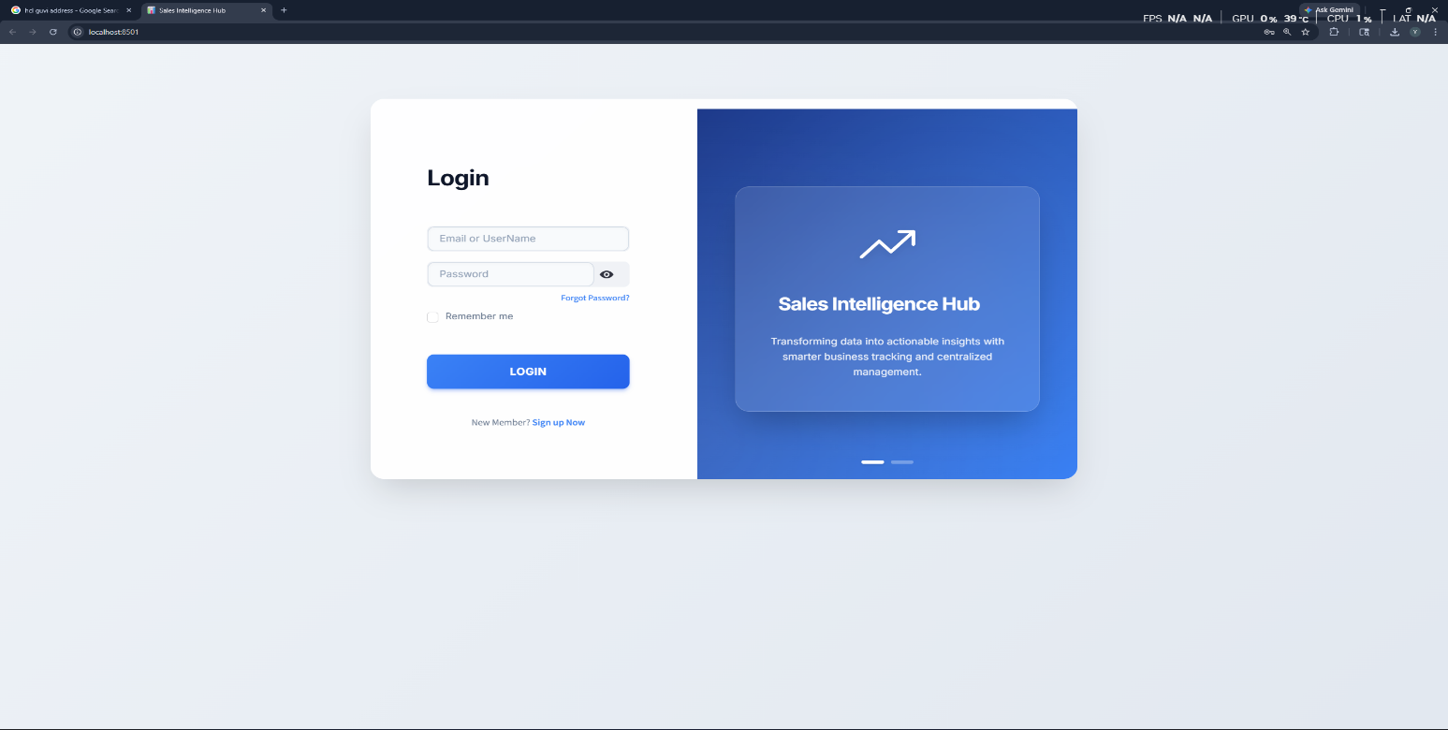

Dashboard Overview:
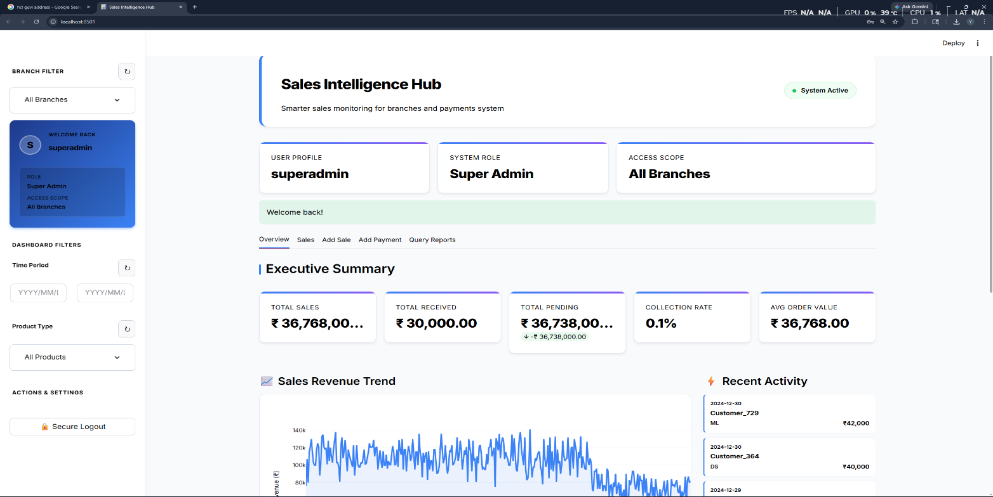

Sales Tab:

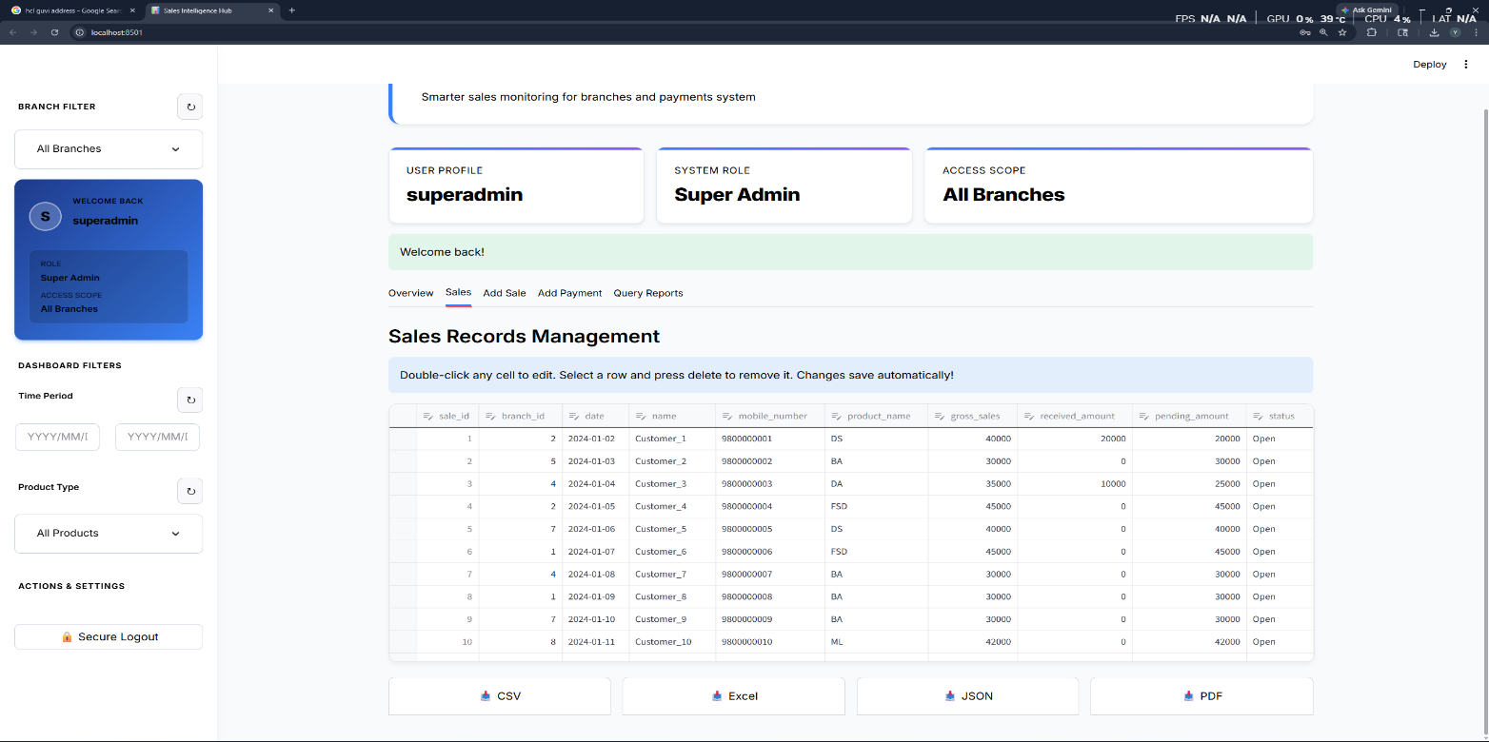

Add Sales Tab:
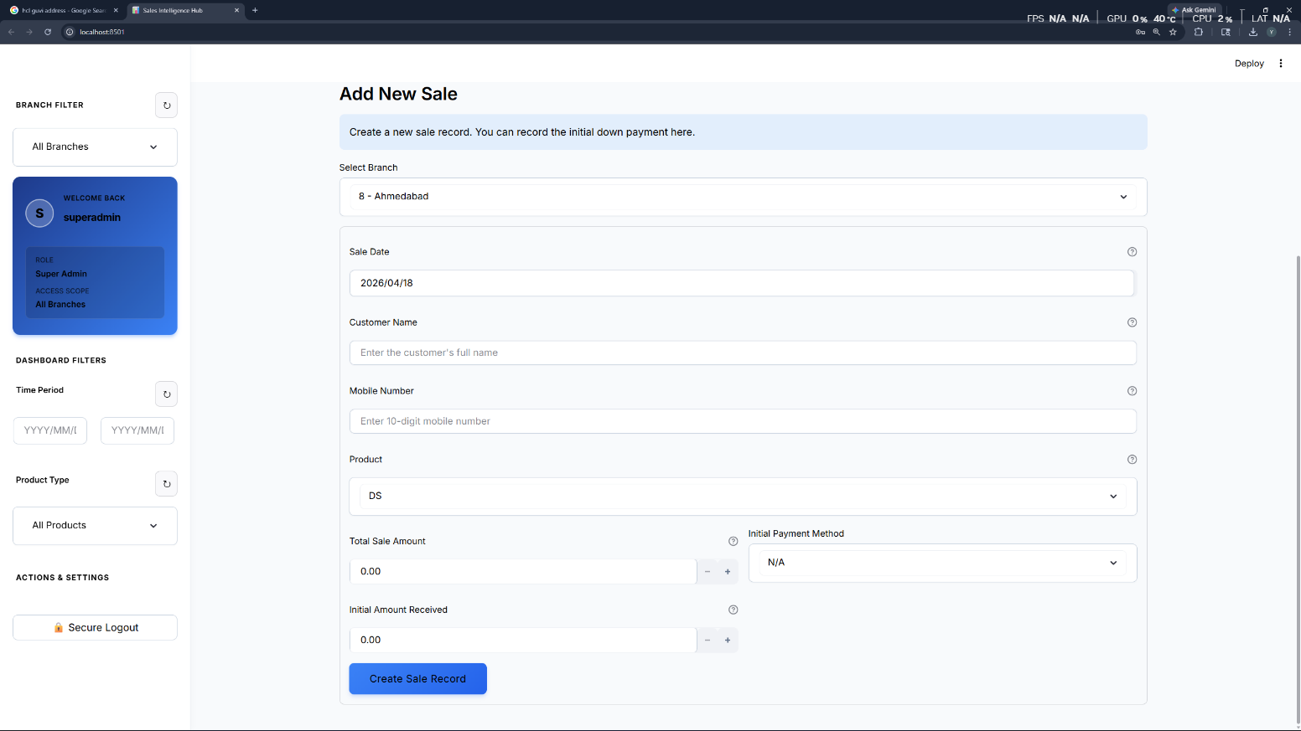

Add Payment Tab:

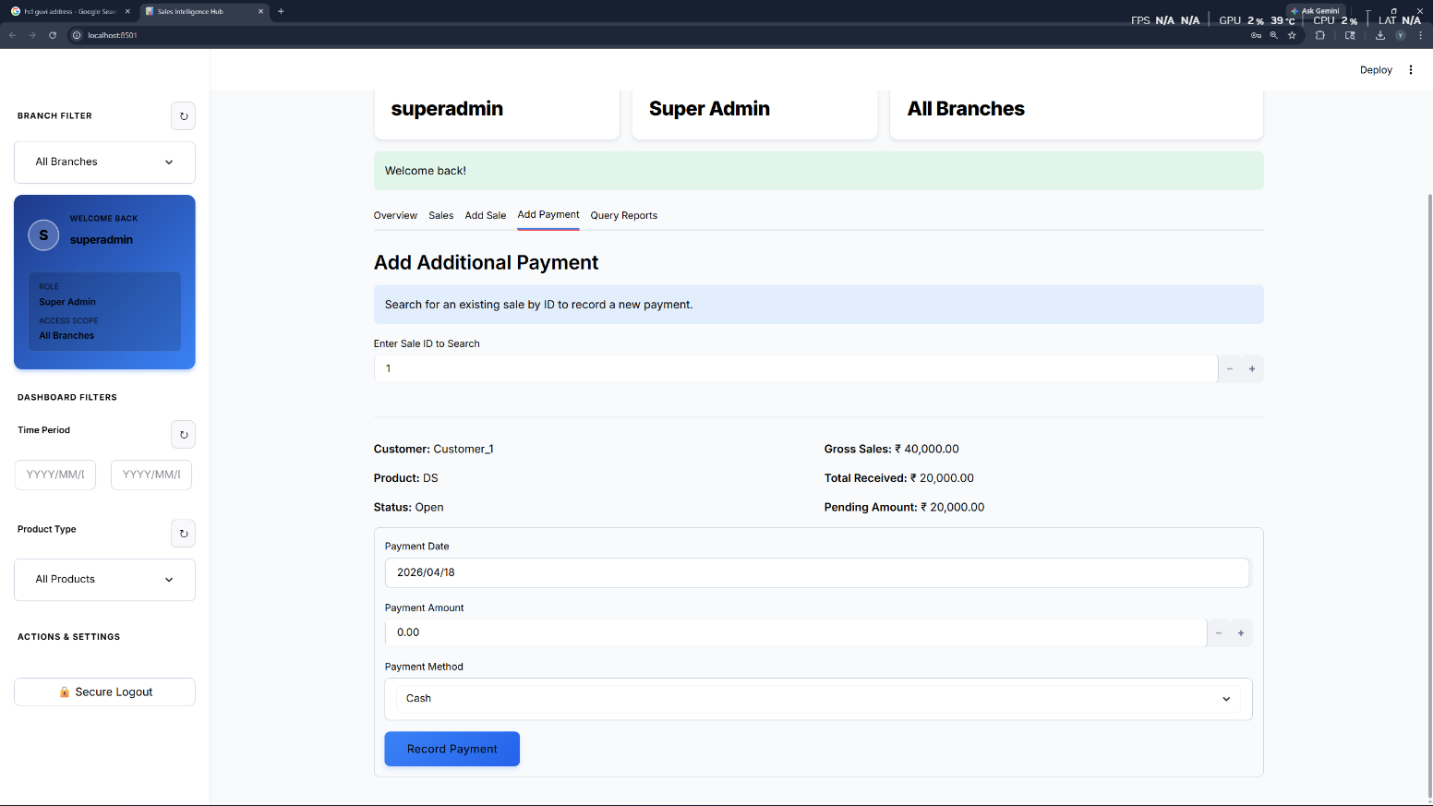

Query Reports Tab:

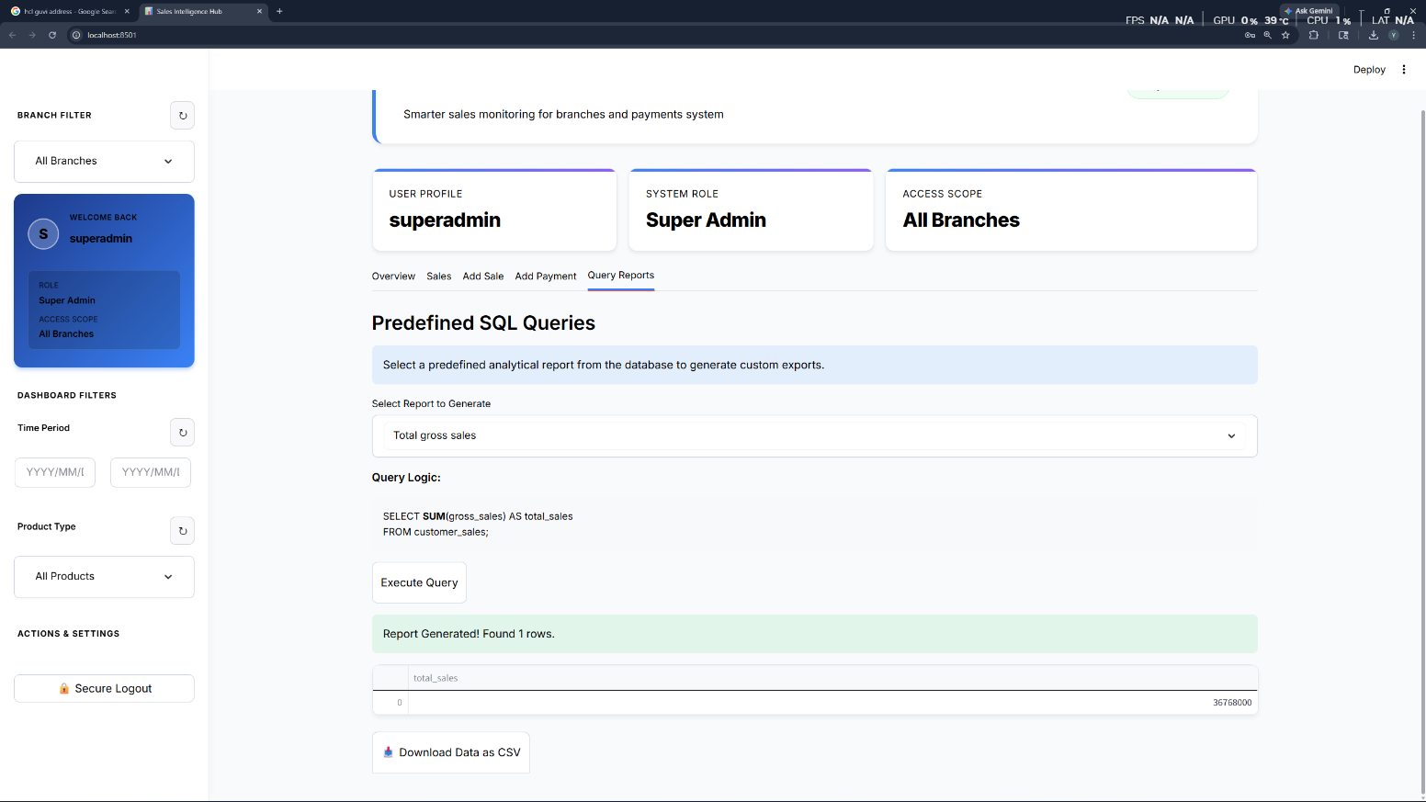
9.CONCLUSION

This project focused on building an effective and intelligent Fake News Detection System capable of classifying news articles as either real or fake based on their textual content. Leveraging the power of transformer-based language models, particularly DistilBERT, the system understands the semantic context of news statements and performs accurate classification. We designed a streamlined pipeline that includes text preprocessing, tokenization, semantic embedding generation, and finally, binary classification using a fine-tuned transformer. The system is capable of processing user input in the form of natural language and providing instant feedback on the credibility of the news content. We also explored tools like Hugging Face Transformers, and gained hands-on experience in NLP model integration, Flask-based web deployment, and evaluating real-world datasets.

Throughout the project, we deepened our understanding of natural language processing, transfer learning, model fine-tuning, and the importance of data integrity in machine learning workflows. This experience highlighted the practical challenges in detecting misinformation, such as handling biased data or understanding subtle manipulations in language.

In future work, the system can be improved by integrating multi-modal analysis (e.g., images or source credibility), real-time news scraping, and user feedback loops to adaptively learn over time. Additionally, incorporating explainable AI techniques could help users understand why a piece of news is flagged, increasing trust and transparency in the system.
This project not only strengthened our technical skills but also reinforced the significance of AI in combating misinformation in today’s digital world.

10.FUTURE ENHANCEMENT
Here are several impactful ways the Sales Intelligence Hub can be expanded in the future. These points are perfect for the "Future Scope" section of your project report:
- Predictive Analytics & Forecasting:
  - Integrate Machine Learning models (like Linear Regression or ARIMA) to predict future sales trends and revenue based on historical data patterns.
- Automated Inventory Management:
  - Connect the sales transaction system to an inventory database to provide real-time stock alerts and automatically generate "re-order" requests when product quantities are low.
- Enhanced Security Features:
  - Implement industry-standard security measures such as Two-Factor Authentication (2FA), password hashing (e.g., using bcrypt), and session timeout management for better data protection.
- Mobile Companion Application:
  - Develop a lightweight mobile app (Android/iOS) using frameworks like Flutter or React Native to allow branch managers to track sales and record payments on the go.
- AI-Powered Chatbot:
  - Integrate a Natural Language Processing (NLP) chatbot that allows admins to ask questions like "What were the total sales for Branch A last week?" and receive instant textual or visual answers.
- Automated Notification System:
  - Set up automated email or WhatsApp notifications to send daily/weekly performance summaries to stakeholders or alert customers about pending payments.
- Cloud Migration & Scalability:
  - Transition the local MySQL database and Streamlit app to a cloud platform (e.g., AWS RDS or Google Cloud SQL) to ensure 24/7 global availability and high-speed performance as data volume grows.

