HCL GUVI, IITM RESEARCH PARK, THARAMANI, CHENNAI, 600113

DATA SCIENCE COURSE

MINI PROJECT REPORT

TOPIC

MOBILE PRODUCT SEGEMENTATION

Submitted by

YOGESWARAN P N

BATCH CODE: DS-S-WD-T-B154

Under the Guidance of
Mr. VIGNESH P – PROJECT CO-ORDINATOR

DECLARATION

I hereby declare that the project titled "Mobile Product Segmentation and Recommendation System" is a genuine work carried out by me. This project was developed to analyze mobile product data, perform product segmentation using machine learning techniques, and generate intelligent recommendations based on product similarity.
I further declare that the datasets, source code, machine learning models, visualizations, Streamlit application, and documentation submitted herewith are my original work, and to the best of my knowledge, this project has not been submitted previously for the award of any degree, diploma, or other similar titles in any University or Institution.
All libraries, frameworks, datasets, and external resources used during the development of this project have been appropriately acknowledged and utilized in accordance with their respective licenses and usage policies.
This project demonstrates the practical application of Data Science, Machine Learning, Data Analysis, and Recommendation Systems to solve real-world product discovery and decision-making challenges.
Station: Chennai
Date: 18/04/2026

Name : Yogeswaran P N
Batch Code : DS-S-WD-T-B154
Course Name : Data Science
Institution Name : HCL GUVI
TABLE OF CONTENT

CHAPTER | TOPICS | PAGE NO
01 | ABSTRACT | 01
02 | INTRODUCTION | 02
03 | SYSTEM REQUIREMENTS  3.1HARDWARE  REQUIREMENTS  3.2 SOFTWARE  REQUIREMENTS | 03
04 | TECHNOLOGIES USED | 05
05 | DATASET | 08
06 | SOURCE CODE | 10
07 | PROJECT OUTPUT | 13
08 | CONCLUSION | 15
09 | FUTURE ENHANCEMENT | 16

1.ABSTRACT

The rapid growth of the smartphone industry has resulted in a vast number of mobile devices with varying specifications, prices, and user ratings. Consumers often face difficulties in identifying suitable smartphones due to the large number of available options. To address this challenge, the Mobile Product Segmentation and Recommendation System was developed using Machine Learning techniques to analyze mobile phone data, categorize products into meaningful segments, and provide personalized product recommendations.
The project utilizes a Global Mobile Reviews dataset containing information such as mobile brands, prices, ratings, battery performance, camera quality, display quality, and other device specifications. The collected data undergoes extensive preprocessing, including data cleaning, handling missing values, feature engineering, encoding, and scaling to ensure data quality and consistency.
K-Means Clustering is employed to group similar mobile devices into distinct segments such as Budget Devices, Value for Money Devices, Performance Focused Devices, and Flagship Devices. The optimal number of clusters is determined using the Elbow Method and validated through Silhouette Score analysis. In addition, a recommendation system based on Cosine Similarity is implemented to suggest similar mobile devices according to user preferences and product characteristics.
A Streamlit-based interactive dashboard is developed to visualize exploratory data analysis, cluster distributions, product insights, and recommendation results. The system transforms raw mobile review data into actionable insights that assist consumers in making informed purchasing decisions and help businesses understand product positioning within the competitive smartphone market.

2. INTRODUCTION

In today's highly competitive smartphone market, consumers are presented with thousands of mobile devices that differ in terms of specifications, pricing, performance, and user experience. With the rapid advancement of technology and the continuous release of new smartphone models, selecting the most suitable mobile device has become increasingly challenging. Customers often rely on online reviews, ratings, and product specifications to make purchasing decisions, but the large volume of available information can make the decision-making process complex and time-consuming.
The Mobile Product Segmentation and Recommendation System was developed to address these challenges by utilizing Data Science and Machine Learning techniques to analyze mobile phone data and generate meaningful insights. The primary objective of this project is to classify smartphones into distinct market segments and provide intelligent product recommendations based on similarities in features, specifications, and user ratings.
The project uses a Global Mobile Reviews dataset containing information such as mobile brands, prices, ratings, battery performance, camera quality, display quality, and other key attributes. Through a systematic data science workflow, the raw dataset undergoes data cleaning, preprocessing, feature engineering, encoding, and scaling to prepare the data for machine learning analysis.
K-Means Clustering is employed to identify natural groupings among smartphones, enabling the classification of devices into categories such as Budget Devices, Value for Money Devices, Performance Focused Devices, and Flagship Devices. To ensure effective clustering, the Elbow Method and Silhouette Score techniques are used to determine the optimal number of clusters and evaluate cluster quality.
In addition to product segmentation, the project incorporates a recommendation system that uses Cosine Similarity to identify and suggest mobile devices with similar characteristics. This feature helps users discover alternative products that match their preferences, budget, and performance requirements.

3. SYSTEM REQUIREMENTS

To ensure the Mobile Product Segmentation and Recommendation System operates efficiently, the following hardware and software requirements are recommended:
3.1 Software Requirements
• Operating System: Windows 10/11, macOS, or Linux
• Python Version: Python 3.10 or higher
• Development Environment: Jupyter Notebook / VS Code
• Web Framework: Streamlit
• Data Processing Libraries:
- Pandas
- NumPy
• Data Visualization Libraries:
- Matplotlib
- Seaborn
• Machine Learning Libraries:
- Scikit-learn
- Joblib
• File Handling:
- Pickle (PKL Models)
• Web Browser:
- Google Chrome
- Microsoft Edge
- Mozilla Firefox
3.2 Hardware Requirements
• Processor:
- Intel Core i3 / AMD Ryzen 3 or higher
• Memory (RAM):
- Minimum 4 GB
- Recommended 8 GB or higher
• Storage:
- Minimum 1 GB free disk space for datasets, models, reports, and visualizations
• Display:
- 1366 × 768 resolution or higher
• Internet Connectivity:
- Required for Python package installation and project deployment
The above configuration is sufficient for performing data preprocessing, exploratory data analysis, machine learning model training, clustering operations, recommendation generation, and execution of the Streamlit dashboard. Systems with higher processing power and memory can provide faster model training and improved application performance when handling large datasets.

4. TECHNOLOGIES USED:

The Mobile Product Segmentation and Recommendation System is developed using a combination of modern Data Science, Machine Learning, and Web Application technologies. These technologies enable efficient data processing, model development, visualization, and user interaction.
• Python
Python serves as the primary programming language for the project. It is used for data preprocessing, exploratory data analysis, feature engineering, machine learning model development, recommendation generation, and application integration.
• Pandas
Pandas is used for data manipulation and analysis. It provides powerful data structures and functions for cleaning, transforming, filtering, and processing large datasets efficiently.
• NumPy
NumPy is utilized for numerical computations and mathematical operations. It helps in handling arrays, matrices, and statistical calculations required during preprocessing and machine learning tasks.
• Matplotlib
Matplotlib is used for creating various visualizations such as histograms, scatter plots, box plots, and trend charts that help in understanding the dataset and model behavior.
• Seaborn
Seaborn is employed to generate advanced statistical visualizations and correlation heatmaps, making data patterns and relationships easier to interpret.
• Scikit-Learn
Scikit-Learn is the primary machine learning library used in the project. It provides implementations for StandardScaler, LabelEncoder, K-Means Clustering, Silhouette Score evaluation, and Cosine Similarity-based recommendation systems.
• K-Means Clustering
K-Means is the core machine learning algorithm used to segment mobile devices into meaningful clusters based on product specifications, ratings, and pricing information.
• Cosine Similarity
Cosine Similarity is used to build the recommendation system. It measures similarity between mobile devices and recommends products with comparable characteristics and performance.
• Joblib / Pickle
These libraries are used to save and load trained machine learning models, scalers, encoders, and similarity matrices for efficient deployment and reuse.
• Jupyter Notebook
Jupyter Notebook is used during project development for data cleaning, exploratory data analysis, feature engineering, clustering experiments, and recommendation model development.
• Streamlit
Streamlit is used to develop the interactive web application. It provides an easy-to-use interface where users can explore insights, view clustering results, and receive mobile recommendations.
• Visual Studio Code (VS Code)
VS Code serves as the primary development environment for writing source code, debugging applications, managing project files, and integrating various project components.
The combination of these technologies enables the development of a complete end-to-end machine learning solution capable of analyzing mobile products, generating market segments, and delivering intelligent recommendations through an interactive dashboard.

5. DATASET:

The Mobile Product Segmentation and Recommendation System utilizes a Global Mobile Reviews dataset containing detailed information about smartphones from multiple leading brands. The dataset is designed to provide insights into mobile device specifications, pricing, ratings, and user sentiment, enabling effective product segmentation and recommendation generation.
The dataset contains information collected from various smartphone brands including Samsung, Apple, Xiaomi, Google, Motorola, OnePlus, and Realme. Each record represents a mobile review along with product-related attributes that can be used for analytical and machine learning purposes.
Dataset Attributes
The dataset includes the following major features:
• Brand Name – Name of the smartphone manufacturer.
• Product Name – Name of the mobile device model.
• Country – Country associated with the review or market.
• Price (USD) – Selling price of the mobile device.
• Overall Rating – User rating provided for the product.
• Battery Life Rating – Rating representing battery performance.
• Camera Rating – Rating representing camera quality.
• Performance Rating – Rating representing processor and overall performance.
• Display Rating – Rating representing display quality.
• Review Text – Customer review describing product experience.
• Sentiment Category – Sentiment classification such as Positive, Negative, Neutral, or Unknown.
• Product Age – Age of the mobile device in the market.
Dataset Preprocessing
Before applying machine learning algorithms, the dataset underwent several preprocessing steps:
• Handling missing values.
• Removal of duplicate records.
• Data type correction and validation.
• Feature engineering to create additional analytical features.
• Label encoding of categorical variables.
• Standardization and scaling of numerical features.
• Preparation of data for clustering and recommendation models.
Dataset Purpose
The dataset serves two primary objectives:
- Product Segmentation
Mobile devices are grouped into meaningful clusters based on price, ratings, hardware performance, and overall product characteristics using K-Means Clustering.
- Product Recommendation
Similar mobile devices are identified using Cosine Similarity, allowing the system to recommend alternative products with comparable specifications and ratings.
The processed dataset provides a strong foundation for machine learning analysis, enabling the discovery of hidden patterns within the smartphone market and supporting intelligent recommendation generation for end users.

7.SOURCE CODE:

7.1 main.py (Project Execution File):

from src.pipeline import MobileSegmentationPipeline

def main():
pipeline = MobileSegmentationPipeline()
pipeline.run_complete_pipeline()

if __name__ == "__main__":
main()

class MobileDataCleaner:

def clean_data(self, df):
df = df.drop_duplicates()

numeric_cols = [
'price_usd',
'rating',
'battery_rating',
'camera_rating',
'performance_rating',
'display_rating'
]

for col in numeric_cols:
df[col] = df[col].fillna(df[col].median())

return df

class FeatureEngineer:

def create_features(self, df):

df['overall_hardware_score'] = (
df['battery_rating'] +
df['camera_rating'] +
df['performance_rating'] +
df['display_rating']
) / 4

df['rating_price_ratio'] = (
df['rating'] / df['price_usd']
)

return df

from sklearn.cluster import KMeans

class MobileClusterer:

def perform_clustering(self, X):

kmeans = KMeans(
n_clusters=4,
random_state=42
)

clusters = kmeans.fit_predict(X)

return clusters

from sklearn.metrics.pairwise import cosine_similarity

class MobileRecommender:

def generate_similarity_matrix(self, features):

similarity_matrix = cosine_similarity(features)

return similarity_matrix

import streamlit as st

st.title(
"Mobile Product Segmentation & Recommendation System"
)

st.sidebar.title("Navigation")

page = st.sidebar.selectbox(
"Select Page",
[
"Overview",
"EDA",
"Segmentation",
"Recommendation"
]
)

8.OUTPUT

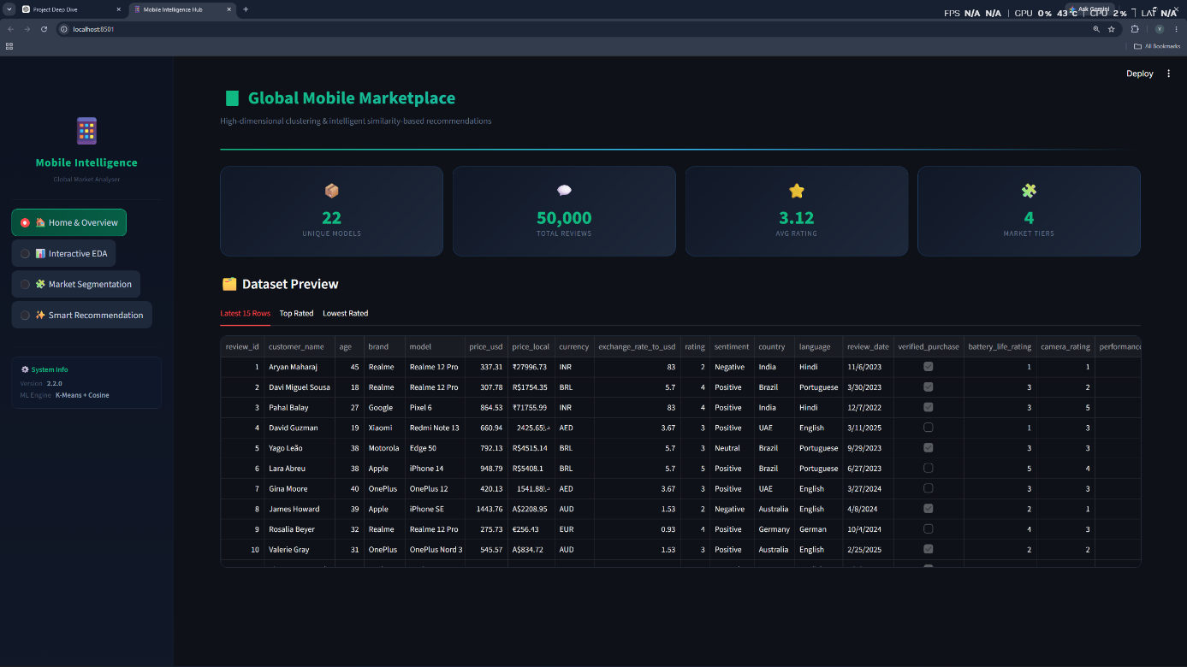

Dashboard Overview:
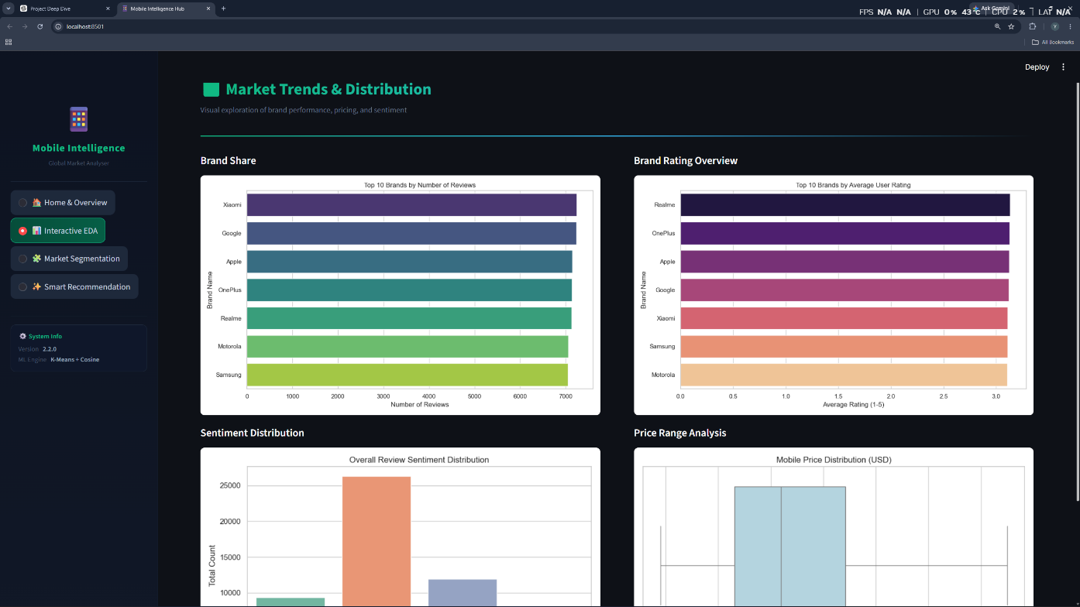

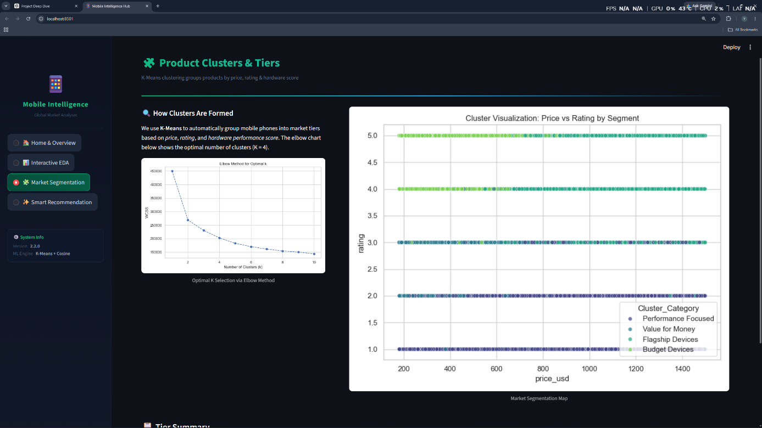

Add Sales Tab:
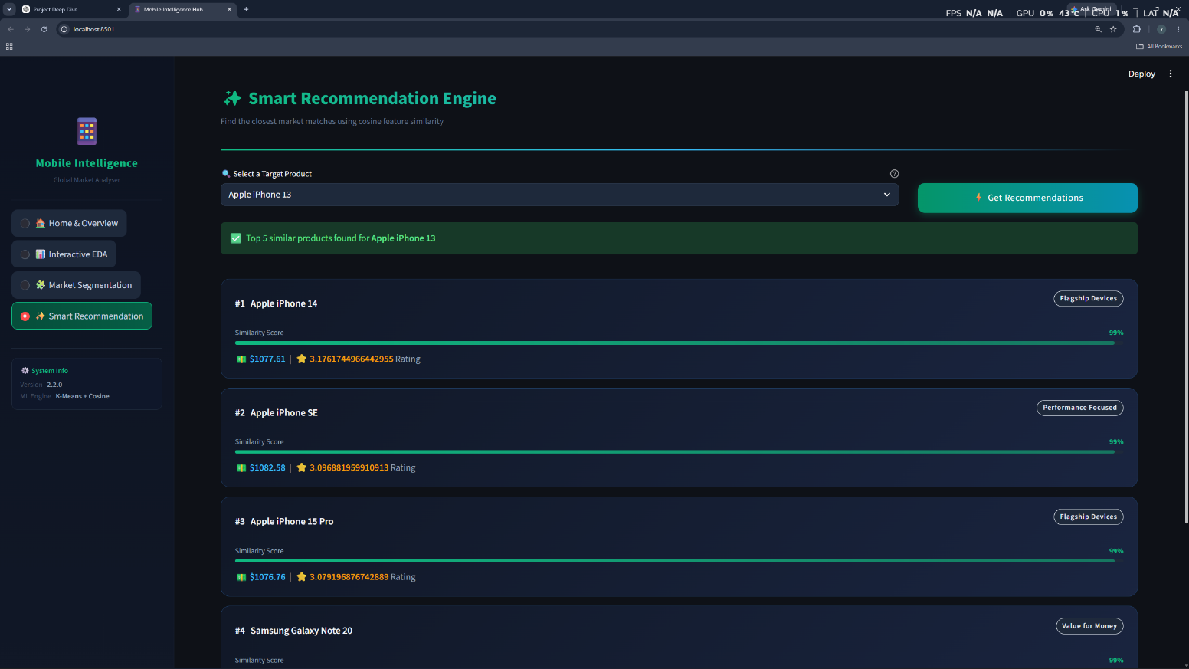

9.CONCLUSION

The Mobile Product Segmentation and Recommendation System successfully demonstrates the practical application of Data Science and Machine Learning techniques in analyzing smartphone market data. Through systematic data preprocessing, exploratory data analysis, feature engineering, clustering, and recommendation generation, the project transforms raw mobile review data into meaningful business insights and user-focused recommendations.
The implementation of K-Means Clustering enabled the identification of distinct smartphone segments based on specifications, pricing, and performance characteristics. These clusters provide a better understanding of product positioning within the market and help categorize devices into meaningful groups such as Budget Devices, Value for Money Devices, Performance Focused Devices, and Flagship Devices.
Additionally, the recommendation system developed using Cosine Similarity effectively identifies similar mobile devices and provides personalized recommendations based on product characteristics. This functionality enhances the user experience by simplifying product discovery and assisting customers in making informed purchasing decisions.
The Streamlit-based dashboard provides an interactive platform for exploring the dataset, visualizing market trends, analyzing cluster distributions, and generating recommendations. The combination of machine learning models and data visualization techniques makes the system both informative and user-friendly.
Overall, the project successfully achieves its objectives by delivering an end-to-end machine learning solution that supports product segmentation, recommendation generation, and data-driven decision-making. The system demonstrates how modern analytical techniques can be utilized to extract valuable insights from large datasets and create intelligent applications for real-world business scenarios.

10.FUTURE ENHANCEMENT

Although the Mobile Product Segmentation and Recommendation System successfully achieves its current objectives, several enhancements can be implemented in the future to improve its performance, scalability, and user experience.
• Advanced Recommendation Algorithms
The current recommendation system utilizes Cosine Similarity to identify similar mobile devices. Future versions can incorporate advanced recommendation techniques such as Collaborative Filtering, Content-Based Filtering, Hybrid Recommendation Systems, and Deep Learning models to provide more personalized recommendations.
• Real-Time Data Integration
The system currently operates on a static dataset. Future enhancements can include integration with online mobile marketplaces, review platforms, and APIs to automatically fetch real-time product information, prices, ratings, and customer reviews.
• Sentiment Analysis Enhancement
Advanced Natural Language Processing (NLP) techniques can be applied to customer reviews to perform detailed sentiment analysis and extract valuable insights regarding user satisfaction, product strengths, and common complaints.
• Dynamic Cluster Updating
As new mobile devices are released frequently, future versions can support automatic retraining of clustering models to ensure that product segments remain accurate and up to date.
• Interactive Filtering and Search
Additional dashboard features can allow users to filter mobile devices based on budget, brand, battery performance, camera quality, display quality, and other specifications to improve product discovery.
• Deployment on Cloud Platforms
The application can be deployed on cloud platforms such as AWS, Microsoft Azure, or Google Cloud Platform to provide wider accessibility, better scalability, and improved system availability.
• Mobile-Friendly Application
Future development can focus on creating a responsive mobile application that enables users to access recommendations and product insights directly from smartphones and tablets.
• Integration with E-Commerce Platforms
The system can be integrated with online shopping platforms to provide direct purchase links and compare prices across multiple sellers.
• Predictive Analytics
Machine learning models can be developed to predict future smartphone trends, customer preferences, and potential market demand based on historical product data.
In conclusion, these enhancements will further improve the accuracy, usability, and business value of the system, transforming it into a more comprehensive intelligent platform for mobile product analysis, segmentation, and recommendation.

