Read Me Document
Screen Shot of the Dashboard
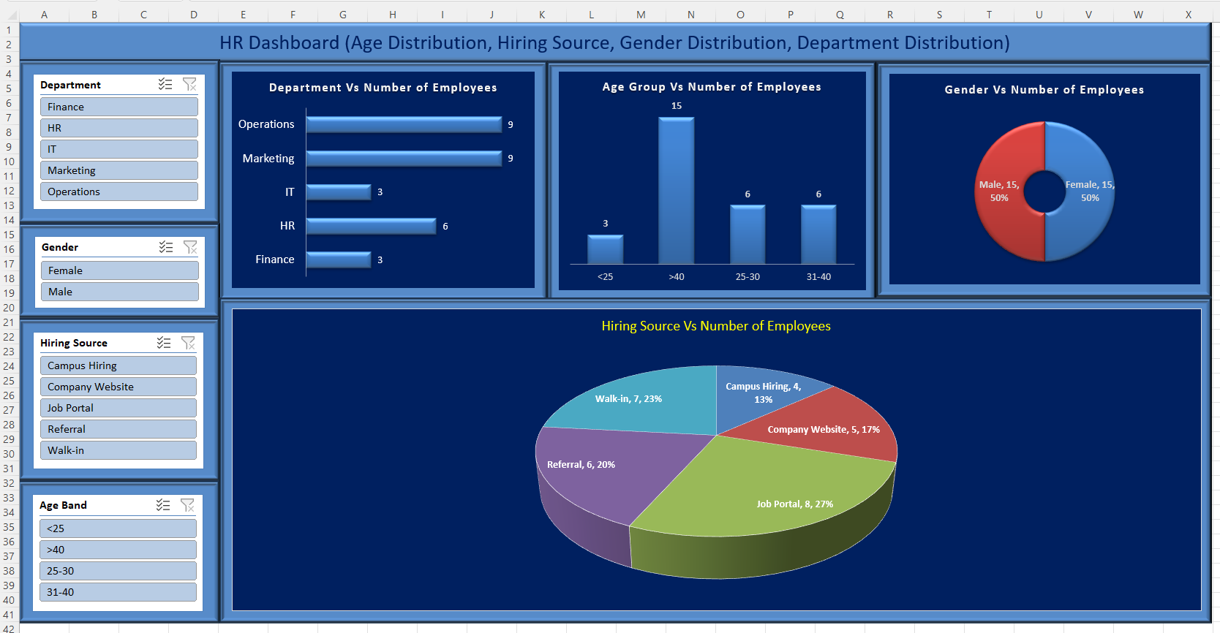
Below are the KPIs:
1️⃣ Workforce Structure KPIs
🔹 Total Headcount
Definition: Total number of active employees
Excel Formula:
=COUNTA(A2:A100)
Insight: Overall workforce size

🔹 Department-wise Headcount
Definition: Employees per department
Formula Logic: COUNTIFS
=COUNTIFS(E:E,"IT")
Insight: Resource allocation across functions

🔹 Location-wise Headcount
Insight: Regional workforce distribution

🔹 Age Band Distribution
Insight: Workforce age composition (young vs experienced)

2️⃣ Diversity & Inclusion KPIs
🔹 Gender Ratio (%)
Definition: Gender representation
=COUNTIF(D:D,"Female") / Total Headcount
Insight: Gender diversity balance

🔹 Gender Mix by Department
Insight: Department-level diversity gaps

3️⃣ Hiring & Recruitment KPIs
🔹 Hiring Source Effectiveness
Definition: Employees hired per source
=COUNTIFS(F:F,"Job Portal")
Insight: Most effective recruitment channel 🎯

🔹 Average Experience at Joining
=AVERAGE(I:I)
Insight: Quality of hiring (freshers vs lateral)

🔹 Average Age at Joining
=AVERAGE(C:C)
Insight: Hiring strategy orientation

🔹 Hiring Trend (Year-wise)
Derived from Date of Joining
Insight: Growth / slowdown pattern 📈

4️⃣ Experience & Talent KPIs
🔹 Average Experience (Years)
=AVERAGE(I:I)
Insight: Overall workforce maturity

🔹 Experience Band Distribution
(0–2, 2–5, 5–10, 10+)
Insight: Succession & leadership readiness

🔹 Senior Workforce Ratio (>10 yrs)
=COUNTIF(I:I,">10") / Total Headcount
Insight: Dependency on senior talent

5️⃣ Tenure-Based KPIs (Derived)
🔹 Average Tenure (Years)
=AVERAGE(TODAY()-Date_of_Joining)/365
Insight: Retention strength

🔹 Long-Tenure Employees (>5 years)
Insight: Organizational stability

🔹 Recent Joiners (<1 year)
Insight: Growth / replacement hiring

6️⃣ Demographic Analytics KPIs
🔹 Average Age by Department
Insight: Aging vs young teams

🔹 Age vs Experience Correlation
Insight: Career progression consistency

7️⃣ Strategic HR KPIs (MBA-Oriented)
🔹 Talent Concentration Index
Definition: % of experienced employees in critical departments
Insight: Risk exposure if attrition happens

🔹 Hiring Source Diversity Index
Definition: Dependency on limited sources
Insight: Recruitment risk ⚠️

🔹 Workforce Mobility Indicator
(Location × Department)
Insight: Location-specific hiring dependence

Recommended KPI Tiles (Top Dashboard)
✔ Total Headcount
✔ Avg Age
✔ Avg Experience
✔ % Female Employees
✔ Top Hiring Source
✔ Avg Tenure

