Student ID:2400030838
Name:K.yogendhar Reddy
Skill Experiment Number:1
Section Number:65
SKILL - 1 Git Version Control
Github:https:github.com/Yoge435/Skill-experiment-1-fsda
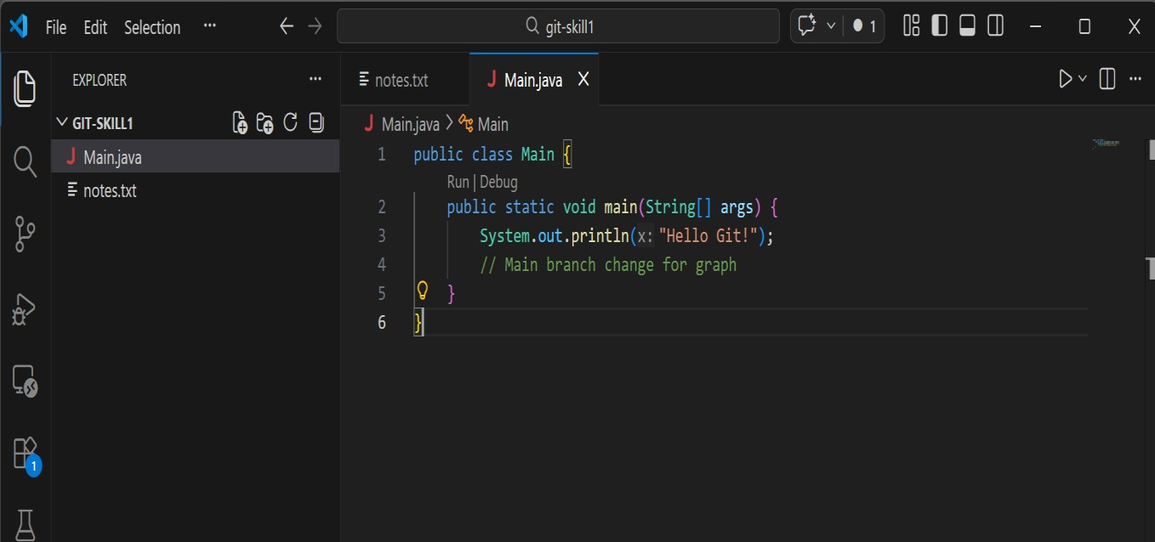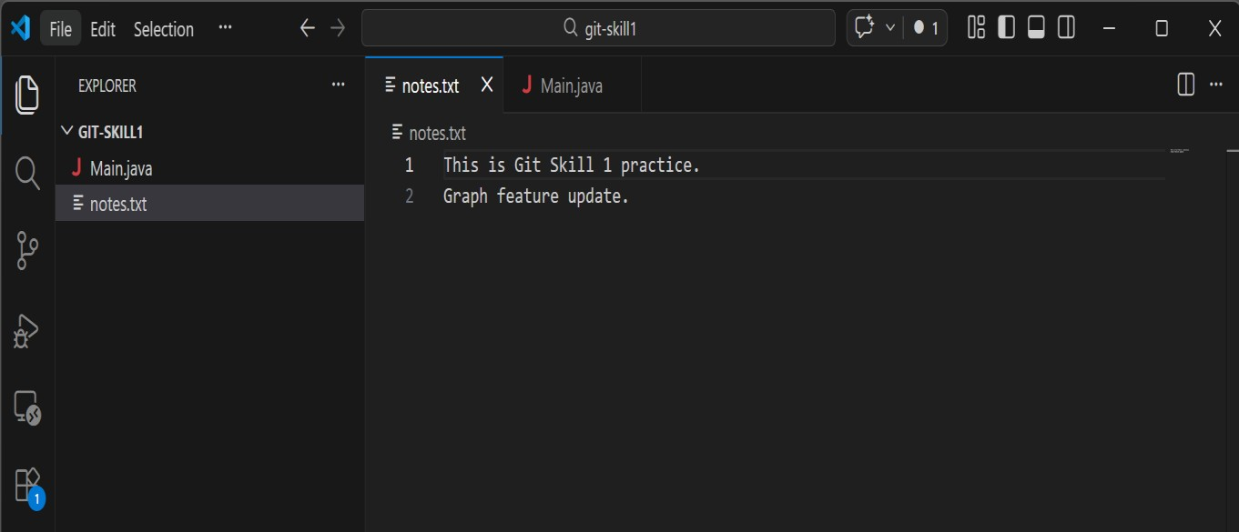
Output:
