Phase-4 Project- Kitchen Story

**Project Objective & Background:** To develop an e-commerce portal that allows people to shop for basic food items. Kitchen Story is an e-commerce portal that lets people shop for basic food items on their website.

# Developer Details:

**Name:** Yogendra Bire

## Github link: <https://github.com/Yogenda/KitchenStory>

# Product Features:

1. Kitchen Story application is made specifically to the required business needs, it’s completely flexible and scalable to the business demands and growth.
2. The whole application is a Single Page Application that is more efficient in terms of processing and provides a seamless user experience.
3. The application web pages are responsive and secure.
4. The user can search and buy a variety of daily needs products. For payment user can select cash on delivery or card payment.
5. For management of orders and products there is an Administrator to manage.
6. The administrator can login through username and password. The admin can change the password if required.
7. The admin can add the new products. Admin can also update or delete the products in the master list.
8. Admin can also see the all the orders created by users.

# Core Concepts used & Project Architecture:

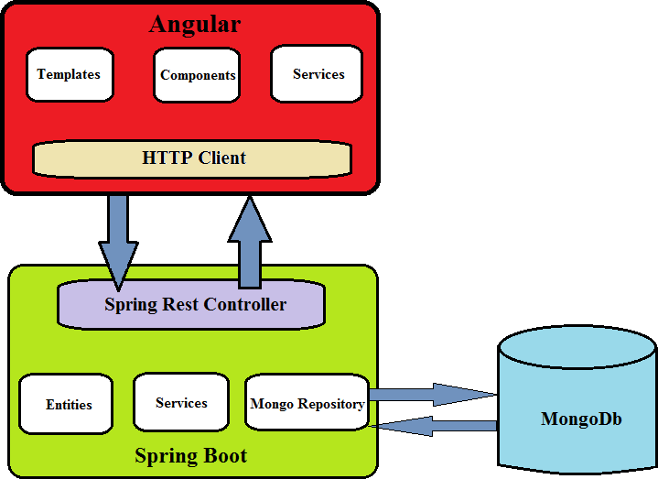

1. Angular framework for frontend.
2. Spring boot framework for backend.
3. MongoDb database.
4. Bootstrap 4.
5. Spring Security.
6. Jwt authentication.
7. Spring web, Spring data mongodb.
8. Typescript, Html.

# Sprint planning and task achieved:

Number of sprint planned = 3.

## Sprint 1:

1. Planned to develop backend code for project. Generated spring boot project from https://start.spring.io .
2. Planned to develop an admin login feature rest api. Used spring security and jwt authentication to develop this feature.
3. Successfully tested the login feature in the postman software.
4. Planned to develop required api’s related to Product like add, remove, update and search etc.. Successfully created rest api’s and tested in postman software.
5. Planned to develop required api’s related to Orders like save order, show order etc. Successfully created rest api’s and tested in postman software.

## Sprint 2:

1. Planned to develop frontend code for project. Generated Angular project using angular cli.
2. Planned to develop required components and services. Added bootstrap 4 to project. Successfully generated the required components and services.
3. Planned to develop the templates associated with respective components. Successfully created the templates.

## Sprint 3:

1. Planned to test complete web application by giving the inputs in the respective fields.
2. The web application is responsive, secure and all features are working successfully.