Objective Questions
Task 1: What is the total no. of tables present in the data?
Ans: There is only 1 table present in the data.

Task 2: What is the total no. of attributes present in the data?
Ans: There are total 39 attributes present in the data.

Task 3: The data consists of some inconsistent and missing values so ensure that the data used for further analysis is cleaned.
Ans: Filled all the missing values and cleared the data from inconsistency.

Task 4: What is the change in daily call volume day by day and also find the average daily call volume.
Ans: The Average daily call volume = 246.029
The below pivot table shows the day by day call volume and change in daily call volume.

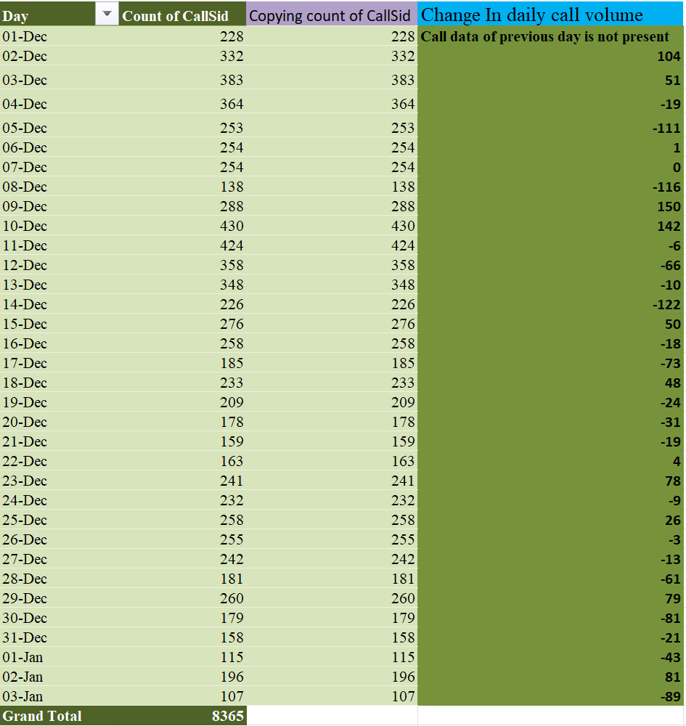
Task 5: Which months experienced the highest and lowest call volumes?
Ans: December has the highest call volume with 7947 calls, where as January has the lowest call volume with 418 calls.
The below pivot chart shows the highest and lowest call volumes and the months corresponding to it.
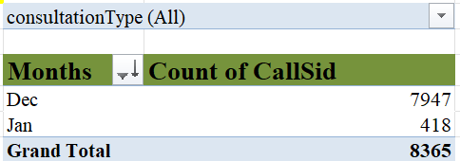
Task 6: What is the total operational cost for that month?
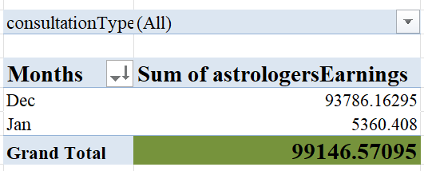
Ans: The total operational cost for each month is shown in the below pivot table.

Task 7: What is the average number of calls handled per agent per day?
Ans: Total no of agents who worked in Call category = 129
Total no of calls = 8508
Total no of days = 34
average no of calls handled per agent per day = (8508 / 129) / 34
= 1.9549
Task 8: How many repeat callers are there, and what percentage of total calls do they represent?
Ans: Total no of repeated callers = 1277
Total no of callers = 3629
Total calls = 8365
Percentage of total calls by the repeated callers
= ((8365 - 3629) * 100) / 8365
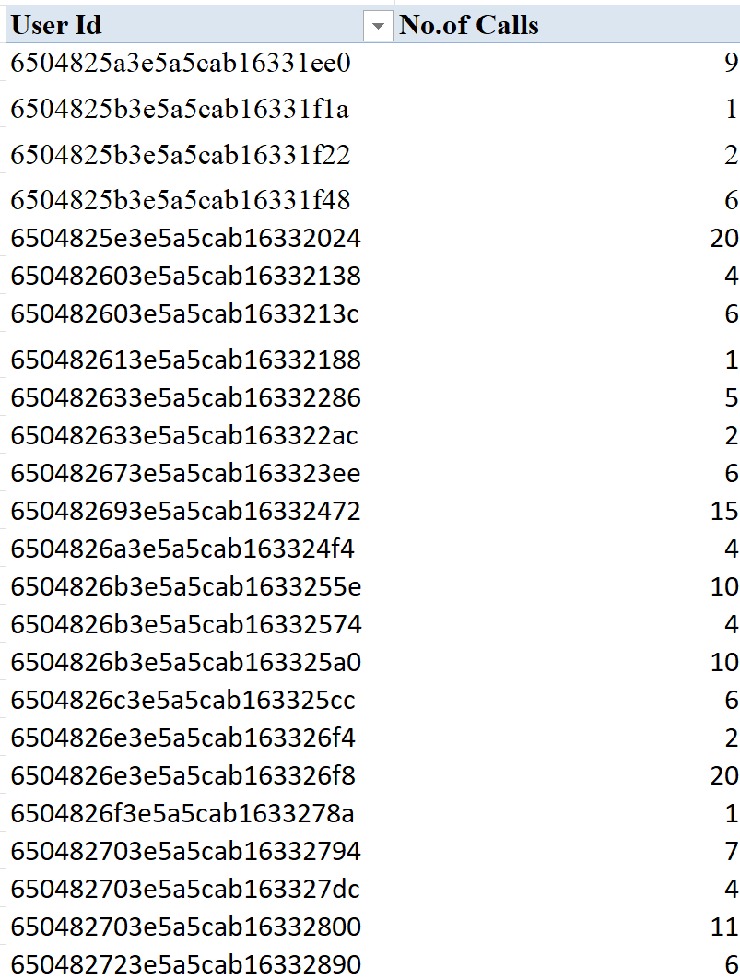
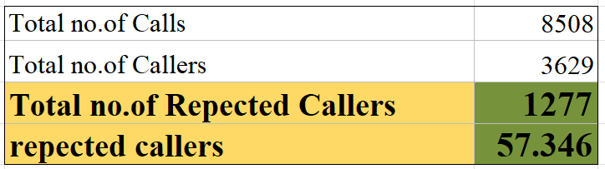
= 57.346%

Task 9: What are the total sales generated by the call centre for each product category?
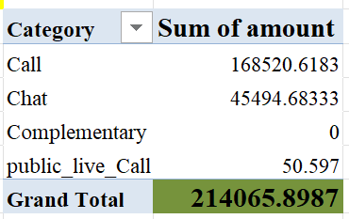
Ans: The total sales generated by the call centre for each product category is shown in the below pivot table.

Task 10: How many calls were made for each user ID and guru ID?
Ans: The below pivot tables show how many calls were made for each user ID and guru ID. For complete pivot table please refer to the Excel Sheet.
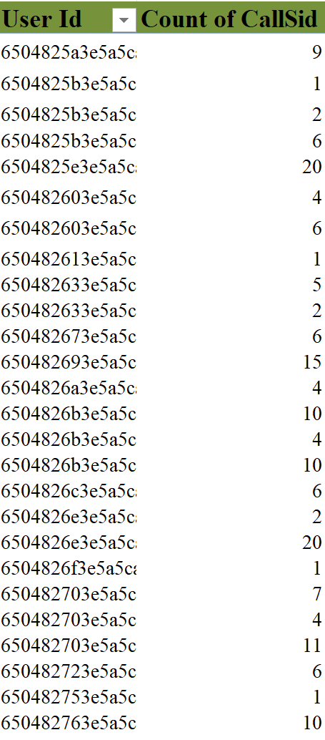
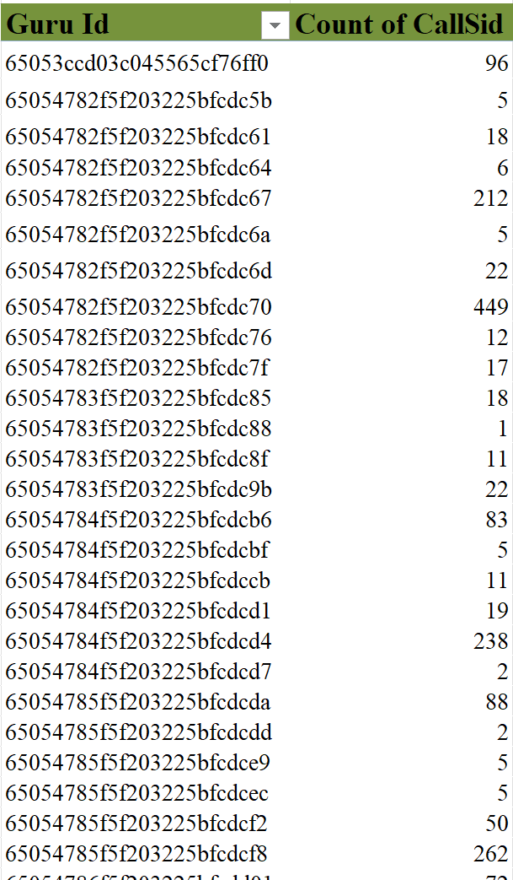
Task 11: What is the correlation between call duration and customer satisfaction?
Ans: The correlation between call duration and customer satisfaction is calculated using the CORREL function in the Excel.
Correlation between call duration and customer satisfaction = 0.0547

Task 12: Which guru has the highest and lowest customer satisfaction scores?
Ans: Tarot Mystical has the highest guru rating of 7.5, where as Tarot Rittika has the lowest guru rating of 0.

Task 13: What is the average customer satisfaction score by month?
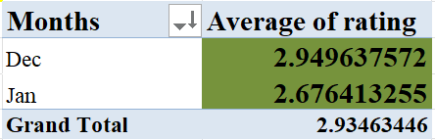
Ans: The average customer satisfaction score for December is 2.949, for January is 2.676.

Task 14: How many categorical columns are there in the data?
Ans: There are 21 categorical columns in the data after removing inconsistent data and after adding some new column.

Subjective Question
Task 1: Should the investment be used to hire more agents, improve training programs, or upgrade call center technology?
Ans: I carefully examined the data trends, here’s my summary and the observations.
Insights and Key findings:
Poor performance of agents:
The average number of calls per agent per day is 1.954, which is very low, this gives insights that either the agent performance is very poor or it might be the system mistake.
Very low average rating of agents:
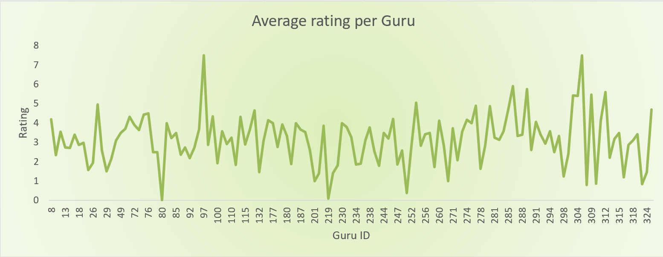
The average rating of all agents is 2.934 which can be considered as very poor, it’s clear that the agents performance is effecting the call center with poor service, tough the maximum average rating is 8 but most of the agents rating is not acceptable.

Inefficient Call management:
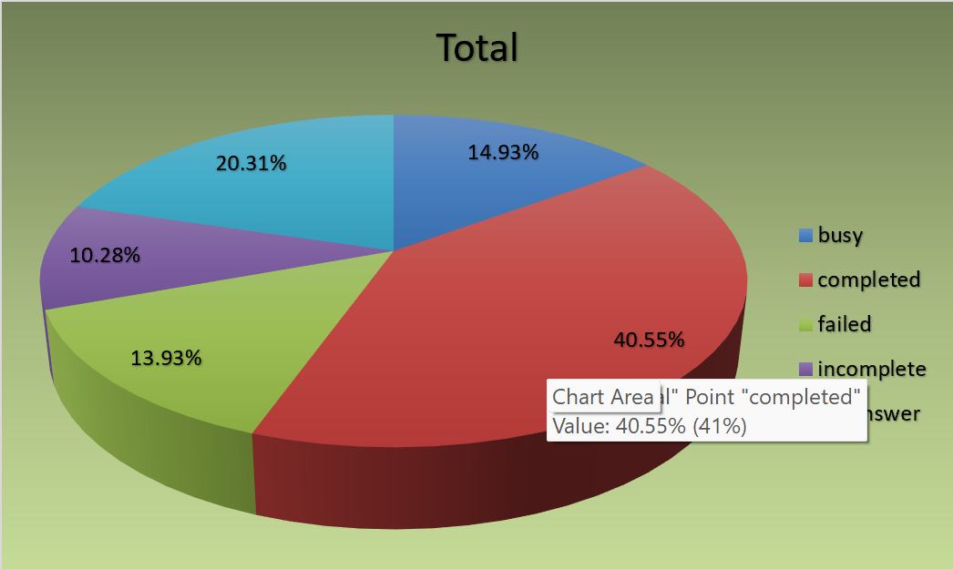
From the below chart we can see that only 40.5% of the calls were completed, rest of the 60% shows the inefficient management by the call center, ever after only 1.95 was the average call per agent only 40.5% of the calls where completed which is inefficiencies in handling user requests and agent performance.

Decline in Users:
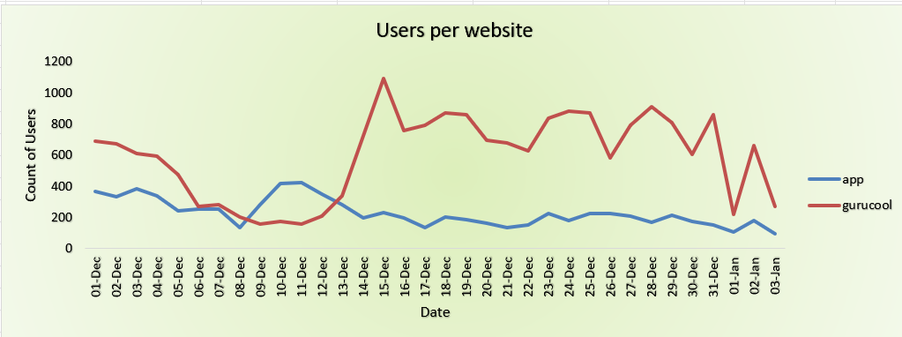
The call center is facing a decline in the no of customers, this if because of the poor service by the agents and management of the Astrosage.

Recommendations based on these analysis:
The recommendations in order to provide better customer service, efficient management.
Enhance Customer Experience:
- Providing proper training to the agents to overcome the weaknesses and reasons for the low rating.
- Handling Call and Chat management in such a way that it leads to less waiting time and decrease in incomplete status.
Improving Call Center Technology:
- Upgrading the technology for better handling in the busy conditions which leads to higher completion rate.
- Implementing Uniform distribution of Chats and Calls among the agents to split the workload which enhances the productivity and customer satisfaction.
Focusing on this recommendations Astrosage can overcome the problems mentioned above and also it can enhance the customer satisfaction to a reasonable level.

Task 2: What are the potential risks of each investment option (hiring, training, technology upgrades), and how can they be mitigated? Name the chart/spreadsheet function you will use for solving the problem.
Ans: The potential risks and mitigation strategies:
Hiring:
- Potential risks: High recruitment cost, Poor cultural fit and recruiting more than needed.
- Mitigation strategies: Implement structured interviews, Using data driven hiring tools, ROI of each employee.
Training:
- Potential risks: Low ROI if employees leave, Ineffective training content, Time lost from regular work.
- Mitigation strategies: Align training with company goals, Measure outcomes via KPIs, Flexible working hours, Online training programs.
Technology upgrades:
- Potential risks: High upgrading costs, Implementation delays, Employee resistance to new systems.
- Mitigation strategies: Providing proper training on new technology, Plan phased rollouts and backup systems.
The chart/spreadsheet function I will use for solving the problems:
- IF(): to identify risk categories (e.g., IF(cost > 100000, "High Risk", "Low Risk"))
- AVERAGE() or SUM(): to calculate total or average investment costs.
- RANK(): to rank investment options by risk and cost of Implementation.
- Risk Matrix Chart (Scatter Chart): to plot Probability vs Impact for each investment option.

Task 3: How does AstroSage's call center performance compare to AstroGuru's average call volume, customer satisfaction, and agent performance? Will you use any aggregation function or a visualization here to solve the problem?
Ans: Data of AstroGuru isn’t provided so it can’t be compared.

Task 4: How can the call center improve its handling of peak call periods to ensure high customer satisfaction? Mention the functionality you will use for giving the suggestions, will it be any aggregated function or a visualization?
Ans: The below graph tells us the Hourly Call Distribution, from the graph we can say that the peak call period is between 4 AM to 5 PM. The steps for the improvement of customer satisfaction is to Allocate more no of gurus from 4 AM to 5 PM so that no customer feels ignored or wait for to long. The Astrosage should also provide proper management to take care of the waiting customers and they might also follow rule like no customer can consult for more then 10 minutes, or the customer should pay depending on the time duration of consultation.
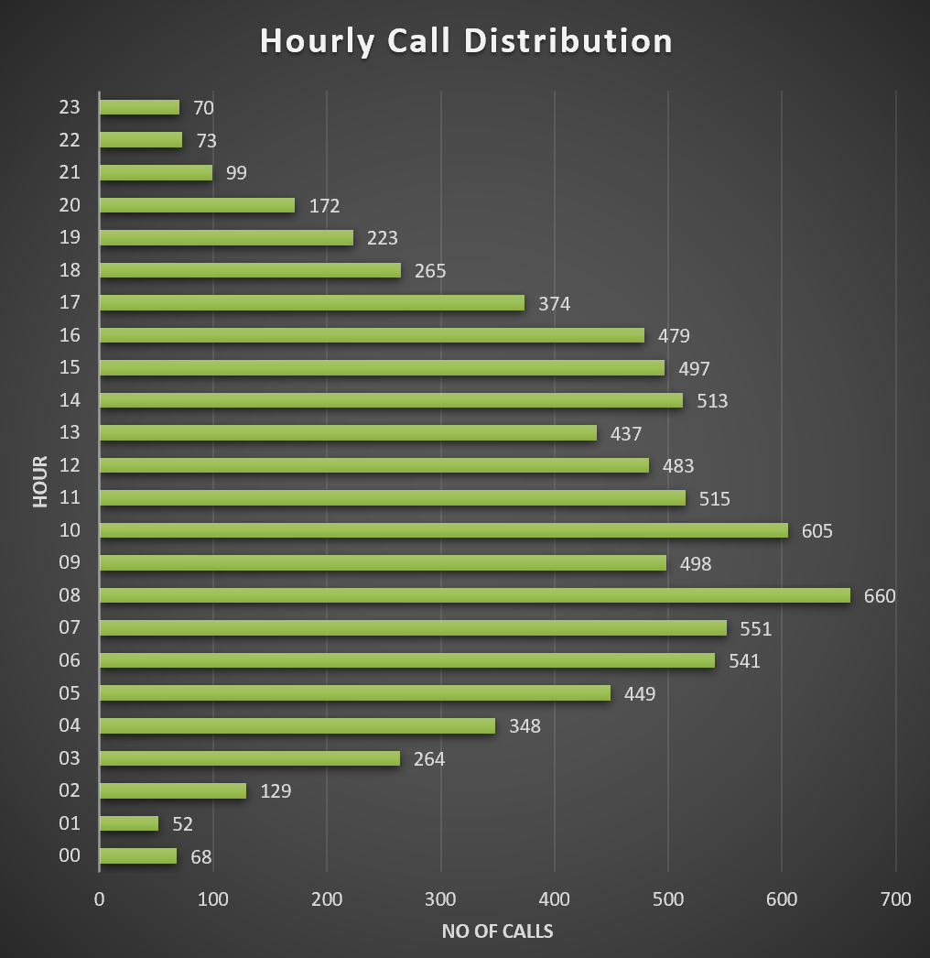
The visualization gives us the exact idea of peak call periods rather then the aggregated functions and also it’s east to understand and take actions faster.

Task 5: Based on historical data, what strategic initiatives should be prioritized to improve efficiency and customer satisfaction?
Ans: After analysing historical call center data and to improving overall efficiency and customer satisfaction, the following strategic initiatives should be prioritized:
Selective training for the Agents
Based on the historical data, it was seen that the agents failure rates was very high, and the customers ratings are also very poor. Giving a selective traning to the agents will enhance their performance, decrease call and chat failure rate, and increase customer satisfaction.
Recommendations:
Creating effective training sessions based on the employee needs for improvement in areas like communication skills, problem solving skills and technical knowledge.
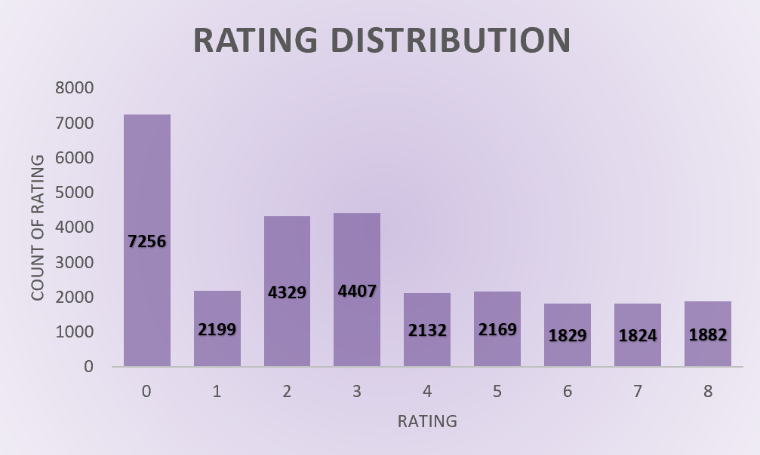
It is necessary to assess changes in performance after training so that it is possible to determine whether the training was beneficial and value added.
Poor rating in every Consultation type
We can see from that pie chart that every consultation type have very low ratings, also we know that most of the customers consult through chat and call the rating corresponding to it is completely unacceptable, to enhance the rating Astrosage must focus on improving technology and handling customer requests without fail and proving the best possible service to customers.
Recommendations:
Improving the consultation technology and management in order to satisfy the customer needs.
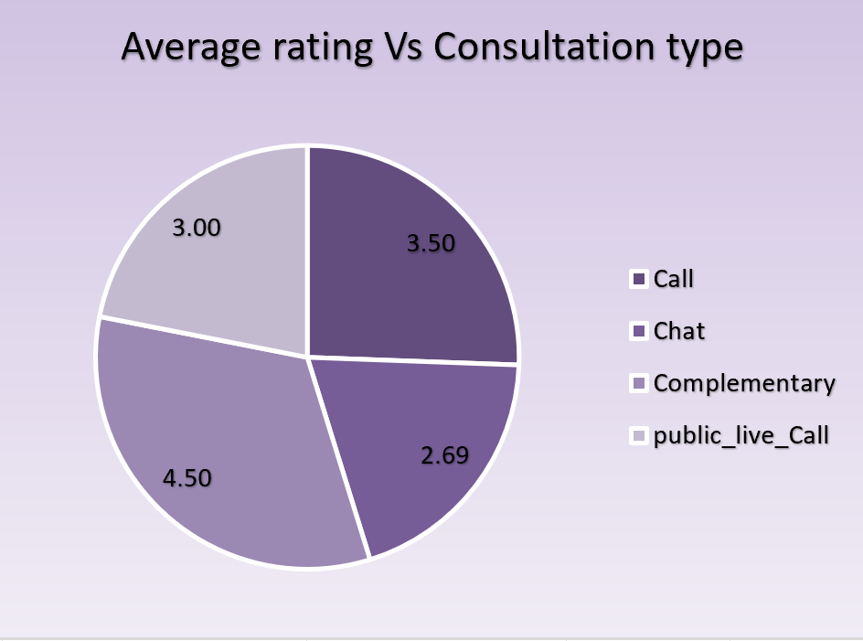
Focusing on reducing the incompletion and failure rate and also decreasing the waiting period will definitely higher the ratings and customer satisfaction.

Enhancing Call Management
Poor call routing leads to longer waiting period for customers, become unhappy, and agents may be used inappropriately. This rises the integration of intelligent call routing systems to match the needs of the customers with the right agents.
Recommendations:
Enhancing the call Technology routing that will help to route the calls to agents who will be in the right position to attend the calls.
Implementing the concept of priority queue so that valued or returning customers receive their services earlier, especially during the rush hour.
Minimizing Call Failure Risks
Records of past calls showing call failures or technical challenges that are making customers unhappy. It is therefore recommended for the organization to upgrade the technology used in call center since this would increase call quality, reduce call failure and increase efficiency.
Recommendations:
Introduce effective IVR systems to minimize the need for agents in handling simple calls.
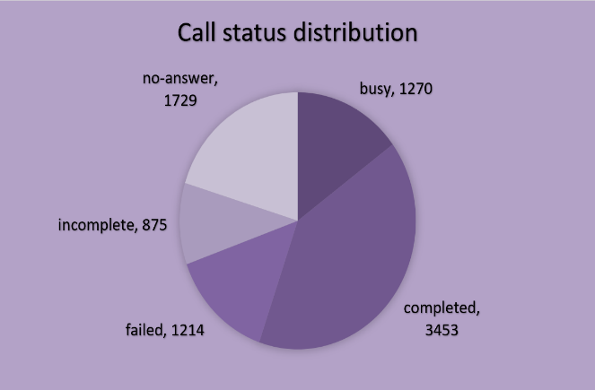
The communication should also be more reliable and have a larger capacity and the customer should have longer call duration if its necessary, and this is why one should think about investing in a better infrastructure.
Task 6: What can be the key factors contributing to high customer satisfaction scores, and how can these be leveraged to improve overall performance? What is the basis for the suggestions? And mention how you decided if the satisfaction score affects the ratings.
Ans: The key factors contributing to high customer satisfaction scores are
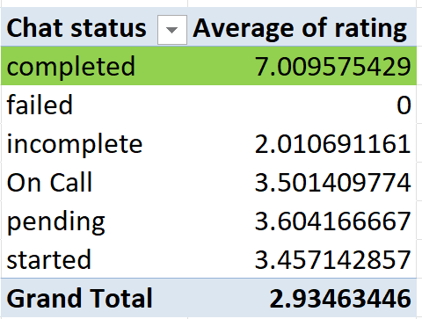
- Chat Status: If the chat status is completed then the average rating is 7, so this has a great effort on the customer satisfaction. To improve the customer satisfaction the gurus should complete as many chats as possible so that every customer is happy with the service provided.
- Call Status: If the call status is completed then the average rating is 4.5, from the pivot table we can see that it has highest rating than other status. The gurus must complete the call in order to optain good ratings from the customers.
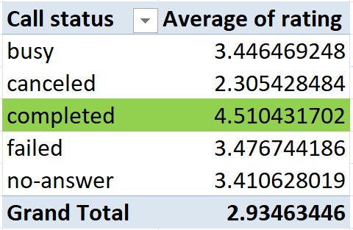
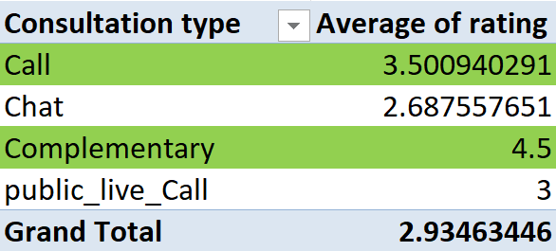
- Consultation type: Calls and Complementary has good ratings among all, the astrosage should concentrate more on the call and the complementary to attract more customers and give them the best service possible.

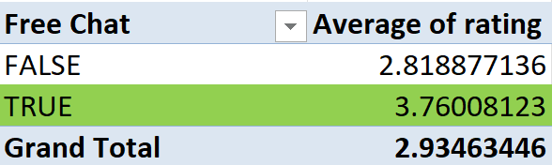
- Free Chat: Free Chat has more ratings then the paid chat, so initially to gain the customers astrosage should proved free chats for everyone or for each customer first two or chats must be free so that the customer can trust the service.

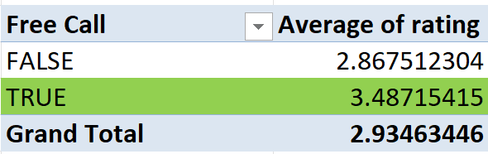
- Free Call: It’s the same as free chat, Astrosage should proved atleast one free call for the customers to understand how the Astrosage works and about the service in a better way.

Recommendations
- Proper call volume distribution: Customer experience gradually improves when the agents handle lesser customers, their consultation and rating are better. The rating drops if the agents become overburden in providing efficiency to the customers. High customers satisfactions are contributed by agents having high demand and higher expertise.
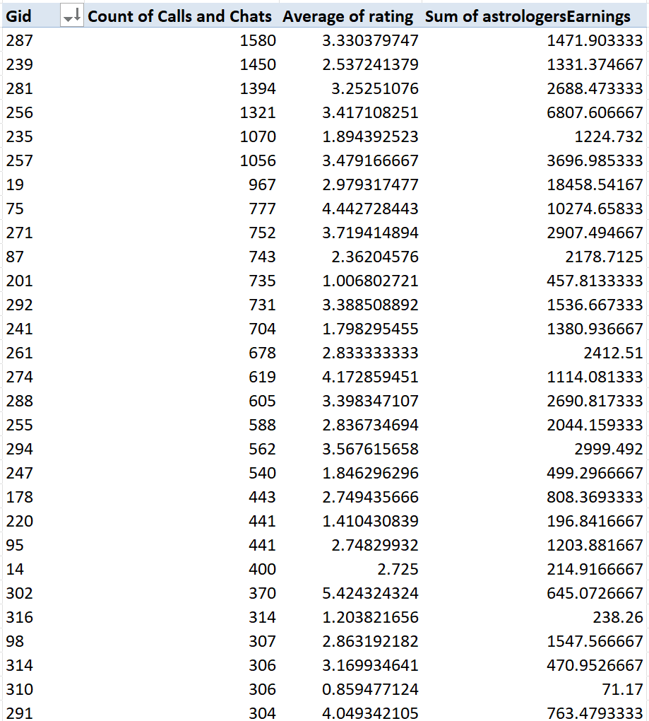
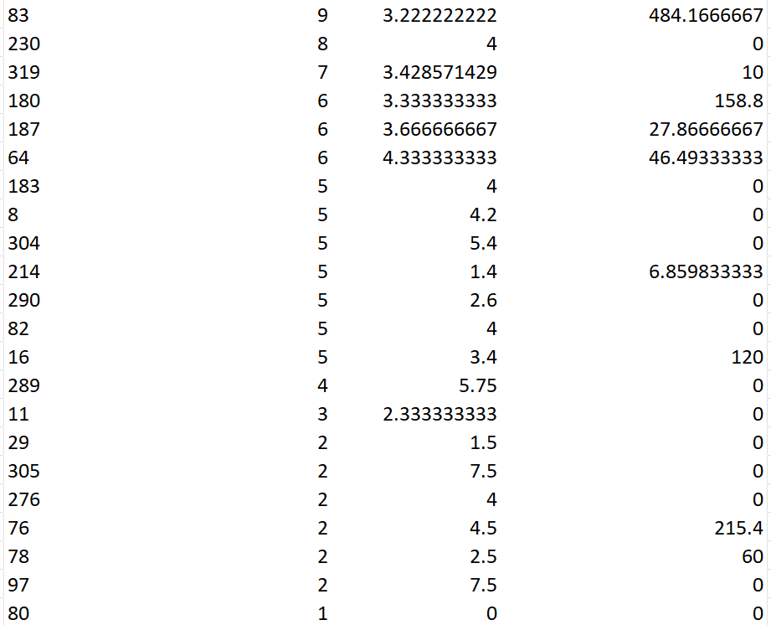
- An Agent who is experienced, well learned and manage well trained agents with effectively lower call volumes would provide better output to customers.

From the above pivot table we can understand that agents handling more consultations have very less rating, where as agents with less no of consultations have higher rating then agents with high no of consultations, the insight is that agents handling consultations within their limit are maintaining better rating.
There is nothing to do with the guru earning with the rating there is only 0.02 correaltion between rating and earnings.
From all the insights above I can say that customer satisfaction score influences the ratings.
Task 7: How should the call center balance the workload among agents to ensure optimal performance and avoid burnout? Mention your approach and spreadsheet function for the answer.
Ans: This is the approach and spreadsheet functions I follow to balance the workload among the agents:
Step 1: Analysing Current Workload Distribution
- Create pivot table
- Rows: Agent names
- Value: Count of CallSID or Call duration
This shows total calls handled by each agent.
From the below pivot table we can understand that there is not workload distribution among agents, some agents are handling too many calls where some agents handling calls below 5. The uneven call distribution should be handled to make customers satisfied and get better ratings.
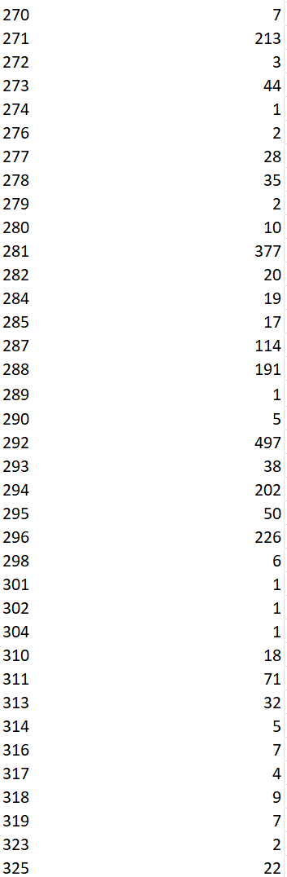
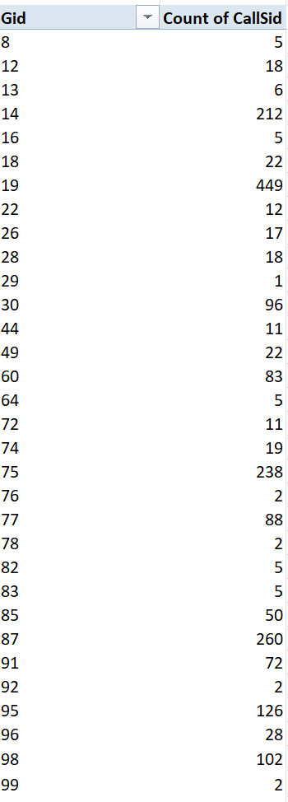
Step 2: Identify Overloaded Agents
Using AVERAGE() to find the average workload across all agents:
AVERAGE(PIVOT_TABLE_RANGE)
Then by using Conditional Formatting to highlight:
- Agents above the average → Overloaded
- Agents below the average → Underutilized
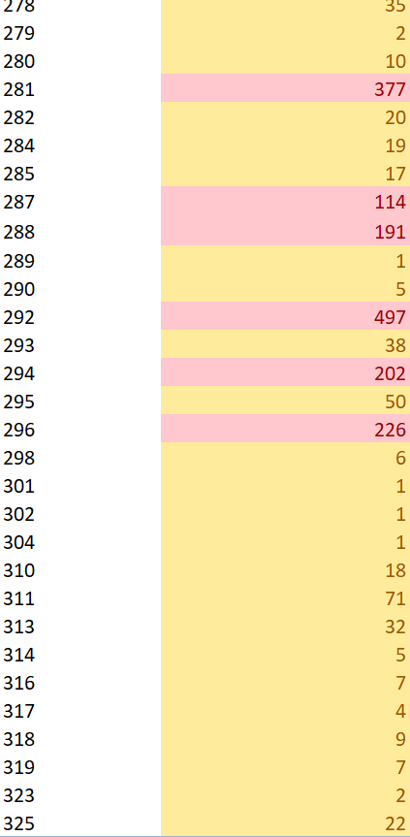
Average calls per agent = 76.008
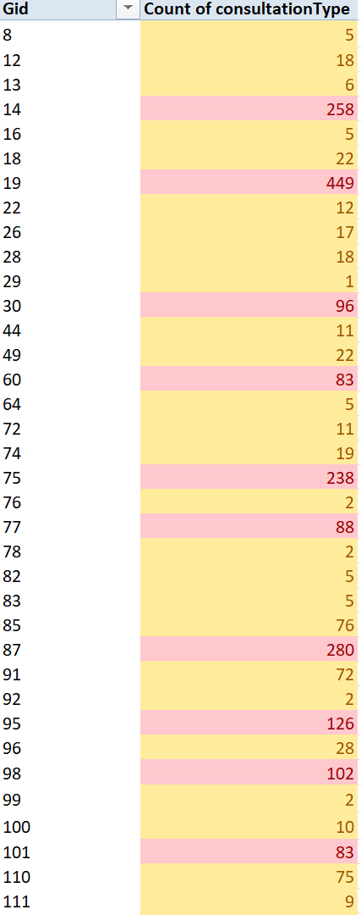
In the above pivot table the Gid in the yellow represents agents with less then the average calls per agent while red shows agents with calls more then the average calls.
Step 3: Balance Strategy
- Redistribute Calls:
- Using the PivotTable to see imbalance.
- Reassign clients from overloaded to underutilized agents.
- Flexible Scheduling:
- Adjust shift timings based on call volume.
- Historical call data can be analysed to predict the peak periods and then schedule the employees accordingly. This enables the management to employ adequate personnel during the busy hours.
- One should also introduce shift work so that the agents do not always work during periods when stress levels are high. This rotation assists in ensuring that other members of the team are also involved in handling the work.
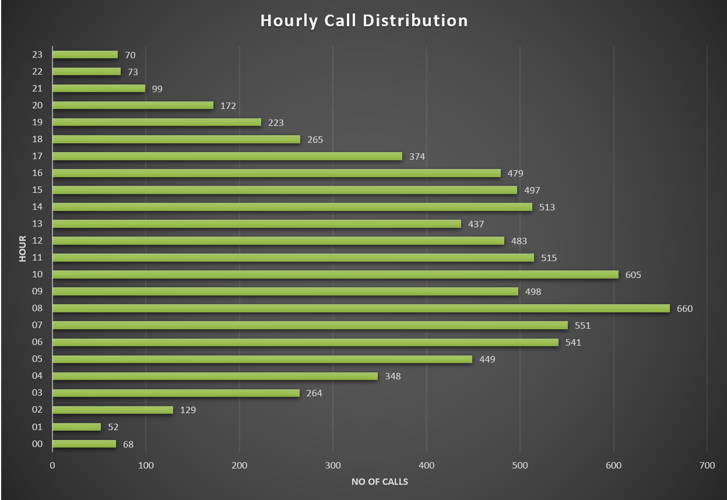
- Monitor the performance of call center in real time using tools that will help in monitoring call handling time, queue lengths, and the workload of the agents. In case any particular agent is receiving a large number of calls more than others, then managers should step in to modify the distribution of the call.
Task 8: What new technologies or tools could be implemented to enhance call center operations and customer service?
Ans: The new technologies or tools that could be implemented to enhance call center operations and customer service are
- AI-Powered Call Routing: Automatically directs customer calls to the most suitable agent based on issue type, sentiment, or past interactions.
Benefits:
- Reduces call transfer time.
- Balances workload effectively.
- Improves first-call resolution.
- Customer Relationship Management: Integrating tools like Salesforce or Zoho CRM with call systems.
Benefits:
- Centralized customer data for personalized responses.
- Increases agent efficiency.
- Sentiment Analysis: Uses AI to analyse tone, sentiment, and keywords in reviews and recorded calls.
Benefits:
- Detecting frustrated or unsatisfied customers early.
- Improves quality assurance and training insights.
- Chatbots & Virtual Assistants: Deploy AI chatbots for routine queries.
Benefits:
- 24/7 support without extra staff.
- Frees up agents for complex calls.

Task 9: What metrics should be included in the final dashboard to comprehensively view call center performance and guide investment decisions?
Ans: The metrics which I will be including in the final dashboard to comprehensively view call center performance and guide investment decisions are
- User rating distribution: This tells us where the call center was lagging and what actions should be taken in order to pull it of with a suitable action. As we can see from the below graph that most of the ratings are below 4 so the call center should invest to take actions to satisfy the customers to get better ratings.
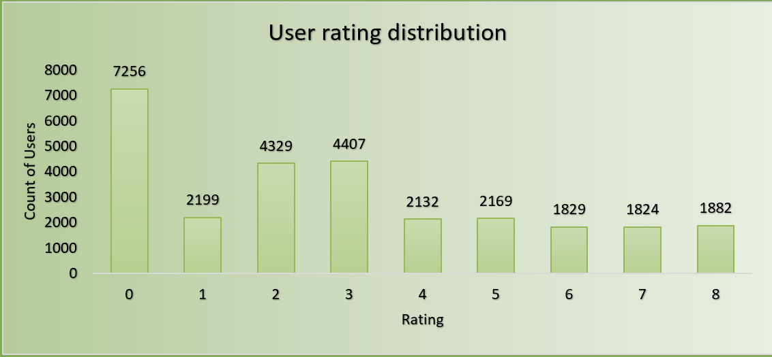
- Total revenue by each category: The revenue by each category gives insights about how each category is performing well and which is not. This insights will help the call center to focus more on the category which is not performing well.
- Website type: We can analyse each website type to get better understanding about how many customers are using which type. The call center can improve the website type which has less customer then the other type.
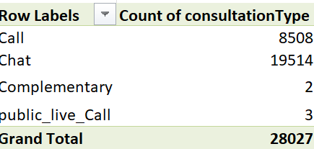
- Consultation type: This plays an important roll as we can we from the below pivot table that Chat has more then half of the customer consultations, to improve the consultations on the other types the investment should be spend on it in order to obtain more consultations for every type.

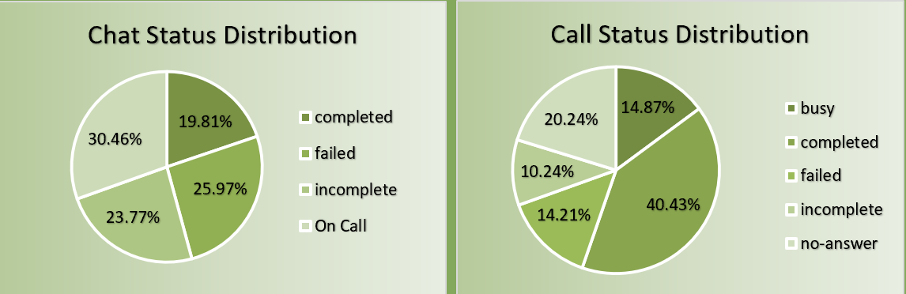
- Chat and call status distribution: The status distribution gives exact insights on what is the status of the customers. The call center should focus more on completing each and every call and chats rather then leaving it incomplete or in a failed state.
Task 10: How would you allocate a 1 crore rupee investment to optimize operational efficiency, enhance customer satisfaction, and boost profitability, and what analysis based recommendations would you offer to support this?
Ans: This is the strategy I will follow to allocate investment to optimize operational efficiency, enhance customer satisfaction, and boost profitability.
- Technology Upgrades – ₹40 Lakhs (40%)
- Implementing AI-powered chatbot systems to automate basic queries and reduce agent workload.
- Introduce analytics dashboards (Power BI/Tableau) for real-time performance monitoring.
- Adopt CRM software (like Salesforce) for centralized customer data and personalized service.
- Agent Training & Development – ₹20 Lakhs (20%)
- Conduct soft skills and technical training to improve first call resolution and satisfaction scores.
- Introduce performance-based incentives tied to satisfaction and efficiency metrics.
- Correlation analysis (CORREL() between training hours and satisfaction score) often shows a positive link.
- Workforce Expansion & Optimization – ₹15 Lakhs (15%)
- Hire additional part-time or full-time agents during peak call periods (identified using PivotTable or Chart by time).
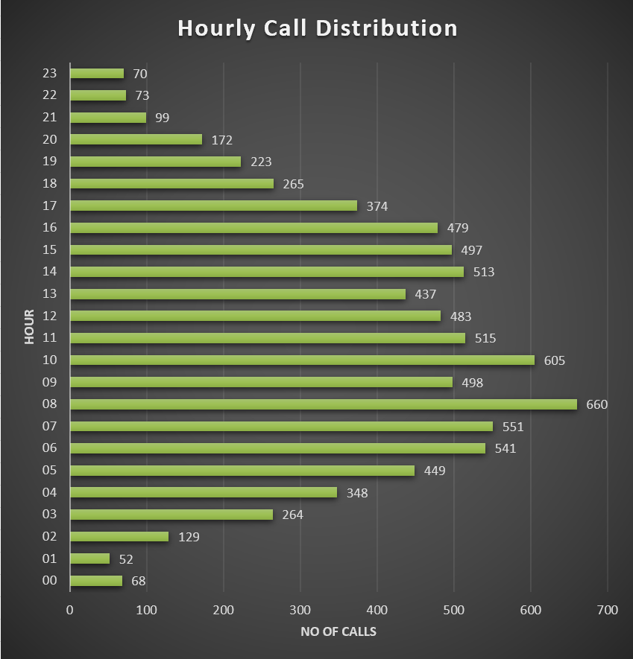
- Use workforce management tools for optimal shift scheduling.

- Call volume per agent and average wait time (AVERAGE() + MAX() analysis) indicate agent overload → hiring reduces burnout.
- Customer Experience Enhancement – ₹10 Lakhs (10%)
- Launch automated feedback surveys post-call to measure satisfaction in real time.
- Offer loyalty or referral incentives to repeated customers.
- Customer satisfaction trends (AVERAGEIFS() by category/guru) show improvement opportunities in specific segments.
- Infrastructure & System Upgrades – ₹10 Lakhs (10%)
- Upgrade internet, telephones, and system reliability to reduce downtime.
- Introduce cloud-based call recording and monitoring for quality control.
- Downtime logs (counted via COUNTIF() on “System Error” tags) highlight lost efficiency.
- Contingency Reserve – ₹5 Lakhs (5%)
- Maintain a safety buffer for unexpected expenses or scaling of successful pilot projects.
Analysis-Based Recommendations
- Use PivotTables & Trend Analysis to monitor key KPIs like call volume, response time, and satisfaction.
- Apply Scenario Analysis / What-If Analysis in Excel to simulate ROI from different investment combinations.

