CHINOOK MUSIC STORE ANALYSIS
Objective Questions
1. Does any table have missing values or duplicates? If yes how would you handle it?
Ans: The data doesn’t have any duplicate values in all the tables, but the data have the null values in columns of two tables as given below
1. customers table - company, state, postal_code, phone, fax
2. track table – composer
There are two ways to handle missing or NULL values:
1. Using COALESCE() to handle null values in select statements
SYNTAX : COALESCE(column_name, “value to replaces NULL”)
2.Using UPDATE statement to replaces NULL values in the tables.
SYNTAX : UPDATE table_name
SET column_name = “value”
WHERE condition;
Table with NULL values | Column Name | Value used to replace NULL
customer | company | “Unknown”
customer | state | “Unknown”
customer | postel_code | “Unknown”
customer | phone | “+0 000 000-0000”
customer | fax | “+0 000 000-0000”
track | composer | “Unknown”

Queries used to handle missing or NULL values:
S.NO. | Using COALESCE() | Using UPDATE
1 | SELECT COALESCE(company, “Unknown”)  FROM customer; | UPDATE customer  SET company = "Unknown"  WHERE company IS NULL;
2 | SELECT COALESCE(state, “Unknown”)  FROM customer; | UPDATE customer  SET state = "Unknown"  WHERE state IS NULL;
3 | SELECT COALESCE(postal_code, “Unknown”)  FROM customer; | UPDATE customer  SET postal_code = "Unknown"  WHERE postal_code IS NULL;
4 | SELECT COALESCE(phone, “+0 000 000-0000”)  FROM customer; | UPDATE customer  SET phone = "+0 000 000-0000"  WHERE phone IS NULL;
5 | SELECT COALESCE(fax, “+0 000 000-0000”)  FROM customer; | UPDATE customer  SET fax = "+0 000 000-0000"  WHERE fax IS NULL;
6 | SELECT COALESCE(composer, “Unknown”)  FROM track; | UPDATE track  SET composer = 'Unknown'  WHERE composer IS NULL;

2. Find the top-selling tracks and top artist in the USA and identify their most famous genres.
Ans: To find the top-selling tracks and top artist in the USA and most famous genres, I have joined the tables listed below to get the required data to solve the question. I have filtered the joined data using WHERE clause and used GROUP BY clause to aggregate the data to find top tracts, artists and genres. I have taken total revenue in decreasing order as the key point to list the top tracts, artists and genres.
- Tables used: invoice, invoice_line, track, album, artist, genre
- Concepts used: Joins, GROUP BY, Aggregate Functions, ORDER BY (Sorting)
Query:
SELECT
t.name AS track_name,
ar.name AS artist_name,
g.name as genre_name,
SUM(i.total) total_revenue,
COUNT(t.track_id) AS total_purchases
FROM invoice i
JOIN invoice_line il ON i.invoice_id = il.invoice_id
JOIN track t ON il.track_id = t.track_id
JOIN album al ON t.album_id = al.album_id
JOIN artist ar ON al.artist_id = ar.artist_id
JOIN genre g ON t.genre_id = g.genre_id
WHERE i.billing_country = "USA"
GROUP BY t.name, ar.name, g.name
ORDER BY total_revenue DESC
LIMIT 10;
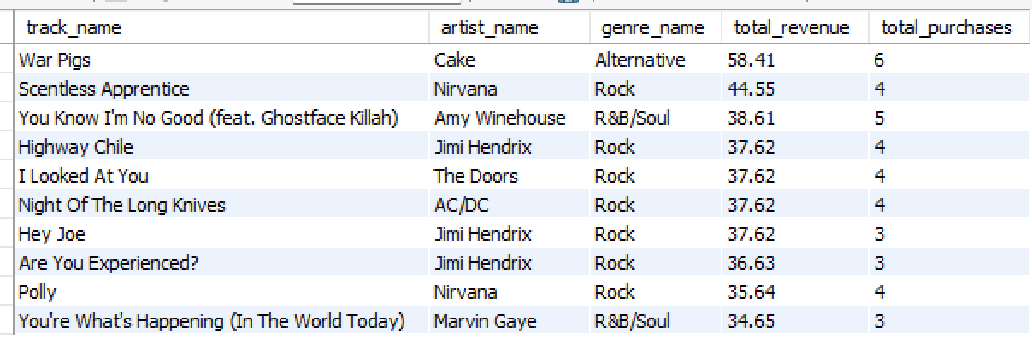
Output:

The insights from the output are Jimi Hendrix is top artists and other artists as well are in the top artist list, when it comes to most famous genres Rock, R&B/Soul and Alternative made the place.
3. What is the customer demographic breakdown (age, gender, location) of Chinook's customer base?
Ans: To find the customer demographic breakdown based on location I have taken customer table and then used GROUP BY clause on country, state and city so that I can use aggregate function i.e. COUNT() to get the customer_count based on cutomer location.
- Table used: customer
- Concepts used: Aggregate Functions, GROUP BY, ORDER BY
Query:
SELECT
country,
state,
city,
COUNT(*) AS customer_count
FROM customer
GROUP BY country, state, city
ORDER BY country, state, city;
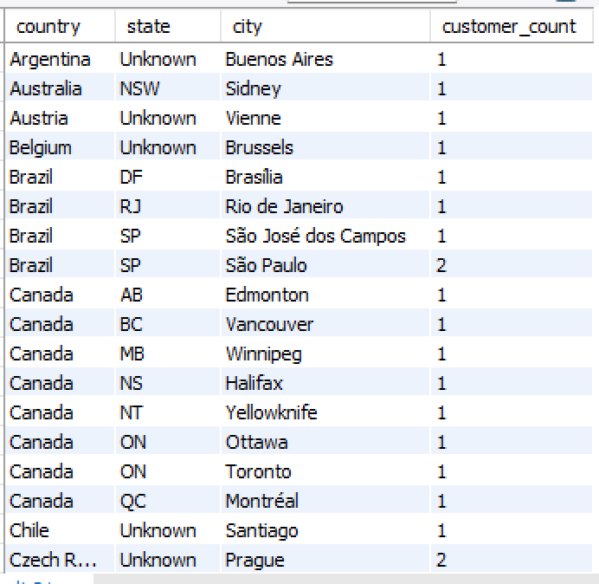
Output:
4. Calculate the total revenue and number of invoices for each country, state, and city:
Ans: To find the total revenue and number of invoices for each country, state, and city I have taken invoice table and then used GROUP BY clause on billing_country, billing_state and billing_city so that I can use aggregate function i.e. SUM() and COUNT() to get the total revenue and number of invoices for each country, state, and city. I have ordered the output based on ascending order of billing_country and decending order of total revenue.
- Table used: invoice
- Concepts used: Aggregate Functions, GROUP BY, ORDER BY
Query:
SELECT
billing_country,
billing_state,
billing_city,
SUM(total) AS total_revenue,
COUNT(invoice_id) AS total_invoices
FROM invoice
GROUP BY billing_country, billing_state, billing_city
ORDER BY billing_country, total_revenue DESC;
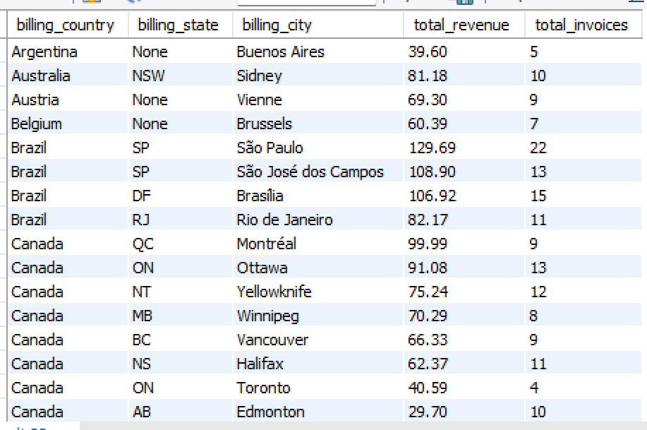
Output:
5. Find the top 5 customers by total revenue in each country
Ans. To find the top 5 customers by total revenue in each country I have joined invoice and customer table, then by using GROUP BY clause on country and customer so that I can use aggregate function i.e. SUM() to calculate total revenue. I also used the RANK() window function so rank the customer on decreasing order of total revenue where the window was partitioned by country and I have selected the customer with rank less then or equal to 5.
- Table used: invoice and customer
- Concepts used: CTE, Aggregate Functions, RANK() OVER(), Joins, GROUP BY, ORDER BY
Query:
WITH cus_data AS (
SELECT
c.customer_id,
c.first_name,
c.last_name,
c.country,
SUM(i.total) AS total_revenue,
RANK() OVER(PARTITION BY c.country ORDER BY SUM(i.total) DESC) AS rnk
FROM invoice i
JOIN customer c ON i.customer_id = c.customer_id
GROUP BY c.customer_id, c.first_name, c.last_name, c.country
)

SELECT
customer_id,
first_name,
last_name,
country,
total_revenue
FROM cus_data
WHERE rnk <= 5
ORDER BY country, total_revenue DESC;
Output:
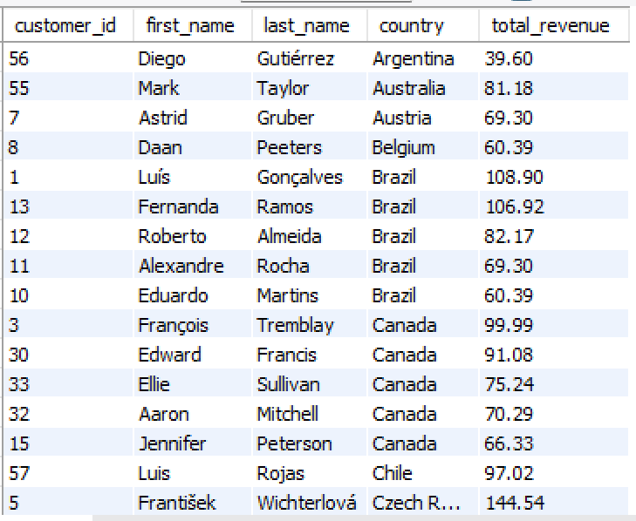

6. Identify the top-selling track for each customer
Ans: To find the top-selling track for each customer I have joined customer, invoice, invoice_line and track tables. I have used GROUP BY clause on customer details and then used aggregate functions to find the total tracks sold and total revenue for each customer. I have assigned ranks to customers based on total tracks sold using RANK() OVER() window function and displayed the results only of rank equal to 1 to find top selling track for each customer. At last I have stored the data by using ORDER BY on total tracks sold in decreasing order and customer_id in increasing order.
- Table used: customer, invoice, invoice_line and track
- Concepts used: CTE, Aggregate Functions, RANK() OVER(), Joins, GROUP BY, ORDER BY
Query:
WITH cus_data AS (
SELECT
c.customer_id,
CONCAT(c.first_name, " ", c.last_name) AS customer_full_name,
t.track_id,
t.name AS track_name,
COUNT(il.quantity) AS total_tracks_sold,
SUM(i.total) AS total_cost,
RANK() OVER(PARTITION BY c.customer_id ORDER BY COUNT(il.quantity) DESC, SUM(i.total) DESC) AS rnk
FROM customer c
JOIN invoice i ON c.customer_id = i.customer_id
JOIN invoice_line il ON i.invoice_id = il.invoice_id
JOIN track t ON il.track_id = t.track_id
GROUP BY c.customer_id, c.first_name, c.last_name, t.track_id, t.name
)

SELECT *
FROM cus_data
WHERE rnk = 1
ORDER BY total_tracks_sold DESC, customer_id;
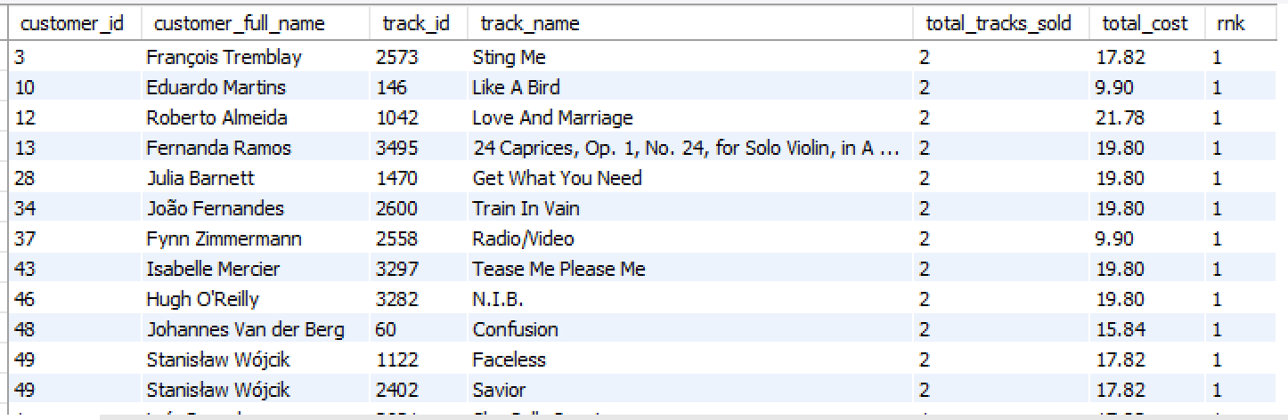
Output:

7. Are there any patterns or trends in customer purchasing behavior (e.g., frequency of purchases, preferred payment methods, average order value)?
Ans: To find the patterns or trends in customer purchasing behavior based on frequency of purchases, average order value I have joined customer and invoice table then used GROUP BY clause on customer details, later used aggregate function like AVG(), COUNT() and SUM() to find the frequency of purchases and average order value, then I ordered the result by customer_id.
- Table used: invoice and customer
- Concepts used: CTE, Aggregate Function, Joins, GROUP BY, ORDER BY
Query:
WITH summary_data AS (
SELECT
c.customer_id,
CONCAT(c.first_name, " ", c.last_name) AS customer_name,
MIN(DATE(invoice_date)) AS first_purchase,
MAX(DATE(invoice_date)) AS lastest_purchase,
ROUND(
DATEDIFF(MAX(invoice_date), MIN(invoice_date))
/
COUNT(i.invoice_id) - 1
, 0) as avg_days,
COUNT(i.invoice_id) AS total_purchases,
SUM(i.total) AS total_purchase_amount,
ROUND(AVG(i.total), 2) AS avg_purchase_amount
FROM customer c
JOIN invoice i ON c.customer_id = i.customer_id
GROUP BY c.customer_id, c.first_name, c.last_name
)

SELECT *
FROM summary_data
ORDER BY customer_id;
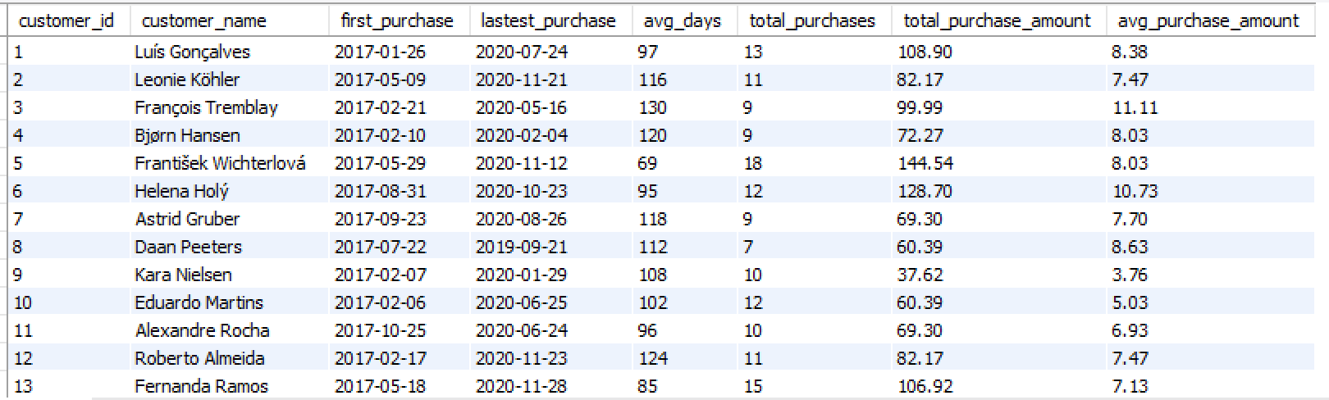
Output:
8. What is the customer churn rate?
Ans: I have taken churn period as 6 months with the reference to the date ‘2020-12-30’.
Churn rate = No.of customers not in the period * 100 / total no.of cutomers
I found out the customers who purchased in the last 6 months, by using this list of customers I found out the customers not in the above list this gives me the customers who didn’t make any purchase in the last 6 months. I have counted the customers who didn’t make any purchase in the given period and divided it by total no.of customers.
- Table used: invoice and customer
- Concepts used: CTE, Aggregate Function, Sub Queries, ORDER BY
Query:
WITH filter_data AS (
SELECT
DISTINCT customer_id
FROM invoice
WHERE invoice_date >= '2020-12-30' - INTERVAL 6 MONTH
),
chunk_customers AS (
SELECT
customer_id
FROM customer
WHERE customer_id NOT IN (SELECT customer_id FROM filter_data)
)

SELECT
(SELECT COUNT(DISTINCT customer_id) FROM invoice) AS total_customers,
(SELECT COUNT(*) FROM chunk_customers) AS total_chunk_customers,
ROUND(
((SELECT COUNT(*) FROM chunk_customers) * 100)
/
(SELECT COUNT(DISTINCT customer_id) FROM invoice)
, 2) AS customer_chunk_rate
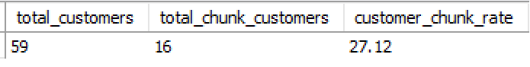
Output:

9. Calculate the percentage of total sales contributed by each genre in the USA and identify the best-selling genres and artists.
Ans:
9.1 Percentage of total sales contributed by each genre in the USA
I have joined invoice, invoice_line, track and genre tables to obtain the data needed to solve the problem. I used GROUP BY clause on genre_name to find the total sales made by each genre, then I calculated total sales in the USA country. To find the percentage of each genre I have divided the corresponding genre sales by total revenue.
- Table used: invoice, invoice_line, track and genre
- Concepts used: CTE, GROUP BY, Aggregate Function, Sub Queries, ORDER BY
Query:
WITH genre_sales AS (
SELECT
g.name AS genre_name,
sum(il.unit_price * il.quantity) AS revenue
FROM invoice i
JOIN invoice_line il ON i.invoice_id = il.invoice_id
JOIN track t ON il.track_id = t.track_id
JOIN genre g ON t.genre_id = g.genre_id
WHERE i.billing_country = "USA"
GROUP BY g.name
),
total_sales AS (
SELECT
sum(il.unit_price * il.quantity) AS total_revenue
FROM invoice i
JOIN invoice_line il ON i.invoice_id = il.invoice_id
WHERE billing_country = "USA"
)

SELECT
genre_name,
ROUND( revenue * 100 / (SELECT total_revenue FROM total_sales), 2) AS percentage_sales
FROM genre_sales
ORDER BY percentage_sales DESC;
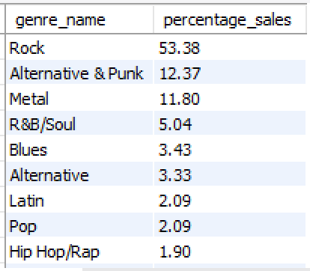
Output:
9.2 Best selling genres and artists in USA
To find the best selling genres and artist in the USA, I have joined the tables listed below to get the required data to solve the question. I have filtered the joined data using WHERE clause and used GROUP BY clause to aggregate the data to find best selling artists and genres. I have taken total revenue in decreasing order as the key point to list the best selling artists and genres.
- Tables used: invoice, invoice_line, track, album, artist, genre
- Concepts used: Joins, GROUP BY, Aggregate Functions, ORDER BY
Query:
SELECT
ar.name AS artist_name,
g.name as genre_name,
SUM(il.unit_price * il.quantity) total_revenue
FROM invoice i
JOIN invoice_line il ON i.invoice_id = il.invoice_id
JOIN track t ON il.track_id = t.track_id
JOIN album al ON t.album_id = al.album_id
JOIN artist ar ON al.artist_id = ar.artist_id
JOIN genre g ON t.genre_id = g.genre_id
WHERE i.billing_country = "USA"
GROUP BY ar.name, g.name
ORDER BY total_revenue DESC
LIMIT 5;
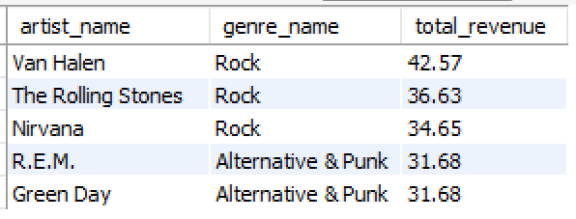
Output:

10. Find customers who have purchased tracks from at least 3 different genres
Ans: To find customers who have purchased tracks from at least 3 different genres, I have joined the tables listed below to get the required data to solve the question. I have used GROUP BY clause on customer details and used aggregate function i.e., COUNT() to get the distinct genres purchased by each customer. I have taken different_genres_purchased in decreasing order as the key point to list customers who have purchased tracks from at least 3 different genres.
- Tables used: customer, invoice, invoice_line, track
- Concepts used: Joins, GROUP BY, Aggregate Functions, ORDER BY
Query:
SELECT
c.customer_id,
CONCAT(c.first_name, " ", c.last_name) AS customer_name,
COUNT(DISTINCT t.genre_id) AS different_genres_purchased
FROM customer c
JOIN invoice i ON c.customer_id = i.customer_id
JOIN invoice_line il ON i.invoice_id = il.invoice_id
JOIN track t ON il.track_id = t.track_id
GROUP BY c.customer_id, c.first_name, c.last_name
HAVING COUNT(DISTINCT t.genre_id) >= 3
ORDER BY different_genres_purchased DESC, c.customer_id;

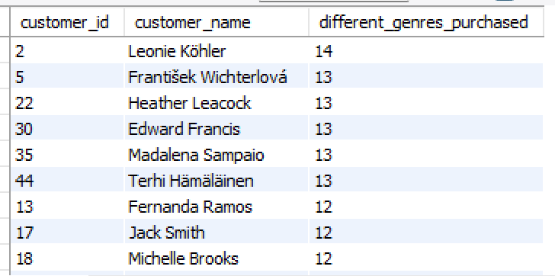
Output:
11. Rank genres based on their sales performance in the USA
Ans: To Rank genres based on their sales performance in the USA, I have joined the tables listed below to get the required data to solve the question. I have used GROUP BY clause on genre details and used aggregate function i.e., SUM() to calculate total sales per each. Then used RANK() OVER() window function to rank the genre based on decreasing order of total sales.
- Tables used: invoice, invoice_line, track and genre
- Concepts used: RANK() OVER(), Joins, GROUP BY, Aggregate Functions, ORDER BY
Query:
SELECT
g.genre_id,
g.name AS genre_name,
SUM(il.quantity * il.unit_price) AS total_sales,
RANK() OVER(ORDER BY SUM(il.quantity * il.unit_price) DESC) AS genre_rank
FROM invoice i
JOIN invoice_line il ON i.invoice_id = il.invoice_id
JOIN track t ON il.track_id = t.track_id
JOIN genre g ON t.genre_id = g.genre_id
WHERE i.billing_country = "USA"
GROUP BY g.genre_id, g.name
ORDER BY genre_rank;
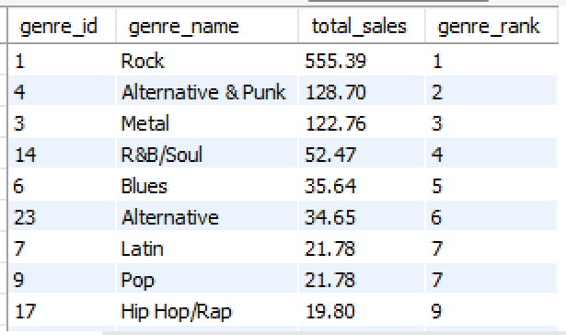
Output:
12. Identify customers who have not made a purchase in the last 3 months
Ans: To find out the customers who have not made a purchase in the last 3 months with respect to date ‘2020-12-30’. I have taken a list of customers who purchased in last 3 month in the CTE. Later I joined customer and invoice tables and made a list of customers who was not in the list given by CTE result, I also used GROUP BY just to calculate the last purchase date of customers who haven’t purchased in last 3 months and ordered the result on increasing order og customer_id.
There are total 22 customers who haven’t made any purchases in last 3 months.
- Tables used: customer and invoice
- Concepts used: CTE, Joins, GROUP BY, Aggregate Functions, ORDER BY
Query:
SELECT
MAX(invoice_date) as latest_sales_date
FROM invoice;
-- '2020-12-30'

-- To find customers who have not made a purchase in the last 3 months
WITH cus_data AS (
SELECT
DISTINCT customer_id
FROM invoice
WHERE invoice_date >= '2020-12-30' - INTERVAL 3 MONTH
)
SELECT
c.customer_id,
CONCAT(c.first_name, " ", c.last_name) AS customer_name,
MAX(DATE(i.invoice_date)) AS last_purchase_date
FROM customer c
JOIN invoice i ON c.customer_id = i.customer_id
WHERE c.customer_id NOT IN (SELECT customer_id FROM cus_data)
GROUP BY c.customer_id, c.first_name, c.last_name
ORDER BY c.customer_id;
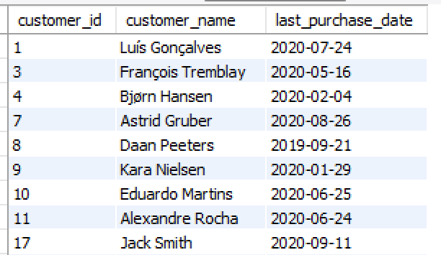
Output:

Subjective Questions
1. Recommend the three albums from the new record label that should be prioritised for advertising and promotion in the USA based on genre sales analysis.
Ans: To recommend the three albums for advertising and promotion in the USA based on genre sales analysis, I have joined the below listed tables to get the data to solve the problem, by using WHERE clause I have filtered only USA data, and then I have used GROUP BY clause on album and genre data, also used aggegate function i.e.. SUM() to calculate the total sales. I have ordered the result set based on decreasing order of total sales and took only top 5 ablums.
- Tables used: invoice, invoice_line, track, genre, album, artist
- Concepts used: CTE, Joins, GROUP BY, Aggregate Functions, ORDER BY
Query:
SELECT
al.album_id,
al.title AS album_title,
ar.name AS artist_name,
g.name AS genre_name,
SUM(il.unit_price * il.quantity) AS total_sales
FROM invoice i
JOIN invoice_line il ON i.invoice_id = il.invoice_id
JOIN track t ON il.track_id = t.track_id
JOIN genre g ON t.genre_id = g.genre_id
JOIN album al ON t.album_id = al.album_id
JOIN artist ar ON al.artist_id = ar.artist_id
WHERE i.billing_country = "USA"
GROUP BY al.album_id, al.title, ar.name, g.name
ORDER BY total_sales DESC, genre_name
LIMIT 5;

Output:
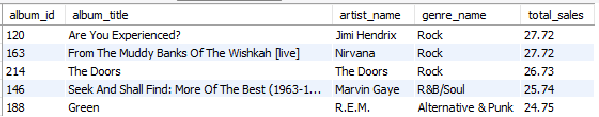
Insights:
- USA music market is dominated by Rock, R&B/Soul and Alternative & Punk genres.
- Top 5 albums belongs to the 3 genres mentioned above.
- Top artists belongs to Jimi Hendrix, From The Muddy Banks Of The Wishkah [live], The Doors.
Visualization:

Recommendations:
Based on the analysis on album and genre level the below albums must be prioritised for advertising and promotion in the USA:
- Are You Experienced? – Jimi Hendrix (Rock)
- From The Muddy Banks Of The Wishkah [live] – Nirvana (Rock)
- The Doors – The Doors (Rock)

2. Determine the top-selling genres in countries other than the USA and identify any commonalities or differences.
Ans: To find the top-selling genres in countries other than the USA, I have joined the tables listed below to get the required data to solve the question. I have used GROUP BY clause on genre details and used aggregate function i.e., SUM() to calculate total sales. I have taken total sales of genres in decreasing order and only top 5 genres into consideration.
- Tables used: invoice, invoice_line, track and genre
- Concepts used: Joins, GROUP BY, Aggregate Functions, ORDER BY
Query:
SELECT
g.genre_id,
g.name AS genre_name,
SUM(il.unit_price * il.quantity) AS total_sales
FROM invoice i
JOIN invoice_line il ON i.invoice_id = il.invoice_id
JOIN track t ON il.track_id = t.track_id
JOIN genre g ON t.genre_id = g.genre_id
WHERE i.billing_country != "USA"
GROUP BY g.genre_id, g.name
ORDER BY total_sales DESC, genre_name
LIMIT 5;

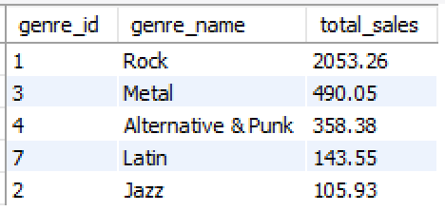
Output:

Visualization:

Insights:
- From the charts we can observe some similarities between them, such as Rock genre being the most selling not only in USA but also in other countries as well.
- Metal and Alternative & Punk were in the 2nd and 3rd place in other countries but where as in USA the positions got swapped that is Alternative & Punk was at 2nd and Metal was at 3rd place.
- When it comes to 4th and 5th place it belongs to Latin and Jazz genres in other countries, In USA 4th and 5th position was taken by R&B/Soul and Blues.

3. Customer Purchasing Behaviour Analysis: How do the purchasing habits (frequency, basket size, spending amount) of long-term customers differ from those of new customers? What insights can these patterns provide about customer loyalty and retention strategies?
Ans: To find the customer purchasing behaviour on basis of purchase frequency, basket size and spending amount, I have joined invoice and invoice_line tables in order to get the required data to solve the question. As per my Observation all the customers were registered in year 2017 so there is no meaning in breaking customer as new and old within the same year, so to solve the question I have taken orders in or below 2019 as Long-term and order in 2020 as New. I have used Case statement to group order into long-term and new as customer category, also grouped the data on customer category to calculate average purchase frequency, average basket size and average spending amount.
- Tables used: invoice and invoice_line
- Concepts used: Joins, GROUP BY, Aggregate Functions, Case statements

Query:
WITH cus_data AS (
SELECT
CASE
WHEN YEAR(invoice_date) <= 2019 THEN 'Long-Term'
ELSE 'New'
END AS customer_category,
COUNT(DISTINCT i.invoice_id) AS purchase_frequency,
SUM(il.quantity) / COUNT(DISTINCT i.invoice_id) AS avg_basket_size,
SUM(i.total) AS total_amount
FROM invoice i
JOIN invoice_line il ON i.invoice_id = il.invoice_id
GROUP BY customer_category
)

SELECT
customer_category,
ROUND(AVG(purchase_frequency), 2) AS avg_purchase_frequency,
ROUND(AVG(avg_basket_size), 2) AS avg_basket_size,
ROUND(AVG(total_amount), 2) AS avg_total_amount
FROM cus_data
GROUP BY customer_category;

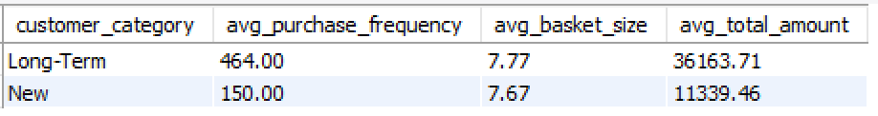
Output:

Visualization:

Insights:
- As we broke the data for Long-team as 3/4th and for New as 1/4th the same patterns were followed by avg_purchase_frequency, avg_basket_size and avg_total_amount as shown in the above graph.
- We can see that the 3 behaviours are following same pattern I can say that Long-term customer retention and loyalty towards Chinook Music Store is high.
- The average no.of purchases by the customers in every year being the same says that the Chinook Music Store was able to satisfy the customer music needs to gain their loyalty.
- In order to increase sales and retention rate music store should focus more on Rock genre because it’s the top genre both in sales and quantity sold all the countries.

4. Product Affinity Analysis: Which music genres, artists, or albums are frequently purchased together by customers? How can this information guide product recommendations and cross-selling initiatives?
Ans: To improve the product recommendations and to identify cross selling initiatives, I have done product affinity analysis on combinations of genres, artists and albums which were frequently purchased together. This information will provide as the idea of customer music listening behaviour and the combinations which can attract the customers.
have joined the tables listed below to get the invoice level data to find the product affinity. I have used CTE for genre affinity, artist affinity and album affinity to find out the combinations with frequent purchases. Then I have performed self join on the CTE on invoice_id with condition as
- For genre CTE: genre_name_1 < genre_name_2
- For artist CTE: artist_name_1 < artist_name_2
- For album CTE: album_title_1 < album_title_2

- Tables used: invoice, invoice_line, track , genre, album and artist
- Concepts used: CTE, Joins, GROUP BY, Aggregate Functions, ORDER BY
Query: Genre Affinity
WITH genre_data AS (
SELECT
i.invoice_id,
g.name
FROM invoice i
JOIN invoice_line il ON i.invoice_id = il.invoice_id
JOIN track t ON il.track_id = t.track_id
JOIN genre g ON t.genre_id = g.genre_id
)

SELECT
g1.name AS genre_1,
g2.name AS genre_2,
COUNT(*) AS genre_frequent_purchases
FROM genre_data g1
JOIN genre_data g2 ON g1.invoice_id = g2.invoice_id AND g1.name < g2.name
GROUP BY g1.name, g2.name
ORDER BY genre_frequent_purchases DESC
LIMIT 5;
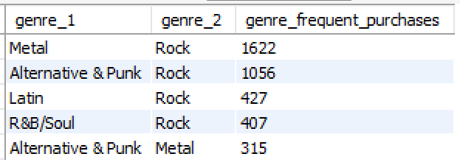
Output:
Query: Artist Affinity
WITH artist_data AS (
SELECT
i.invoice_id,
ar.name
FROM invoice i
JOIN invoice_line il ON i.invoice_id = il.invoice_id
JOIN track t ON il.track_id = t.track_id
JOIN album al ON t.album_id = al.album_id
JOIN artist ar ON al.artist_id = ar.artist_id
)

SELECT
ar1.name AS artist_1,
ar2.name AS artist_2,
COUNT(*) AS artist_frequent_purchases
FROM artist_data ar1
JOIN artist_data ar2 ON ar1.invoice_id = ar2.invoice_id AND ar1.name < ar2.name
GROUP BY ar1.name, ar2.name
ORDER BY artist_frequent_purchases DESC
LIMIT 5;

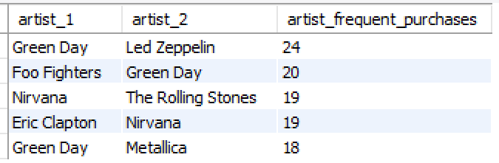
Output:
Query: Album Affinity
WITH album_data AS (
SELECT
i.invoice_id,
al.title
FROM invoice i
JOIN invoice_line il ON i.invoice_id = il.invoice_id
JOIN track t ON il.track_id = t.track_id
JOIN album al ON t.album_id = al.album_id
)

SELECT
al1.title AS album_1,
al2.title AS album_2,
COUNT(*) AS album_frequent_purchases
FROM album_data al1
JOIN album_data al2 ON al1.invoice_id = al2.invoice_id AND al1.title < al2.title
GROUP BY al1.title, al2.title
ORDER BY album_frequent_purchases DESC
LIMIT 5;

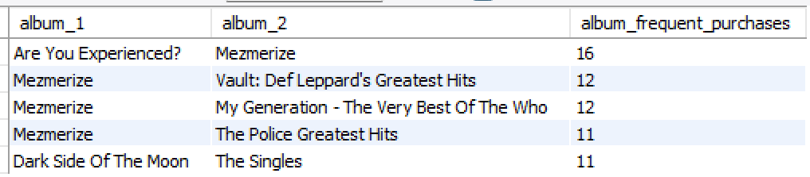
Output:

Insights:
- Rock genre is the most popular genre and it’s is purchased with the combination such as Metal, Alternative & Punk, Latin and R&B/Soul.
- Green Day and Nirvana has a count of 3 and 2 in the top 5 groups which indicates the two artists are famous among the customers and the two artist goes well with other top artists with a great count of combined sales.
- Mezmerize being the top with 4 out 5 top list which achieved top album combinations in frequent purchases this clearly gives us the idea about customer liking and it’s easy to identity that album Mezmerize should be recommended to the customers.
Recommendations:
- Focusing on the top genres, artists and album combinations such as Rock + Metal, Green Day + Led zeppelin and Are You Experienced? + Mezmerize and corresponding combinations will lead to overall sales and customer satisfaction and retention rate.
- Giving Discount and Offers on the combinations which are popular among the customer can gain significate sales and customer retention and also the genre, artist and albums will be known to non-customers to Chinook Music store which may lead to new customers.
- Also performing live music concerts will gain a huge popularity among all the people and the fans of the music combinations mentioned above also will be happy and might also buy the different combinations with their favourite being the common.

5. Regional Market Analysis: Do customer purchasing behaviours and churn rates vary across different geographic regions or store locations? How might these correlate with local demographic or economic factors?
Ans: In order to understand customer regional market analysis I have taken data at country level to do analysis on factors like total revenue, total customers, average order amount, total orders. For each country I also calculated the number of churn customers to find out the churn percentage at country level.
For customer regional market analysis I have used multiple CTEs for purpose like finding out the churned customers and active customers at country level. Also to summarize data at country level for factors like total revenue, total customers, average order amount, total orders. At the last used the CTEs and used Joins in order to combine the results of each CTE. The result set contains Country, total revenue, average order amount, total customers and churn percentage at country level.
- Tables used: invoice
- Concepts used: CTE, Joins, GROUP BY, Aggregate Functions, ORDER BY

Query:
WITH latest_sales AS (
SELECT
customer_id,
MAX(invoice_date) AS latest_purchase
FROM invoice
GROUP BY customer_id
),
churn_data AS (
SELECT
customer_id,
latest_purchase,
CASE
WHEN latest_purchase < '2020-12-30' - INTERVAL 3 MONTH THEN "churned_user"
ELSE "Active_user"
END as customer_category
FROM latest_sales
),
country_data AS (
SELECT
billing_country AS country,
COUNT(DISTINCT customer_id) AS total_customers,
SUM(total) AS revenue,
AVG(total) AS avg_order_amount,
COUNT(invoice_id) AS total_orders
FROM invoice
GROUP BY billing_country
),
chunk_calculations AS (
SELECT
i.billing_country AS country,
c.customer_category,
COUNT(DISTINCT c.customer_id) AS total_customers
FROM invoice i
JOIN churn_data c ON i.customer_id = c.customer_id
AND c.customer_category = "churned_user"
GROUP BY country, c.customer_category
)

SELECT
cd.country,
cd.revenue,
cd.avg_order_amount,
cd.total_orders,
cd.total_customers,
ROUND(
COALESCE(CASE WHEN cc.customer_category = "churned_user" THEN cc.total_customers END, 0) * 100
/
cd.total_customers
, 2) AS churn_percentage
FROM country_data cd
LEFT JOIN chunk_calculations cc ON cd.country = cc.country
ORDER BY cd.country;

Output:
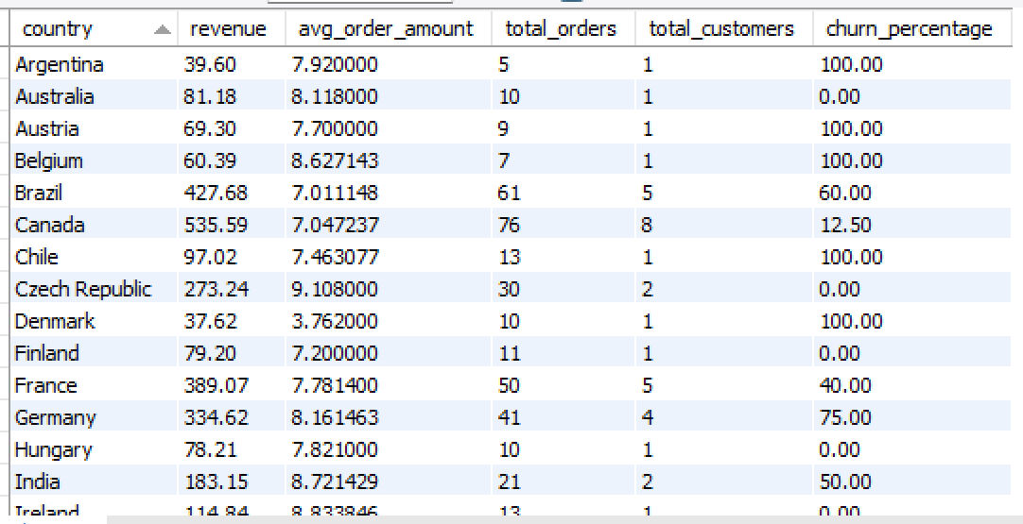
Visualization:

Insights:
- Many countries like Australia, Finland, Hungary, Italy, Poland have a single customer with multiple invoices and with 0 churn percentage.
- Countries with less churn percentage such as USA with 23% have 13 customers and Canada with 12.5% with 8 customers, this shows that this countries have very good retention rate with more customers.
- Countries with little higher churn percentage like India with 50%, Germany with 60% and United Kingdom with 33% have more then 3 customers, they should focus on customer retention rather then attracting new customers.
- Argentina, Austria, Belgium, Chile etc have 100% churn percentage with only single customer with very less order repetition.
Recommendation:
- Chinook Music store must focus on customer retention in countries with moderate churn rate and few customers like Germany, United Kingdom and India.
- Countries with 0% churn rate with single customer must focus on attracting new customers and with very high product publicity and recommendations on basis of customer likings.
- Countries with high and very high churn rate such as Brazil, Argentina, Austria much clearly focus on customer retention also on product recommendation and new gaining new customers.

6. Customer Risk Profiling: Based on customer profiles (age, gender, location, purchase history), which customer segments are more likely to churn or pose a higher risk of reduced spending? What factors contribute to this risk?
Ans: The Chinook Music Store doesn’t have age and gender data so to figure out customer risk profiling I have used customer location previous purchases, total amount spent and total orders into consideration whether the customer falls into high risk or low risk category.
I have used CTEs to find out the total no.of orders made by customers in last 1 year, in the 2nd CTE I have summarized the customer detail such as customer country, total amount spent, total orders and average order amount. Finally I have joined the data from both the CTE’s and to segment the customer into high risk or low risk I have taken a rule into consideration that is, if customer’s last 1 year total orders is less than 1 OR if the total orders less than 5 OR total spent is less than 20$ then customer is said to be at High Risk if not customer is at Low Risk.
- Tables used: invoice
- Concepts used: CTE, Joins, GROUP BY, Aggregate Functions, ORDER BY
Query:
WITH cus_data AS (
SELECT
DISTINCT customer_id,
COUNT(*) AS total_latest_orders
FROM invoice
WHERE invoice_date > '2020-12-30' - INTERVAL 1 YEAR
GROUP BY customer_id
),
summary AS (
SELECT
customer_id,
billing_country AS country,
SUM(total) AS total_spent,
COUNT(*) AS total_orders,
AVG(total) AS avg_order_amount
FROM invoice
GROUP BY customer_id, billing_country
)

SELECT
s.*,
CASE
WHEN c.total_latest_orders < 2 OR s.total_orders < 5 OR s.total_spent < 20 THEN "High Risk"
ELSE "Low Risk"
END customer_status
FROM summary s
JOIN cus_data c ON s.customer_id = c.customer_id
ORDER BY customer_status, s.customer_id;

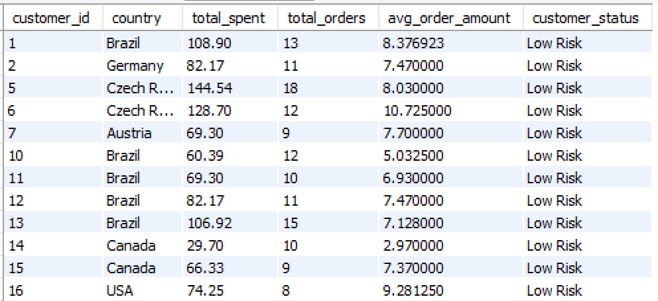
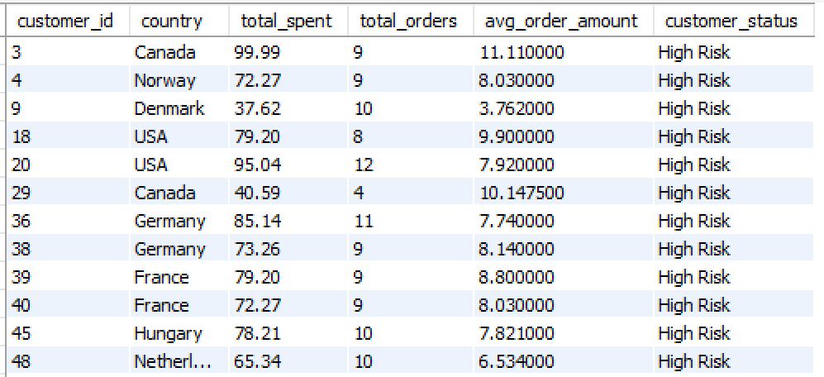
Output:
Visualization:

Insights:
- Customers with more than 10 total orders and spend more than 75$ were at high risk this shows that even with high orders and amount spent doesn’t guarantee customer retention.
- Countries like USA, Indian, Brazil, Canada, Portugal has 0 high risk customers this shows that the Chinook Music store is performing well with high customer retention rate and satisfaction.
- Average amount spent per order doesn’t have any effect on the customer even customers with 2.9$ and 5$ are at low risk.
- Germany and France have equal no.of high risk and low risk customers even with high total amount spent and total orders.
- There are a total of 15 high risk customers in all countries, Chinnok Music Store must focus on this customers to make purchases again to reduce the retention rate.

7. Customer Lifetime Value Modeling: How can you leverage customer data (tenure, purchase history, engagement) to predict the lifetime value of different customer segments? This could inform targeted marketing and loyalty program strategies. Can you observe any common characteristics or purchase patterns among customers who have stopped purchasing?
Ans: To predict the lifetime value of different customer segments by leveraging customer data I have segmented customers into churn and active users. I have used tenure (difference between first purchase date and latest purchase date), total amount spent, total orders, average order amount.
I have joined customer and invoice tables to get data to solve the problem, I have taken latest order date among all customers that is ‘2020-12-30’ as reference to segment the customers into churned customers and active customers. I have grouped the data on customers data in order to calculate first purchase date, latest purchase date, tenure, total amount spent, total orders, average order amount with the help of aggregate functions.
- Tables used: customer and invoice
- Concepts used: Joins, GROUP BY, Aggregate Functions, ORDER BY
Query:
SELECT
c.customer_id,
CONCAT(c.first_name, " ", c.last_name) AS customer_full_name,
MIN(DATE(i.invoice_date)) AS first_purchase,
MAX(DATE(i.invoice_date)) AS latest_purchase,
DATEDIFF(MAX(DATE(i.invoice_date)), MIN(DATE(i.invoice_date))) AS tenure,
SUM(i.total) AS total_spent,
COUNT(i.invoice_id) AS total_orders,
ROUND(AVG(i.total), 2) AS avg_order_amount,
CASE
WHEN MAX(DATE(i.invoice_date)) < '2020-12-30' - INTERVAL 6 MONTH THEN "churned customer"
ELSE "Active customer"
END AS customer_category
FROM customer c
JOIN invoice i ON c.customer_id = i.customer_id
GROUP BY c.customer_id
ORDER BY c.customer_id;

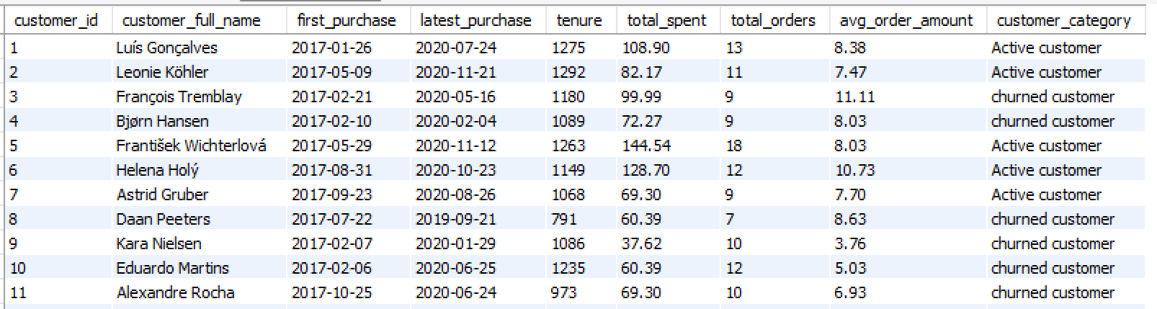
Output:
Visualization:

Insights:
- Customers like Francois Tramblay(id 3), Eduardo Martins (id 10) have tenure more than 1100 and total orders greater than 9, if the Chinook Music Store focus on such customers there are high chances on retaining the customers back.
- Most of the churned customers made 7 to 10 total orders and average order amount was from 5 to 9$, they lost the engagement with the store around mid of 2020.
- Most of the active customers have tenure from 1200 to 1400 days which was a great deal to the music store, they should focus on this customers to keep them purchasing their favorite genre or album tracks.
- Customers like Robert Brown, Diego Gutiérrez have tenure greater then 1000 but the total orders are less then equal to 5 and total amount spent is less then 40$ this indicates this customers are long term customers but with very low engagement with the music store.

8. If data on promotional campaigns (discounts, events, email marketing) is available, how could you measure their impact on customer acquisition, retention, and overall sales?
Ans:
1. Approach:
If promotional campaign data (such as discounts, email marketing, or events) is available, the impact can be measured by comparing customer acquisition, retention, and sales performance before, during, and after the campaign period. Customers exposed to campaigns are compared against those who were not exposed to understand the true effect of promotions on behavior.
2. Query and Explanation:
- The query compares total revenue and order volume before and after a campaign start date (I have taken ‘2019-01-01’ as reference date) to evaluate overall sales uplift.
Query:
SELECT
CASE
WHEN invoice_date < '2019-01-01' THEN 'Before Campaign'
ELSE 'After Campaign'
END AS period,
COUNT(DISTINCT invoice_id) AS total_orders,
SUM(total) AS total_revenue
FROM invoice
GROUP BY period;

- The query checks whether customers purchased or active after the campaign duration which indicates retention. I have taken campaign duration from ‘2019-01-01’ to ‘2019-03-31’.
Query:
SELECT
COUNT(DISTINCT customer_id) AS retained_customers
FROM invoice
WHERE invoice_date > '2019-03-31'
AND customer_id IN (
SELECT DISTINCT customer_id
FROM invoice
WHERE invoice_date BETWEEN '2019-01-01' AND '2019-03-31'
);

3. Insights:
- If the Campaign periods show an increase in total revenue and order volume compared to pre-campaign period then it’s a very positive response from the customers.
- A noticeable number of new customers can be acquired during promotional periods.
- Customers exposed to promotions can demonstrate higher repeat purchase behavior, indicating improved retention.
- Promotional campaigns can positively influence both short-term sales uplift and long-term customer engagement.
4. Recommendations:
- Continue running targeted promotional campaigns focusing on high-performing genres, artists and albums.
- Use email marketing and personalized discounts to convert first-time buyers into repeat customers.
- Track post-campaign behavior to refine retention strategies.
- Invest more in campaigns that drive both acquisition and repeat purchases, rather than one-time sales spikes.

9. How would you approach this problem, if the objective and subjective questions weren't given?
Ans: If the objective and subjective questions were not provided, I would approach the Chinook Music Store analysis using a structured, data-driven analytics framework focused on understanding the data provided, understanding business performance, customer behaviour, and growth opportunities.
1. Understand the Business Context
First, I would clarify the business model of Chinook as a digital music store and identify high-level goals such as:
- Revenue growth
- Customer retention
- Popular product identification
This ensures that the analysis aligns with real business needs, not just technical outputs.
2. Data Understanding & Quality Assessment
I would explore the database schema to understand relationships between customers, invoices, tracks, genres, artists, and employees. I would also assess data quality by checking for:
- Missing or null values
- Duplicate records
- Inconsistent or invalid entries
This step ensures the analysis is built on reliable data.
3. Define Key Business Metrics (KPIs)
Based on the business context, I would define meaningful KPIs such as:
- Total revenue and revenue trends
- Average order value
- Customer purchase frequency
- Top-selling genres, artists, and albums
- Customer retention and churn indicators
These KPIs form the foundation for all further analysis.
4. Perform Exploratory Data Analysis
Using SQL, I would perform exploratory analysis to identify patterns and trends, including:
- Sales performance across countries and regions
- Customer purchasing behaviour over time
- Product performance by genre and artist
This step helps uncover hidden insights and guides deeper analysis.
5. Customer & Product Segmentation
I would segment customers and products to enable targeted insights:
- Customer segmentation based on purchase behaviour and spending
- Product segmentation based on genre popularity and revenue contribution
Segmentation allows for actionable and personalized business strategies.
6. Insight Generation & Visualization
I would visualize key findings using, making insights easy to interpret. Each visualization would be paired with a clear business insight explaining what is happening and why it matters.
7. Translate Insights into Recommendations
Finally, I would convert analytical insights into practical recommendations such as:
- Optimizing marketing efforts toward high-value customers
- Promoting top-performing genres and artists
- Designing retention strategies for at-risk customers
This ensures the analysis delivers real business value, not just numbers.
This structured approach ensures that even without predefined questions, the analysis remains objective driven, insight focused, and aligned with business decision-making.

10. How can you alter the "Albums" table to add a new column named "ReleaseYear" of type INTEGER to store the release year of each album?
Ans: To alter the Album table with new column named “ReleaseYear”, I have used DDL statement that is ALTER TABLE.

Syntax: to add to column into a table
ALTER TABLE table_name
ADD column_name data_type;
Query:
ALTER TABLE album
ADD ReleaseYear INT;

SELECT * FROM album;

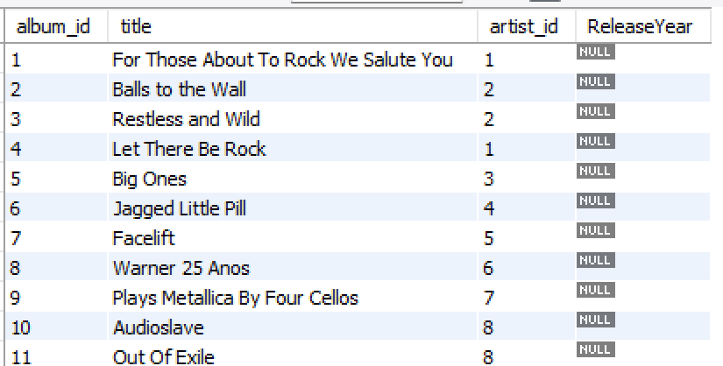
Output:
As we haven’t inserted data into ReleaseYear column so every value is been showed as NULL.

11. Chinook is interested in understanding the purchasing behavior of customers based on their geographical location. They want to know the average total amount spent by customers from each country, along with the number of customers and the average number of tracks purchased per customer. Write an SQL query to provide this information.
Ans: To understand the purchasing behavior of customers based on their geographical location I have used CTE. In CTE I have calculated the factors such as total amount spent and total tracks by grouping the data on customer details. In the final select statement I have grouped the data on country to calculate total no.of customers, average tracks per customer, total amount spent and average amount spent per customer at country level using aggregate functions.
- Tables used: invoice
- Concepts used: CTE, GROUP BY, Aggregate Functions, ORDER BY

Query:
WITH cus_data AS (
SELECT
customer_id,
billing_country AS country,
SUM(total) AS total_spent,
COUNT(invoice_id) AS total_tracks
FROM invoice
GROUP BY customer_id, billing_country
)

SELECT
country,
COUNT(*) AS total_customers,
ROUND(AVG(total_tracks),2) AS avg_tracks_per_customer,
SUM(total_spent) AS total_spent,
ROUND(AVG(total_spent), 2) AS avg_amount_spent_per_customer
FROM cus_data
GROUP BY country
ORDER BY country;

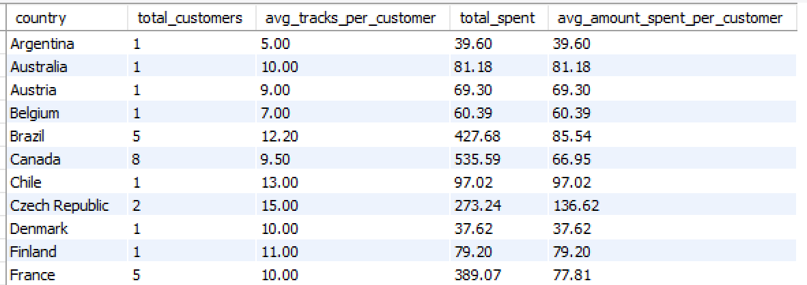
Output:

Insights:
- India, Brazil and Germany was well balanced, with good no.of customers and moderate average sales per customers.
- Spain, Ireland and Czech Republic have the highest average amount spent per customer which indicates customers in those countries has a very good engagement with the Chinook Music store.
- Argentine and Denmark has very less no.of customers and very low average amount spent per customer which indicates this countries have less potential for the music sales.

