How to access the protected endpoint with access-token:

Now in our gateway service (act as Resource Server)all endpoints (POST, PUT, DELTE) of microservices(accounts/cards) are protected except(GET ) endpoints.

To access the protected endpoints (POST, PUT, DELTE) of our microservice we need to send the access token along with the body.

To generate the Oath access token. follow below steps:

Below is the endpoint(POST) of Oauth server that provide the access token.

<http://localhost:8180/realms/master/protocol/openid-connect/token>

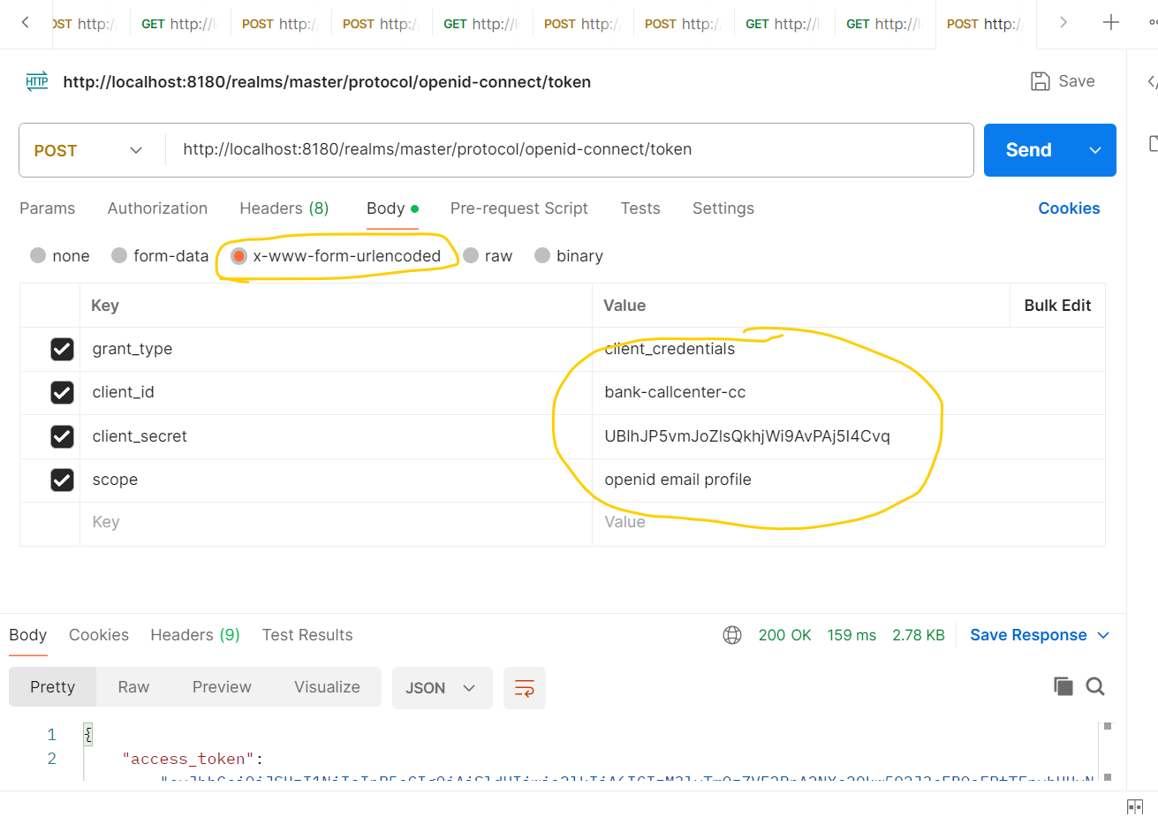

After generated access_token in above request need to pass with the restricted endpoints

