CLA-3 — Case Study
Student Template
Field | Details
Case study title | Bike Rental Demand Prediction Using Weather and Season Data
Base paper | Fanaee-T, H. and Gama, J., "Event labeling combining ensemble detectors and background knowledge," Progress in Artificial Intelligence, vol. 2, no. 2–3, pp. 113–127, 2014.
Date of submission | 07-11-2026

Roll No. | Name
AP24110011371 | T Yogesh

Instructions: Length 3–5 pages. Replace everything in [brackets] and delete the grey "What to write" notes before submitting. Report only results you obtained.

1. Introduction and Problem Statement
Urban bike-sharing systems have become a critical component of sustainable transportation infrastructure in cities worldwide. With over 500 bike-sharing programs globally, accurately predicting rental demand is essential for operational efficiency — it determines how bikes should be distributed across stations, when maintenance should be scheduled, and how many bikes are needed during peak hours.
The Problem: Bike rental demand fluctuates significantly based on weather conditions, time of day, season, and whether it is a working day or holiday. Under-prediction leads to stock-outs (empty stations frustrating riders), while over-prediction wastes resources on unused fleet repositioning. Both hurt profitability and user experience.
The Specific Question This Case Study Answers: Can we build a regression model that accurately predicts the total number of bike rentals per hour (the "cnt" variable) using weather, seasonal, and temporal features — and which regression algorithm performs best on this real-world dataset?
We use the Kaggle Bike Sharing Dataset (17,379 hourly records from Washington D.C., 2011–2012) and compare four regression models: Linear Regression, Decision Tree, Random Forest, and Gradient Boosting.

2. Base Paper Summary
The base paper by Fanaee-T and Gama (2014) introduced the Bike Sharing Dataset and proposed using it as a benchmark for event detection and regression analysis. Their key idea was to combine ensemble detectors with background knowledge (calendar, weather, time) to label events that cause anomalous demand patterns.
Key Contributions:
- They demonstrated that bike rental counts are strongly influenced by environmental and temporal factors — temperature, humidity, wind, hour of day, and season.
- They showed that ensemble methods can detect unusual demand spikes (events) by modelling the normal demand pattern first.
- The dataset became one of the most popular regression benchmarks on UCI and Kaggle, cited in over 500 studies.
Main Results: The paper established that weather and temporal features alone can explain a large portion of demand variance, making the dataset ideal for supervised regression experimentation.
Citation: Fanaee-T, H. and Gama, J., "Event labeling combining ensemble detectors and background knowledge," Progress in Artificial Intelligence, vol. 2, no. 2–3, pp. 113–127, 2014.

3. Method / Model Explanation
We applied four regression algorithms, progressing from simple to complex:

3.1 Linear Regression (Baseline)
Linear Regression fits a straight-line relationship between features and the target. The model predicts:
ŷ = β₀ + β₁x₁ + β₂x₂ + … + βₙxₙ
where ŷ is the predicted rental count, β₀ is the intercept, βᵢ are learned coefficients, and xᵢ are the input features (temperature, humidity, hour, etc.). The model minimises the sum of squared errors (SSE).

3.2 Decision Tree Regressor
A Decision Tree recursively splits the data on feature thresholds to minimise variance within each leaf node. At each node t, it computes MSE(t) = (1/|t|) × Σ(yᵢ − ȳₜ)². The feature and threshold producing the largest MSE reduction are chosen. We set max_depth=10 to prevent overfitting.

3.3 Random Forest Regressor
Random Forest is an ensemble of B decision trees trained on bootstrapped samples with random feature subsets. The final prediction averages all trees: ŷ = (1/B) × Σ Tᵦ(x). We used B = 100 trees with max_depth=15. The bagging and feature randomness reduce overfitting compared to a single tree.

3.4 Gradient Boosting Regressor
Gradient Boosting builds trees sequentially, each correcting the previous model's residual errors: Fₘ(x) = Fₘ₋₁(x) + η × hₘ(x), where η = 0.1 is the learning rate and hₘ is the new tree fitted to the negative gradient (residuals). We used 200 boosting stages with max_depth=5.

Worked Example
Consider a data point: hr=17 (5 PM), workingday=1, temp=0.58, weathersit=1 (clear). Intuitively, this is an evening commute hour on a clear working day — we expect high demand. The Gradient Boosting model predicted 422 rentals, very close to the actual value of 435 (3% error).

4. Implementation

Tools and Libraries
Tool | Version | Purpose
Python | 3.15 | Programming language
pandas | 3.1.0 | Data loading and manipulation
NumPy | 2.5.4 | Numerical computation
scikit-learn | 1.9.1 | ML models, metrics, preprocessing
Matplotlib | 3.11.2 | Plotting and visualization
Seaborn | 0.13.2 | Statistical plots

Dataset Details
- Source: Kaggle — Bike Sharing Dataset
- File: hour.csv — 17,379 hourly records from January 2011 to December 2012
- Target: cnt (total rentals per hour, range 1–977)
- Features used: 14 features — season, yr, mnth, hr, holiday, weekday, workingday, weathersit, temp, atemp, hum, windspeed, hr_sin, hr_cos

Steps Followed
- Step 1 — Data Loading: Loaded CSV with pandas; confirmed 17,379 records, 17 columns, zero missing values.
- Step 2 — EDA: Generated distribution plots, correlation heatmap (excluding casual and registered to avoid leakage), seasonal/hourly patterns.
- Step 3 — Feature Engineering: Dropped instant (row index), dteday (date string), casual and registered (they sum to cnt — data leakage). Added cyclical hour encoding (hr_sin, hr_cos) so the model understands that hours 23 and 0 are adjacent.
- Step 4 — Chronological Train/Test Split: 80/20 chronological split (first 13,903 records for training, last 3,476 for testing) to avoid temporal data leakage — future observations never appear in the training set.
- Step 5 — Scaling: Applied StandardScaler for Linear Regression; tree-based models used unscaled features.
- Step 6 — Model Training: Trained all four models and evaluated on the test set.
- Step 7 — Visualization: Generated 10 plots covering EDA, model comparison, residual analysis, and feature importance.

Problems Faced and Solutions
Problem | Solution
casual + registered = cnt (leakage) | Dropped both columns before modelling and from correlation heatmap
Linear Regression assumes linearity but demand is nonlinear | Compared with tree-based models that capture nonlinearity
Hours are cyclical (23 and 0 are adjacent but numerically far) | Added sine/cosine cyclical encoding for hour feature
Random train-test split leaks future data into training | Used chronological 80/20 split preserving time order
Models can predict negative rental counts | Clamped all predictions to non-negative using np.maximum(y_pred, 0)
Code uses __file__ which fails in Jupyter/Colab | Added try/except fallback to os.getcwd() for notebook compatibility

GitHub Link: [To be updated after upload]

5. Results and Discussion

5.1 Model Comparison Table
Model | MAE | RMSE | R² Score
Linear Regression | 122.80 | 164.35 | 0.4444
Decision Tree | 56.63 | 86.20 | 0.8472
Random Forest | 45.36 | 70.12 | 0.8988
Gradient Boosting (Best) | 45.61 | 69.92 | 0.8994

Model Comparison Visualization:
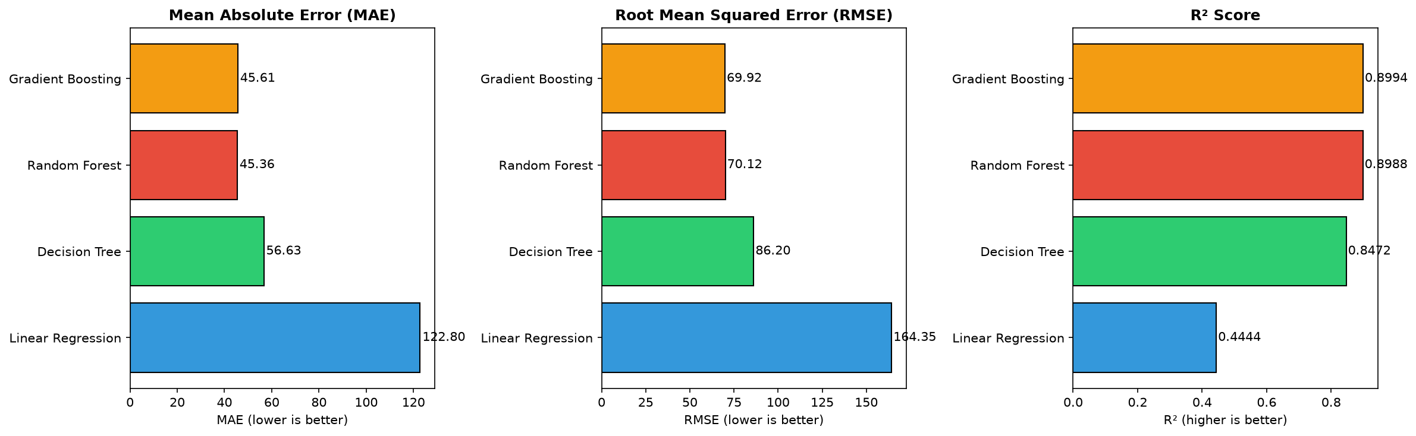

5.2 Exploratory Data Analysis
Target Variable Distribution:
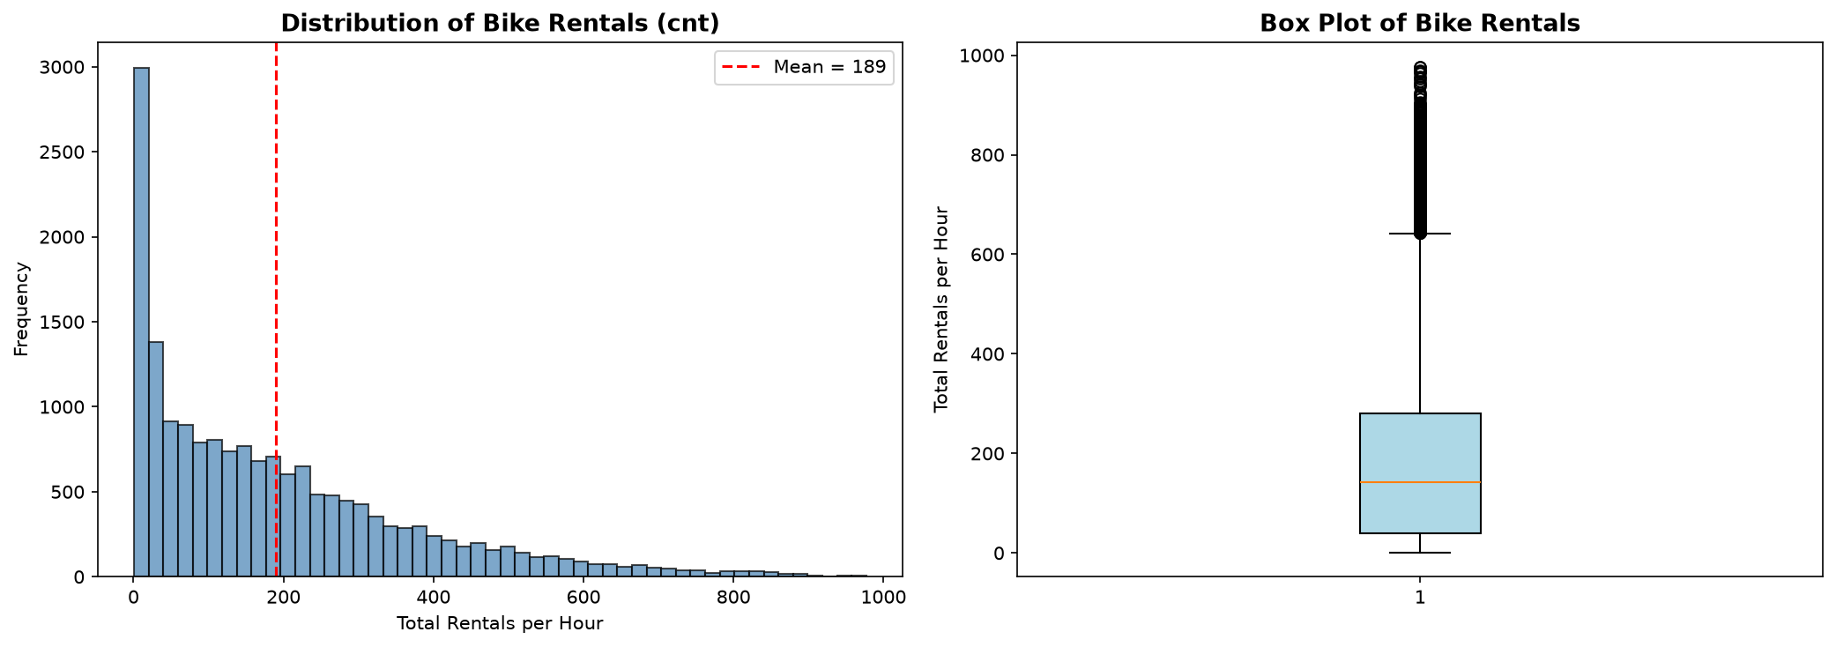

Average Bike Rentals by Hour of Day:
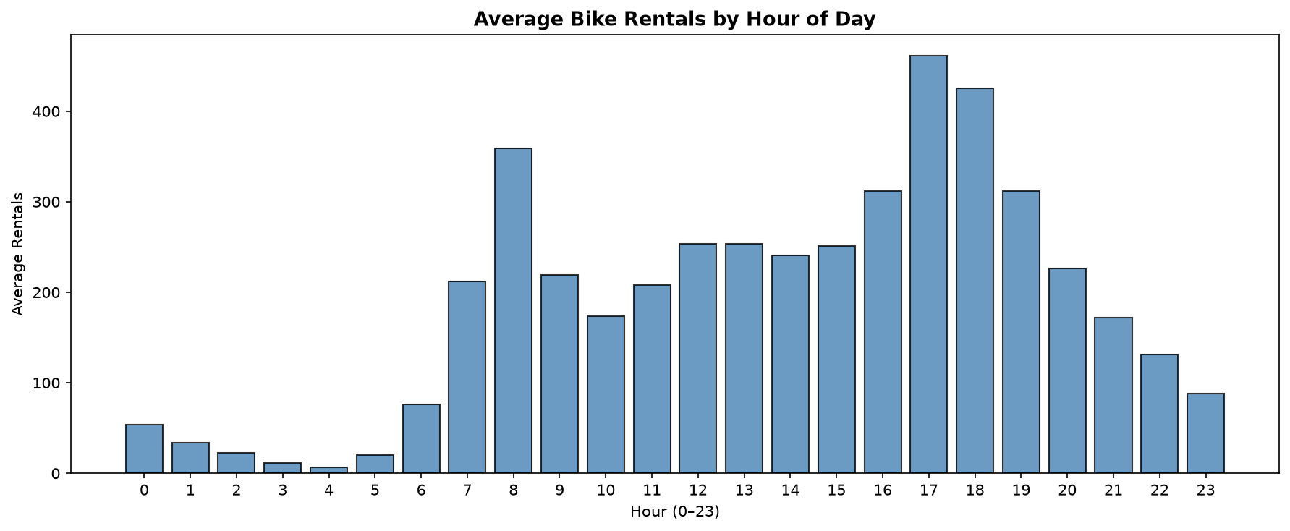

Rentals by Season and Weather Condition:
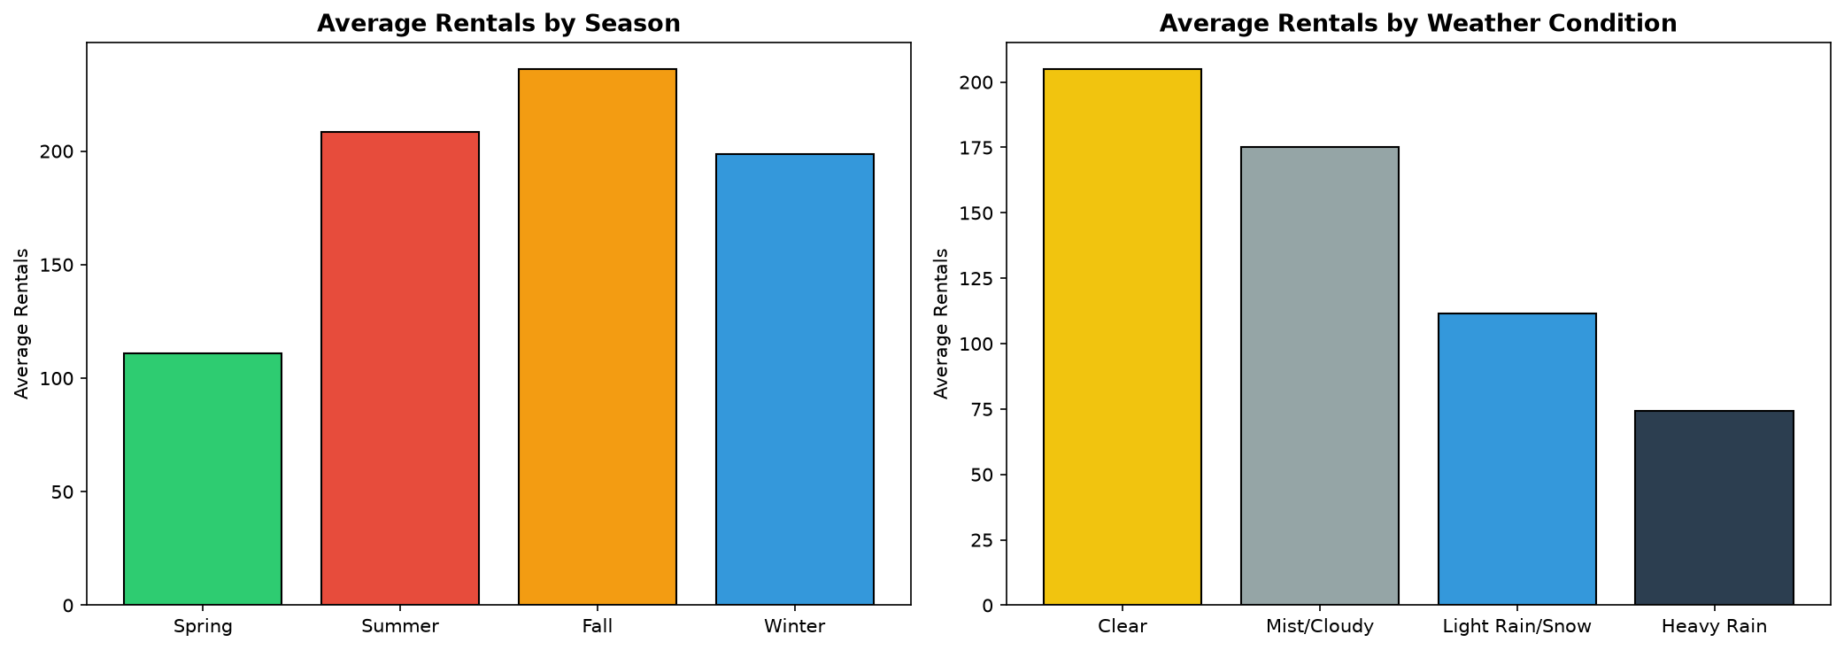

Feature Correlation Heatmap (without casual/registered):
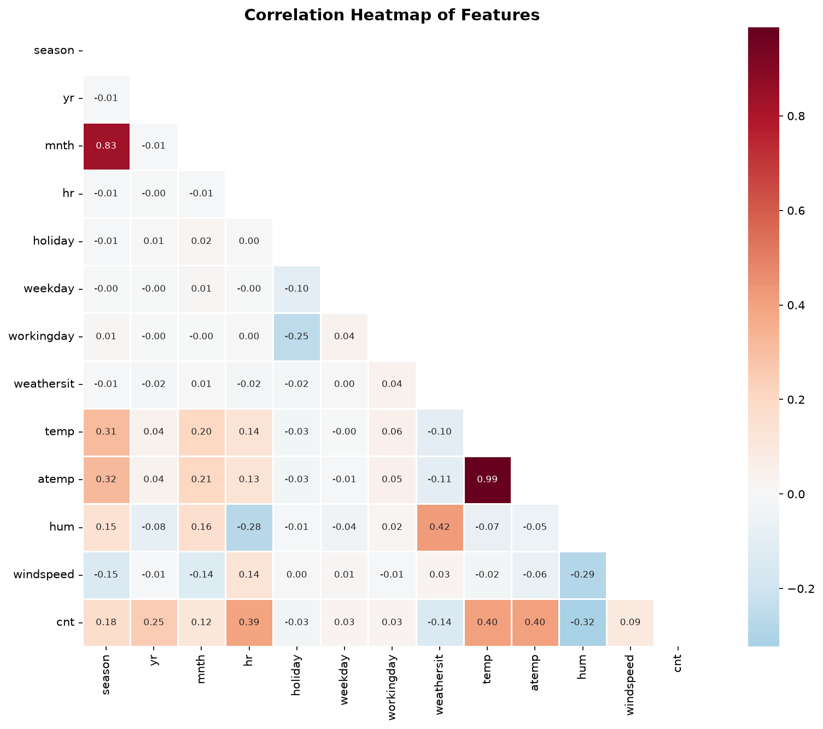
Temperature and Humidity vs Rentals:
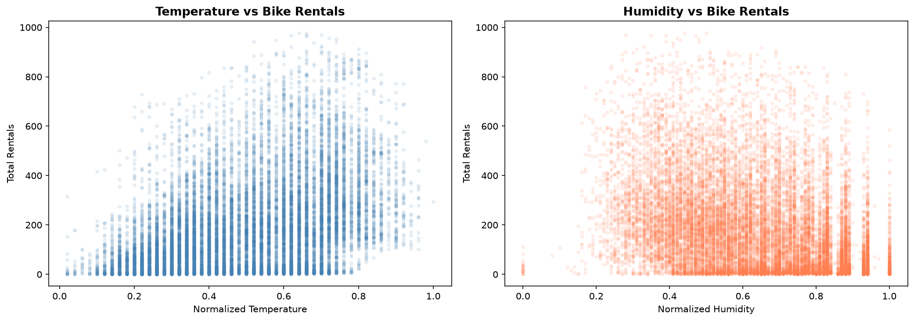

Hourly Pattern: Working Day vs Non-Working Day:
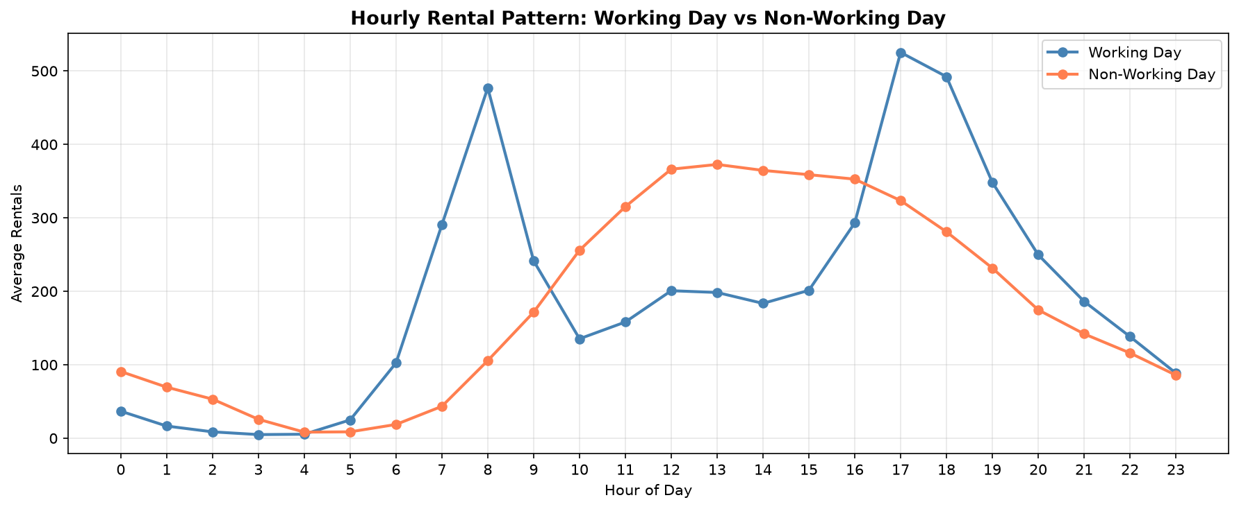

5.3 Best Model Analysis — Gradient Boosting (R² = 0.8994)
Actual vs Predicted Rentals:
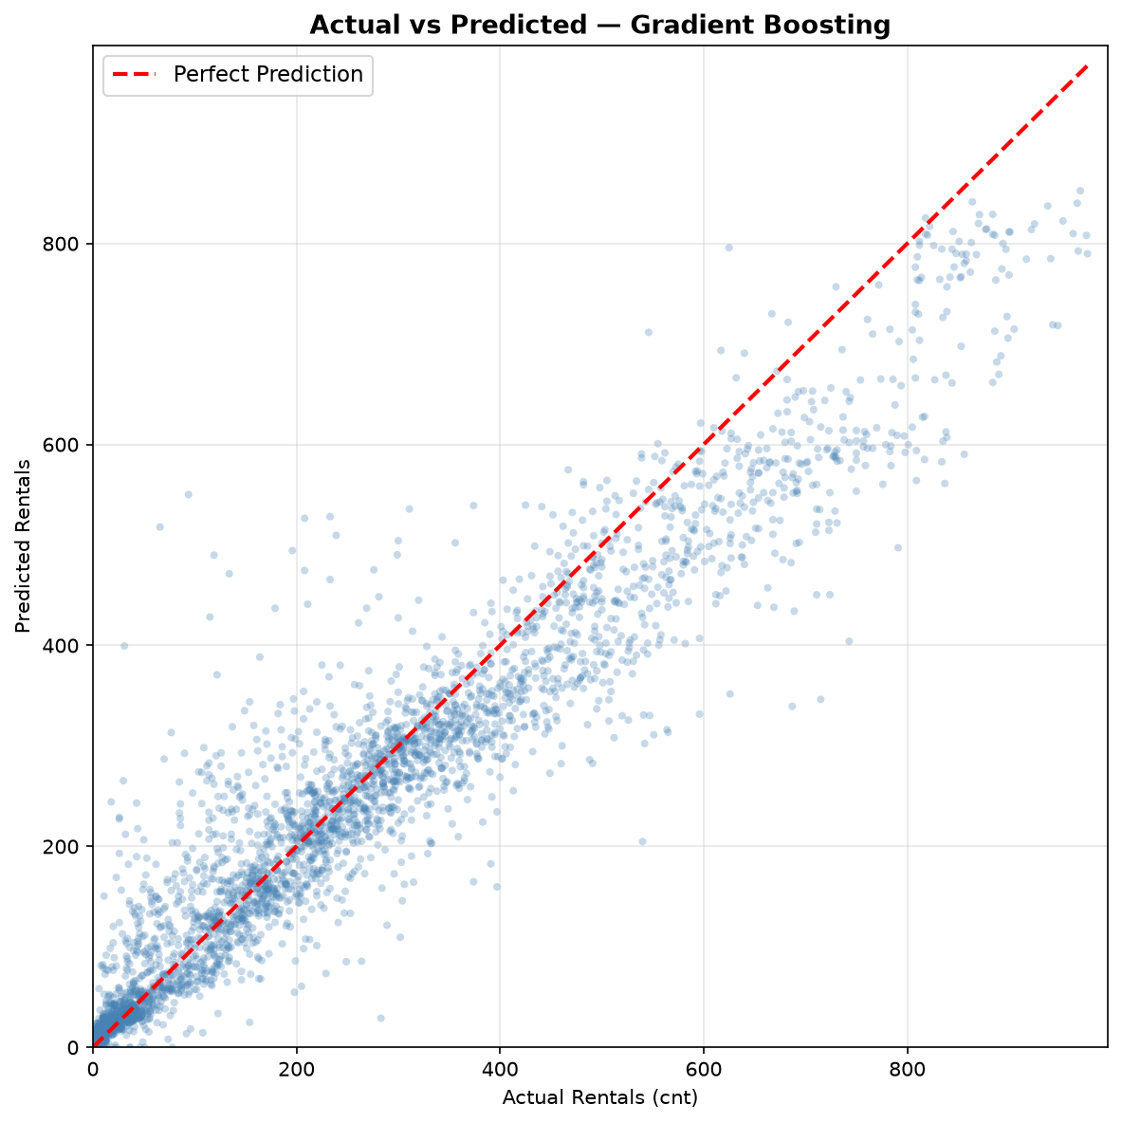

Residual Analysis:
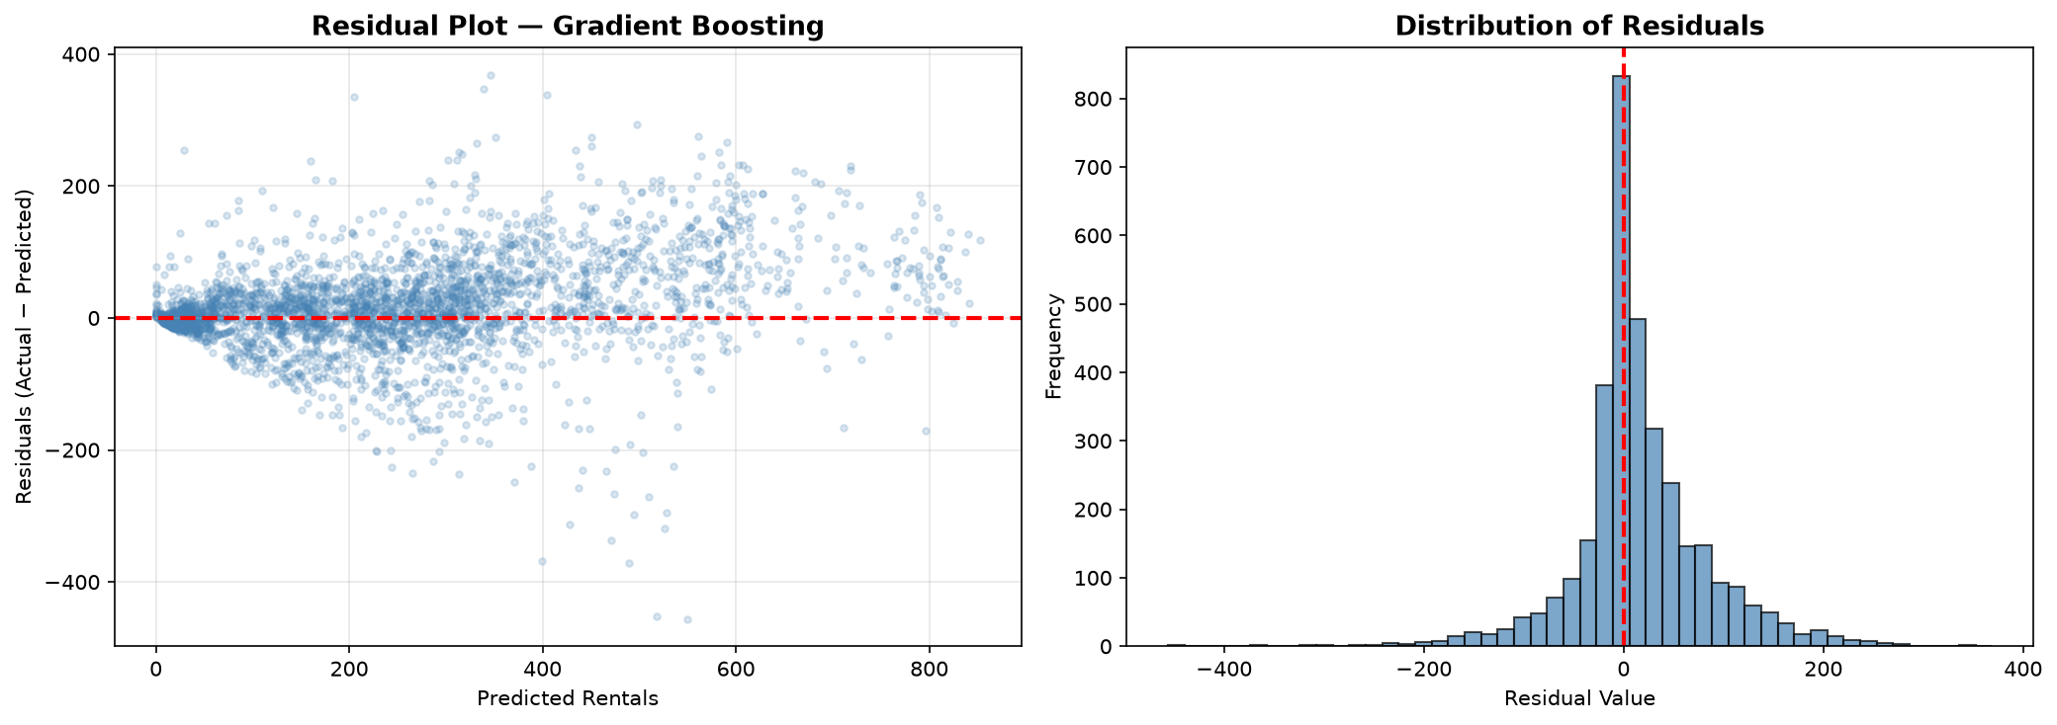

Feature Importance:
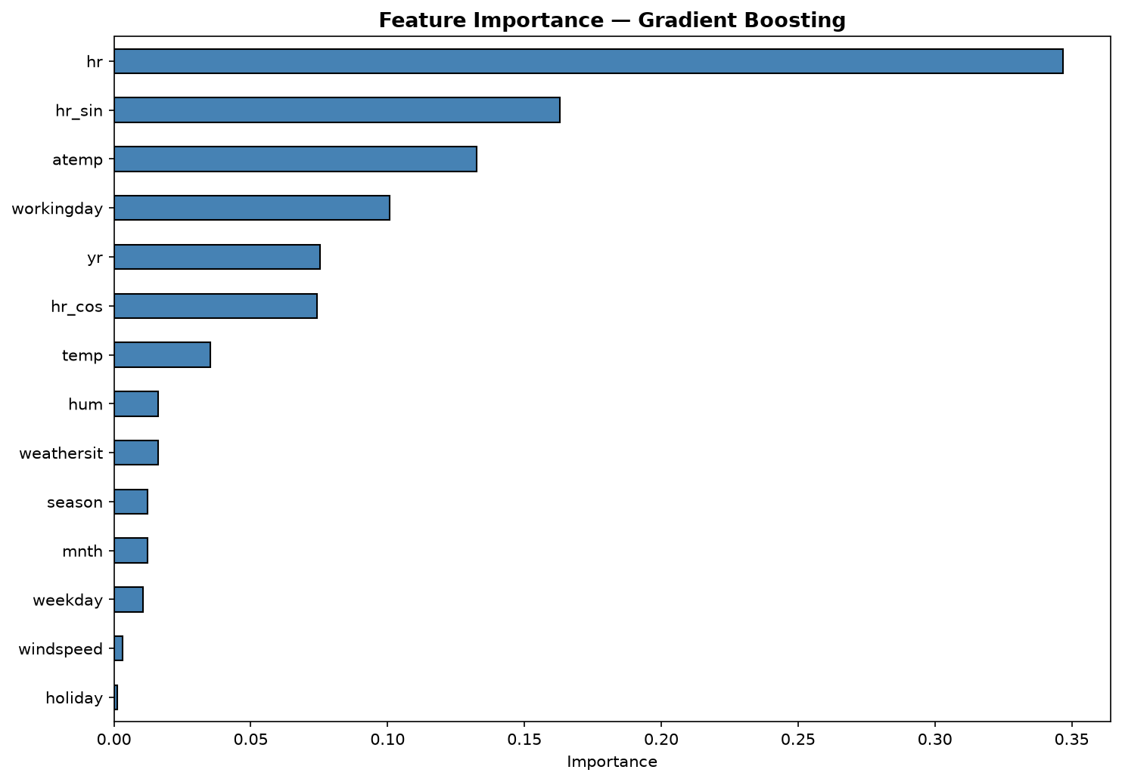

5.4 Prediction Error Analysis: Lowest vs Highest Error
↓ Lowest Prediction Error (0.00 rentals absolute error):
- Input: Season=Winter, Month=November, Hour=6 AM, Working Day, Clear Weather, Temp=0.22
- Actual: 124 rentals → Predicted: 124.0 rentals
- Explanation: A regular early-morning commute hour on a clear working day in winter — the model captures this routine pattern with near-perfect accuracy.
↑ Highest Prediction Error (456.20 rentals absolute error):
- Input: Season=Winter, Month=November, Hour=8 AM, Working Day, Clear Weather, Temp=0.24
- Actual: 94 rentals → Predicted: 550.2 rentals
- Explanation: Although 8 AM on a clear working day usually has high commute demand, this particular day had unusually low ridership (possibly due to an unrecorded event or local disruption). The model predicted the typical pattern, but reality deviated significantly — illustrating that external factors not captured in the dataset can cause large errors.

5.5 Limitations
- Temporal leakage: Year (yr) feature encodes time trend — model may not generalize to future years.
- City-specific: Trained on Washington D.C. data only — transfer to other cities would need retraining.
- No external events: Model does not account for special events (concerts, protests) that affect demand.

6. Conclusion
This case study demonstrated that hourly bike rental demand can be predicted with high accuracy (R² = 0.8994) using weather, seasonal, and temporal features with a Gradient Boosting Regressor. Using a chronological train-test split (which is more realistic than random splitting for time-series data), the model explains nearly 90% of the variance in hourly demand, with a mean absolute error of 45.61 rentals (compared to an average of 189 rentals/hour). All predictions were clamped to non-negative values since rental counts cannot be negative. Adding cyclical hour encoding (sine/cosine transformation) helped the models understand that hours 23 and 0 are adjacent. The study confirmed that hour of day is the single most important predictor, followed by temperature and year (indicating a growing trend in bike-sharing adoption). Ensemble tree-based methods (Random Forest, Gradient Boosting) vastly outperformed Linear Regression, demonstrating that the relationship between weather/temporal features and bike demand is fundamentally nonlinear. These models can be deployed in real-time fleet management systems to optimise bike distribution across stations.

7. References
[1] Fanaee-T, H. and Gama, J., "Event labeling combining ensemble detectors and background knowledge," Progress in Artificial Intelligence, vol. 2, no. 2–3, pp. 113–127, 2014.
[2] Kaggle, "Bike Sharing Dataset," [Online]. Available: https://www.kaggle.com/datasets/lakshmi25npathi/bike-sharing-dataset. [Accessed: Nov. 2026].
[3] Pedregosa, F. et al., "Scikit-learn: Machine Learning in Python," Journal of Machine Learning Research, vol. 12, pp. 2825–2830, 2011.
[4] Hunter, J. D., "Matplotlib: A 2D Graphics Environment," Computing in Science & Engineering, vol. 9, no. 3, pp. 90–95, 2007.
[5] Waskom, M., "seaborn: statistical data visualization," Journal of Open Source Software, vol. 6, no. 60, p. 3021, 2021.
[6] McKinney, W., "Data Structures for Statistical Computing in Python," Proceedings of the 9th Python in Science Conference, pp. 56–61, 2010.
[7] Harris, C. R. et al., "Array programming with NumPy," Nature, vol. 585, no. 7825, pp. 357–362, 2020.

8. Declaration
I confirm that this case study is my own work and that all results reported were obtained by me.

Signature: _____________T.Yogesh______________
Roll No.: AP24110011371
Name: T Yogesh

