MCWC(2170701)

Assignment 2 (Android App)

Name: Yogesh Bavishi

Division: E Sem: 7th

Enrollment No.: 170200107003

*MainActivity.java

**package** com.example.texteditor;  
  
import androidx.annotation.NonNull;  
import androidx.annotation.Nullable;  
import androidx.appcompat.app.AppCompatActivity;  
import androidx.core.app.ActivityCompat;  
import androidx.core.content.ContextCompat;  
  
import java.net.URI;  
import java.util.regex.*;  
import android.Manifest;  
import android.annotation.SuppressLint;  
import android.app.ActionBar;  
import android.app.AlertDialog;  
import android.content.DialogInterface;  
import android.content.Intent;  
import android.content.pm.PackageManager;  
import android.database.Cursor;  
import android.net.Uri;  
import android.os.Bundle;  
import android.os.Environment;  
import android.provider.DocumentsProvider;  
import android.provider.MediaStore;  
import android.provider.OpenableColumns;  
import android.view.Menu;  
import android.view.MenuInflater;  
import android.view.MenuItem;  
import android.view.View;  
import android.widget.Button;  
import android.widget.EditText;  
import android.widget.TextView;  
import android.widget.Toast;  
  
import java.io.BufferedReader;  
import java.io.File;  
import java.io.FileNotFoundException;  
import java.io.FileOutputStream;  
import java.io.IOException;  
import java.io.InputStreamReader;  
  
public class MainActivity **extends** AppCompatActivity {  
  
 **public static int** *PICK_FILE* = 1;  
 **private** EditText **mainEditor**;  
 **private** Intent **openFileIntent**;  
 **private static final int *STORAGE_PERMISSION_CODE*** = 101;  
// public static final String ACTION_OPEN_DOCUMENT = "open_file"  
 **private static** Uri *file_path*;  
 **private** String **filePath**;  
  
  
 @Override  
 **protected void** onCreate(Bundle savedInstanceState) {  
 **super**.onCreate(savedInstanceState);  
 setContentView(R.layout.***activity_main***);  
 *//check permissions*  
checkPermissionStatus(**new** String[] {Manifest.permission.***READ_EXTERNAL_STORAGE***, Manifest.permission.***WRITE_EXTERNAL_STORAGE***});  
 *//get ids*  
**mainEditor** = findViewById(R.id.***editText1***);  
  
  
  
 }  
  
 **private void** checkPermissionStatus(String[] permission) {  
  
 **if** (ContextCompat.*checkSelfPermission*(MainActivity.**this**, permission[1] )  
 == PackageManager.***PERMISSION_DENIED***){  
 Toast.*makeText*(MainActivity.**this**, **"Without Storage Permission you won't be able to SAVE files!!!"**, Toast.***LENGTH_SHORT***).show();  
 ActivityCompat.*requestPermissions*(MainActivity.**this**,permission,***STORAGE_PERMISSION_CODE***);  
 }  
 **else** {  
 Toast.*makeText*(MainActivity.**this**, **"Permission already granted"**, Toast.***LENGTH_SHORT***).show();  
 }  
 }  
  
 *//menu items creation*  
@Override  
 **public boolean** onCreateOptionsMenu(Menu menu) {  
 MenuInflater inflater = getMenuInflater();  
 inflater.inflate(R.menu.***main_menu***, menu);  
 **return true**;  
 }  
  
 *//menu item selected*  
@Override  
 **public boolean** onOptionsItemSelected(MenuItem item) {  
 **switch** (item.getItemId()) {  
 **case** R.id.***open_file***:  
 *//newGame();*  
openFile();  
 **return true**;  
 **case** R.id.***save_file***:  
 saveFile();  
 **return true**;  
 **case** R.id.***close_file***:  
 AlertDialog.Builder alert_close = **new** AlertDialog.Builder(MainActivity.**this**);  
 alert_close.setTitle(**"TextEditor:"**);  
 alert_close.setMessage(**"Unsaved work will be lost. Are you sure to exit?"**);  
 alert_close.setNegativeButton(**"No"**,**null**);  
 alert_close.setPositiveButton(**"Yes"**,**new** DialogInterface.OnClickListener(){  
 @Override  
 **public void** onClick(DialogInterface diag1,**int** id){  
 finish();  
 }  
 });  
 alert_close.setNeutralButton(**"Save File"**,**new** DialogInterface.OnClickListener(){  
 @Override  
 **public void** onClick(DialogInterface diag1,**int** id){  
 Toast.*makeText*( MainActivity.**this**,**"Saving file before exit!!!"**,Toast.***LENGTH_SHORT***).show();  
 saveFile();  
 }  
 });  
 alert_close.show();  
 **return true**;  
 **default**:  
 **return super**.onOptionsItemSelected(item);  
 }  
  
 }  
  
 *//file open option*  
**private void** openFile() {  
 **openFileIntent** = **new** Intent(Intent.***ACTION_GET_CONTENT***);  
 **openFileIntent**.setType(**"text/plain"**);  
 startActivityForResult(**openFileIntent**,*PICK_FILE*);  
 setFileName();  
  
  
 }  
  
  
 *//FileName set for ActionBar when opened/saved*  
**private void** setFileName() {  
// ActionBar act = getActionBar();  
// act.setTitle(file_path.getLastPathSegment().toString());  
  
   
 }  
  
 *//openfile subfunction*  
@Override  
 **protected void** onActivityResult(**int** requestCode, **int** resultCode, @Nullable Intent data) {  
 **if**(requestCode==*PICK_FILE*){  
 **if**(resultCode==***RESULT_OK***){  
  
 **filePath**=data.getData().getPath();  
 *file_path*=data.getData();  
 String str=data.getData().getLastPathSegment();  
 Toast.*makeText*(MainActivity.**this**,**filePath**+**" Opened! "**,Toast.***LENGTH_SHORT***).show();  
 String fileContent = readTextFile(*file_path*);  
 **mainEditor**.setText(fileContent);  
  
 }  
 }  
 }  
  
 *//openfile subfuntion2*  
**private** String readTextFile(Uri file_path1) {  
 BufferedReader reader = **null**;  
 StringBuilder builder = **new** StringBuilder();  
  
 **try** {  
 reader = **new** BufferedReader(**new** InputStreamReader(getContentResolver().openInputStream(file_path1)));  
 String line = **""**;  
 **while** ((line = reader.readLine()) != **null**)  
 {  
 builder.append(line+**"\n"**);  
 }  
 reader.close();  
 }  
 **catch** (IOException e) { e.printStackTrace(); }  
 **return** builder.toString();  
 }  
  
  
 *//permission request*  
@Override  
 **public void** onRequestPermissionsResult(**int** requestCode, @NonNull String[] permissions,@NonNull **int**[] grantResults){  
 **super**.onRequestPermissionsResult(requestCode,permissions,grantResults);  
 **if** (requestCode == ***STORAGE_PERMISSION_CODE***) {  
 **if** (grantResults.**length** > 0 && grantResults[0] == PackageManager.***PERMISSION_GRANTED***) {  
 Toast.*makeText*(MainActivity.**this**,**"Storage Permission Granted"**,Toast.***LENGTH_SHORT***).show();  
 }  
 **else** {  
 Toast.*makeText*(MainActivity.**this**,**"Storage Permission Denied"**,Toast.***LENGTH_SHORT***).show();  
 }  
 }  
 }  
  
  
 *//file save option*  
**private void** saveFile(){  
 **final** TextView messageSaveFile = (TextView)findViewById(R.id.***textView_save***);  
 **final** AlertDialog.Builder alert = **new** AlertDialog.Builder(MainActivity.**this**);  
 View mView = getLayoutInflater().inflate(R.layout.***custom_dialog***,**null**);  
 **final** EditText txt_inputText = (EditText) mView.findViewById(R.id.***editText_save***);  
 Button btn_cancel = (Button)mView.findViewById(R.id.***btnCancel_save***);  
 Button btn_okay = (Button)mView.findViewById(R.id.***btnSave_save***);  
 alert.setView(mView);  
 **final** AlertDialog alertDialog = alert.create();  
 alertDialog.setCanceledOnTouchOutside(**false**);  
 btn_cancel.setOnClickListener(**new** View.OnClickListener() {  
 @Override  
 **public void** onClick(View v) {  
 alertDialog.dismiss();  
 }  
 });  
 btn_okay.setOnClickListener(**new** View.OnClickListener() {  
 @Override  
 **public void** onClick(View v) {  
 **filePath**=txt_inputText.getText().toString();  
 **try** {  
 writeFileToStorage(**filePath**);  
 } **catch** (IOException e) {  
 e.printStackTrace();  
 }  
 alertDialog.dismiss();  
 }  
 });  
 alertDialog.show();  
 setFileName();  
  
 }  
  
 **private void** writeFileToStorage(String path) **throws** IOException {  
 String state = Environment.*getExternalStorageState*();  
  
 **if**(Environment.***MEDIA_MOUNTED***.equals(state)){  
 File root = Environment.*getExternalStorageDirectory*();  
 File folderPath = **new** File(root.getAbsolutePath()+**"/TextEditor"**);  
 *//to be devided into folder path and file name using pattern in future release*  
 *//also directory chooser to be added*  
**if**(!folderPath.exists()){  
 folderPath.mkdir();  
 Toast.*makeText*(getApplicationContext(),**"FOLDER CREATED"**,Toast.***LENGTH_SHORT***).show();  
  
 }  
 File file = **new** File(folderPath, **filePath**);  
 **if**(!file.exists()){  
 file.createNewFile();  
 Toast.*makeText*(getApplicationContext(),**filePath**+**" file saved"**,Toast.***LENGTH_SHORT***).show();  
 }  
 String textData = **mainEditor**.getText().toString();  
 **try** {  
 FileOutputStream fos = **new** FileOutputStream(file);  
 fos.write(textData.getBytes());  
 Toast.*makeText*(getApplicationContext(),**"data to file written and saved"**,Toast.***LENGTH_SHORT***).show();  
 fos.close();  
 } **catch** (Exception e) {  
 **mainEditor**.setText(**mainEditor**.getText() +**" \n\n"** +e.toString());  
 Toast.*makeText*(getApplicationContext(),**"Toast of exception"**,Toast.***LENGTH_SHORT***).show();  
 }  
  
  
 }  
 **else**{  
 Toast.*makeText*(getApplicationContext(),**"File not saving error!!!"**,Toast.***LENGTH_LONG***).show();  
 }  
  
  
  
 }  
  
  
  
}

*activity_main.xml

*<?***xml version="1.0" encoding="utf-8"***?>*  
*<***androidx.constraintlayout.widget.ConstraintLayout xmlns:android="http://schemas.android.com/apk/res/android"**  
 **xmlns:app="http://schemas.android.com/apk/res-auto"**  
 **xmlns:tools="http://schemas.android.com/tools"**  
 **android:layout_width="match_parent"**  
 **android:layout_height="match_parent"**  
 **tools:context=".MainActivity"**>  
  
 <**EditText**  
 **android:id="@+id/editText1"**  
 **android:layout_width="0dp"**  
 **android:layout_height="0dp"**  
 **android:ems="10"**  
 **android:gravity="start|top"**  
 **android:inputType="textMultiLine"**  
 **app:layout_constraintBottom_toBottomOf="parent"**  
 **app:layout_constraintEnd_toEndOf="parent"**  
 **app:layout_constraintHorizontal_bias="0.466"**  
 **app:layout_constraintStart_toStartOf="parent"**  
 **app:layout_constraintTop_toTopOf="parent"**  
 **app:layout_constraintVertical_bias="0.409"** />  
  
  
</**androidx.constraintlayout.widget.ConstraintLayout**>

*AndroidManifest.xml

*<?***xml version="1.0" encoding="utf-8"***?>*  
*<***manifest xmlns:android="http://schemas.android.com/apk/res/android"**  
 **package="com.example.texteditor"**>  
 <**uses-permission android:name="android.permission.READ_EXTERNAL_STORAGE"**/>  
 <**uses-permission android:name="android.permission.WRITE_EXTERNAL_STORAGE"**/>  
 <**application**  
 **android:requestLegacyExternalStorage="true"**  
 **android:allowBackup="true"**  
 **android:icon="@drawable/ic_texteditor"**  
 **android:label="@string/app_name"**  
 **android:roundIcon="@drawable/ic_texteditor"**  
 **android:supportsRtl="true"**  
 **android:theme="@style/AppTheme"**>  
  
 <**activity android:name=".MainActivity"**>  
 <**intent-filter**>  
 <**action android:name="android.intent.action.MAIN"** />  
  
 <**category android:name="android.intent.category.LAUNCHER"** />  
 </**intent-filter**>  
 </**activity**>  
 </**application**>  
  
</**manifest**>

*main_menu.xml

*<?***xml version="1.0" encoding="utf-8"***?>*  
*<***menu xmlns:app="http://schemas.android.com/apk/res-auto"**  
 **xmlns:android="http://schemas.android.com/apk/res/android"**  
>  
  
 <**item**  
 **android:id="@+id/close_file"**  
 **android:icon="@drawable/ic_close"**  
 **android:title="@string/close_file"**  
 **android:tooltipText="@string/close_file"**  
 **app:showAsAction="always"**/>  
 <**item**  
 **android:id="@+id/save_file"**  
 **android:icon="@drawable/ic_save"**  
 **android:title="@string/save_file"**  
 **android:tooltipText="@string/save_file"**  
 **app:showAsAction="always"** />  
 <**item**  
 **android:id="@+id/open_file"**  
 **android:icon="@drawable/ic_open"**  
 **app:showAsAction="always"**  
 **android:title="@string/open_file"**  
 **android:tooltipText="@string/open_file"**  
/>  
  
</**menu**>

*custom_dialog.xml (for save menu)

*<?***xml version="1.0" encoding="utf-8"***?>*  
*<***LinearLayout xmlns:android="http://schemas.android.com/apk/res/android"**  
 **android:layout_width="match_parent"**  
 **android:layout_height="match_parent"**  
 **android:orientation="vertical"**>  
  
 <**TextView**  
 **android:id="@+id/textView_save"**  
 **android:layout_width="match_parent"**  
 **android:layout_height="wrap_content"**  
 **android:text="@string/save_path_sdcard"**  
 **android:textAlignment="center"**  
 **android:textSize="22sp"** />  
  
 <**EditText**  
 **android:id="@+id/editText_save"**  
 **android:layout_width="match_parent"**  
 **android:layout_height="wrap_content"**  
 **android:layout_marginTop="10dp"**  
 **android:hint="@string/enter_path"**  
 **android:importantForAutofill="no"**  
 **android:inputType="text"**  
 **android:textSize="20sp"** />  
 <**LinearLayout**  
 **android:layout_width="match_parent"**  
 **android:layout_height="wrap_content"**  
 **android:layout_marginTop="15dp"**>  
 <**Button**  
 **android:layout_width="match_parent"**  
 **android:layout_height="wrap_content"**  
 **android:backgroundTint="@color/colorPrimary"**  
 **android:text="Cancel"**  
 **android:textColor="#ffffff"**  
 **android:textSize="18sp"**  
 **android:layout_weight="1"**  
 **android:id="@+id/btnCancel_save"**/>  
 <**Button**  
 **android:layout_width="match_parent"**  
 **android:layout_height="wrap_content"**  
 **android:backgroundTint="@color/colorPrimary"**  
 **android:text="Save"**  
 **android:textColor="#ffffff"**  
 **android:textSize="18sp"**  
 **android:layout_weight="1"**  
 **android:id="@+id/btnSave_save"**/>  
 </**LinearLayout**>  
</**LinearLayout**>

*strings.xml

<**resources**>  
 <**string name="app_name"**>TextEditor</**string**>  
 <**string name="save_file"**>Save</**string**>  
 <**string name="open_file"**>Open</**string**>  
 <**string name="close_file"**>Close</**string**>  
 <**string name="save_path_sdcard"**>Save Path sdcard/:</**string**>  
 <**string name="enter_path"**>Enter path</**string**>  
  
</**resources**>

*Output:

-Custom icon -Editing Text

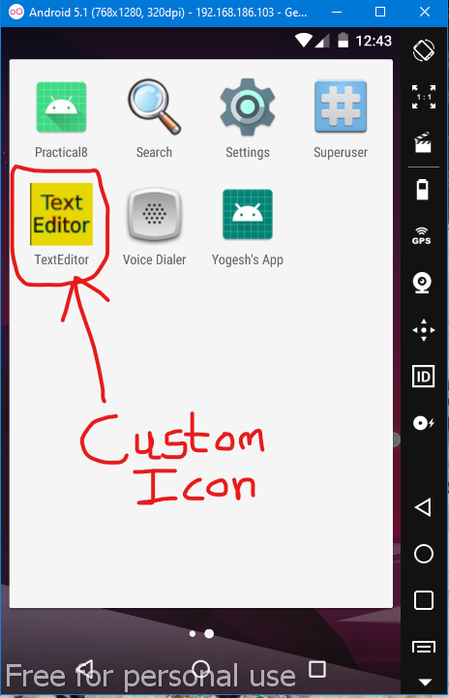 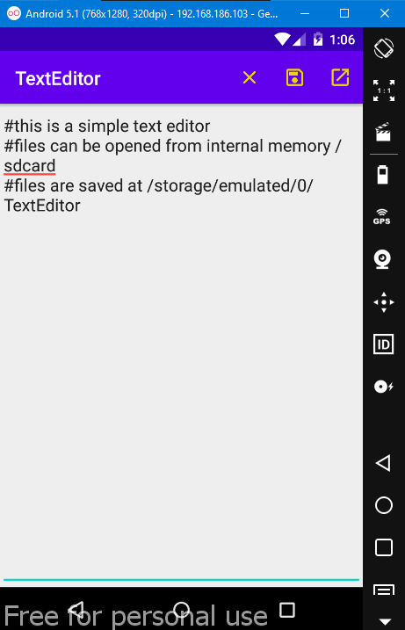

-Saving File -Opening File

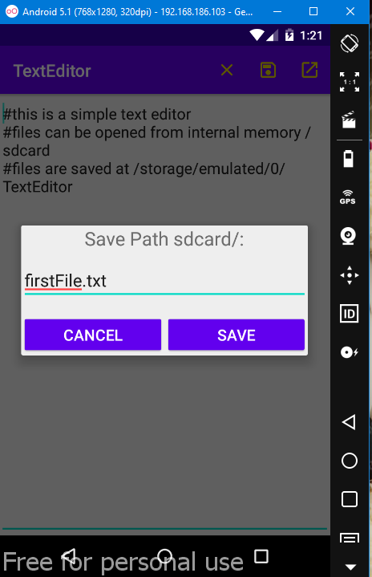 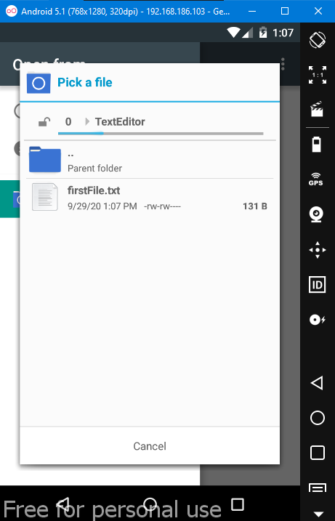

-Closing File

