Government Engineering College, Rajkot

Computer Engineering

Semester – 7

Mobile Computing and Wireless Communication (2170710)

Lab Manual

Name : Yogesh Bavishi

Enrollment No. : 170200107003

Division: E

Semester : 7th

Department : Computer

Experiment - 1

* Write a program to simulate Fixed Time Division Multiplexing. Take 12 stations. Every station has time slice of 417 microseconds. Delay should be 10ms. Every time the station gets turn, it shows message.
* Description:
* **TDM Technique:**

Time division multiplexing (TDM) is a technique of multiplexing, where the users are allowed the total available bandwidth on time sharing basis. Here the time domain is divided into several recurrent slots of fixed length, and each signal is allotted a time slot on a round-robin basis. It is widely used in telephone and cellular networks.

* **Example:**

Consider a system having four input streams, A, B, C and D. Each of the data streams is divided into units which are allocated time slots in the round – robin manner. Hence, the time slot 1 is allotted to D, slot 2 is allotted to C, slot 3 is allotted to B, slot 4 is allotted to A, slot 5 is allocated to D again, and this goes on till the data in all the streams are transmitted.

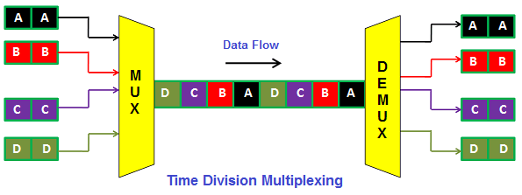

* **Algorithm for applying Time Division Multiplexing:**

Step 1: Input Station time for all the channels as an array Station_Time[]

Step 2: Make sum of all the Stations Times as Total

Step 3: Initialize Data_Sent with 0 and Time_Slice with 10

Step 4: while(Data_Sent<Total) repeat steps 5 and 6

Step 5: for i = 0 to 11 repeat step 6

Step 6: if (Station_Time[i] > 0) then

Print ("Channel i is Sending Data")

if (Station_Time[i] > Time_Slice) then

Data_sent = Data_sent + Time_Slice

Station_Time[i] = Station_Time[i] - Time_Slice

else

Data_sent = Data_sent + Station_Time[i]

Station_Time[i] = 0

Step 7: Print (Data_sent)

* **Pseudocode for applying Time Division Multiplexing:**

Initialize array Station_Time[]

Total = 0

Data_sent = 0

Time_Slice = 10

for i in 0 to 11

{

Total = Total + Station_Time[i]

}

for i in 0 to 11

{

if (Station_Time[i] > 0)

Print ("Channel i is Sending Data")

if (Station_Time[i] > Time_Slice)

Data_sent = Data_sent + Time_Slice

Station_Time[i] = Station_Time[i] - Time_Slice

else

Data_sent = Data_sent + Station_Time[i]

Station_Time[i] = 0

}

Print (Data_sent)

* Code : (Pract1.java)

import java.util.Date;

import java.util.Scanner;

import java.util.concurrent.TimeUnit;

public class Pract1 {

    public static void main(String[] args) {

        int n = 12, Total = 0, Time_Slice = 10, i, Data_sent = 0;

        int[] Station_Time = new int[] { 20, 30, 10, 20, 10, 20, 10, 10, 10, 30, 20, 40, };

        Scanner input = new Scanner(System.in);

        for (i = 0; i < n; i++) {

            Total = Total + Station_Time[i];

        }

        System.out.println("Total data of all the chnnels: " + Total + " Units");

        while (Data_sent < Total) {

            for (i = 0; i < n; i++) {

                if (Station_Time[i] > 0) {

                    System.out.println("Channel " + i + " Sending Data");

                    if (Station_Time[i] > Time_Slice) {

                        Data_sent = Data_sent + Time_Slice;

                        Station_Time[i] = Station_Time[i] - Time_Slice;

                    } else {

                        Data_sent = Data_sent + Station_Time[i];

                        Station_Time[i] = 0;

                    }

                    try {

                        Thread.sleep(1000);

                    } catch (InterruptedException e) {

                        e.printStackTrace();

                    }

                }

            }

            System.out.println("Total data sent : " + Data_sent + " Units");

        }

    }

}

* Output :

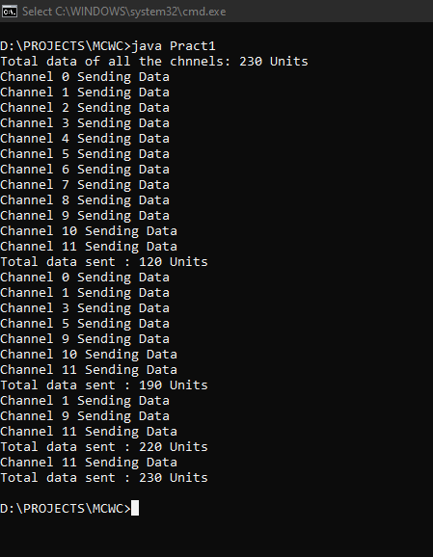

Experiment - 2

* Write a program that identifies the bluetooth devices in the wireless range.
* Description :
* **Discover Nearby Bluetooth Devices in Android :**

We can discover the devices which is not paired with yet, unknown devices, and add them to the list of paired devices. We do this when the user taps the scan button. The code to handle this is located in DeviceListFragment.

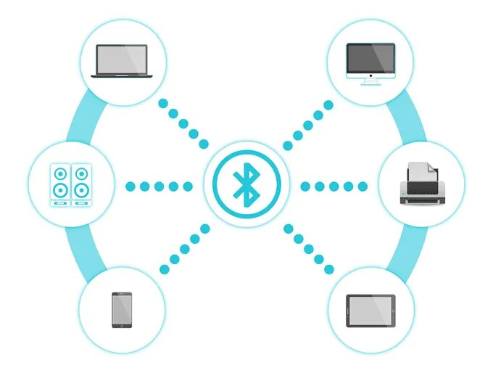

We first need to make a BroadcastReceiver and override the onReceive() method. The onReceive() method is invoked whenever a a Bluetooth device is found. The onReceive() method takes an intent as its second argument. We can check what kind of intent is broadcasting with by invoking getAction(). If the action is BluetoothDevice.ACTION_FOUND, then we know we have found a Bluetooth device. When this occurs, we create a DeviceItem object using the device's name and MAC address. Finally, we add the DeviceItem object to the ArrayAdapter to display it in our app.

* Code :
* **(AndroidManifest.xml) :**

*<?***xml version="1.0" encoding="utf-8"***?>*<**manifest xmlns:android="http://schemas.android.com/apk/res/android"  
 package="com.example.practical2"**>  
  
 <**uses-permission android:name="android.permission.BLUETOOTH"**/>  
 <**uses-permission android:name="android.permission.BLUETOOTH_ADMIN"** />  
  
 <**application  
 android:allowBackup="true"  
 android:icon="@mipmap/ic_launcher"  
 android:label="@string/app_name"  
 android:roundIcon="@mipmap/ic_launcher_round"  
 android:supportsRtl="true"  
 android:theme="@style/AppTheme"**>  
 <**activity android:name=".MainActivity"**>  
 <**intent-filter**>  
 <**action android:name="android.intent.action.MAIN"** />  
  
 <**category android:name="android.intent.category.LAUNCHER"** />  
 </**intent-filter**>  
 </**activity**>  
 </**application**>  
</**manifest**>

* **(MainActivity.java) :**

**package** com.example.practical2;  
  
**import** androidx.appcompat.app.AppCompatActivity;  
  
**import** android.bluetooth.BluetoothAdapter;  
**import** android.bluetooth.BluetoothDevice;  
**import** android.content.BroadcastReceiver;  
**import** android.content.Context;  
**import** android.content.Intent;  
**import** android.content.IntentFilter;  
**import** android.os.Bundle;  
**import** android.view.View;  
**import** android.widget.ArrayAdapter;  
**import** android.widget.Button;  
**import** android.widget.ListView;  
**import** android.widget.Toast;  
  
**import** com.google.android.material.floatingactionbutton.FloatingActionButton;  
  
**import** java.util.Set;  
  
**public class** MainActivity **extends** AppCompatActivity {  
  
 **private** IntentFilter **mActionFoundFilter**, **mActionDiscoveryFinishedFilter**;  
 **private** BluetoothAdapter **mBluetoothAdapter**;  
 **private** ArrayAdapter<String> **mPairedDeviceAdapter**, **mNewDevicesArrayAdapter**;  
 **int REQUEST_CODE** = 1000;  
  
  
 @Override  
 **protected void** onCreate(Bundle savedInstanceState) {  
 **super**.onCreate(savedInstanceState);  
 setContentView(R.layout.***activity_main***);  
  
 *//search button code* Button scanDevicesButton = findViewById(R.id.***btn_search***);  
 scanDevicesButton.setOnClickListener(**new** View.OnClickListener() {  
 @Override  
 **public void** onClick(View v) {  
 startDiscovery();  
 }  
 });  
  
 **mPairedDeviceAdapter** = **new** ArrayAdapter<>(**this**, R.layout.***device_name***, R.id.***tv***);  
 **mNewDevicesArrayAdapter** = **new** ArrayAdapter<>(**this**, R.layout.***device_name***, R.id.***tv***);  
  
  
 ListView pairedListView = findViewById(R.id.***device_list_listView***);  
 pairedListView.setAdapter(**mPairedDeviceAdapter**);  
  
 **mBluetoothAdapter** = BluetoothAdapter.*getDefaultAdapter*();  
 **if** (**mBluetoothAdapter** == **null**) {  
 Toast.*makeText*(**this**, **"Bluetooth devices not found...!!!"**, Toast.***LENGTH_SHORT***).show();  
 }  
 }  
  
 @Override  
 **protected void** onResume() {  
 **super**.onResume();  
 *//initializing filters and registering call for broadcast receiver* **mActionFoundFilter** = **new** IntentFilter(BluetoothDevice.***ACTION_FOUND***);  
 **this**.registerReceiver(**mReceiver**, **mActionFoundFilter**);  
  
 **mActionDiscoveryFinishedFilter** = **new** IntentFilter(BluetoothAdapter.***ACTION_DISCOVERY_FINISHED***);  
 **this**.registerReceiver(**mReceiver**, **mActionDiscoveryFinishedFilter**);  
 }  
  
 @Override  
 **protected void** onPause() {  
 **super**.onPause();  
 **this**.unregisterReceiver(**mReceiver**);  
 }  
  
 **public void** startDiscovery() {  
 **if** (!**mBluetoothAdapter**.isEnabled()) {  
 Intent i = **new** Intent(BluetoothAdapter.***ACTION_REQUEST_ENABLE***);  
 startActivityForResult(i, **REQUEST_CODE**);  
 } **else** {  
 Intent i = **new** Intent(BluetoothAdapter.***ACTION_REQUEST_DISCOVERABLE***);  
 startActivityForResult(i, **REQUEST_CODE**);  
  
 }  
 *//start discovery* **mBluetoothAdapter**.startDiscovery();  
 }  
  
  
 @Override  
 **protected void** onActivityResult(**int** requestCode, **int** resultCode, Intent data) {  
 **if** (requestCode == **REQUEST_CODE**) {  
 **if** (requestCode == ***RESULT_OK***) {  
 Toast.*makeText*(**this**, **"Bluetooth turned on!"**, Toast.***LENGTH_LONG***).show();  
 }  
 }  
 **if** (requestCode == **REQUEST_CODE**) {  
 Toast.*makeText*(**this**, **"Bluetooth is already on!"**, Toast.***LENGTH_LONG***).show();  
 }  
  
 Set<BluetoothDevice> paireDevices = **mBluetoothAdapter**.getBondedDevices();  
 **if** (paireDevices.size() > 0) {  
  
 **if** (**mPairedDeviceAdapter** != **null** && !**mPairedDeviceAdapter**.isEmpty())  
 **mPairedDeviceAdapter**.clear();  
  
 **for** (BluetoothDevice bDevice : paireDevices) {  
 **mPairedDeviceAdapter**.add(bDevice.getName() + **" \n"** + bDevice.getAddress());  
 }  
  
 } **else** {  
 String noDevice = getString(R.string.***no_devices_connected***);  
 **mPairedDeviceAdapter**.add(noDevice);  
  
 }  
 }  
  
 BroadcastReceiver **mReceiver** = **new** BroadcastReceiver() {  
 @Override  
 **public void** onReceive(Context context, Intent intent) {  
 String action = intent.getAction();  
  
 *// When discovery finds a device* **if** (BluetoothDevice.***ACTION_FOUND***.equals(action)) {  
 *// Get the BluetoothDevice object from the Intent* BluetoothDevice device = intent.getParcelableExtra(BluetoothDevice.***EXTRA_DEVICE***);  
 *// If it's already paired, skip it, because it's been listed already* **if** (device.getBondState() != BluetoothDevice.***BOND_BONDED***) {  
 **mNewDevicesArrayAdapter**.add(device.getName() + **"\n"** + device.getAddress());  
 }  
 *// When discovery is finished, change the Activity title* } **else if** (BluetoothAdapter.***ACTION_DISCOVERY_FINISHED***.equals(action)) {  
 setProgressBarIndeterminateVisibility(**false**);  
  
 **if** (**mNewDevicesArrayAdapter**.getCount() == 0) {  
 String noDevices = **"NO DEVICE FOUND"**;  
 **mNewDevicesArrayAdapter**.add(noDevices);  
 }  
 }  
 }  
 };  
}

* **(activity_main.xml) :**

*<?***xml version="1.0" encoding="utf-8"***?>*<**androidx.constraintlayout.widget.ConstraintLayout xmlns:android="http://schemas.android.com/apk/res/android"  
 xmlns:app="http://schemas.android.com/apk/res-auto"  
 xmlns:tools="http://schemas.android.com/tools"  
 android:layout_width="match_parent"  
 android:layout_height="match_parent"  
 tools:context="com.example.practical2.MainActivity"**>  
  
 <**RelativeLayout  
 android:layout_width="match_parent"  
 android:layout_height="match_parent"**>  
  
 <**LinearLayout  
 android:id="@+id/header"  
 android:layout_width="match_parent"  
 android:layout_height="80sp"  
 android:gravity="center"**>  
  
 <**TextView  
 android:layout_width="wrap_content"  
 android:layout_height="wrap_content"  
 android:layout_margin="10sp"  
 android:fontFamily="sans-serif"  
 android:gravity="center"  
 android:text="Bluetooth List"  
 android:textAppearance="@style/TextAppearance.AppCompat.Large"  
 android:textColor="#000000"  
 android:textSize="25sp"  
 android:textStyle="bold"** />  
 <**Button  
 android:id="@+id/btn_search"  
 android:text="Search devices"  
 android:layout_width="wrap_content"  
 android:layout_height="wrap_content"** />  
  
 </**LinearLayout**>  
  
 <**LinearLayout  
 android:layout_width="match_parent"  
 android:layout_height="match_parent"  
 android:layout_below="@+id/header"  
 android:orientation="vertical"  
 android:weightSum="1"**>  
  
 <**LinearLayout  
 android:layout_width="match_parent"  
 android:layout_height="match_parent"  
 android:layout_margin="10sp"  
 android:layout_weight="0.5"  
 android:orientation="vertical"**>  
  
 <**TextView  
 android:id="@+id/device_list_textView"  
 android:layout_width="match_parent"  
 android:layout_height="wrap_content"  
 android:layout_margin="10sp"  
 android:fontFamily="sans-serif"  
 android:gravity="center"  
 android:text="@string/paired_list_text"  
 android:textAppearance="@style/TextAppearance.AppCompat.Large"  
 android:textColor="#000000"  
 app:layout_constraintEnd_toEndOf="parent"  
 app:layout_constraintStart_toStartOf="parent"  
 app:layout_constraintTop_toTopOf="parent"** />  
  
 <**ListView  
 android:id="@+id/device_list_listView"  
 android:layout_width="match_parent"  
 android:layout_height="wrap_content"  
 android:layout_margin="10sp"  
 android:visibility="visible"  
 app:layout_constraintEnd_toEndOf="parent"  
 app:layout_constraintStart_toStartOf="parent"  
 app:layout_constraintTop_toBottomOf="@+id/paired_title_text_view"  
 tools:listitem="@layout/device_name"** />  
  
 </**LinearLayout**>  
 </**LinearLayout**></**RelativeLayout**>  
</**androidx.constraintlayout.widget.ConstraintLayout**>

* **(device_name.xml) :**

*<?***xml version="1.0" encoding="utf-8"***?>*<**LinearLayout xmlns:android="http://schemas.android.com/apk/res/android"  
 android:layout_width="match_parent"  
 android:layout_height="60sp"  
 android:orientation="horizontal"**>  
  
 <**ImageView  
 android:layout_width="40sp"  
 android:layout_height="40sp"  
 android:layout_gravity="center"  
 android:layout_marginLeft="10sp"  
 android:layout_marginStart="10sp"  
 android:background="@drawable/phone"**/>  
  
 <**TextView  
 android:id="@+id/tv"  
 android:layout_width="fill_parent"  
 android:layout_height="60sp"  
 android:layout_marginLeft="20sp"  
 android:layout_marginStart="20sp"  
 android:text="list text"  
 android:textStyle="bold"  
 android:textSize="15sp"  
 android:gravity="center_vertical"  
 android:textColor="#000000"** />  
  
</**LinearLayout**>

* Output :

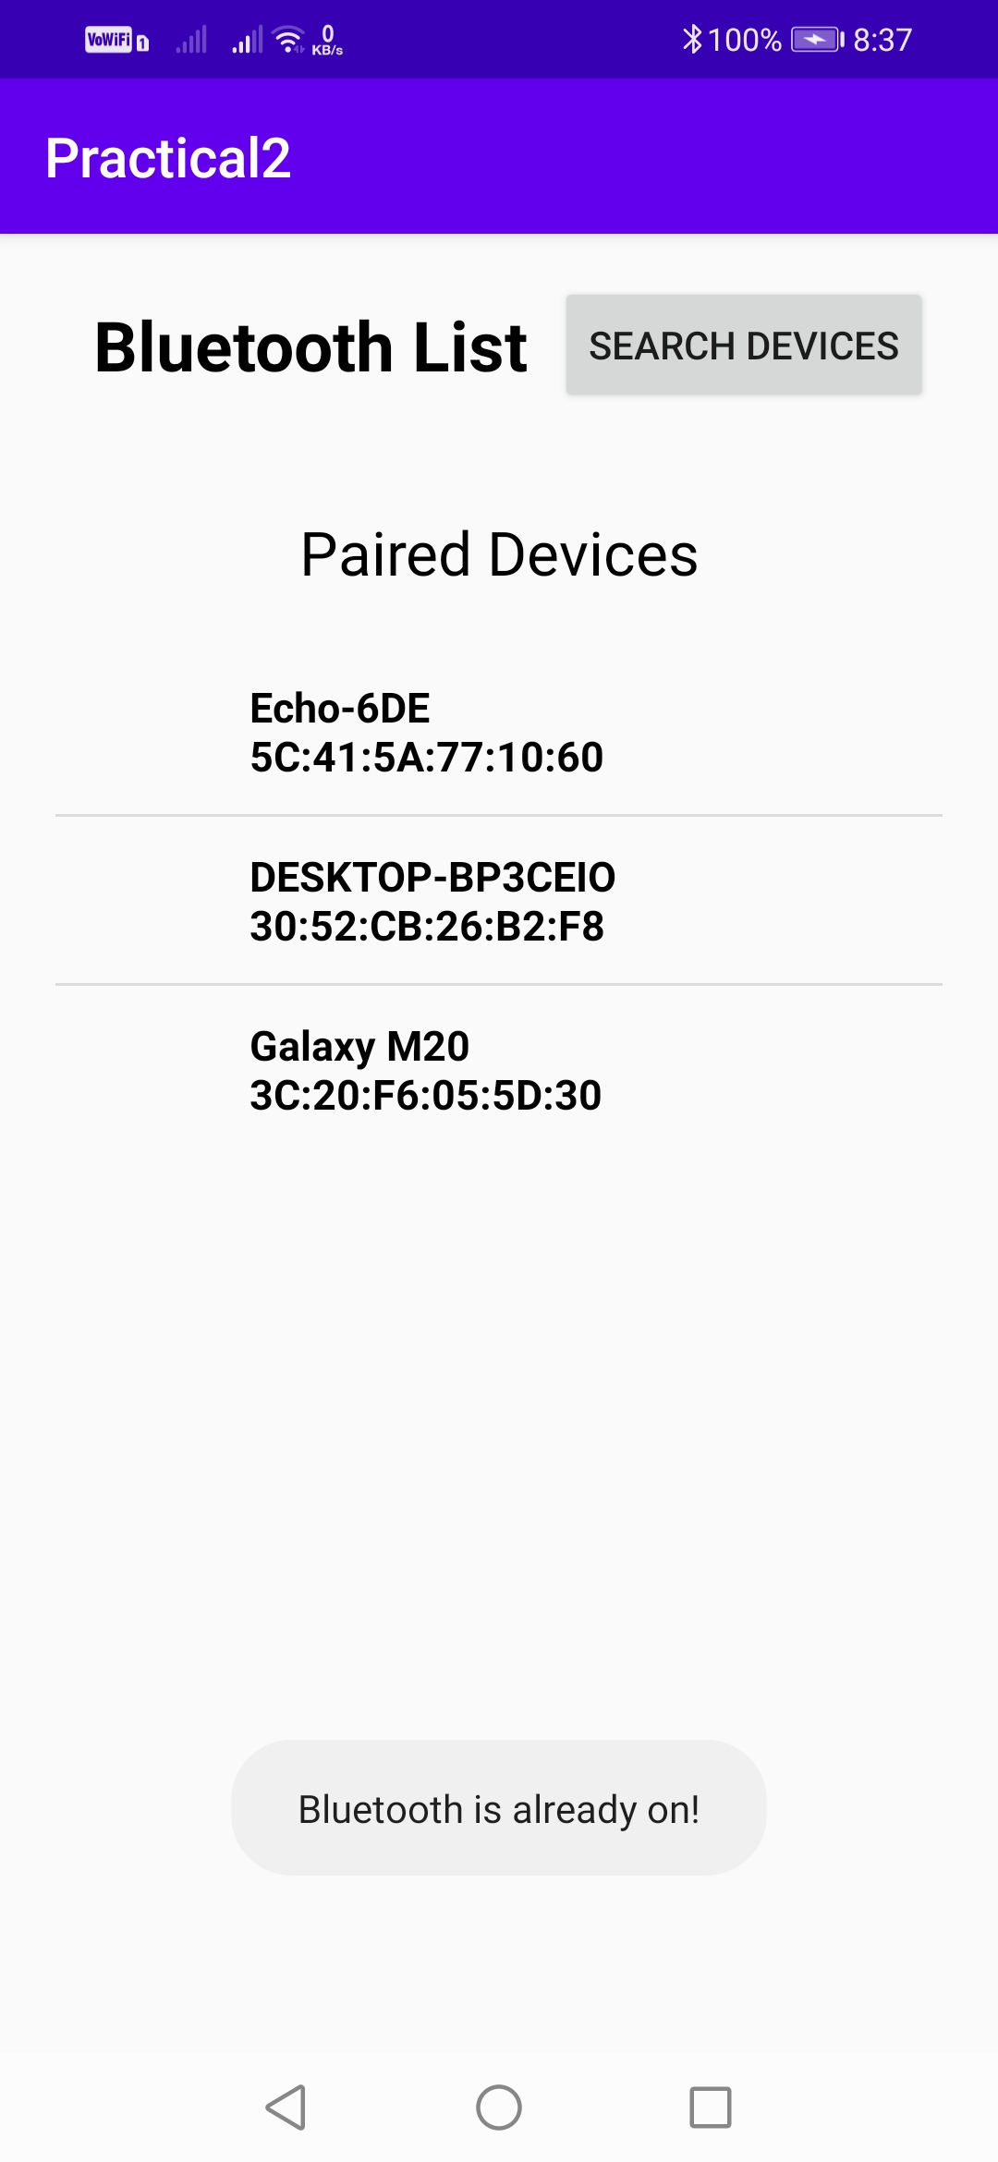

Experiment - 3

* Write a program that prints the signal strength of WiFi connection of the given computer.
* Description :
* **WiFi connection:**

The wireless connection speed of your computer is different from the Internet speed from your service provider. The former is the communication speed between your device's wireless adapter and your router. A good wireless router is important to get the desired speed you want on your network. However, there are many factors that can affect the wireless network connection speed between your router and computers.

To determine your computer's wireless connection speed in Windows10, use the following steps :

Step 1: Open **Control Panel** from **Start menu.**

Step 2: Open **Network and Sharing Center** as shown below.

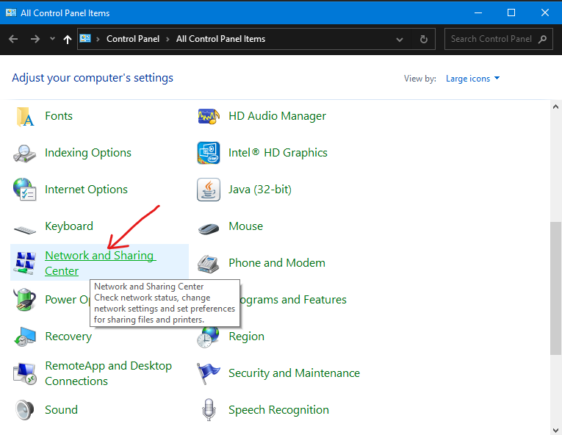

Step 3: : On the Network and Sharing Center window, click Wireless Network Connection.

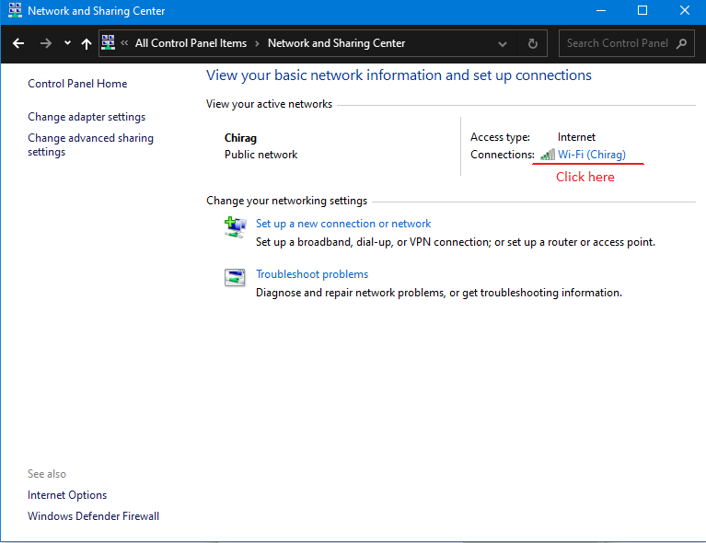

Step 4: The Wireless Network Connection Status window will appear showing your computer’s wireless connection details. The Speed section indicates the connection speed between the wireless adapter and the router.

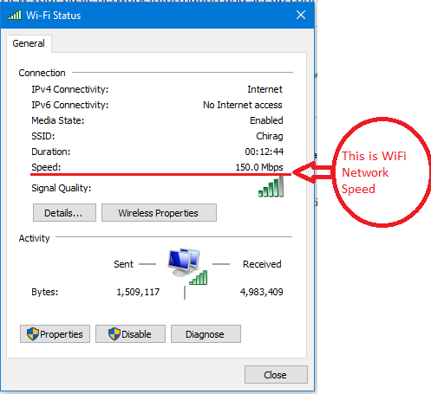

* Code : (Pract3.c)

#if defined(_WIN32)

    #define PLATFORM_NAME "windows" // Windows

#elif defined(__linux__)

    #define PLATFORM_NAME "linux" // Debian, Ubuntu, Gentoo, Fedora, openSUSE, RedHat, Centos and other

#elif defined(__unix__)

    #define PLATEFORM_NAME "linux"  //unix/macos

#endif

#include <stdio.h>

#include <stdlib.h>

int main(){

    if(PLATFORM_NAME=="windows"){

        system("netsh wlan show interfaces");

    }

    else if ( PLATFORM_NAME == "linux")

        {

            system("iwconfig ");

        }

}

* Output :

**(Windows10)**

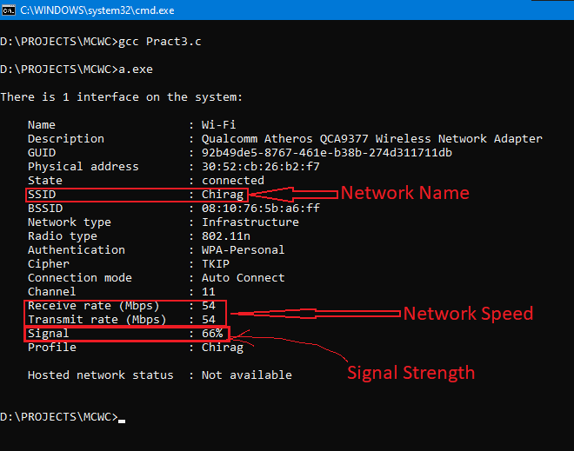

**(LinuxMint Live Usb)**

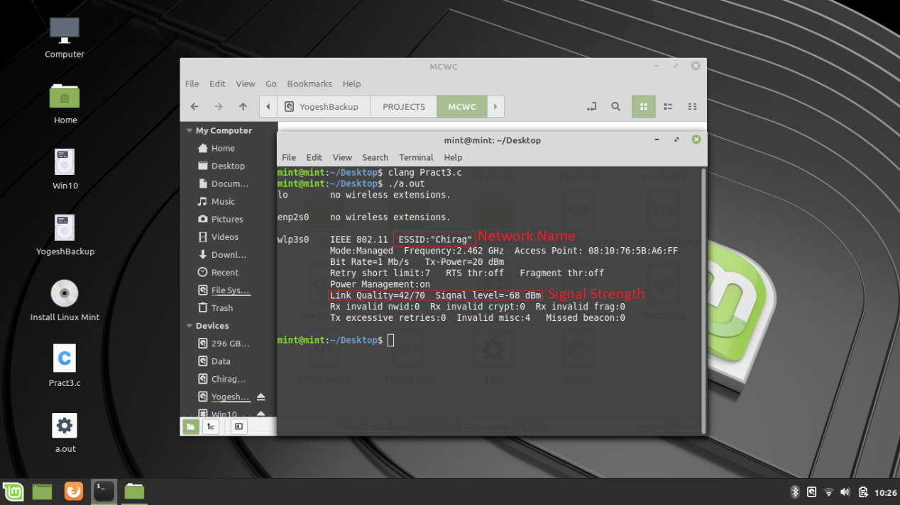

Experiment - 4

* Prepare a wireless ad hoc network and show its working.
* Description :
* **Wireless ad hoc network Concept :**

A wireless ad hoc network (WANET) or Mobile ad hoc network (MANET) is a decentralized type of wireless network. The network is ad hoc because it does not rely on a pre-existing infrastructure, such as routers in wired networks or access points in managed (infrastructure) wireless networks.

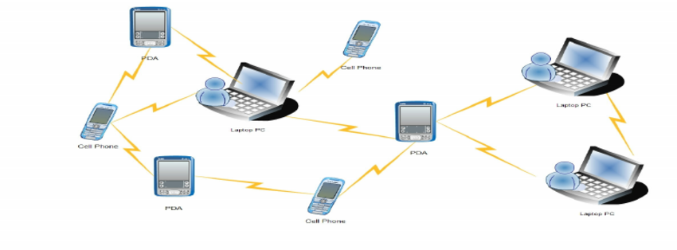

In an ad hoc mode wireless local-area network, wireless devices can communicate directly with each other. Wireless ad hoc networks are distributed networks that work without fixed infrastructures and in which each network node is willing to forward network packets for other network nodes.

* **Characteristics and Working of Wireless Ad hoc Network :**

* Wireless ad hoc networks are distributed networks that do not require fixed infrastructures to work. Network nodes in a wireless ad hoc network can be randomly deployed to form the wireless ad hoc network.

* Network nodes will forward network packets for other network nodes. Network nodes in a wireless ad hoc network directly communicate with other nodes within their ranges. When these networks communicate with network nodes outside their ranges, network packets will be forwarded by the nearby network nodes and other nodes that are on the path from the source nodes to the destination nodes.

* Wireless ad hoc networks are self-organizing. Without fixed infrastructures and central administration, wireless ad hoc networks must be capable of establishing cooperation between nodes on their own. Network nodes must also be able to adapt to changes in the network, such as the network topology.

* Wireless ad hoc networks have dynamic network topologies. Network nodes of a wireless ad hoc network connect to other network nodes through wireless links. The network nodes are mostly mobile. The topology of a wireless ad hoc network can change from time to time, since network nodes move around from within the range to the outside, and new network nodes may join the network, just as existing network nodes may leave the network.

* **Steps to prepare a wireless ad hoc network :**

If you have a Windows 7 computer (or a Windows Vista computer, which is very similar), you will use a process similar to the following to create and activate your ad hoc WLAN network.

Step 1: From **Start menu** open **Control Panel**.

Step 2: Open the **Network and Sharing Center** .

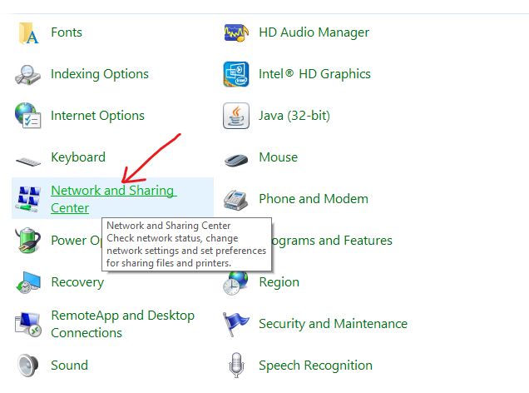

Step 3: Select Set Up a New Connection or Network.

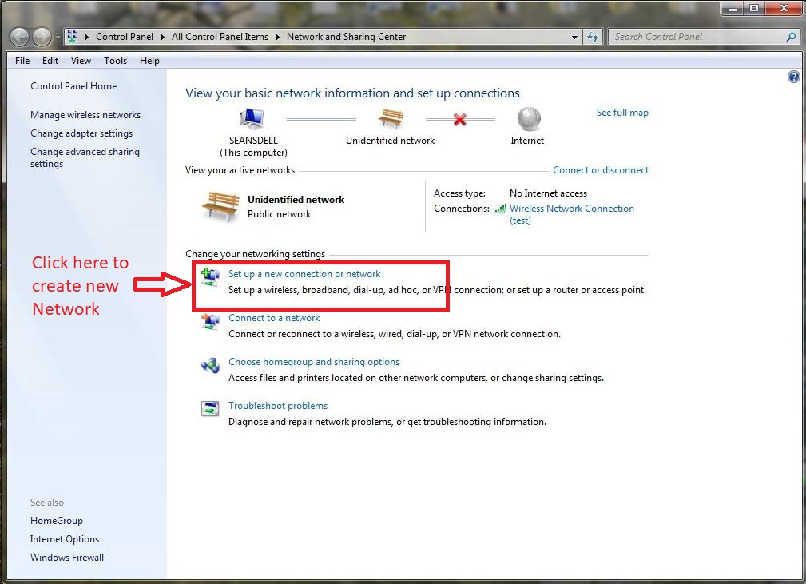

Step 4: From the Set Up a Connection or Network dialog box, choose Set Up a Wireless Ad Hoc (Computer-to-Computer) Network and click Next; click Next again.

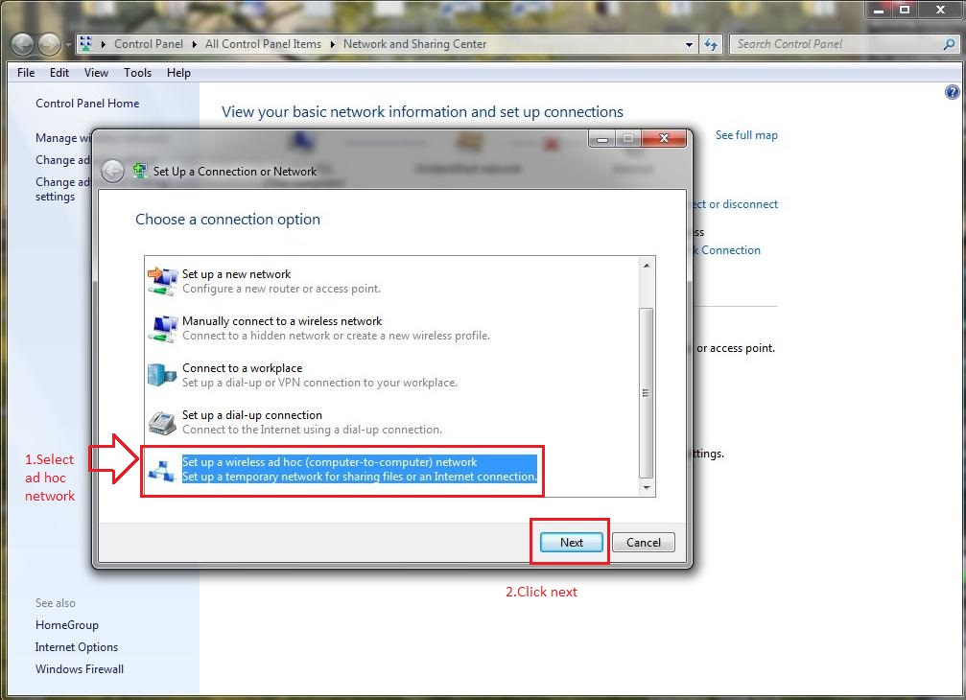

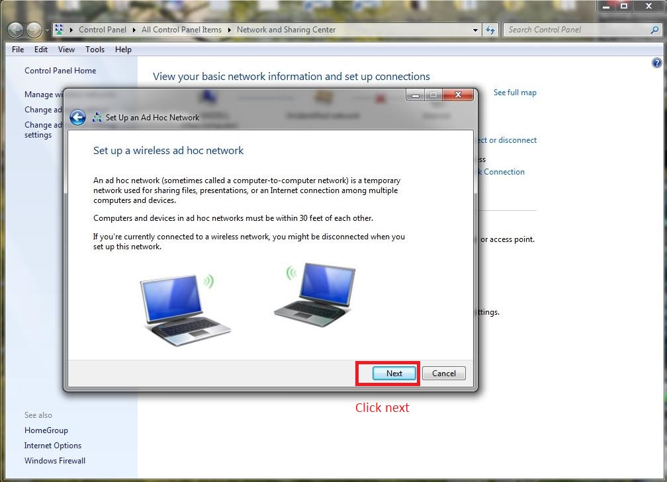

Step 5: In the Set Up an Ad Hoc Network dialog box, provide the following information:

1. Add a network name for your wireless network.
2. Indicate the security type as either WEP or No Authentication.
3. If you chose WEP, provide the security key for the network and optionally select the Hide Characters box.
4. Select Save This Network to keep this network for longer than one session.

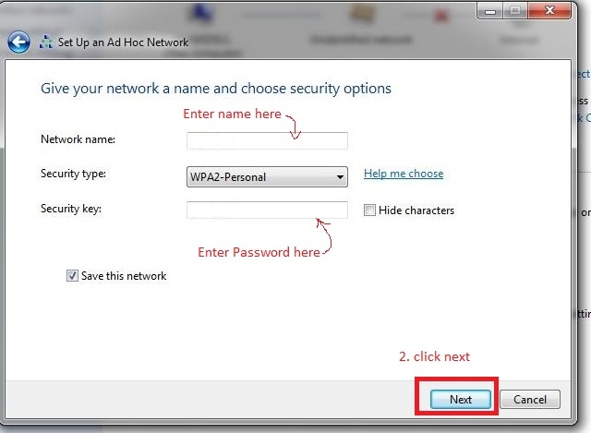

The confirmation dialog is displayed, showing you the information that you need to provide to other people who will want to connect to your ad hoc network.

After the connection is set up, it initially becomes active and remains so until you connect to another network. If you did not choose to save the connection, it will be removed from your wireless configuration at that time and you will need to repeat this process to reactivate an ad hoc network connection.

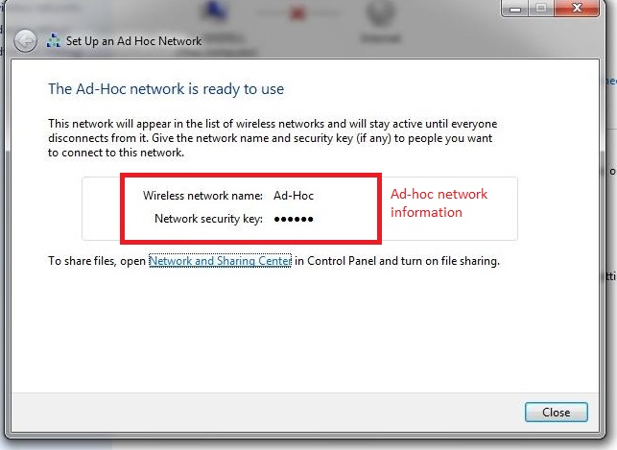

Experiment - 5

* Write a program to find hamming distance. For example Hamming distance d(v1,v2)=3 if v1=011011,v2=110001.
* Description :
* **Definition:**

Hamming distance is a metric for comparing two binary data strings. While comparing two binary strings of equal length, Hamming distance is the number of bit positions in which the two bits are different.

* **Application:**

It is used for error detection or error correction when data is transmitted over computer networks. It is used for the strings with the same length.

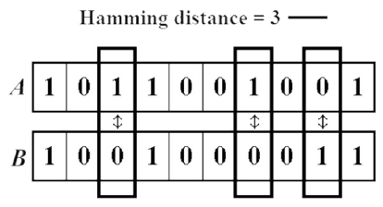

* **Algorithm to find Hamming Distance:**

Step 1: Input 2 strings: str1 and str2

Step 2: Set n = length( str1 )

Step 3: initialize i = 0, count = 0

Step 4: while ( n > 0 ) repeat steps 5 and 6

Step 5: Compare if ( str1[i] != str2[i] ) then count = count + 1

Step 6: Increment i = i + 1 and go to step 4

Step 7: print ( count )

* **Pseudocode to find Hamming Distance:**

Input( str1 )

Input( str2 )

N = length( str1 )

while ( n>0 )

if ( str1[i] != str2[i] )

count = count + 1

i = i + 1

print ( count )

* Code : (Pract5.java)

public class Pract5 {

  static int HammingDistance(String str1, String str2) {

    int i = 0, count = 0;

    while (i < str1.length()) {

      if (str1.charAt(i) != str2.charAt(i)) count++;

      i++;

    }

    return count;

  }

  public static void main(String[] args) {

    String str1 = "011011";

    String str2 = "110001";

    System.out.println("A = "+str1);

    System.out.println("B = "+str2);

    System.out.println("Hamming distance = "+HammingDistance(str1, str2));

  }

}

* Output :

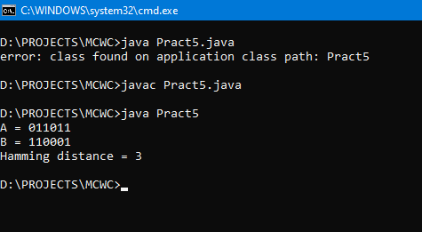

Experiment - 6

* Write a program to perform infrared communication.
* Description :
* **InfraRed communication :**

* Infrared (IR) is a wireless mobile technology used for device communication over short ranges. IR communication has major limitations because it requires line-of-sight, has a short transmission range and is unable to penetrate walls. IR transceivers are quite cheap and serve as short-range communication solutions.

* Because of IR's limitations, communication interception is difficult. In fact, Infrared Data Association (IrDA) device communication is usually exchanged on a one-to-one basis. Thus, data transmitted between IrDA devices is normally unencrypted.

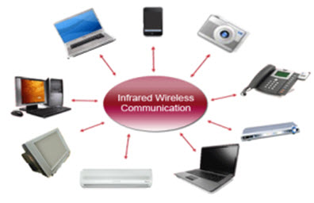

* Code & Output :
* **Receiving IR Example :**

The first thing you need to do is install the IR Arduino library. After downloading the IR library, go to your Arduino project directory -> libraries ->IRremote -> examples ->IRrecvDemo ->and open the IRrecvDemo.ino. Upload the sketch to your Arduino.

The sketch will automatically decode the type of remote you are using and identify which button on your remote is pressed. Open the serial port in the Arduino IDE at 9600 bps and hit different buttons on your remote.

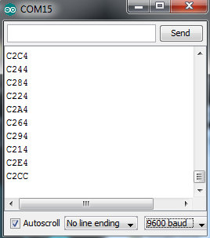

*Terminal window displaying random button presses on my remote. Different buttons show different codes*

When specific buttons are pressed, you can use the incoming values to do something else in your code, for example turn on and off a motor or LED. The results from each button press can be found by calling the value() method:

results.value

You can print the values to the terminal window :

Serial.println(results.value, HEX); //prints the hex value a button press

Or you might need read the values to run a conditional statement :

if(irrecv.decode(&results)) //this checks to see if a code has been received

{

if(results.value == 0xC284) //if the button press equals the hex value 0xC284

{

//do something useful here

}

irrecv.resume(); //receive the next value

}

* **Transmitting IR Example :**

After you have loaded the sketch, open the Arduino serial monitor to 9600bps. Point your remote directly at the TSOP382 and hit a button. You should see specific codes in the terminal window, corresponding to the button you hit on the remote.

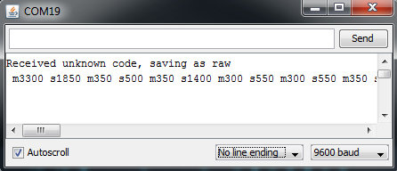

Now, if you point the LED at your appliance and hit the push button that is connected to your Arduino, the code for the button press on your remote will be sent. Once you know which codes correspond to each button, you can create your own remote with the Arduino and IR LED.

For example, in the image above, the circuit received and unknown code when the volume up button on my Panasonic remote was hit. The data bytes on the second line are the raw codes displayed as mark and space timings for the volume up command. If you received an unknown code and want to send it, use this line in your Arduino sketch:

irsend.sendRaw(rawCodes, codeLen, 38);

If you don’t have the appliance’s remote or if you are lucky enough to have a remote that uses a common protocol, then you can try the pre-loaded manufacturer codes from the IRSendDemo example in the IR Arduino library.

For example, if you have a Sony TV, and want the LED to turn your TV on and off, you can use this piece of code:

for (int i = 0; i < 3; i++)

{

irsend.sendSony(0xa90, 12); // Sony TV power code

delay(40);

}

Outlines for IR Communication between IR LED And IR Photodiode Using Arduino :

* **Sketch for Transmitter :**

void setup()

{

  Serial.begin(9600); /* Define baud rate for serial communication */

}

void loop() {

  int count;

  for(count = 0; count<100; count++)

  {

  Serial.println(count);

  delay(1000);

  }

}

* **Sketch For Receiver :**

void setup()

{

 Serial.begin(9600); /* Define baud rate for serial communication */

}

void loop()

{

if(Serial.available()) /* If data is available on serial port */

  {

  Serial.print(char(Serial.read())); /* Print character received on to the serial monitor */

  }

}

Experiment - 7

* Write a program to perform Bluetooth file transfer.
* Description :
* **Bluetooth Concept:**

* A Bluetooth technology is a high speed low powered wireless technology link that is designed to connect phones or other portable equipment together. It is a specification (IEEE 802.15.1) for the use of low power radio communications to link phones, computers and other network devices over short distance without wires. Wireless signals transmitted with Bluetooth cover short distances, typically up to 30 feet (10 meters).

* It is achieved by embedded low cost transceivers into the devices. It supports on the frequency band of 2.45GHz and can support upto 721KBps along with three voice channels. This frequency band has been set aside by international agreement for the use of industrial, scientific and medical devices (ISM).rdcompatible with 1.0 devices.

* Bluetooth can connect up to “**eight devices**” simultaneously and each device offers a unique 48 bit address from the IEEE 802 standard with the connections being made point to point or multipoint.

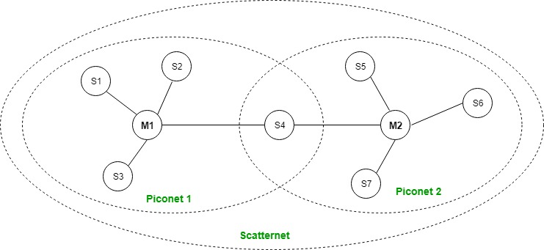

* **How Bluetooth Works :**

* Bluetooth Network consists of a Personal Area Network or a piconet which contains a minimum of 2 to maximum of 8 bluetooth peer devices- Usually a single master and upto 7 slaves.

* A master is the device which initiates communication with other devices. The master device governs the communications link and traffic between itself and the slave devices associated with it.

* A slave device is the device that responds to the master device. Slave devices are required to synchronize their transmit/receive timing with that of the masters. In addition, transmissions by slave devices are governed by the master device (i.e., the master device dictates when a slave device may transmit).

* Specifically, a slave may only begin its transmissions in a time slot immediately following the time slot in which it was addressed by the master, or in a time slot explicitly reserved for use by the slave device.

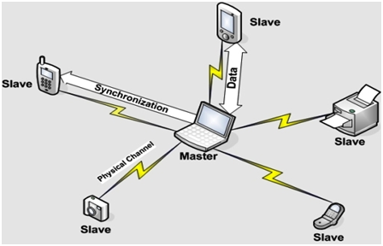

* Code :
* **(MainActivity.java):**

**package** com.example.practical7;  
**import** android.bluetooth.BluetoothAdapter;  
**import** android.bluetooth.BluetoothDevice;  
**import** android.content.Intent;  
**import** android.os.Bundle;  
**import** android.view.Menu;  
**import** android.view.MenuItem;  
**import** android.view.View;  
**import** android.widget.ArrayAdapter;  
**import** android.widget.Button;  
**import** android.widget.ListView;  
**import** android.widget.Toast;  
**import** androidx.appcompat.app.AppCompatActivity;  
**import** java.util.ArrayList;  
**import** java.util.Set;  
  
**public class** MainActivity **extends** AppCompatActivity {  
 Button **b1**,**b2**,**b3**,**b4**;  
 **private** BluetoothAdapter **BA**;  
 **private** Set<BluetoothDevice> **pairedDevices**;  
 ListView **lv**;  
 @Override  
 **protected void** onCreate(Bundle savedInstanceState) {  
 **super**.onCreate(savedInstanceState);  
 setContentView(R.layout.***activity_main***);  
 **b1** = findViewById(R.id.***button***);  
 **b2**=(Button)findViewById(R.id.***button2***);  
 **b3**=(Button)findViewById(R.id.***button3***);  
 **b4**=(Button)findViewById(R.id.***button4***);  
 **BA** = BluetoothAdapter.*getDefaultAdapter*();  
 **lv** = (ListView)findViewById(R.id.***listView***);  
 }  
 **public void** on(View v){  
 **if** (!**BA**.isEnabled()) {  
 Intent turnOn = **new** Intent(BluetoothAdapter.***ACTION_REQUEST_ENABLE***);  
 startActivityForResult(turnOn, 0);  
 Toast.*makeText*(getApplicationContext(),**"Turned on"**,Toast.***LENGTH_LONG***).show();  
 }  
 **else** {  
 Toast.*makeText*(getApplicationContext(),**"Already on"**, Toast.***LENGTH_LONG***).show();  
 }  
 }  
 **public void** off(View v) {  
 **BA**.disable();  
 Toast.*makeText*(getApplicationContext(), **"Turned off"** , Toast.***LENGTH_LONG***).show();  
 }  
 **public void** visible(View v){  
 Intent getVisible = **new** Intent(BluetoothAdapter.***ACTION_REQUEST_DISCOVERABLE***);  
 startActivityForResult(getVisible, 0);  
 }  
 **public void** list(View v){  
 **pairedDevices** = **BA**.getBondedDevices(); ArrayList list = **new** ArrayList();  
 **for**(BluetoothDevice bt : **pairedDevices**) list.add(bt.getName());  
 Toast.*makeText*(getApplicationContext(),**"Showing Paired Devices"**,Toast.***LENGTH_SHORT***).show();  
 **final** ArrayAdapter adapter = **new** ArrayAdapter(**this**,android.R.layout.***simple_list_item_1***, list);  
 **lv**.setAdapter(adapter);  
 }  
 @Override  
 **public boolean** onCreateOptionsMenu(Menu menu) {  
*// Inflate the menu; this adds items to the action bar if it is present.* getMenuInflater().inflate(R.menu.***menu_main***, menu);  
 **return true**;  
 }  
 @Override  
 **public boolean** onOptionsItemSelected(MenuItem item) {  
*// Handle action bar item clicks here. The action bar will  
// automatically handle clicks on the Home/Up button, so long  
// as you specify a parent activity in AndroidManifest.xml.* **int** id = item.getItemId();  
*//noinspection SimplifiableIfStatement* **if** (id == R.id.***action_settings***) {  
 **return true**;  
 }  
 **return super**.onOptionsItemSelected(item);  
 }  
}

* **(activity_main.xml):**

*<?***xml version="1.0" encoding="utf-8"***?>*<**RelativeLayout xmlns:android="http://schemas.android.com/apk/res/android"  
 xmlns:tools="http://schemas.android.com/tools"  
 android:layout_width="wrap_content"  
 android:layout_height="wrap_content"  
 tools:context=".MainActivity"**>  
  
 <**TextView  
 android:id="@+id/textview"  
 android:layout_width="wrap_content"  
 android:layout_height="wrap_content"  
 android:layout_alignParentTop="true"  
 android:layout_centerHorizontal="true"  
 android:text="Bluetooth Practical"  
 android:textSize="35dp"** />  
  
  
 <**Button  
 android:id="@+id/button"  
 android:layout_width="wrap_content"  
 android:layout_height="wrap_content"  
 android:layout_alignTop="@+id/button4"  
 android:layout_marginTop="0dp"  
 android:clickable="true"  
 android:onClick="on"  
 android:text="ON"** />  
  
 <**Button  
 android:id="@+id/button3"  
 android:layout_width="wrap_content"  
 android:layout_height="wrap_content"  
 android:layout_alignTop="@+id/button4"  
 android:layout_alignParentEnd="true"  
 android:layout_alignParentRight="true"  
 android:onClick="list"  
 android:text="List"** />  
  
  
 <**Button  
 android:id="@+id/button2"  
 android:layout_width="wrap_content"  
 android:layout_height="wrap_content"  
 android:layout_below="@id/textview"  
 android:layout_alignBottom="@id/button4"  
 android:layout_marginStart="17dp"  
 android:layout_marginLeft="17dp"  
 android:layout_marginTop="21dp"  
 android:layout_marginRight="29dp"  
 android:layout_marginBottom="-1dp"  
 android:layout_toLeftOf="@+id/button3"  
 android:layout_toEndOf="@+id/button4"  
 android:layout_toRightOf="@+id/button4"  
 android:onClick="visible"  
 android:text="visible"** />  
  
 <**Button  
 android:id="@+id/button4"  
 android:layout_width="wrap_content"  
 android:layout_height="wrap_content"  
 android:layout_below="@id/textview"  
 android:layout_marginStart="13dp"  
 android:layout_marginLeft="13dp"  
 android:layout_marginTop="20dp"  
 android:layout_toEndOf="@+id/button"  
 android:layout_toRightOf="@+id/button"  
 android:onClick="off"  
 android:text="OFF"** />  
  
 <**TextView  
 android:id="@+id/textView2"  
 android:layout_width="wrap_content"  
 android:layout_height="wrap_content"  
 android:layout_below="@id/button3"  
 android:layout_alignStart="@+id/button4"  
 android:layout_alignLeft="@+id/button4"  
 android:layout_marginStart="2dp"  
 android:layout_marginLeft="2dp"  
 android:layout_marginTop="4dp"  
 android:text="Paired devices:"  
 android:textColor="@color/colorPrimary"  
 android:textSize="25dp"** />  
  
 <**ListView  
 android:layout_width="wrap_content"  
 android:layout_height="wrap_content"  
 android:id="@+id/listView"  
 android:layout_alignParentBottom="true"  
 android:layout_alignLeft="@+id/button"  
 android:layout_alignStart="@+id/button"  
 android:layout_below="@+id/textView2"** />  
  
  
</**RelativeLayout**>

* Output :

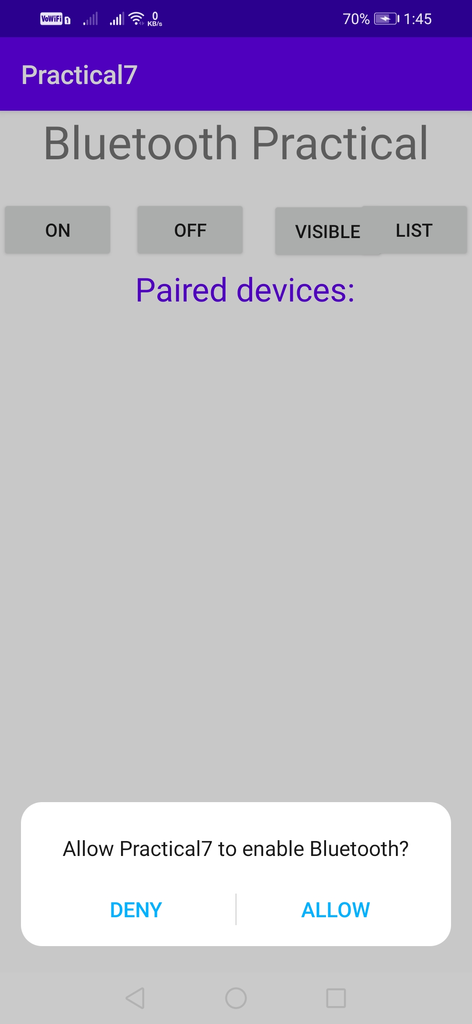 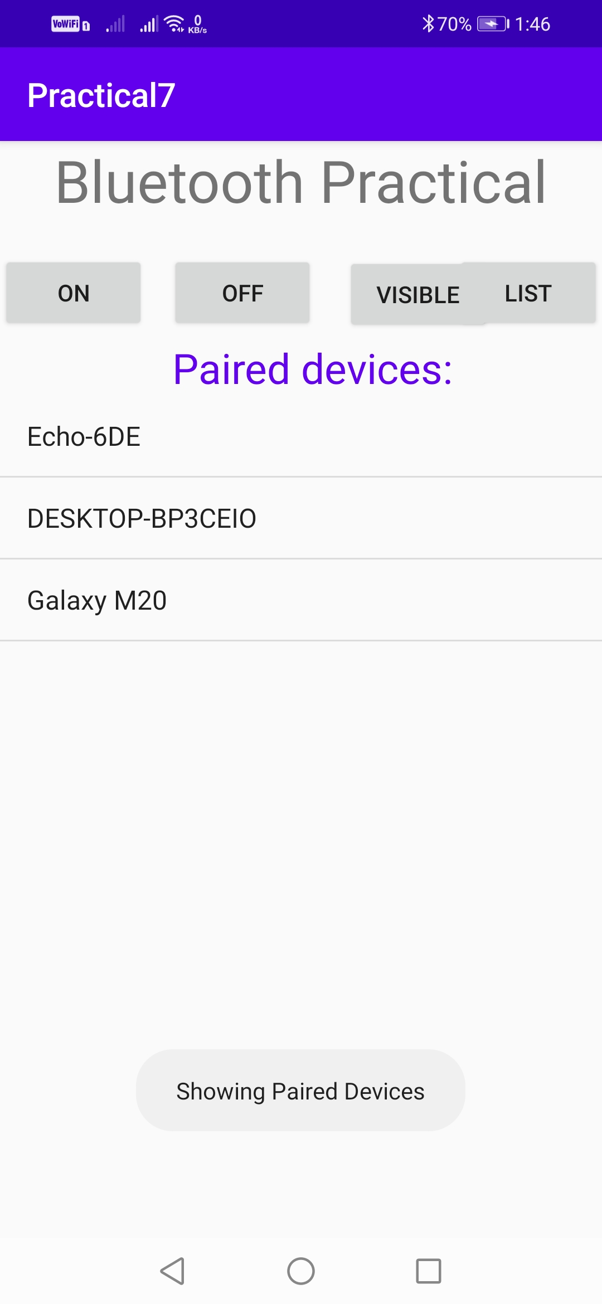

Experiment - 8

* Develop an android app which displays “Hello, welcome to Android Lab” message.
* Description :
* **Toast in Android :**

* An **Android Toast** is a small message displayed on the screen, similar to a tool tip or other similar popup notification. A **Toast** is displayed on top of the main content of an activity, and only remains visible for a short time period.

* We can use makeText method to build a custom Toast. We will invoke a Toast using show method.

* Code :
* **(MainActivity.java):**

**package** com.example.practical8;  
  
**import** androidx.appcompat.app.AppCompatActivity;  
  
**import** android.os.Bundle;  
**import** android.view.View;  
**import** android.widget.Button;  
**import** android.widget.EditText;  
**import** android.widget.TextView;  
**import** android.widget.Toast;  
  
**public class** MainActivity **extends** AppCompatActivity {  
  
 Button btn_clickHere;  
 TextView txt_messageOutput;  
 EditText txt_messageInput;  
  
  
 @Override  
 **protected void** onCreate(Bundle savedInstanceState) {  
 **super**.onCreate(savedInstanceState);  
 setContentView(R.layout.activity_main);  
  
 btn_clickHere = findViewById(R.id.btn_clickHere);  
 txt_messageInput = findViewById(R.id.txt_messageInput);  
 txt_messageOutput = findViewById(R.id.txt_messageOutput);  
  
  
 btn_clickHere.setOnClickListener(**new** View.OnClickListener() {  
 @Override  
 **public void** onClick(View v) {  
 String message = **"Hello, "**+(txt_messageInput.getText());  
 txt_messageOutput.setText(message);  
 Toast toast = Toast.makeText(getApplicationContext(),message,Toast.LENGTH_SHORT);  
 toast.show();  
 }  
 });  
  
 }  
}

* **(activity_main.xml) :**

*<?***xml version="1.0" encoding="utf-8"***?>*<**androidx.constraintlayout.widget.ConstraintLayout xmlns:android="http://schemas.android.com/apk/res/android"  
 xmlns:app="http://schemas.android.com/apk/res-auto"  
 xmlns:tools="http://schemas.android.com/tools"  
 android:layout_width="match_parent"  
 android:layout_height="match_parent"  
 tools:context=".MainActivity"**>  
  
 <**Button  
 android:id="@+id/btn_clickHere"  
 android:layout_width="wrap_content"  
 android:layout_height="wrap_content"  
 android:layout_marginTop="48dp"  
 android:layout_marginEnd="28dp"  
 android:text="@string/click_here"  
 app:layout_constraintEnd_toEndOf="parent"  
 app:layout_constraintHorizontal_bias="0.771"  
 app:layout_constraintStart_toEndOf="@+id/txt_messageInput"  
 app:layout_constraintTop_toTopOf="parent"** />  
  
 <**EditText  
 android:id="@+id/txt_messageInput"  
 android:layout_width="wrap_content"  
 android:layout_height="wrap_content"  
 android:layout_marginStart="16dp"  
 android:layout_marginTop="48dp"  
 android:ems="10"  
 android:hint="@string/message_input"  
 android:inputType="textPersonName"  
 app:layout_constraintStart_toStartOf="parent"  
 app:layout_constraintTop_toTopOf="parent"** />  
  
 <**TextView  
 android:id="@+id/txt_messageOutput"  
 android:layout_width="wrap_content"  
 android:layout_height="wrap_content"  
 android:layout_marginStart="176dp"  
 android:layout_marginTop="133dp"  
 android:layout_marginEnd="177dp"  
 android:text="@string/message_output"  
 android:textSize="18dp"  
 app:layout_constraintEnd_toEndOf="parent"  
 app:layout_constraintStart_toStartOf="parent"  
 app:layout_constraintTop_toBottomOf="@+id/txt_messageInput"** />  
  
</**androidx.constraintlayout.widget.ConstraintLayout**>

* Output :

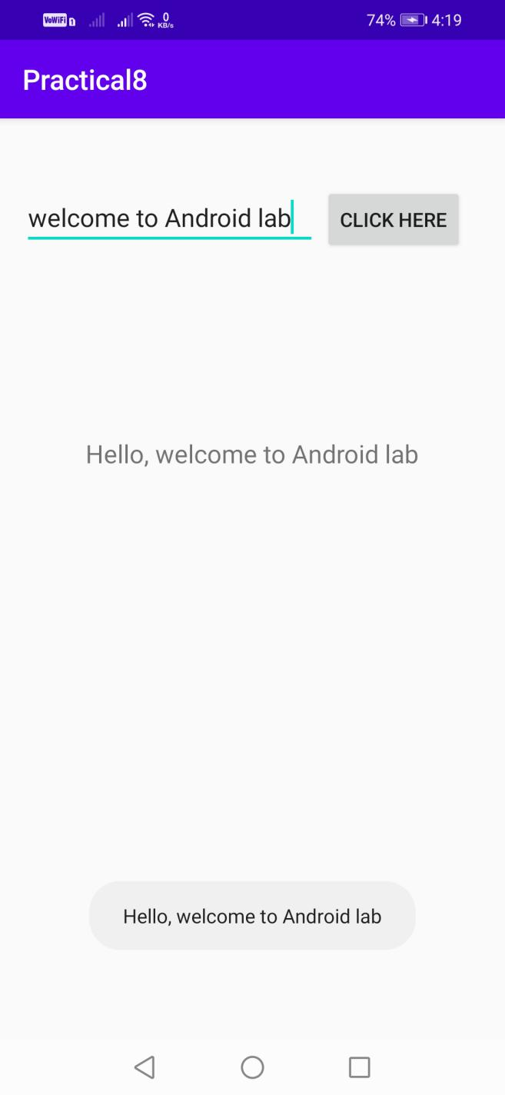

Experiment - 9

* Develop an android app which displays a form to get user information from user. Form should be followed by a Button with label “Submit”. When user clicks the button, a message should be displayed to user describing the information entered.

Utilize suitable UI controls (i.e. widgets). [When user enters country in AutoCompleteTextView, list of states should be displayed in Spinner automatically.]

* Description :
* **UI Controls :**

* In android **UI** or**input** controls are the interactive or View components that are used to design the user interface of an application.

*   In android we have a wide variety of UI or input controls available, those are TextView, EditText, Buttons, Checkbox, Progressbar, Spinners, etc.

* Following is the pictorial representation of user interface (UI) or input controls in android application.

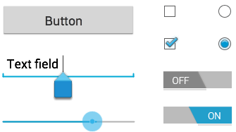

* Generally, in android the user interface of an app is made with a collection of View and ViewGroup objects.

* The View is a base class for all UI components in android and it is used to create interactive UI components such as TextView, EditText, Checkbox, Radio Button, etc. and it is responsible for event handling and drawing. The ViewGroup is a subclass of View and it will act as a base class for layouts and layout parameters. The ViewGroup will provide invisible containers to hold other Views or ViewGroups and to define the layout properties.

* Code :
* **(activity_main.xml):**

*<?***xml version="1.0" encoding="utf-8"***?>*<**ScrollView  
 xmlns:android="http://schemas.android.com/apk/res/android"  
 xmlns:app="http://schemas.android.com/apk/res-auto"  
 xmlns:tools="http://schemas.android.com/tools"  
 android:layout_width="match_parent"  
 android:layout_height="match_parent"  
 android:paddingTop="16dp"  
 android:paddingBottom="16dp"  
 android:paddingRight="8dp"  
 android:paddingLeft="8dp"  
 tools:context="com.example.practical9.MainActivity"**>  
 <**LinearLayout  
 android:layout_width="match_parent"  
 android:layout_height="match_parent"  
 android:orientation="vertical"**>  
 <**EditText  
 android:id="@+id/et_username"  
 android:layout_width="match_parent"  
 android:layout_height="wrap_content"  
 android:hint="Username"  
 android:ems="10"  
 android:layout_marginBottom="8dp"  
 android:textSize="18dp"**/>  
 <**EditText  
 android:id="@+id/et_password"  
 android:layout_width="match_parent"  
 android:layout_height="wrap_content"  
 android:hint="Password"  
 android:ems="10"  
 android:inputType="textPassword"  
 android:layout_marginBottom="16dp"  
 android:textSize="18dp"**/>  
 <**EditText  
 android:id="@+id/et_email"  
 android:layout_width="match_parent"  
 android:layout_height="wrap_content"  
 android:hint="Email"  
 android:ems="10"  
 android:inputType="textEmailAddress"  
 android:layout_marginBottom="16dp"  
 android:textSize="18dp"**/>  
 <**EditText  
 android:id="@+id/et_phone_number"  
 android:layout_width="match_parent"  
 android:layout_height="wrap_content"  
 android:hint="Phone Number"  
 android:ems="10"  
 android:inputType="phone"  
 android:layout_marginBottom="16dp"  
 android:textSize="18dp"**/>  
 <**AutoCompleteTextView  
 android:id="@+id/actv_country"  
 android:layout_width="match_parent"  
 android:layout_height="wrap_content"  
 android:hint="Country"  
 android:textSize="18dp"  
 android:ems="10"  
 android:inputType="textAutoComplete"**/>  
 <**Spinner  
 android:id="@+id/sp_states"  
 android:layout_width="match_parent"  
 android:layout_height="wrap_content"  
 android:ems="10"  
 android:spinnerMode="dialog"  
 android:textSize="18dp"**></**Spinner**>  
 <**Spinner  
 android:id="@+id/sp_gender"  
 android:layout_width="match_parent"  
 android:layout_height="wrap_content"  
 android:ems="10"  
 android:spinnerMode="dialog"  
 android:textSize="18dp"**></**Spinner**>  
 <**EditText  
 android:id="@+id/et_interests"  
 android:layout_width="match_parent"  
 android:layout_height="wrap_content"  
 android:hint="Interests"  
 android:ems="10"  
 android:inputType="text"  
 android:layout_marginBottom="16dp"  
 android:textSize="18dp"**/>  
 <**TextView  
 android:id="@+id/tv_birth_date_label"  
 android:layout_width="wrap_content"  
 android:layout_height="wrap_content"  
 android:text="Select your Birth Date:"  
 android:layout_marginBottom="16dp"  
 android:textSize="18dp"**/>  
 <**Button  
 android:id="@+id/bt_birth_date"  
 android:layout_width="match_parent"  
 android:layout_height="wrap_content"  
 android:layout_marginBottom="16dp"  
 android:text="Select Date"  
 android:textSize="18dp"** />  
 <**TextView  
 android:id="@+id/tv_birth_time_label"  
 android:layout_width="wrap_content"  
 android:layout_height="wrap_content"  
 android:text="Select your Birth Time:"  
 android:layout_marginBottom="16dp"  
 android:textSize="18dp"**/>  
 <**Button  
 android:id="@+id/bt_birth_time"  
 android:layout_width="match_parent"  
 android:layout_height="wrap_content"  
 android:layout_marginBottom="16dp"  
 android:text="Select Date"  
 android:textSize="18dp"** />  
 <**Button  
 android:id="@+id/bt_submit"  
 android:layout_width="wrap_content"  
 android:layout_height="wrap_content"  
 android:layout_gravity="center"  
 android:layout_marginBottom="16dp"  
 android:layout_marginTop="16dp"  
 android:text="Submit"  
 android:textSize="18dp"** />  
 </**LinearLayout**>  
</**ScrollView**>

* **(MainActivity.java):**

**package** com.example.practical9;  
  
**import** androidx.appcompat.app.AppCompatActivity;  
  
**import** android.app.Activity;  
**import** android.app.DatePickerDialog;  
**import** android.app.TimePickerDialog;  
**import** android.content.Intent;  
**import** android.os.Bundle;  
**import** android.view.View;  
**import** android.view.inputmethod.InputMethodManager;  
**import** android.widget.AdapterView;  
**import** android.widget.ArrayAdapter;  
**import** android.widget.AutoCompleteTextView;  
**import** android.widget.Button;  
**import** android.widget.DatePicker;  
**import** android.widget.EditText;  
**import** android.widget.Spinner;  
**import** android.widget.TimePicker;  
**import** android.widget.Toast;  
  
**import** java.util.ArrayList;  
**import** java.util.Calendar;  
**import** java.util.Collections;  
**import** java.util.Locale;  
  
**public class** MainActivity **extends** AppCompatActivity {  
  
 ArrayList<String> **countries**=**new** ArrayList<String>();  
 AutoCompleteTextView **mcountry**;  
 Spinner **mstates**;  
 EditText **musername**;  
 EditText **mpassword**;  
 EditText **memail**;  
 EditText **mphoneNumber**;  
 Spinner **mgender**;  
 Button **mbirthDate**;  
 Button **mbirthTime**;  
 EditText **minterests**;  
 Button **msubmit**;  
 String []**states** = {**"New Delhi"**,**"Andaman/Nicobar Islands"**,**"Andhra Pradesh"**,**"Arunachal Pradesh"**,**"Assam"**,**"Bihar"**,**"Chandigarh"**,**"Chhattisgarh"**,**"Dadra/Nagar Haveli"**,**"Daman/Diu"**,**"Goa"**,**"Gujarat"**,**"Haryana"**,**"Himachal Pradesh"**,**"Jammu/Kashmir"**,**"Jharkhand"**,**"Karnataka"**,**"Kerala"**,**"Lakshadweep"**,**"Madhya Pradesh"**,**"Maharashtra"**,**"Manipur"**,**"Meghalaya"**,**"Mizoram"**,**"Nagaland"**,**"Orissa"**,**"Pondicherry"**,**"Punjab"**,**"Rajasthan"**,**"Sikkim"**,**"Tamil Nadu"**,**"Tripura"**,**"Uttaranchal"**,**"Uttar Pradesh"**,**"West Bengal"**};  
 ArrayList<String> **allStates**=**new** ArrayList<String>();  
 ArrayList<String> **genderList**=**new** ArrayList<String>();  
 **private int mYear**, **mMonth**, **mDay**, **mHour**, **mMinute**;  
 String **username**;  
 String **password**;  
 String **email**;  
 String **phoneNumber**;  
 String **country**;  
 String **state**;  
 String **gender**;  
 String **interests**;  
 String **bdate**;  
 String **btime**;  
 @Override  
 **protected void** onCreate(Bundle savedInstanceState) {  
 **super**.onCreate(savedInstanceState);  
 setContentView(R.layout.***activity_main***);  
  
 **musername**=(EditText)findViewById(R.id.***et_username***);  
 **mcountry**=(AutoCompleteTextView)findViewById(R.id.***actv_country***);  
 **mstates**=(Spinner)findViewById(R.id.***sp_states***);  
 **musername**=(EditText)findViewById(R.id.***et_username***);  
 **mpassword**=(EditText)findViewById(R.id.***et_password***);  
 **memail**=(EditText)findViewById(R.id.***et_email***);  
 **mphoneNumber**=(EditText)findViewById(R.id.***et_phone_number***);  
 **mgender**=(Spinner)findViewById(R.id.***sp_gender***);  
 **mbirthDate**=(Button)findViewById(R.id.***bt_birth_date***);  
 **mbirthTime**=(Button)findViewById(R.id.***bt_birth_time***);  
 **minterests**=(EditText)findViewById(R.id.***et_interests***);  
 **msubmit**=(Button)findViewById(R.id.***bt_submit***);  
  
 **mbirthDate**.setOnClickListener(**new** View.OnClickListener() {  
 @Override  
 **public void** onClick(View view) {  
 *// Get Current Date* **final** Calendar c = Calendar.*getInstance*();  
 **mYear** = c.get(Calendar.***YEAR***);  
 **mMonth** = c.get(Calendar.***MONTH***);  
 **mDay** = c.get(Calendar.***DAY_OF_MONTH***);  
 DatePickerDialog datePickerDialog = **new** DatePickerDialog(MainActivity.**this**,  
 **new** DatePickerDialog.OnDateSetListener() {  
 @Override  
 **public void** onDateSet(DatePicker view, **int** year,  
 **int** monthOfYear, **int** dayOfMonth)  
 {  
 **mbirthDate**.setText(dayOfMonth + **"-"** + (monthOfYear  
 + 1) + **"-"** + year);  
 }  
 }, **mYear**, **mMonth**, **mDay**);  
 datePickerDialog.show();  
 }  
 });  
 **mbirthTime**.setOnClickListener(**new** View.OnClickListener() {  
 @Override  
 **public void** onClick(View view) {  
 *// Get Current Time* **final** Calendar c = Calendar.*getInstance*();  
 **mHour** = c.get(Calendar.***HOUR_OF_DAY***);  
 **mMinute** = c.get(Calendar.***MINUTE***);  
 *// Launch Time Picker Dialog* TimePickerDialog timePickerDialog = **new** TimePickerDialog(MainActivity.**this**,  
 **new** TimePickerDialog.OnTimeSetListener() {  
 @Override  
 **public void** onTimeSet(TimePicker view, **int** hourOfDay,  
 **int** minute) {  
 **mbirthTime**.setText(hourOfDay + **":"** + minute);  
 }  
 }, **mHour**, **mMinute**, **false**);  
 timePickerDialog.show();  
 }  
 });  
  
 **msubmit**.setOnClickListener(**new** View.OnClickListener() {  
 @Override  
 **public void** onClick(View view) {  
 **if**(isFilled())  
 {  
 **username**=**musername**.getText().toString();  
 **password**=**mpassword**.getText().toString();  
 **email**=**memail**.getText().toString();  
 **phoneNumber**=**mphoneNumber**.getText().toString();  
 **country**=**mcountry**.getText().toString();  
 **state**=**mstates**.getSelectedItem().toString();  
 **gender**=**mgender**.getSelectedItem().toString();  
 **interests**=**minterests**.getText().toString();  
 **bdate**=**mbirthDate**.getText().toString();  
 **btime**=**mbirthTime**.getText().toString();  
 Intent intent=**new** Intent(MainActivity.**this**,ViewDataActivity.**class**);  
 intent.putExtra(**"username"**,**username**);  
 intent.putExtra(**"password"**,**password**);  
 intent.putExtra(**"email"**,**email**);  
 intent.putExtra(**"phone"**,**phoneNumber**);  
 intent.putExtra(**"country"**,**country**);  
 intent.putExtra(**"state"**,**state**);  
 intent.putExtra(**"gender"**,**gender**);  
 intent.putExtra(**"interests"**,**interests**);  
 intent.putExtra(**"bdate"**,**bdate**);  
 intent.putExtra(**"btime"**,**btime**);  
 startActivity(intent);  
 }  
 **else** {  
 Toast.*makeText*(MainActivity.**this**,**"Please fill all the fileds!"**,Toast.***LENGTH_SHORT***).show();  
 }  
 }  
 });  
 *//setting gender spinner* **genderList**.add(**"Male"**);  
 **genderList**.add(**"Female"**);  
 ArrayAdapter<String> genderAdapter=**new** ArrayAdapter<String>(**this**,android.R.layout.***simple_list_item_1***,**genderList**);  
 **mgender**.setAdapter(genderAdapter);  
 *//setting country autocompletetextview* **mcountry**.setThreshold(1);  
 **allStates**.add(**"Select a country first"**);  
 ArrayAdapter<String> adapter=**new** ArrayAdapter<String>(MainActivity.**this**,android.R.layout.***simple_list_item_1***,**allStates**);  
 **mstates**.setAdapter(adapter);  
 getCountries();  
 ArrayAdapter<String> adapter2=**new** ArrayAdapter<String>(**this**,android.R.layout.***simple_list_item_1***,**countries**);  
 **mcountry**.setAdapter(adapter2);  
 **mcountry**.setOnItemClickListener(**new** AdapterView.OnItemClickListener() {  
 @Override  
 **public void** onItemClick(AdapterView<?> adapterView, View view, **int** i,  
 **long** l) {  
  
*//Toast.makeText(MainActivity.this,"Selected",Toast.LENGTH_SHORT).show();  
 hideKeyboard*(MainActivity.**this**);  
 String selectedItem=(String)adapterView.getItemAtPosition(i);  
 **if**(selectedItem.equalsIgnoreCase(**"India"**))  
 {  
 getStates();  
 ArrayAdapter<String> adapter=**new** ArrayAdapter<String>(MainActivity.**this**,android.R.layout.***simple_list_item_1***,**allStates**);  
 **mstates**.setAdapter(adapter);  
 }  
 }  
 });  
 }  
 **private void** getCountries()  
 {  
 Locale []locale= Locale.*getAvailableLocales*();  
 String country;  
 **for**(Locale loc:locale)  
 {  
 country=loc.getDisplayCountry();  
 **if**(country.length()>0 && !**countries**.contains(country))  
 {  
 **countries**.add(country);  
 }  
 }  
 Collections.*sort*(**countries**,String.***CASE_INSENSITIVE_ORDER***);  
 }  
 **private void** getStates()  
 {  
 **allStates**.remove(0);  
 **for**(**int** i=0;i<**states**.**length**;i++)  
 {  
 **allStates**.add(**states**[i]);  
 }  
 Collections.*sort*(**allStates**);  
 }  
 **public static void** hideKeyboard(Activity activity) {  
 InputMethodManager imm = (InputMethodManager)  
 activity.getSystemService(Activity.***INPUT_METHOD_SERVICE***);  
 *//Find the currently focused view, so we can grab the correct window token from it.* View view = activity.getCurrentFocus();  
 *//If no view currently has focus, create a new one, just so we can grab a window token from it* **if** (view == **null**) {  
 view = **new** View(activity);  
 }  
 imm.hideSoftInputFromWindow(view.getWindowToken(), 0);  
 }  
 **private boolean** isFilled()  
 {  
 **if**(!**musername**.getText().toString().equals(**""**) &&  
 !**mpassword**.getText().toString().equals(**""**) &&  
 !**memail**.getText().toString().equals(**""**) &&  
 !**mphoneNumber**.getText().toString().equals(**""**) &&  
 !**mcountry**.getText().toString().equals(**""**) &&  
 !**mstates**.getSelectedItem().toString().equals(**""**) &&  
 !**mgender**.getSelectedItem().toString().equals(**""**) &&  
 !**minterests**.getText().toString().equals(**""**) &&  
 !**mbirthDate**.getText().toString().equalsIgnoreCase(**"SELECT DATE"**) &&  
 !**mbirthTime**.getText().toString().equalsIgnoreCase(**"SELECT TIME"**))  
 {  
 **return true**;  
 }  
 **else** {  
  
 **return false**;  
 }  
 }  
}

* **(activity_view_data.xml):**

*<?***xml version="1.0" encoding="utf-8"***?>*<**ScrollView  
 xmlns:android="http://schemas.android.com/apk/res/android"  
 xmlns:app="http://schemas.android.com/apk/res-auto"  
 xmlns:tools="http://schemas.android.com/tools"  
 android:layout_width="match_parent"  
 android:layout_height="match_parent"  
 tools:context=".ViewDataActivity"**>  
 <**LinearLayout  
 android:layout_width="match_parent"  
 android:layout_height="match_parent"  
 android:layout_marginTop="16dp"  
 android:layout_marginBottom="16dp"  
 android:orientation="vertical"  
 android:gravity="center"**>  
 <**TextView  
 android:layout_width="wrap_content"  
 android:layout_height="wrap_content"  
 android:text="Username"  
 android:layout_gravity="center"  
 android:textSize="18dp"**/>  
 <**TextView  
 android:id="@+id/tv_username"  
 android:layout_width="wrap_content"  
 android:layout_height="wrap_content"  
 android:text="Username"  
 android:textColor="@color/colorAccent"  
 android:layout_gravity="center"  
 android:layout_marginBottom="16dp"  
 android:textSize="18dp"**/>  
 <**TextView  
 android:layout_width="wrap_content"  
 android:layout_height="wrap_content"  
 android:text="Password"  
 android:layout_gravity="center"  
 android:textSize="18dp"**/>  
 <**TextView  
 android:id="@+id/tv_password"  
 android:layout_width="wrap_content"  
 android:layout_height="wrap_content"  
 android:text="Username"  
 android:textColor="@color/colorAccent"  
 android:layout_gravity="center"  
 android:layout_marginBottom="16dp"  
 android:textSize="18dp"**/>  
 <**TextView  
 android:layout_width="wrap_content"  
 android:layout_height="wrap_content"  
 android:text="Email"  
 android:layout_gravity="center"  
 android:textSize="18dp"**/>  
 <**TextView  
 android:id="@+id/tv_email"  
 android:layout_width="wrap_content"  
 android:layout_height="wrap_content"  
 android:text="Username"  
 android:textColor="@color/colorAccent"  
 android:layout_gravity="center"  
 android:layout_marginBottom="16dp"  
 android:textSize="18dp"**/>  
 <**TextView  
 android:layout_width="wrap_content"  
 android:layout_height="wrap_content"  
 android:text="Phone Number"  
 android:layout_gravity="center"  
 android:textSize="18dp"**/>  
 <**TextView  
 android:id="@+id/tv_phone_number"  
 android:layout_width="wrap_content"  
 android:layout_height="wrap_content"  
 android:text="Username"  
 android:textColor="@color/colorAccent"  
 android:layout_gravity="center"  
 android:layout_marginBottom="16dp"  
 android:textSize="18dp"**/>  
 <**TextView  
 android:layout_width="wrap_content"  
 android:layout_height="wrap_content"  
 android:text="Country"  
 android:layout_gravity="center"  
 android:textSize="18dp"**/>  
 <**TextView  
 android:id="@+id/tv_country"  
 android:layout_width="wrap_content"  
 android:layout_height="wrap_content"  
 android:text="Username"  
 android:textColor="@color/colorAccent"  
 android:layout_gravity="center"  
 android:layout_marginBottom="16dp"  
 android:textSize="18dp"**/>  
 <**TextView  
 android:layout_width="wrap_content"  
 android:layout_height="wrap_content"  
 android:text="State"  
 android:layout_gravity="center"  
 android:textSize="18dp"**/>  
 <**TextView  
 android:id="@+id/tv_state"  
 android:layout_width="wrap_content"  
 android:layout_height="wrap_content"  
 android:text="Username"  
 android:textColor="@color/colorAccent"  
 android:layout_gravity="center"  
 android:layout_marginBottom="16dp"  
 android:textSize="18dp"**/>  
 <**TextView  
 android:layout_width="wrap_content"  
 android:layout_height="wrap_content"  
 android:text="Gender"  
 android:layout_gravity="center"  
 android:textSize="18dp"**/>  
 <**TextView  
 android:id="@+id/tv_gender"  
 android:layout_width="wrap_content"  
 android:layout_height="wrap_content"  
 android:text="Username"  
 android:textColor="@color/colorAccent"  
 android:layout_gravity="center"  
 android:layout_marginBottom="16dp"  
 android:textSize="18dp"**/>  
 <**TextView  
 android:layout_width="wrap_content"  
 android:layout_height="wrap_content"  
 android:text="Interests"  
 android:layout_gravity="center"  
 android:textSize="18dp"**/>  
 <**TextView  
 android:id="@+id/tv_interests"  
 android:layout_width="wrap_content"  
 android:layout_height="wrap_content"  
 android:text="Username"  
 android:textColor="@color/colorAccent"  
 android:layout_gravity="center"  
 android:layout_marginBottom="16dp"  
 android:textSize="18dp"**/>  
 <**TextView  
 android:layout_width="wrap_content"  
 android:layout_height="wrap_content"  
 android:text="Birth Date"  
 android:layout_gravity="center"  
 android:textSize="18dp"**/>  
 <**TextView  
 android:id="@+id/tv_birth_date"  
 android:layout_width="wrap_content"  
 android:layout_height="wrap_content"  
 android:text="Username"  
 android:textColor="@color/colorAccent"  
 android:layout_gravity="center"  
 android:layout_marginBottom="16dp"  
 android:textSize="18dp"**/>  
 <**TextView  
 android:layout_width="wrap_content"  
 android:layout_height="wrap_content"  
 android:text="Birth Time"  
 android:layout_gravity="center"  
 android:textSize="18dp"**/>  
 <**TextView  
 android:id="@+id/tv_birth_time"  
 android:layout_width="wrap_content"  
 android:layout_height="wrap_content"  
 android:text="Username"  
 android:textColor="@color/colorAccent"  
 android:layout_gravity="center"  
 android:layout_marginBottom="16dp"  
 android:textSize="18dp"**/>  
 </**LinearLayout**>  
</**ScrollView**>

* **(ViewDataActivity.java):**

**package** com.example.practical9;  
**import** android.content.Intent;  
**import** android.os.Bundle;  
**import** android.widget.TextView;  
  
**import** androidx.appcompat.app.AppCompatActivity;  
  
**public class** ViewDataActivity **extends** AppCompatActivity {  
 TextView **musername**;  
 TextView **mpassword**;  
 TextView **memail**;  
 TextView **mphoneNumber**;  
 TextView **mcountry**;  
 TextView **mstate**;  
 TextView **mgender**;  
 TextView **minterests**;  
 TextView **mbirthDate**;  
 TextView **mbirthTime**;  
 @Override  
 **protected void** onCreate(Bundle savedInstanceState) {  
 **super**.onCreate(savedInstanceState);  
 setContentView(R.layout.***activity_view_data***);  
 **musername**=(TextView)findViewById(R.id.***tv_username***);  
 **mpassword**=(TextView)findViewById(R.id.***tv_password***);  
 **memail**=(TextView)findViewById(R.id.***tv_email***);  
 **mphoneNumber**=(TextView)findViewById(R.id.***tv_phone_number***);  
 **mcountry**=(TextView)findViewById(R.id.***tv_country***);  
 **mstate**=(TextView)findViewById(R.id.***tv_state***);  
 **mgender**=(TextView)findViewById(R.id.***tv_gender***);  
 **minterests**=(TextView)findViewById(R.id.***tv_interests***);  
 **mbirthDate**=(TextView)findViewById(R.id.***tv_birth_date***);  
 **mbirthTime**=(TextView)findViewById(R.id.***tv_birth_time***);  
 Intent intent=getIntent();  
 Bundle data=intent.getExtras();  
 **musername**.setText(data.getString(**"username"**).toString());  
 **mpassword**.setText(data.getString(**"password"**).toString());  
 **memail**.setText(data.getString(**"email"**).toString());  
 **mphoneNumber**.setText(data.getString(**"phone"**).toString());  
 **mcountry**.setText(data.getString(**"country"**).toString());  
 **mstate**.setText(data.getString(**"state"**).toString());  
 **mgender**.setText(data.getString(**"gender"**).toString());  
 **minterests**.setText(data.getString(**"interests"**).toString());  
 **mbirthDate**.setText(data.getString(**"bdate"**).toString());  
 **mbirthTime**.setText(data.getString(**"btime"**).toString());  
 }  
}

* Output :

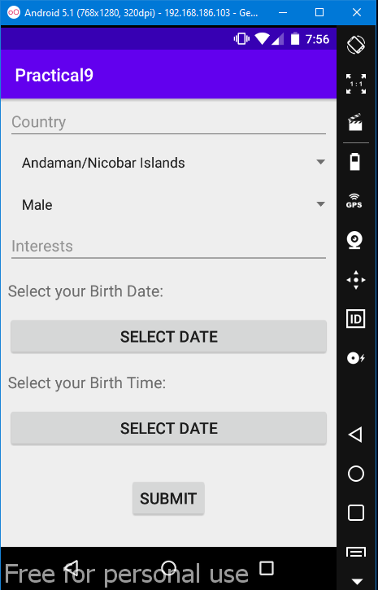

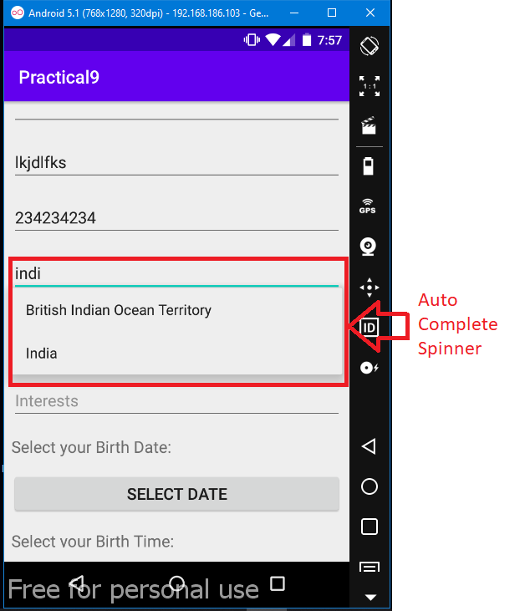 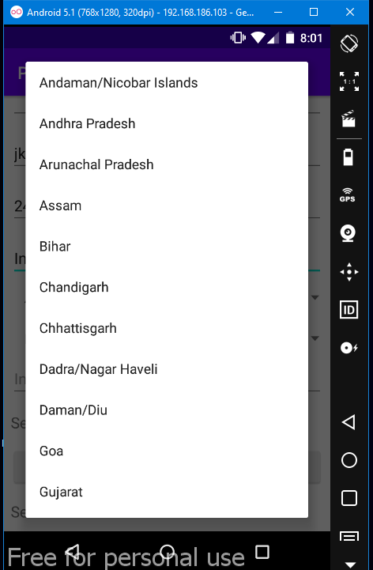

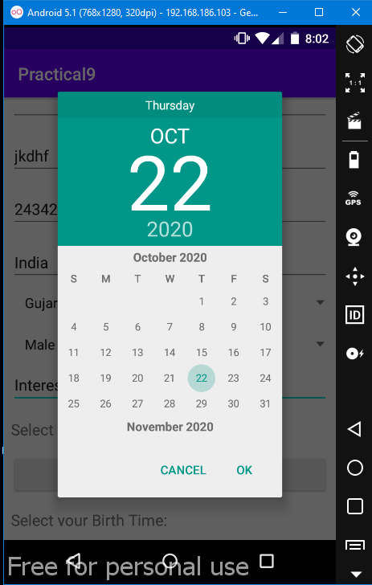 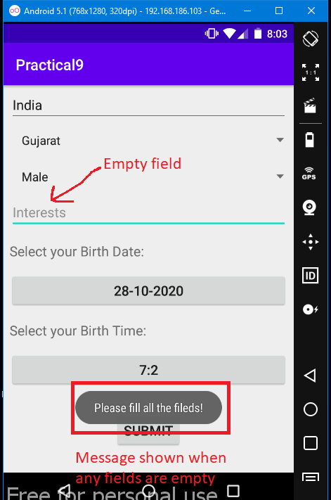

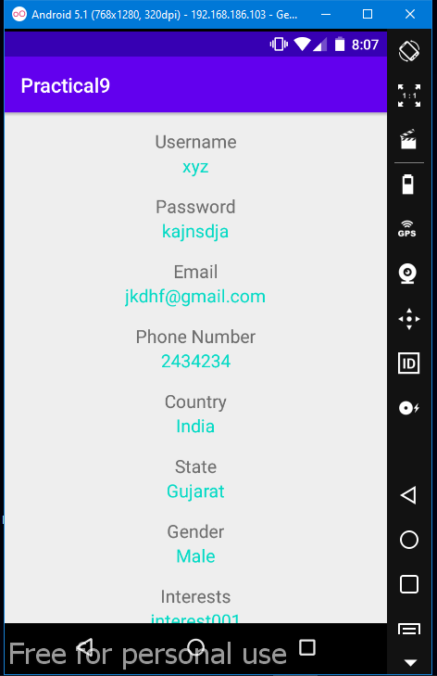

Experiment - 10

* Using Android, Create a login Activity. It asks “username” and “password” from user. If username and password are valid, it displays Welcome message using new activity.
* Description :
* **Intent in Android :**

* Android Intent is the message that is passed between components such as activities, content providers, broadcast receivers, services etc. It is generally used with startActivity() method to invoke activity, broadcast receivers etc.

* Android intents are mainly used to:

Start the service

Launch an activity

Display a web page

Display a list of contacts

Broadcast a message

Dial a phone call etc.

* Code :
* **(MainActivity.java):**

**package** com.example.practical10;  
  
**import** android.content.Intent;  
**import** android.os.Build;  
  
**import** android.os.Bundle;  
**import** android.view.View;  
**import** android.view.Window;  
**import** android.view.WindowManager;  
**import** android.widget.Button;  
**import** android.widget.EditText;  
**import** android.widget.Toast;  
  
**import** androidx.appcompat.app.AppCompatActivity;  
  
**public class** MainActivity **extends** AppCompatActivity {  
 EditText **musername**;  
 EditText **mpassword**;  
 Button **mlogin**;  
 @Override  
 **protected void** onCreate(Bundle savedInstanceState) {  
 **super**.onCreate(savedInstanceState);  
 setContentView(R.layout.***activity_main***);  
 **if** (Build.VERSION.***SDK_INT*** >= Build.VERSION_CODES.***KITKAT***) {  
 Window w = getWindow(); *// in Activity's onCreate() for instance* w.setFlags(WindowManager.LayoutParams.***FLAG_LAYOUT_NO_LIMITS***,  
 WindowManager.LayoutParams.***FLAG_LAYOUT_NO_LIMITS***);  
 }  
 **musername**=(EditText)findViewById(R.id.***et_username***);  
 **mpassword**=(EditText)findViewById(R.id.***et_password***);  
 **mlogin**=(Button)findViewById(R.id.***bt_login***);  
 **musername**.setOnFocusChangeListener(**new** View.OnFocusChangeListener() {  
 **public void** onFocusChange(View v, **boolean** hasFocus) {  
 **if** (hasFocus)  
 **musername**.setHint(**""**);  
 **else  
 musername**.setHint(**"Username"**);  
 }  
 });  
 **mpassword**.setOnFocusChangeListener(**new** View.OnFocusChangeListener() {  
 **public void** onFocusChange(View v, **boolean** hasFocus) {  
 **if** (hasFocus)  
 **mpassword**.setHint(**""**);  
 **else  
 mpassword**.setHint(**"Password"**);  
 }  
 });  
 **mlogin**.setOnClickListener(**new** View.OnClickListener() {  
 @Override  
 **public void** onClick(View view) {  
 **if**(!**musername**.getText().toString().equals(**""**) &&  
 !**mpassword**.getText().toString().equals(**""**))  
 {  
 **if**(**musername**.getText().toString().equals(**"yogesh001"**))  
 {  
 **if**(**mpassword**.getText().toString().equals(**"yogesh001"**))  
 {  
 Intent intent=**new** Intent(MainActivity.**this**,WelcomeScreen.**class**);  
 intent.putExtra(**"user"**,**musername**.getText().toString());  
 startActivity(intent);  
 }  
 **else** {  
 Toast.*makeText*(MainActivity.**this**,**"Password is incorrect!"**,Toast.***LENGTH_SHORT***).show();  
 }  
 }  
 **else** {  
 Toast.*makeText*(MainActivity.**this**,**"Invaild username!"**,Toast.***LENGTH_SHORT***).show();  
 }  
 }  
 **else** {  
 Toast.*makeText*(MainActivity.**this**,**"Please fill both fields!"**,Toast.***LENGTH_SHORT***).show();  
 }  
 }  
 });  
 }  
}

* **(activity_main.xml):**

*<?***xml version="1.0" encoding="utf-8"***?>*<**androidx.constraintlayout.widget.ConstraintLayout xmlns:android="http://schemas.android.com/apk/res/android"  
 xmlns:tools="http://schemas.android.com/tools"  
 xmlns:app="http://schemas.android.com/apk/res-auto"  
 android:layout_width="match_parent"  
 android:layout_height="match_parent"  
 tools:context=".MainActivity"**>  
 <**EditText  
 android:id="@+id/et_username"  
 android:layout_width="match_parent"  
 android:layout_height="wrap_content"  
 android:layout_marginStart="32dp"  
 android:layout_marginTop="32dp"  
 android:layout_marginEnd="32dp"  
 android:hint="Username"  
 android:inputType="text"  
 android:textAlignment="viewStart"  
 app:layout_constraintEnd_toEndOf="parent"  
 app:layout_constraintStart_toStartOf="parent"  
 app:layout_constraintTop_toTopOf="parent"** />  
 <**EditText  
 android:id="@+id/et_password"  
 android:layout_width="match_parent"  
 android:layout_height="wrap_content"  
 android:layout_marginStart="32dp"  
 android:layout_marginTop="32dp"  
 android:layout_marginEnd="32dp"  
 android:hint="Password"  
 android:inputType="textPassword"  
 android:textAlignment="viewStart"  
 app:layout_constraintEnd_toEndOf="parent"  
 app:layout_constraintStart_toStartOf="parent"  
 app:layout_constraintTop_toBottomOf="@+id/et_username"** />  
 <**Button  
 android:id="@+id/bt_login"  
 android:layout_width="match_parent"  
 android:layout_height="wrap_content"  
 android:layout_alignParentBottom="true"  
 android:layout_marginLeft="32dp"  
 android:layout_marginTop="32dp"  
 android:layout_marginRight="32dp"  
 android:text="Login"  
 app:layout_constraintLeft_toLeftOf="parent"  
 app:layout_constraintRight_toRightOf="parent"  
 app:layout_constraintTop_toBottomOf="@+id/et_password"** />  
</**androidx.constraintlayout.widget.ConstraintLayout**>

* **(WelcomeScreen.java):**

**package** com.example.practical10;  
  
  
**import** android.os.Bundle;  
**import** android.widget.TextView;  
  
**import** androidx.appcompat.app.AppCompatActivity;  
  
**public class** WelcomeScreen **extends** AppCompatActivity {  
 TextView **musername**;  
 @Override  
 **protected void** onCreate(Bundle savedInstanceState) {  
 **super**.onCreate(savedInstanceState);  
 setContentView(R.layout.***activity_welcome_screen***);  
 **musername**=(TextView)findViewById(R.id.***tv_user***);  
 **musername**.setText(getIntent().getExtras().getString(**"user"**));  
 }  
}

* **(activity_welcome_screen.xml):**

*<?***xml version="1.0" encoding="utf-8"***?>*<**LinearLayout  
 xmlns:android="http://schemas.android.com/apk/res/android"  
 xmlns:app="http://schemas.android.com/apk/res-auto"  
 xmlns:tools="http://schemas.android.com/tools"  
 android:layout_width="match_parent"  
 android:layout_height="match_parent"  
 android:orientation="vertical"  
 android:layout_gravity="center"  
 android:gravity="center"  
 tools:context=".WelcomeScreen"**>  
 <**TextView  
 android:layout_width="wrap_content"  
 android:layout_height="wrap_content"  
 android:text="Welcome"  
 android:textSize="50sp"**/>  
 <**TextView  
 android:id="@+id/tv_user"  
 android:layout_width="wrap_content"  
 android:layout_height="wrap_content"  
 android:text="username"  
 android:layout_marginTop="16dp"  
 android:textColor="@color/colorAccent"  
 android:textSize="32sp"**/>  
 <**TextView  
 android:layout_width="wrap_content"  
 android:layout_height="wrap_content"  
 android:layout_marginTop="16dp"  
 android:text="You are successfully logged in!"  
 android:textSize="24sp"**/>  
</**LinearLayout**>

* Output :

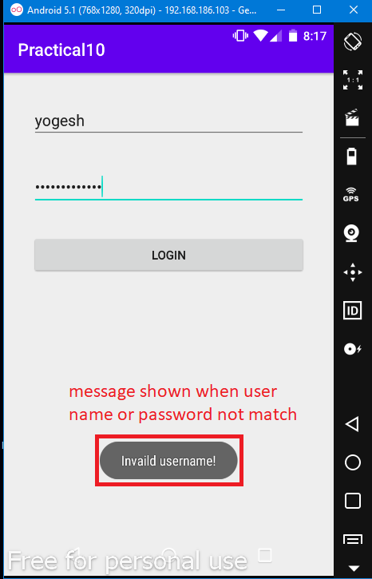 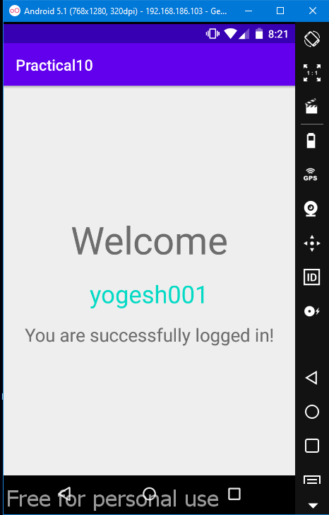

Experiment - 11

* Develop calculator Android Application.
* Description :

* Use various android controls and components to build a basic arithmetic calculator.

* Code :
* **(MainActivity.java):**

**package** com.example.practical11;  
  
**import** androidx.appcompat.app.AppCompatActivity;  
  
**import** android.os.Bundle;  
**import** android.view.View;  
**import** android.widget.Button;  
**import** android.widget.EditText;  
**import** android.widget.TextView;  
**import** android.widget.Toast;  
  
**public class** MainActivity **extends** AppCompatActivity {  
 **private boolean** isOpPressed = **false**;  
 **private double** firstNumber=0;  
 **private int** secondNumberIndex = 0;  
 **private char** currentOp;  
  
  
 @Override  
 **protected void** onCreate(Bundle savedInstanceState) {  
 **super**.onCreate(savedInstanceState);  
 setContentView(R.layout.mylayout);  
  
 **final** TextView calculatorScreen = findViewById(R.id.calculatorScreen);  
 **final** Button btn_0 = findViewById(R.id.btn_0);  
 **final** Button btn_1 = findViewById(R.id.btn_1);  
 **final** Button btn_2 = findViewById(R.id.btn_2);  
 **final** Button btn_3 = findViewById(R.id.btn_3);  
 **final** Button btn_4 = findViewById(R.id.btn_4);  
 **final** Button btn_5 = findViewById(R.id.btn_5);  
 **final** Button btn_6 = findViewById(R.id.btn_6);  
 **final** Button btn_7 = findViewById(R.id.btn_7);  
 **final** Button btn_8 = findViewById(R.id.btn_8);  
 **final** Button btn_9 = findViewById(R.id.btn_9);  
 **final** Button btn_add = findViewById(R.id.btn_add);  
 **final** Button btn_sub = findViewById(R.id.btn_sub);  
 **final** Button btn_mul = findViewById(R.id.btn_mul);  
 **final** Button btn_div = findViewById(R.id.btn_div);  
 **final** Button btn_dot = findViewById(R.id.btn_dot);  
 **final** Button btn_eql = findViewById(R.id.btn_eql);  
  
  
  
 **final** View.OnClickListener calculatorListener =**new** View.OnClickListener() {  
 @Override  
 **public void** onClick(View v) {  
 **final int** id = v.getId();  
 **switch**(id){  
 **case** R.id.btn_0:  
 calculatorScreen.append(**"0"**);  
 **break**;  
 **case** R.id.btn_1:  
 calculatorScreen.append(**"1"**);  
 **break**;  
 **case** R.id.btn_2:  
 calculatorScreen.append(**"2"**);  
 **break**;  
 **case** R.id.btn_3:  
 calculatorScreen.append(**"3"**);  
 **break**;  
 **case** R.id.btn_4:  
 calculatorScreen.append(**"4"**);  
 **break**;  
 **case** R.id.btn_5:  
 calculatorScreen.append(**"5"**);  
 **break**;  
 **case** R.id.btn_6:  
 calculatorScreen.append(**"6"**);  
 **break**;  
 **case** R.id.btn_7:  
 calculatorScreen.append(**"7"**);  
 **break**;  
 **case** R.id.btn_8:  
 calculatorScreen.append(**"8"**);  
 **break**;  
 **case** R.id.btn_9:  
 calculatorScreen.append(**"9"**);  
 **break**;  
 **case** R.id.btn_add:  
 String screenContent = calculatorScreen.getText().toString();  
 secondNumberIndex=screenContent.length()+1;  
 firstNumber=Double.parseDouble(screenContent);  
 calculatorScreen.append(**"+"**);  
 isOpPressed=**true**;  
 currentOp=**'+'**;  
 **break**;  
 **case** R.id.btn_sub:  
 screenContent = calculatorScreen.getText().toString();  
 secondNumberIndex=screenContent.length()+1;  
 firstNumber=Double.parseDouble(screenContent);  
 calculatorScreen.append(**"-"**);  
 isOpPressed=**true**;  
 currentOp=**'-'**;  
 **break**;  
 **case** R.id.btn_mul:  
 screenContent = calculatorScreen.getText().toString();  
 secondNumberIndex=screenContent.length()+1;  
 firstNumber=Double.parseDouble(screenContent);  
 calculatorScreen.append(**"*"**);  
 isOpPressed=**true**;  
 currentOp=**'*'**;  
 **break**;  
 **case** R.id.btn_div:  
 screenContent = calculatorScreen.getText().toString();  
 secondNumberIndex=screenContent.length()+1;  
 firstNumber=Double.parseDouble(screenContent);  
 calculatorScreen.append(**"/"**);  
 isOpPressed=**true**;  
 currentOp=**'/'**;  
 **break**;  
 **case** R.id.btn_dot:  
 calculatorScreen.append(**"."**);  
 **break**;  
 **case** R.id.btn_eql:  
 **if**(isOpPressed){  
 **switch** (currentOp){  
 **case '+'**:  
 String content = calculatorScreen.getText().toString();  
 **double** secondNumber = Double.parseDouble(content.substring(secondNumberIndex, content.length()));  
 secondNumber=secondNumber + firstNumber;  
 calculatorScreen.setText(Double.toString(secondNumber));  
 **break**;  
 **case '-'**:  
 content = calculatorScreen.getText().toString();  
 secondNumber = Double.parseDouble(content.substring(secondNumberIndex, content.length()));  
 secondNumber=firstNumber-secondNumber;  
 calculatorScreen.setText(Double.toString(secondNumber));  
 **break**;  
 **case '*'**:  
 content = calculatorScreen.getText().toString();  
 secondNumber = Double.parseDouble(content.substring(secondNumberIndex, content.length()));  
 secondNumber=firstNumber*secondNumber;  
 calculatorScreen.setText(Double.toString(secondNumber));  
 **break**;  
 **case '/'**:  
 content = calculatorScreen.getText().toString();  
 secondNumber = Double.parseDouble(content.substring(secondNumberIndex, content.length()));  
 secondNumber=firstNumber/secondNumber;  
 calculatorScreen.setText(Double.toString(secondNumber));  
 **break**;  
 **default**:  
 Toast.makeText(MainActivity.**this**,**"Default executed in = button..."**,Toast.LENGTH_SHORT).show();  
 }  
  
 }  
 **else**{  
 Toast.makeText(MainActivity.**this**,**"= button could not find isOpPressed..."**,Toast.LENGTH_SHORT).show();  
 }  
 **break**;  
 **default**:  
 Toast.makeText(MainActivity. **this**,**"Button case default executed..."**,Toast.LENGTH_SHORT).show();  
 **break**;  
 }  
 }  
 };  
  
 btn_0.setOnClickListener(calculatorListener);  
 btn_1.setOnClickListener(calculatorListener);  
 btn_2.setOnClickListener(calculatorListener);  
 btn_3.setOnClickListener(calculatorListener);  
 btn_4.setOnClickListener(calculatorListener);  
 btn_5.setOnClickListener(calculatorListener);  
 btn_6.setOnClickListener(calculatorListener);  
 btn_7.setOnClickListener(calculatorListener);  
 btn_8.setOnClickListener(calculatorListener);  
 btn_9.setOnClickListener(calculatorListener);  
 btn_add.setOnClickListener(calculatorListener);  
 btn_sub.setOnClickListener(calculatorListener);  
 btn_mul.setOnClickListener(calculatorListener);  
 btn_div.setOnClickListener(calculatorListener);  
 btn_dot.setOnClickListener(calculatorListener);  
 btn_eql.setOnClickListener(calculatorListener);  
  
 *//delete button code below* **final** Button btn_del = findViewById(R.id.btn_del);  
 btn_del.setOnClickListener(**new** View.OnClickListener() {  
 @Override  
 **public void** onClick(View v) {  
 String currentElements = calculatorScreen.getText().toString();  
 **int** length = currentElements.length();  
 **if**(length>0){  
 currentElements = currentElements.substring(0,length-1);  
 calculatorScreen.setText(currentElements);  
 }  
 }  
 });  
  
 *//Clear button code* **final** Button btn_ce = findViewById(R.id.btn_ce);  
 btn_ce.setOnClickListener(**new** View.OnClickListener() {  
 @Override  
 **public void** onClick(View v) {  
 calculatorScreen.setText(**""**);  
 }  
 });  
  
 }  
}

* **(mylayout.xml):**

*<?***xml version="1.0" encoding="utf-8"***?>*<**LinearLayout xmlns:android="http://schemas.android.com/apk/res/android"  
 android:layout_width="match_parent"  
 android:layout_height="match_parent"  
 android:orientation="vertical"**>  
  
 <**TextView  
 android:id="@+id/calculatorScreen"  
 android:layout_width="match_parent"  
 android:layout_height="100dp"  
 android:layout_margin="5dp"  
 android:gravity="center_vertical | right"  
 android:textSize="25sp"** />  
  
 <**LinearLayout  
 android:layout_width="match_parent"  
 android:layout_height="0dp"  
 android:layout_weight="1"  
 android:orientation="horizontal"**>  
 <**Button  
 android:id="@+id/btn_del"  
 android:layout_width="0dp"  
 android:layout_height="match_parent"  
 android:layout_weight="1"  
 android:text="DEL"  
 android:textSize="25sp"** />  
  
 <**Button  
 android:id="@+id/btn_ce"  
 android:layout_width="0dp"  
 android:layout_height="match_parent"  
 android:layout_weight="1"  
 android:text="CE"  
 android:textSize="25sp"** />  
 </**LinearLayout**>  
  
 <**LinearLayout  
 android:layout_width="match_parent"  
 android:layout_height="0dp"  
 android:layout_weight="1"  
 android:orientation="horizontal"**>  
  
 <**Button  
 android:id="@+id/btn_7"  
 android:layout_width="0dp"  
 android:layout_height="match_parent"  
 android:layout_weight="1"  
 android:text="7"  
 android:textSize="25sp"** />  
  
 <**Button  
 android:id="@+id/btn_8"  
 android:layout_width="0dp"  
 android:layout_height="match_parent"  
 android:layout_weight="1"  
 android:text="8"  
 android:textSize="25sp"** />  
  
 <**Button  
 android:id="@+id/btn_9"  
 android:layout_width="0dp"  
 android:layout_height="match_parent"  
 android:layout_weight="1"  
 android:text="9"  
 android:textSize="25sp"** />  
  
 <**Button  
 android:id="@+id/btn_div"  
 android:layout_width="0dp"  
 android:layout_height="match_parent"  
 android:layout_weight="1"  
 android:text="/"  
 android:textSize="25sp"** />  
 </**LinearLayout**>  
  
 <**LinearLayout  
 android:layout_width="match_parent"  
 android:layout_height="0dp"  
 android:layout_weight="1"  
 android:orientation="horizontal"**>  
  
 <**Button  
 android:id="@+id/btn_4"  
 android:layout_width="0dp"  
 android:layout_height="match_parent"  
 android:layout_weight="1"  
 android:text="4"  
 android:textSize="25sp"** />  
  
 <**Button  
 android:id="@+id/btn_5"  
 android:layout_width="0dp"  
 android:layout_height="match_parent"  
 android:layout_weight="1"  
 android:text="5"  
 android:textSize="25sp"** />  
  
 <**Button  
 android:id="@+id/btn_6"  
 android:layout_width="0dp"  
 android:layout_height="match_parent"  
 android:layout_weight="1"  
 android:text="6"  
 android:textSize="25sp"** />  
  
 <**Button  
 android:id="@+id/btn_mul"  
 android:layout_width="0dp"  
 android:layout_height="match_parent"  
 android:layout_weight="1"  
 android:text="*"  
 android:textSize="25sp"** />  
 </**LinearLayout**>  
  
 <**LinearLayout  
 android:layout_width="match_parent"  
 android:layout_height="0dp"  
 android:layout_weight="1"  
 android:orientation="horizontal"**>  
  
 <**Button  
 android:id="@+id/btn_1"  
 android:layout_width="0dp"  
 android:layout_height="match_parent"  
 android:layout_weight="1"  
 android:text="1"  
 android:textSize="25sp"** />  
  
 <**Button  
 android:id="@+id/btn_2"  
 android:layout_width="0dp"  
 android:layout_height="match_parent"  
 android:layout_weight="1"  
 android:text="2"  
 android:textSize="25sp"** />  
  
 <**Button  
 android:id="@+id/btn_3"  
 android:layout_width="0dp"  
 android:layout_height="match_parent"  
 android:layout_weight="1"  
 android:text="3"  
 android:textSize="25sp"** />  
  
 <**Button  
 android:id="@+id/btn_sub"  
 android:layout_width="0dp"  
 android:layout_height="match_parent"  
 android:layout_weight="1"  
 android:text="-"  
 android:textSize="25sp"** />  
 </**LinearLayout**>  
  
 <**LinearLayout  
 android:layout_width="match_parent"  
 android:layout_height="0dp"  
 android:layout_weight="1"  
 android:orientation="horizontal"**>  
  
 <**Button  
 android:id="@+id/btn_dot"  
 android:layout_width="0dp"  
 android:layout_height="match_parent"  
 android:layout_weight="1"  
 android:text="."  
 android:textSize="25sp"** />  
  
 <**Button  
 android:id="@+id/btn_0"  
 android:layout_width="0dp"  
 android:layout_height="match_parent"  
 android:layout_weight="1"  
 android:text="0"  
 android:textSize="25sp"** />  
  
 <**Button  
 android:id="@+id/btn_eql"  
 android:layout_width="0dp"  
 android:layout_height="match_parent"  
 android:layout_weight="1"  
 android:text="="  
 android:textSize="25sp"** />  
  
 <**Button  
 android:id="@+id/btn_add"  
 android:layout_width="0dp"  
 android:layout_height="match_parent"  
 android:layout_weight="1"  
 android:text="+"  
 android:textSize="25sp"** />  
 </**LinearLayout**>  
</**LinearLayout**>

* Output :

