1.HTML

1) Write a HTML code to display student registration form.
Code:pract11.html

<!DOCTYPE html>
<!-- 1) Write a HTML code to display student registration form-->
<html>
<head><title>Student Registration Form</title></head>
<body>
<h1 align="center">Student Registration Form</h1>
<form name="st_reg_form" method="POST">
<fieldset>
<legend>Login Details</legend>
User name:<input type="text" name="txt_name"/><br/>
Password:<input type="password" name="txt_passwd"/><br/>
Email_id:<input type="text" name="txt_mail"/><br/>
</fieldset>

<fieldset>
<legend>Qualification</legend>
<input type="checkbox" name="check_10"/>10<sup>th</sup><br/>
<input type="checkbox" name="check_12"/>12<sup>th</sup><br/>
<input type="checkbox" name="check_diplo"/>Diploma<br/>
<input type="checkbox" name="check_degree"/>Degree<br/>
<input type="checkbox" name="check_master"/>Master-Degree<br/>
</fieldset>

<fieldset>
<legend>Gender</legend>
<input type="radio" name="radio_gen" value="radio_m"/>Male<br/>
<input type="radio" name="radio_gen"/>Female<br/>
</fieldset>

<fieldset>
<legend>Profession</legend>
<select name="select_prof">
<option>selects</option>
</select>
</fieldset>

<fieldset>
<legend>Lines About You</legend>
<textarea name="txt_area_you" placeholder="hello, you are welcome"></textarea>
</fieldset><br/><br/>

<button type="submit" name="submit">Submit</button>
<button type="reset" name="reset">Reset</button>
</form>
</body>
</html>

Output:
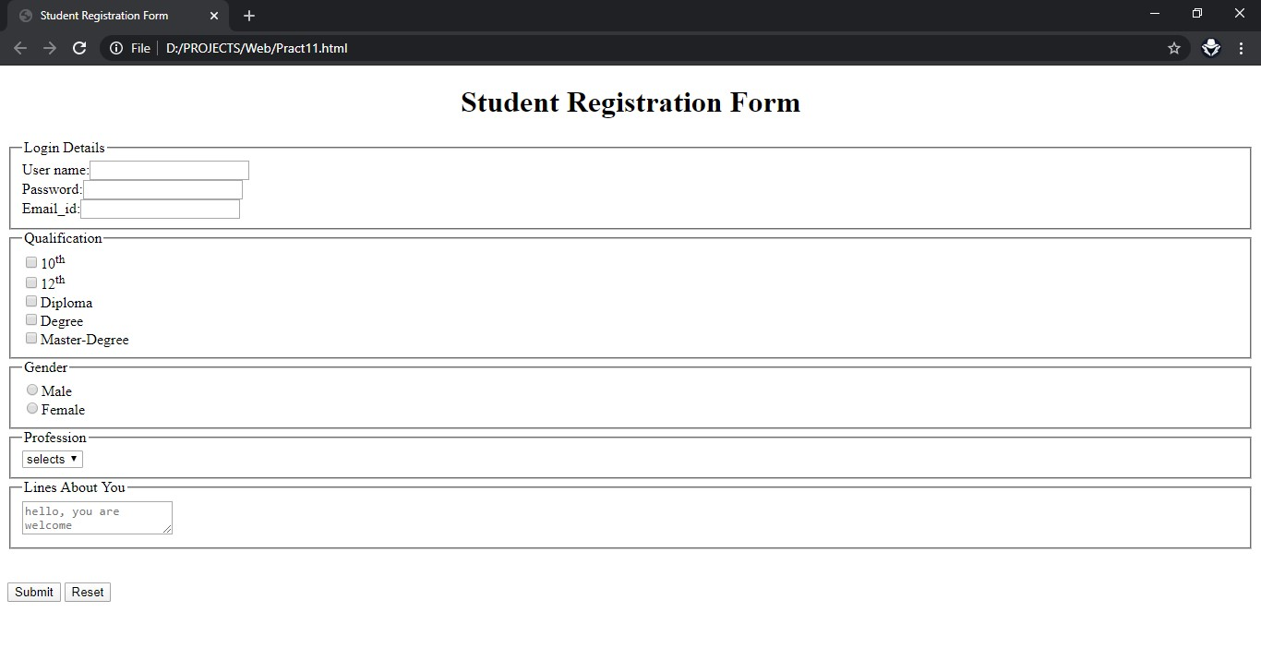

2) Write a HTML code for section demo.

Code:pract12.html

<!DOCTYPE html>
<!--2) Write a HTML code for section demo.-->
<html >
<head><title>Section Demo</title></head>
<body>

<h2 name="top">
<a href="#wad">WAD</a>&nbsp; <a href="#cg">CG</a> &nbsp;<a href="#se">SE</a> &nbsp;<a href="#sp">SP</a>
</h2>
<font size="4px">
<hr size="4px" color="black"/>
<h1 align="center" id="wad">WAD</h1>
<hr size="4px" color="black"/>
This is WAD...<br/>
WWW<br/>
HTML<br/>
CSS<br/>
JAVASCRIPT<br/>
XML<br/><br/>
<a href="#top">Top</a>
<hr size="4px" color="black"/>

<h1 align="center" id="cg">CG</h1>
<hr size="4px" color="black"/>
This is CG...<br/>
2D<br/>
3D<br/>
Scaling<br/>
Rotation<br/>
Transformation<br/>
Device.<br/><br/>
<a href="#top">Top</a>
<hr size="4px" color="black"/>

<h1 align="center" id="se">SE</h1>
<hr size="4px" color="black"/>
This is SE...<br/>
Requirement Engg.<br/>
Modeling<br/>
Coding<br/>
Testing<br/>
Communication<br/>
Risk Analysis<br/>
ETC.<br/><br/>
<a href="#top">Top</a>
<hr size="4px" color="black"/>

<h1 align="center" id="sp">SP</h1>
<hr size="4px" color="black"/>
This is SP...<br/>
Scanning<br/>
Parsing<br/>
Assembler<br/>
Macro<br/>
Linker & Loader<br/>
Intro. of Compiler<br/><br/>
<a href="#top">Top</a>
<hr size="4px" color="black"/>
</font>
<h2>
<a href="#wad">WAD</a>&nbsp; <a href="#cg">CG</a> &nbsp;<a href="#se">SE</a> &nbsp;<a href="#sp">SP</a>
</h2>
</body>
</html>

Output:
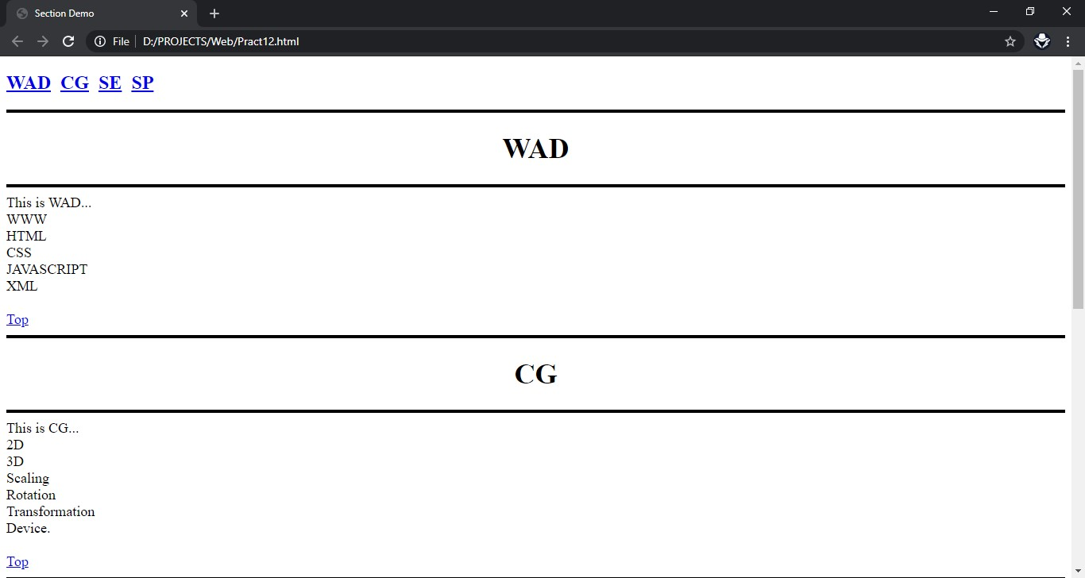

3) HTML code to build a tour package.

Code:pract13.html

<!DOCTYPE html>
<!-- 3) HTML code to build a tour package.r-->
<html>
<head><title>Tour Package</title></head>
<body>

<h1 align="center"><font size="7px" >Welcome to India</font></h1>
<hr color="black" size="4px"/>

<image src="./Images/map_india.jpg" align="left" height="40%" width="20%" alt="India map" title="Map of India">
<font size="6px" >
Welcome to India,a naturally beatiful country in every season.<font color="red">NIRVANA HOLIDAYS LTD</font> is a tour operating agency that arranges Sightseeing, Tours Packages and Overland program that have been creatively designed offering experiences of high value.
</font><br/><br/><br/><br/><br/><br/><br/><br/><br/><br/><br/>

<b><font size="6px">We offer following packages:</font></b>
<font size="5px">
<ol >
<li><a href="#">Rajsthan package</a></li>
<ul type="square">
<li>Jaypur</li>
<li>Udaipur</li>
<li>Pushkar</li>
</ul>
<li><a href="#">Kerala package</a></li>
<ul type="square">
<li>Kumarokom Resort</li>
<li>Periyar Wildlife Santury</li>
<li>Kovalam Beach</li>
</ul>
</ol>
</font>
<center>
<caption><b>Tarriff</b></caption>
<table border="2px" cellspacing="1px" cellpadding="6px">
<tr align="center">
<td>Package</td><td>Normal</td><td>Delux</td>
</tr>
<tr align="center">
<td>Rajsthan</td><td>Rs.7000</td><td>Rs.10500</td>
</tr>
<tr align="center">
<td>Kerala</td><td>Rs.11500</td><td>Rs.18000</td>
</tr>
</table>
</center><br/><br/>
</body>
</html>

Output:
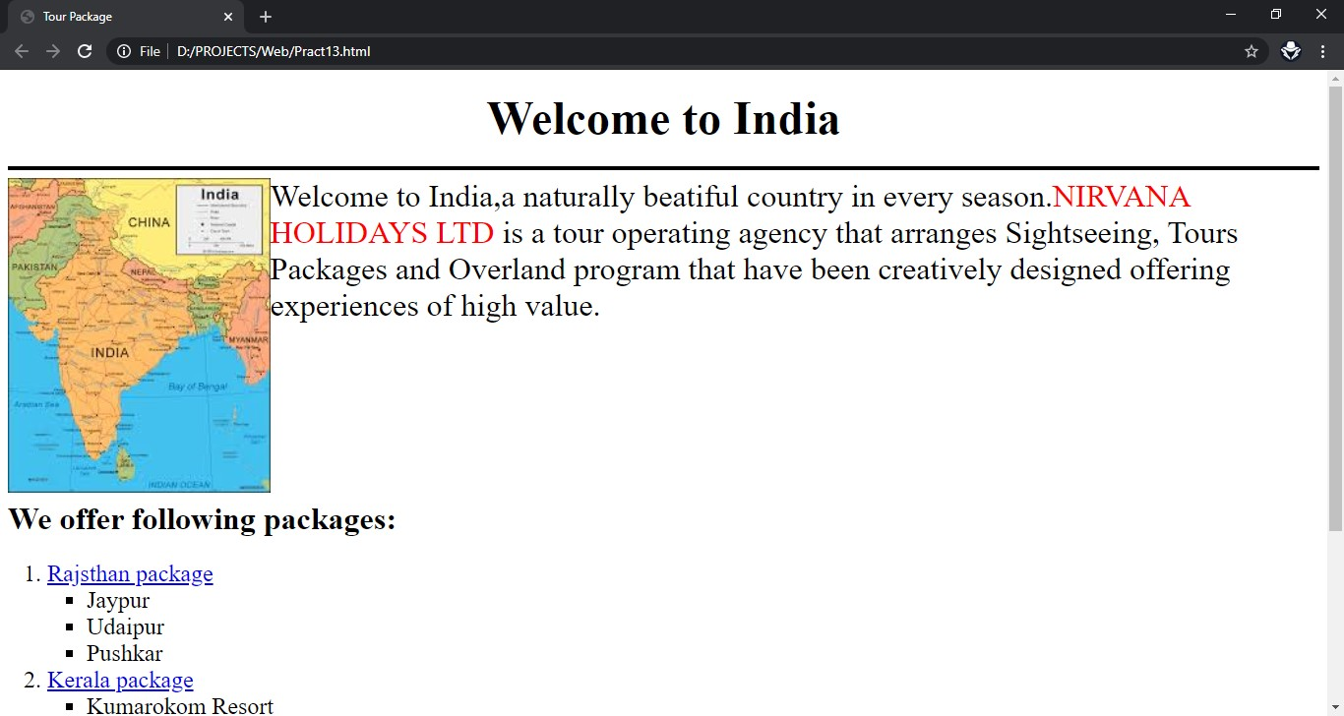

4) Write a HTML code to build a calculator.

Code:pract14.html

<!DOCTYPE html>
<!--4) Write a HTML code to build a calculator-->
<html>
<head><title>Calculator using HTML</title></head>
<body>
<form method="POST" name="calc"><center>
<table border="2px" cellpadding="3px" cellpadding="4px">
<caption>Calculator using HTML</caption>
<tr align="center">
<td colspan="4"><input type="text" name="text1" value=""/></td>
</tr>
<tr align="center">
<td><input type="button" name="btn1" value="1" onclick="calc.text1.value+='1'"></td>
<td><input type="button" name="btn2" value="2" onclick="calc.text1.value+='2'"></td>
<td><input type="button" name="btn3" value="3" onclick="calc.text1.value+='3'"></td>
<td><input type="button" name="btn+" value="+" onclick="calc.text1.value+='+'"></td>
</tr>

<tr align="center">
<td><input type="button" name="btn4" value="4" onclick="calc.text1.value+='4'"></td>
<td><input type="button" name="btn5" value="5" onclick="calc.text1.value+='5'"></td>
<td><input type="button" name="btn6" value="6" onclick="calc.text1.value+='6'"></td>
<td><input type="button" name="btn-" value="-" onclick="calc.text1.value+='-'"></td>
</tr>

<tr align="center">
<td><input type="button" name="btn7" value="7" onclick="calc.text1.value+='7'"></td>
<td><input type="button" name="btn8" value="8" onclick="calc.text1.value+='8'"></td>
<td><input type="button" name="btn9" value="9" onclick="calc.text1.value+='9'"></td>
<td><input type="button" name="btnx" value="x" onclick="calc.text1.value+='*'"></td>
</tr>

<tr align="center">
<td><input type="button" name="btnc" value="C" onclick="calc.text1.value=''"></td>
<td><input type="button" name="btn0" value="0" onclick="calc.text1.value+='0'"></td>
<td><input type="button" name="btn=" value="=" onclick="calc.text1.value=eval(calc.text1.value)"></td>
<td><input type="button" name="btn/" value="/" onclick="calc.text1.value+='/'"></td>
</tr>
</table></center>
</form>

</body>
</html>

Output:
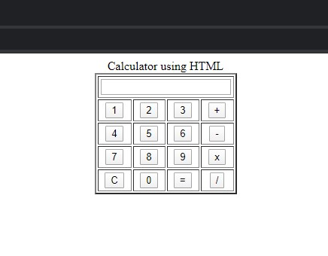

2.CSS

1) CSS code to display GEC-Rajkot Brizinger information.

Code:pract21.html

<!DOCTYPE html>
<!--1) CSS code to display GEC-Rajkot Brizinger information. -->
<html>
<head>
<title>Brizingz T20</title>
<style>
body{
background-color: #2e2e2e;
}
#header1{
text-align:center;
font-size :45px;
margin:auto 30%;
color:transparent;
background:linear-gradient(90deg,#ff0000,#ff7b00,#fffb00,#7bff00,#00f7ff,#0066ff,#0026ff,#c300ff);
-webkit-background-clip:text;
background-clip:text;
}
div{
margin:2% 12%;
padding:2px;
}
div.div1{
background-color:#3a3a3a;
color:#dfdfdf;
font-size: 18px;
}
.div11{
background-color: #582a66;
margin:1%;
color:#dfdfdf;
font-size: 15px;
}
p{

}
span{
color:red;
}
</style>
</head>
<body>
<div id="header1">Brizinger T20</div>
<div class="div1">
<p>Hello friends , Government Engineering College Rajkot is organizing <span>BRIZINGR T20</span> this year, Which is a state level tech fest and one of the biggest tech fest of the zone.</p>
<p>There will be a lot of fun with many technical as well as non-technical events also. Participants will be provided certificates which will be usefull in GTU 100 points. And special gifts for the winner is must.</p>
<p>
Some of the events are listed below:
<ul>
<li>Codeur C</li>
<li>Gully Cricket</li>
<li>and more...</li>
</ul>
</p>
<div class="div11">
Event Venue : GEC Rajkot, Near Hanuman Mandir, Mavdi-Kankot Road, Rajkot.<br/>
Date : 20,21,22 of April 2020<br/>
Time : 9:00am TO 5:00pm<br/>
For Registration and more information visit : brizingr2020.com<br/>
</div>
</div>
</body>

</html>

Output:
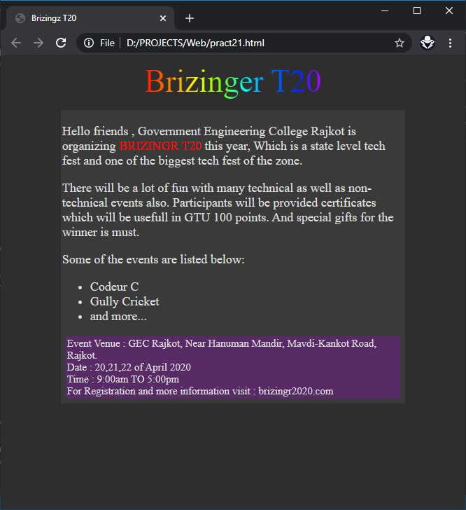

2) Write a CSS code that create table with odd rows white color and even rows blue color.

Code:pract22.html

<!DOCTYPE html>
<!--2) Write a CSS code that create table with odd rows white color and even rows blue color. -->
<html>
<head>

<title>Alternate Row Colors</title>
<style>
.odd{
background-color: white;
}
.even{
background-color: blue;
}
tr{
text-align: center;
}
table{
margin:auto;
}
</style>
</head>
<body>
<table border>
<caption>Sem 8 Result</caption>
<tr><th>Enrollment No.</th><th>Student Name</th><th>SPI</th></tr>
<tr><td>170200107001</td><td>Yogesh</td><td>9.9</td></tr>
<tr class="even"><td>170200107002</td><td>Mohan</td><td>10.0</td></tr>
<tr><td>170200107003</td><td>Rakesh</td><td>8.9</td></tr>
<tr class="even"><td>170200107004</td><td>Ramesh</td><td>7.8</td></tr>
<tr><td>170200107005</td><td>Kalpesh</td><td>9.6</td></tr>
<tr class="even"><td>170200107006</td><td>Alpesh</td><td>8.8</td></tr>
<tr><td>170200107007</td><td>Paresh</td><td>9.8</td></tr>
<tr class="even"><td>170200107008</td><td>Haresh</td><td>8.6</td></tr>
<tr><td>170200107009</td><td>Raman</td><td>8.7</td></tr>
</table>

</body>
</html>

Output:
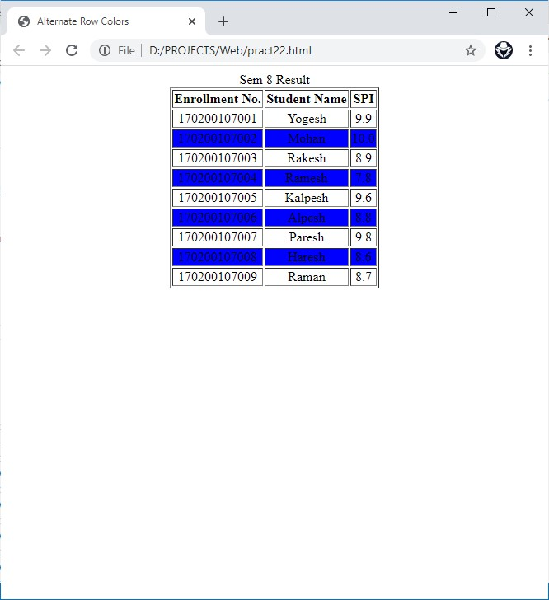

3) Write a CSS code to provide link after visited blue color and before visited red color

Code:pract23.html
<!DOCTYPE html>
<!-- 3) Write a CSS code to provide link after visited blue color and before visited red color. -->
<html>
<head>

<title>Link Color Change</title>
<style>
a{
color:red;
}
a:visited{
color:blue;
}
</style>
</head>
<body>
Links given below: before red and after blue
<ul>
<li><a href="http://google.com" target="_blank">Google.com</a></li>
<li><a href="http://youtube.com" target="_blank">Youtube.com</a></li>
<li><a href="http://facebook.com" target="_blank">Facebook.com</a></li>
<li><a href="http://yahoo.in" target="_blank">Yahoo.in</a></li>
<li><a href="http://github.com" target="_blank">Github.com</a></li>
</ul>
</body>
</html>

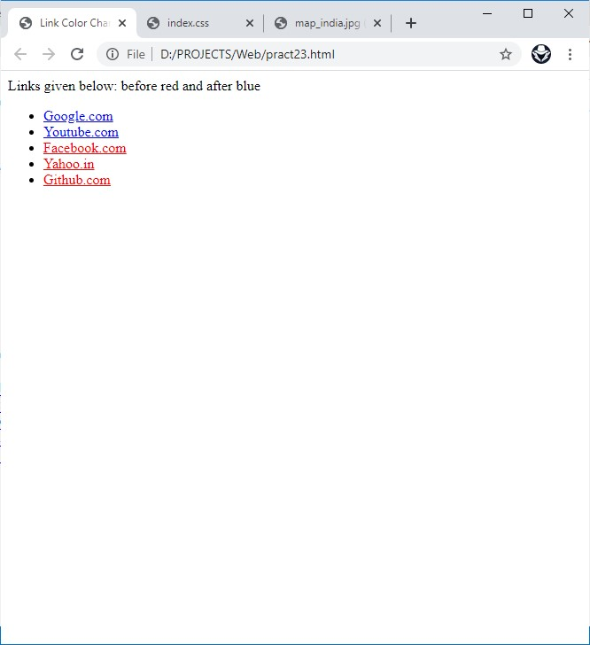
Output:

4) Write the following styles in separate CSS file and also show how to link this CSS file inHTML file and show use of styles.
(a) The headings should have normal font style and font size should be 120%.
(b)Define a class arial for paragraph width defines font family.
(c)Apply a background color yellow and apply a background image “abcd.jpg”.

Code: pract24.html

<!DOCTYPE html>
<!-- 4) Write the following styles in separate CSS file and also show how to link this
CSS file inHTML file and show use of styles.
(a) The headings should have normal font style and font size should be 120%.
(b)Define a class arial for paragraph width defines font family.
(c)Apply a background color yellow and apply a background image “abcd.jpg”. -->
<html>
<head>
<title>CSS Font Styles</title>
<style>
.heading{
font-size:120%;
}
.arial{
font-family: arial;
}
.coloredText{
background-color:yellow;
}
body{
background-image: url("./Images/logo.png") ;
background-size: cover;
}
</style>
</head>
<body>
<p>This is Normal text without any CSS added within...!!!</p>
<p class="heading">This is a Heading with 120% size</p>
<p class="arial">This paragraph has class as "arial"...</p>
<p class="coloredText">This paragraph has Yellow Colored Text and a Background Image</p>
</body>
</html>

Output:
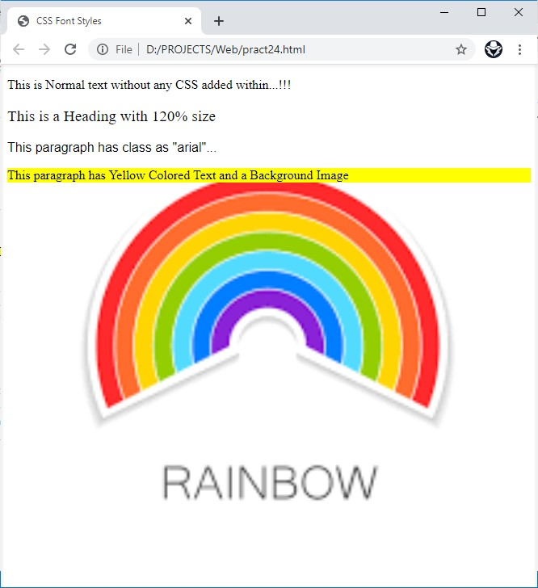

3.XML

1) To Design an XML document to store information about a student in an engineering college affiliated to GTU. The information must include RollNo, Name, Name of the College, Branch, Year of Joining, and email id. Make up sample data for 5 students. Create a CSS style sheet and use it to display the document.

Code:practt31.xml

<?xml version="1.0" encoding="utf-8"?>
<?xml-stylesheet type="text/xsl" href="./student.xsl"?>
<!-- 1) To Design an XML document to store information about a student in an engineering college affiliated
to GTU. The information must include RollNo, Name, Name of the College, Branch, Year of Joining, and email id.
Make up sample data for 5 students. Create a CSS style sheet and use it to display the document. -->
<student>
<object>
<rollNo>170200107001</rollNo>
<name>Yogesh</name>
<college>GEC Rajkot</college>
<branch>CE</branch>
<joinYear>2017</joinYear>
<email>yogesh@gmail.com</email>
</object>
<object>
<rollNo>170200107002</rollNo>
<name>Rajesh</name>
<college>GEC Bhuj</college>
<branch>MECH</branch>
<joinYear>2019</joinYear>
<email>rajesh@gmail.com</email>
</object>
<object>
<rollNo>170200107003</rollNo>
<name>Komal</name>
<college>GEC Bhavnagar</college>
<branch>EC</branch>
<joinYear>2020</joinYear>
<email>komal@gmail.com</email>
</object>
<object>
<rollNo>170200107004</rollNo>
<name>Subhash</name>
<college>GEC Gandhinagar</college>
<branch>Computer</branch>
<joinYear>2018</joinYear>
<email>subhash@gmail.com</email>
</object>
<object>
<rollNo>170200107005</rollNo>
<name>Lalit</name>
<college>GEC Bhuj</college>
<branch>IC</branch>
<joinYear>2021</joinYear>
<email>lalit@gmail.com</email>
</object>
</student>

Code:student.xsl

<?xml version="1.0" encoding="UTF-8"?>
<xsl:stylesheet version="1.0"
xmlns:xsl="http://www.w3.org/1999/XSL/Transform">
<xsl:template match="/">
<html>
<head>
<title>Student XML</title>
</head>
<body>
<table border="1">
<caption>Student Details</caption>
<tr>
<th>RollNo</th>
<th>Name</th>
<th>Name of College</th>
<th>Branch</th>
<th>Year of Joining</th>
<th>email id</th>
</tr>
<xsl:for-each select="student/object">
<tr>
<td><xsl:value-of select="rollNo"></xsl:value-of></td>
<td><xsl:value-of select="name"></xsl:value-of></td>
<td><xsl:value-of select="college"></xsl:value-of></td>
<td><xsl:value-of select="branch"></xsl:value-of></td>
<td><xsl:value-of select="joinYear"></xsl:value-of></td>
<td><xsl:value-of select="email"></xsl:value-of></td>
</tr>
</xsl:for-each>
</table>
</body>
</html>
</xsl:template>
</xsl:stylesheet>

Output:
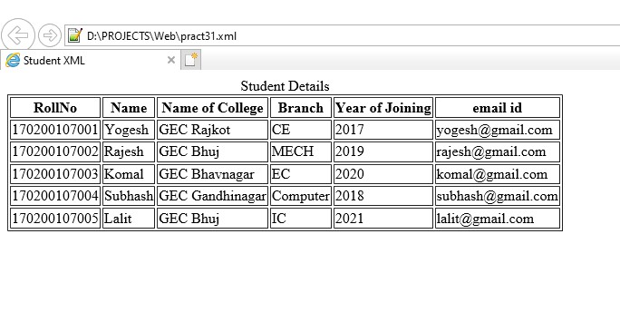

2) Create XML page to store employee information.

Code:pract32.xml

<?xml version="1.0" encoding="utf-8" ?>
<employee>
<object>
<id>1</id>
<name>Yogesh</name>
<email>yogesh@gmail.com</email>
<contact>1234567890</contact>
<address>Barvala Bavishi, Amreli</address>
<salary>6500000</salary>
</object>
<object>
<id>2</id>
<name>Mohan</name>
<email>mohan@gmail.com</email>
<contact>4561237890</contact>
<address>Mavdi, Rajkot</address>
<salary>4550000</salary>
</object>
<object>
<id>3</id>
<name>Ramesh</name>
<email>ramesh@gmail.com</email>
<contact>9876543210</contact>
<address>Kankot, Rajkot</address>
<salary>1200000</salary>
</object>
<object>
<id>3</id>
<name>Parul</name>
<email>parul@gmail.com</email>
<contact>4566546540</contact>
<address>Mota Mava, Rajkot</address>
<salary>3400000</salary>
</object>

</employee>

<!-- 2) Create XML page to store employee information. -->

Output:
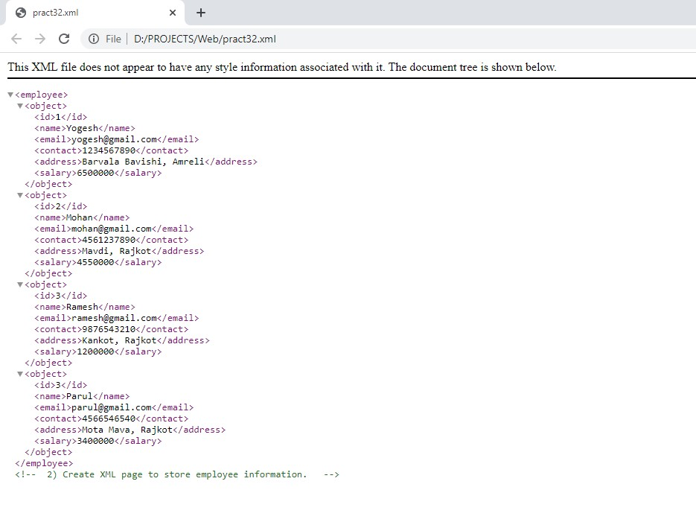

4.JAVASCRIPT

1) Write javascript code to validate username and password (password length must between 6 to 12 characters. User name should not start with _,@, or any number, both are not blank).

Code:pract41.html

<!DOCTYPE html>
<!-- 1) Write javascript code to validate username and password (password length must between 6 to
12 characters. User name should not start with _,@, or any number, both are not blank). -->
<html>

<head>
<title>User Validation</title>
</head>

<body>
<form action="" name="form1">
<div class="form">
<input type="text" name="txt_user" placeholder="User Name" required /><br /><br />
<input type="password" name="txt_password" placeholder="Password" required /><br /><br />
<button type="submit" onclick="Validate()">Log in</button>
</div>
</form>
<h3 id="message"></h3>

<script type="text/javascript">
function Validate() {
var user = document.getElementsByClassName("form")[0]['children'][0].value;
var password = document.getElementsByClassName("form")[0]['children'][3].value;
var message;
if (password.length >= 6 && password.length <= 12)
if (user.startsWith("_") || user.startsWith("@") || user.match(/^\d/))
message = "Username is not Valid";
else {
document.write("<h1>Login Successful</h1>");
return true;
}
else
message = "Password is not Valid";

var node = document.createElement("p");
var textnode = document.createTextNode(message);
node.appendChild(textnode);
document.getElementById("message").appendChild(node);
return false;
}
</script>
</body>

</html>

Code:pract41.html

<!DOCTYPE html>
<!-- 1) Write javascript code to validate username and password (password length must between 6 to
12 characters. User name should not start with _,@, or any number, both are not blank). -->
<html>

<head>
<title>User Validation</title>
</head>

<body>
<form action="" name="form1">
<div class="form">
<input type="text" name="txt_user" placeholder="User Name" required /><br /><br />
<input type="password" name="txt_password" placeholder="Password" required /><br /><br />
<button type="submit" onclick="Validate()">Log in</button>
</div>
</form>
<h3 id="message"></h3>

<script type="text/javascript">
function Validate() {
var user = document.getElementsByClassName("form")[0]['children'][0].value;
var password = document.getElementsByClassName("form")[0]['children'][3].value;
var message;
if (password.length >= 6 && password.length <= 12)
if (user.startsWith("_") || user.startsWith("@") || user.match(/^\d/))
message = "Username is not Valid";
else {
document.write("<h1>Login Successful</h1>");
return true;
}
else
message = "Password is not Valid";

var node = document.createElement("p");
var textnode = document.createTextNode(message);
node.appendChild(textnode);
document.getElementById("message").appendChild(node);
return false;
}
</script>
</body>

</html>

Output:
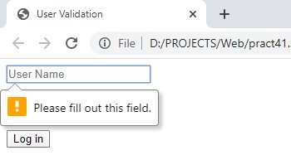

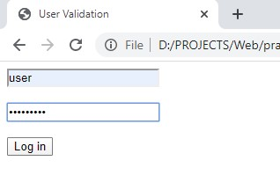

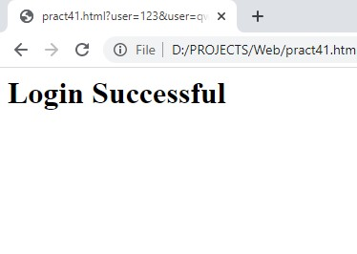

2) Write a Javascript code to build a calculator.

Code:pract42.html

<!DOCTYPE html>
<!-- 2) Write a Javascript code to build a calculator -->
<html>

<head>
<title>Calculator Using Javascript</title>
<style>
tr{
text-align: center;
}
</style>
</head>

<body>
<h1>Calculator using Javascript</h1>
<div class="container">
<form name="form">
<table border="1px">
<tr><td colspan="4"><input type="text" placeholder="0" name="displayResult" /></td></tr>
<tr>
<td><input type="button" name="b7" value="7" onClick="calcNumbers(b7.value)"></td>
<td><input type="button" name="b8" value="8" onClick="calcNumbers(b8.value)"></td>
<td><input type="button" name="b9" value="9" onClick="calcNumbers(b9.value)"></td>
<td><input type="reset" name="clear" value="C"></td>
</tr>
<tr>
<td><input type="button" name="b4" value="4" onClick="calcNumbers(b4.value)"></td>
<td><input type="button" name="b5" value="5" onClick="calcNumbers(b5.value)"></td>
<td><input type="button" name="b6" value="6" onClick="calcNumbers(b6.value)"></td>
<td><input type="button" name="mulb" value="*" onClick="calcNumbers(mulb.value)"></td>
</tr>
<tr>
<td><input type="button" name="b1" value="1" onClick="calcNumbers(b1.value)"></td>
<td> <input type="button" name="b2" value="2" onClick="calcNumbers(b2.value)"></td>
<td><input type="button" name="b3" value="3" onClick="calcNumbers(b3.value)"></td>
<td> <input type="button" name="divb" value="/" onClick="calcNumbers(divb.value)"></td>
</tr>
<tr>
<td> <input type="button" name="b0" value="0" onClick="calcNumbers(b0.value)"></td>
<td><input type="button" name="addb" value="+" onClick="calcNumbers(addb.value)"></td>
<td> <input type="button" name="subb" value="-" onClick="calcNumbers(subb.value)"></td>
<td> <input type="button" class="red" value="=" onClick="displayResult.value=eval(displayResult.value)"></td>
</tr>
</table>
</form>
</div>
<script>
function calcNumbers(result) {
form.displayResult.value = form.displayResult.value + result;
}
</script>
</body>

</html>

Output:
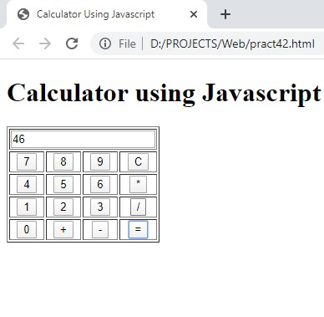

3) Write a Javascript program to calculate area of triangle and rectangle.

Code:pract43.html

<!DOCTYPE html>
<!-- 3) Write a Javascript program to calculate area of triangle and rectangle. -->
<html>

<head>
<title> Area of Triangle/Rectangle </title>
</head>

<body>

<h1>Area Calculation</h1>
<div class="triangle">
<h2>Triangle Details</h2>
<input type="text" placeholder="Enter Base Value"><br><br>
<input type="text" placeholder="Enter Height Value"><br><br>
<input type="button" value="Submit" onClick="t_area()"><br><br>
</div>
<div class="rectangle">
<h2>Rectangle Details</h2>
<input type="text" name="width" placeholder="Enter Width Value"><br><br>
<input type="text" name="height" placeholder="Enter Height Value"><br><br>
<button type="submit" onclick="r_area()">Submit</button><br><br>
</div>

<script type="text/javascript">
function t_area() {
var base = document.getElementsByClassName('triangle')[0]['children'][1].value;
var height = document.getElementsByClassName('triangle')[0]['children'][4].value;
var area = base * height * 0.5;
form.displayResult.value = "Area of Triangle is : " + area;
}

function r_area() {
var width = document.getElementsByClassName('rectangle')[0]['children'][1].value;
var height = document.getElementsByClassName('rectangle')[0]['children'][4].value;
var area = width * height;
form.displayResult.value = "Area of Rectangle is : " + area;
}
</script>
</body>

<form name="form">
<input type="text" placeholder="Answer" name="displayResult" style="width:300px" disabled></h2>
</form>

</html>

Output:
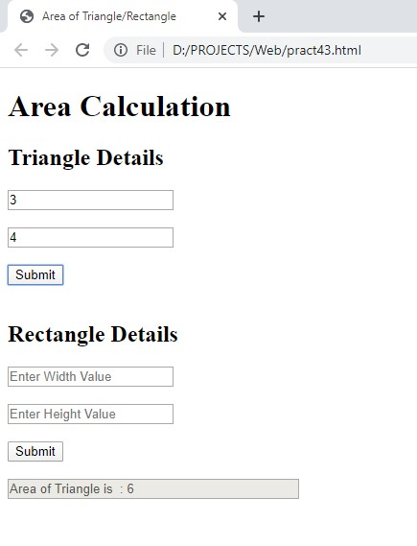
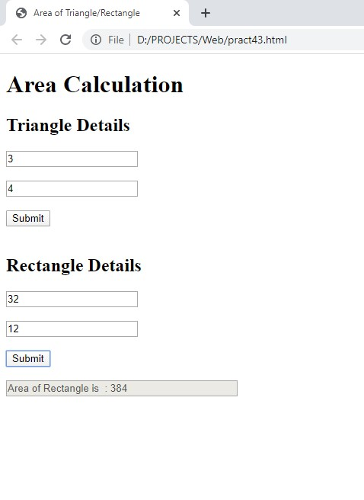

4) Write a sample program to demonstrate how a user defined objest are created in Javascript? How a a constructor can be used to populate data object?

Code:pract44.html

<!DOCTYPE html>
<!-- 4) Write a sample program to demonstrate how a user defined
objest are created in Javascript? How a a constructor can be used to populate data object? -->
<html>

<head>
<title>User defined object</title>
</head>

<body>
<h1>User define Object</h1>
<div class="object"> <input type="text" placeholder="Enter First Name">
<input type="text" placeholder="Enter Middle Name"> <br /><br />
<input type="text" placeholder="Enter Last Name"><br /><br />
<input type="text" placeholder="Enter Age"> <br /><br />
<input type="text" placeholder="Enter Nationality"><br /><br />
<input type="text" placeholder="Enter State "> <br/><br/>
<input type="text" placeholder="Enter City"> <br/><br/>
<input type="button" value="Submit" onclick="createObj()"> <br/><br/>
</div>
<script type="text/javascript">
function person(firstName, middleName, lastName, age, nationality, state, city) {
this.firstName = firstName;
this.middleName = middleName;
this.lastName = lastName;
this.age = age;
this.nation = new Object();
this.nation.nationality = nationality;
this.nation.state = state;
this.nation.city = city;
this.show = function showPerson() {
var str = "First Name : " + this.firstName + "<br/>" +
"Middle Name : " + this.middleName + "<br/>" +
"Last Name : " + this.lastName + "<br/>" +
"Age : " + this.age + "<br/>" +
"Nationality : " + this.nation.nationality + "<br/>" +
"State : " + this.nation.state + "<br/>" +
"City : " + this.nation.city + "<br/>";
document.write("<h1>" + str + "</h1>");
}
}
function createObj() {
var firstName = document.getElementsByClassName('object')[0]['children'][0].value;
var middleName = document.getElementsByClassName('object')[0]['children'][1].value;
var lastName = document.getElementsByClassName('object')[0]['children'][2].value;
var age = document.getElementsByClassName('object')[0]['children'][3].value;
var nationality = document.getElementsByClassName('object')[0]['children'][4].value;
var state = document.getElementsByClassName('object')[0]['children'][5].value;
var city = document.getElementsByClassName('object')[0]['children'][6].value;
var person1 = new person(firstName, middleName, lastName, age, nationality, state, city);
person1.show();

}
</script>
</body>

</html>

Output:
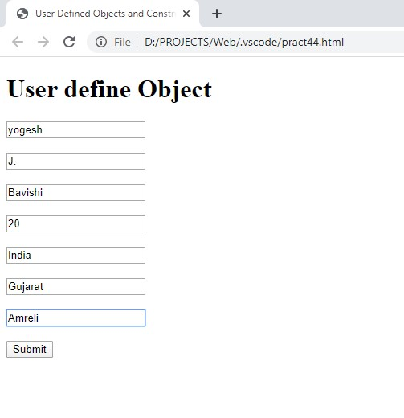

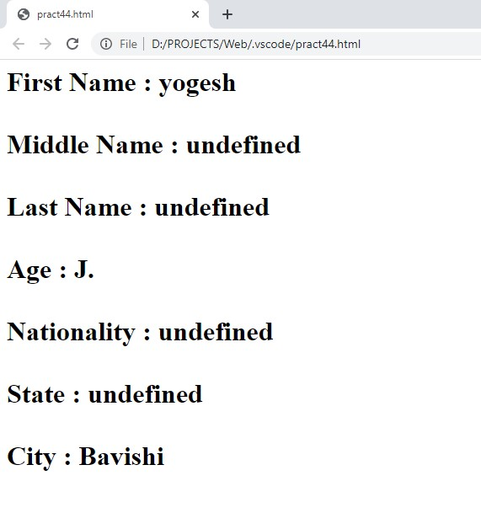

5) Write a Javascript to take 2 digit number and then separate this two digits then multiply first digit by

Code:pract45.html

<!DOCTYPE html>
<!-- 5) Write a Javascript to take 2 digit number and then separate this two digits then multiply
first digit by itself for second digit times. -->
<html>

<head>

<title>Multiply Digit1 by Digit2</title>
</head>

<body>
<h1>Multiply Digit1 by Digit2</h1>
<div class="Number">
<input type="text" placeholder="Enter Two Digit Number ">
<button type="button" onclick="callFunction()">Submit</button>
</div>
<form name="form">
<input type="text" name="displayResult" placeholder="Answer" disabled>
</form>

<script type="text/javascript">
function callFunction() {
var number = Math.floor(document.getElementsByClassName('Number')[0]['children'][0].value);
if (number > 9 && number < 100) {
var num1 = Math.floor(number / 10);
var num2 = (number - (10 * num1));
var result = 1;
for (var i = 0; i < num2; i++)
result = result * num1;
form.displayResult.value = "Answer is : " + result;
}
else {
form.displayResult.value = "Number is not Valid";
}
}
</script>
</body>

</html>

Output:
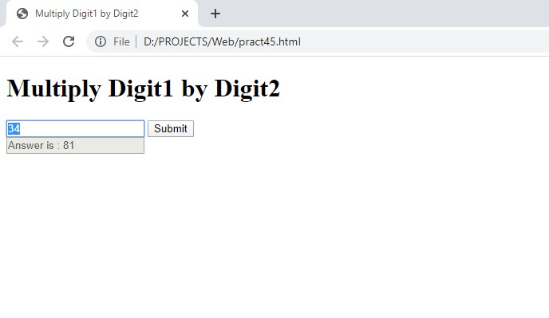

6) Write a Javascript to print characters of a string at odd position.

Code:pract46.html

<!DOCTYPE html>
<!-- 6) Write a Javascript to print characters of a string at odd position. -->
<html>

<head>

<title>Character at Odd position</title>
</head>

<body>
<h1>Odd Postion String</h1>
<div class="input">
<textarea name="string1" rows="8" cols="80" placeholder="Enter String... "></textarea>
<button type="button" onclick="callFunction()">Submit</button>
</div>
<form name="form">
<textarea name="output" rows="8" cols="80" disabled placeholder="Output... "></textarea>
</form>
<script type="text/javascript">
function callFunction() {
var string1 = " " + document.getElementsByClassName('input')[0]['children'][0].value;
var result = "";
for (var t = 0; t < string1.length; t++)
if (t % 2 != 0)
result += string1[t] + " ";
form.output.value = result;
}
</script>
</body>

</html>

Output:
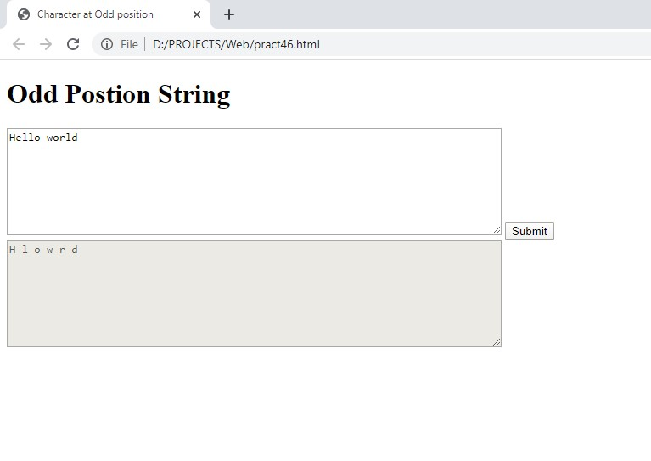

5.PHP

1) Write PHP program to: To print whether given number is odd or even

Code:pract51.php

<!DOCTYPE html>
<!-- 1) Write PHP program to: To print whether given number is odd or even. -->
<html>

<head>

<title>PHP Odd/Even</title>

<body>
<h1>Odd-Even Test</h1>
<form action="pract51.php" method="POST">
<div class="Number">
<input type="text" name="number" placeholder="Enter Any Number" autocomplete="off">
<button type="submit">Submit</button>
</div>
</form>

<?php
if(isset($_POST['number'])){
$number = $_POST['number'];
if($number%2==0){
echo "<h1>Number is Even</h1>";
}
else{
echo "<h1>Number is Odd</h1>";
}
}
?>

</body>

</html>

Output:
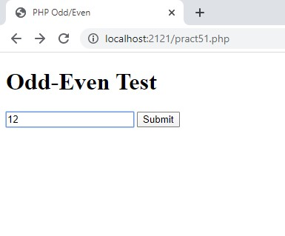
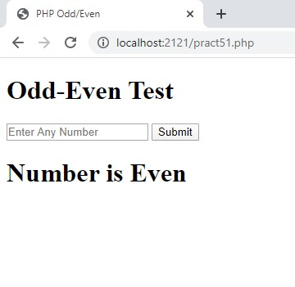

2) Write PHP program to first 10 Fibonacci number

Code:pract52.php

<!DOCTYPE html>
<!-- 2) Write PHP program to first 10 Fibonacci number. -->
<html>

<head>
<title>Fibonacci Series</title>
</head>

<body>
<h1>Fibonacci Series</h1>
<form action="pract52.php" method="POST">
<div class="Number">
<input type="text" name="number" placeholder="Enter Number" autocomplete="off">
<button type="submit">Submit</button>
</div>
</form>

<?php
if (isset($_POST['number'])) {
$number = $_POST['number'];
$previous = 0;
$current = 1;
$result = " ";
for ($i = 0; $i < $number; $i++) {
$next = $previous + $current;
$previous = $current;
$current = $next;
$result = " " . $result . " " . $next . " ";
}
echo "<h1> " . $result . "</h1>";
}
?>
</body>

</html>

Output:
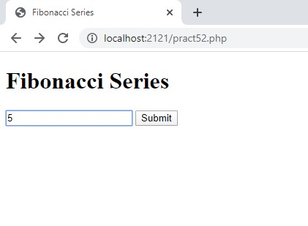

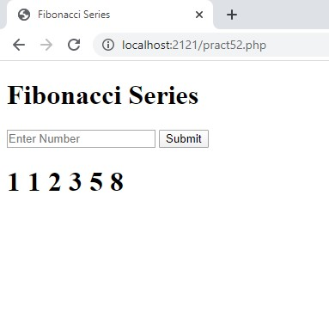

3) Write modules using HTML and PHP to store information of employee (employee id, job title, years of experience) in an array. And output the data to a web page by arranging the employees in ascending order of experience.

Code:pract53.php

<!DOCTYPE html>
<!-- 3) Write modules using HTML and PHP to store information of
employee (employee id, job title, years of experience)
in an array. And output the data to a web page by arranging the employees in ascending order
of experience. -->
<html>

<head>
<title> Employee Information</title>
</style>
</head>

<body>
<h1>Employee Details</h1>
<table>
<form action="pract53.php" method="POST">
<tr>
<td>
<input type="text" name="eid0" placeholder="Enter Employee Id" required>
</td>
<td>
<input type="text" name="title0" placeholder="Enter Job Title" required>
</td>
<td>
<input type="text" name="experience0" placeholder="Enter Year of Experience" required>
</td>
</tr>
<tr>
<td>
<input type="text" name="eid1" placeholder="Enter Employee Id" required>
</td>
<td>
<input type="text" name="title1" placeholder="Enter Job Title" required>
</td>
<td>
<input type="text" name="experience1" placeholder="Enter Year of Experience" required>
</td>
</tr>
<tr>
<td>
<input type="text" name="eid2" placeholder="Enter Employee Id" required>
</td>
<td>
<input type="text" name="title2" placeholder="Enter Job Title" required>
</td>
<td>
<input type="text" name="experience2" placeholder="Enter Year of Experience" required>
</td>
</tr>
<tr>
<center>
<td colspan="3">
<button type="submit">Submit</button>
</td>
</tr>
</form>
</table>

<?php
if (isset($_POST['eid0'])) {

$eid0 = $_POST['eid0'];
$title0 = $_POST['title0'];
$exp0 = $_POST['experience0'];

$eid1 = $_POST['eid1'];
$title1 = $_POST['title1'];
$exp1 = $_POST['experience1'];

$eid2 = $_POST['eid2'];
$title2 = $_POST['title2'];
$exp2 = $_POST['experience2'];

$employee = array(
array('eid' => $eid0, 'title' => "$title0", 'experience' => $exp0),
array('eid' => $eid1, 'title' => "$title1", 'experience' => $exp1),
array('eid' => $eid2, 'title' => "$title2", 'experience' => $exp2),
);

class Employee
{
var $eid, $title, $experience;

public function Employee($data)
{
$this->eid = $data['eid'];
$this->title = $data['title'];
$this->experience = $data['experience'];
}
}
function data2Object($data)
{
$class_object = new Employee($data);
return $class_object;
}
function comparator($object1, $object2)
{
return $object1->experience > $object2->experience;
}
$emp_data = array_map('data2Object', $employee);
usort($emp_data, 'comparator');
echo ("<h1>After Sorting</h1>");
foreach ($emp_data as $key) {
$str = "Id : " . $key->eid . " Title : " . $key->title . " Experience : " . $key->experience . "<br>";
echo ("<h1>" . $str . "</h1>");
}
}
?>

</body>

</html>

Output:
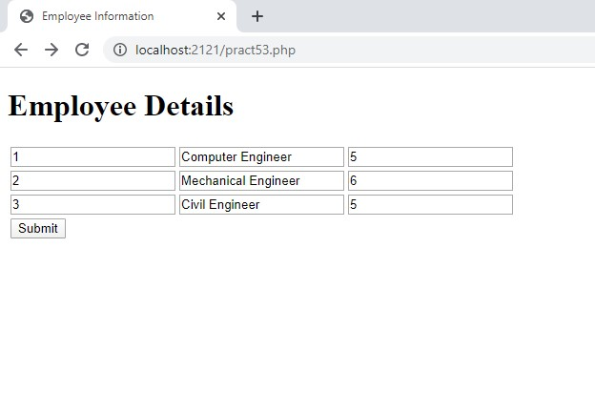

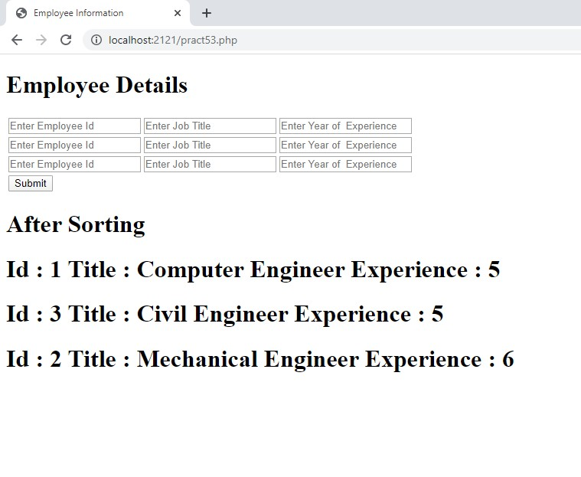

4) Create a database called country and create table called city having fields (cityname, area, population) using PHP commands. Create an HTML form to get the city data and write a script to insert that data into the table.

Code:pract54.php

<!DOCTYPE html>
<!-- 4) Create a database called country and create table called city having fields
(cityname, area, population) using PHP commands.
Create an HTML form to get the city data and write a script to insert that data into the table. -->

<html>

<head>

<title>Country Database</title>
</head>

<body>
<form action="pract54.php" method="POST">
<input type="text" name="cityname" placeholder="Enter City Name"><br/><br/>
<input type="text" name="area" placeholder="Enter Area Name"><br/><br/>
<input type="text" name="population" placeholder="Enter Population"><br/><br/>
<button type="submit">Submit</button>
</form>
<?php

if (isset($_POST['cityname'])) {
$cityname = $_POST['cityname'];
$area = $_POST['area'];
$population = $_POST['population'];
$connect = mysqli_connect("localhost", "LMS", "library123","country",3306) or die(mysqli_connect_error());
$db = mysqli_select_db("country", $connect) or die(mysqli_connect_error());
$query = sprintf("INSERT INTO `city`(`cityname`, `area`, `population`) VALUES ('%s','%s',%d)", $cityname, $area, $population);
$result = mysqli_query($query,MYSQLI_STORE_RESULT) or die(mysqli_connect_error());
if ($result) {
echo "<h1>Data added to database...</h1>";
}
}
?>
</body>

</html>

Output:
