4.ASP.Net

(1) Develop a web form for calculator. Use Autopostback mechanism.

Code:WebForm1.aspx

<%@ Page Language="C#" AutoEventWireup="true" CodeBehind="WebForm1.aspx.cs" Inherits="CalculatorAsp.WebForm1" %>

<!DOCTYPE html>

<html xmlns="http://www.w3.org/1999/xhtml">
<head runat="server">
<title></title>
</head>
<body>
<form id="form1" runat="server">
<div style="margin-left: 720px">
</div>
<p style="margin-left: 520px">
<asp:Label ID="Label2" runat="server" Font-Bold="True" Font-Size="X-Large" ForeColor="#003366" Text="Simple Calculator"></asp:Label>
</p>
<p style="margin-left: 520px">
<asp:TextBox ID="TextBox1" runat="server" placeholder="Enter first number" ></asp:TextBox>
<asp:RequiredFieldValidator ID="RequiredFieldValidatorFirstNumber" runat="server" ErrorMessage="Please Enter First Number!" ForeColor="Red" ControlToValidate="TextBox1"></asp:RequiredFieldValidator>
</p>
<p style="margin-left: 520px">
<asp:TextBox ID="TextBox2" runat="server" placeholder="Enter Second number"></asp:TextBox>
<asp:RequiredFieldValidator ID="RequiredFieldValidatorSecondNumber" runat="server" ErrorMessage="Please Enter Second Number!" ForeColor="Red" ControlToValidate="TextBox2"></asp:RequiredFieldValidator>
</p>
<p>
&nbsp;</p>
<div style="margin-left: 520px">
<asp:DropDownList ID="DropDownList1" runat="server" AutoPostBack="True" OnSelectedIndexChanged="DropDownList1_SelectedIndexChanged">
<asp:ListItem Value="-1">Select Operator</asp:ListItem>
<asp:ListItem Value="1">+</asp:ListItem>
<asp:ListItem Value="2">-</asp:ListItem>
<asp:ListItem Value="3">*</asp:ListItem>
<asp:ListItem Value="4">/</asp:ListItem>
</asp:DropDownList>
<asp:Button ID="Button1" runat="server" OnClick="Button1_Click" Text="Clear" />
</div>
<p style="margin-left: 560px">
<asp:Label ID="Label1" runat="server" ForeColor="#003300"></asp:Label>
</p>
<Page Language="C#" EnableViewState="true">
</form>
</body></html>

Code:WebForm1.aspx.cs

using System;
using System.Collections.Generic;
using System.Linq;
using System.Web;
using System.Web.UI;
using System.Web.UI.WebControls;

namespace CalculatorAsp
{
public partial class WebForm1 : System.Web.UI.Page
{
double total;
protected void Page_Load(object sender, EventArgs e)
{
ValidationSettings.UnobtrusiveValidationMode = UnobtrusiveValidationMode.None;
TextBox1.EnableViewState = true;
TextBox2.EnableViewState = true;
DropDownList1.EnableViewState = true;
Label1.EnableViewState = true;
}

protected void DropDownList1_SelectedIndexChanged(object sender, EventArgs e)
{
if (DropDownList1.SelectedItem.Text == "+")
{
try
{
total = double.Parse(TextBox1.Text) + double.Parse(TextBox2.Text);
Label1.Text = "Result is: " + total.ToString();

}
catch (FormatException ex)
{

}
}
else if (DropDownList1.SelectedItem.Text == "-")
{
try
{
total = double.Parse(TextBox1.Text) - double.Parse(TextBox2.Text);
Label1.Text = "Result is: " + total.ToString();

}
catch (FormatException ex)
{

}

}
else if (DropDownList1.SelectedItem.Text == "*")
{
try
{

total = double.Parse(TextBox1.Text) * double.Parse(TextBox2.Text);
Label1.Text = "Result is: " + total.ToString();

}
catch (FormatException ex)
{

}
}
else if (DropDownList1.SelectedItem.Text == "/")
{
try
{
total = double.Parse(TextBox1.Text) / double.Parse(TextBox2.Text);
Label1.Text = "Result is: " + total.ToString();

}
catch (DivideByZeroException ex)
{

}
}
}

protected void Button1_Click(object sender, EventArgs e)
{
TextBox2.Text = "";
TextBox1.Text = "";
Label1.Text = "";
}
}
}

Output:

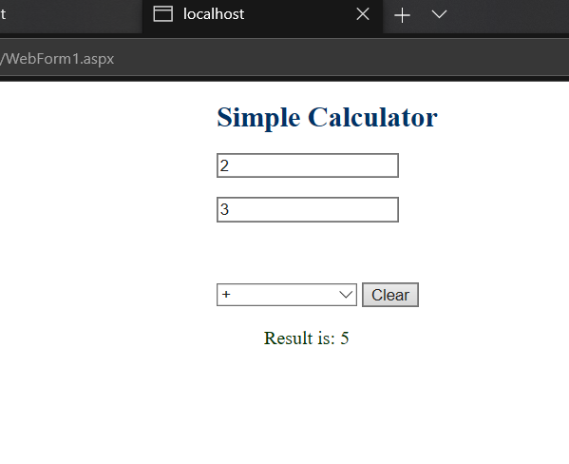
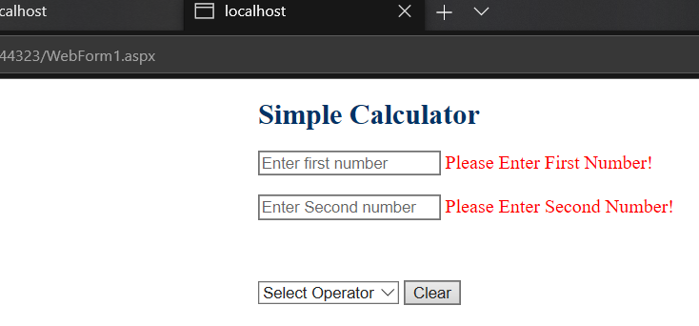

(2) Develop a web form for user registration. Perform validation with validation controls.
Code:WebForm1.aspx

<%@ Page Language="C#" AutoEventWireup="true" CodeBehind="WebForm1.aspx.cs" Inherits="RegistrationForm.WebForm1" %>

<!DOCTYPE html>

<html xmlns="http://www.w3.org/1999/xhtml">
<head runat="server">
<title></title>
</head>
<body>

<h1>User Registration Form</h1>
<fieldset>
<legend>Registration</legend>

<form id="form1" runat="server">
<div>
</div>
<p>
Username:<asp:TextBox ID="txtUsername" runat="server"></asp:TextBox>
<asp:RequiredFieldValidator ID="RequiredFieldValidatorUsername" runat="server" ErrorMessage="Username is required" ForeColor="Red"
ControlToValidate="txtUsername" Display="Dynamic"></asp:RequiredFieldValidator>
<asp:RegularExpressionValidator ID="RegularExpressionValidatorUsername" runat="server" ErrorMessage="Username should be correct Format!!"
ControlToValidate="txtUsername" ValidationExpression="^(?i)(((?=.{6,21}$)[a-z\d]+\.[a-z\d]+)|[a-z\d]{5,20})$" ForeColor="Red" Display="Dynamic"></asp:RegularExpressionValidator>
</p>

<p>
Email&nbsp;&nbsp;&nbsp;&nbsp;&nbsp; :<asp:TextBox ID="txtEmail" runat="server"></asp:TextBox>
<asp:RequiredFieldValidator ID="RequiredFieldValidatorEmail" runat="server" ErrorMessage="Email is required" ForeColor="Red"
ControlToValidate="txtEmail" Display="Dynamic"></asp:RequiredFieldValidator>
<asp:RegularExpressionValidator ID="RegularExpressionValidatorEmail" runat="server" ErrorMessage="Email Should correct format!" ForeColor="Red"
ControlToValidate="txtEmail" ValidationExpression="\w+([-+.']\w+)*@\w+([-.]\w+)*\.\w+([-.]\w+)*" Display="Dynamic"></asp:RegularExpressionValidator>
</p>
<p>
Mobile&nbsp;&nbsp;&nbsp; :<asp:TextBox ID="txtMobile" runat="server"></asp:TextBox>
<asp:RequiredFieldValidator ID="RequiredFieldValidatorMobile" runat="server" ErrorMessage="Mobile is required" ForeColor="Red"
ControlToValidate="txtMobile" Display="Dynamic"></asp:RequiredFieldValidator>

<asp:RegularExpressionValidator ID="RegularExpressionValidatorMobile" runat="server" ErrorMessage="Enter Valid mobile number!" ForeColor="Red"
ValidationExpression="^[01]?[- .]?(\([2-9]\d{2}\)|[2-9]\d{2})[- .]?\d{3}[- .]?\d{4}$" ControlToValidate="txtMobile" Display="Dynamic"></asp:RegularExpressionValidator>

</p>

<p>
Password:<asp:TextBox type="password" ID="txtPassword" runat="server"></asp:TextBox>
<asp:RequiredFieldValidator ID="RequiredFieldValidatorPassword" runat="server" ErrorMessage="Password is required" ForeColor="Red"
ControlToValidate="txtPassword" Display="Dynamic"></asp:RequiredFieldValidator>
<asp:RegularExpressionValidator ID="RegularExpressionValidatorPassword" runat="server" ErrorMessage="Password must greater than seven characters. - Contains at least one digit. - Contains at least one special (non-alphanumeric) character."
ControlToValidate="txtPassword" ForeColor="Red" ValidationExpression="^.*(?=.{8,})(?=.*[\d])(?=.*[\W]).*$" Display="Dynamic"></asp:RegularExpressionValidator>
</p>
<p>
Re-Type Password:<asp:TextBox type="password" ID="txtReTypePassword" runat="server"></asp:TextBox>
<asp:RequiredFieldValidator ID="RequiredFieldValidatorReTypePassword" runat="server" ErrorMessage="Please retype the password"
ForeColor="Red" ControlToValidate="txtReTypePassword" Display="Dynamic"></asp:RequiredFieldValidator>

<asp:CompareValidator ID="CompareValidatorReTypeValidator" runat="server" ErrorMessage="Password and Re-Type password must match"
ControlToValidate="txtReTypePassword" ControlToCompare="txtPassword" ForeColor="Red" Operator="Equal" Type="String" Display="Dynamic"></asp:CompareValidator>
</p>

<p>
<asp:Button ID="Button1" runat="server" OnClick="Button1_Click" Text="Submit" />
</p>
<p>
<asp:Label ID="Label1" runat="server" ForeColor="#339933"></asp:Label>
</p>
</form>
</fieldset>

</body>
</html>

Code:WebForm1.aspx.cs

using System;
using System.Collections.Generic;
using System.Linq;
using System.Web;
using System.Web.UI;
using System.Web.UI.WebControls;

namespace RegistrationForm
{
public partial class WebForm1 : System.Web.UI.Page
{
protected void Page_Load(object sender, EventArgs e)
{
ValidationSettings.UnobtrusiveValidationMode = UnobtrusiveValidationMode.None;
}

protected void Button1_Click(object sender, EventArgs e)

{
Label1.Text = "submitted Successfully.";}}}

Output:

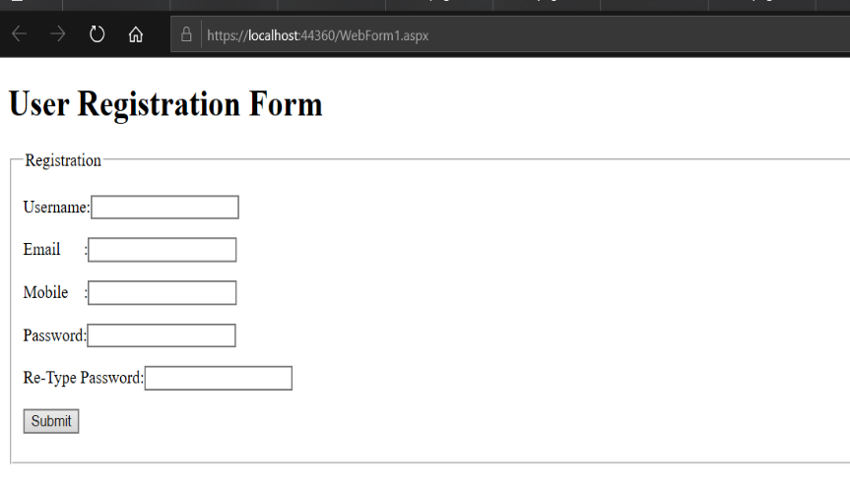
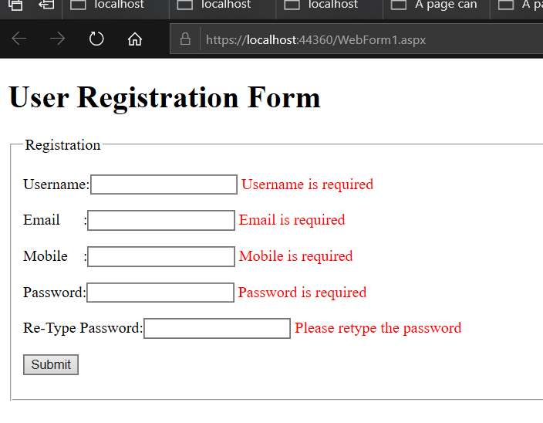

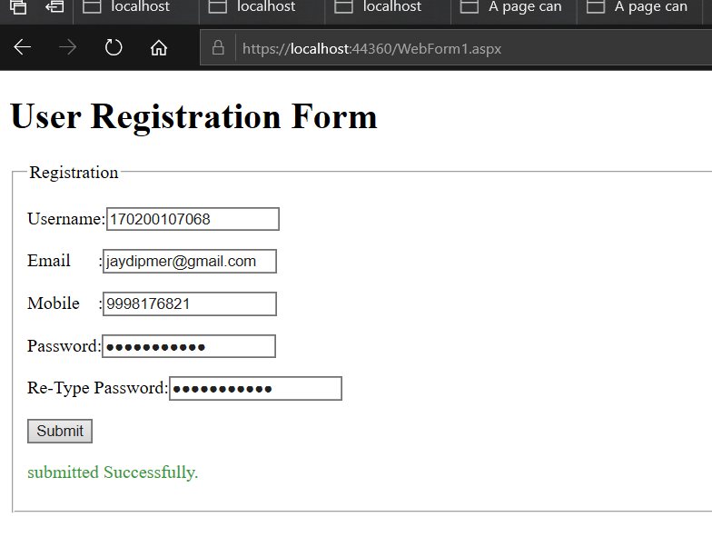
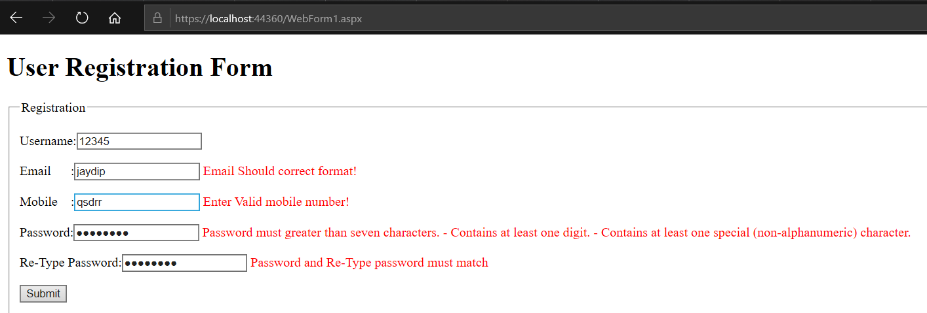

(3) Develop web forms which demonstrate use of cookies and session.

(I)Cookie

Code: WebForm1.aspx

<%@ Page Language="C#" AutoEventWireup="true" CodeBehind="WebForm1.aspx.cs" Inherits="CookiesInASP.WebForm1" %>

<!DOCTYPE html>

<html xmlns="http://www.w3.org/1999/xhtml">
<head runat="server">
<title></title>
</head>
<body>
<form id="form1" runat="server">
<h1>Web Form1</h1>
<br />
Name:<asp:TextBox ID="txtName" runat="server"></asp:TextBox>
<br />
Email:<asp:TextBox ID="txtEmail" runat="server"></asp:TextBox>
<div>
</div>
<asp:Button ID="Send_data" runat="server" Height="44px" OnClick="Button1_Click" Text="Submit" Width="121px" />
</form>
</body>
</html>

Code: WebForm1.aspx.cs

using System;
using System.Collections.Generic;
using System.Linq;
using System.Web;
using System.Web.UI;
using System.Web.UI.WebControls;

namespace CookiesInASP
{
public partial class WebForm1 : System.Web.UI.Page
{
protected void Page_Load(object sender, EventArgs e)
{

}

protected void Button1_Click(object sender, EventArgs e)
{
HttpCookie cookie = new HttpCookie("UserInfo");
cookie["Name"] = txtName.Text;

cookie["Email"] = txtEmail.Text;

cookie.Expires = DateTime.Now.AddDays(30);
Response.Cookies.Add(cookie);
Response.Redirect("WebForm2.aspx");}}}

Code: WebForm2.aspx

<%@ Page Language="C#" AutoEventWireup="true" CodeBehind="WebForm2.aspx.cs" Inherits="CookiesInASP.WebForm2" %>

<!DOCTYPE html>

<html xmlns="http://www.w3.org/1999/xhtml">
<head runat="server">
<title></title>
</head>
<body>
<form id="form1" runat="server">
<h2>Web Form2</h2>
<br />
Name:<asp:Label ID="lblName" runat="server"></asp:Label>
<br />
Email:<asp:Label ID="lblEmail" runat="server"></asp:Label>
<div>
</div>
</form>
</body>
</html>

Code: WebForm2.aspx.cs

using System;
using System.Collections.Generic;
using System.Linq;
using System.Web;
using System.Web.UI;
using System.Web.UI.WebControls;

namespace CookiesInASP
{
public partial class WebForm2 : System.Web.UI.Page
{
protected void Page_Load(object sender, EventArgs e)
{
HttpCookie cookie = Request.Cookies["UserInfo"];
if (cookie != null) {
lblName.Text = cookie["Name"];

lblEmail.Text = cookie["Email"];}}}

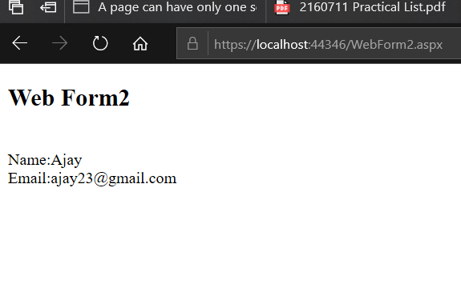
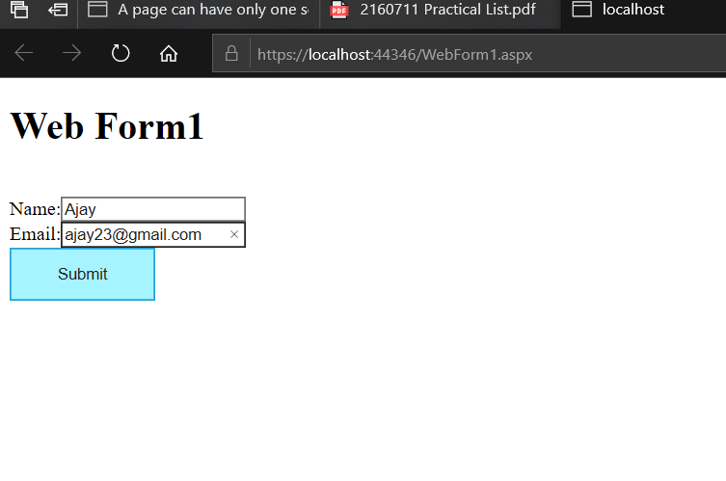
Output:

(II)Session:

Code: WebForm3.aspx

<%@ Page Language="C#" AutoEventWireup="true" CodeBehind="WebForm3.aspx.cs" Inherits="aspprac3.WebForm3" %>

<!DOCTYPE html>

<html xmlns="http://www.w3.org/1999/xhtml">
<head runat="server">
<title></title>
</head>
<body>
<h2> Example of Session</h2>
<form id="form1" runat="server">
<div>
<div>
<asp:Label ID="Label1" runat="server" Text="Name:"></asp:Label>
&nbsp;&nbsp;&nbsp;
<asp:TextBox ID="TextBox1" runat="server"></asp:TextBox>
<br />
</div>
<p>
<asp:Label ID="Label2" runat="server" Text="Email:"></asp:Label>
&nbsp;&nbsp;&nbsp;
<asp:TextBox ID="TextBox2" runat="server"></asp:TextBox>
</p>
<div style="margin-left: 80px">
<asp:Button ID="Button1" runat="server" OnClick="Button1_Click" Text="Submit" />
</div>
<br />
</div>
</form>
</body>
</html>

Code: WebForm3.aspx.cs

using System;
using System.Collections.Generic;
using System.Linq;
using System.Web;
using System.Web.UI;
using System.Web.UI.WebControls;

namespace aspprac3
{
public partial class WebForm3 : System.Web.UI.Page
{
protected void Page_Load(object sender, EventArgs e)
{
}

protected void Button1_Click(object sender, EventArgs e)

{
Session.Add("uname", TextBox1.Text);
Session["Name"]= TextBox1.Text;
Session.Add("uemail", TextBox2.Text);
Session["Email"] = TextBox2.Text;
Response.Redirect("WebForm4.aspx");}}}

Code: WebForm4.aspx

<%@ Page Language="C#" AutoEventWireup="true" CodeBehind="WebForm4.aspx.cs" Inherits="aspprac3.WebForm4" %>

<!DOCTYPE html>

<html xmlns="http://www.w3.org/1999/xhtml">
<head runat="server">
<title></title>
</head>
<body>
<form id="form1" runat="server">
<h1>WebForm 2</h1>
<div>

<asp:Label ID="Label1" runat="server" Text="Name:"></asp:Label>
&nbsp;&nbsp;&nbsp;&nbsp;&nbsp;&nbsp;&nbsp;&nbsp;&nbsp;&nbsp;
<asp:Label ID="Label3" runat="server"></asp:Label>
<br />
<br />
<asp:Label ID="Label2" runat="server" Text="Email:"></asp:Label>
&nbsp;&nbsp;&nbsp;&nbsp;&nbsp;&nbsp;&nbsp;&nbsp;&nbsp;&nbsp;
<asp:Label ID="Label4" runat="server"></asp:Label>
</div>

</form>
</body>
</html>

Code: WebForm4.aspx.cs

using System;
using System.Collections.Generic;
using System.Linq;
using System.Web;
using System.Web.UI;
using System.Web.UI.WebControls;

namespace aspprac3
{
public partial class WebForm4 : System.Web.UI.Page
{
protected void Page_Load(object sender, EventArgs e)

{

if (Session["uname"] != null)
{

Label3.Text = Session["Name"].ToString();
}
if (Session["uemail"] != null)
{
Label4.Text = Session["Email"].ToString();
}}}}

Output:
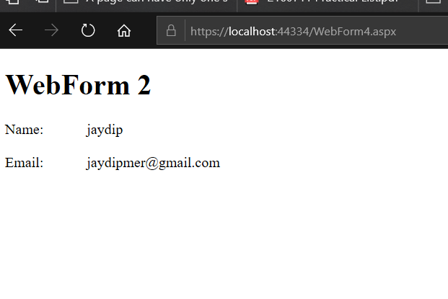
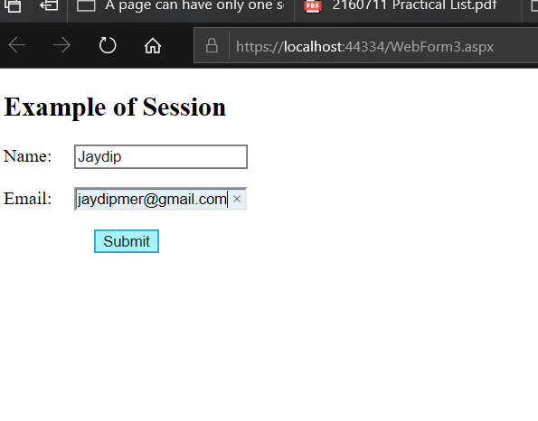

(4) Develop a home page with a hit counter using application and advertisements using Ad Rotator.

Code:WebForm1.aspx.cs
using System;
using System.Collections.Generic;
using System.Linq;
using System.Web;
using System.Web.UI;
using System.Web.UI.WebControls;
using System.Data.SqlClient;
using System.Data;

namespace aspprac4
{
public partial class WebForm1 : System.Web.UI.Page
{
protected void Page_Load(object sender, EventArgs e)
{
findview();
updatecounter();

}
private void findview()
{
string cs = @"Data Source=.\SQLEXPRESS; Initial Catalog=hitcounter1; Integrated Security= True";
string cq = "select * from hit_counter";
SqlConnection cn = new SqlConnection(cs);
SqlCommand cm = new SqlCommand(cq, cn);
cm.CommandText = cq;
cm.Connection = cn;
SqlDataAdapter ds = new SqlDataAdapter();
ds.SelectCommand = cm;
DataSet ds1 = new DataSet();
ds.Fill(ds1);
Label3.Text = "website view counter : " + ds1.Tables[0].Rows[0]["view_counter"].ToString();
cn.Close();
}
private void updatecounter()
{
string cs = @"Data Source=.\SQLEXPRESS; Initial Catalog=hitcounter1; Integrated Security= True";
string cq1 = "update hit_counter set view_counter=view_counter+1";
SqlConnection cn = new SqlConnection(cs);
cn.Open();
SqlCommand cm = new SqlCommand();
cm.CommandText = cq1;
cm.Connection = cn;
cm.ExecuteNonQuery();

}
}
}

Code:WebForm1.aspx

<%@ Page Language="C#" AutoEventWireup="true" CodeBehind="WebForm1.aspx.cs" Inherits="aspprac4.WebForm1" %>

<!DOCTYPE html>

<html xmlns="http://www.w3.org/1999/xhtml">
<head runat="server">
<title></title>
</head>
<body>
<form id="form1" runat="server">
<div>
<h2> Example of Hit Counter And Advertisementes...<br /></h2>
<br />
<h2><asp:Label ID="Label3" runat="server"></asp:Label></h2>
<p>&nbsp;</p>
<asp:AdRotator ID="AdRotator1" runat="server" AdvertisementFile="~/XMLFile1.xml" Height="150px" Width="150px" Target="" />
<br />
<br />
<br />
<br />
</div>
</form>
</body>
</html>

XMLFile1.xml
<?xml version="1.0" encoding="utf-8" ?>
<Advertisements>
<Ad>
<ImageUrl>a1.jpeg</ImageUrl>
</Ad>
<Ad>
<ImageUrl>a2.jpeg</ImageUrl>
</Ad>
<Ad>
<ImageUrl>a3.jpeg</ImageUrl>
</Ad>
<Ad>
<ImageUrl>a4.jpeg</ImageUrl>
</Ad>
<Ad>
<ImageUrl>a5.jpeg</ImageUrl>
</Ad>
</Advertisements>

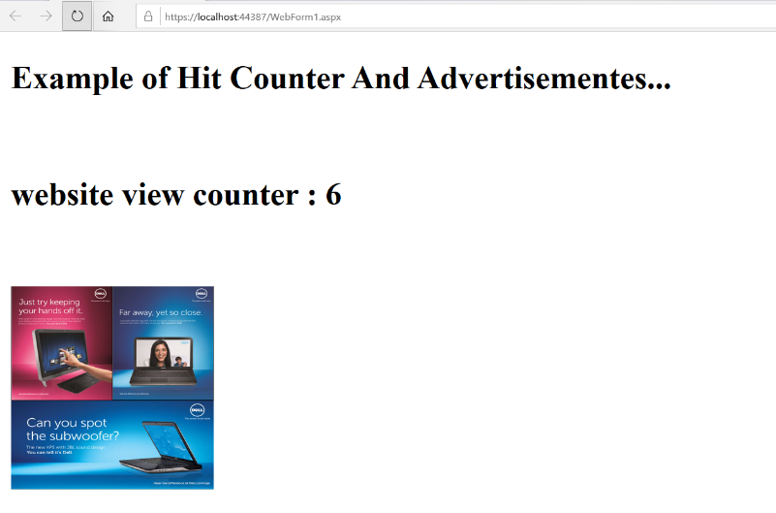
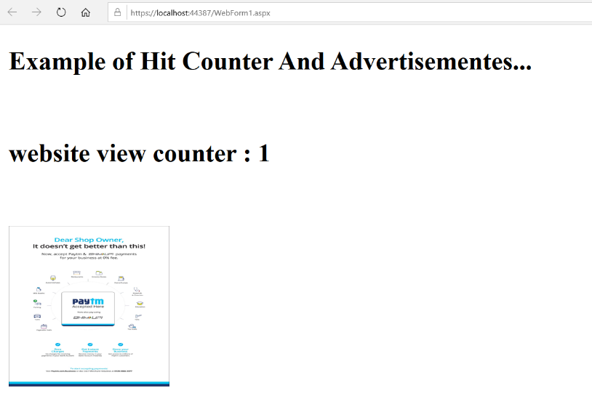
Output:

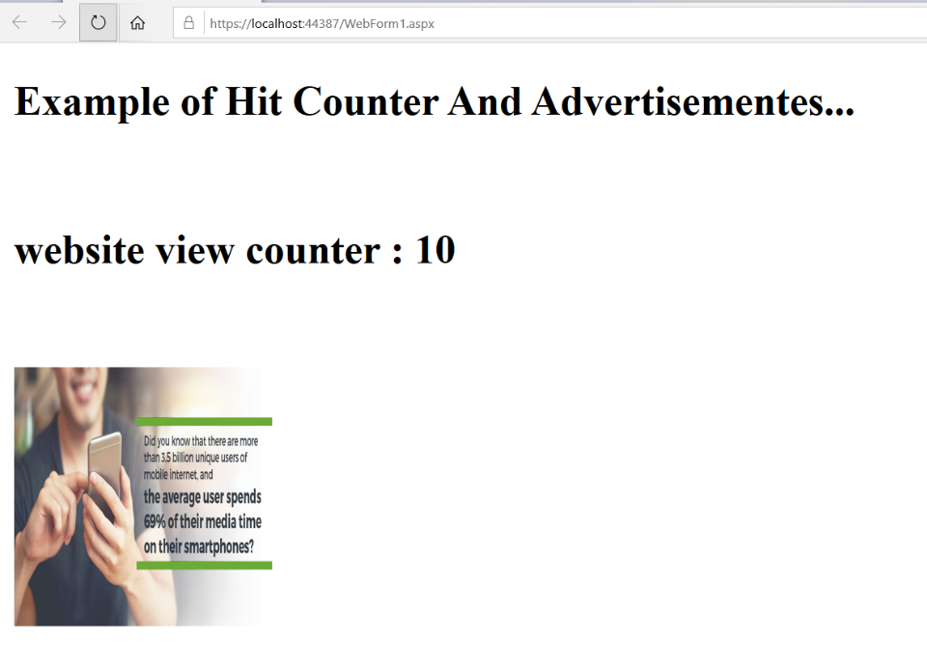

(5) Develop a web form to access student. Provide links for search and edit the records.

Code:aspprac5.aspx.cs

using System;
using System.Collections.Generic;
using System.Linq;
using System.Web;
using System.Web.UI;
using System.Web.UI.WebControls;
using System.Data.SqlClient;
using System.Data;

namespace aspprac5
{
public partial class WebForm1 : System.Web.UI.Page
{
protected void Page_Load(object sender, EventArgs e)
{

}
protected void Button1_Click(object sender, EventArgs e)
{

}
}
}

Code:WebForm1.aspx
<%@ Page Language="C#" AutoEventWireup="true" CodeBehind="WebForm1.aspx.cs" Inherits="aspprac5.WebForm1" %>

<!DOCTYPE html>

<html xmlns="http://www.w3.org/1999/xhtml">
<head runat="server">
<title></title>
</head>
<body>
<form id="form1" runat="server">
<div>
&nbsp;&nbsp;&nbsp;&nbsp;&nbsp;&nbsp;<h1>Select any one ....</h1></div>
<p>
&nbsp;&nbsp;&nbsp;&nbsp;
<asp:HyperLink ID="HyperLink1" runat="server" NavigateUrl="~/WebForm2.aspx">Search</asp:HyperLink>
&nbsp;&nbsp;&nbsp;&nbsp;&nbsp;&nbsp;&nbsp;&nbsp;&nbsp;&nbsp;&nbsp;&nbsp;&nbsp;&nbsp;&nbsp;&nbsp;&nbsp;&nbsp;&nbsp;&nbsp;&nbsp;&nbsp;
<asp:HyperLink ID="HyperLink2" runat="server" NavigateUrl="~/WebForm3.aspx">Edit</asp:HyperLink>

</p>
</form>
</body>
</html>

Code:WebForm2.aspx.cs
using System;
using System.Collections.Generic;
using System.Linq;
using System.Web;
using System.Web.UI;
using System.Web.UI.WebControls;
using System.Data.SqlClient;

namespace aspprac5
{
public partial class WebForm2 : System.Web.UI.Page
{
protected void Page_Load(object sender, EventArgs e)
{

}

protected void Button1_Click(object sender, EventArgs e)
{
string cs = @"Data Source=.\SQLEXPRESS; Initial Catalog=master1; Integrated Security= True";
SqlConnection cn = new SqlConnection(cs);
cn.Open();
int en = int.Parse(TextBox1.Text);
string cq = "select sname,cpi from student where enroll=" + en;
SqlCommand cm = new SqlCommand(cq, cn);
SqlDataReader dr = cm.ExecuteReader();
dr.Read();
Label3.Text = dr["cpi"].ToString();
Label5.Text = dr["sname"].ToString();
}
}
}
Code:WebForm2.aspx
<%@ Page Language="C#" AutoEventWireup="true" CodeBehind="WebForm2.aspx.cs" Inherits="aspprac5.WebForm2" %>

<!DOCTYPE html>

<html xmlns="http://www.w3.org/1999/xhtml">
<head runat="server">
<title></title>
</head>
<body>
<form id="form1" runat="server">
<p>
&nbsp;<h2>Search</h2>
<asp:Label ID="Label1" runat="server" Text="Enter enrollment:"></asp:Label>

&nbsp;&nbsp;&nbsp;&nbsp;&nbsp;&nbsp;&nbsp;
<asp:TextBox ID="TextBox1" runat="server"></asp:TextBox>
<br />
<br />
<asp:Label ID="Label2" runat="server" Text="Result is:"></asp:Label>
&nbsp;&nbsp;&nbsp;&nbsp;&nbsp;
<asp:Label ID="Label3" runat="server"></asp:Label>
<br />
<br />
<asp:Label ID="Label4" runat="server">Student name is:</asp:Label>
&nbsp;&nbsp;&nbsp;
<asp:Label ID="Label5" runat="server"></asp:Label>
</p>
<div style="margin-left: 80px">
<asp:Button ID="Button1" runat="server" OnClick="Button1_Click" Text="submit" />
</div>
</form>
</body>
</html>

Code:WebForm3.aspx.cs
using System;
using System.Collections.Generic;
using System.Linq;
using System.Web;
using System.Web.UI;
using System.Web.UI.WebControls;
using System.Data.SqlClient;

namespace aspprac5
{
public partial class WebForm3 : System.Web.UI.Page
{
protected void Page_Load(object sender, EventArgs e)
{

}

protected void Button1_Click(object sender, EventArgs e)
{
string cs = @"Data Source=.\SQLEXPRESS; Initial Catalog=master1; Integrated Security= True";
SqlConnection cn = new SqlConnection(cs);
cn.Open();
int a1 = int.Parse(TextBox1.Text);
int a2 = int.Parse(TextBox2.Text);
String b1 = TextBox3.Text;
double c2 = double.Parse(TextBox4.Text);
string cq1 = "update student set enroll=" + a2 + ",sname='" + b1 + "',cpi=" + c2 + " where enroll=" + a1;
SqlCommand cm1 = new SqlCommand(cq1, cn);
cm1.ExecuteNonQuery();

Label7.Text = "record edit successfully...";
}
}

}
WebForm3.aspx
<%@ Page Language="C#" AutoEventWireup="true" CodeBehind="WebForm3.aspx.cs" Inherits="aspprac5.WebForm3" %>

<!DOCTYPE html>

<html xmlns="http://www.w3.org/1999/xhtml">
<head runat="server">
<title></title>
</head>
<body>
<form id="form1" runat="server">
<div>
<h2> Edit</h2>
<asp:Label ID="Label1" runat="server" Text="Enter old Enrollment:"></asp:Label>
&nbsp;&nbsp;&nbsp;&nbsp;&nbsp;&nbsp;&nbsp;&nbsp;&nbsp;&nbsp;&nbsp;&nbsp;&nbsp;&nbsp;&nbsp;
<asp:TextBox ID="TextBox1" runat="server"></asp:TextBox>
<br />
<br />
<asp:Label ID="Label2" runat="server" Text="Enter new Enrollment:"></asp:Label>
&nbsp;&nbsp;&nbsp;&nbsp;&nbsp;&nbsp;&nbsp;&nbsp;&nbsp;&nbsp;&nbsp;&nbsp;&nbsp;&nbsp;
<asp:TextBox ID="TextBox2" runat="server"></asp:TextBox>
<br />
<br />
<asp:Label ID="Label3" runat="server" Text="Enter new student name:"></asp:Label>
&nbsp;&nbsp;&nbsp;&nbsp;&nbsp;&nbsp;&nbsp;&nbsp;&nbsp;&nbsp;&nbsp;
<asp:TextBox ID="TextBox3" runat="server"></asp:TextBox>
<br />
<br />
<asp:Label ID="Label4" runat="server" Text="Enter new cpi:"></asp:Label>
&nbsp;&nbsp;&nbsp;&nbsp;&nbsp;&nbsp;&nbsp;&nbsp;&nbsp;&nbsp;&nbsp;&nbsp;&nbsp;&nbsp;&nbsp;&nbsp;&nbsp;&nbsp;&nbsp;&nbsp;&nbsp;&nbsp;&nbsp;&nbsp;&nbsp;&nbsp;
<asp:TextBox ID="TextBox4" runat="server"></asp:TextBox>
<br />
<br />
&nbsp;&nbsp;&nbsp;&nbsp;&nbsp;&nbsp;&nbsp;&nbsp;&nbsp;&nbsp;&nbsp;&nbsp;&nbsp;&nbsp;&nbsp;&nbsp;&nbsp;&nbsp;&nbsp;&nbsp;&nbsp;&nbsp;&nbsp;&nbsp;&nbsp;&nbsp;
<br />
</div>
<div style="margin-left: 160px">
<asp:Button ID="Button1" runat="server" OnClick="Button1_Click" Text="submit" />
</div>
&nbsp;&nbsp;
<br />
<br />
<asp:Label ID="Label7" runat="server"></asp:Label>
</form>
</body>
</html>

Output:

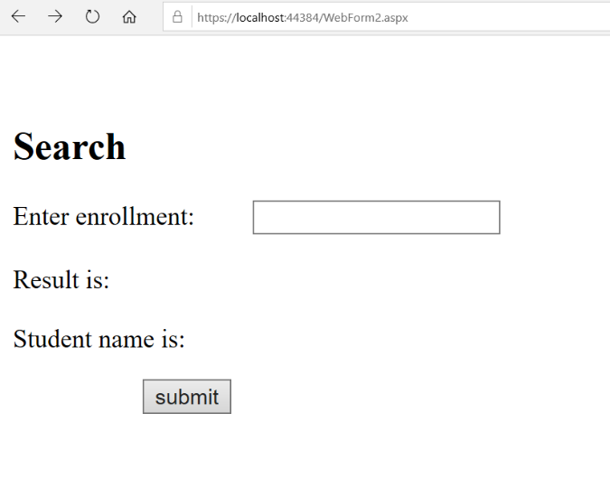
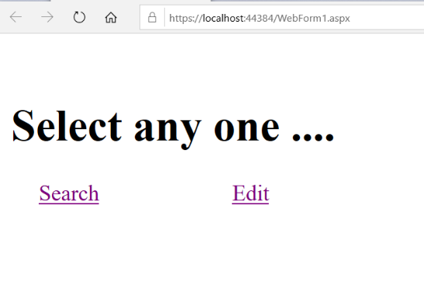

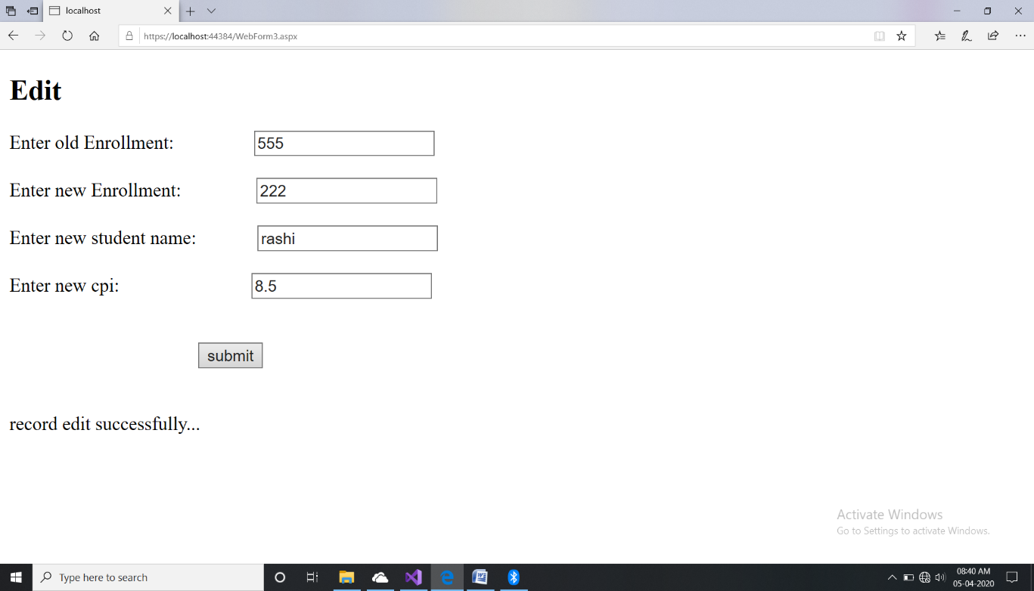
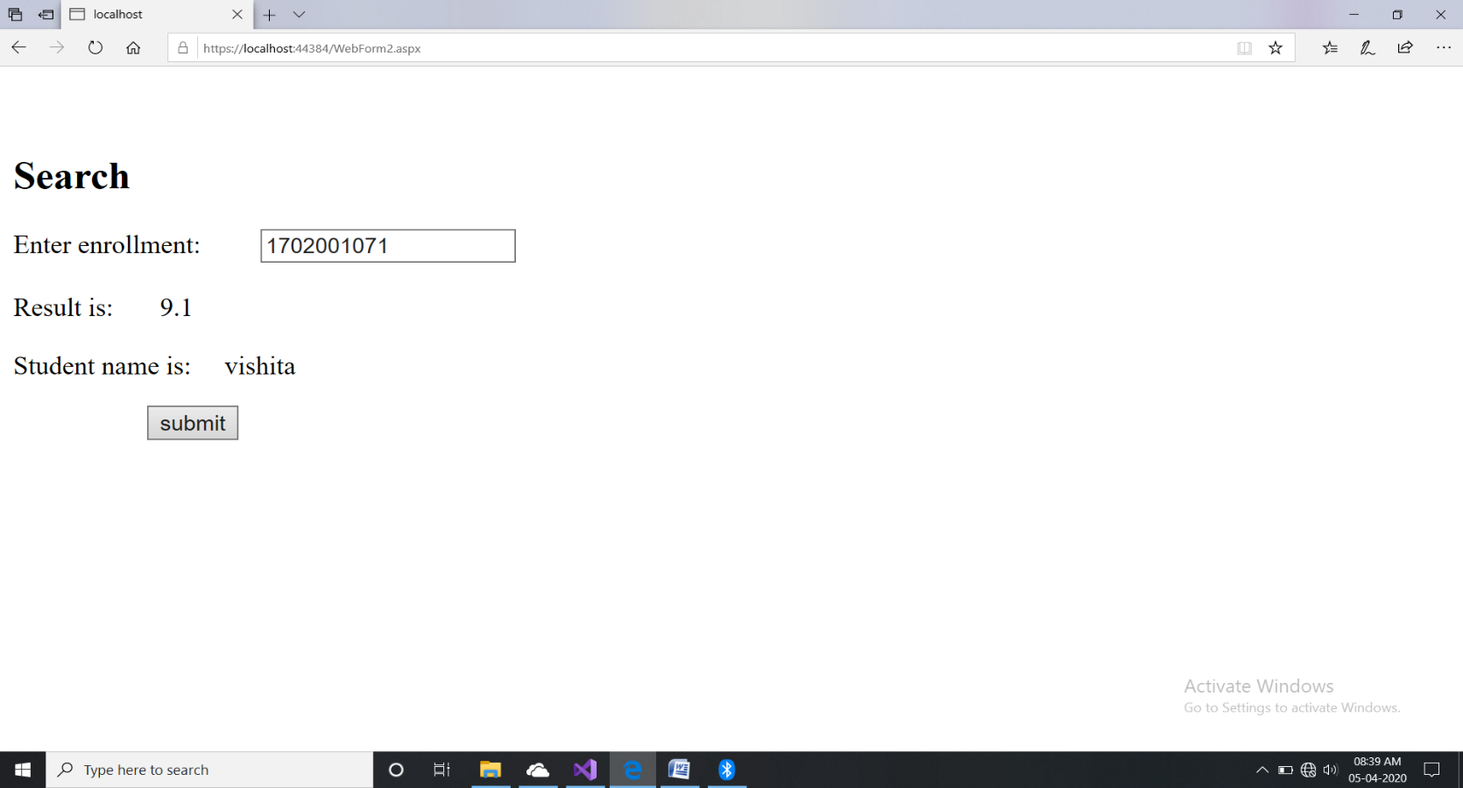

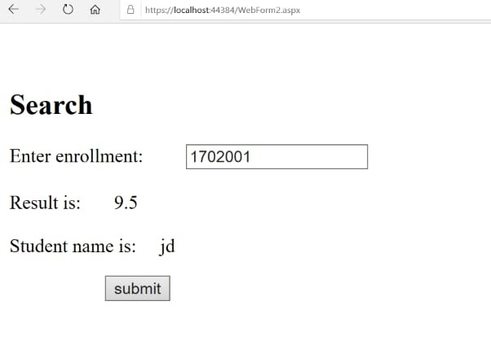

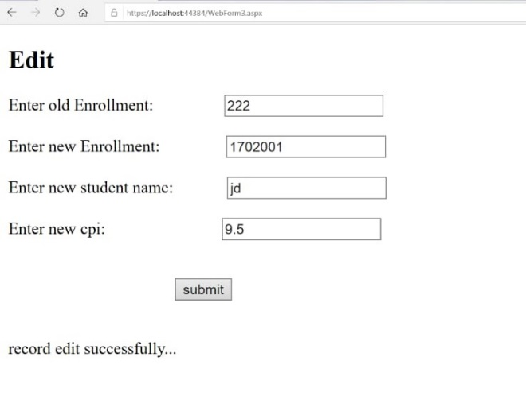
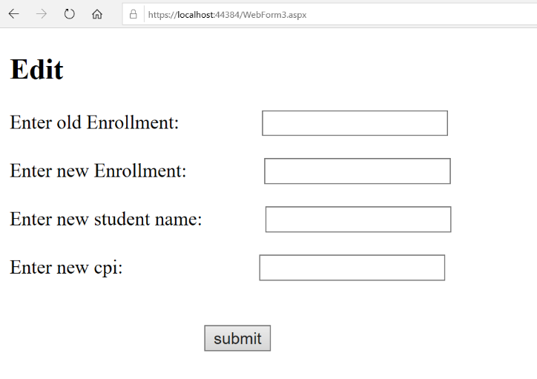

(6) Develop a web form to view and modify data of library database using grid view and other controls.

Code:WebForm1.aspx

<%@ Page Language="C#" AutoEventWireup="true" CodeBehind="WebForm1.aspx.cs" Inherits="ASPPractical6new.WebForm1" %>

<!DOCTYPE html>

<html xmlns="http://www.w3.org/1999/xhtml">
<head runat="server">
<title></title>
</head>
<body>
<form id="form1" runat="server">
<div>
</div>
<asp:GridView ID="GridView1" runat="server" AutoGenerateColumns="False" BackColor="White" BorderColor="#DEDFDE" BorderStyle="None" BorderWidth="1px" CellPadding="4" DataKeyNames="Id" DataSourceID="SqlDataSource1" ForeColor="Black" GridLines="Vertical" ShowFooter="True" OnSelectedIndexChanged="GridView1_SelectedIndexChanged">
<AlternatingRowStyle BackColor="White" />
<Columns>
<asp:TemplateField ShowHeader="False">
<EditItemTemplate>
<asp:LinkButton ID="LinkButton1" runat="server" CausesValidation="True" CommandName="Update" Text="Update"></asp:LinkButton>
&nbsp;<asp:LinkButton ID="LinkButton2" runat="server" CausesValidation="False" CommandName="Cancel" Text="Cancel"></asp:LinkButton>
</EditItemTemplate>
<ItemTemplate>
<asp:LinkButton ID="LinkButton1" runat="server" CausesValidation="False" CommandName="Edit" Text="Edit"></asp:LinkButton>
&nbsp;<asp:LinkButton ID="LinkButton2" runat="server" CausesValidation="False" CommandName="Delete" Text="Delete"></asp:LinkButton>
</ItemTemplate>
<FooterTemplate>
<asp:LinkButton ID="lnkbtnInsert" OnClick="lnkbtnInsert_Click" ValidationGroup="INSERT" runat="server">Insert</asp:LinkButton>

</FooterTemplate>
</asp:TemplateField>
<asp:TemplateField HeaderText="Id" SortExpression="Id">
<EditItemTemplate>
<asp:TextBox ID="TextBoxId" runat="server" Text='<%# Bind("Id") %>'></asp:TextBox>
<asp:RequiredFieldValidator ID="rfvId" runat="server" ErrorMessage="Id Is Required!"
Text="*" ForeColor="Red" ControlToValidate="TextBoxId"></asp:RequiredFieldValidator>
</EditItemTemplate>
<ItemTemplate>
<asp:Label ID="Label1" runat="server" Text='<%# Bind("Id") %>'></asp:Label>
</ItemTemplate>
<FooterTemplate>

<asp:TextBox ID="txtId" runat="server"></asp:TextBox>

<asp:RequiredFieldValidator ID="rfvInsertId" runat="server" ErrorMessage="Id Is Required!"

Text="*" ForeColor="Red" ValidationGroup="INSERT" ControlToValidate="txtId"></asp:RequiredFieldValidator>
</FooterTemplate>

</asp:TemplateField>
<asp:TemplateField HeaderText="Enrollment_No" SortExpression="Enrollment_No">
<EditItemTemplate>
<asp:TextBox ID="TextBox1" runat="server" Text='<%# Bind("Enrollment_No") %>'></asp:TextBox>
<asp:RequiredFieldValidator ID="rfvEnrollmentNo" runat="server" ErrorMessage="Enrollment Is Required!"
Text="*" ForeColor="Red" ControlToValidate="TextBox1"></asp:RequiredFieldValidator>
</EditItemTemplate>

<ItemTemplate>
<asp:Label ID="Label2" runat="server" Text='<%# Bind("Enrollment_No") %>'></asp:Label>
</ItemTemplate>
<FooterTemplate>
<asp:TextBox ID="txtEnrollmentNo" runat="server"></asp:TextBox>
<asp:RequiredFieldValidator ID="rfvInsertEnrollmentNo" runat="server" ErrorMessage="Enrollment Is Required!"
Text="*" ForeColor="Red" ValidationGroup="INSERT" ControlToValidate="txtEnrollmentNo"></asp:RequiredFieldValidator>
</FooterTemplate>

</asp:TemplateField>
<asp:TemplateField HeaderText="Name" SortExpression="Name">
<EditItemTemplate>
<asp:TextBox ID="TextBox2" runat="server" Text='<%# Bind("Name") %>'></asp:TextBox>
<asp:RequiredFieldValidator ID="rfvName" runat="server" ErrorMessage="Please Enter Name!" ForeColor="Red"
ControlToValidate="TextBox2" Text="*"></asp:RequiredFieldValidator>
</EditItemTemplate>
<ItemTemplate>
<asp:Label ID="Label3" runat="server" Text='<%# Bind("Name") %>'></asp:Label>
</ItemTemplate>
<FooterTemplate>
<asp:TextBox ID="txtName" runat="server"></asp:TextBox>
<asp:RequiredFieldValidator ID="rfvInsertName" runat="server" ErrorMessage="Enter Book name!" ForeColor="Red"
ControlToValidate="txtName" ValidationGroup="INSERT" Text="*"></asp:RequiredFieldValidator>
</FooterTemplate>
</asp:TemplateField>
<asp:TemplateField HeaderText="Book Name" SortExpression="Book Name">
<EditItemTemplate>
<asp:TextBox ID="TextBox3" runat="server" Text='<%# Bind("[Book Name]") %>'></asp:TextBox>
<asp:RequiredFieldValidator ID="rfvBookName" runat="server" ErrorMessage="Enter Book name!" ForeColor="Red"
ControlToValidate="TextBox3" Text="*"></asp:RequiredFieldValidator>

</EditItemTemplate>
<ItemTemplate>
<asp:Label ID="Label4" runat="server" Text='<%# Bind("[Book Name]") %>'></asp:Label>

</ItemTemplate>
<FooterTemplate>
<asp:TextBox ID="txtBookName" runat="server"></asp:TextBox>

<asp:RequiredFieldValidator ID="rfvInsertBookName" runat="server" ErrorMessage="Enter Book name!" ForeColor="Red"

ControlToValidate="txtBookName" ValidationGroup="INSERT" Text="*"></asp:RequiredFieldValidator>

</FooterTemplate>
</asp:TemplateField>
<asp:TemplateField HeaderText="Issue_Date" SortExpression="Issue_Date">
<EditItemTemplate>
<asp:TextBox ID="TextBox4" runat="server" Text='<%# Bind("Issue_Date") %>'></asp:TextBox>
<asp:RequiredFieldValidator ID="rfvIssueDate" runat="server" ErrorMessage="Date Is Required!" ForeColor="Red"
ControlToValidate="TextBox4" Text="*"></asp:RequiredFieldValidator>
</EditItemTemplate>
<ItemTemplate>
<asp:Label ID="Label5" runat="server" Text='<%# Bind("Issue_Date") %>'></asp:Label>
</ItemTemplate>
<FooterTemplate>
<asp:TextBox ID="txtIssueDate" runat="server"></asp:TextBox>
<asp:RequiredFieldValidator ID="rfvInsertIssueDate" runat="server" ErrorMessage="Date Is Required!" ForeColor="Red"
ControlToValidate="txtIssueDate" ValidationGroup="INSERT" Text="*"></asp:RequiredFieldValidator>

</FooterTemplate>
</asp:TemplateField>
</Columns>
<FooterStyle BackColor="#CCCC99" />
<HeaderStyle BackColor="#6B696B" Font-Bold="True" ForeColor="White" />
<PagerStyle BackColor="#F7F7DE" ForeColor="Black" HorizontalAlign="Right" />
<RowStyle BackColor="#F7F7DE" />
<SelectedRowStyle BackColor="#CE5D5A" Font-Bold="True" ForeColor="White" />
<SortedAscendingCellStyle BackColor="#FBFBF2" />
<SortedAscendingHeaderStyle BackColor="#848384" />
<SortedDescendingCellStyle BackColor="#EAEAD3" />
<SortedDescendingHeaderStyle BackColor="#575357" />
</asp:GridView>
<asp:ValidationSummary ID="ValidationSummary1" ValidationGroup="INSERT" ForeColor="Red" runat="server" />
<asp:ValidationSummary ID="ValidationSummary2" ForeColor="Red" runat="server" />

<br />
<asp:SqlDataSource ID="SqlDataSource1" runat="server" ConnectionString="<%$ ConnectionStrings:LibraryConnectionString %>" DeleteCommand="DELETE FROM [StudentRecord] WHERE [Id] = @Id" InsertCommand="INSERT INTO [StudentRecord] ([Id], [Enrollment_No], [Name], [Book Name], [Issue_Date]) VALUES (@Id, @Enrollment_No, @Name, @Book_Name, @Issue_Date)" SelectCommand="SELECT * FROM [StudentRecord]" UpdateCommand="UPDATE [StudentRecord] SET [Enrollment_No] = @Enrollment_No, [Name] = @Name, [Book Name] = @Book_Name, [Issue_Date] = @Issue_Date WHERE [Id] = @Id">
<DeleteParameters>
<asp:Parameter Name="Id" Type="Int32" />
</DeleteParameters>
<InsertParameters>

<asp:Parameter Name="Id" Type="Int32" />
<asp:Parameter Name="Enrollment_No" Type="String" />
<asp:Parameter Name="Name" Type="String" />
<asp:Parameter Name="Book_Name" Type="String" />
<asp:Parameter Name="Issue_Date" Type="String" />
</InsertParameters>
<UpdateParameters>
<asp:Parameter Name="Enrollment_No" Type="String" />
<asp:Parameter Name="Name" Type="String" />
<asp:Parameter Name="Book_Name" Type="String" />

<asp:Parameter Name="Issue_Date" Type="String" />
<asp:Parameter Name="Id" Type="Int32" />

</UpdateParameters>
</asp:SqlDataSource>
</form>
</body>
</html>

Code:WebForm1.aspx.cs

using System;
using System.Collections.Generic;
using System.Linq;
using System.Web;
using System.Web.UI;
using System.Web.UI.WebControls;

namespace ASPPractical6new
{
public partial class WebForm1 : System.Web.UI.Page
{
protected void Page_Load(object sender, EventArgs e)
{
ValidationSettings.UnobtrusiveValidationMode = UnobtrusiveValidationMode.None;

}
protected void lnkbtnInsert_Click(object sender, EventArgs e) {
SqlDataSource1.InsertParameters["Id"].DefaultValue = ((TextBox)GridView1.FooterRow.FindControl("txtId")).Text;
SqlDataSource1.InsertParameters["Enrollment_no"].DefaultValue = ((TextBox)GridView1.FooterRow.FindControl("txtEnrollmentNo")).Text;
SqlDataSource1.InsertParameters["Name"].DefaultValue = ((TextBox)GridView1.FooterRow.FindControl("txtName")).Text;
SqlDataSource1.InsertParameters["Book_Name"].DefaultValue = ((TextBox)GridView1.FooterRow.FindControl("txtBookName")).Text;
SqlDataSource1.InsertParameters["Issue_Date"].DefaultValue = ((TextBox)GridView1.FooterRow.FindControl("txtIssueDate")).Text;

SqlDataSource1.Insert();
}}}

Output:

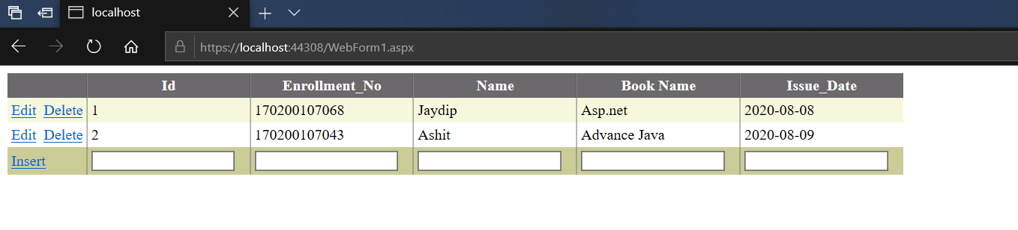
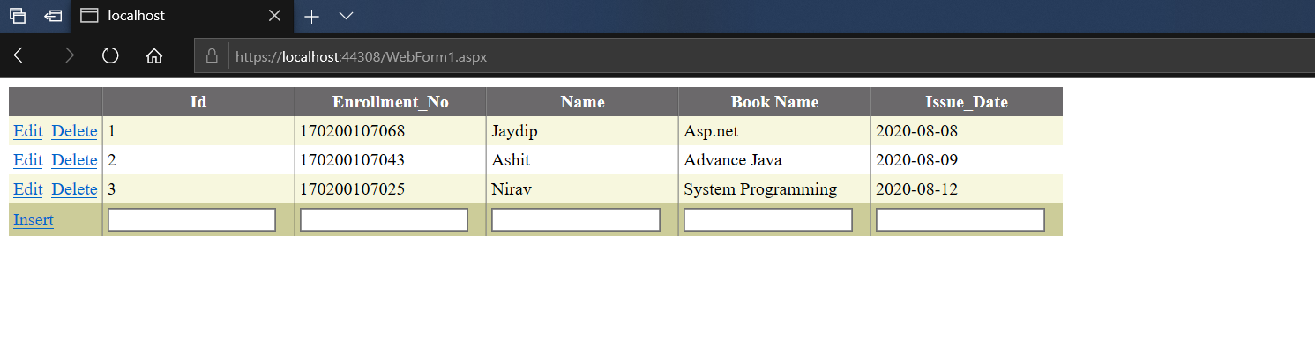
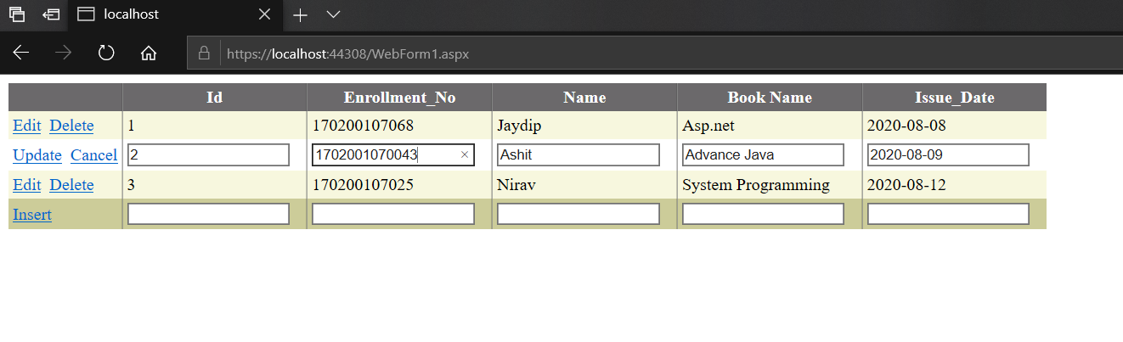
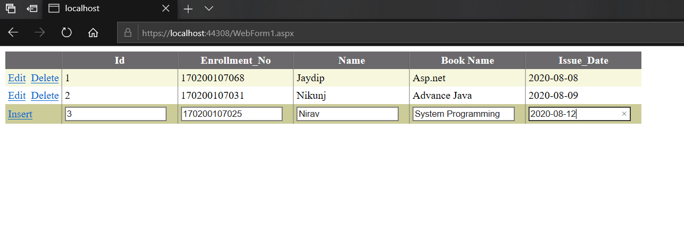

(7) Develop a web service for temperature conversion. Use it with a console application and web form.

Code:WebService1.asmx.cs

using System;
using System.Collections.Generic;
using System.Linq;
using System.Web;
using System.Web.Services;

namespace WebService
{
/// <summary>
/// Summary description for WebService1
/// </summary>
[WebService(Namespace = "http://tempuri.org/")]
[WebServiceBinding(ConformsTo = WsiProfiles.BasicProfile1_1)]
[System.ComponentModel.ToolboxItem(false)]
// To allow this Web Service to be called from script, using ASP.NET AJAX, uncomment the following line.
// [System.Web.Script.Services.ScriptService]
public class WebService1 : System.Web.Services.WebService
{

[WebMethod(Description="This method converts a degree fahrenheit to celcius.")]
public double TempratureF(double f)
{
double c = (f - 32) * (5.0 / 9.0);
return (c);
}
[WebMethod(Description = "This method converts a degree celcius to fahrenheit.")]
public double TempratureC(double c)
{
double f = c * (9.0 / 5.0) + 32;
return (f);
}}}

Output:

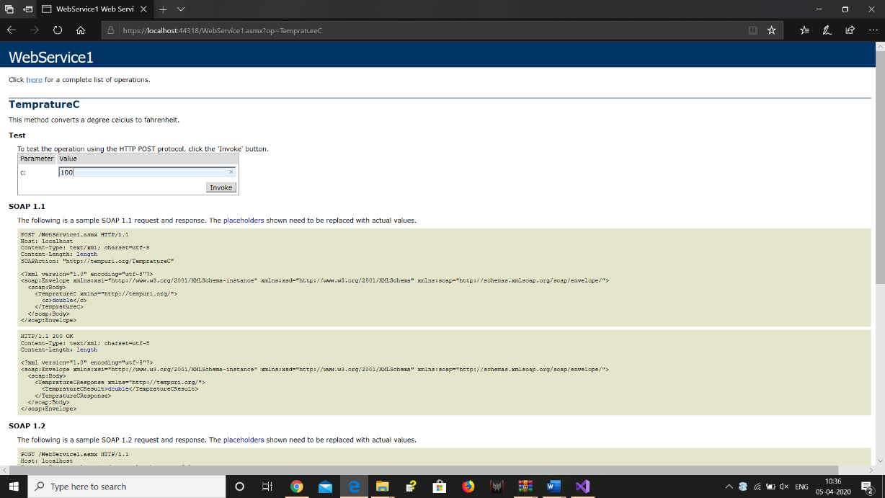

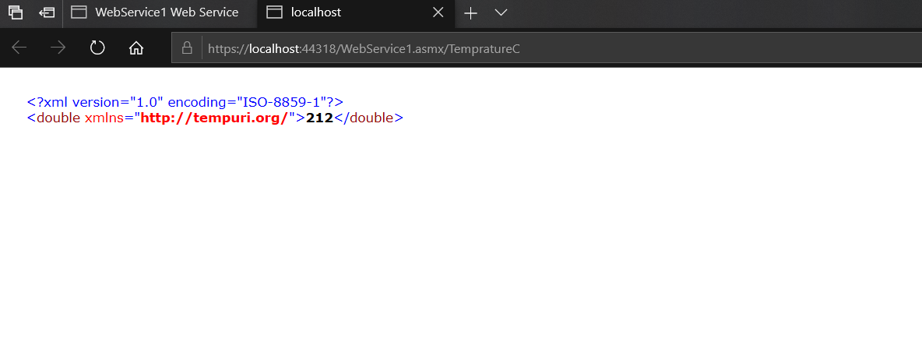

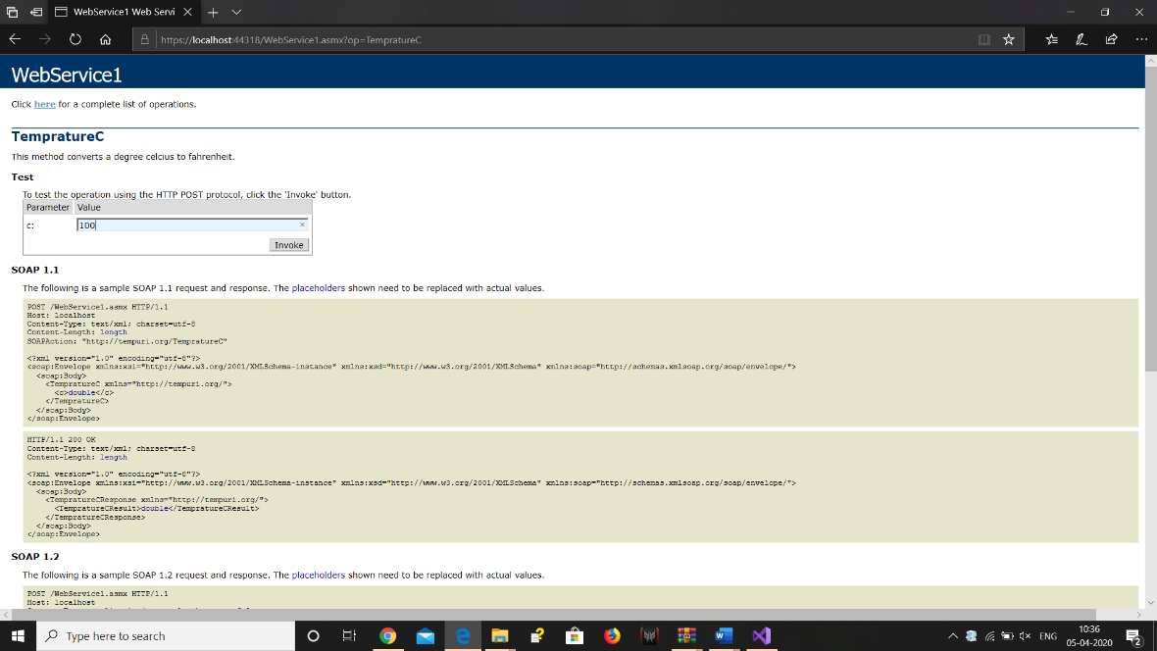

*Use WebService with Console application.
Code:Program.cs
using System;
using System.Collections.Generic;
using System.Linq;
using System.Text;
using System.Threading.Tasks;

namespace ConsoleApp1
{
class Program
{
static void Main(string[] args)
{
ServiceReference1.WebService1SoapClient client = new ServiceReference1.WebService1SoapClient();
double f, c;
Console.WriteLine("Enter temprature in fehrenheit:");
f = double.Parse(Console.ReadLine());
double resultCelcius = client.TempratureF(f);

Console.WriteLine( "Celcius={0}", resultCelcius.ToString() );

Console.WriteLine();

Console.WriteLine("Enter tempreture in celcius");
c = double.Parse(Console.ReadLine());
double resultFehrenheit = client.TempratureC(c);
Console.WriteLine("Fehrenheit={0}", resultFehrenheit.ToString());
Console.ReadLine();

}}}

Output:
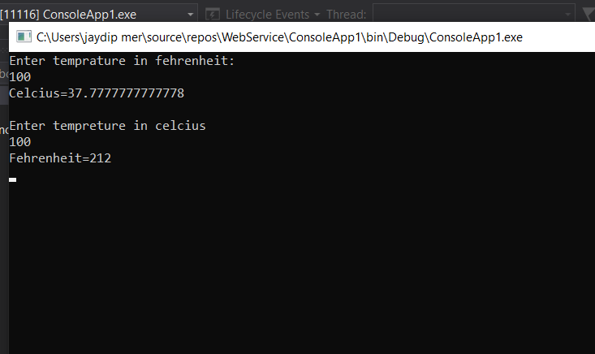

*Use WebService With Web Application.
Code:WebForm1.aspx

<%@ Page Language="C#" AutoEventWireup="true" CodeBehind="WebForm1.aspx.cs" Inherits="WebApplication1.WebForm1" %>

<!DOCTYPE html>

<html xmlns="http://www.w3.org/1999/xhtml">
<head runat="server">
<title></title>
</head>
<body>
<form id="form1" runat="server">
<div>
<h1>Temprature Convertor</h1>
<p>&nbsp;</p>

<fieldset
<legend>Convert Fehrenheit to Celcius</legend>
<p>
Enter Temprature in Fehrenheit:<asp:TextBox ID="txtF" runat="server"></asp:TextBox>
</p>

<p>
<asp:Button ID="Button1" runat="server" OnClick="Button1_Click" Text="Convert" />
</p>
<p>
Celcius=<asp:Label ID="Label1" runat="server"></asp:Label>
</p>
</fieldset>
</div>

<p>
&nbsp;</p>
<fieldset>
<legend>Convert Celcius to Fehrenheit</legend>
<p>
Enter Temprature in Fehrenheit:<asp:TextBox ID="txtC" runat="server"></asp:TextBox>
</p>
<p>
<asp:Button ID="Button2" runat="server" OnClick="Button2_Click" Text="Convert" />
</p>
<p>
Fehrenheit:<asp:Label ID="Label2" runat="server"></asp:Label>
</p>
</fieldset>

</form>
</body>
</html>

Code:WebForm1.aspx.cs

using System;
using System.Collections.Generic;
using System.Linq;
using System.Web;
using System.Web.UI;
using System.Web.UI.WebControls;

namespace WebApplication1
{
public partial class WebForm1 : System.Web.UI.Page
{
protected void Page_Load(object sender, EventArgs e)
{

}

protected void Button1_Click(object sender, EventArgs e)
{
ServiceReference2.WebService1SoapClient client = new ServiceReference2.WebService1SoapClient();
double result= client.TempratureF(double.Parse(txtF.Text));
Label1.Text = result.ToString();

}

protected void Button2_Click(object sender, EventArgs e)
{
ServiceReference2.WebService1SoapClient client = new ServiceReference2.WebService1SoapClient();
double result1 = client.TempratureC(double.Parse(txtC.Text));
Label2.Text = result1.ToString();
}
}
}

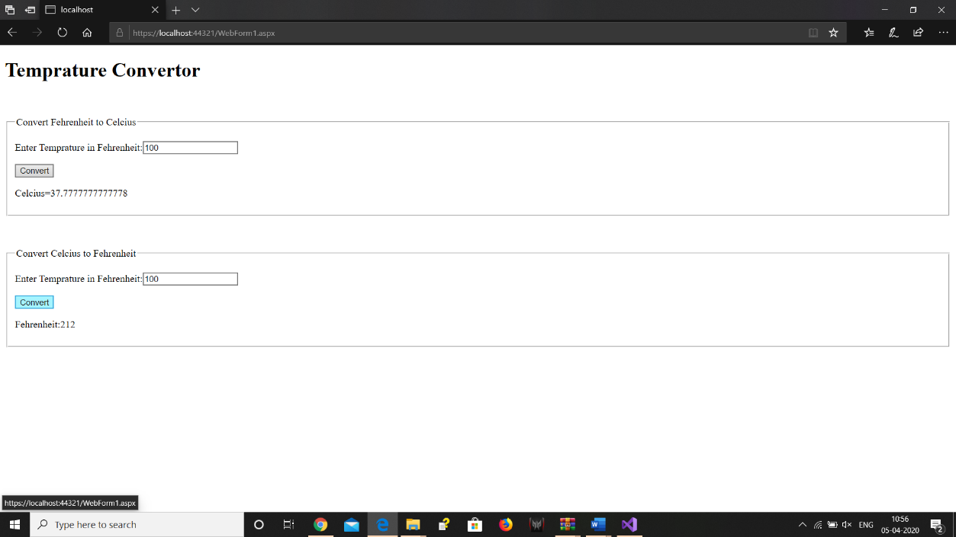
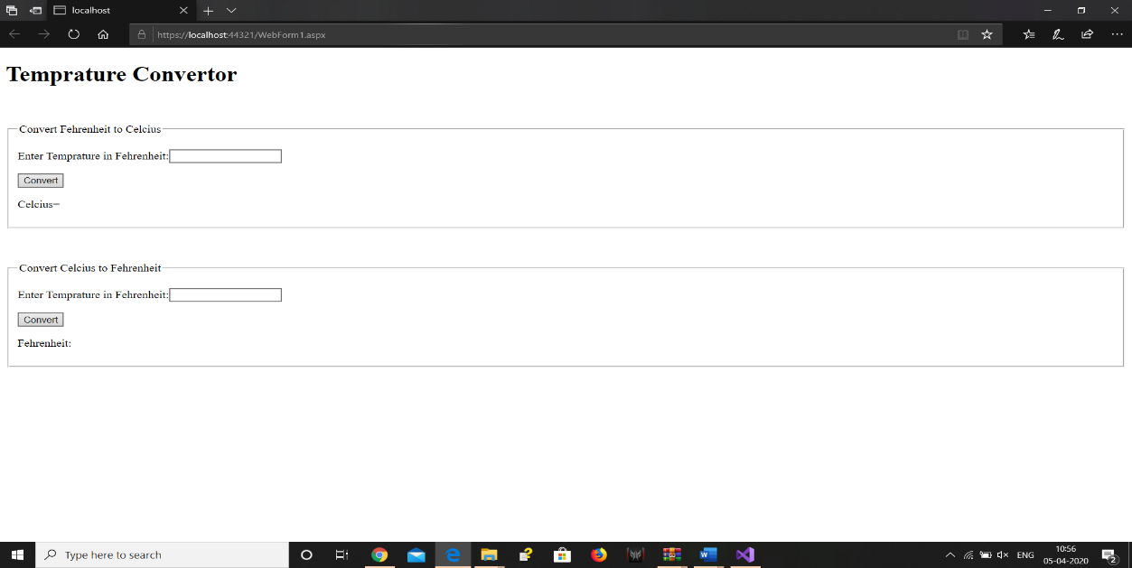
Output:

