3.C# Windows Application
(1) Develop a windows application for arithmetic calculator.
Code:Form1.cs

using System;
using System.Collections.Generic;
using System.ComponentModel;
using System.Data;
using System.Drawing;
using System.Linq;
using System.Text;
using System.Threading.Tasks;
using System.Windows.Forms;

namespace WinApp3_1
{
public partial class Form1 : Form
{
public Form1()
{
InitializeComponent();
}

private void Form1_Load(object sender, EventArgs e)
{

}

private void button1_Click(object sender, EventArgs e)
{
textBox1.Text += "1";
}

private void button2_Click(object sender, EventArgs e)
{
textBox1.Text += "2";
}

private void button3_Click(object sender, EventArgs e)
{
textBox1.Text += "3";
}

private void buttonAdd_Click(object sender, EventArgs e)
{
if (textBox1.Text.Length != 0)
{
char c = textBox1.Text[textBox1.Text.Length - 1];
if (c != '+' && c != '-' && c != '*' && c != '/')
textBox1.Text += "+";
}
}

private void button4_Click(object sender, EventArgs e)
{
textBox1.Text += "4";
}

private void button5_Click(object sender, EventArgs e)
{
textBox1.Text += "5";
}

private void button6_Click(object sender, EventArgs e)
{
textBox1.Text += "6";
}

private void buttonSub_Click(object sender, EventArgs e)
{
if (textBox1.Text.Length != 0)
{
char c = textBox1.Text[textBox1.Text.Length - 1];
if (c != '+' && c != '-' && c != '*' && c != '/')
textBox1.Text += "-";
}
}

private void button7_Click(object sender, EventArgs e)
{
textBox1.Text += "7";
}

private void button8_Click(object sender, EventArgs e)
{
textBox1.Text += "8";
}

private void button9_Click(object sender, EventArgs e)
{
textBox1.Text += "9";
}

private void buttonMul_Click(object sender, EventArgs e)
{
if (textBox1.Text.Length != 0)
{
char c = textBox1.Text[textBox1.Text.Length - 1];
if (c != '+' && c != '-' && c != '*' && c != '/')
textBox1.Text += "*";
}
}

private void buttonC_Click(object sender, EventArgs e)
{
textBox1.Text = "";
}

private void button0_Click(object sender, EventArgs e)
{
textBox1.Text += "0";
}

private void buttonDiv_Click(object sender, EventArgs e)
{
if (textBox1.Text.Length != 0)
{
char c = textBox1.Text[textBox1.Text.Length - 1];
if (c != '+' && c != '-' && c != '*' && c != '/')
textBox1.Text += "/";
}
}

private void buttonEql_Click(object sender, EventArgs e)
{
try
{
DataTable dt = new DataTable();
var v = dt.Compute(textBox1.Text, "");
textBox1.Text = v.ToString();
}
catch (Exception ex)
{
MessageBox.Show(ex.ToString());
}
}
}
}

Output:
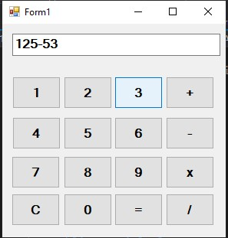
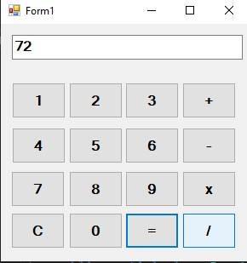
1. 2.

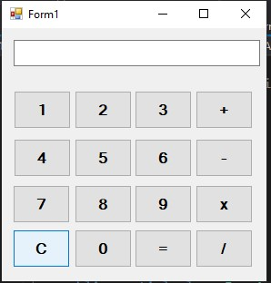
3.

(2) Develop a windows application for restaurant billing.
Code:Form1.cs

using System;
using System.Collections.Generic;
using System.ComponentModel;
using System.Data;
using System.Drawing;
using System.Linq;
using System.Text;
using System.Threading.Tasks;
using System.Windows.Forms;

namespace WinApp3_2
{
public partial class Form1 : Form
{
public Form1()
{
InitializeComponent();
}

public int count = 0;
public double total = 0;

private void Form1_Load(object sender, EventArgs e)
{

}

private void btn_AddItem_Click(object sender, EventArgs e)
{
try
{
count++;
double total2 = double.Parse(txt_Price.Text) * double.Parse(txt_Quantity.Text);
DGV1.Rows.Add(count, txt_ItemName.Text, txt_Price.Text, txt_Quantity.Text, total2.ToString());

txt_ItemName.Clear();
txt_Price.Clear();
txt_Quantity.Clear();
}
catch (Exception ex)
{
MessageBox.Show(ex.ToString());
}

}

private void btn_Total_Click(object sender, EventArgs e)
{
for (int i = 0; i < DGV1.Rows.Count; i++)
{

total+=double.Parse(this.DGV1.Rows[i].Cells["Total1"].Value.ToString());

}
txt_Total.Text = total.ToString();
}

private void lbl_Qauntity_Click(object sender, EventArgs e)
{

}

private void richTextBox1_TextChanged(object sender, EventArgs e)
{

}

}
}

Output:

1. 2.
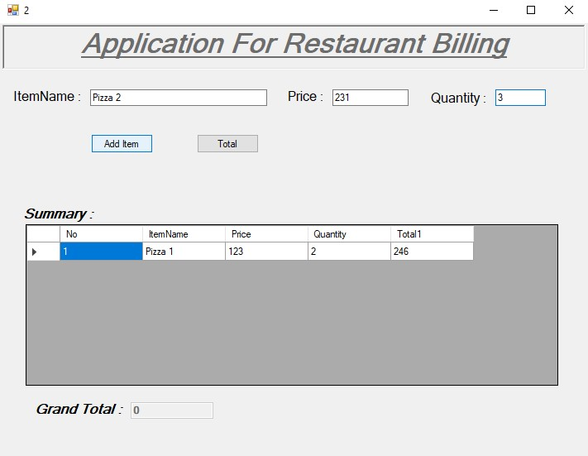
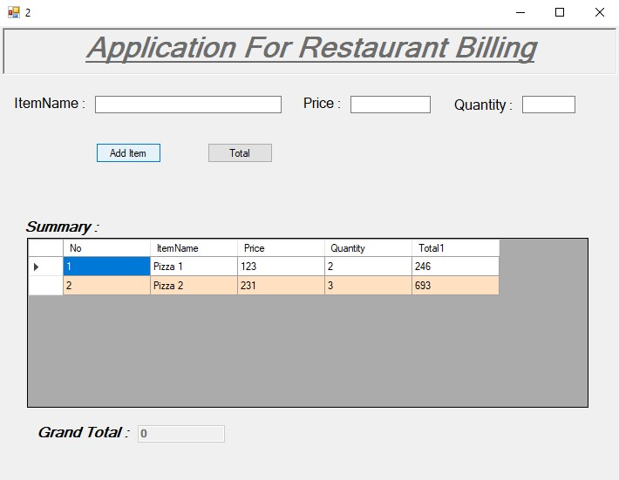
3.
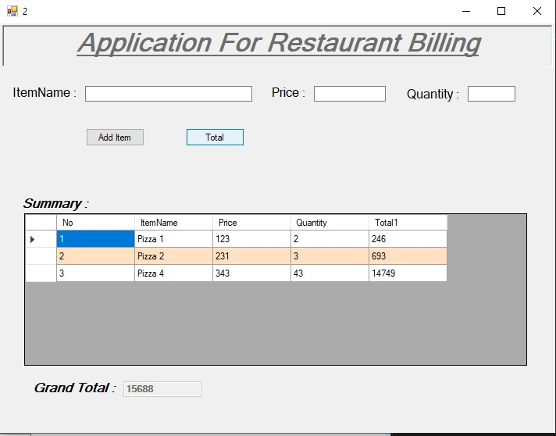

(3) Develop a windows application for simple text editor. Use menus and dialog controls.
Code:Form1.cs

using System;
using System.Collections.Generic;
using System.ComponentModel;
using System.Data;
using System.Drawing;
using System.IO;
using System.Linq;
using System.Text;
using System.Threading.Tasks;
using System.Windows.Forms;

namespace WinApp3_3
{
public partial class Form1 : Form
{
public Form1()
{
InitializeComponent();
}

private void richTextBox1_TextChanged(object sender, EventArgs e)
{

}

private void newToolStripMenuItem_Click(object sender, EventArgs e)
{
richTextBox1.ResetText();
}

private void openToolStripMenuItem_Click(object sender, EventArgs e)
{
if (openFileDialog1.ShowDialog() == DialogResult.OK)
{
richTextBox1.Text = File.ReadAllText(openFileDialog1.FileName);
}
}

private void saveToolStripMenuItem_Click(object sender, EventArgs e)
{
if (saveFileDialog1.ShowDialog() == DialogResult.OK)
{
File.WriteAllText(saveFileDialog1.FileName, richTextBox1.Text);
}
}

private void exitToolStripMenuItem_Click(object sender, EventArgs e)
{
Application.Exit();
}

private void undoToolStripMenuItem_Click(object sender, EventArgs e)
{
richTextBox1.Undo();
}

private void cutToolStripMenuItem_Click(object sender, EventArgs e)
{
richTextBox1.Cut();
}

private void redoStripMenuItem_Click(object sender, EventArgs e)
{
richTextBox1.Redo();
}

private void copyToolStripMenuItem_Click(object sender, EventArgs e)
{
richTextBox1.Copy();
}

private void pasteToolStripMenuItem_Click(object sender, EventArgs e)
{
richTextBox1.Paste();
}

private void selectAllStripMenuItem_Click(object sender, EventArgs e)
{
richTextBox1.SelectAll();
}

private void boldStripMenuItem_Click(object sender, EventArgs e)
{
if (richTextBox1.SelectionFont.Style == FontStyle.Bold)
richTextBox1.SelectionFont = new Font(richTextBox1.SelectionFont, FontStyle.Regular);
else
richTextBox1.SelectionFont = new Font(richTextBox1.SelectionFont, FontStyle.Bold);
}

private void italicStripMenuItem_Click(object sender, EventArgs e)
{
if (richTextBox1.SelectionFont.Style == FontStyle.Italic)
richTextBox1.SelectionFont = new Font(richTextBox1.SelectionFont, FontStyle.Regular);
else
richTextBox1.SelectionFont = new Font(richTextBox1.SelectionFont, FontStyle.Italic);
}

private void underlineStripMenuItem_Click(object sender, EventArgs e)
{
if (richTextBox1.SelectionFont.Style == FontStyle.Underline)
richTextBox1.SelectionFont = new Font(richTextBox1.SelectionFont, FontStyle.Regular);
else
richTextBox1.SelectionFont = new Font(richTextBox1.SelectionFont, FontStyle.Underline);
}

private void wrapWordToolStripMenuItem_Click(object sender, EventArgs e)
{
//richTextBox1.SelectAll();
//richTextBox1.SelectionFont = new Font();
richTextBox1.WordWrap = true;
}

private void fontToolStripMenuItem1_Click(object sender, EventArgs e)
{
fontDialog1.ShowDialog();

}

private void btn_Find_Click(object sender, EventArgs e)
{
int index = richTextBox1.Find(txt_Find.Text);
int len = txt_Find.Text.Length;
richTextBox1.SelectionStart = index;
richTextBox1.SelectionLength = len;

}
}
}

Output:
1. 2.
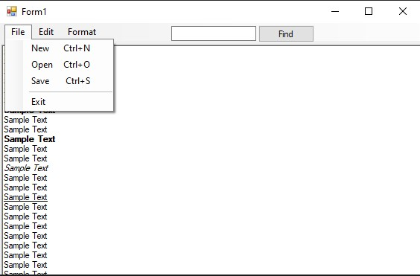
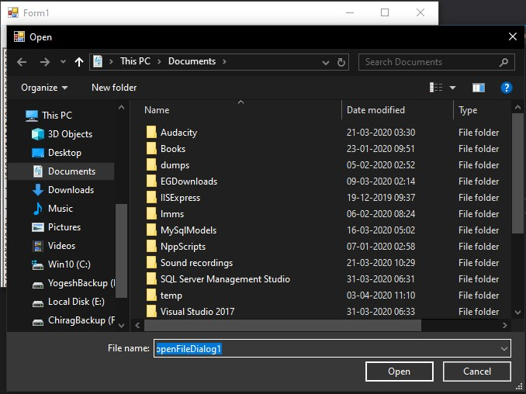

3. 4.
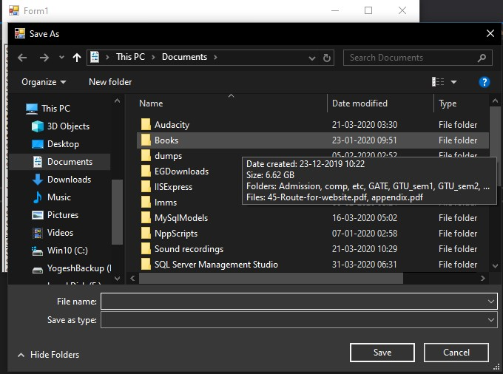
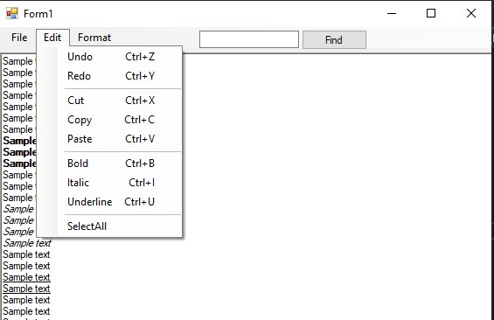

5.
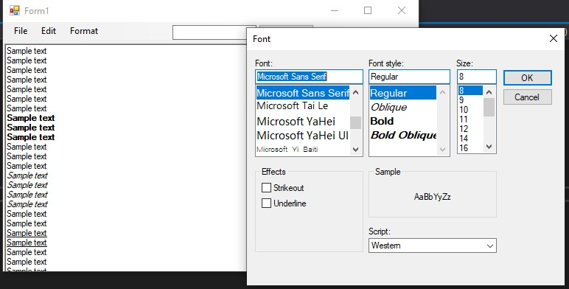

6.
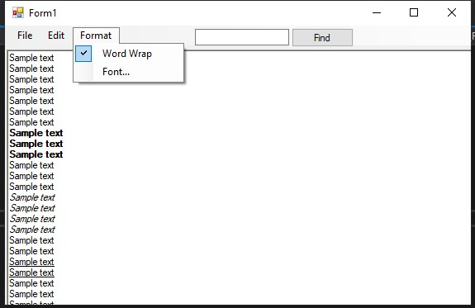

(4) Develop a windows application to display result of a student given his enrollment number.
Code:Form1.cs

using System;
using System.Collections.Generic;
using System.ComponentModel;
using System.Data;
using System.Drawing;
using System.Linq;
using System.Text;
using System.Threading.Tasks;
using System.Windows.Forms;
using System.Data.SqlClient;

namespace WinApp3_4
{
public partial class Form1 : Form
{
public Form1()
{
InitializeComponent();
}

private void btn_Result_Click(object sender, EventArgs e)
{
string cs = @"Data Source=.\SQLEXPRESS; Initial Catalog=student; Integrated Security= True";
SqlConnection cn = new SqlConnection(cs);
cn.Open();
Int64 enroll = Int64.Parse(txt_Enrollment.Text);
string query = "select SPI from dbo.result where Enrollment=" + enroll;
SqlCommand command= new SqlCommand(query, cn);

SqlDataReader reader = command.ExecuteReader();
reader.Read();
txt_Result.Text = reader["SPI"].ToString();

cn.Close();
}
}
}

Output:
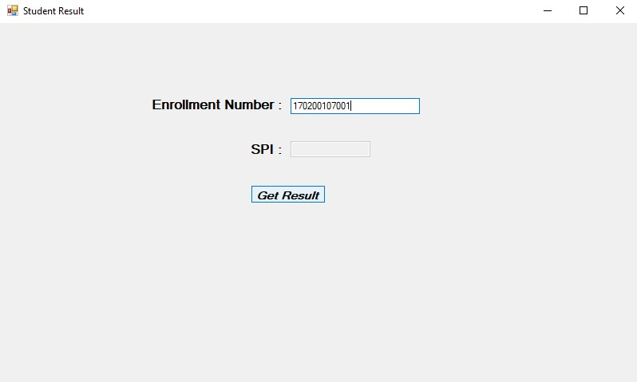
1. 2.
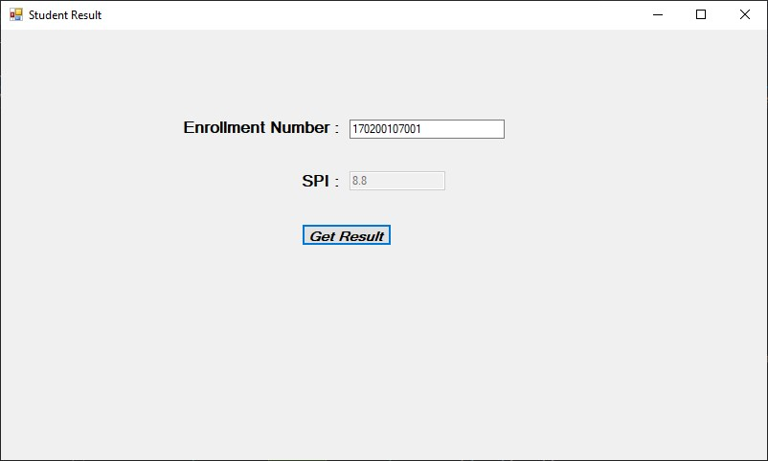
(5) Develop a windows application to demonstrate visual inheritance.
Code:Form1.cs
using System;
using System.Collections.Generic;
using System.ComponentModel;
using System.Data;
using System.Drawing;
using System.Linq;
using System.Text;
using System.Threading.Tasks;
using System.Windows.Forms;

namespace WinApp3_5
{
public partial class Form1 : Form
{
public Form1()
{
InitializeComponent();
}

private void timer1_Tick(object sender, EventArgs e)
{
lbl_Time.Text = DateTime.Now.ToString();
}

private void btn_Search_Click(object sender, EventArgs e)
{
MessageBox.Show("Searching " + txt_Search.Text + "... ");
}

private void Form1_Load(object sender, EventArgs e)
{

}
}
}

Code:Form2.cs
using System;
using System.Collections.Generic;
using System.ComponentModel;
using System.Data;
using System.Drawing;
using System.Text;
using System.Windows.Forms;

namespace WinApp3_5
{
public partial class Form2 : WinApp3_5.Form1
{
public Form2()
{
InitializeComponent();
}

private void btn_AddStudent_Click(object sender, EventArgs e)
{
Form3 f = new Form3();
f.Show();
}

private void btn_Remove_Click(object sender, EventArgs e)
{
Form4 f = new Form4();
f.Show();
}
}
}

Code:Form3.cs
using System;
using System.Collections.Generic;
using System.ComponentModel;
using System.Data;
using System.Drawing;
using System.Text;
using System.Windows.Forms;

namespace WinApp3_5
{
public partial class Form3 : WinApp3_5.Form1
{
public Form3()
{
InitializeComponent();
}
}
}

Code:Form4.cs
using System;
using System.Collections.Generic;
using System.ComponentModel;
using System.Data;
using System.Drawing;
using System.Text;
using System.Windows.Forms;

namespace WinApp3_5
{
public partial class Form4 : WinApp3_5.Form1
{
public Form4()
{
InitializeComponent();
}
}
}

Output:
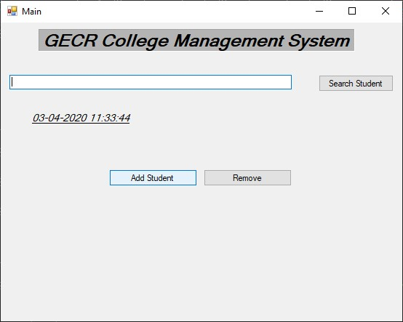
1.

2.
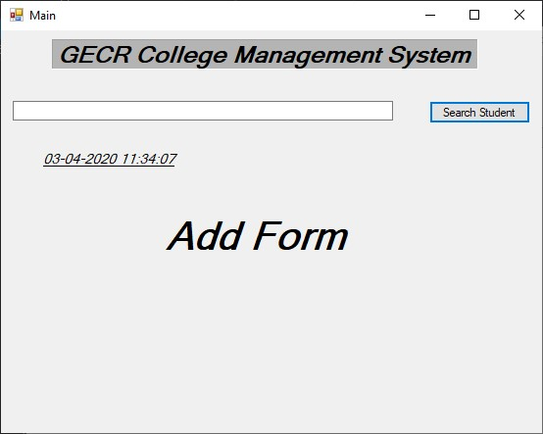
3.
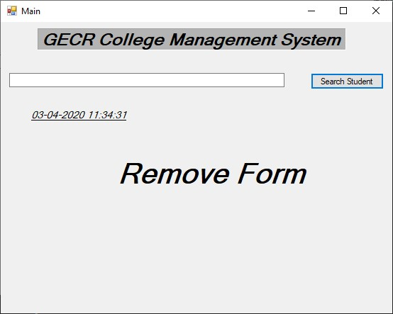

(6) Develop a WPF application for income tax calculation.
Code:Form1.cs
using System;
using System.Collections.Generic;
using System.ComponentModel;
using System.Data;
using System.Drawing;
using System.Linq;
using System.Text;
using System.Threading.Tasks;
using System.Windows.Forms;

namespace WinApp3_6
{
public partial class Form1 : Form
{
public Form1()
{
InitializeComponent();
}

private void btn_CalculateTax_Click(object sender, EventArgs e)
{
//temp variables
double income = double.Parse(txt_Income.Text);
float rate = 0;
double tax = 0;
double remaining = double.Parse(txt_Income.Text);

//calculate
if (income <= 250000)
{
remaining = income - tax;
}
else if (income > 250000 && income <= 500000)
{
rate = 0.05F;
tax = income * rate;
remaining = income - tax;
}
else if (income > 500000 && income <= 750000)
{
rate = 0.1F;
tax = income * rate;
remaining = income - tax;
}
else if (income > 750000 && income <= 1000000)
{
rate = 0.15F;
tax = income * rate;
remaining = income - tax;
}
else if (income > 1000000 && income <= 1250000)
{
rate = 0.2F;
tax = income * rate;
remaining = income - tax;
}
else if (income > 1250000 && income <= 1500000)
{
rate = 0.25F;
tax = income * rate;
remaining = income - tax;
}
else if (income > 1500000)
{
rate = 0.3F;
tax = income * rate;
remaining = income - tax;
}
else { MessageBox.Show("Case not matched"); }

//set output
txt_Rate.Text = ((rate * 100).ToString()) + "%";
txt_Tax.Text = tax.ToString();
txt_Remaining.Text = remaining.ToString();

}
}
}

Output:
1. 2.
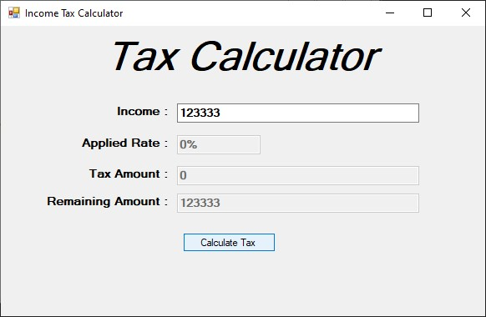
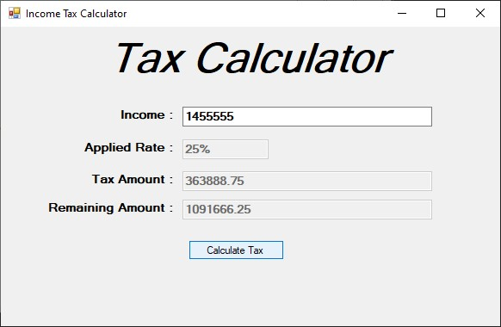
3.
