PROJECT ON

**“RFID TOLL COLLECTION SYSTEM”**

BY

**MR.YOGESH SHALIGRAM**

**MR.YASH SATHE**

**MR.SWAPNIL SHINDE**

**MR.SHUBHAM SABALE**

UNDER RHE GUIDANCE OF

**MRS. M S KULKARNI**

IN PARTIAL FULLMENT OF

DIPLOMA IN

**ELECTRONICS & TELECOMMUNICATION ENGINEERING**

DEPARTMENT OF

**ELECTRONICS & TELECOMMUNICATION**

**MAEER’S MIT POLYTECHNIC**

PUNE-411037

2016-2017

**ABSTRACT**

This project is related to RFID technology; this system uses a tag and the reader which collects information of vehicle passing through the toll plaza and will automatically debits the toll amount from the prepaid account of each vehicle, which in turn will reduce the traffic congestion and human errors. The vehicle owner has to register his vehicle with RFID tag, creating a rechargeable account.

A manual toll collection system is been used widely in India. But it is not very reliable. Manual toll collection system requires more processing time at the toll booth. This leads a very long queue at the toll booths and results in increase in pollution in that area. This also increases the traffic resulting in waste of fuel.

This project is designed to reduce these kinds of problems which are being faced by the travellers. This project will reduce the queue in front of the toll booths and pollution to some extent. This will also reduce the cost by less manpower requirement. This will also ensure correct toll collection & correct record keeping.

The project focuses on the collection of toll by RFID [Radio Frequency Identification]. The RFID card uses RFID tags for identification. Each card is given a unique number which is been saved in the system. This unique code is used by the RFID reader to get the information embedded in the tags.

In this system, each vehicle is given these tags. Every Toll collection booth will have a RFID system setup. The only thing driver needs to do is place his RFID tag on the reader. RFID reader will identify the unique code and will collect the amount of toll from the account the vehicle holds. After the toll is deducted, driver will receive a message for toll amount deducted and the remaining balance in his amount. This information will also be displayed on the screen at the toll booth gate.

After the toll is deducted, system will open the barrier and the vehicle can pass through.

**INTRODUCTION-**

Manual toll collection system is been used widely in India, but it is not very reliable. Manual toll collection system requires more time to collect the toll. This leads a very long queue on the toll booths and results in increase in pollution in that area. This also increases the traffic.

This system is designed to reduce these kinds of problems which are being faced by the travellers. It will also reduce the man power and the queue in front of the toll booths and pollution at some instance.

This system focuses on the collection of toll by RFID [Radio Frequency Identification]. The RFID card uses RFID tags for identification. Each card is given a unique number which is been saved in the system. This unique code is used by the RFID reader to get the information embedded in the tags.

In this system, each car is given these tags. Every Toll collection booth will have a RFID system setup. The only thing driver needs to do is place his RFID tag on the reader. RFID reader will identify the unique code and will deduct the amount of estimated toll from the account the driver holds. After the toll is deducted, driver will receive a message saying about the toll amount deducted and the remaining balance in his amount. This information will also be displayed on the screen provided in the system itself.

After the toll is deducted, system gives the instruction to the motor which opens the barrier and the driver can leave for the remaining journey.

This project will help in “SMART CITY” project laded by our Prime Minister Hon. Narendra Modi.

**WHAT IS RFID-**

**Radio-frequency identification** (*RFID*) uses electromagnetic fields to automatically identify the tags. The tags contain electronically stored information. Passive tags collect energy from a nearby RFID reader's interrogating radio waves. Active tags have a local power source such as a battery and may operate at hundreds of meters from the RFID reader. Unlike a barcode, the tag need not be within the line of sight of the reader, so it may be embedded in the tracked object. RFID is one method for Automatic Identification and Data Capture (AIDC)

**Literature Survey**

William Vickrey, the Nobel Economics prize winner, in 1959, was the first who proposed electronic toll system for Washington Metropolitan Area. Free flow tolling with fixed transponders undersides of vehicles and the readers were located under the highway surfaces (1960s and 1970s). This system was first introduced in Bergen (1986). World’s first use of completely unaided full speed electronic toll system was introduced by Trondheim (1991). Norway has electronic fee collection (EFC). The United States was the first to used ETC system in several states. In California, Texas, Florida, vehicles can travel at full speed through electronic lanes.

In 1959, Nobel Economics Prize winner William Vickrey was the first to propose a system of electronic tolling for the Washington Metropolitan Area. He proposed that each car would be equipped with a transponder. “The transponder’s personalised signal would be picked up when the car passed through an intersection, and then relayed to a central computer which would calculate the charge according to the intersection and the time of day and add it to the car’s bill”  Electronic toll collection has facilitated the concession to the private sector of the construction and operation of urban freeways, as well as made feasible the improvement and the practical implementation of road congestion pricing schemes in a limited number of urban areas to restrict auto travel in the most congested areas.

In the 1960s and 1970s, free flow tolling was tested with fixed transponders at the undersides of the vehicles and readers, which were located under the surface of the highway.

Norway has been the world's pioneer in the widespread implementation of this technology. ETC was first introduced in Bergen, in 1986, operating together with traditional tollbooths. In 1991, Trondheim introduced the world's first use of completely unaided full-speed electronic tolling. Norway now has 25 toll roads operating with electronic fee collection (EFC), as the Norwegian technology is called AutoPASS. In 1995, Portugal became the first country to apply a single, universal system to all tolls in the country, the Via Verde, which can also be used in parking lots and gas stations. The United States is another country with widespread use of ETC in several states, though many U.S. toll roads maintain the option of manual collection.

**PROPOSED ALGORITHIM-**

When a vehicle will enter in the toll area the IR sensor will get activated. First the driver has to place the RFID tag in front of the RFID reader. The RFID reader detects the unique number assigned to that tag. Then system checks if it has sufficient balance for the toll amount.

If there is sufficient balance, the system deducts the applicable toll amount from the account and the gate will open. When the amount is deducted from the account, car owner will get a message regarding the toll amount and the remaining balance.

If there is insufficient balance, system will indicate for the low or no balance and gates will not open.

**Flowchart**

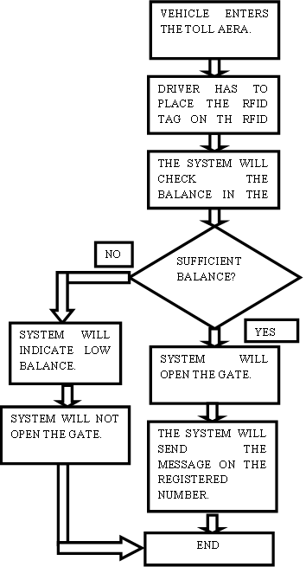

**Block Diagram**

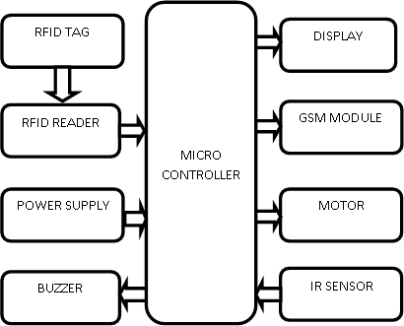

1. **RFID Tag-**

RFID Tag used here is passive Tag. A passive tag is an RFID tag that does not contain a battery; the power is supplied by the reader. When radio waves from the reader are encountered by a passive RFID tag, the coiled antenna within the tag forms a magnetic field. The tag draws power from it, energizing the circuits in the tag.

1. **RFID Reader-**

A radio frequency identification reader (RFID reader) is a device used to gather information from an RFID tag, which is used to track individual objects. Radio waves are used to transfer data from the tag to a reader.

1. **Power Supply-**

As we have used a 12V Stepper motor, we have to design a power supply which can provide 12V as well as 5V for microcontroller and other devices.

So, we can use LM7805 IC. This gives two different output voltages*.*

1. **Display-**

LCD (Liquid Crystal Display) screen is an electronic display module and find a wide range of applications. A 16x2 LCD display is very basic module and is very commonly used in various devices and circuits. A 16x2 LCD means it can display 16 characters per line and there are 2 such lines.

1. **GSM Module-**

GSM/GPRS module is used to establish communication between a computer and a GSM system. Global System for Mobile communication (GSM) is an architecture used for mobile communication in most of the countries.

1. **IR Sensor-**

An infrared sensor is an electronic device that emits in order to sense some aspects of the surroundings. An IR sensor can detects the motion of the object. These types of sensors measures only infrared radiation, rather than emitting it that is called as a passive IR sensor.

1. **Buzzer-**

A buzzer or beeper is an audio signalling device which may be mechanical, electromechanical, or piezoelectric. Typical uses of buzzers and beepers include alarm devices, timers, etc.

1. **Motor-**

A DC motor is any of a class of electrical machines that converts direct current electrical power into mechanical power. Nearly all types of DC motors have some internal mechanism, either electromechanical or electronic, to periodically change the direction of current flow in part of the motor. Most types produce rotary motion; a linear motor directly produces force and motion in a straight line.

**Circuit diagram**

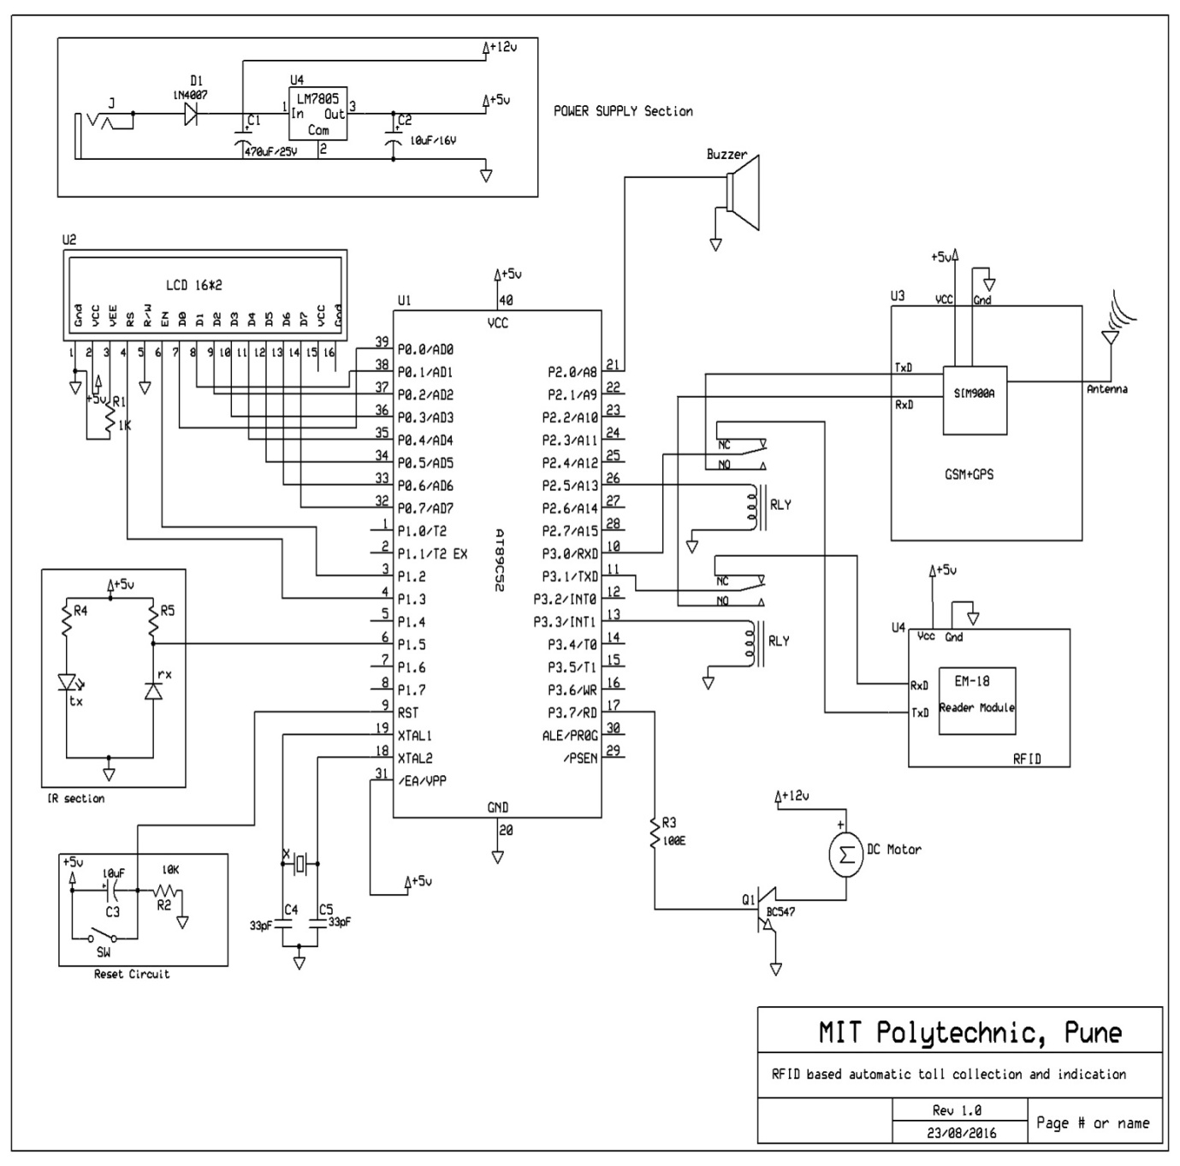

**Scope can be advanced to-**

As we have used a short range RFID reader, the driver has to take the tag near the reader. But if we use a high range RFID reader, we can stick the tag to the wind shield and the reader will automatically detect the tag from a long range. This way no car has to stop on the toll booth. This system is called as Electronic Toll Collection System.

Electronic toll collection (ETC) aims to eliminate the delay on toll roads by collecting tolls electronically. ETC determines whether the cars passing are enrolled in the program, alerts enforcers for those that are not, and electronically debits the accounts of registered car owners without requiring them to stop.

Cashless tolling is when cash tolls are not collected on the roadway. Electronic toll collection becomes the primary option for payment, with payment by mail as a secondary option.Open road tolling (ORT) is a type of electronic toll collection without the use of toll booths. The major advantage to ORT is that users are able to drive through the toll plaza at highway speeds without having to slow down to pay the toll.

**Features-**

* Man power is reduced.
* We get a message of toll amount and remaining balance in the account.
* Queue in front of toll booths is reduced.
* Pollution gets decreased.
* Toll information is displayed on the screen.
* Fuel consumed is less.
* Traffic gets reduced.
* Requires less time to pay the toll.
* Transparency of Toll Transactions.
* Reduces Revenue Leakages.

**Limitations-**

If a man owns a truck and a car, he might use the car RFID card for truck. So, he pays fewer tolls for truck.

**Conclusion-**

The proposed RFID Toll collection system discussed in this work applies passive RFID technology. By doing so, increased efficiency will be guaranteed since RFID is known as a highly stable technology. With the elimination of human interaction in the entire toll collection process, we can create a better toll collection system to be implemented in India. It can also significantly improve the efficiency of toll stations and the traffic abilities of the toll road.

**References-**

[1] ELECTRONIC TOLL COLLECTION SYSTEM- <https://en.wikipedia.org/wiki/Electronic_toll_collection>

### [2] Automated Toll Collection System Using RFID

<http://www.iosrjournals.org/iosr-jce/papers/Vol9-Issue2/L0926166.pdf?id=283>

[3]How does RFID Toll Collection System works?

<http://www.rfidjournal.com/blogs/experts/entry?10743>

[4] Dr. Paul Polishuk, Hui Pan, “RFID Monthly Newsletter”, Page 12, volume 3, number 9, September 2006.

[5] Sudha Bhalekar, Adesh Chanegiri G., Indra Prakash Chauhan “automatic Toll Tax using RFID”, IJCTEE Volume 3, Special Issue, March-April 2013.

[6] C.M. Roberts, “Radio Frequency Identification (RFID),” Computers & Security, Elsevier, 2006.