REAL-TIME OBJECT DETECTION
USING YOLO
A Project Report
submitted for the course
Image Processing and Computer Vision
Course: Image Processing and Computer Vision (IPCV)
Section: D
Team Number: 17

Submitted by
Name | Reg. Number
Yogesh Dixit | 20233362
Sumitabh Ahirwar | 20233280
Smit Thakkar | 20233570
Vishal Prabhu | 20233582

Abstract
Object detection is the task of finding which objects are present in an image and where they are. In this project a simple application was built that detects objects in real time using a laptop webcam. Frames are read with OpenCV, passed to a pretrained YOLO (You Only Look Once) model, and each object is drawn with a bounding box, class name and confidence score. The processed video is shown in Streamlit with the frames per second (FPS) and a per-frame object count. The YOLO11n (nano) model from Ultralytics, already trained on the COCO dataset (80 classes), was used without training or modification. On the test laptop, the application ran at about 22–24 FPS. A person in the live feed was detected with scores between 0.77 and 0.94. An empty scene and an unavailable camera were handled without crashing. The app was also deployed on Streamlit Community Cloud with WebRTC.
Introduction
Computer vision tries to make computers understand images and videos. For a computer, a picture is only a large grid of pixel values. Object detection answers two questions: what objects are present, and where they are. The answer is a list of bounding boxes, each with a class name and a confidence score between 0 and 1. The problem is practical. Given a live webcam stream, common objects must be identified in each frame and shown immediately. Frames arrive at up to about 30 per second, so each frame must be processed quickly. Objects appear at different sizes, positions and lighting. The system should run on a normal student laptop without a GPU. A new algorithm was not invented; the work is a small system around an existing pretrained detector. The objectives are to capture frames with OpenCV, detect objects with a lightweight YOLO model, draw boxes, labels and scores, show the video in Streamlit, allow start/stop and a confidence slider, display actual FPS and a per-frame object count, handle a missing webcam or empty scene without crashing, and make the application available online from the viewer’s webcam.
Methodology
Digital images, colour conversion and pre-processing
A digital image is a two-dimensional array of pixels. A 640x480 colour frame is an array of shape 480 x 640 x 3 (921,600 numbers). OpenCV stores colour in BGR order, but Streamlit expects RGB, so every frame is converted from BGR to RGB before display. Without this, red and blue would be swapped. Before a frame enters the network it is letterbox-resized so that its longer side is 640 pixels, keeping the aspect ratio, and padded with grey if needed. Pixel values are then scaled from 0–255 to 0–1. No other pre-processing was added.
YOLO11n detector
YOLO is a family of real-time object detection models first published by Joseph Redmon and co-authors in 2016. The network looks at the image only once, in a single forward pass, and predicts all objects together. In the original paper the input is divided into an S x S grid (7 x 7). Each grid cell is responsible for objects whose centre falls inside it and predicts boxes, a confidence score and class probabilities. YOLO11 predicts at three scales and is anchor-free. YOLO was not developed or trained in this project; the pretrained YOLO11n model from Ultralytics was used as it is. A bounding box is stored as corners (x1, y1, x2, y2) because cv2.rectangle needs those two points. The class with the highest of the 80 COCO scores becomes the label. Only detections at or above a confidence threshold are kept (default 0.50; slider 0.10 to 1.00). Non-maximum suppression (NMS) keeps the highest-scoring box and removes other boxes of the same class that overlap it too much. Overlap is Intersection over Union: IoU = (area of overlap) / (area of union). Ultralytics applies NMS with a default IoU limit of 0.7, which was kept. The nano model was selected because it is the smallest of the five YOLO11 sizes and runs in real time on a laptop CPU.
Property | Value
Model | YOLO11n (nano)
Trained by / on | Ultralytics, on the COCO dataset (80 classes). Not trained by us.
Input size | 640 pixels
Parameters | about 2.6 million (2,624,080 reported by model.info())
Accuracy (by Ultralytics) | 39.5 mAP50-95 on the COCO validation set. We did not measure this ourselves.
Weights file | yolo11n.pt, about 5.4 MB, downloaded automatically on first run into models/
Measured speed on our laptop | about 31 ms per 640x480 frame on the CPU

System architecture and processing loop
The system is a single Python application with three source files: app.py (user interface and webcam modes), src/detector.py (YOLO) and src/utils.py (drawing and helper functions). It is started with streamlit run app.py. In Local webcam (OpenCV) mode the program reads the webcam directly with OpenCV. In Browser webcam mode, the browser captures the webcam and sends the video with WebRTC, which works both locally and online.
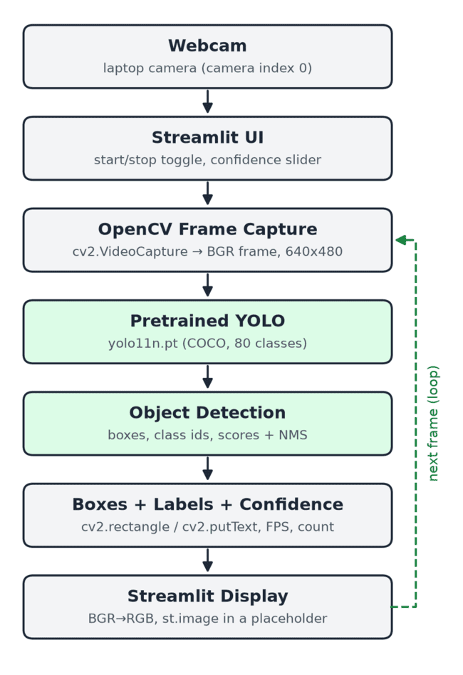
Data flows as follows for every frame, The webcam (camera index 0) produces a frame. OpenCV Frame Capture (cv2.VideoCapture, cap.read()) returns one BGR image of 640x480. The pretrained YOLO11n model, loaded once when the app starts, predicts boxes, classes and scores. NMS and the confidence threshold remove duplicate and weak boxes. A rectangle and a “label score” text are drawn for every detection, and the FPS and object counts are calculated. The frame is converted from BGR to RGB and shown in Streamlit. The loop repeats until the user switches detection off.
Results and Discussion
All tests were run on a MacBook Air (Apple M3, 8 GB RAM, no separate GPU), with the built-in FaceTime HD camera, Python 3.11.9, Streamlit, OpenCV, Ultralytics and PyTorch (CPU). Online tests used Streamlit Community Cloud. Live webcam tests, image-mode tests on bus.jpg and zidane.jpg, and OpenCV simulations of lighting and distance were used. Screenshots are real and were not edited. In the live webcam tests the person in front of the camera was detected in all 52 saved frames, with confidence scores between 0.77 and 0.94 (most between 0.82 and 0.93) at threshold 0.50. The box followed the person as they moved (person 0.93 further away; person 0.94 close). An inference time of 31.3 ms means the model alone could handle about 32 FPS. The full loop reached about 22–24 FPS. The extra time is spent reading the frame, drawing, converting colours and sending the image to the browser.
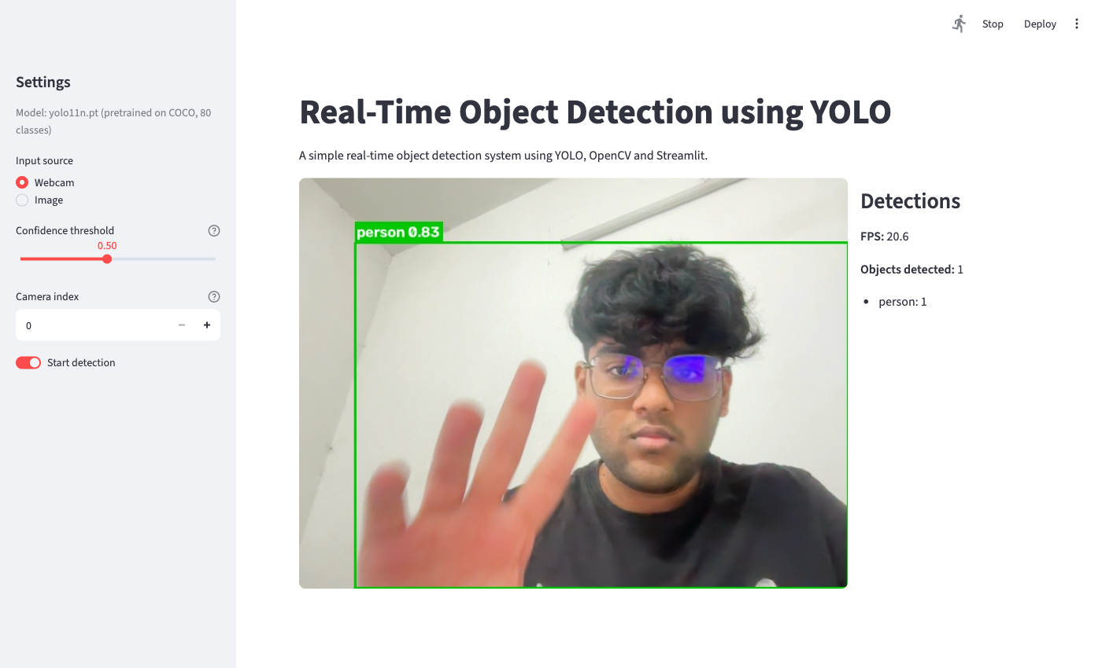
Sample images, threshold, lighting and distance
With the default threshold of 0.50, bus.jpg gave 5 detections: bus 0.94 and four persons (0.89, 0.88, 0.86, 0.62). zidane.jpg gave two persons (0.84 and 0.77). At 0.25, zidane.jpg gave 3 detections (2 persons, tie 0.46); at 0.80 it gave 1 (person 0.84). In the live webcam test at threshold 0.25, a wristwatch was detected as “clock 0.33” in one frame and wrongly as “bottle 0.25” in another. A wristwatch is not a COCO class. At 0.50 these weak detections were not shown.
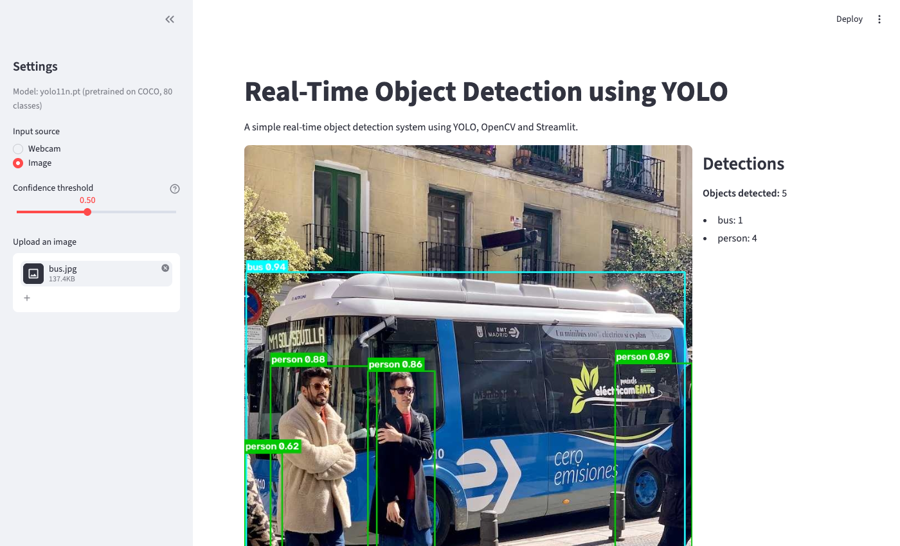
To study lighting, all pixel values of bus.jpg were multiplied by a factor (100%, 50%, 25%, 10% and 5%) with cv2.convertScaleAbs at threshold 0.50. This is a simulation; real low light also adds noise and blur. Detection stayed stable down to about 25% brightness. At 5% even the large bus was missed.
To study distance, bus.jpg was shrunk to half, a quarter and an eighth of its size and placed in the middle of a grey image of the original size. The objects then look as if they were further away. This is also a simulation.
Limitations
FPS depends on the laptop’s CPU; older laptops may be much slower. Low resolution, motion blur and auto-exposure changes of the webcam affect the results. Very dark images lose detections; real low light, with noise, is likely to be worse. Objects that cover only a few pixels are missed. The model knows only the 80 COCO classes; other objects are missed or mislabelled. Values below about 0.4 start to show wrong detections. The object count is per frame only. The local webcam mode only works on the computer that runs the Streamlit app. Online, speed depends on the shared cloud CPU and the viewer’s internet; some networks block WebRTC and need a TURN relay. FPS drops when several people use the app together. Some live situations (many objects, several people, a dark room) were tested only with sample images and simulations. The online version was tested with Chrome’s fake camera, not a real webcam on another network; that is left for the team’s final demo.
Conclusion
In this project a real-time object detection application was built using a pretrained YOLO11n model, OpenCV and a simple Streamlit interface. The application reads frames from the laptop webcam, detects objects in every frame, draws bounding boxes with class names and confidence scores, and shows the result live together with the measured FPS and a per-frame object count. On the test laptop the system ran at about 22–24 FPS without a GPU, and it detected a person in the live feed with confidence scores between 0.77 and 0.94. It handled an empty scene and an unavailable webcam correctly. The tests also showed the limits: very dark images, very small objects and objects outside the 80 COCO classes. The application was deployed online with WebRTC and stayed real-time, mostly at 15–24 FPS. YOLO was not trained or developed. The contribution is integrating a pretrained Ultralytics model with OpenCV and Streamlit into a working real-time system. Possible future work includes a larger pretrained model or a GPU, custom training for objects not in COCO, object tracking, and repeating the lighting and distance tests with a real camera.

