PROJECT REPORT OF INDUSTRY ORIENTED HANDS ON EXPERIENCE (IOHE)
ON
NoteChat
submitted in partial fulfilment of the requirements for the award of degree of
BACHELOR OF ENGINEERING
In
COMPUTER SCIENCE AND ENGINEERING

Submitted by: Supervised By:
Yogesh Choudhary 2210990986 Dr. Lalit Sharma
Aastik Mehta 2210991131 Assistant Professor , CUIET
Arshia 2210991368 Chitkara University, Rajpura



DEPARTMENT OF COMPUTER SCIENCE AND ENGINEERING

CHITKARA UNIVERSITY INSTITUTE OF ENGINEERING AND TECHNOLOGY
CHITKARA UNIVERSITY, PUNJAB, INDIA

CONTENTS

S.No. | Title | Page No.
 | List of Figures and Tables | 2
 | Abstract | 3
1 | Introduction | 1
2 | Methodology | 5
3 | Tools and Technologies | 6
4 | Implementation | 7
5 | Major Findings/Outcomes/Output/Results | 8
6 | Conclusion and Future Scope | 10
 | References | 11

ABSTRACT

  - Problem Background
Academic collaboration tools available today are fragmented — students rely on separate platforms for file sharing, messaging, and social interaction. There is no unified environment where learners can share study materials, engage in real-time discussions, and build an academic network simultaneously. This separation leads to reduced productivity, disorganized content, and a lack of academic community.
Most existing platforms focus exclusively on either file storage (like Google Drive) or messaging (like WhatsApp groups), without integrating both in a student-centric context. Shared study notes are disconnected from conversations about them, and there is no mechanism for reactions, comments, or community discovery of shared academic content.
Furthermore, real-time communication in these tools is either absent or generic, lacking context-specific features for academic collaboration. Students need a platform that ties note sharing directly to conversation, profile building, and a dynamic content feed driven by social connections.
Therefore, there is a clear need for a unified platform that combines note sharing, real-time chat, user profiles, and a social follow system into a single cohesive academic environment. Such a system would improve content discoverability, enable instant communication, and foster a connected learning community.

1.2 Objective of the Project
The primary objective of NoteChat is to design and develop a full-stack MERN-based web application that enables students and academics to share study notes, collaborate in real time through messaging, and interact within a structured social environment. The platform integrates note upload and discovery, live private chat, a user follow system, and comment/reaction functionality into a single unified interface.
The project also focuses on building a secure, scalable backend capable of handling file uploads, concurrent WebSocket connections, and persistent data storage. A key goal is to ensure responsive performance even with multiple simultaneous users connected via Socket.io, while maintaining data integrity and security through bcrypt-based authentication.
Additionally, NoteChat aims to provide a seamless and intuitive user experience through a React-based frontend powered by Redux for global state management. The platform is built with a modular architecture — separating the REST API backend, Socket server, and frontend — to ensure maintainability and future scalability.
Furthermore, the project aims to reduce dependency on multiple tools by consolidating note sharing, real-time chat, and social interaction into a single platform. This improves productivity and enhances the overall academic experience by providing a structured and consistent workflow.
Overall, the objective of this project is to build a robust, scalable, and user-centric platform that simplifies the technical hiring process while effectively showcasing candidates’ problem-solving and coding abilities.

1.3 Proposed Solution / System Overview
NoteChat is a comprehensive web-based application with a three-tier MERN architecture. The frontend is built with React and communicates with two backend services: a Node.js/Express REST API on port 8000 for data operations, and a dedicated Socket.io server on port 8900 for real-time messaging. All persistent data — users, notes, comments, conversations, and messages — is stored in MongoDB using Mongoose schemas.
The note-sharing module allows users to upload academic material (PDF or image thumbnails) with a title, description, and optional price. Notes appear in a social feed visible to followers of the uploader. Users can react to and comment on notes, enabling structured academic discussion around shared content.
The real-time chat module is powered by a standalone Socket.io server that maintains a live registry of online users (userId to socketId mappings). When a user sends a private message, it is routed directly to the recipient’s socket for instant delivery. Messages are simultaneously persisted in MongoDB via the REST API, ensuring full conversation history is available on reconnection.
User profiles support followers and followings, enabling social discovery where the home feed shows notes from followed users. Multer handles file uploads to the backend’s public directory, and all sensitive routes are protected via session-based authorization headers. The modular architecture cleanly separates the REST API, Socket server, and frontend for independent scalability.
NoteChat is designed with scalability and performance in mind. The three-server separation ensures that real-time WebSocket load does not impact REST API response times. The system supports concurrent users with low-latency Socket.io communication and efficient Mongoose queries with indexed fields.
Overall, NoteChat delivers a robust, secure, and scalable academic collaboration platform. By combining note sharing, real-time messaging, and social interaction into a single ecosystem, it significantly improves student productivity and the quality of academic knowledge exchange.

1.4 Key Features or Functionality
NoteChat is designed as a full-featured platform that makes academic collaboration more interactive and engaging. It starts with a secure authentication system, where users can sign up and log in safely using bcrypt-based password hashing, ensuring that sensitive data remains protected. Once inside the platform, users can upload their notes along with thumbnails and relevant metadata, making the content more organized and visually accessible. These notes are then showcased in a dynamic, socially-driven feed that encourages knowledge sharing within the community.

To make communication seamless, NoteChat includes real-time private messaging powered by a dedicated Socket.io server. Conversations are not just instant but also reliably stored in MongoDB, so users can revisit them anytime. The platform also introduces a follow/unfollow mechanism, allowing users to connect with peers and build their own academic network. Based on these connections, the home feed is intelligently personalized using Redux state management to display content from followed users.

Engagement is further enhanced through interactive features like likes and comments, giving users the ability to discuss and appreciate shared notes. Each user profile acts as a personal academic space, showcasing uploaded notes, follower statistics, and a customizable bio section.

On the backend, file handling is efficiently managed using Multer, which processes uploads for notes and profile pictures. These files are stored in a public directory and served through static endpoints for easy access. The frontend is built with Styled Components, combined with a custom breakpoint utility to ensure the interface adapts smoothly across different screen sizes, providing a consistent experience on both desktop and mobile devices.

Additional functionalities include a dedicated search page that helps users discover others by username and follow them instantly. Session persistence is handled through Redux and localStorage, so users stay logged in even after refreshing the page. To ensure smooth communication between different parts of the system, CORS is properly configured, allowing the frontend and backend to interact seamlessly across various deployment environments.

1.5 Technology / Method Used
NoteChat is built on a full-stack JavaScript architecture. The frontend uses React with Redux Toolkit for state management, Styled Components for styling, Axios for REST API calls, and Socket.io-client for real-time connectivity. The backend consists of two Node.js services: an Express REST API and a standalone Socket.io server.
MongoDB with Mongoose serves as the database, providing flexible schema design for users, notes, comments, conversations, and messages. Bcrypt handles password hashing, Multer manages file uploads, and Helmet and Morgan provide security headers and HTTP logging respectively.
The Socket.io server is deployed as an independent service, decoupling real-time state from the stateless REST layer. Dot env manages all environment variables. The three-server separation ensures that each tier can be scaled independently based on load requirements.
Overall, the chosen technologies ensure NoteChat is scalable, secure, and capable of handling real-time operations alongside persistent data management with high reliability.

1.6 Expected Outcome & Benefits
The expected outcome is a unified academic collaboration platform where students can discover, share, and discuss study materials within a socially connected environment. The platform eliminates the need to switch between separate tools for file sharing and communication, improving productivity and knowledge accessibility.
For individual students, NoteChat provides a structured note library, instant messaging with peers, and a personalized feed based on academic connections. The platform supports knowledge sharing and peer learning in a focused academic context.
For recruiters and organizations, the system enables efficient and structured technical assessments. Interviewers can evaluate candidates in real time, monitor their coding approach, and make informed hiring decisions. The platform’s automated evaluation and real-time interaction capabilities significantly reduce manual effort and improve the accuracy of assessments.
The system ensures secure data storage, scalable real-time communication, and responsive UI, making it suitable for both individual students and institutional deployment. Overall, NoteChat enhances productivity, streamlines academic workflows, and improves the quality of collaborative learning.

1.7 Original Contribution Statement
This project brings together academic note sharing and real-time communication in a way that feels cohesive rather than forced. Instead of being a generic social or file-sharing platform, NoteChat is built specifically with students and academic use cases in mind. Notes are treated as the core piece of content, not an afterthought, and the entire experience revolves around discovering, sharing, and discussing study material. The social layer is also more meaningful here — connections are not just random follows, but are based on academic context such as shared interests, subjects, or institutions. Even the real-time chat feature is designed to complement this flow, allowing users to have discussions that are directly related to the notes they come across.

What makes this project stand out is the way the system is structured behind the scenes. Instead of a single monolithic backend, it uses a three-server MERN-based architecture, where the REST API, the Socket.io server, and the React frontend operate as separate services. This approach reflects how real-world production systems are often designed, making the application more scalable and easier to maintain. Each component can be developed, deployed, and scaled independently, which is especially useful as the user base grows.

Another unique aspect is how the follow system is tightly connected to content discovery. Rather than just following users for updates, the system shapes a personalized academic feed, surfacing relevant notes from people within a user’s network. This creates a focused and purposeful content experience that typical file-sharing or social platforms don’t offer.

Overall, the project aims to make academic collaboration simpler, more interactive, and more accessible. At the same time, its modular and scalable design means it can be adapted beyond a single use case — whether for universities, online learning platforms, or larger student communities looking for a structured way to share knowledge.

Implementation / Results:
- Home Page
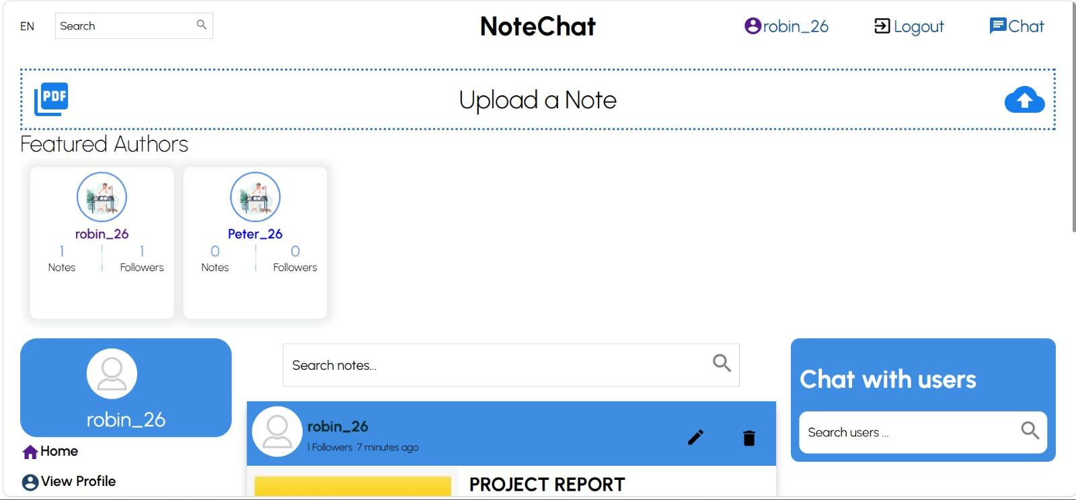
- Login / Sign Up Page
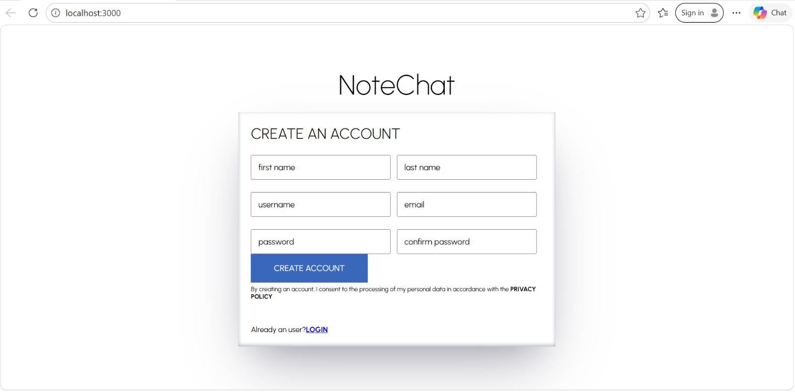

- Messenger Page
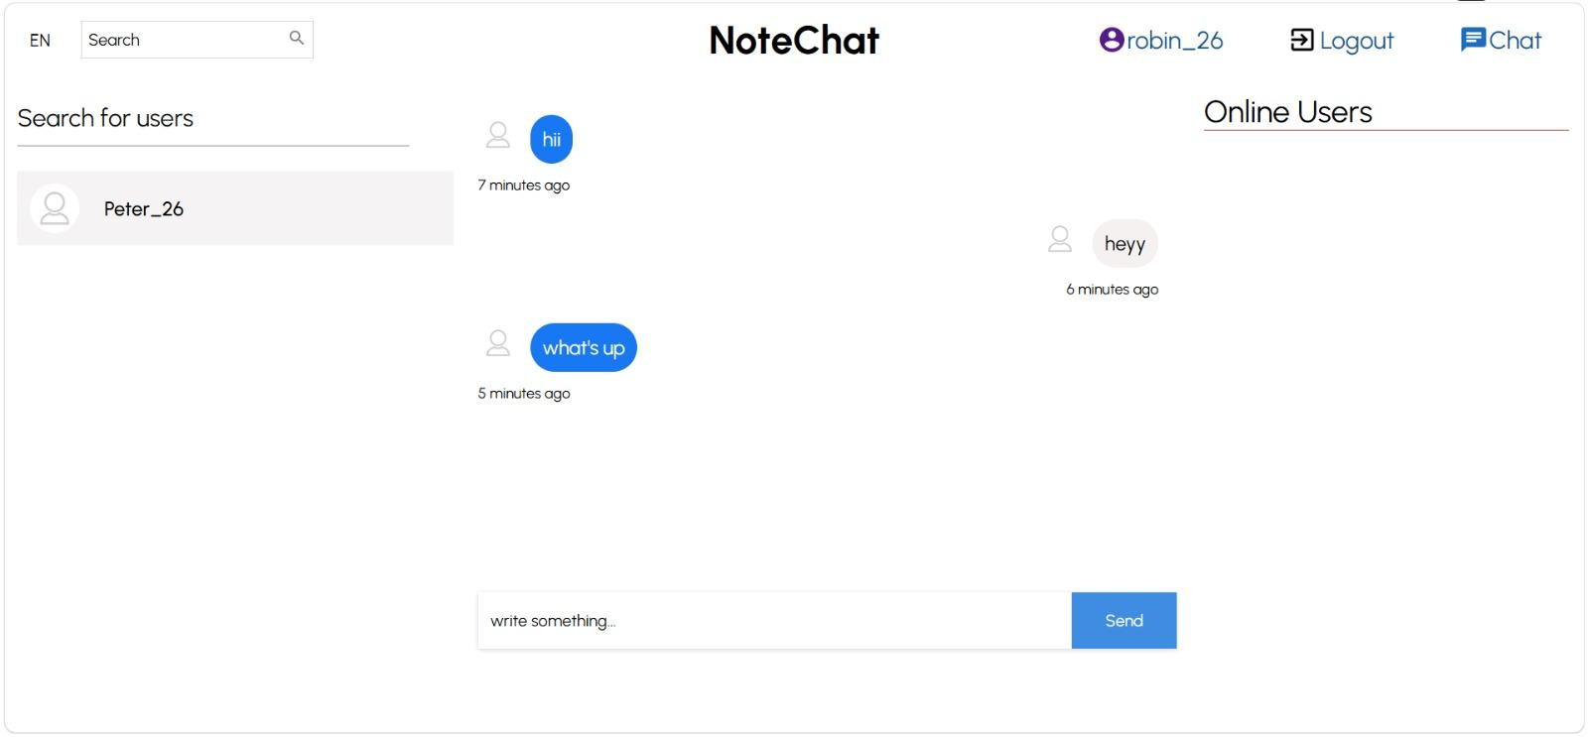
- Profile Page
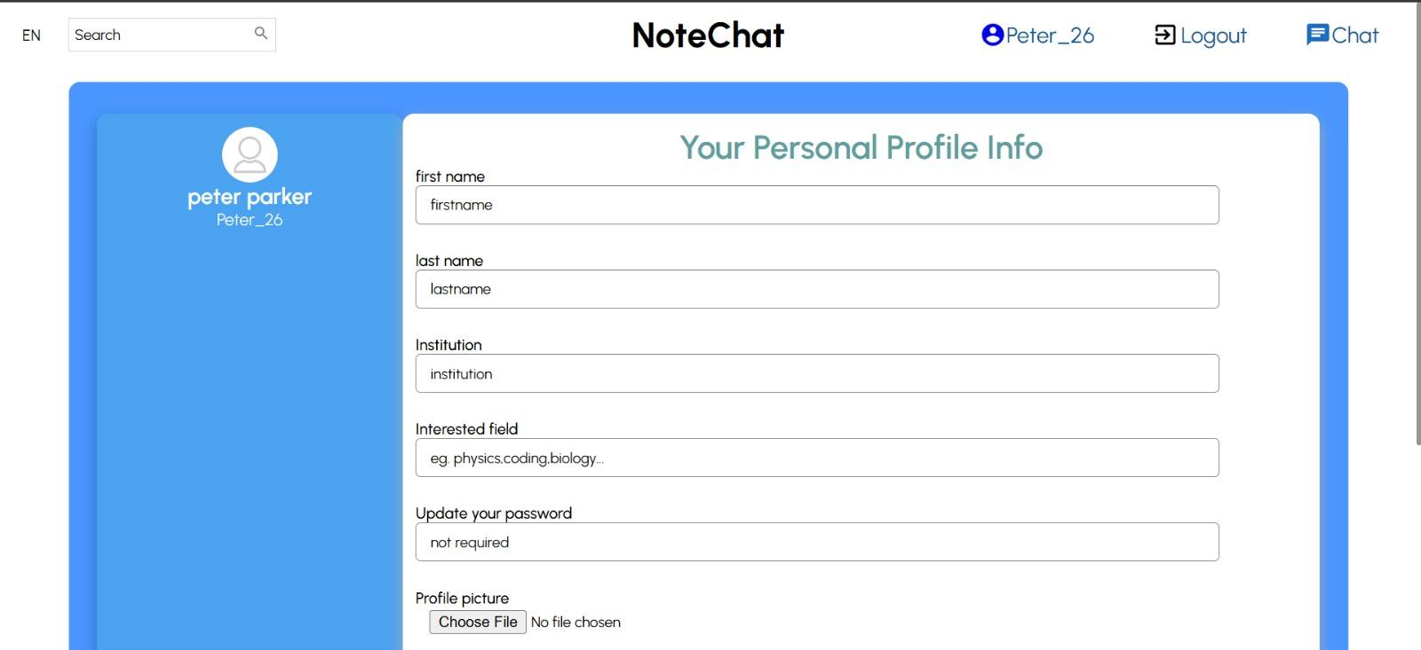

- Search Page
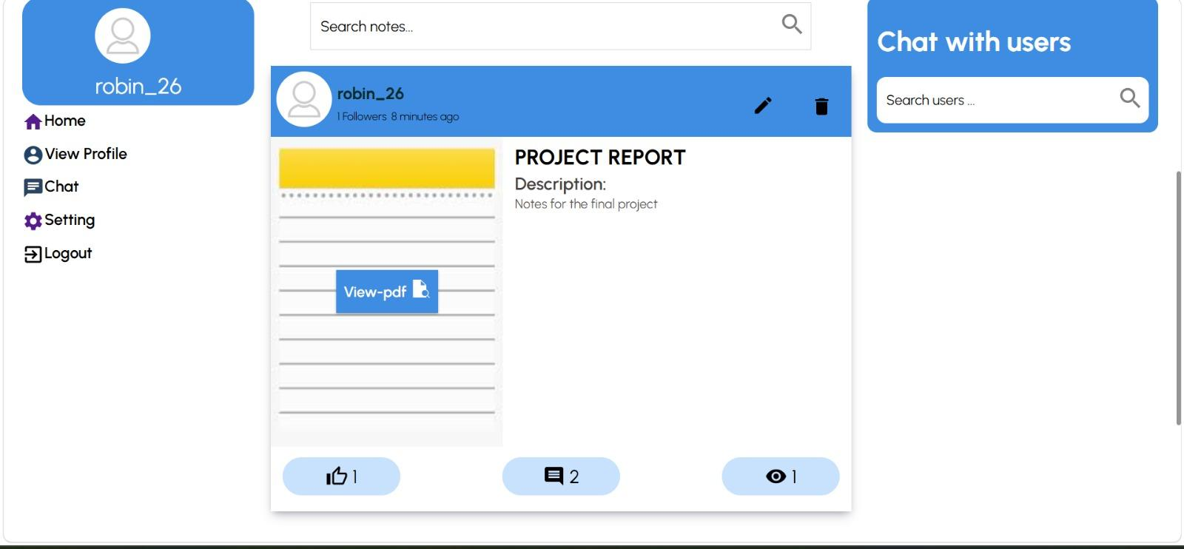

Conclusion:
NoteChat successfully addresses the problem of fragmented academic tools by bringing note sharing, real-time communication, and social interaction into a single unified platform. Instead of relying on multiple disconnected applications, users are provided with a cohesive environment where study materials, discussions, and academic networking exist together, leading to improved productivity and a more organized learning experience.

The platform fulfills its core objective of enabling students to share notes, engage in real-time conversations, and build meaningful academic connections. Features such as personalized feeds, follow systems, comments, and reactions ensure that content is not only shared but also actively discussed and discovered within a relevant academic context. The integration of a dedicated Socket.io server further enhances the system by enabling low-latency, real-time messaging without compromising overall performance.

From a technical perspective, the project demonstrates strong full-stack development capabilities. The use of React with Redux ensures a responsive and state-driven frontend, while the Express-based REST API provides a clean and scalable backend structure. MongoDB with Mongoose enables efficient and flexible data management, and Multer handles file uploads seamlessly. The separation of the REST API, Socket server, and frontend into a three-tier architecture reflects a production-level system design, allowing independent scalability and maintainability.

Additionally, the platform ensures security and reliability through bcrypt-based authentication, structured data handling, and optimized communication between services. The modular design and technology choices make the system adaptable for broader use cases, including educational institutions and online learning environments.

In conclusion, NoteChat represents a practical and scalable solution to modern academic collaboration challenges. It not only improves how students share and interact with study materials but also demonstrates strong problem-solving ability, system design understanding, and the effective application of modern web technologies in building real-world solutions.

References / Technologies Used
∙ MongoDB – Used for storing users, notes, comments, conversations, and messages with flexible schema design.
∙ Express.js – Handles REST API routing, middleware configuration, and server-side logic for NoteChat.
∙ React – Builds dynamic and responsive user interfaces for the note feed, chat, and profile pages.
∙ Node.js – Powers both the REST API backend and the Socket.io event server.
∙ Socket.io – Enables bi-directional real-time communication for private messaging between users.
∙ Clerk – Provides secure authentication, user management, and session handling.
∙ Multer – Handles multipart file uploads for note files and profile pictures, stored in the backend public directory.

