**Module – 1(Fundamental)**

* What is SDLC ?

- SDLC stands for Software Development Life Cycle. It's a process used by software development teams to design, develop, test, and deploy high-quality software products.

- It has Different phases.

1) Planning and Requirement Gathering:

- In this phase software team collect the data regarding client requirement, decide the flow of software, defines the timeline etc.

2) Analysis phase:

- In this phase requirement is in-detail analyzed, by understanding client need and functionalities.

3) Design:

- In this phase designer can design the prototype of a software, and html developer make user friendly design by using editor, by using that prototype.

4) Development:

- In this phase developer develop the software by coding and other tools what they needed.

5) Testing:

- After software is build tester test the software based on client requirement, if any issue are their in software then it reports to the developer team and after fixing that issue/bug , again tester will RETEST that software.

6) Deployment & Maintenance:

- In DEPLOYMENT phase after successfully testing the software it uploads to the production server.

- In MAINTENNANCE phase where software/app continuously monitored, updated, and improved to meet changing user needs and address any issues that arise.

* What is Software Testing ?

- Software testing assures the quality, correctness and completeness of any software or app.

- Basically Software tester checks the software for any bug or issue if any find then it’s responsibility is report to the responsible person.

* What is agile methodology ?

- Agile methodology is a project management framework that breaks projects down into several dynamic phases, commonly known as sprints.

- It focuses on delivering smaller pieces of work regularly instead of one big launch.

- This allows teams to adapt to changes quickly and provide customer value faster.

=> It have different phases:  
Planning <--> Analysis < -- >Designing < -- > Implementation < -->

Testing < -- >Deployment

- In all the phases you are freely route to each other without following sequence.  
  
Ex: Scrum framework.  
Tools: Jira

* What is SRS ?

- SRS stands for Software Requirements Specification. It's a document that outlines the detailed description of the software system to be developed.

- The SRS serves as a blueprint for developers, testers, and stakeholders, ensuring everyone has a clear understanding of what needs to be built and how the software should function.

Uses:

- Development team require it for developing product according to the need.

- Test plans are generated by testing group based on the describe external behaviour.

- Maintenance and support staff need it to understand what the software product is supposed to do.  
- Project manager base their plans and estimates of schedule, effort and resources on it.  
- customer rely on it to know that product they can expect.

* What is oops ?

- Object Oriented Programming, Is the way we program the software, by applying the different concepts like class, object etc.  
  
* Write Basis concepts of oops.

- -> Class

-> Object

-> Inheritance

-> Encapsulation

-> Polymorphism

* What is object.

- Object is a instance of class, class is a collection of methods and properties.By object we can access the properties and methods of class.

* What is encapsulation.

- Encapsulation in object-oriented programming involves combining methods (behavior) and properties (data) into a single unit. , typically a class, and controlling access to them using access modifiers. Access modifiers such as public, private, and protected allow for the enforcement of encapsulation by defining the visibility and accessibility of class members.

* What is Inheritance.

- By inheritance we can access the properties and methods of another class by extends keyword.We reuse the methods and call in other other class.

* What is Polymorphism.

- It means more than one forms of method.polymorphism allow us to define methods in super class and override this methods in subclasses to provide implemetations.There are two types we can use based on different parameter and type of arguments.By overloading(compileTime) and overriding(RunTime).

* Draw Usecase on Online book shopping.

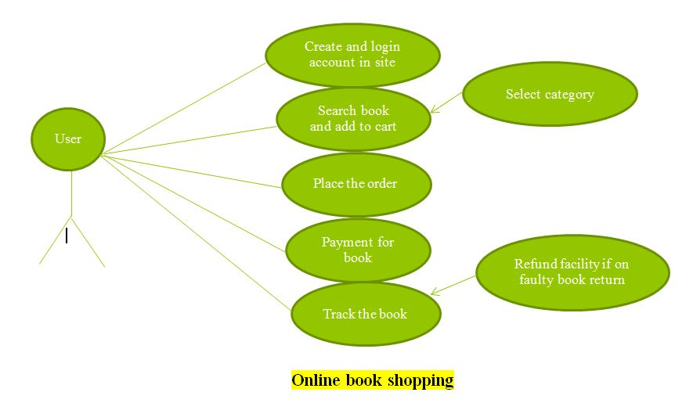

* Draw Usecase on online bill payment system (paytm).

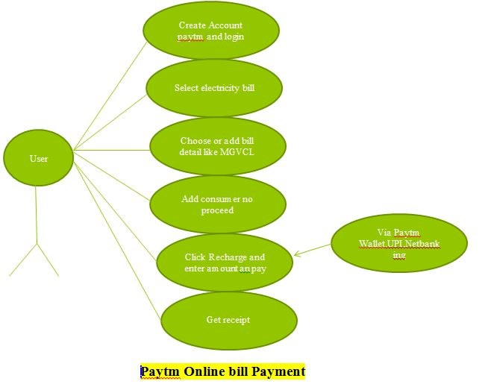

* Write SDLC phases with basic introduction.

- Software development life cycle is a way of development of any software and app.By following the process we can make a high quality product. It has six phases.  
  
1) **Planning/Requirement Gathering:**   
We gather a requirement from a client for product.

2) **Analysis:**   
Once a requirement is collected, then analyze and identify the conflicts or ambiguity exist there!

3) **Design Software:**In this phase design the software by using prototype, editors like figma, adobe xd, Make database structure includes tables and related database.

4) **Building/Implementation of software and app**:  
Construct a actual code, by the team of developers and documents the functionalities of code.

5) **Testing/QA/QC:** Tesing the product for better quality and client satisfaction, by finding bugs, issues and report to the developers-designers to solve that bug, and after that retest that functionality.

6) **Deployment/ Maintainence:   
Deploy:** Once all errors are fixed, deploy the software to production server.  
**Maintainence:** Ensure that software continuous to operate effectively and efficiently over time.

* Explain Phases of the waterfall model.

- Is a approach for developing any software by following phases. By using this model we can’t go back to previous phase.We can go sequentially that is the disadvantage of this model.

1. **Requirement and Gathering :**We gather a requirement from a client for product.
2. **Design**:

In this phase design the software by using prototype, editors like figma, adobe xd, Make database structure includes tables and related database.

1. **Development:**Developing the code for a program / software /app.
2. **Testing**:

Testing the product to satisfy client requirement, for completness and to provide high quality of software .

1. **Deployment:**Upload the software to the server
2. **Maintainence**:

Maintain software after deploying to the server.  
  
  
* Explain Phases of the spiral model.

- When we use spiral model we can easily deal with changes , due to user involvement user satisfaction is important.

- New idea and functionality can be easily added at later state.

- There are four different phases/quadrant:

1) **Determine objectives:**

Define the specific goals and objectives of the project, outlining what needs to be achieved and why it is important.

2) **Identify and resolve risks:**

Identify potential risks and uncertainties associated with the project, analyze their potential impact, and develop strategies to mitigate or resolve them.

3) **Develop next level product:**

Proceed with the development of the next iteration or increment of the product, incorporating feedback from previous iterations and adding new features or enhancements.

4) **Review and planning:**

Review the progress made in the current iteration, assess the effectiveness of the implemented strategies, and plan for the next iteration or phase based on lessons learned and updated objectives.

* Explain manifesto principles of the Agile model.

1) **Customer Satisfaction:**

Focus on satisfying the customer through early and continuous delivery of valuable software.  
2) **Embrace Changes:**

Welcome changes in requirements, even late in development, to harness customer feedback and adapt to evolving needs.

3) **Frequent Deliveries:**

Deliver working software frequently by modules/build, in short timeframes, to ensure rapid progress and maintain a sustainable pace.

4) **Collaborative Approach:**Build projects and collaboration between customers, developers, and stakeholders.

4) **Face-to-Face Communication**Face-to-face interactions as the most effective means of conveying information and building trust within teams.

* Explain working methodology of agile model and also write pros and cons.

- Agile methodology is iterative and incremental, focusing on delivering working software in short cycles called sprints.

**Methodology:**  
  
- **Backlog:**

Requirements are captured as user stories and added to the product backlog.

- **Sprint Planning:**

The team selects a set of user stories from the backlog to work on during the sprint

- **Daily standups:**

Team members meet daily to discuss progress, challenges, and plan for the day.

- **Development:**

Work on user stories begins, with frequent collaboration between developers, testers, and stakeholders.

- **Sprint Review:**

At the end of the sprint, the team demonstrates completed user stories to stakeholders for feedback.

- **Sprint Retrospective:**

The team reflects on the sprint, identifying what went well and areas for improvement.

**Pros:**

- Flexibility to adapt to changing requirements.

- Early and continuous delivery of valuable software.

- Enhanced collaboration and communication within teams.

- Stakeholder involvement throughout the development process.

- Focus on customer satisfaction and delivering working solutions.

- Improved quality through frequent testing and feedback loops.

Cons:

- Lack of predictability in delivery timelines.

- Dependency on active stakeholder involvement.

- Difficulty in scaling for large, complex projects.

* Draw usecase on Online shopping product using COD.

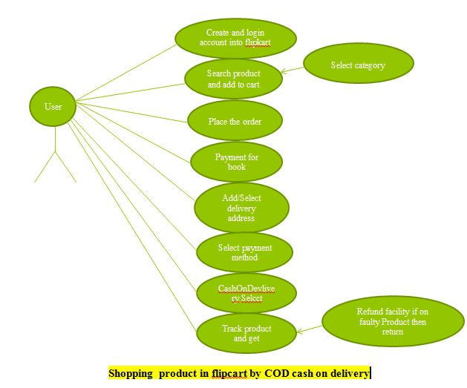

* Draw usecase on Online shopping product using payment gateway.

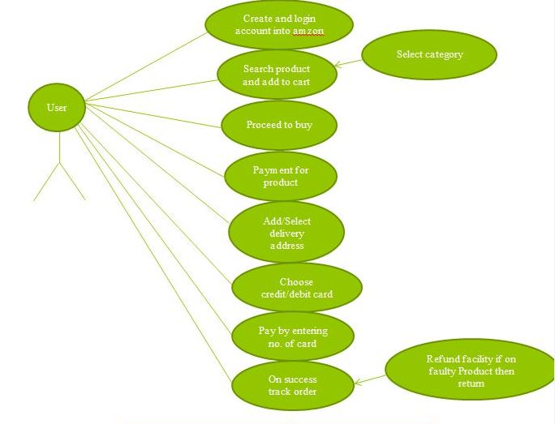

Amzon-product-puchase-debit-credit-card-shopping