📘Azure Application Hosting Design – PDF to TIFF Converter (Internal Tool)
Prepared By: Yogesh P
Date: 22 July 2025
Executive Summary
This document outlines the design and architecture of the PDF to TIFF Converter application to be hosted on Microsoft Azure. The application enables internal users to upload PDF files, which are then converted into monochrome TIFF images suitable for AutoCAD processing.
The solution is built using FastAPI (Python) & Flask and will be deployed using Docker. The backend and frontend can be hosted separately to improve scalability and manageability.
Diagrammatic Flow:
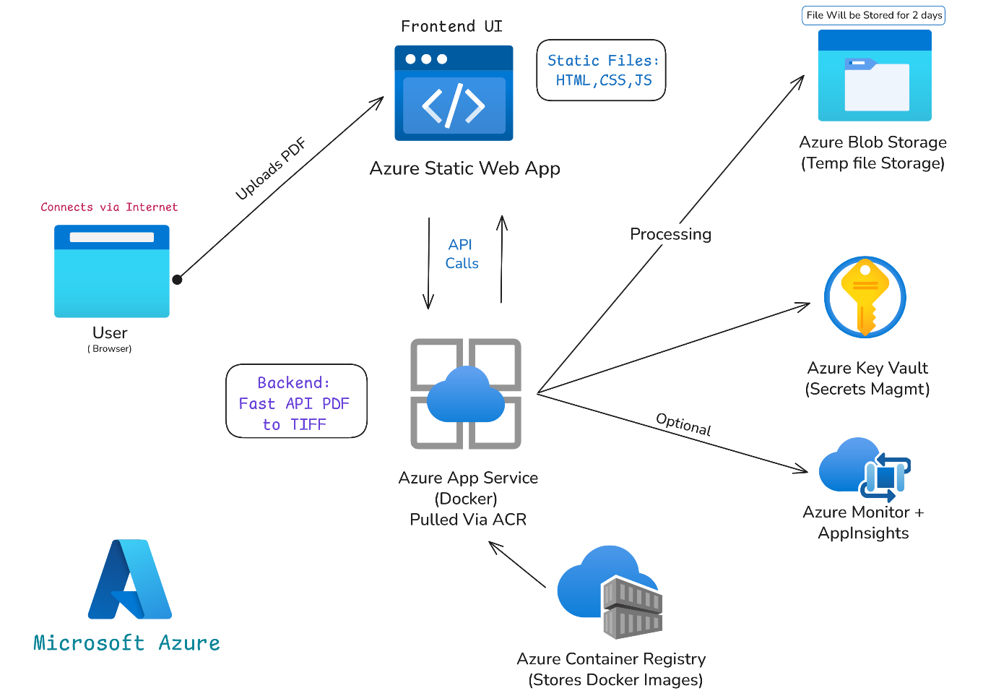

- User → Frontend (Static Web App)
- Frontend → Backend (App Service)
- Backend → Azure Blob Storage (Temporary Storage)
- Secrets → Azure Key Vault
- Logs → App Insights
🌐 Networking Requirements
Since this is an internal app, and security matters:
- Use Azure VNet Integration with App Service.
- Enable Private Endpoint for:
  - Azure Blob Storage
  - Key Vault
- Optional: Use NSG (Network Security Groups) to block public access except for frontend/API endpoint.
- Enforce HTTPS only for App Service and Static Web App.
⚙️ Required Azure Services
Component | Azure Service | SKU/Tier | Configuration Notes
Frontend | Static Web Apps / Front Door | Standard or Premium | Custom domain, SSL
Backend API | App Service / Container App | B1 or PremiumV2 Plan | Python/Node runtime
Database | Azure Database for PostgreSQL | Basic/General Purpose | Backup, SSL on
File Storage | Azure Blob Storage | Hot Tier | Public access off
Secrets Management | Azure Key Vault | Standard Tier | RBAC-based access
Monitoring | Azure Monitor + App Insights | Included | Alert rules optional
🔐 Security Considerations
- Key Vault for:
  - Storage account keys
  - Any secrets or future API keys
- Access Policy or RBAC to control who can upload/process files
- HTTPS enforced on frontend/backend
- If needed: Use Managed Identity for App Service to access Azure Blob Storage securely.

✅ Functional Overview
- User uploads PDF from frontend.
- Backend (FastAPI / Flask) processes it to generate monochrome TIFF.
- Generated TIFFs and PDFs are stored in Azure Blob Storage temporarily (auto-delete after 1 day).
- App logs are tracked via App Insights.
- App secrets (e.g., storage keys) are stored in Key Vault.
- Optionally, access to services is routed through a private network.

🔁 Deployment Workflow
Docker image is built locally or via CI/CD (e.g., GitHub Actions).
1. Image is pushed to Azure Container Registry (ACR).
2. App Service pulls the Docker image from ACR.
3. Static frontend (if separate) is deployed to Azure Static Web App.
4. Environment variables and secrets are injected via Key Vault references.
5. Azure Monitor and App Insights capture logs and metrics.
📦 Azure Container Registry (ACR)
Used to store and manage Docker images securely.
- Required for App Service to pull container image.
- ACR will be configured with imagePull access.
- Images can be pushed from CI/CD pipelines.
🧱 Terraform Provisioning Scope
The infrastructure team is expected to provision the following Azure resources using Terraform:
- Azure App Service with Linux Plan and Docker configuration
- Azure Container Registry (ACR)
- Azure Blob Storage with 1-day lifecycle deletion rule
- Azure Key Vault with access policies for App Service and Developer
- Azure Static Web App (for frontend)
- Virtual Network (VNet), NSGs, and Private Endpoints for secure access

🛑 Failure Recovery / Fault Handling

- Failed PDF conversions will be logged via App Insights.
- Optional retry mechanism can be added in code.
- All critical exceptions are handled and shown in user-friendly messages.

📌 Non-Functional Requirements (NFRs)
- Performance: The system must process each PDF within 5 seconds (for an average 1MB file).
- Availability: Target uptime is 99.9%, as this is a non-critical internal tool.
- Security: All data in transit must be encrypted (HTTPS only). There will be no public access to either the Blob or the App.
- Retention: Files will be deleted automatically after 1 day via a lifecycle policy.
- Compliance: The tool is designed for internal-only usage in accordance with the AusNet data handling policy.
📋 Future Enhancements
- Add authentication using Azure AD for access control.
- Add historical job tracking via Azure Table Storage or PostgreSQL.
- Introduce retry queue (e.g., Azure Queue Storage) for failed jobs.
- Archive TIFFs beyond 1 day in cool tier Blob for audit logs.

