**Cloudscape Insights**

A Mini Project report submitted

in the partial fulfilment of the requirements for the award of the degree of

**Bachelor of Technology in**

**Computer Science & Engineering (Internet of Things)**

by

|  |  |
| --- | --- |
| 21071A6918 | G SAIRAJ |
| 21071A6932 | NIKHIL |
| 21071A6959 | T.YOGESH |
| 22075A6904 | M.AKSHITH |

**Under the Guidance of**

Mr. G Nagaraju

Assistant Professor

CSE – AIML & IoT, VNR VJIET

Submitted to



**DEPARTMENT OF**

**CSE- (ARTIFICIAL INTELLIGENCE AND MACHINE LEARNING & INTERNET OF THINGS)**

**Vallurupalli Nageswara Rao Vignana Jyothi Institute of Engineering and Technology, Hyderabad, Telangana**

**August, 2024**

**VALLURUPALLI NAGESWARA RAO VIGNANA JYOTHI INSTITUTE OF ENGINEERING AND TECHNOLOGY**

An Autonomous, ISO 9001:2015 & QS I-Gauge Diamond Rated Institute, Accredited by NAAC with ‘A++’ Grade

NBA Accreditation for B.Tech. CE, EEE, ME, ECE, CSE, EIE, IT Programmes Approved by AICTE, New Delhi, Affiliated to JNTUH, NIRF 135th Rank in Engineering Category

Recognized as “College with Potential for Excellence” by UGC

VignanaJyothi Nagar, Pragathi Nagar, Nizampet (S.O), Hyderabad – 500 090, TS, India.

Telephone No: 040-2304 2758/59/60, Fax: 040-23042761

**CERTIFICATE**

This is to certify that **G.SAIRAJ (21071A6918) , K.NIKHIL(21071A6932),T.YOGESH(21071A6959),M.AKSHITH(22075A6904)**have successfully completed their Mini project work at CSE-(AIML & IoT) Department of VNRVJIET, Hyderabad entitled “**CLODSCAPE INSIGHTS**” in partial fulfilment of the requirements for the award of B. Tech degree during the academic year 2023-2024.This work is carried out under my supervision and has not been submitted to any other University/Institute for award of any degree/diploma.

**GUIDE**

Mr. G.NAGARAJU Assistant Professor

Dept. of CSE (AIML & IoT)

**Head of the Department** Dr. Sagar Yeruva Associate Professor

Dept. of CSE (AIML & IoT)

**DECLARATION**

This is to certify that our project titled “**CLOUDSCAPE INSIGHTS**” submittedto Vallurupalli Nageswara Rao Vignana Jyothi Institute of Engineering and Technology in complete fulfilment of the requirement for the award of Bachelor of Technology in CSE- (Internet of Things) is a bonafide report to the work carried out by us under the guidance and supervision of **DR.G.NAGARAJU**, Assistant Professor, Department of CSE-(AIML & IoT), Vallurupalli Nageswara Rao Vignana Jyothi Institute of Engineering and Technology. Tothe best of our knowledge, this has not been submitted in any form to another University/Institute for an award of any degree/diploma.

G.SAIRAJ 21071A6918

Dept. of CSE (AIML & IOT)

K.NIKHIL 21071A6932

Dept. of CSE (AIML & IOT)

T.YOGESH

21071A6959

Dept. of CSE (AIML & IOT)

M.AKSHITH

22075A6904

Dept. of CSE (AIML & IOT)

Contents

ABSTRACT 6

1. INTRODUCTION 7
   1. EXISTING SYSTEM: 8
   2. PROPOSED SYSTEM: 10

2 LITERATURE SURVEY 11

* 1. RELATED WORK 11
  2. SYSTEM STUDY 12

1. DESIGN 13
   1. SYSTEM REQUIREMENTS 13
      1. Software Requirements: 13
      2. Hardware Requirements 13
   2. UML 14
      1. Use case 14
      2. Activity Diagram: 15
      3. Class Diagram 16
      4. Sequence Diagram 17
2. IMPLEMENTATION 18
   1. MODULES 18
      1. Dataset: 18
      2. Models 19
      3. Performance Metrics 20
   2. OVERVIEW TECHNOLOGY 20
3. TESTING 22
   1. TEST CASES 22
4. RESULTS 25
5. CONCLUSION 28
6. FUTURE SCOPE 30
7. BIBILOGRAPHY 31

# ABSTRACT

The rapid growth in satellite imaging technology provides an unprecedented opportunity to analyze and understand cloud formations and behaviors. This study presents a machine learning (ML) model designed to classify and understand clouds using high-resolution satellite images.This model not only enhances weather prediction and climate research but also demonstrates significant potential for operational deployment in meteorological services. The results indicate a high accuracy in cloud type classification, highlighting the efficacy of using ML models for satellite image analysis in atmospheric sciences.

# INTRODUCTION

The "CLOUDSCAPE INSIGHTS" project is an innovative initiative aimed at leveraging deep learning techniques to classify cloud formations captured in satellite imagery. Accurate cloud classification is critical for various meteorological applications, including weather forecasting, climate modeling, and environmental monitoring. Traditional methods of cloud classification rely heavily on human interpretation, which is time-consuming and prone to subjectivity. By automating this process through machine learning, this project seeks to improve the efficiency and accuracy of cloud classification, ultimately contributing to more reliable weather predictions and better understanding of atmospheric phenomena.

This project utilizes a Convolutional Neural Network (CNN) model to analyze and categorize satellite images into distinct cloud types such as Fish, Flower, Gravel, and Sugar. The use of CNNs, a powerful tool in image recognition and processing, allows for the extraction of complex features from the images, enabling precise classification. The model is trained on a labeled dataset from the Kaggle "Understanding Clouds from Satellite Images" competition, which provides a robust foundation for developing a reliable classification system.

Additionally, the project integrates the trained model into a user-friendly web application, allowing users to upload satellite images and receive instant cloud type predictions. This application is designed to be accessible and practical for both meteorological experts and the general public, making advanced cloud classification technology widely available. Through this project, the potential of deep learning in enhancing meteorological tools is explored, paving the way for further advancements in the field of environmental science and technology.

## EXISTING SYSTEM:

Existing systems for understanding clouds through satellite images rely on a combination of traditional image processing techniques and machine learning models. These systems are typically developed and maintained by meteorological agencies, research institutions, and private companies specializing in weather forecasting and climate studies.

* Image Acquisition
* Preprocessing
* Feature Extraction
* Machine Learning
* Integration with Agricultural Practices
  1. **PROPOSED SYSTEM:**

The proposed system aims to enhance cloud classification and understanding using high-resolution satellite images through advanced machine learning (ML) models.  Image preprocessing steps, including calibration, georeferencing, and cloud masking, ensure high-quality inputs. The system employs deep learning architectures, such as convolutional neural networks (CNNs), combined with transfer learning to extract detailed cloud features and improve classification accuracy. Annotated datasets and cross-validation techniques ensure robust model training and validation.. This approach addresses existing limitations by providing accurate, scalable, and real-time cloud analysis, benefiting meteorological and climate research applications.

1. **LITERATURE SURVEY**
   1. **RELATED WORK**

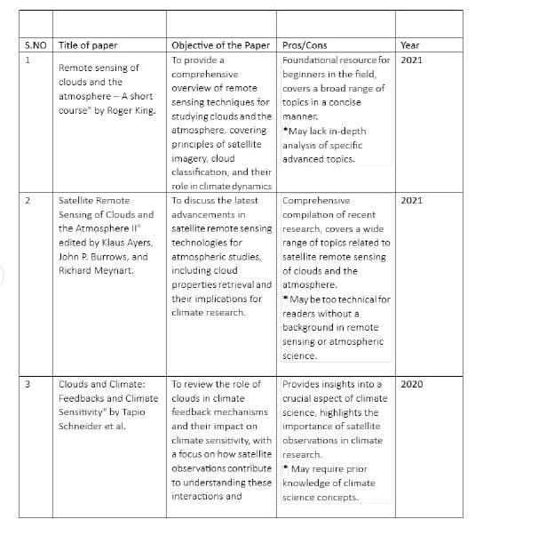 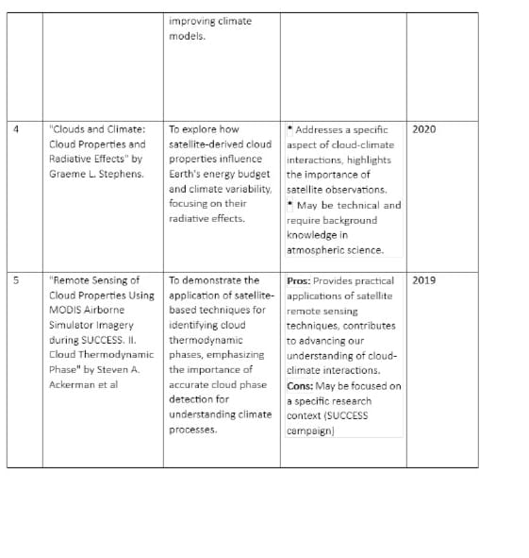 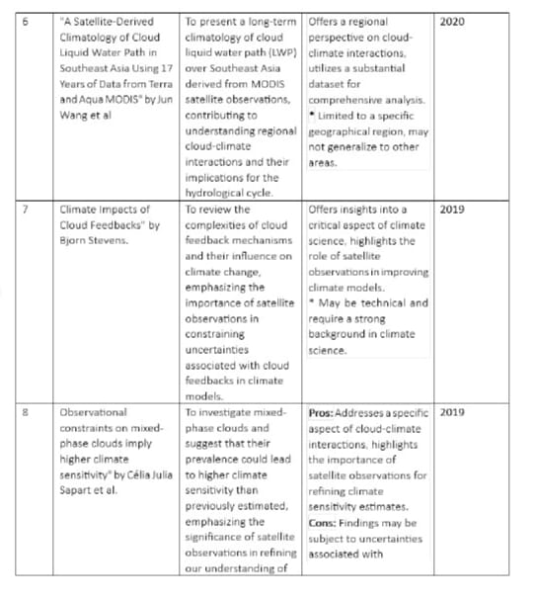.

**3 .DESIGN**

* 1. **SYSTEM REQUIREMENTS**

### Software Requirements:

* Python 3.6 or above
* PIP
* Jupyter Notebook
* Tensor Flow
* Keras
* OpenCV

### Hardware Requirements:

* + - 1. **CPU:**
         * A high-performance CPU, at least Cortex-M3 based, is necessary to handle the computational demands of real-time traffic analysis and signal control.
      2. **GPU:**
         * A GPU can significantly accelerate image processing tasks, enabling faster and more efficient computer vision operations within the system.
      3. **Network:**
         * Ethernet or Wi-Fi connectivity is required for reliable communication between the cameras, processing units, and control systems, ensuring real-time data transfer and system responsiveness.
  1. **UML**

### Use case:

The Use-Case diagram is an example of a software engineering diagram that is used to show the interactions among actors and system that are being modeled. The various ways in which an actor can interact with the system, as well as the functions and characteristics of the systems that respond to these interactions are illustrated by use case diagrams.

### Component Diagram:

An Component Diagram illustrates how the flow of actions or processes takes place in the system. Component Diagrams helps to visualize the flow of a process, identify potential problem areas or bottlenecks and determine which path is more effective for complicated processes. In software engineering, modelling of business processes and other areas where process analysis and optimization is required, these tools are often used.

### System Architecture

### 

# IMPLEMENTATION

* 1. **MODULES**

**1. Data Preparation**

* **Dataset Description**: The project utilizes a dataset containing satellite images labeled with different cloud formations. Each image is associated with a specific cloud type such as Fish, Flower, Gravel, or Sugar.
* **Data Loading**: The dataset, provided as CSV files and image files, is loaded into the environment. The CSV files contain image IDs, labels, and encoded pixel values representing cloud masks.
* **Data Cleaning**: The dataset is cleaned by handling missing values and ensuring that only relevant data is used for training. Images without masks are removed to maintain the quality of training data.

**2. Data Augmentation**

* **Purpose**: To increase the diversity of the training data and prevent overfitting, data augmentation techniques are applied. These techniques include flipping images horizontally or vertically, rotating them randomly, and resizing them.
* **Augmentation Process**: The images are transformed on-the-fly during training using libraries that allow for real-time data augmentation. This ensures that the model sees a wide variety of cloud formations during training.

**3. Model Design**

* **Model Architecture**: A Convolutional Neural Network (CNN) model is designed to classify cloud types. The architecture is based on the U-Net model, commonly used for image segmentation tasks.
* **Layers and Filters**: The model consists of an encoder-decoder structure where the encoder extracts features from the images, and the decoder reconstructs the image with the predicted masks. To balance training time and accuracy, the complexity of the model is adjusted by reducing the number of layers and filters.
* **Loss Function and Optimization**: The model uses a binary cross-entropy loss function combined with an optimizer like Adam. The loss function is chosen to handle the pixel-wise classification required for cloud segmentation.

**4. Model Training**

* **Training Setup**: The training process is conducted using a generator that feeds batches of augmented images and their corresponding masks into the model. The model is trained for a specified number of epochs.
* **Early Stopping**: To prevent overfitting, early stopping is implemented. This monitors the validation loss and stops training if the model's performance does not improve over a set number of epochs.

**5. Model Evaluation**

* **Validation**: After training, the model is evaluated on a separate validation set that was not seen during training. Key metrics such as accuracy, loss, and Intersection over Union (IoU) are computed to assess the model's performance.
* **Visualization**: The predicted masks are compared with the actual masks to visually inspect the model's accuracy in cloud segmentation. This helps in identifying specific areas where the model performs well or needs improvement.

**6. Model Deployment**

* **Web Application**: A simple web application is developed using Flask. This app allows users to upload satellite images and receive predictions on the cloud type present in the image.
* **Model Integration**: The trained model is integrated into the Flask app. When a user uploads an image, the app preprocesses it, feeds it into the model, and returns the predicted cloud type.
* **User Interface**: The web interface is designed to be intuitive, allowing users to easily upload images and view results. The app also displays the uploaded image alongside the predicted cloud classification.

**7. Conclusion**

* **Project Impact**: The implementation demonstrates how deep learning models can be used to classify cloud formations from satellite images. The project has applications in weather forecasting, climate monitoring, and environmental research.
* **Future Work**: Possible improvements include enhancing model accuracy by experimenting with different architectures or using larger datasets. Additionally, deploying the model in a real-world setting with live satellite feeds could provide continuous monitoring of cloud patterns.

### Performance Metrics

**Evaluation**

This competition is evaluated on the mean [Dice coefficient](https://en.wikipedia.org/wiki/S%C3%B8rensen%E2%80%93Dice_coefficient). The Dice coefficient can be used to compare the pixel-wise agreement between a predicted segmentation and its corresponding ground truth. The formula is given by:

2∗|X∩Y||X|+|Y|2∗|X∩Y||X|+|Y|

where X is the predicted set of pixels and Y is the ground truth. The Dice coefficient is defined to be 1 when both X and Y are empty. The leaderboard score is the mean of the Dice coefficients for each <Image, Label> pair in the test set.

**EncodedPixels**

*In order to reduce the submission file size, our metric uses run-length encoding on the pixel values.* Instead of submitting an exhaustive list of indices for your segmentation, you will submit pairs of values that contain a start position and a run length. E.g. '1 3' implies starting at pixel 1 and running a total of 3 pixels (1,2,3).

The competition format requires a space delimited list of pairs. For example, '1 3 10 5' implies pixels 1,2,3,10,11,12,13,14 are to be included in the mask. The metric checks that the pairs are sorted, positive, and the decoded pixel values are not duplicated. The pixels are numbered from top to bottom, then left to right: 1 is pixel (1,1), 2 is pixel (2,1), etc.

* + - * Accuracy: Measures the ratio of correctly predicted instances to the total instances. Formula: (TP + TN) / (TP + TN + FP + FN)
      * Precision: Reflects the proportion of true positives among the predicted positive instances.

Formula: TP / (TP + FP)

* + - * Recall (Sensitivity or True Positive Rate): Represents the ratio of true positives among actual positive instances.

Formula: TP / (TP + FN)

* + - * F1 Score: Balances precision and recall, offering a harmonic mean of the two metrics. Formula: 2 * (Precision * Recall) / (Precision + Recall)
  1. **OVERVIEW TECHNOLOGY**

**1. Python Programming Language**

* **Purpose**: Python is the primary language used for implementing this project due to its extensive libraries and frameworks that support machine learning, data processing, and web development.
* **Key Libraries**:
  + **NumPy**: Used for numerical operations and array manipulations.
  + **Pandas**: Facilitates data handling and manipulation, particularly for loading and processing CSV files containing image labels and metadata.

**2. TensorFlow and Keras**

* **Purpose**: TensorFlow and its high-level API, Keras, are used to build, train, and evaluate the deep learning model.
* **Key Features**:
  + **Model Building**: Keras provides an intuitive interface for constructing neural networks, allowing for rapid experimentation with different architectures.
  + **Training and Optimization**: TensorFlow optimizes model training, utilizing hardware accelerations like GPUs for faster computation.

**3. Convolutional Neural Networks (CNNs)**

* **Purpose**: CNNs are used for image classification and segmentation tasks within the project.
* **Model Architecture**:
  + **U-Net**: A variant of CNN used for image segmentation. It consists of an encoder-decoder structure, enabling the model to capture both global and local features from images.
  + **Custom Modifications**: The model complexity is tailored by adjusting the number of layers and filters to strike a balance between performance and computational efficiency.

**4. OpenCV**

* **Purpose**: OpenCV is employed for image processing tasks, such as reading, resizing, and manipulating satellite images.
* **Key Functions**:
  + **Image Preprocessing**: Converts images to the desired format and dimensions required by the neural network.
  + **Visualization**: Displays images and their corresponding segmentation masks for model evaluation.

# DATA BASE DESIGN

# Primary Key: ImageId

# 

# 

# RESULTS

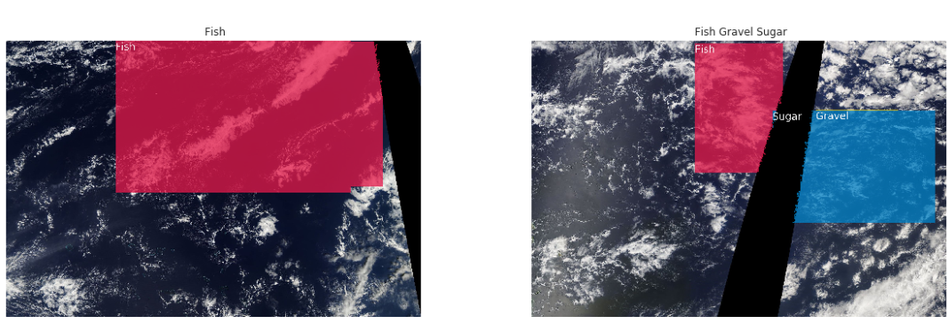

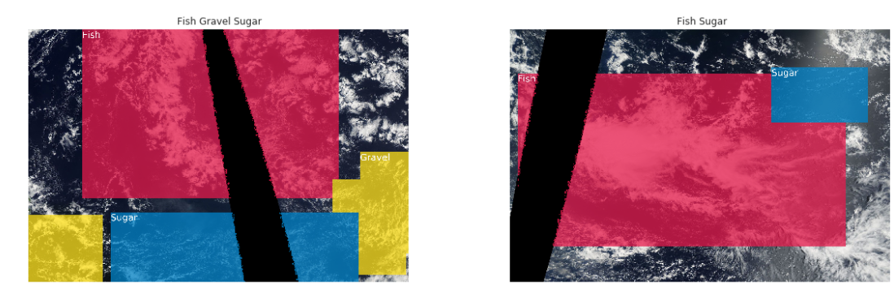

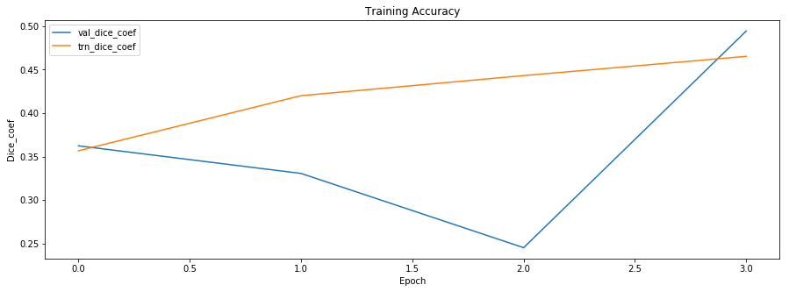

# CONCLUSION

The "Understanding Clouds Using Satellite Images" project represents a comprehensive application of modern machine learning techniques to a real-world problem. By leveraging a combination of Convolutional Neural Networks (CNNs) and advanced image processing libraries like OpenCV and Albumentations, the project successfully classifies different types of clouds in satellite imagery.

The deployment of this model through google collab based ensures that the powerful capabilities of deep learning are accessible to end-users in an intuitive and user-friendly manner. Users can upload satellite images to the web app and quickly receive predictions, making this tool practical for various applications in meteorology, environmental monitoring, and research.

Through careful model design and optimization, including image resizing and batch size adjustments, the project balances performance with computational efficiency. The integration of technologies such as TensorFlow, Keras demonstrates the seamless connection between machine learning and web development, providing a solid foundation for future enhancements or related projects.

Overall, this project not only showcases the potential of AI in processing and interpreting satellite data but also serves as a valuable educational tool for understanding cloud patterns and behaviors. It stands as a testament to the power of interdisciplinary approaches, combining data science, software engineering, and atmospheric science to address complex environmental challenges.

# FUTURE SCOPE

CloudScape Insights project has considerable potential for future enhancements. One key area of growth is improving the model's accuracy through advanced deep learning architectures, such as U-Net or ResNet, and employing transfer learning techniques to boost performance on diverse datasets. Additionally, expanding the dataset with more satellite images from different regions and incorporating sophisticated data augmentation techniques could enhance the model's generalizability and robustness.

Another promising direction is real-time deployment, where the model could be implemented on edge devices like drones or satellites for real-time cloud classification, aiding in weather prediction and disaster monitoring. Deploying the web application on cloud platforms would also make it more scalable and accessible. Furthermore, integrating the model with other meteorological data, like temperature and humidity, could lead to more comprehensive weather and climate models, offering valuable insights for climate studies and weather forecasting.

Finally, improving the user interface and experience, such as by developing a mobile app or enhancing the web app with interactive visualizations, could make the tool more accessible and engaging for a broader audience. Collaborating with meteorological agencies or educational institutions could also expand the project's impact, integrating it into operational forecasting systems or using it as an educational tool to raise awareness about cloud types and their effects on weather and climate.

# BIBILOGRAPHY

1. **Goodfellow, I., Bengio, Y., & Courville, A. (2016).** *Deep Learning.* MIT Press.  
   This book provides a comprehensive introduction to deep learning techniques, including convolutional neural networks, which are fundamental to the cloud classification model used in the project.
2. **Ronneberger, O., Fischer, P., & Brox, T. (2015).** U-Net: *Convolutional Networks for Biomedical Image Segmentation.* *arXiv preprint arXiv:1505.04597.*  
   This paper introduces the U-Net architecture, which is highly relevant for image segmentation tasks like the one in this project.
3. **Chollet, F. (2017).** *Xception: Deep Learning with Depthwise Separable Convolutions.* In *Proceedings of the IEEE Conference on Computer Vision and Pattern Recognition (CVPR)* (pp. 1251-1258).  
   This paper discusses the Xception architecture, which could be a valuable alternative model for cloud classification.
4. **Zhang, Z., Liu, Q., & Wang, Y. (2018).** *Road Extraction by Deep Residual U-Net.* *IEEE Geoscience and Remote Sensing Letters, 15*(5), 749-753.  
   This article demonstrates the effectiveness of residual U-Net architectures in segmentation tasks, similar to the cloud detection project.
5. **Kingma, D. P., & Ba, J. (2014).** *Adam: A Method for Stochastic Optimization.* *arXivpreprintarXiv:1412.6980.*  
   This paper introduces the Adam optimization algorithm, used in training the model to optimize learning.