**Test2_ARM Processor Key Answers**

1. **Write Embedded C statements to configure**
2. Pin 19 of Port 0 as Output and want to drive it High(Logic 1)
3. Making output configured Pin 15 High of Port 0 and then Low
4. Configuring P0.13 and P0.19 as Output and Setting them High:
5. Configuring 1st 16 Pins of Port 0 (P0.0 to P0.15) as Output and Setting them High
6. Select p0.0 pin TXD3 function among (GPIO/RD1/TXD3/SDA1)

Ans:

(i) LPC_GPIO0->FIODIR |=(1<<19); //P0.19 configured as O/P

LPC_GPIO0->FIOSET |=(1<<19); //P0.19 is HIGH

(ii) LPC_GPIO0->FIODIR |=(1<<15); //P0.15 configured as O/P

LPC_GPIO0->FIOSET |=(1<<15); //P0.19 is HIGH

LPC_GPIO0->FIOCLR |=(1<<15); //P0.19 is LOW

(iii) LPC_GPIO0->FIODIR |= (1<<13) | (1<<19); // P0.13 and P0.19 as O/Ps

LPC_GPIO0->FIOSET |=(1<<13) | (1<<19); //P0.13 and P0.19 are HIGH

(iv) LPC_GPIO0->FIODIR = 0xffff; //P0.0 to P0.15 as O/Ps

LPC_GPIO0->FIOSET = 0xffff; //P0.0 to P0.15 are HIGH

1. LPC_PINCON->PINSEL0 |=(2<<0); //P0.0 function as TXD3
2. **Calculate**
3. The PR value for timer resolution of 1ms on a timer with 25 MHz PCLK
4. The delay generated for MR0 value of 2^23 with 100MHz PCLK

Ans:

1. PR = (PCLK/Timer resolution) – 1

= (25MHz/1ms) – 1

= (25000000/1000) - 1 = 25000 – 1 = 24999

1. Delay generated = MR0 (1/PCLK)

=2^23(1/100000000)

= 0.083 second

1. **Explain the following**
2. Interrupts (ii) Interrupt latency



Ans: (i)

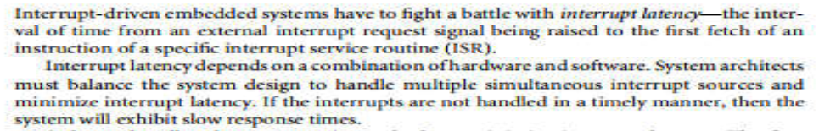 (ii)

1. **Write an embedded C program**
2. To GLOW LED connected to P0.30 pin when switch connected to P0.7 pin is Pressed
3. To LED dimming connected to P1.18 pin using PWM1.1 channel

Ans: #include "lpc17xx.h"

int main(void)

{

LPC_GPIO0->FIODIR |= (1<<30); //P0.30 as O/P

LPC_GPIO0->FIODIR &=~(1<<7); //P0.7 as I/P

while(1)

{

if(!(LPC_GPIO0->FIOPIN & (1<<7));

{

LPC_GPIO0->FIOSET |=(1<<30); // if switch is closed, LED ON

}

}

1. #include<stdio.h>

#include <lpc17xx.h>

uint32_t x;

void delay(uint32_t);

void PWM_init(void)

{

LPC_PINCON->PINSEL3 |= (2<<4);// pwm1.1 , p1.18

LPC_PWM1->TCR=(1<<0);// enable counter and PWM

LPC_PWM1->PR=0;//to fix the period of pwm

LPC_PWM1->MCR=(1<<1);//reset the timer on match

LPC_PWM1->MR0=500;//24999;//ton+toff = 1ms

LPC_PWM1->PCR=(1<<9);//PWM enable

}

int main (void)

{

PWM_init();

while(1)

{

for(x=0;x<=500;x=x+10)

{

LPC_PWM1->MR1=x; //ton,duty cycle = 24999/6250=25%

//ton=12500,duty cycle = 24999/12500=50%

//ton=18750,duty cycle = 24999/18750=75%

LPC_PWM1->LER=(1<<1);//Enable the bits in LER register to load and latch the new

//match values

delay(300000);

}

}

}

void delay(uint32_t i)

{

uint32_t a;

for(a=0;a<=i;a++);

}