**FACTORIAL NUMBER**

**PROGRAM:**

**package** hi;

**import** java.util.Scanner;

**public** **class** factorial {

**public** **static** **void** main(String args[]){

**int** i,fact=1;

**int** number;

Scanner a=**new** Scanner(System.***in***);

System.***out***.println("Enter the number");

number=a.nextInt();

**for**(i=1;i<=number;i++){

fact=fact*i;

}

System.***out***.println("Factorial of "+number+" is: "+fact);

}

}

**OUTPUT:**

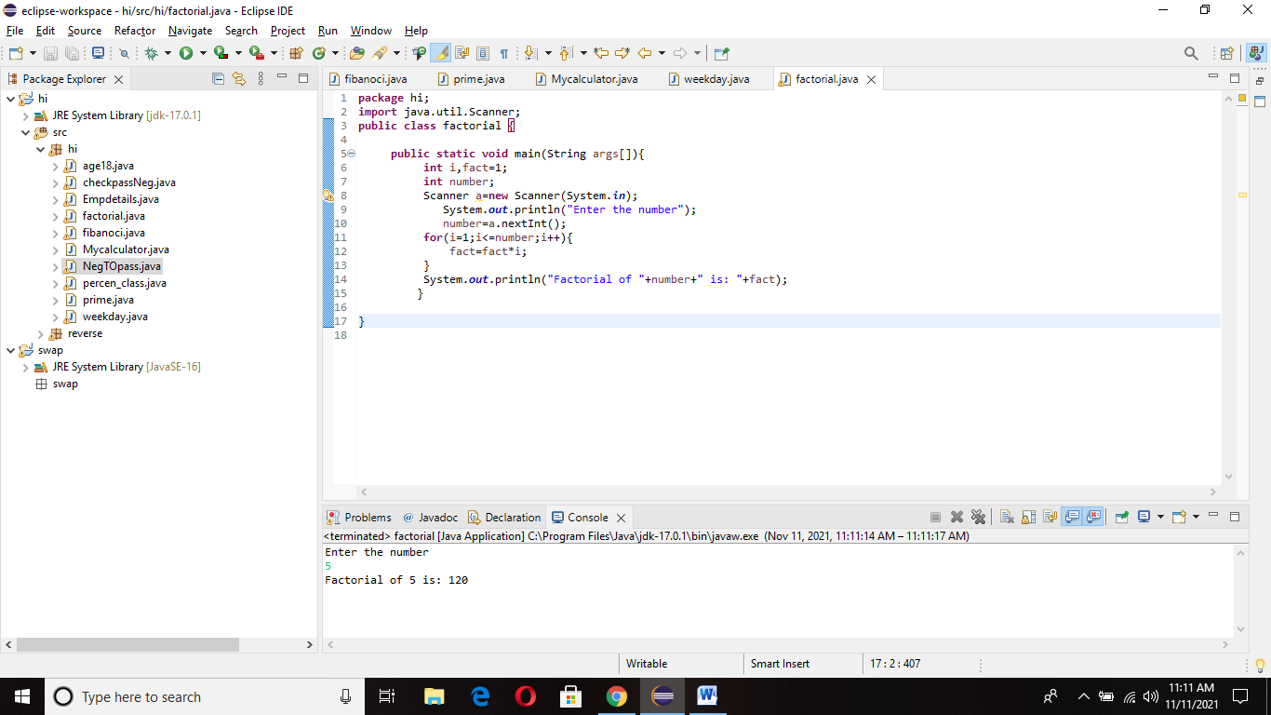

**FIBANOCCI OF A SERIES**

**PROGRAM:**

**package** hi;

**import** java.util.Scanner;

**public** **class** fibanoci {

**public** **static** **void** main (String[] args)

{

**int** n1=0,n2=1,n3,i,count=10;

Scanner a=**new** Scanner(System.***in***);

System.***out***.println("Enter the number");

count=a.nextInt();

System.***out***.print(n1+" "+n2);

**for**(i=2;i<count;++i)

{

n3=n1+n2;

System.***out***.print(" "+n3);

n1=n2;

n2=n3;

}

}

}

**OUTPUT:**

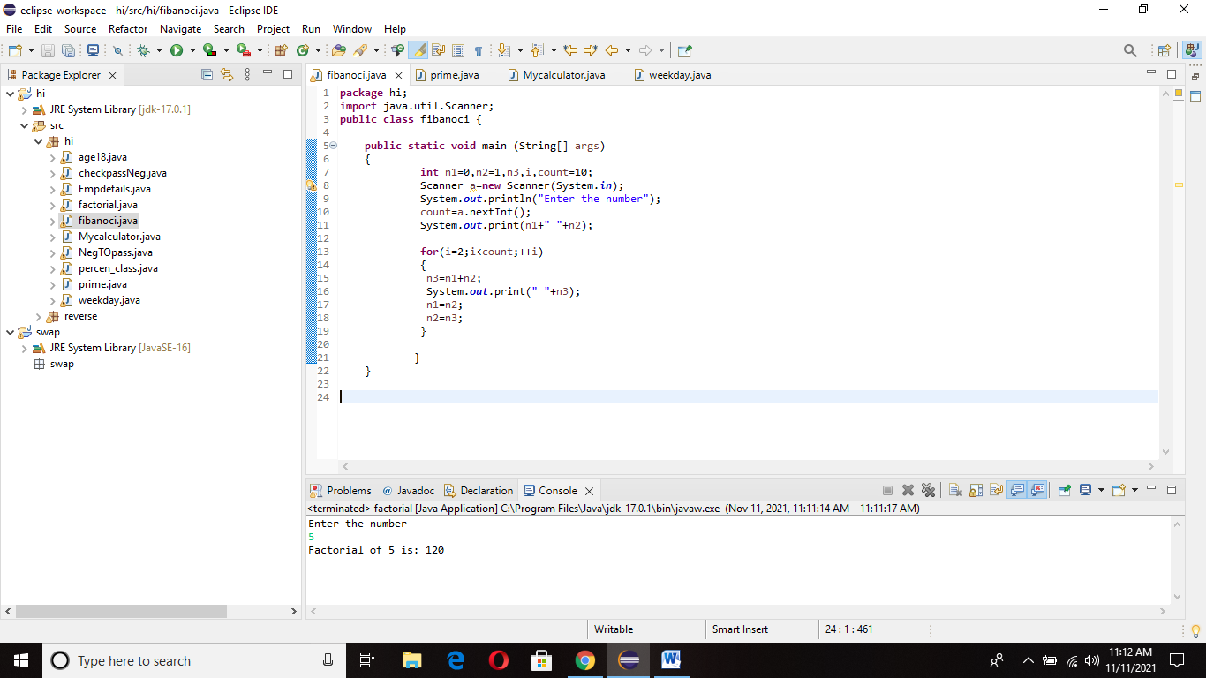

**PRIME NUMBER**

**PROGRAM:**

**package** hi;

**public** **class** prime {

**public** **static** **void** main(String[] args) {

**int** i,a=0,flag=0;

**int** n=96;

**if**(n==0 || n==1) {

System.***out***.println(n+ " Is not a prime number");

}

**else** {

**for**(i=2;i<=a;i++) {

**if**(n%i==0) {

System.***out***.println(n+ " Is not a prime number");

flag=1;

**break**;

}

}

**if**(flag==0) {

System.***out***.println(n+" Is a prime number");

}

}

}

}

**OUTPUT:**

