**Computer Vision TA-2**

**Problem Statements Implemented:**

1. Use RANSAC to remove outlier key point matches and fit a transformation model between two images.
2. Use the Shi-Tomasi corner detector to identify and mark corner points in an image.

**Theory:**

**RANSAC:**

RANSAC (Random Sample Consensus) is an iterative algorithm used to estimate parameters of a mathematical model from a dataset that may contain outliers. Instead of fitting a model to all data points, RANSAC randomly selects a subset of points and fits the model to them. It then checks how many other points fit this model within a certain error margin—these are considered inliers. This process is repeated multiple times, and the model with the highest number of inliers is chosen as the best fit. RANSAC is commonly used in computer vision tasks such as estimating homography between images or finding fundamental matrices in stereo vision, especially when data may include incorrect or misleading points

**Shi-Tomasi:**

Shi-Tomasi Corner Detection is an improvement over the Harris Corner Detection algorithm, aimed at detecting good features to track in an image. It works by analyzing the intensity changes in all directions of a small window around each pixel. Unlike Harris, which considers the response based on a mathematical expression involving both eigenvalues, Shi-Tomasi focuses on the minimum eigenvalue of the gradient matrix. If this minimum value is above a certain threshold, the pixel is considered a strong and stable corner. This method is often used in real-time tracking applications, and forms the basis of the Kanade–Lucas–Tomasi (KLT) tracking algorithm..

Ramsac output

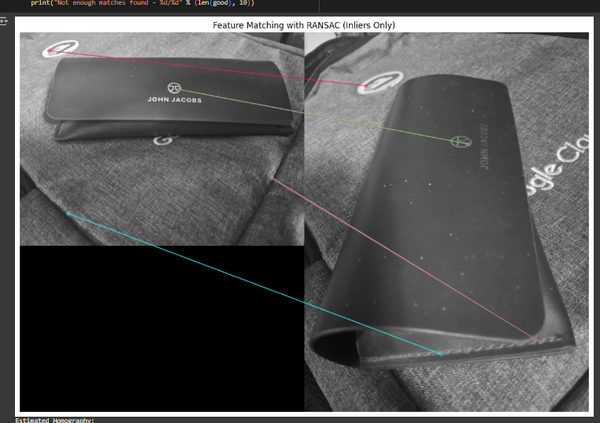

**Shi-Tomasi:**

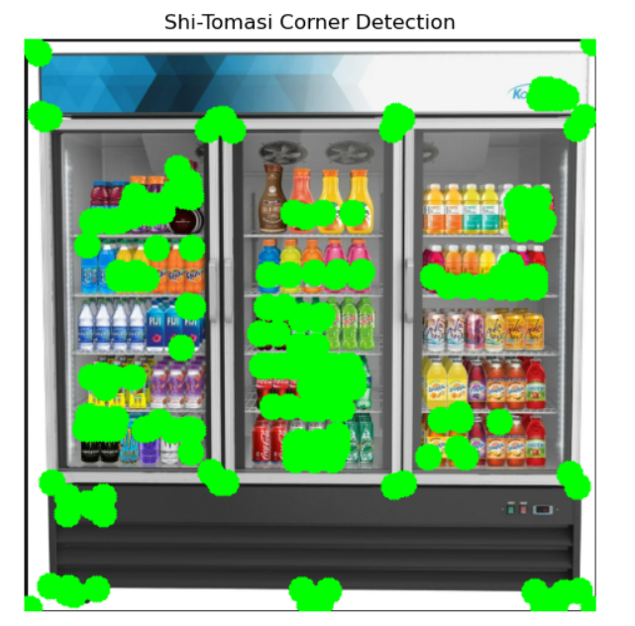

**Observation:**

**RANSAC:** RANSAC was used to filter out mismatched keypoints and estimate a homography for aligning the two images. While it effectively removed many outliers and improved the consistency of matches, the transformation model it generated did not always accurately blend or align the images. In cases with fewer accurate matches or challenging perspective differences, RANSAC struggled to produce a seamless result.

**Shi-Tomasi:** For Shi-Tomasi corner detection, the algorithm identified well-defined and stable corners, particularly in regions with strong intensity changes. Compared to Harris corner detection, it provided better localization of features. However, some corners were left undetected, especially in regions with subtle edges or lower contrast. The method also lacked scale invariance, which made its performance less consistent under zoomed-in or zoomed-out image conditions.

**Conclusion :**

Based on the implementations and results, it is evident that each algorithm has its strengths and limitations. SIFT proved to be effective in detecting keypoints across images with scale and rotation differences but did not always capture all corresponding features, which affected the completeness of image matching. RANSAC was helpful in refining matches by eliminating outliers and fitting a transformation model; however, the alignment results were not always precise, especially in challenging scenarios. Shi-Tomasi corner detection was fast and reliable for detecting corners in high-contrast areas but failed to detect some weaker corners and lacked robustness to scale changes. Overall, these algorithms offer strong foundations for feature detection and matching, but their combined use and further refinement are often necessary for more accurate and reliable computer vision applications.