**DOCUMENTATION FOR ISO 14224 CHATBOT**

* **OVERVEIW:**

This ISO CHATBOT has been created to query the **ISO 14224 2016 edition pdf** toextract essential information about ISO standardsandgenerate insights from different failure code tables.

**Kindly have the python installed in your system, before starting this Application.**

* **HOW to get the Application Running:**

Initially run the Requirements.txt file in the terminal to install all the dependencies.

Then, run this command in the terminal

**“streamlit run Home.py --theme.primaryColor light”**

**Then you will see the App open in a browser as localhost**

**ISO CHATBOT has three pages**:

1. **First page (Home)**:

In this page, it briefly explains about the application and what it does. Users can know about it clearly as shown above.

1. **Second page (DOCUMENT INTELLIGENCE)**:

In this page where you can query the ISO PDF file and get the response from the file with citation.

**STEP 1**: Upload the ISO document in the UI, as shown below.

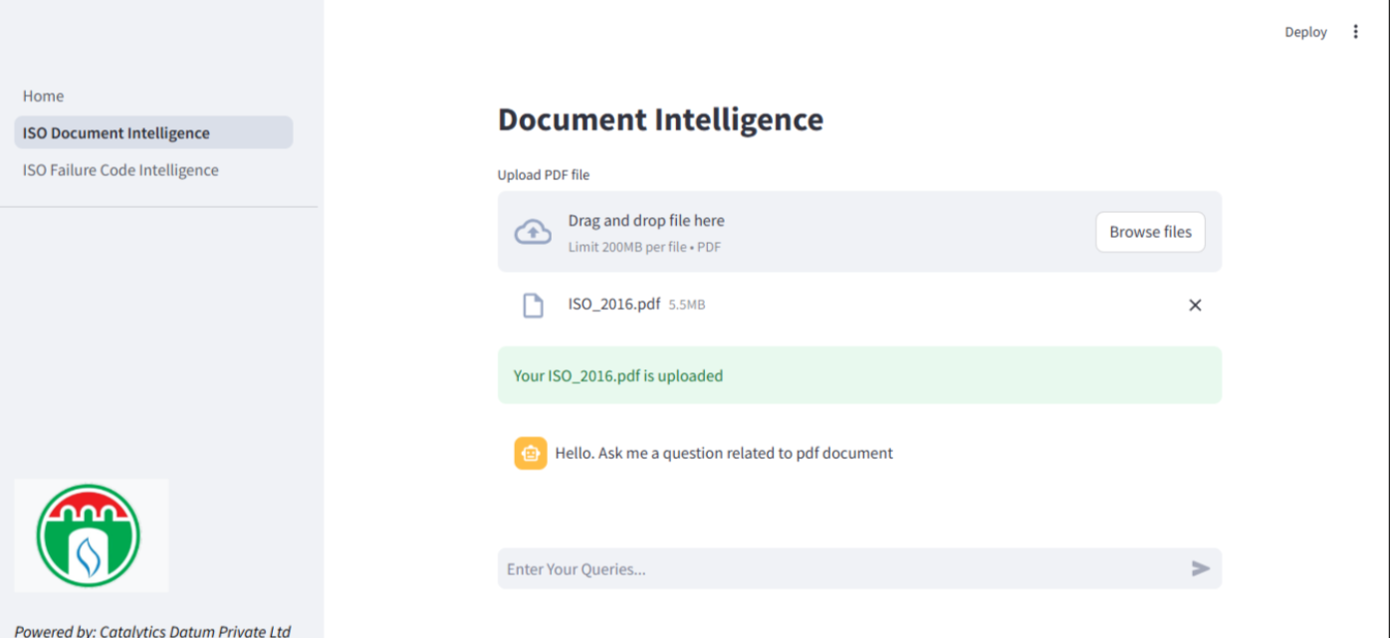

After uploading, you will get a successful message of file upload as shown above and chatbot appears to query the PDF file.

Then, you can query with prompts and see the responses.

After querying, you will see the response with citation like shown below:

1. **Third page (ISO FAILURE CODE INTELLIGENCE):**

As you switch to the next page where you can query the tables of Annexure A and B series tables and get the response with the citation.

**STEP 1**: As you switch to the next page **(ISO FAILURE CODE INTELLIGENCE),** you will see the screen as shown below.

The above shown table explains about the data you are going to query for. It has a short description of what each table contains. Then, the user can choose the table from the dropdown as shown below.

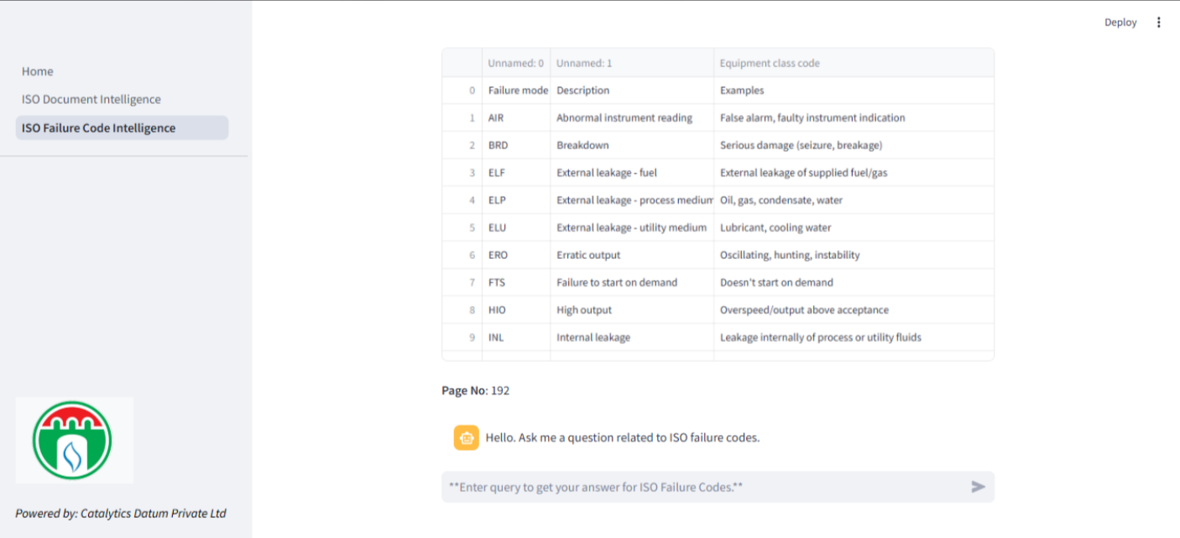 After selection, the table appears, with the citation.

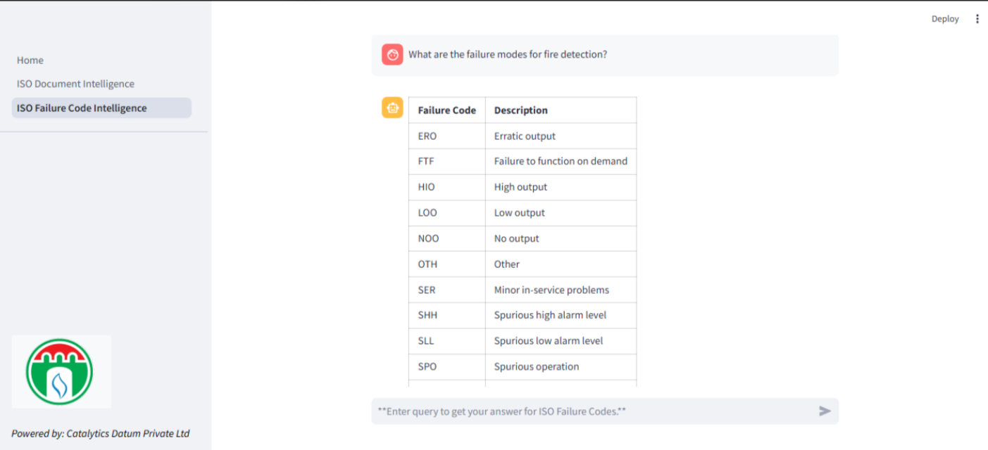After trying out the prompts for the tables, you will see the response as shown below:

It will show the response in a tabular format. And we can validate it also.

While dealing with one table, if you want to switch the table you can go to the dropdown menu and select another table to query for. Currently selected table will be displayed then you can start querying.

The response format will be same for all the tables.

**After querying all the pages, you can close the browser.**

**Here, is the list of prompts for each table that has been tested and validated**

**Table A.4:**

1. Give me details about exchange of RM data  
2. what is Equipment boundary, taxonomy and time definitions   
3. what are Data collection process and its usage  
4. explain Timeline issues in Surveillance and operating period  
5. Explain Logical structure in a database  
6. give me details about Equipment data common to all equipment classes  
7. Explain Equipment boundary definition for compressors   
8. Explain Boundary definitions for fire and gas detectors

**Table b.6:**

1. What are the possible failure modes for combustion engines?

2. What are the potential breakdown scenarios for compressors?

3. How can electric generators experience external fuel leakage?

4. What failure modes could lead to overheating in electric motors?

5. Which failure modes might cause erratic output in gas turbines?

6. What are the potential causes of abnormal vibration in pumps?

7. How might steam turbines experience structural deficiencies?

8. What could cause a failure to start on demand for turboexpanders?

9. What are common parameter deviations in compressors?

10. What failure modes are associated with noise in electric motors?

**Table b7:**

1. What are the possible failure modes for cranes?

2. What could cause insufficient heat transfer in heat exchangers?

3. What failure modes might lead to external leakage of process medium in heaters and boilers?

4. How can structural deficiencies impact pressure vessels?

5. What are potential reasons for failure to rotate in winches?

6. What could lead to power or signal transmission failure in piping systems?

7. What are common failure modes related to internal leakage in storage tanks?

8. What might cause spurious operations in winches?

9. What are the possible causes of overheating in heaters and boilers?

10. What failure modes are associated with noise in piping systems?

**Table b8:**

1. What are the possible failure modes for uninterruptible power supplies?

2. What could cause external leakage of utility medium in power transformers?

3. What failure modes might lead to delayed operation in frequency converters?

4. How can failure to function on demand affect switchgears?

5. What are potential reasons for faulty output voltage in uninterruptible power supplies?

6. What could lead to overheating in frequency converters?

7. What failure modes could result in spurious operation in power transformers?

8. What are common causes of internal leakage in power transformers?

9. How might structural deficiencies impact power transformers?

10. What could cause abnormal noise in switchgears?

**Table b9:**

1. What are the possible failure modes related to abnormal instrument readings in control systems?

2. What are the possible failure modes that can lead to breakdowns in valves or lifeboats?

3. What are the possible failure modes related to delayed operation in control logic units and nozzles?

4. What are the possible failure modes associated with external process medium leakage in valves and input devices?

5. What are the possible failure modes related to erratic output in gas detection and control logic units?

6. What are the possible failure modes that could cause failure to function on demand in valves and nozzles?

7. What are the possible failure modes related to internal leakage in valves and nozzles?

8. What are the possible failure modes that can cause load drops in lifeboats?

9. What are the possible failure modes associated with noise issues in valves and input devices?

10. What are the possible failure modes related to power or signal transmission failures in lifeboats and valves?

**Table b10:**

1. What are the possible failure modes related to abnormal instrument readings in subsea pipelines and pressure vessels?

2. What are the possible failure modes associated with breakdowns in risers and subsea pipelines?

3. What are the possible failure modes related to control or signal failures in subsea production control systems?

4. What are the possible failure modes associated with delayed operations in subsea pumps and risers?

5. What are the possible failure modes related to external leakage of process medium in subsea wellheads, pumps, and pipelines?

6. What are the possible failure modes that could cause failure to connect in subsea wellheads and risers?

7. What are the possible failure modes related to failure to lock or unlock in subsea wellheads and pipelines?

8. What are the possible failure modes associated with insufficient power supply in subsea electrical power distribution and subsea pipelines?

9. What are the possible failure modes related to plugged or choked flow in subsea wellheads, risers, and subsea pressure vessels?

10. What are the possible failure modes related to spurious operations in subsea wellheads, electrical power distribution, and pipelines?

**Table b11:**

1. What are the possible failure modes related to abnormal instrument readings in electrical submersible pumps?

2. What are the possible failure modes associated with breakdowns in electrical submersible pumps?

3. What are the possible failure modes related to control-line-to-well communication loss in downhole safety valves?

4. What are the possible failure modes related to external process medium leakage in downhole safety valves and surface wellheads?

5. What are the possible failure modes that could cause failure to close on demand in downhole safety valves and surface wellheads?

6. What are the possible failure modes associated with internal leakage of process fluids in surface wellheads and X-mas trees?

7. What are the possible failure modes related to spurious operations or premature closure in downhole safety valves and surface wellheads?

8. What are the possible failure modes related to structural deficiencies in electrical submersible pumps and downhole safety valves?

9. What are the possible failure modes associated with plugged or choked flow in electrical submersible pumps and surface wellheads?

10. What are the possible failure modes that could cause vibration issues in electrical submersible pumps?

**Table b12:**

1. What are the possible failure modes related to abnormal instrument readings in all the equipment types?

2. What failure modes are associated with external process medium leakage in downhole safety valves and surface wellheads?

3. What failure modes are linked to external utility medium leakage across all the equipment types?

4. What failure modes are connected to erratic output in all the equipment types?

5. What are the failure modes related to failure to connect and failure to disconnect in downhole safety valves and surface wellheads?

6. What are the failure modes linked to failure to close on demand in downhole safety valves and surface wellheads?

7. What are the failure modes related to internal leakage of process or utility fluids in all the equipment types?

8. What are the failure modes related to noise and overheating in electrical submersible pumps?

9. What are the failure modes associated with plugged or choked lines in downhole safety valves and surface wellheads?

10. What are the failure modes related to structural deficiencies across all equipment types?

**Table b13:**

1. What are the possible failure modes for surface well control equipment during well intervention?

2. What are the possible failure modes for subsea well intervention?

3. What are the possible failure modes related to breakdown in well intervention equipment?

4. What are the possible failure modes involving control or signal failure in well control systems?

5. What are the possible failure modes related to delayed operation in well intervention equipment?

6. What are the possible failure modes involving external leakage of process medium in well intervention systems?

7. What are the possible failure modes related to failure to connect upper connectors in well intervention operations?

8. What are the possible failure modes involving internal leakage of utility fluids in well control equipment?

9. What are the possible failure modes related to failure to open or close on demand in well control systems?

10. What are the possible failure modes involving erratic or spurious operation in subsea well intervention?

**Table b14:**

1. What are the possible failure modes for jacking and fixation systems?

2. What are the possible failure modes involving abnormal instrument readings in jacking systems?

3. What are the possible failure modes related to breakdown or serious damage in jacking and fixation equipment?

4. What are the possible failure modes involving external leakage of utility mediums in jacking systems?

5. What are the possible failure modes related to failure to rotate in jacking equipment?

6. What are the possible failure modes involving insufficient heat transfer in jacking systems?

7. What are the possible failure modes related to low oil supply pressure in jacking equipment?

8. What are the possible failure modes involving noise or abnormal vibrations in jacking systems?

9. What are the possible failure modes related to structural deficiencies in jacking and fixation equipment?

10. What are the possible failure modes involving power or signal transmission failure in jacking systems?

**Table b15:**

1. What are the possible failure modes related to on-demand type failures in equipment systems?

2. What are the possible failure modes involving external leakage of fuel or process medium?

3. What are the possible failure modes related to erratic output or faulty output frequency in equipment systems?

4. What are the possible failure modes involving failure to connect or cut in on-demand operations?

5. What are the possible failure modes related to failure to open or close on demand in equipment systems?

6. What are the possible failure modes involving internal leakage of process or utility mediums?

7. What are the possible failure modes related to failure to regulate or start on demand?

8. What are the possible failure modes involving spurious operation or unexpected shutdown in systems?

9. What are the possible failure modes related to failure to function as intended in on-demand operations?

10. What are the possible failure modes involving overheating, noise, or structural deficiencies in equipment systems?