PROJECT 2
Credit Scoring & Risk Analysis in Lending
Complete Solution — ETL Pipeline, SQL Analysis & BI Dashboard
Dataset: 20,000 synthetic loan applications · 7 UK regions · Apr 2023 – Apr 2025
Prepared September 2026

1. Objective
This project uses a synthetic loan-application dataset of 20,000 records to analyse risk factors, credit score behaviour, and default likelihood across a simulated lending portfolio. The solution is delivered in four stages that mirror a real-world lending analytics workflow: an automated Python ETL pipeline (Phase 0), exploratory data analysis (Phase 1), SQL-based risk and approval analysis (Phase 2), and an interactive BI dashboard covering the KPIs and visuals a credit risk team would monitor day to day (Phase 3).

Deliverables in this package
File | Contents
credit_pipeline.py | Phase 0 ETL pipeline — extract, transform, validate, save functions (runnable end to end)
cleaned_credit_data.csv | Pipeline output: 20,000 validated rows plus 5 engineered columns, ready for SQL / Tableau / Power BI
credit_analysis.db | SQLite database loaded with the cleaned table, for Phase 2 SQL work
phase2_sql_queries.sql | The five required SQL analyses as a standalone script
dashboard.html | Phase 3 interactive dashboard — KPI cards, scatter, bar, pie charts with live Region / Risk Tier / Employment-years filters
This report (.docx) | Full write-up: methodology, code walkthrough, results, and insights

2. Phase 0 — Python Data Pipeline (ETL)
The pipeline follows a standard four-stage ETL pattern so the same cleaned dataset can feed SQL analysis and the BI dashboard without repeating logic in either place.

2.1 Pipeline stages
Function | Purpose | Key logic
extract_credit_data() | Load raw applicant data | Reads the source CSV (20,000 rows, 20 columns) into a DataFrame and logs row/column counts
transform_credit_data(df) | Fix types, engineer features | Casts dates and categoricals; adds debt_to_income_ratio, credit_risk_tier, income_group, approved_flag, late_payment_band
validate_credit_data(df) | Enforce data-quality rules | Flags/drops rows with invalid income, credit score, age, loan amount, or duplicate applicant_id
save_credit_data(df) | Persist cleaned data | Writes cleaned_credit_data.csv (for BI tools) and credit_analysis.db (SQLite, indexed, for SQL work)

2.2 Engineered features
The raw dataset has no missing values, so the transform stage focuses on adding the analysis features the brief calls for, plus a few that make the SQL and dashboard work cleaner:
Column | Definition | Note
debt_to_income_ratio | monthly_expense ÷ (annual_income / 12) | Assumption: the dataset has no explicit monthly-debt-payment field, so monthly_expense is used as the debt-service proxy
credit_risk_tier | 300–579 Poor · 580–669 Fair · 670–739 Good · 740–799 Very Good · 800–850 Exceptional | Standard FICO-style banding
income_group | <30K · 30K–60K · 60K–90K · 90K+ | Used for the “avg. loan size by income group” analysis
approved_flag | 1 if approval_status = Approved, else 0 | Numeric helper for approval-rate calculations
late_payment_band | 0 · 1-2 · 3+ late payments | Used for the risk-by-late-payments analysis

2.3 Validation results
Five data-quality rules were applied: valid income (> 0), valid credit score (300–850), valid age (18–100), valid loan amount (> 0), and no duplicate applicant IDs. The source data is a clean synthetic dataset, so every row passed:
Rule | Rows flagged
Invalid income | 0
Invalid credit score | 0
Invalid age | 0
Invalid loan amount | 0
Duplicate applicant_id | 0
Total retained | 20,000 / 20,000 (100%)

2.4 Core pipeline code
Extract, validate, and save stages (abridged — full source in credit_pipeline.py):
def extract_credit_data(path=RAW_PATH):
df = pd.read_csv(path)
return df

def validate_credit_data(df):
bad_income = df.annual_income.isna() | (df.annual_income <= 0)
bad_score = ~df.credit_score.between(300, 850)
bad_age = ~df.age.between(18, 100)
bad_loan = df.loan_amount.isna() | (df.loan_amount <= 0)
dup = df.duplicated(subset='applicant_id')
bad = bad_income | bad_score | bad_age | bad_loan | dup
return df.loc[~bad].reset_index(drop=True)

def save_credit_data(df):
df.to_csv('cleaned_credit_data.csv', index=False)
with sqlite3.connect('credit_analysis.db') as conn:
df.to_sql('credit_applications', conn, if_exists='replace', index=False)

3. Phase 1 — Exploratory Data Analysis
Before running the required SQL analyses, a quick pandas exploration checks the shape of the underlying variables — this changes how the Phase 2 results should be read.

3.1 Income distribution
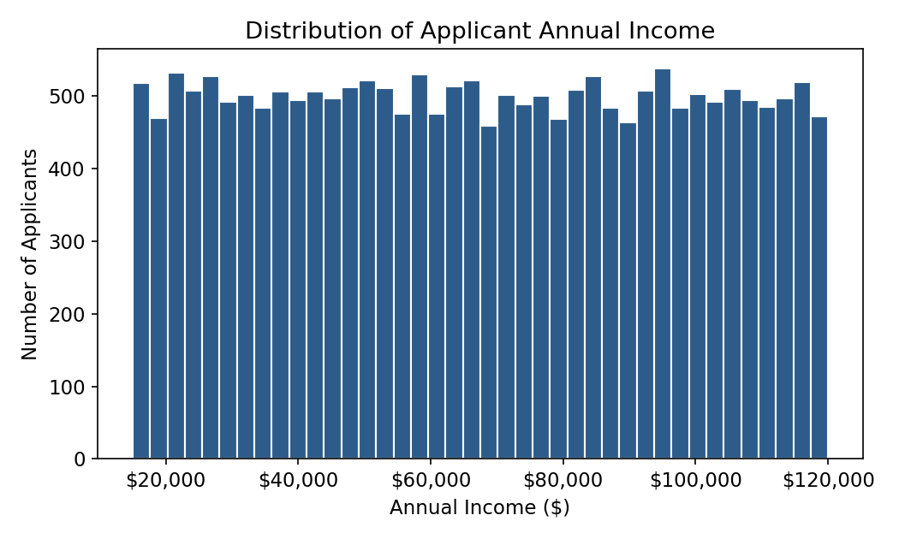
Applicant annual income, $15,011 – $119,998 (mean $67,306, std $30,339, skew ≈ 0.01).
Income is essentially flat across its range rather than concentrated around a typical salary band: the mean, standard deviation, and near-zero skew match what a uniform random draw over $15K–$120K would produce. That is a property of this synthetic dataset — a real applicant pool would show a right-skewed income distribution clustered at lower/mid incomes with a long tail.

3.2 Credit score risk tiers
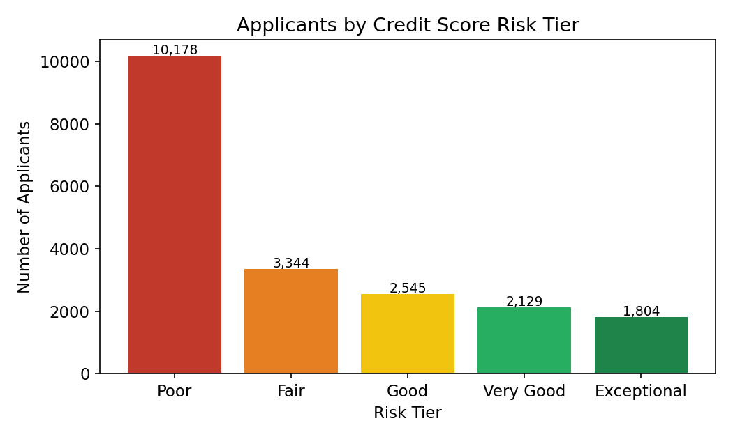
Applicants binned into standard FICO-style risk tiers.
51% of applicants fall into the “Poor” tier (10,178 of 20,000). This is not evidence that the portfolio is unusually risky — credit_score itself is uniformly distributed from 300–850 (mean 574.5, std 158.0, matching the theoretical uniform std of 158.8), and the Poor band (300–579) is simply the widest of the five FICO bands, so it captures the largest share of a flat distribution by construction.

3.3 Employment years vs. approval rate
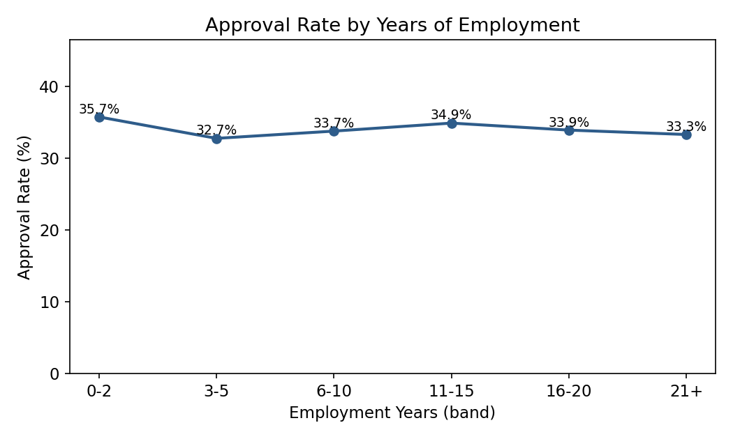
Loan approval rate by banded years of employment.
Approval rate stays in a narrow 32.7%–35.7% band across every employment-tenure group, with no upward or downward trend. In this dataset, employment tenure does not appear to drive approval outcomes — consistent with the uniform/independent generation of the underlying fields noted above.

4. Phase 2 — SQL Analysis
All five queries run against the credit_applications table in credit_analysis.db (SQLite dialect; portable to MySQL/PostgreSQL/T-SQL with minor syntax changes). Full script: phase2_sql_queries.sql.

4.1 Top loan purposes requested
SELECT loan_purpose, COUNT(*) AS num_applications,
ROUND(100.0*COUNT(*)/(SELECT COUNT(*) FROM credit_applications),2) AS pct_of_total
FROM credit_applications
GROUP BY loan_purpose ORDER BY num_applications DESC;

Loan purpose | Applications | % of total
Business | 4,092 | 20.46%
Home | 4,021 | 20.11%
Education | 4,007 | 20.04%
Personal | 3,969 | 19.84%
Car | 3,911 | 19.55%

Demand is essentially even across all five loan purposes (19.5%–20.5% each) — no single purpose dominates applicant intent in this portfolio.

4.2 Approval rates by region and employment type
SELECT region, COUNT(*) AS total,
SUM(CASE WHEN approval_status='Approved' THEN 1 ELSE 0 END) AS approved,
ROUND(100.0*SUM(CASE WHEN approval_status='Approved' THEN 1 ELSE 0 END)/COUNT(*),2) AS approval_rate_pct
FROM credit_applications GROUP BY region ORDER BY approval_rate_pct DESC;
-- (same pattern grouped by employment_status for the second view)

Region | Applications | Approved | Approval rate
Manchester | 2,884 | 1,032 | 35.78%
London | 2,877 | 993 | 34.52%
Leeds | 2,821 | 973 | 34.49%
Glasgow | 2,849 | 976 | 34.26%
Birmingham | 2,849 | 944 | 33.13%
Sheffield | 2,876 | 938 | 32.61%
Liverpool | 2,844 | 924 | 32.49%

Employment type | Applications | Approved | Approval rate
Unemployed | 6,712 | 2,313 | 34.46%
Employed | 6,698 | 2,296 | 34.28%
Self-employed | 6,590 | 2,171 | 32.94%

Approval rates cluster tightly around 33–36% for every region and every employment type — a 3.3-point spread across regions and under 1.5 points across employment types. Neither geography nor employment status is a meaningful driver of approval outcome in this dataset; the small differences observed are consistent with random noise rather than a systematic effect.

4.3 Credit score trends vs. default history
SELECT defaulted_before, COUNT(*) AS num_applicants,
ROUND(AVG(credit_score),1) AS avg_credit_score
FROM credit_applications GROUP BY defaulted_before;

Defaulted before? | Applicants | Avg. credit score | Min | Max
No | 17,967 | 575.3 | 300 | 850
Yes | 2,033 | 567.7 | 300 | 850

Applicants with a prior default average only 7.6 points lower on credit score than those without one (567.7 vs. 575.3) — a small gap on a 550-point scale. In a real bureau dataset, prior default is usually one of the strongest score predictors, so this weak relationship is again a signature of the synthetic, largely independent generation of these fields rather than a market finding.

4.4 Risk classification by late payments
SELECT late_payment_band, COUNT(*) AS n,
ROUND(100.0*SUM(risk_flag)/COUNT(*),2) AS pct_flagged_high_risk,
ROUND(100.0*SUM(defaulted_before)/COUNT(*),2) AS pct_defaulted_before
FROM credit_applications GROUP BY late_payment_band;

Late payments | Applicants | % flagged high risk | % defaulted before
0 | 7,326 | 15.30% | 10.24%
1-2 | 11,053 | 14.96% | 10.30%
3+ | 1,621 | 16.04% | 8.88%

Both the high-risk flag rate (~15–16%) and prior-default rate (~9–10%) stay flat across late-payment bands. In a live risk model, more late payments would normally raise the default rate monotonically — its absence here is a further sign that risk_flag and defaulted_before were generated independently of late_payments in this dataset, worth flagging if the dataset is later used to train a scoring model.

4.5 Average loan size by income group
SELECT income_group, COUNT(*) AS n, ROUND(AVG(loan_amount),2) AS avg_loan_amount,
ROUND(AVG(debt_to_income_ratio),3) AS avg_dti_ratio
FROM credit_applications GROUP BY income_group ORDER BY income_group;

Income group | Applicants | Avg. loan amount | Avg. income | Avg. DTI ratio
<30K | 2,907 | $25,604 | $22,519 | 1.510
30K-60K | 5,743 | $25,294 | $45,067 | 0.762
60K-90K | 5,649 | $25,500 | $74,989 | 0.450
90K+ | 5,701 | $25,603 | $104,933 | 0.312

Average loan size is essentially flat at ~$25,300–$25,600 across every income group — applicants are not requesting larger loans as their income rises. Because loan size doesn't scale with income, the debt-to-income ratio falls sharply as income rises (1.51 in the <$30K group down to 0.31 in the $90K+ group), which is the expected mechanical result of dividing a roughly constant expense figure by a rising income denominator.

5. Phase 3 — BI Dashboard
An interactive dashboard (dashboard.html, delivered alongside this report) covers every visual the brief calls for, with the three requested filters wired to every chart and KPI live in the browser — no Tableau/Power BI licence required to view it. The static equivalents below are captured from the same cleaned dataset for the record; the live file is the primary deliverable for this phase.

5.1 KPI summary
KPI | Value
Average credit score | 574.5
Default rate | 10.17% (2,033 / 20,000)
Approved loans | 6,780 / 20,000 (33.9%)

5.2 Income vs. credit score
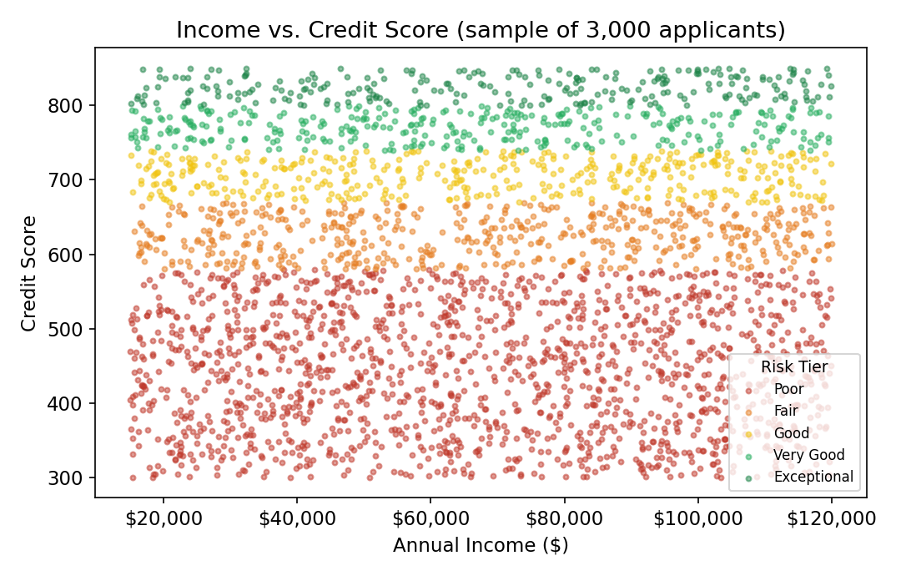
Scatter of income vs. credit score, coloured by risk tier (3,000-point sample).
Points spread evenly across the full income/score plane with no visible clustering by tier along the income axis — consistent with the two variables being generated independently.

5.3 Loan purposes & employment mix
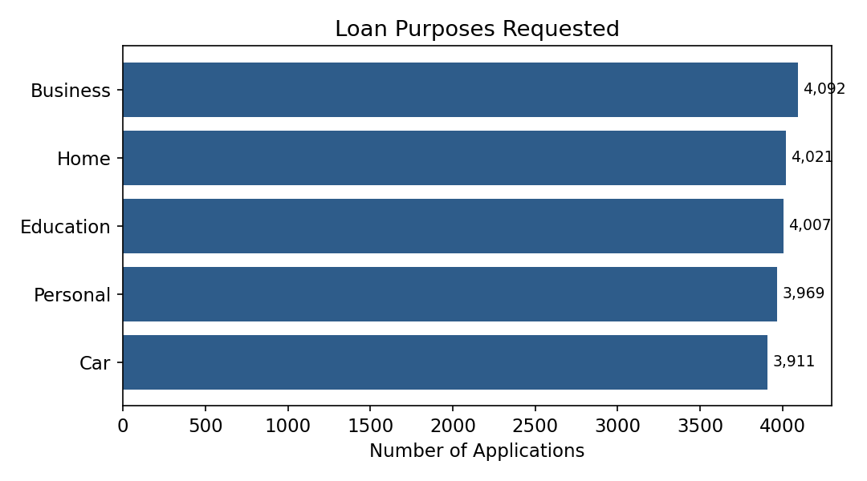
Loan purpose demand (bar).
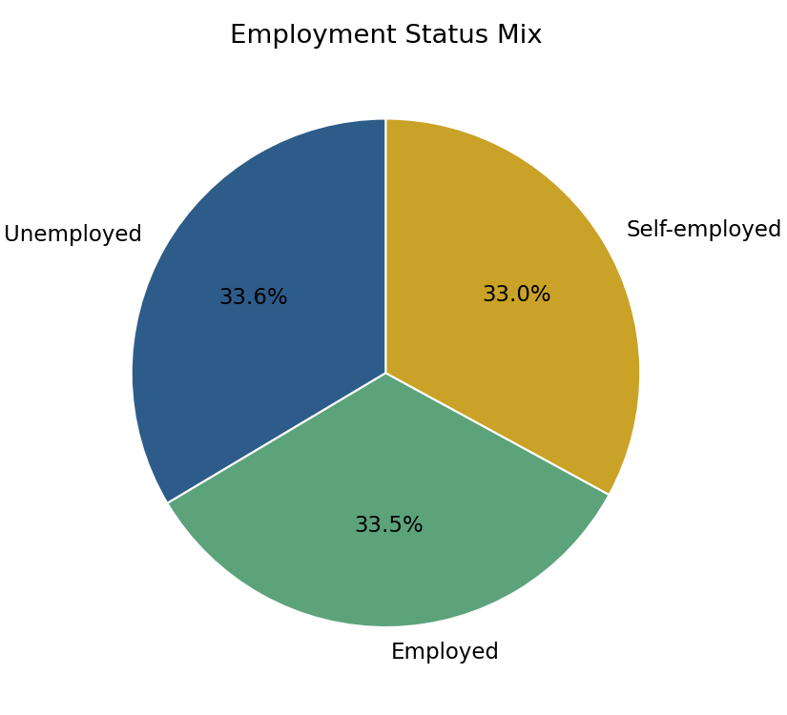
Employment status mix (pie) — 33.6% Unemployed, 33.5% Employed, 33.0% Self-employed.

5.4 Rebuilding the same views in Tableau / Power BI
cleaned_credit_data.csv already contains every field needed — connect it directly and map:
Visual | Fields | Chart type | Notes
KPI cards | credit_score (avg), defaulted_before (avg ×100), approval_status (count where = Approved) | Card / BAN | Power BI: Card visual. Tableau: single-value worksheets pinned to a dashboard
Income vs credit score | annual_income (x), credit_score (y), credit_risk_tier (colour) | Scatter plot | Add a trend line to test correlation visually
Loan purposes | loan_purpose (axis), COUNT(applicant_id) (value) | Horizontal bar | Sort descending by count
Employment status | employment_status (legend), COUNT(applicant_id) (value) | Pie / donut | Keep to 3 slices — avoid a pie with >5-6 categories
Filters | region, credit_risk_tier, employment_years | Slicer (Power BI) / Filter shelf + Quick Filter (Tableau) | Apply as report-level / dashboard-level filters so they affect every visual

6. Key Insights & Recommendations

6.1 What the data shows
- Loan demand is balanced across all five purposes (~20% each) — no single product line dominates intake.
- Approval rate sits in a tight 33–36% band regardless of region or employment status; geography and employment type are not meaningful approval drivers here.
- Credit score, income, and employment tenure are each close to uniformly distributed and largely independent of one another and of the outcome fields (approval, default, risk flag).
- Debt-to-income ratio scales as expected with income group (1.51 → 0.31 from lowest to highest income band), since average loan size barely moves across income groups.
- Late-payment count does not show a monotonic relationship with either the risk flag or prior default — a pattern a real underwriting dataset would not normally show.

6.2 Recommendations
- Treat this dataset as a pipeline/BI proving ground rather than a source of lending strategy: the weak correlations above mean the ETL → SQL → dashboard mechanics are sound, but the findings themselves shouldn't be read as real market behaviour.
- If a scoring model is trained later, engineer interaction features deliberately (e.g. late_payments × credit_risk_tier, employment_years × loan_amount) since none currently carry a built-in signal.
- For a production version, add an interest-rate / installment field so debt_to_income_ratio can be computed from actual debt service rather than the monthly_expense proxy used here.
- Re-run the validation stage whenever new data lands — the pipeline's five rules (income, score, age, loan amount, duplicates) are cheap checks worth keeping in any refresh job.

6.3 Assumptions log
- debt_to_income_ratio uses monthly_expense as a proxy for monthly debt service, since no explicit debt-payment column exists in the source data.
- credit_risk_tier uses standard FICO-style bands (Poor/Fair/Good/Very Good/Exceptional); these bands are unequal in width, which affects tier counts (see §3.2).
- income_group bands (<30K / 30K-60K / 60K-90K / 90K+) were chosen to give roughly even group sizes given the ~$15K-$120K income range.
- Validation age range (18-100) is a general working-adult bound; the observed data (21-64) sits comfortably inside it.

Appendix — Data Dictionary

Original columns
Column | Type | Description
applicant_id | text | Unique applicant identifier (UUID)
name | text | Applicant name
gender | category | Female / Male / Other
age | int | Applicant age (21-64 observed)
marital_status | category | Single / Married / Divorced / Widowed
employment_status | category | Employed / Self-employed / Unemployed
annual_income | float | Annual income, $
loan_amount | float | Requested loan amount, $
loan_term_months | int | Requested term, months
loan_purpose | category | Business / Car / Education / Home / Personal
credit_score | int | 300-850
existing_loans_count | int | Number of existing loans
monthly_expense | float | Reported monthly expenses, $
application_date | date | 2023-04-23 to 2025-04-22
approval_status | category | Approved / Denied / Pending
late_payments | int | Count of late payments, 0-8
risk_flag | int (0/1) | High-risk flag
region | category | 7 UK cities
employment_years | int | Years in current employment, 0-29
defaulted_before | int (0/1) | Prior default indicator

Engineered columns (added in Phase 0)
Column | Type | Description
debt_to_income_ratio | float | monthly_expense ÷ (annual_income / 12)
credit_risk_tier | category | FICO-style band derived from credit_score
income_group | category | Banded annual_income
approved_flag | int (0/1) | 1 if approval_status = Approved
late_payment_band | category | late_payments grouped 0 / 1-2 / 3+

