# Generated Math Questions

@title Uniform Combinations at Greenwood High

@description Determine the number of unique uniform combinations possible based on given clothing options.

@question Each student at Greenwood High School wears a uniform consisting of 1 polo shirt and 1 pair of trousers. The table below shows the colors available for each item of clothing. How many different uniform combinations can be made?

## Uniform Options

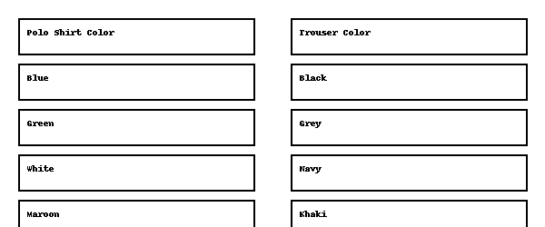

@instruction Select the correct answer.

@difficulty easy

@Order 1

@option Ten

@option Twelve

@@option Sixteen

@option Twenty

@option Twenty-four

@explanation Multiply the number of shirt colors (4) by the number of trouser colors (4) to get 16 combinations.

@subject Quantitative Math

@unit Problem Solving

@topic Numbers and Operations

@plusmarks 1

@title Dimensions of a Box of Cylinders

@description Calculate the approximate dimensions of a rectangular box containing stacked cylindrical cans based on given measurements.

@question A rectangular box contains 8 identical cylindrical cans arranged in 2 rows and 4 columns, as shown in the top view image below. If each can has a radius of 3 cm and a height of 10 cm, what are the closest dimensions (length × width × height) of the box in centimeters?

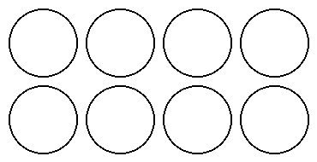

@instruction Select the correct answer.

@difficulty moderate

@Order 2

@option 6 × 12 × 10

@option 6 × 24 × 10

@@option 12 × 24 × 10

@option 12 × 24 × 12

@option 6 × 24 × 12

@explanation Width = 2 × radius × rows = 12 cm, Length = 2 × radius × columns = 24 cm, Height = 10 cm.

@subject Quantitative Math

@unit Geometry and Measurement

@topic Area & Volume

@plusmarks 1

GitHub Repository Link (replace with your own after upload): https://github.com/yourusername/math_questions_repo