

DSA8002 Assignment

Singapore Airbnb Data Analysis

Yogesh Kashiram Bore

Student No:40311162

Email: ybore01@qub.ac.uk

Contents

1. Background: 2

1.1 Domain information: 2

1.2 Technical information: 2

2. Class Design: 3

2.1 Class information: 4

3. Database Design: 5

4. SQL Operation Design: 6

5. Essential Key Code Snippets: 7

6. Project Demo: 16

7. Unit Testing Cases: 18

8. Summary: 19

9. References: 20

10. Appendix: Source Code 21

Appendix A: Host Code 21

Appendix B: Neighbourhood Data Code 25

Appendix C: Neighbourhood Group Data Code 28

Appendix D: Review Data Code 32

Appendix E: Room Data Code 37

Appendix F: Room Type Data Code 41

Appendix F: Inheritance Code 44

Appendix G: Unit Testing Code 46

Appendix H: Demo Function Code 48

# Background:

In this project Airbnb in Singapore listing data analysis, cleaning and converting into useful form is done along with data operations like insert, update, delete. I have tried to distribute every Airbnb listing based on their host, review, room type, Neighbourhood data, and few other things. Given 7907 sample data from listing csv file is used for Data analysis, cleaning and perform certain operations to convert data into normal form and store it into data frame by using python panda’s library. Then insert this sorted and cleaned data into database in Sqlite3. Then created a relational database to perform like display, insert, update, and delete operations. Python classes are used for development.

Data analysis on millions of listings provided through Airbnb is a difficult to make conclusions and take decisions for the organization. So we took this raw data transform it into a structured data using database normalization and make it ready for organization to take the decisions and to find out the answers of the questions by populating the data from the created database. In this project

We populated listing records that has 200 or above total reviews in the database. We can get answer of the multiple such questions by populating required data. It is really easy for organization to take decision from these answers and populated data.

## 1.1 Domain information:

I used an Airbnb in Singapore listing dataset from www.kaggle.com, Today Airbnb is one of the most commonly used service worldwide which is creating a huge amount of data day by day. Every day millions of listing generated. Airbnb is rapidly used in Singapore as it is great tourist place. So we used this data set to perform data operations and analysis.

The listing csv file which we get has the raw data present in it which is not in a structured format. These data has the duplicate and blanks values for some fields. Data redundancy is there similar type of data present for multiples records. We have to transform all these data into normal form, clean it and make it structured. So that we can make use of it.

## 1.2 Technical information:

The development of this project Python 3.9.0, Any Python IDE (Pycharm Used), SQLite 3.34.1 for Data Base Python libraries pandas, numpy, and SQLite3 should be added in AN IDE, MS-Excel for input file all other details are provided in the readme file. Panda’s library is used to performance data manipulation in Python. Data frame is used to perform all the operations on the data. Data analysis requires cleaning, merging, and restructuring for which pandas is the best solution which can perform all these operations.

Sqlite3 is used for all the database operations like from create database to the inserting updating deleting record from table through python. SQLite library is imported into the python file to perform all this operations without any operations.

# Class Design:

I have created 6 python classes for Airbnb listing based on their host, review, room type, and Neighbourhood data for implementation.

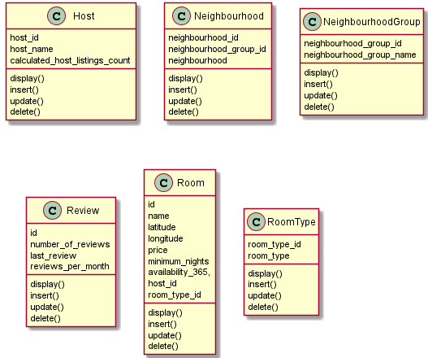

There are more 2 classes created one is for Unit testing and one Demo class for project presentation and use:

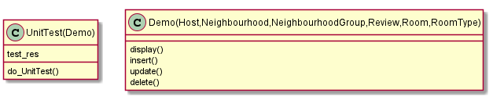

## 2.1 Class information:

1. **Host :** Host class contains all the host attributes like host id , host name, calculated_host_listings_count and functions to perform operations on host data like insert update, delete and display In this class I have extracted the all the host related data, performed data validation and data cleaning and stored it into Host table.
2. **Neighbourhood:** Neighbourhood class contains all the neighbourhood attributes like neighbourhood_id, neighbourhood_group_id, neighbourhood and functions same like host calls we perform operations on neighbourhood data.
3. **NeighbourhoodGroup:** NeighbourhoodGroup class only have 2 class attributes which is used to perform all the operations on the Neighbourhood Group data.
4. **Review:** Review class is design to perform all the operations on the review data which, we got from the listing. It has the class attributes like id, number_of_reviews, last_review, reviews_per_month
5. **Room:** In room class we have attributes designed for room related data: id, name, latitude, longitude, price, minimum_nights, availability_365, host_id, room_type_id and all the operation functions which all other classes have display insert update delete.
6. **RoomType:** This class contains two attributes room id and room type like this class and all the functions which other classes have.
7. **UnitTest:** Unit testing class contains functions to test display, insert, update, delete operations and test_res class attribute to check the test case passed or failed.
8. **Demo:** Demo class import all the other classes Host, Neighbourhood, NeighbourhoodGroup, Review, Room, RoomType and UnitTest. Objects of all classes created in this class and call the respective class functions as per the user’s choice. This class file is the entry point for all operations.Menu options are provided in this class.

# Database Design:

Airbnb in Singapore listing data csv is used to import the data, and design the database. Given dataset is having 7907 records. All the data given in a single file. Data is not in structured form. There are 16 columns given in the file some of columns have no values, also some redundant data present.

Normalization is used to convert this unstructured data into multiple 6 tables. Also removed the redundant data. And convert it into 1NF that first normal form where no redundant value is allowed for each table cell. And each record should be unique. Created a relationship between all 6 tables so that it can satisfies 1NF rules. And our data is clean and structured format.

Now to create a relationship between all tables we have to use the key. A KEY is used to identify a record in a table uniquely. Also Foreign Key is used to references the primary key of another Table. Given data is divided into below 6 tables and applied both primary and foreign key on it so that it can be in 1st normal form:

|  |  |  |
| --- | --- | --- |
| **Host Table : host** | | |
| **Column** | **DataType** | **Key** |
| host_id | INTEGER | Primary Key |
| host_name | TEXT |  |
| calculated_host_listings_count | INTEGER |  |
|  |  |  |
| **Neighbourhood Table :nbh_data** | | |
| **Column** | **DataType** | **Key** |
| neighbourhood_id | INTEGER | Primary Key |
| neighbourhood_group_id | INTEGER | Foreign Key |
| neighbourhood | TEXT |  |
|  |  |  |
|  |  |  |
| **NeighbourhoodGroup Table :nbh_grp** | | |
| **Column** | **DataType** | **Key** |
| neighbourhood_group_id | INTEGER | Primary Key |
| neighbourhood_group_name | TEXT |  |
|  |  |  |
|  |  |  |  |
| **Review Table :review** | | |
| **Column** | **DataType** | **Key** |
| id | INTEGER | Foreign Key |
| number_of_reviews | INTEGER |  |
| last_review | TEXT |  |
| reviews_per_month | REAL |  |
|  |  |  |
|  |  |  |
| **Room Table: room** | | |
| **Column** | **DataType** | **Key** |
| id | INTEGER | Primary Key |
| name | TEXT |  |
| latitude | REAL |  |
| longitude | REAL |  |
| price | INTEGER |  |
| minimum_nights | INTEGER |  |
| availability_365, | INTEGER |  |
| host_id | INTEGER | Foreign Key |
| room_type_id | INTEGER | Foreign Key |
|  |  |  |
| **RoomType Table :roomtype** | | |
| **Column** | **DataType** | **Key** |
| room_type_id | INTEGER | Primary Key |
| room_type | TEXT |  |

# SQL Operation Design:

Sqlite3 is used to create a data base. First import the Sqlite3 as below:



Created a connection and cursor to perform operations on data:

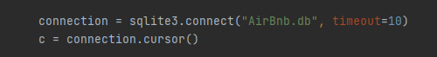

First check if the table with same name is created in work space if not created then create a new table using below logic:

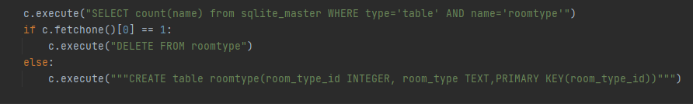

In above example created a table for roomtype, same logic is used for all other 6 table. All other 5 tables are created as mentioned in the above tables.

Data Base Design:

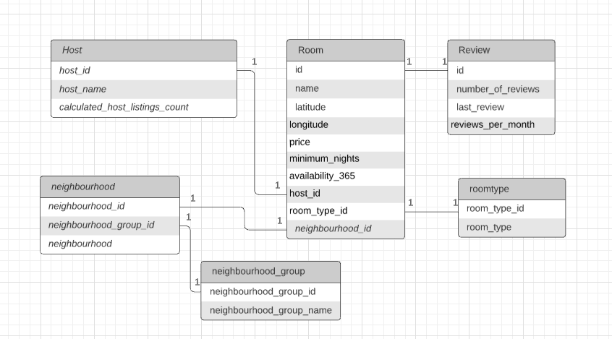

# Essential Key Code Snippets:

1. **Data cleaning:** By using below code snippets required fields from csv file are copied to the host_df data frame and then drop the duplicate values from the data frame same code is used for all other tables imported the required data from the listing csv file according to the table columns and create a data frame then clean that data using below code:

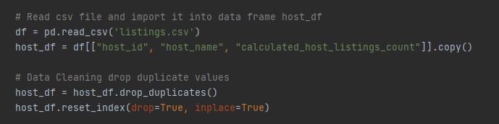

In room data observed some fields are blank for room name column. Fill that values with some data using below code snippet: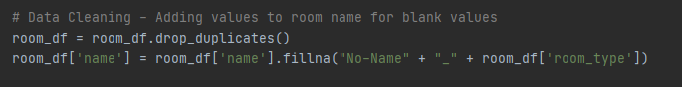

1. **Create DB Connection and Table:** Create a Sqlite3 connection and cursor c then create a table for respective class given above in SQL operation and insert that data from data frame to table :

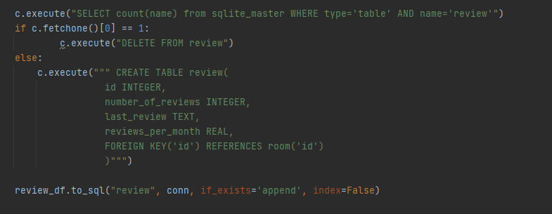

1. **Display the Records:** One option is given to check the data in demo so that we can get the data by calling to the display function. This type of function is written for all 6 classes. In below example display function is given for the roomtype class:

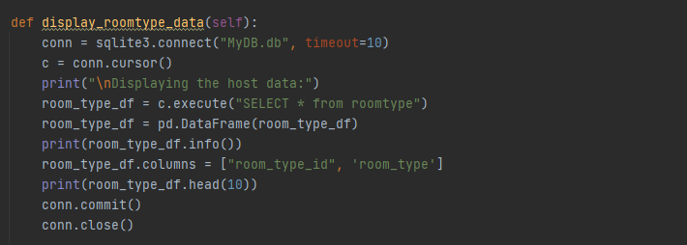

1. **Insert Data :** To insert the new data in the table for all 6 options host, room, review, room, neighbourhood data below function is used:

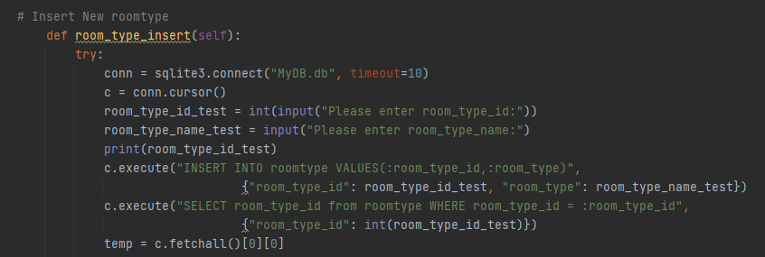

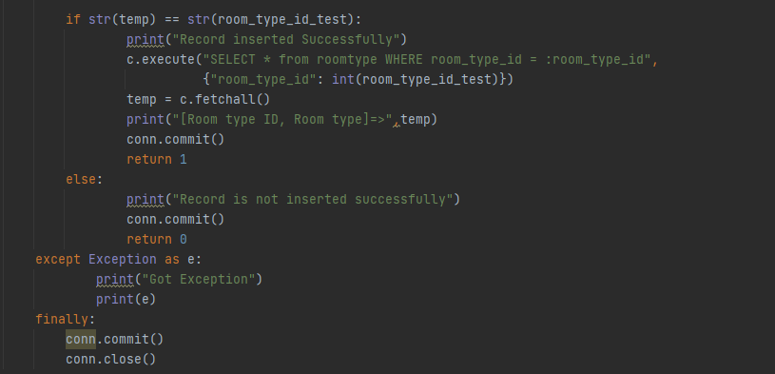

Same logic used for all other tables as well.

1. **Insert Room Data Using Excel file:** For room data insertion we can insert multiple records at a time using input_data file given in project folder. Just we have to update the file for new data. We can apply the data validation in the excel file so that only valid data can be inserted into the table. Below code is used to update the room data. This feature is given only for room data:

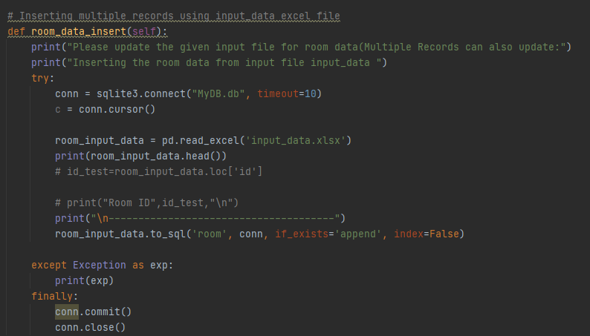

**Input Excel File: input_data.xlsx:**

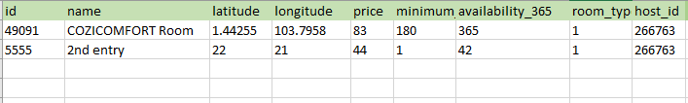

1. **Update Existing Data:** To update the data we need some unique constraint for any table like room id, host id then for that record we can update the data as per the user input.

Here we are also checking the key constraints and data validation so we have to enter the valid data while updating any record. Below code is given for the neighbourhood data:

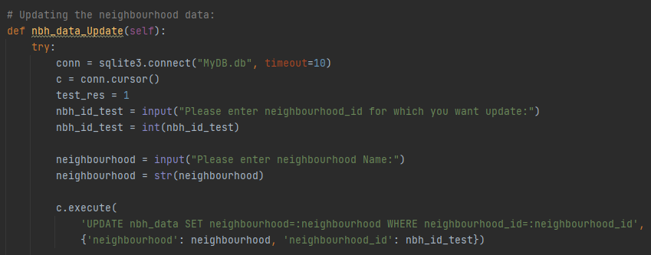

After this we will check by using select weather the data is updated correctly in the table or not by using below code:

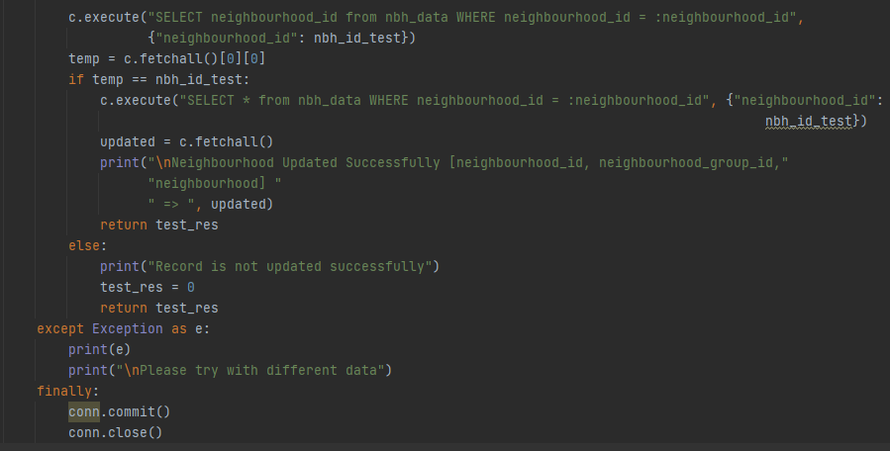

1. **Data Validation:**  While inserting new data into table we are checking whether data is already exist in the table by using primary key constraints and also validating input data using data type given while creating table. Also we are validating the date input entry whether it is in correct format like: YYYY-MM-DD or not. If not it will give an error message. We can see the unit cases for this. Below is code given to check the date in update and insert option here import datetime to validate date :

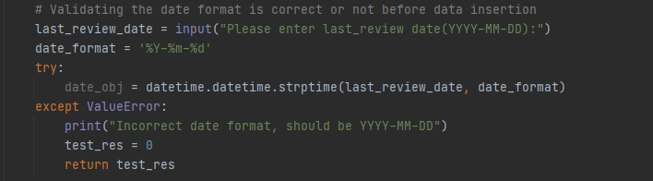

1. **Delete a Record:** To delete record we need some unique key for which we need to delete the record and It should be present in the table so first we will check the given input for which records need to delete is available in the table or not. If it is not available then throw an error message. Otherwise delete the record for valid id:

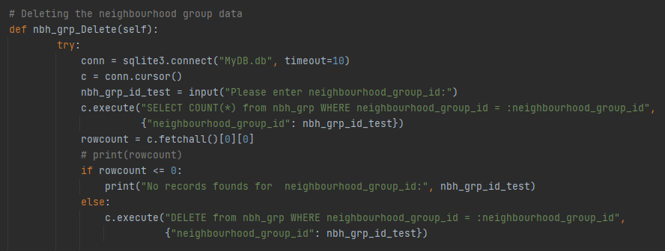

After deleting the record we have to cross check if the record is deleted successfully or not by using select query for id which we recently deleted if we didn’t get any output means record is deleted successfully. Below is the code continues to check if it deleted or not:

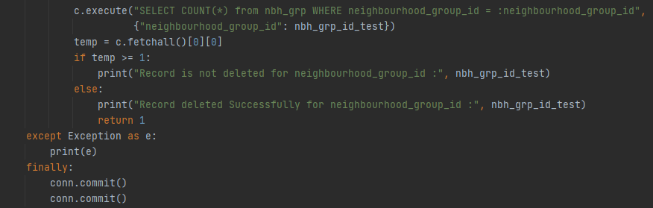

1. **Unit Test:** For unit testing of each functionality by passing the class object for which we have to test, the function which we have to test and if the function works successfully then we will get actual value as 1 then given functions works successfully. If we get other than 1 the function is not worked as expected and test case failed.

In below code we are checking if review data can be deleted successfully or not. We passed review delete function, review object and expected result as 1 to test_review_Data_delete function and checked:

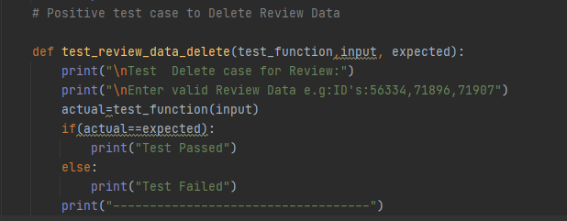

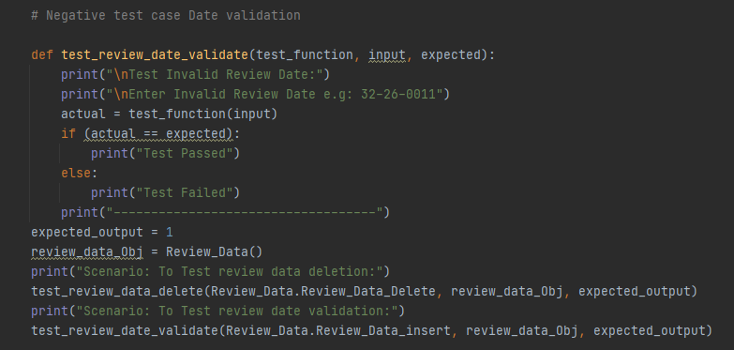

Also in negative test case we are checking date format review insert function to test function we can also do this using review update function.

1. **Demo:** This class is the entry point for our project from where we can perform all the operations like data display, insert, update, delete. Also we can populate data on given condition in the assessment that populate all the data/listing that has 200 or above total reviews in option 5.

While loop and if elif else is used for Demo main menu and submenus for all options:

Main Menu as given below:

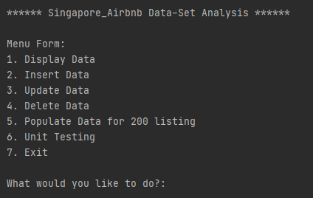

And Submenu for Insert, Update, and Delete is like:

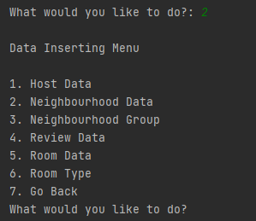

1. **Populate Data for 200 or more review in listing:**  We can use total number of review condition and filter the data from review table then by using inner join combine two join and populate the required data also we are creating a csv file to store a populated data. By using below code we can populate data for 200 or more review and store it into csv file:

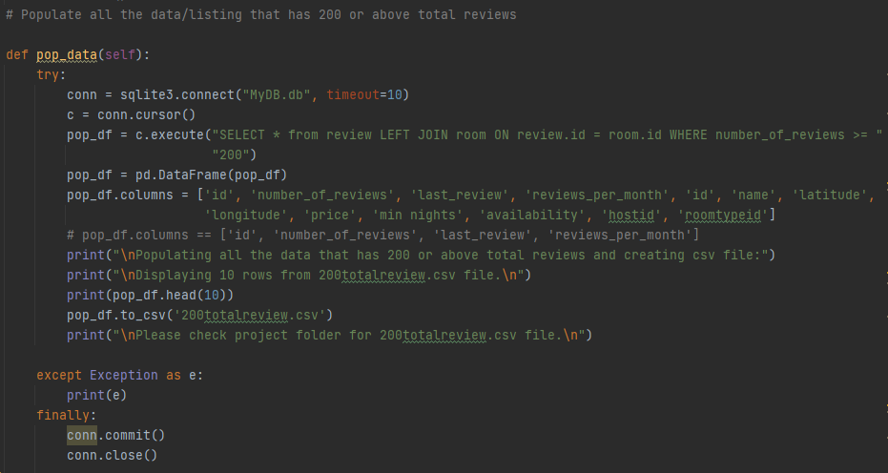

**Result for Populate Data for 200 or more review in listing option 5 from main menu:**

Also check the project folder for created 200totalreview.csv file

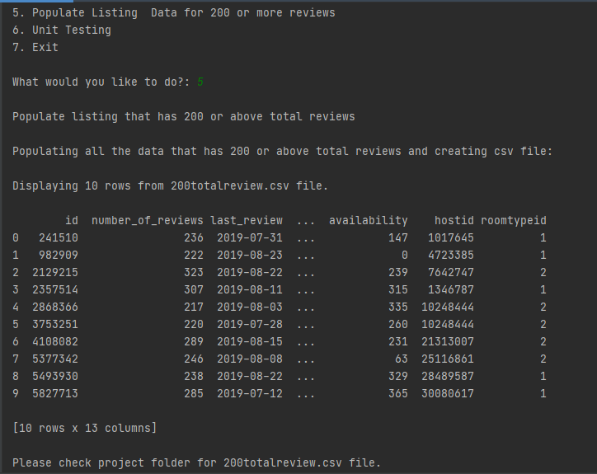

# Project Demo:

In this section we can see the execution of each operation like insert update delete and display for any random table. However same operations are possible for all other table. Only for room data we are using the excel file for data entry because there are multiple fields present in room data. And one advantage is we can insert multiple room records at time using file input which is shown earlier. Except of that all other operations are almost similar for all data just the input is changed according to the table.

The below snippets can show the execution for each operation we are performing for all data. For demo selected random tables below:

1. **Display Data : (e.g. Displaying Host Data)**

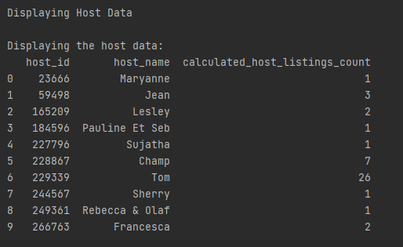

1. **Insert Data: (e.g. Inserting Neighbourhood Data)**

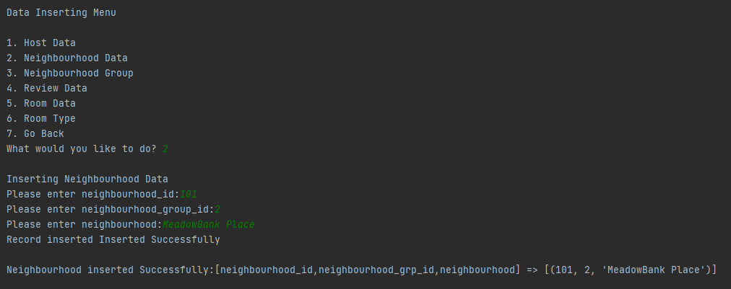

1. **Update Data: (e.g. Updating Review Data)**

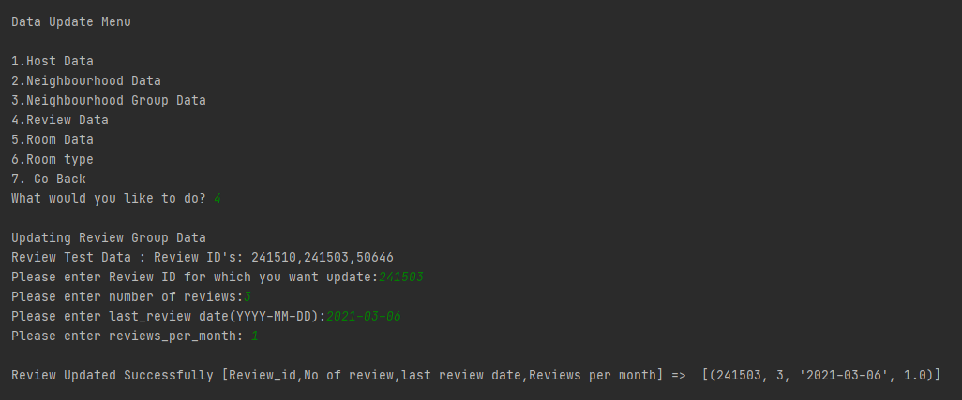

1. **Delete Data: (e.g. Deleting Room Data)**

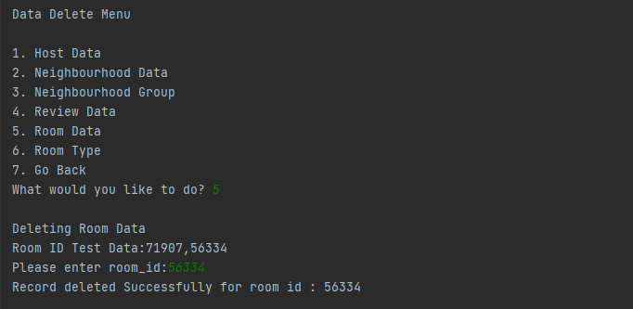

1. **Populate Data for 200 or more review in listing:**  Result is given in above section for this
2. **Unit Testing:** In next section unit testing demo is given separately.
3. **Exit:** To stop the execution of program and End.
4. Unit Testing Cases:

For unit testing created a separate class to perform some random scenario testing below results we will get after performing unit testing in option 6 from menu option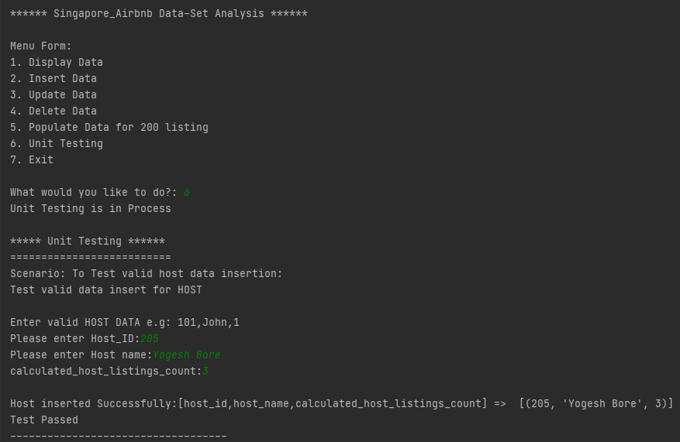

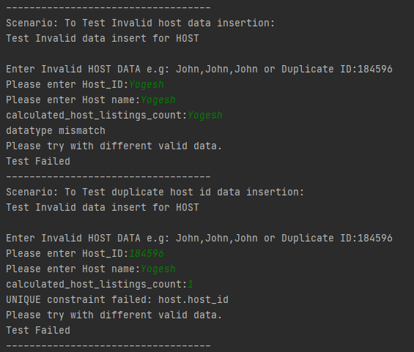

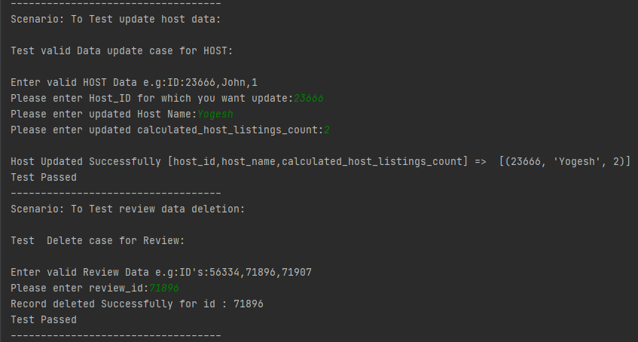

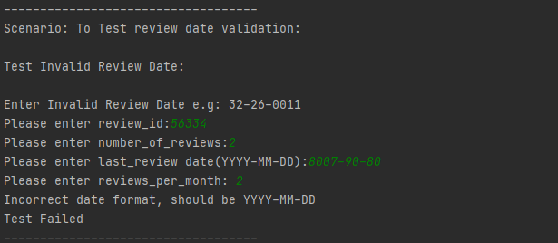

# Summary:

In this project Singapore Airbnb listing data Analysis we transformed unstructured data into a structured one and perform operations on the data like display, insert, update and delete. To perform all this operations we used data frames from the python panda’s library. And On the given condition we populated data and created a new csv file to insert populated data. Also for room data insertion we used excel file. So that we can insert multiple records at time. Data validation done while inserting and updating data using some panda’s inbuilt functions. We successfully converted raw data into structured format so that we can make use of it and take decision.

# References:

1. Python: https://www.python.org/downloads/

2. SQLite3: https://www.sqlite.org/releaselog/3_34_1.html

3. Python Numpy Library: https://numpy.org/install/

4. Python Pandas Library: https://pandas.pydata.org/pandas-docs/

5. Airbnb listing dataset: https://www.kaggle.com/jojoker/singapore-irbnb

# Appendix: Source Code

## Appendix A: Host Code

import pandas as pd  
import sqlite3  
  
  
class Host_Data:  
 # Read csv file and import it into data frame host_df  
 df = pd.read_csv('listings.csv')  
 host_df = df[["host_id", "host_name", "calculated_host_listings_count"]].copy()  
  
 # Data Cleaning drop duplicate values  
 host_df = host_df.drop_duplicates()  
 host_df.reset_index(drop=True, inplace=True)  
  
 conn = sqlite3.connect("MyDB.db", timeout=10)  
 c = conn.cursor()  
  
 c.execute("SELECT count(name) from sqlite_master WHERE type='table' AND name='host'")  
 if c.fetchone()[0] == 1:  
 c.execute("DELETE FROM host")  
 # c.execute("DROP TABLE host")  
  
 else:  
 c.execute('''CREATE TABLE host(  
 host_id INTEGER PRIMARY KEY,  
 host_name TEXT,  
 calculated_host_listings_count INTEGER)''')  
  
 host_df.to_sql('host', conn, if_exists='append', index=False)  
  
 conn.commit()  
 conn.close()  
  
 # c.execute("SELECT * FROM host")  
 # print(c.fetchall())  
 # Insert Host data  
  
 @staticmethod  
 def host_insert():  
 conn = sqlite3.connect("MyDB.db", timeout=10)  
 c = conn.cursor()  
  
 try:  
  
 test_res = 1  
 host_id_test = input("Please enter Host_ID:")  
 host_name_test = input("Please enter Host name:")  
 list_count_test = input("calculated_host_listings_count:")  
  
 c.execute("INSERT INTO host VALUES(:host_id,:host_name,:calculated_host_listings_count)",  
 {"host_id": host_id_test, "host_name": host_name_test,  
 "calculated_host_listings_count": list_count_test})  
 # self.conn.commit()  
 c.execute("SELECT host_id from host WHERE host_id = :host_id", {"host_id": host_id_test})  
 temp = c.fetchall()[0][0]  
 # print(temp)  
 # print(type(host_id_test))  
  
 if str(temp) == host_id_test:  
 c.execute("SELECT * from host WHERE host_id = :host_id", {"host_id": host_id_test})  
 inserted = c.fetchall()  
 print("\nHost inserted Successfully:[host_id,host_name,calculated_host_listings_count] => ", inserted)  
 conn.commit()  
 return test_res  
 else:  
 print("Host Record is not inserted successfully")  
 # self.conn.commit()  
 test_res = 0  
 return test_res  
  
 except Exception as e:  
 print(e)  
 print("Please try with different valid data.")  
 finally:  
 conn.commit()  
 conn.close()  
  
 # update host  
 @staticmethod  
 def host_update():  
  
 conn = sqlite3.connect("MyDB.db", timeout=10)  
 c = conn.cursor()  
  
 try:  
 test_res = 1  
 host_id_test = input("Please enter Host_ID for which you want update:")  
 host_id_test = int(host_id_test)  
  
 host_name_test = input("Please enter updated Host Name:")  
 host_name_test = str(host_name_test)  
  
 list_count_test = input("Please enter updated calculated_host_listings_count:")  
 list_count_test = float(list_count_test)  
  
 """self.c.execute(  
 'UPDATE host SET host_name=:host_name WHERE host_id=:host_id',  
 {'host_name': host_name_test,'host_id': host_id_test })"""  
  
 c.execute(  
 'UPDATE host SET host_name=:host_name,calculated_host_listings_count=:calculated_host_listings_count '  
 'WHERE host_id=:host_id',  
 {'host_name': host_name_test, 'host_id': host_id_test,  
 'calculated_host_listings_count': list_count_test})  
  
 # self.conn.commit()  
 c.execute("SELECT host_id from host WHERE host_id = :host_id", {"host_id": host_id_test})  
 temp = c.fetchall()[0][0]  
 # print(temp)  
 # print(type(host_id_test))  
  
 if temp == host_id_test:  
 c.execute("SELECT * from host WHERE host_id = :host_id", {"host_id": host_id_test})  
 updated = c.fetchall()  
 print("\nHost Updated Successfully [host_id,host_name,calculated_host_listings_count] => ", updated)  
 # self.conn.commit()  
  
 return test_res  
 else:  
 print("Record is not updated successfully")  
 test_res = 0  
 return test_res  
  
 except Exception as e:  
 print(e)  
 print("\nPlease try with different data")  
 finally:  
 conn.commit()  
 conn.close()  
  
 @staticmethod  
 def display_host_data():  
 conn = sqlite3.connect("MyDB.db", timeout=10)  
 c = conn.cursor()  
 print("\nDisplaying the host data:")  
 hostdata = c.execute("SELECT * from host")  
 hostdata = pd.DataFrame(hostdata)  
 hostdata.columns = ["host_id", 'host_name', 'calculated_host_listings_count']  
 print(hostdata.head(10))  
 conn.commit()  
 conn.close()  
  
 # Delete host data  
  
 @staticmethod  
 def host_data_delete():  
 conn = sqlite3.connect("MyDB.db", timeout=10)  
 c = conn.cursor()  
  
 try:  
 host_id_test = input("Please enter Host_id:")  
 c.execute("SELECT COUNT(*) from host WHERE host_id = :host_id", {"host_id": host_id_test})  
 rowcount = c.fetchall()[0][0]  
 # print(rowcount)  
 if rowcount <= 0:  
 print("No records founds for host_id:", host_id_test)  
 else:  
  
 c.execute("DELETE from host WHERE host_id = :host_id", {"host_id": host_id_test})  
  
 c.execute("SELECT COUNT(*) from host WHERE host_id = :host_id", {"host_id": host_id_test})  
  
 conn.commit()  
  
 temp = c.fetchall()[0][0]  
 # print(temp)  
 if temp >= 1:  
 print("Record is not deleted for Host id :", host_id_test)  
  
 else:  
 print("Record deleted Successfully for host id :", host_id_test)  
  
 return 1  
  
 except Exception as e:  
 print(e)  
 finally:  
 conn.commit()  
 conn.commit()  
  
  
# Host_Obj = Host_Data()  
# Host_Obj.host_data_delete()  
  
# Host_Obj = host_Data()  
  
# Host_Obj.Host_Data_Delete()  
"""  
Host_Obj.host_insert()  
Host_Obj.display_host_data()  
Host_Obj.host_Update()  
Host_Obj.display_host_data()  
#Host_Obj.host_insert()  
  
Host_Obj.host_Update() # Test data for valid scenario:23666  
  
  
Host_Obj.display_host_data()"""

## Appendix B: Neighbourhood Data Code

import sqlite3  
import pandas as pd  
  
  
class Neighbourhood_Data:  
 # Read csv file and save it into data frame neighbourhood_df  
 df = pd.read_csv('listings.csv')  
 neighbourhood_df = df[["neighbourhood", "neighbourhood_group"]].copy()  
  
 # Data cleaning  
 neighbourhood_df = neighbourhood_df.drop_duplicates()  
 neighbourhood_df.reset_index(drop=True, inplace=True)  
  
 s1 = pd.Series(range(1, len(neighbourhood_df.index) + 1))  
  
 neighbourhood_df['neighbourhood_id'] = s1  
  
 def makeid(data):  
 if data['neighbourhood_group'] == 'North Region':  
 return 1  
 elif data['neighbourhood_group'] == 'Central Region':  
 return 2  
  
 elif data['neighbourhood_group'] == 'East Region':  
 return 3  
 elif data['neighbourhood_group'] == 'West Region':  
  
 return 4  
 else:  
 return 5  
  
 neighbourhood_df['neighbourhood_group_id'] = neighbourhood_df.apply(makeid, axis=1)  
  
 # print(neighbourhood_df)  
 del neighbourhood_df['neighbourhood_group']  
 # print(neighbourhood_df)  
  
 conn = sqlite3.connect("MyDB.db", timeout=10)  
 c = conn.cursor()  
  
 c.execute("SELECT count(name) from sqlite_master WHERE type='table' AND name='nbh_data'")  
 if c.fetchone()[0] == 1:  
 # c.execute("DROP TABLE nbh_data")  
 c.execute("DELETE FROM nbh_data")  
 else:  
 c.execute("""CREATE TABLE nbh_data(  
 neighbourhood_id INTEGER PRIMARY KEY,  
 neighbourhood_group_id INTEGER,  
 neighbourhood TEXT,  
 FOREIGN KEY("neighbourhood_group_id") REFERENCES nbh_grp("neighbourhood_group_id")   
 )""")  
  
 neighbourhood_df.to_sql("nbh_data", conn, if_exists='append', index=False)  
 c.execute("SELECT * FROM nbh_data")  
 # print(c.fetchall())  
  
 conn.commit()  
 conn.close()  
  
 # Insert New neighbourhood record  
  
 def nbh_insert(self):  
  
 try:  
 conn = sqlite3.connect("MyDB.db", timeout=10)  
 c = conn.cursor()  
  
 nbh_id_test = input("Please enter neighbourhood_id:")  
 nbh_grp_id_test = input("Please enter neighbourhood_group_id:")  
 nbh_test = input("Please enter neighbourhood:")  
  
 c.execute("INSERT INTO nbh_data VALUES(:neighbourhood_id,:neighbourhood_group_id,:neighbourhood)",  
 {"neighbourhood_id": int(nbh_id_test), "neighbourhood_group_id": int(nbh_grp_id_test),  
 "neighbourhood": nbh_test})  
  
 c.execute("SELECT neighbourhood_id from nbh_data WHERE neighbourhood_id = :neighbourhood_id",  
 {"neighbourhood_id": int(nbh_id_test)})  
 temp = c.fetchall()[0][0]  
  
 if str(temp) == nbh_id_test:  
 print("Record inserted Inserted Successfully")  
  
 c.execute("SELECT * from nbh_data WHERE neighbourhood_id = :neighbourhood_id",  
 {"neighbourhood_id": int(nbh_id_test)})  
 temp = c.fetchall()  
 print("\nNeighbourhood inserted Successfully:[neighbourhood_id,neighbourhood_grp_id,neighbourhood] =>",  
 temp)  
 conn.commit()  
 return 1  
 else:  
 print("NeighbourhoodRecord is not inserted successfully")  
 return 0  
  
 except Exception as e:  
 print("Got Exception as ", e)  
 print(str(e))  
 finally:  
 conn.commit()  
 conn.close()  
  
 # Updating the neighbourhood data:  
 def nbh_data_Update(self):  
 try:  
 conn = sqlite3.connect("MyDB.db", timeout=10)  
 c = conn.cursor()  
 test_res = 1  
 nbh_id_test = input("Please enter neighbourhood_id for which you want update:")  
 nbh_id_test = int(nbh_id_test)  
  
 neighbourhood = input("Please enter neighbourhood Name:")  
 neighbourhood = str(neighbourhood)  
  
 c.execute(  
 'UPDATE nbh_data SET neighbourhood=:neighbourhood WHERE neighbourhood_id=:neighbourhood_id',  
 {'neighbourhood': neighbourhood, 'neighbourhood_id': nbh_id_test})  
  
 c.execute("SELECT neighbourhood_id from nbh_data WHERE neighbourhood_id = :neighbourhood_id",  
 {"neighbourhood_id": nbh_id_test})  
 temp = c.fetchall()[0][0]  
 if temp == nbh_id_test:  
 c.execute("SELECT * from nbh_data WHERE neighbourhood_id = :neighbourhood_id", {"neighbourhood_id":  
 nbh_id_test})  
 updated = c.fetchall()  
 print("\nNeighbourhood Updated Successfully [neighbourhood_id, neighbourhood_group_id,"  
 "neighbourhood] "  
 " => ", updated)  
 return test_res  
 else:  
 print("Record is not updated successfully")  
 test_res = 0  
 return test_res  
 except Exception as e:  
 print(e)  
 print("\nPlease try with different data")  
 finally:  
 conn.commit()  
 conn.close()  
  
 def display_nbh_data(self):  
 conn = sqlite3.connect("MyDB.db")  
 c = conn.cursor()  
 neighbourhood_df = c.execute("SELECT * from nbh_data")  
 neighbourhood_df = pd.DataFrame(neighbourhood_df)  
 neighbourhood_df.columns = ["neighbourhood_id", 'neighbourhood_group_id', 'neighbourhood']  
 print(neighbourhood_df.head(10))  
 conn.commit()  
 conn.close()  
  
 def nbh_Data_Delete(self):  
  
 try:  
 conn = sqlite3.connect("MyDB.db", timeout=10)  
 c = conn.cursor()  
 nbh_id_test = input("Please enter neighbourhood_id:")  
 c.execute("SELECT COUNT(*) from nbh_data WHERE neighbourhood_id = :neighbourhood_id",  
 {"neighbourhood_id": nbh_id_test})  
 rowcount = c.fetchall()[0][0]  
 # print(rowcount)  
 if rowcount <= 0:  
 print("No records founds for neighbourhood_id:", nbh_id_test)  
 else:  
  
 c.execute("DELETE from nbh_data WHERE neighbourhood_id = :neighbourhood_id",  
 {"neighbourhood_id": nbh_id_test})  
  
 c.execute("SELECT COUNT(*) from nbh_data WHERE neighbourhood_id = :neighbourhood_id",  
 {"neighbourhood_id": nbh_id_test})  
  
 conn.commit()  
  
 temp = c.fetchall()[0][0]  
 # print(temp)  
 if temp >= 1:  
 print("Record is not deleted for neighbourhood_id :", nbh_id_test)  
  
 else:  
 print("Record deleted Successfully for neighbourhood_id :", nbh_id_test)  
  
 return 1  
  
 except Exception as e:  
 print(e)  
 finally:  
 conn.commit()  
 conn.commit()  
  
# neighbourhood_data_Obj = neighbourhood_data()  
  
# neighbourhood_data_Obj.display_nbh_data()  
# neighbourhood_data_Obj.nbh_data_Update()  
# print(neighbourhood_data_Obj.nbh_insert())  
# neighbourhood_data_Obj.nbh_Data_Delete()

## Appendix C: Neighbourhood Group Data Code

import sqlite3  
import pandas as pd  
  
  
class Neighbourhood_Group:  
 df = pd.read_csv('listings.csv')  
 nbh_grp_df_old = df[["neighbourhood_group"]].copy()  
 nbh_grp_df = nbh_grp_df_old["neighbourhood_group"].unique()  
  
 s1 = pd.Series(nbh_grp_df)  
 len = len(s1.index)  
 # print(len)  
  
 s2 = pd.Series(range(1,len+5))  
 # print(s2)  
  
 nbh_grp_df = pd.DataFrame(nbh_grp_df)  
 nbh_grp_df.columns = ['neighbourhood_group_name']  
 nbh_grp_df['neighbourhood_group_id'] = s2  
  
 # print(nbh_grp_df)  
 # Data Cleaning  
  
 conn = sqlite3.connect('MyDB.db',timeout=10)  
 c = conn.cursor()  
  
 c.execute("SELECT count(name) from sqlite_master WHERE type='table' AND name='nbh_grp'")  
 if c.fetchone()[0] == 1:  
 # c.execute("DROP TABLE nbh_grp")  
 c.execute("DELETE FROM nbh_grp")  
 else:  
 c.execute(""" CREATE TABLE nbh_grp(  
 neighbourhood_group_id INTEGER PRIMARY KEY,  
 neighbourhood_group_name TEXT  
 )""")  
  
 nbh_grp_df.to_sql("nbh_grp", conn, if_exists='append', index=False)  
 c.execute("SELECT * FROM nbh_grp")  
 # print(c.fetchall())  
# Insert the data for neighbourhood group  
  
 conn.commit()  
 conn.close()  
  
 def nbh_grp_inser(self):  
  
 try:  
 conn = sqlite3.connect('MyDB.db', timeout=10)  
 c = conn.cursor()  
  
 nbh_grp_id_test = input("Please enter Neighbourhood_group_ID:")  
 nbh_grp_name_test=input("Please enter Neighbourhood_group_Name:")  
  
  
 c.execute("INSERT INTO nbh_grp VALUES(:neighbourhood_group_id,:neighbourhood_group_name)",  
 {"neighbourhood_group_id":nbh_grp_id_test,"neighbourhood_group_name":nbh_grp_name_test})  
  
  
 c.execute("SELECT neighbourhood_group_id from nbh_grp WHERE neighbourhood_group_id = "  
 ":neighbourhood_group_id",{"neighbourhood_group_id":nbh_grp_id_test})  
 temp = c.fetchall()[0][0]  
  
 if str(temp) == nbh_grp_id_test:  
 print("Neighbourhood_group record inserted Successfully")  
 c.execute(  
 "SELECT * from nbh_grp WHERE neighbourhood_group_id = :neighbourhood_group_id",  
 {"neighbourhood_group_id": nbh_grp_id_test})  
 temp = c.fetchall()  
 print("[Neighbourhood_group_id , neighbourhood_group_name]==>", temp)  
 conn.commit()  
 return 1  
 else:  
 print("Neighbourhood_group record is not inserted successfully")  
 return 0  
  
  
 except Exception as e:  
 print(e)  
 finally:  
 #print("Closing DB Connection")  
 conn.commit()  
 c.close()  
 conn.close()  
  
 # update nbh group  
  
 def nbh_group_update(self):  
  
 try:  
 conn = sqlite3.connect("MyDB.db", timeout=10)  
 c = conn.cursor()  
 test_res = 1  
 nbh_id_test = input("Please enter neighbourhood_group_id for which you want update:")  
 nbh_id_test = int(nbh_id_test)  
  
 nbh_grp_name_test = input("Please enter updated neighbourhood_group_name:")  
 nbh_grp_name_test = str(nbh_grp_name_test)  
  
 c.execute(  
 'UPDATE nbh_grp SET neighbourhood_group_name=:neighbourhood_group_name WHERE '  
 'neighbourhood_group_id=:neighbourhood_group_id',  
 {'neighbourhood_group_name': nbh_grp_name_test, 'neighbourhood_group_id': nbh_id_test})  
  
 # self.conn.commit()  
 c.execute("SELECT neighbourhood_group_id from nbh_grp WHERE neighbourhood_group_id = "  
 ":neighbourhood_group_id", {"neighbourhood_group_id": nbh_id_test})  
 temp = c.fetchall()[0][0]  
 # print(temp)  
 # print(type(host_id_test))  
  
 if temp == nbh_id_test:  
 c.execute("SELECT * from nbh_grp WHERE neighbourhood_group_id = :neighbourhood_group_id",  
 {"neighbourhood_group_id": nbh_id_test})  
 updated = c.fetchall()  
 print("\nNeighbourhood Updated Successfully [Neighbourhood_group_id,Neighbourhood_group_name] => ", updated)  
 # self.conn.commit()  
  
 return test_res  
 else:  
 print("Record is not updated successfully")  
 test_res = 0  
 return test_res  
  
 except Exception as e:  
 print(e)  
 print("\nPlease try with different data")  
 finally:  
 conn.commit()  
 conn.close()  
  
  
 # Deleting the neighbourhood group data  
 def nbh_grp_Delete(self):  
 try:  
 conn = sqlite3.connect("MyDB.db", timeout=10)  
 c = conn.cursor()  
 nbh_grp_id_test = input("Please enter neighbourhood_group_id:")  
 c.execute("SELECT COUNT(*) from nbh_grp WHERE neighbourhood_group_id = :neighbourhood_group_id",  
 {"neighbourhood_group_id": nbh_grp_id_test})  
 rowcount = c.fetchall()[0][0]  
 # print(rowcount)  
 if rowcount <= 0:  
 print("No records founds for neighbourhood_group_id:", nbh_grp_id_test)  
 else:  
 c.execute("DELETE from nbh_grp WHERE neighbourhood_group_id = :neighbourhood_group_id",  
 {"neighbourhood_group_id": nbh_grp_id_test})  
  
 c.execute("SELECT COUNT(*) from nbh_grp WHERE neighbourhood_group_id = :neighbourhood_group_id",  
 {"neighbourhood_group_id": nbh_grp_id_test})  
 temp = c.fetchall()[0][0]  
 if temp >= 1:  
 print("Record is not deleted for neighbourhood_group_id :", nbh_grp_id_test)  
 else:  
 print("Record deleted Successfully for neighbourhood_group_id :", nbh_grp_id_test)  
 return 1  
 except Exception as e:  
 print(e)  
 finally:  
 conn.commit()  
 conn.commit()  
  
 def display_nbh_Grp_data(self):  
 conn = sqlite3.connect('MyDB.db', timeout=10)  
 c = conn.cursor()  
 nbh_grp_df = c.execute("SELECT * from nbh_grp")  
 nbh_grp_df = pd.DataFrame(nbh_grp_df)  
 nbh_grp_df.columns = ['neighbourhood_group_id', 'neighbourhood_group_name']  
 # print(nbh_grp_df.info())  
 print(nbh_grp_df.head(10))  
 # print(hostdata.columns)  
 conn.commit()  
 c.close()  
 conn.close()  
  
# nbh_grp_Obj = neighbourhood_group()  
# nbh_grp_Obj.nbh_grp_Delete()  
# nbh_grp_Obj.nbh_grp_inser()  
# nbh_grp_Obj.display_nbh_Grp_data()  
# nbh_grp_Obj.nbh_group_update()

## Appendix D: Review Data Code

import sqlite3  
import pandas as pd  
import datetime  
  
  
class Review_Data:  
 df = pd.read_csv('listings.csv')  
 review_df = df[["id", "number_of_reviews", "last_review", "reviews_per_month"]].copy()  
  
 review_df = review_df.dropna()  
 review_df = review_df.drop_duplicates()  
  
 # print(review_df)  
  
 conn = sqlite3.connect("MyDB.db", timeout=10)  
 c = conn.cursor()  
  
 c.execute("SELECT count(name) from sqlite_master WHERE type='table' AND name='review'")  
 if c.fetchone()[0] == 1:  
 c.execute("DELETE FROM review")  
 else:  
 c.execute(""" CREATE TABLE review(  
 id INTEGER,  
 number_of_reviews INTEGER,  
 last_review TEXT,  
 reviews_per_month REAL,  
 FOREIGN KEY('id') REFERENCES room('id')  
 )""")  
  
 review_df.to_sql("review", conn, if_exists='append', index=False)  
  
 c.execute("SELECT * FROM review")  
 # print(c.fetchall())  
  
 conn.commit()  
 conn.close()  
  
 # Insert New review record  
  
 def Review_Data_insert(self):  
  
 try:  
 conn = sqlite3.connect("MyDB.db", timeout=10)  
 c = conn.cursor()  
  
 test_res = 1  
  
 review_id_test = input("Please enter review_id:")  
 review_id_test = int(review_id_test)  
 number_of_reviews_test = input("Please enter number_of_reviews:")  
 number_of_reviews_test = int(number_of_reviews_test)  
 last_review_test = input("Please enter last_review date(YYYY-MM-DD):")  
 reviews_per_month_test = input("Please enter reviews_per_month: ")  
 reviews_per_month_test = float(reviews_per_month_test)  
  
 date_format = '%Y-%m-%d'  
 try:  
 date_obj = datetime.datetime.strptime(last_review_test, date_format)  
 # print(date_obj)  
 except ValueError:  
 print("Incorrect date format, should be YYYY-MM-DD")  
 test_res = 0  
 return test_res  
  
 if test_res != 0:  
 c.execute("INSERT INTO review VALUES(:id,:number_of_reviews,:last_review,:reviews_per_month)",  
 {"id": review_id_test, "number_of_reviews": number_of_reviews_test,  
 "last_review": last_review_test, "reviews_per_month": reviews_per_month_test})  
  
 c.execute("SELECT id from review WHERE id = :id", {"id": review_id_test})  
  
 temp = c.fetchall()[0][0]  
  
 if temp == review_id_test:  
 print("Record inserted Successfully")  
 c.execute("SELECT * from review WHERE id = :id", {"id": review_id_test})  
  
 temp = c.fetchall()  
 conn.commit()  
 print("[Id,no of review,last review,review per month]==>", temp)  
 return 1  
 else:  
 print("Reviews record is not inserted successfully")  
 conn.commit()  
 return 0  
 except Exception as e:  
 print("Please enter valid data")  
 print(e)  
 finally:  
 conn.commit()  
 conn.close()  
  
 def Review_Data_Delete(self):  
  
 try:  
 conn = sqlite3.connect("MyDB.db", timeout=10)  
 c = conn.cursor()  
  
 test_res = 1  
  
 review_id_test = input("Please enter review_id:")  
 c.execute("SELECT COUNT(*) from review WHERE id = :id", {"id": review_id_test})  
 rowcount = c.fetchall()[0][0]  
 # print(rowcount)  
 if rowcount <= 0:  
 print("No records founds for :", review_id_test, "review id")  
 else:  
  
 c.execute("DELETE from review WHERE id = :id", {"id": review_id_test})  
  
 c.execute("SELECT COUNT(*) from review WHERE id = :id", {"id": review_id_test})  
  
 conn.commit()  
  
 temp = c.fetchall()[0][0]  
 # print(temp)  
 if temp >= 1:  
 # c.execute("DELETE from review WHERE id = :id", {"id": review_id_test})  
 # print(c.fetchall())  
 print("Record is not deleted Successfully for Review id :", review_id_test)  
 test_res = 0  
 return test_res  
 else:  
 print("Record deleted Successfully for id :", review_id_test)  
 conn.commit()  
 return test_res  
  
 except Exception as e:  
 print(e)  
 finally:  
 conn.commit()  
 conn.close()  
  
 # update host  
  
 def review_data_update(self):  
  
 try:  
 conn = sqlite3.connect("MyDB.db", timeout=10)  
 c = conn.cursor()  
 test_res = 1  
 print("Review Test Data : Review ID's: 241510,241503,50646")  
 review_id_test = input("Please enter Review ID for which you want update:")  
 review_id_test = int(review_id_test)  
  
 no_reviews_test = input("Please enter number of reviews:")  
 no_reviews_test = str(no_reviews_test)  
 # Validating the date format is correct or not before data insertion  
 last_review_date = input("Please enter last_review date(YYYY-MM-DD):")  
 date_format = '%Y-%m-%d'  
 try:  
 date_obj = datetime.datetime.strptime(last_review_date, date_format)  
 except ValueError:  
 print("Incorrect date format, should be YYYY-MM-DD")  
 test_res = 0  
 return test_res  
  
 if test_res != 0:  
 reviews_per_month_test = input("Please enter reviews_per_month: ")  
 reviews_per_month_test = float(reviews_per_month_test)  
  
 c.execute(  
 'UPDATE review SET number_of_reviews=:number_of_reviews,last_review=:last_review,'  
 'reviews_per_month=:reviews_per_month WHERE id=:id',  
 {'number_of_reviews': no_reviews_test, 'last_review': last_review_date,  
 'reviews_per_month': reviews_per_month_test, 'id': review_id_test})  
  
 # self.conn.commit()  
 c.execute("SELECT id from review WHERE id = :id", {"id": review_id_test})  
 temp = c.fetchall()[0][0]  
 # print(temp)  
 # print(type(host_id_test))  
  
 if temp == review_id_test:  
 c.execute("SELECT * from review WHERE id = :id", {"id": review_id_test})  
 updated = c.fetchall()  
 print("\nReview Updated Successfully [Review_id,No of review,last review date,Reviews per month] "  
 "=> "  
 "", updated)  
 # self.conn.commit()  
  
 return test_res  
 else:  
 print("Record is not updated successfully")  
 test_res = 0  
 return test_res  
  
 except Exception as e:  
  
 print(e)  
 print("\nPlease try with different data")  
 finally:  
 conn.commit()  
 conn.close()  
  
 def display_review_data(self):  
  
 conn = sqlite3.connect("MyDB.db", timeout=10)  
 c = conn.cursor()  
 review_df = c.execute("SELECT * from review")  
 review_df = pd.DataFrame(review_df)  
 review_df.columns = ['id', 'number_of_reviews', 'last_review', 'reviews_per_month']  
 print(review_df.head(10))  
 conn.commit()  
 conn.close()  
 # Populate all the data/listing that has 200 or above total reviews  
  
 def pop_data(self):  
 try:  
 conn = sqlite3.connect("MyDB.db", timeout=10)  
 c = conn.cursor()  
 pop_df = c.execute("SELECT * from review LEFT JOIN room ON review.id = room.id WHERE number_of_reviews >= "  
 "200")  
 pop_df = pd.DataFrame(pop_df)  
 pop_df.columns = ['id', 'number_of_reviews', 'last_review', 'reviews_per_month', 'id', 'name', 'latitude',  
 'longitude', 'price', 'min nights', 'availability', 'hostid', 'roomtypeid']  
 # pop_df.columns == ['id', 'number_of_reviews', 'last_review', 'reviews_per_month']  
 print("\nPopulating all the data that has 200 or above total reviews and creating csv file:")  
 print("\nDisplaying 10 rows from 200totalreview.csv file.\n")  
 print(pop_df.head(10))  
 pop_df.to_csv('200totalreview.csv')  
 print("\nPlease check project folder for 200totalreview.csv file.\n")  
  
 except Exception as e:  
 print(e)  
 finally:  
 conn.commit()  
 conn.close()  
  
# Review_Data_Obj = Review_Data()  
# print(Review_Data_Obj.Review_Data_insert())  
# Review_Data_Obj.Review_Data_Delete()  
# Review_Data_Obj.Review_Data_insert()  
# Review_Data_Obj.review_data_update()  
# Review_Data_Obj.display_review_data()  
# Review_Data_Obj.pop_data()

## Appendix E: Room Data Code

import pandas as pd  
import sqlite3  
  
  
class Room_Data:  
  
 df = pd.read_csv('listings.csv')  
  
 room_df = df[["id", "name", "latitude", "longitude", "price", "minimum_nights", "availability_365", "room_type",  
 "host_id"]].copy()  
  
 # Data Cleaning - Adding values to room name for blank values  
 room_df = room_df.drop_duplicates()  
 room_df['name'] = room_df['name'].fillna("No-Name" + "_" + room_df['room_type'])  
  
 room_df.reset_index(drop=True, inplace=True)  
  
 # Create a roomtype id  
 def makermid(data):  
 if data['room_type'] == 'Private room':  
 return 1  
 elif data['room_type'] == 'Entire home/apt':  
 return 2  
 elif data['room_type'] == 'Shared room':  
 return 3  
 else:  
 return 0  
  
 room_df['room_type_id'] = room_df.apply(makermid, axis=1)  
 del room_df['room_type']  
  
 conn = sqlite3.connect("MyDB.db", timeout=10)  
 c = conn.cursor()  
  
 c.execute("SELECT count(name) from sqlite_master WHERE type='table' AND name='room'")  
 if c.fetchone()[0] == 1:  
 # c.execute("DELETE FROM room")  
 c.execute("DROP Table room")  
 else:  
 c.execute(  
 """CREATE TABLE room(id INTEGER,name TEXT,latitude REAL,longitude REAL,price REAL, minimum_nights INTEGER,  
 availability_365 INTEGER,room_type_id INTEGER, host_id INTEGER,neighbourhood_id INTEGER,  
 PRIMARY KEY(id),  
 FOREIGN KEY (room_type_id) REFERENCES roomtype(room_type_id),  
 FOREIGN KEY (host_id) REFERENCES host(host_id) ,   
 FOREIGN KEY (neighbourhood_id) REFERENCES nbh_data(neighbourhood_id)   
 )""")  
  
 room_df.to_sql('room', conn, if_exists='append', index=False)  
  
 c.execute("SELECT * FROM room")  
  
 conn.commit()  
 conn.close()  
 # Inserting multiple records using input_data excel file  
  
  
 def room_data_insert(self):  
 print("Please update the given input file for room data(Multiple Records can also update:")  
 print("Inserting the room data from input file input_data ")  
 try:  
 conn = sqlite3.connect("MyDB.db", timeout=10)  
 #c = conn.cursor()  
  
 room_input_data = pd.read_excel('input_data.xlsx')  
 print(room_input_data.head())  
 # id_test=room_input_data.loc['id']  
  
 # print("Room ID",id_test,"\n")  
 print("\n--------------------------------------")  
 room_input_data.to_sql('room', conn, if_exists='append', index=False)  
  
 except Exception as exp:  
 print(exp)  
 finally:  
 conn.commit()  
 conn.close()  
  
 # Del func  
  
 def Room_Data_Delete(self):  
  
 try:  
 conn = sqlite3.connect("MyDB.db", timeout=10)  
 c = conn.cursor()  
 print("Room ID Test Data:71907,56334")  
 room_id_test = input("Please enter room_id:")  
 c.execute("SELECT COUNT(*) from room WHERE id = :id", {"id": room_id_test})  
 rowcount = c.fetchall()[0][0]  
 # print(rowcount)  
 if rowcount <= 0:  
 print("No records founds for room id:", room_id_test)  
 else:  
  
 c.execute("DELETE from room WHERE id = :id", {"id": room_id_test})  
  
 c.execute("SELECT COUNT(*) from room WHERE id = :id", {"id": room_id_test})  
  
 conn.commit()  
  
 temp = c.fetchall()[0][0]  
 # print(temp)  
 if temp >= 1:  
 print("Record is not deleted for Review id :", room_id_test)  
  
 else:  
 print("Record deleted Successfully for room id :", room_id_test)  
  
 return 1  
  
 except Exception as e:  
 print(e)  
 finally:  
 conn.commit()  
 conn.commit()  
  
 # update room Data  
  
 def room_data_update(self):  
  
 try:  
 conn = sqlite3.connect("MyDB.db", timeout=10)  
 c = conn.cursor()  
 test_res = 1  
  
 room_id_test = int(input("Please enter Room_ID for which you want update:"))  
 room_name_test = input("Please enter updated Room Name:")  
 min_night_test = int(input("Please enter updated minimum nights count:"))  
 availability_test = int(input("Please enter the availability_test out of 365 days:"))  
 room_price_test = int(input("Please enter room price:"))  
 c.execute("Update room set name = :name, minimum_nights =:minimum_nights, availability_365 "  
 "=:availability_365, price =:price "" where id = :id",  
 {"name": room_name_test,  
 "minimum_nights": min_night_test,  
 "availability_365": availability_test,  
 "price": room_price_test,  
 "id": room_id_test})  
  
 c.execute("SELECT id from room WHERE id = :id", {"id": room_id_test})  
 temp = c.fetchall()[0][0]  
 print(temp)  
 if temp == room_id_test:  
 c.execute("SELECT * from room WHERE id = :id", {"id": room_id_test})  
 updated = c.fetchall()  
 print("\nRoom Data Updated Successfully \n['id','name','latitude, 'longitude',Price, "  
 "'minimum_nights','availability_365',host id,room id] => \n", updated)  
 return test_res  
 else:  
 print("Record is not updated successfully")  
 test_res = 0  
 return test_res  
 except Exception as e:  
 print(e)  
 print("\nPlease try with different data")  
 finally:  
 conn.commit()  
 conn.close()  
  
 def display_room_data(self):  
 conn = sqlite3.connect("MyDB.db", timeout=10)  
 c = conn.cursor()  
 room_df = c.execute("SELECT * from room")  
 room_df = pd.DataFrame(room_df)  
 room_df.columns = ["id", "name", "latitude", "longitude", "price", "minimum_nights", "availability_365",  
 "host_id", "room_type_ID"]  
 # print(room_df.info())  
 print((room_df).head(10))  
 conn.commit()  
 conn.close()  
  
  
#Room_Data_Obj = Room_Data()  
# Room_Data_Obj.Room_Data_Delete()  
# Room_Data_Obj.room_data_insert()  
  
# Room_Data_Obj.Room_Data_Delete()  
#Room_Data_Obj.display_room_data()  
# Room_Data_Obj.room_data_update()

## Appendix F: Room Type Data Code

import pandas as pd  
import sqlite3  
  
  
class Room_type:  
 df = pd.read_csv('listings.csv')  
 room_type_df = df[["room_type"]].copy()  
  
 room_type_df = room_type_df.drop_duplicates()  
 room_type_df.reset_index(drop=True, inplace=True)  
  
 # print(room_type_df)  
  
 # Make a roomtypeid  
 def makermid(data):  
 if data['room_type'] == 'Private room':  
 return 1  
 elif data['room_type'] == 'Entire home/apt':  
 return 2  
 elif data['room_type'] == 'Shared room':  
 return 3  
 else:  
 return 4  
  
 room_type_df['room_type_id'] = room_type_df.apply(makermid, axis=1)  
 # del room_df['room_type']  
 # print(room_df['room_type_id'])  
  
 conn = sqlite3.connect("MyDB.db", timeout=10)  
 c = conn.cursor()  
  
 c.execute("SELECT count(name) from sqlite_master WHERE type='table' AND name='roomtype'")  
 if c.fetchone()[0] == 1:  
 c.execute("DELETE FROM roomtype")  
 else:  
 c.execute("""CREATE table roomtype(room_type_id INTEGER, room_type TEXT,PRIMARY KEY(room_type_id))""")  
  
 room_type_df.to_sql("roomtype", conn, if_exists='append', index=False)  
  
 # c.execute("SELECT * FROM roomtype")  
 # print(c.fetchall())  
  
 conn.commit()  
 conn.close()  
  
 # Insert New roomtype  
 def room_type_insert(self):  
 try:  
 conn = sqlite3.connect("MyDB.db", timeout=10)  
 c = conn.cursor()  
 room_type_id_test = int(input("Please enter room_type_id:"))  
 room_type_name_test = input("Please enter room_type_name:")  
 print(room_type_id_test)  
 c.execute("INSERT INTO roomtype VALUES(:room_type_id,:room_type)",  
 {"room_type_id": room_type_id_test, "room_type": room_type_name_test})  
 c.execute("SELECT room_type_id from roomtype WHERE room_type_id = :room_type_id",  
 {"room_type_id": int(room_type_id_test)})  
 temp = c.fetchall()[0][0]  
  
 if str(temp) == str(room_type_id_test):  
 print("Record inserted Successfully")  
 c.execute("SELECT * from roomtype WHERE room_type_id = :room_type_id",  
 {"room_type_id": int(room_type_id_test)})  
 temp = c.fetchall()  
 print("[Room type ID, Room type]=>", temp)  
 # conn.commit()  
 return 1  
 else:  
 print("Record is not inserted successfully")  
 # conn.commit()  
 return 0  
 except Exception as e:  
 print("Got Exception")  
 print(e)  
 finally:  
 conn.commit()  
 conn.close()  
  
 def Roomtype_Update(self):  
 try:  
 conn = sqlite3.connect("MyDB.db", timeout=10)  
 c = conn.cursor()  
 roomtype_id_test = input("Please enter Roomtype_ID for which you want update:")  
 roomtype_id_test = int(roomtype_id_test)  
  
 ls = [1, 2, 3, 4]  
  
 if (roomtype_id_test in ls):  
 roomtype_test = input("Please enter updated room type name given room id:")  
 roomtype_test = str(roomtype_test)  
  
 c.execute(  
 'UPDATE roomtype SET room_type=:room_type WHERE room_type_id=:room_type_id',  
 {'room_type_id': roomtype_id_test, 'room_type': roomtype_test})  
  
 conn.commit()  
 c.execute("SELECT room_type_id from roomtype WHERE room_type_id = :room_type_id",  
 {"room_type_id": roomtype_id_test})  
 temp = c.fetchall()[0][0]  
 # print(temp)  
 # (type(roomtype_id_test))  
  
 if temp == roomtype_id_test:  
 print("Record updated Successfully")  
 c.execute("SELECT * from roomtype WHERE room_type_id = :room_type_id",  
 {"room_type_id": roomtype_id_test})  
 temp = c.fetchall()  
 print(temp)  
 conn.commit()  
 return 1  
 else:  
 print("Record is not updated successfully")  
 conn.commit()  
 return 0  
 else:  
 print("Sorry for given room id no records available ")  
  
 except Exception:  
 # print(e)  
 print("Please try with different data entered Host-ID is not exist")  
 finally:  
 conn.commit()  
 conn.close()  
  
 # Delete host data  
  
 # Del func  
  
 def room_Data_Delete(self):  
  
 try:  
 conn = sqlite3.connect("MyDB.db", timeout=10)  
 c = conn.cursor()  
 room_id = input("Please enter room_id:")  
 c.execute("SELECT COUNT(*) from roomtype WHERE room_type_id = :room_type_id", {"room_type_id": room_id})  
 rowcount = c.fetchall()[0][0]  
 # print(rowcount)  
 if rowcount <= 0:  
 print("No records founds for room_type_id:", room_id)  
 else:  
  
 c.execute("DELETE from roomtype WHERE room_type_id = :room_type_id", {"room_type_id": room_id})  
  
 c.execute("SELECT COUNT(*) from roomtype WHERE room_type_id = :room_type_id", {"room_type_id": room_id})  
  
 conn.commit()  
  
 temp = c.fetchall()[0][0]  
 # print(temp)  
 if temp >= 1:  
 print("Record is not deleted for room_type_id :", room_id)  
  
 else:  
 print("Record deleted Successfully for room_type_id :", room_id)  
  
 return 1  
  
 except Exception as e:  
 print(e)  
 finally:  
 conn.commit()  
 conn.commit()  
  
 def display_roomtype_data(self):  
 conn = sqlite3.connect("MyDB.db", timeout=10)  
 c = conn.cursor()  
 print("\nDisplaying the host data:")  
 room_type_df = c.execute("SELECT * from roomtype")  
 room_type_df = pd.DataFrame(room_type_df)  
 print(room_type_df.info())  
 room_type_df.columns = ["room_type_id", 'room_type']  
 print(room_type_df.head(10))  
 conn.commit()  
 conn.close()  
  
# update fun  
  
  
# Room_type_Obj = Room_type()  
# Room_type_Obj.display_roomtype_data()  
  
# Room_type_Obj.room_Data_Delete()  
  
# print(Room_type_Obj.room_type_insert())  
  
# print(Room_type_Obj.Roomtype_Update())

## Appendix F: Inheritance Code

# Parent class  
class Property_Types(object):  
 print("In super class")  
 # Constructor  
  
 def __init__(self, name, price, availability):  
 self.name = name  
 self.price = price  
 self.availability = availability  
  
 def display(self):  
 print("\nIn parent class display method")  
 print("Name:", self.name)  
 print("Availability:", self.price)  
 print("Price:", self.availability)  
  
# Child Class 1  
class Private_room(Property_Types):  
 print("In subclass private room")  
 str1 = 'Private room'  
 def __int__(self, name, price, availability, room_id):  
 self.room_id = room_id  
  
 # calling parent class constructor  
 Property_Types.__init__(self,name, price, availability)  
  
 print("\n In private room child class")  
  
room = input("Enter room Name:")  
availability = int(input("Enter Availability:"))  
price = int(input("Enter Price:"))  
  
# Creating a Object of child class  
private_room_obj = Private_room(room, availability, price)  
  
private_room_obj.display()  
  
# Child Class 2  
class Entire_Home(Property_Types):  
 print("In subclass Entire_Home")  
 str = "Sweet Home"  
 def __int__(self, name, price, availability, home_id):  
 self.home_id = home_id  
  
 # calling parent class constructor  
 Property_Types.__init__(self,name, price, availability)  
  
 print("\n In Entire_Home child class")  
  
room = input("Enter Home Name:")  
availability = int(input("Enter Availability:"))  
price = int(input("Enter Price:"))  
  
class Shared(Private_room, Entire_Home):  
 def __int__(self):  
 print("Calling constructor of private room and Entire Home subclasses")  
 Private_room.__init__(self, price, availability)  
 self.price=price  
 self.availability=availability  
  
  
 Entire_Home.__init__(self, price, availability)  
 self.price = price  
 self.availability = availability  
  
 print("Shared room class formed from 2 classes Private room & EntireHome by Multiple Inheritance")  
  
 def shared_display(self):  
 print("Got attribute from one parent class:", private_room_obj.str1)  
 print("Got attribute from one parent class:", shared_obj.str)  
  
# Creating a Object of child class  
shared_obj = Shared(room, availability, price)  
shared_obj.shared_display()

## Appendix G: Unit Testing Code

from host_data import Host_Data  
from review_data import Review_Data  
  
class UnitTesing:  
 def do_unit_test(Self ):  
 print("\n***** Unit Testing ******")  
 print("==========================")  
  
 def test_host_insertion(test_function,input, expected):  
 print("Test valid data insert for HOST")  
 print("\nEnter valid HOST DATA e.g: 101,John,1")  
 actual=test_function()  
  
 if(actual==expected):  
 print("Test Passed")  
 else:  
 print("Test Failed")  
 print("-----------------------------------")  
  
  
 def test_host_update(test_function,input, expected):  
 print("\nTest valid Data update case for HOST:")  
 print("\nEnter valid HOST Data e.g:ID:23666,John,1")  
 actual=test_function()  
  
 if(actual==expected):  
 print("Test Passed")  
 else:  
 print("Test Failed")  
 print("-----------------------------------")  
  
 def test_review_data_delete(test_function,input, expected):  
 print("\nTest Delete case for Review:")  
 print("\nEnter valid Review Data e.g:ID's:56334,71896,71907")  
 actual=test_function(input)  
  
 if(actual==expected):  
 print("Test Passed")  
 else:  
 print("Test Failed")  
 print("-----------------------------------")  
  
  
 # Invalid input  
  
 def test_In_host_insertion(test_function, input, expected):  
 print("Test Invalid data insert for HOST")  
 print("\nEnter Invalid HOST DATA e.g: John,John,John or Duplicate ID:184596")  
 actual = test_function()  
  
 if (actual == expected):  
 print("Test Passed")  
 else:  
 print("Test Failed")  
 print("-----------------------------------")  
  
  
 def test_review_date_validate(test_function, input, expected):  
 print("\nTest Invalid Review Date:")  
 print("\nReview ID Test Data e.g:ID's:56334,71896,71907")  
 print("\nEnter Invalid Review Date e.g: 32-26-0011")  
 actual = test_function(input)  
  
 if (actual == expected):  
 print("Test Passed")  
 else:  
 print("Test Failed")  
 print("-----------------------------------")  
  
  
 host_Data_Obj = Host_Data()  
 user_input_host = host_Data_Obj  
 expected_output = 1  
 print("Scenario 1: To Test valid host data insertion:")  
 test_host_insertion(Host_Data.host_insert,user_input_host, expected_output)  
  
  
 print("Scenario 2: To Test Invalid host data insertion for duplicate Host ID:")  
 test_In_host_insertion(Host_Data.host_insert,user_input_host, expected_output)  
  
  
 print("Scenario 3: To Test Invalid host data insertion:")  
 test_In_host_insertion(Host_Data.host_insert, user_input_host, expected_output)  
  
  
 print("Scenario 4: To Test Valid host data update:")  
 test_host_update(Host_Data.host_update,user_input_host, expected_output)  
  
  
 review_data_Obj = Review_Data()  
 #user_input_review = review_data_Obj  
 print("Scenario 5: To Test Review Data Delete:")  
 test_review_data_delete(Review_Data.Review_Data_Delete,review_data_Obj, expected_output)  
  
  
 print("Scenario 6: To Test Review Date validation:")  
 test_review_date_validate(Review_Data.Review_Data_insert,review_data_Obj, expected_output)  
  
  
  
#unit_Obj = UnitTesing()  
#unit_Obj.do_unit_test()

## Appendix H: Demo Function Code

from host_data import Host_Data  
from room_data import Room_Data  
from review_data import Review_Data  
from room_type_data import Room_type  
from neighbourhood_data import Neighbourhood_Data  
from neighbourhood_group import Neighbourhood_Group  
from unit_test import UnitTesing  
  
# Creating objects for all the class file  
  
Host_obj = Host_Data()  
neighbourhood_data_Obj = Neighbourhood_Data()  
nbh_grp_Obj = Neighbourhood_Group()  
Review_Data_Obj = Review_Data()  
Room_Data_Obj = Room_Data()  
Room_type_Obj = Room_type()  
unit_testing_Obj = UnitTesing()  
  
# Main Menu option for all the operations  
  
  
def menu():  
 ans = True  
 while ans:  
 print("Menu Form:")  
 print("1. Display Data\n2. Insert Data\n3. Update Data\n4. Delete Data\n5. Populate Listing Data "  
 "for 200 or more reviews\n6. Unit Testing \n7. Exit\n")  
 ans = input("What would you like to do?: ")  
 if ans == "1":  
  
 sub_wh = True  
 while sub_wh:  
 print("\nDisplay Menu:")  
 print(  
 "\n1. Host Data\n2. Neighbourhood Data\n3. Neighbourhood Group\n4. Review\n5. Room"  
 "\n6. Room Type\n7. Go Back")  
  
 subm = input("What would you like to do? ")  
 if subm == "1":  
 print("\nDisplaying Host Data")  
 Host_obj.display_host_data()  
 elif subm == "2":  
 print("\nDisplaying Neighbourhood Data")  
 neighbourhood_data_Obj.display_nbh_data()  
 elif subm == "3":  
 print("\nDisplaying Neighbourhood Group Data")  
 nbh_grp_Obj.display_nbh_Grp_data()  
 elif subm == "4":  
 print("\nDisplaying Review Data")  
 Review_Data_Obj.display_review_data()  
 elif subm == "5":  
 print("\nDisplaying Room Data")  
 Room_Data_Obj.display_room_data()  
  
 elif subm == "6":  
 print("\nDisplaying Room Type Data")  
 Room_type_Obj.display_roomtype_data()  
 elif subm == "7":  
 sub_wh = False  
 print("\nReturning Back to previous menu")  
 else:  
 print("\nYou have selected invalid option")  
 elif ans == "2":  
 sub_wh = True  
 while sub_wh:  
 print("\nData Inserting Menu")  
 print(  
 "\n1. Host Data\n2. Neighbourhood Data\n3. Neighbourhood Group\n4. Review Data"  
 "\n5. Room Data\n6. Room Type\n7. Go Back")  
 subm = input("What would you like to do? ")  
 if subm == "1":  
 print("\nInserting Host Data")  
 Host_obj.host_insert()  
 elif subm == "2":  
 print("\nInserting Neighbourhood Data")  
 neighbourhood_data_Obj.nbh_insert()  
 elif subm == "3":  
 print("\nInserting Neighbourhood Group Data")  
 nbh_grp_Obj.nbh_grp_inser()  
 elif subm == "4":  
 print("\nInserting Review Data")  
 Review_Data_Obj.Review_Data_insert()  
 elif subm == "5":  
 print("\nInserting Room Data")  
 Room_Data_Obj.room_data_insert()  
 elif subm == "6":  
 print("\nInserting Room Type Data")  
 Room_type_Obj.room_type_insert()  
 elif subm == "7":  
 sub_wh = False  
 print("\nReturning Back to previous menu")  
 else:  
 print("\nYou have selected invalid option")  
 elif ans == "3":  
 sub_wh = True  
 while sub_wh:  
 print("\nData Update Menu")  
 print(  
 "\n1.Host Data\n2.Neighbourhood Data\n3.Neighbourhood Group Data\n4.Review Data"  
 "\n5.Room Data \n6.Room type \n7. Go Back")  
 subm = input("What would you like to do? ")  
 if subm == "1":  
 print("\nUpdating Host Data")  
 Host_obj.host_update()  
 elif subm == "2":  
 print("\nUpdating Neighbourhood Data")  
 neighbourhood_data_Obj.nbh_data_Update()  
 elif subm == "3":  
 print("\nUpdating Neighbourhood Group Data")  
 nbh_grp_Obj.nbh_group_update()  
 elif subm == "4":  
 print("\nUpdating Review Group Data")  
 Review_Data_Obj.review_data_update()  
 elif subm == "5":  
 print("\nUpdating Room Data")  
 Room_Data_Obj.room_data_update()  
 elif subm == "6":  
 print("\nUpdating Room Type")  
 Room_type_Obj.Roomtype_Update()  
 elif subm == "7":  
 sub_wh = False  
 print("\nReturning Back to previous menu")  
 else:  
 print("\nYou have selected invalid option")  
 elif ans == "4":  
 sub_wh = True  
 while sub_wh:  
 print("\nData Delete Menu")  
 print(  
 "\n1. Host Data\n2. Neighbourhood Data\n3. Neighbourhood Group\n4. Review Data"  
 "\n5. Room Data"  
 "\n6. Room Type\n7. Go Back")  
 subm = input("What would you like to do? ")  
 if subm == "1":  
 print("\nDeleting Host Data")  
 Host_obj.host_data_delete()  
 elif subm == "2":  
 print("\nDeleting Neighbourhood Data")  
 neighbourhood_data_Obj.nbh_Data_Delete()  
 elif subm == "3":  
 print("\nDeleting Neighbourhood Group Data")  
 nbh_grp_Obj.nbh_grp_Delete()  
 elif subm == "4":  
 print("\nDeleting Review Data")  
 Review_Data_Obj.Review_Data_Delete()  
 elif subm == "5":  
 print("\nDeleting Room Data")  
 Room_Data_Obj.Room_Data_Delete()  
 elif subm == "6":  
 print("\nDeleting Room Type Data")  
 Room_type_Obj.room_Data_Delete()  
 elif subm == "7":  
 sub_wh = False  
 print("\nReturning Back to previous menu")  
 else:  
 print("\nYou have selected invalid option")  
 elif ans == "5":  
 print("\nPopulate listing that has 200 or above total reviews")  
 Review_Data_Obj.pop_data()  
 elif ans == "6":  
 print("Unit Testing is in Process")  
 unit_testing_Obj.do_unit_test()  
 elif ans == "7":  
 ans = False  
 print("\nGoodbye.....!")  
 elif ans != "":  
 print("\nYou have selected invalid option")  
  
  
class Demo:  
 try:  
 print('\n****** Singapore_Airbnb Data-Set Analysis ******\n')  
  
 except Exception as e:  
 print(e)  
  
  
demo_obj = Demo()  
menu()