Web Service

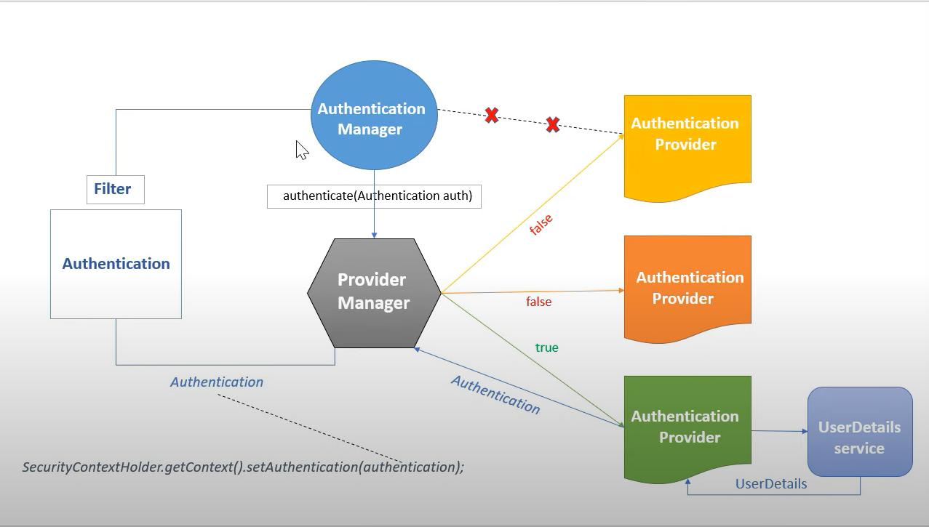

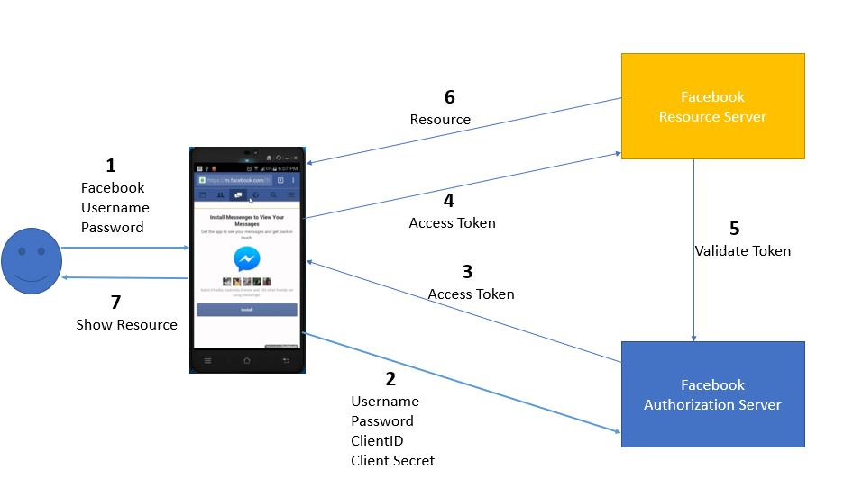

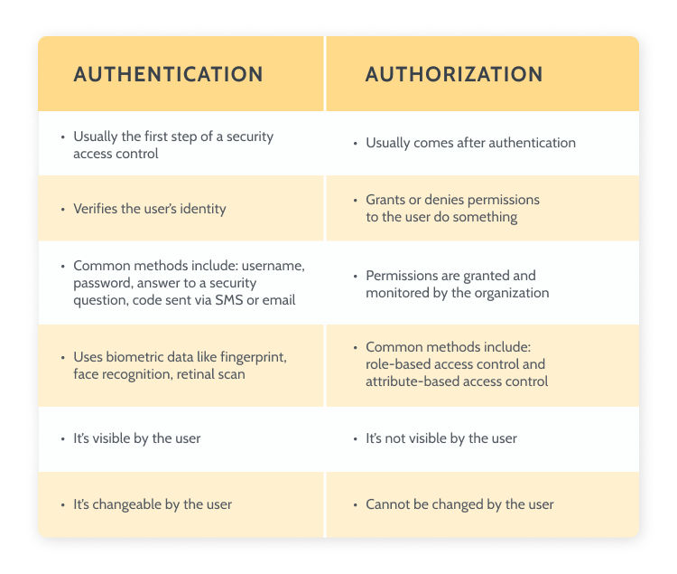

This project mainly concentrate on buying the Office Furniture interior on loan. Our organization is focuses on those clients who are willing to buy a furniture/interior for their offices. The offices which we includes are small scale and medium scale business offices. Our project will help the Banking sector for giving a loan with very less documents and improves the loan process faster than now a days.

**Name the main components of Microservices?.**  
Answer: Containers, cloud infrastructure, API gateway, Service delivery, IaC, and Service bus.

**What is Docker used for?**  
Answer: Docker provides a container environment that is used to host applications. It provides a static background for the app to run. Thus, preventing deployment issues.

**What is sleuth and Zipkin in microservices?**

**Spring Cloud Sleuth** is used to generate and attach the trace id, span id to the logs so that these can then be used by tools like Zipkin and ELK for storage and analyse

**Zipkin**is a distributed tracing system. It helps gather timing data needed to troubleshoot latency problems in service architectures. Features include both the collection and lookup of this data.

**1)What is spring authentication?**

The identity of user are checked for providing the access to the system user is verified ,validating the user are whom they claim to be(facebook).

**Authorization:-**Giving the permission to access a specific resource or function

**Filter:-** it is an object that is invoked at the preprocessing and postprocessing of request.

**What is API gateway in microservices?**

The API Gateway **offers a reverse proxy to redirect or route requests (layer 7 routing, usually HTTP requests) to the endpoints of the internal microservices**. The gateway provides a single endpoint or URL for the client apps and then internally maps the requests to a group of internal microservices.

**2)Who is configuring dispatched servlet?**

Spring boot autoconfiguration will configure dispatch servlet

Spring Boot auto-configures a Dispatcher Servlet if Spring MVC jar is on the classpath.

**3)How does the object convert into JSON?**

With help of HTTP massage Converted and jackson bean will be initializes

**4)who is Configuring the error mapping**

Spring boot autoconfiguration it create default erorr page us

**Explain CopyOnWriteArrayList?**

As the name indicates, CopyOnWriteArrayList creates a Cloned copy of underlying ArrayList, for every update operation at a certain point both will be synchronized automatically, which is taken care of by JVM. Therefore, there is no effect for threads that are performing read operation.

It is costly to use because for every update operation a cloned copy will be created. Hence, CopyOnWriteArrayList is the best choice if our frequent operation is read operation.

The underlined data structure is a grow-able array.

It is a thread-safe version of ArrayList.

Insertion is preserved, duplicates, null, and heterogeneous Objects are allowed.

The main important point about CopyOnWriteArrayList is the [Iterator](https://www.geeksforgeeks.org/iterators-in-java/) of CopyOnWriteArrayList can not perform remove operation otherwise we get Run-time exception saying UnsupportedOperationException. add() and set() methods on CopyOnWriteArrayList iterator also throws UnsupportedOperationException. Also Iterator of CopyOnWriteArrayList will never throw ConcurrentModificationException.

**Q #1) What is Web Service?**

The Web Service is a standard software system used for communication between two devices (client and server) over the network. Web services provide a common platform for various applications written in different languages to communicate with each other over the network.

**Q #2) What are features of web services?**

Interoperability

Reuse already developed(old) functionality into new software

Loosely Coupled

Extensibility

Easy to deploy and integrate, just like web applications.

**Q #3) What are the components of web service?**

Answer: The different components of web services are as follows:

SOAP- Simple Object Access Protocol

UDDI- Universal Description, Discovery, and Integration

WSDL- Web Service Description Language

RDF- Resource Description Framework

XML- Extensible Markup Language

**Q #4) What are the ways to implement Restful web service? Which one you have used?**

In JAX-RS, there are 3 types to implement.

Restful web service.

o Jersey.

o REST easy.

o Spring with REST.

We have used spring with REST type.

**Q #5) What is SOAP?**

The SOAP stands for Simple Object Access Protocol. It is an XML-based protocol for accessing web services. It is platform independent and language independent. By using SOAP, you can interact with other programming language applications.

**Q #6) What are RESTful Web Services?**

REST (Representational State Transfer) is a stateless client-server architecture style used for developing applications that are accessible over the network.

It can be defined as the web service that uses HTTP methods for implementing the REST architecture.

**Q #8) Annotations used in Restful web service?**

@RestController

@GetMapping

@PostMapping

@DeleteMapping

@PutMapping

@PathVariable

@RequestBody

@ResponseBody

**Q #9) Difference between @Controller & @RestController?**

|  |  |
| --- | --- |
| **@Controller** | **@RestController** |
| It is used to mark a class as Spring MVC  Controller. | It is used in RESTFul web services and the  equivalent of @Controller +@ResponseBody |
| It returns view. | It returns data. |
| Added in Spring 2.5 version. | Added in Spring 4.0 version. |

**Q #10) Diffence between Put And Patch?**

PUT:- It is use to update record and each and every details of the particular record will get update

PATCH:-It is use to update record and also update particular field only and remaining filed are unchanged.

**Q #11) Explain different HTTP methods supported by RESTful web services?**

GET: When we require get data in database then will use get method.it return status code is 200

POST: When we require insert data in database then will use post method.it return status code is201

DELETE: When we require delete data in database then will use delete method.it return status code is 204.

PUT: When we require update data in database then will use put method.it return status code is 201,200

Patch: When we require update minimum field in database then will use patch method.it return status code is 200

OPTIONS: Get supported operations on the resource.

HEAD: Returns HTTP header only, nobody.

**Q #10) What are HTTP Status codes?**

1xx - represents informational responses

2xx - represents successful responses

3xx - represents redirects

4xx - represents client errors

5xx - represents server errors

Most commonly used status codes are:

200 - success/OK

201 - CREATED - used in POST or PUT methods.

204-NOT_COTAINED-use for delete method

304 - NOT MODIFIED - used in conditional GET requests to reduce the bandwidth use of the network. Here, the body of the response sent should be empty.

400 - BAD REQUEST - This can be due to validation errors or missing input data.

401- UNAUTHORIZED - This is returned when there is no valid authentication credentials sent along with the request.

403 - FORBIDDEN - sent when the user does not have access (or is forbidden) to the resource.

404 - NOT FOUND - Resource method is not available.

500 - INTERNAL SERVER ERROR - server threw some exceptions while running the method.

502 - BAD GATEWAY - Server was not able to get the response from another upstream server.

**Q #11) What are components in HTTP?**

Request, Body, Header, etc

**Q #12) How to test web service?**

Using ARC & POSTMAN.

Locally

o Create war file.

o Deploy on local Tomcat server

**Q #13) Differentiate between SOAP and REST?**

| SOAP | REST |
| --- | --- |
| SOAP - Simple Object Access Protocol | REST - Representational State Transfer |
| SOAP cannot use REST because  it is a protocol. | REST architecture can have SOAP protocol because it can use any protocol like HTTP, SOAP. |
| SOAP specifies standards that are meant to be followed strictly. | REST defines standards but they need not be strictly followed. |
| SOAP supports only XML transmission between the client and the server. | REST supports data of multiple formats like XML, JSON, MIME, Text, etc. |
| SOAP reads are not cacheable. | REST read requests can be cached. |
| SOAP uses service interfaces for exposing the resource logic. | REST uses URI to expose the resource logic. |
| SOAP is slower. | REST is faster. |
| Since SOAP is a protocol, it defines its own security measures. | REST only inherits the security measures based on what protocol it uses for the implementation. |

**Q #14) Difference between API & web services?**

|  |  |
| --- | --- |
| API | Web Services |
| It is an interface between two different applications. | It is interaction between applications over the network. |
| All APIs are not web services. | All web services are APIs. |
| API can be used for any style of communication. | Web service uses styles like REST, SOAP for communication. |
| It can be used by a client who understands JSON or XML. | It can be used by any client who understands XML. |
| API has a light-weight architecture. | Web Services does not have a lightweight architecture. |

**Q #15) Can we manage session in Restful web service?**

We can’t manage session in Restful web service.

Because Restful web services are stateless means for every request it takes it as a new request.

**Q #16) In Restful web service, how to convert JSON format data to Object format or vice versa?**

Object to JSON format:

o ObjectMapper mapper=new ObjectMapper( );

o String jsonResult=mapper.writeValueAsString(object);

JSON to Object format:

o ObjectMapper mapper=new ObjectMapper( );

o Student s=mapper.readValue (jsonResult, Student.class);

**Q #17) Have you Consumed or Produced Restful web service? Explain?**

Consume or Produce in Restful web service means specifying which type of data to be

requested (it is just telling type of data accepted or send through application)

E.g. While consuming data type we use syntax, consumes=”application/JSON”, it specify

that certain service accepts only JSON data format.

Produce is associated with @GetMapping annotation where we mention type of data

while we are sending it when that method/service is called.

Consume is associated with @PostMapping annotation where we mention type of data

is to be accepted for saving it into the database when that method/service is called.

E.g. Film Producer makes (Produce) Movies & Viewers watch (Consume) those movies.

**Q #18) Difference between put and post ?**

POST is not idempotent while PUT is idempotent

Put is idempotent so it work on specific and Post work on abstract

There is no difference between PUT and POST if the resource is already exist

POST is **NOT idempotent**. So if we retry the request N times, we will end up having N resources with N different URIs created on the server.

PUT method is [**idempotent**](https://restfulapi.net/idempotent-rest-apis/). So if we retry a request multiple times, that should be equivalent to a single request invocation.

**Q #19) Difference between URL and URI?**

|  |  |
| --- | --- |
| **URL** | **URI** |
| URL stands for Uniform Resource Locator. | URI stands for Uniform Resource Identifier. |
| The main aim is to get the location or address of a resource | The main aim of URI is to find a resource and differentiate it from other resources using either name or location. |
| All URLs can be URIs | Not all URIs are URLs since a URI can be a name instead of a locator. |
| Protocol information is given in the URL. | There is no protocol information given in URI. |
| Is a type of URI | URI is the superset of URL |

**JSP---> Java Servlet Pages**

**-json---> JavaScript Object Notation (data gets stored in key value pair)**

**Micro Service**

**Q #1) Why micro Service ?**

Before microservice we use monolithic architecture. Monolithic architecture means it is a big container where the all the software components of an application are assemble together and tightly coupling

**Inflexible:-** Monolithic application can not be build using different different technology

**Unreliable:-** If one application is not working then entire system will not work.

**Doesn’t Support Complex Application:-** when we implement monolithic application some feature are unable to develop application because have tightly couple dependency

**Doesn’t released application in a same time:-** In monolithic we cannot deliver application in same time.

**Q #2) Define MicroService ?**

It is collection of small service, model around the business logic .

In microservice each service self contain and single business logic .

It is distributed app

**Features of Micro Service**

**Decouple** :- Service within the system are largely decouple so that application can be easily integrate.

**Business Capability** :- Microservice are very simple and focus on single capability.

**Autonomy:-**developer and team can work independently so that increase the development speed.

**Responsibilities:-** will focus on small business capability

**Continuous Delivery:-**microservice are allowed to frequently realised of software through the systematic process

**Agility:-** Microservice support agile developments any new features can quickly develop.

**@LoadBalancing**

Load Balancing Definition: Load balancing is the process of distributing network traffic across multiple servers. This ensures no single server bears too much demand. By spreading the work evenly, load balancing **improves application responsiveness**. It also increases availability of applications and websites for users.

**Q #15)Why we use ZUUL in microservices?**

It handles all the requests and performs the dynamic routing of microservice applications. It works as a front door for all the requests. It is also known as Edge Server. Zuul is built to enable dynamic routing, monitoring, resiliency, and security.

**Q #12) Water Fall Model**

**SDLC:-** Software development life cycle

Process of water fall mode as follow:-

Required Gathering

Requirement Analysis

Design

Coding

Testing

Release

Maintenance

Also known as linear sequence model

**Limitations:-**

1) development time will be increases

2)cost of development will be increase

3)it won’t accept requirement changes in the middle

4)client satisfaction is very low

5)Bug fixing is very costly

6) not suitable for large projects

**Q #13) Agile model**

Scum is agile based model

It is not linear sequential model

It is iterative model. Total software product will be developed increment by increment and each increment is called as sprint.

The Agile methodology is **a way to manage a project by breaking it up into several phases**

**Do you know Agile? Have you implemented in your project?**

The Agile Method and methodology is a particular approach to project management that is utilized in software development, it is iterative approach to software delivery that builds software incrementally from the start of the project, instead of trying to deliver it all at once near the end.

We have not implemented 100 % agile, we have followed agile.

**What is Sprint:-**

Total software product will be developed increment by increment and each increment is called as sprint.

It is of maximum 2 weeks or minimum 2 days.

It is time duration, in which decided work is completed.

**What is Story:-**Whichever task is assigned is called as Story.

**Scrum:-**

**1) Project Owner**:- It is person who interacts with client.

Gets requirements from client and convert it into stories in document format. So that it could be assigned to developers.

**2) Scrum Master:-** work with scrum team to make sure each sprint get complete on a time. scrum master ensure proper work flow for the team.

**3)Scrum Team:-**Each member of team should be self-organized, responsible for the high quality work

**What is your daily routine?**

On every start of week, at start time of office at 9 AM, daily stand up or scrum meeting was held approximately 15 min or can be extended to 30 min.

Scrum master manages this meeting and assigns stories to developers.

In this meeting, road blocks or problems occurred in stories are discussed and resolved.

**What is Grooming Session?**

It held by Product Owner.

Also upcoming stories are explained to developers.

**What is Retrospective Call?**

It happens at Sprint end.

All issues that stopped working of stories are discussed and taken care of not repeating them in next sprint.

**What is Demo Call?**

It held at the end of sprint.

Its call with client to show demo of story completed.

Client suggestions are added in next sprint stories by product Owner.

**How did you gather requirements from Client?**

We had resource as a product owner, for gathering requirement who also divided it into stories to assign it to developer

**How did Stories assign to you?**

We used to receive mails from product owner with stories attached in document format.

In big scale companies JIRA like softwares are used to handle all agile process.

Advantages:-

1)Continuous delivery

2) Continuous feedback

3)requirements changes in middle

4)client satisfaction is very high

5)less development time

6)less development cost.

**Q #1) What is Autoboxing and unboxing ?**

**Autoboxing**is the automatic conversion that the Java compiler makes between the primitive types and their corresponding object wrapper classes.

For example, converting an int to an Integer, a double to a Double, and so on.

If the conversion goes the other way, this is called **unboxing**.

**Q #2) What is Functional interface**

1)Interface which have only one abstract method that is call functional interface

2) Functional interface is also call Single abstract method interface(SAM interface)

3)@FunctionalInterface Annotation provide in jdk 8 inside java.lang packagen

4)if any interface annoted with @FunctionInterface then that interface cannot be more then one

abstract method if we try to write then it will give compile time error

5)if we do not mark interface with @FunctionalInterface and that interface have only one abstract

method then that interface is also call functional interface

6)inside functional interface we can write any number of default and static method

7) If functional interface declares an abstract method overriding one of the public methods of Java

Object class, that will also not be counted.

8) The instances of functional interface can be created by using lambda expressions, method

references, or constructor references.

9)A new package java.util.function has been added with bunch of functional interfaces for lamda

Expression and method reference

10)if interface extends functional interface and doesn't declare any abstract method then the new

interface is also call functional interface

**Q #3) Define java 8 features**

**Lambda expression:-** Java 8 Lambda expression (or function) is an anonymous function. Anonymous function means the function who **do not have name** and it is not bound to any class.  
Lambda expression is the shorter form of method writing. Using java 8 lambda expression we can remove the obvious and redundant code from [functional interface](https://stacktraceguru.com/java-8-functional-interface) implementation. Compiler can assume code such as : Class name, method signature, Argument types, return keyword, etc. In this blog we will learn with various Java 8 Lambda expression implementation examples.

**Optional :** Java 8 has introduced a new class Optional in java.util package. It is used to represent a value is present or absent. The main advantage of this new construct is that No more too many null checks and NullPointerException. It avoids any runtime NullPointerExceptions and supports us in developing clean and neat Java APIs or Applications.

**Consumer**: These interfaces have a method which *takes input, but does not return anything*Syntax: Consumer<InputType> object = variable -> method body;  
Example: Consumer<String> print = str -> System.out.println(str);

**Supplier** : In contrast, these interfaces have a method which*returns something without taking any input*Syntax: Supplier<ReturnType> object = ()-> method body;  
Example: Supplier<Long> useIdSupplier = ()-> userDao.getMaxId()+1;

**Predicates** : These interfaces have a method which *takes input and returns boolean value*Syntax: Predicate<InputType> object = variable -> method body;  
Example: Predicate<Long> evenChecker = n->n%2==0;

**Function** : These interfaces have a method which *takes input and returns output,*Take some input and perform some operation and return which is need not be Boolean typeSyntax: Function<InputType,ReturnType> object = variable -> method body;  
Example: Function<Long, Long> square = n -> n*n;

**Q #4) Why java is platform independent**

Java is platform-independent because the same java program can run on any operating system.

If you write a code in Java, then the program will be sent to the compiler for compilation. The compiler creates a .class file that is readable for JVM(Java Virtual Machine). Each operating system will have different JVMs, these are responsible for Java to be a platform-independent otherwise java is a platform dependent.

**Q #5) How to prevent dead lock in multithreading ?**

Avoid Nested Locks: A deadlock mainly happens when we give locks to multiple threads. Avoid giving a lock to multiple threads if we already have given to one.

**Q #6) What is difference bet** **Sequential Stream and Parallel Stream** ?

|  |  |
| --- | --- |
| **Sequential Stream** | **Parallel Stream** |
| It is run on single core computer | It is utilize multiple core of the computer |
| Performance is poor | Performance is high |
| Order is maintain | Order is not maintain |
| Only single iterator at a time | Operate multiple iterator simultaneously |

**Q #7) What is difference bet** **HashMap and ConcurrentHashMap**

|  |  |
| --- | --- |
| **HashMap** | **ConcurrentHashMap** |
| HashMap is not synchronized. | ConcurrentHashMap is synchronized. |
| HashMap is not thread safe. | ConcurrentHashMap is thread safe. |
| HashMap allows key and value to be null. | ConcurrentHashMap does not allow null key/value. It will throw NullPointerException. |
| HashMap iterator is fail-fast and ArrayList throws ConcurrentModificationException if concurrent modification happens during iteration. | ConcurrentHashMap is fail-safe and it will never throw ConcurrentModificationException during iteration. |
| HashMap is faster. | ConcurrentHashMap is slower than HashMap. |
| It is introduce in 1.2v | It is introduce in 1.5v |

**Q #8) What is difference bet** **Primary key and Unique key**

|  |  |
| --- | --- |
| **Primary key** | **Unique key** |
| Only one primary key define in a table | Multiple unique key define in a table |
| Can not accept null value | Can be accept null value |
| Create cluster index | Create non cluster index |

**Q #9) Diffence between Fail-fast and fail-safe**

|  |  |
| --- | --- |
| **Fail-fast** | **fail-safe** |
| Iterator directly work on collection Object itself | Iterator work on clone or copy of collection object |
| This iterator does not have any extra memory required | This iterator required extra memory ,consume heap |
| It doesn’t allowed modification the collection while iterating ,will throws the concurredModificationException | It does allowed modification the collection while iterating ,will not throws the concurredModificationException |
| Example of iterator is ArrayList | Example of iterator is ConcurrentHashMap |

**Q #10) Diffence between** **String and StringBuffer**

|  |  |
| --- | --- |
| **String** | **StringBuffer** |
| String class is immutable | StringBuffer class is mutable. |
| String is slow and consumes more memory when you concat too many strings because every time it creates new instance | StringBuffer is fast and consumes less memory when you cancat strings. |
| String class overrides the equals() method of Object class | StringBuffer class doesn't override the equals() method of Object class |
| It is not synchronized | It is synchronized |

**Q #11) Diffence between StringBuffer** **and StringBuilder**

|  |  |
| --- | --- |
| **StringBuffer** | **StringBuilder** |
| It is synchronized | It is not synchronized |
| It is thread safe. | It is not thread safe. |
| Performance is low | Performance is high |
| It is introduce in 1.0 v | It is introduce in 1.5 v |

**Q #11) Diffence between ArrayList and LinkedList**

|  |  |
| --- | --- |
| **ArrayList** | **LinkedList** |
| Underlying data structure is **dynamic array** | Underlying data structure is double linkedList |
| ArrayList use index base data structure | linkedList use node base data Structure |
| Insertions and Removals in the middle of the ArrayList are very slow | Insertions and Removals from any position in the LinkedList are faster than the ArrayList. |
| If your application does more retrieval than the insertions and deletions, then use ArrayList. | If your application does more insertions and deletions than the retrieval, then use LinkedList. |

**Q #12)whay Static method is not override?**

**No**, you cannot override the static method in Java because the [method overriding](http://java67.blogspot.sg/2012/08/what-is-method-overriding-in-java-example-tutorial.html) is based upon **dynamic binding** at runtime and static methods are bonded using [static binding](http://javarevisited.blogspot.sg/2012/03/what-is-static-and-dynamic-binding-in.html) at compile time

**Q #13)when non-static block will be executes?**

Whenever an object is created, a **non-static block** will be executed **before the execution of the constructor.**

**Q #14)can i declare abstract class as final?**

No, if we declared class as final abstract then don’t override method. can not modify that method.

**Q #14) can we declare class as protected** ?  
No, we cannot declare a top-level class as private or protected

**10) What is JIT compiler ?**

JIT compiler stands for Just in time compiler. JIT compiler compiles byte code in to executable code .

JIT a part of JVM .JIT cannot convert complete java program into executable code it converts as and

when it is needed during execution.

**11) What is bytecode in java ?**

When a javac compiler compiler compiles a class it generates .class file. This .class file contains set of

instructions called byte code. Byte code is a machine independent language and contains set of

instructions which are to be executed only by JVM. JVM can understand this byte codes.

**34) Difference between ‘IS-A’ and ‘HAS-A’ relationship in java?**

|  |  |
| --- | --- |
| ‘IS-A’ | ‘HAS-A’ |
| Is a relationship also known as inheritance | Is a relationship also known as composition or aggregation |
| For IS-A relationship we uses extends keyword | For Has a relationship we use new keyword |
| Ex : Car is a vehicle. | Ex : Car has an engine. We cannot say Car is an engine |
| It is use for reusability code | It is use for reusability code |

**71) Can we write any code after throw statement?**

After throw statement jvm stop execution and subsequent statements are not executed. If we try to write any statement after throw we do get compile time error saying unreachable code.

**57) In how many ways we can do exception handling in java?**

We can handle exceptions in either of the two ways :

1) By specifying try catch block where we can catch the exception.

2) Declaring a method with throws clause .

**77) Can we rethrow the same exception from catch handler?**

Yes we can rethrow the same exception from our catch handler. If we want to rethrow checked exception from a catch block we need to declare that exception.

**catch (WhateverException e) {**

**throw e;**

**}**

will simply rethrow the exception you've caught (obviously the surrounding method has to permit this via its signature etc.). The exception will maintain the original stack trace.

**80) Explain when** **ClassNotFoundException will be raised ?**

For dnyamicaly provided class name at run time if the .class file is not available then we want to get ClassNotFoundException. it is checked Exception

**81) Explain when NoClassDefFoundError will be raised ?**

For Hard coded class name at run time if the .class file is not available then we want to get NoClassDefFoundError. it is Unchecked Exception

**Q #6) do you spilt method in String class?**

The **java string split**() **method splits** this **string** against given regular expression and returns a string array.

**Q #7) do you intern method in String class?**

**intern()**methodof java.lang.String class is used to perform interning i.e creating an exact copy of heap string object in string constant pool. When you call this method on a string object, first it checks whether there exist an object with the same content in the String Constant Pool. If object does not exist in the pool, it will create an object with the same content in the string constant pool and returns the reference of that object. If object exist in the pool than it returns reference of that object without creating a new object.

**Q #8) how we make List as read only?**

An ArrayList can be made read-only easily with the help of **Collections.** **unmodifiableList() method**.

**Q #10) Implementation of Get-Get and Post-Post operation?**

getForObject(), postForObject() Refer Projects

**Q #22)what is use valueOf string class?**

valueOf() function is used to convert primitive data types into Strings.

**Q #24)What is intermediate and termination in stream?**

**intermediate** --map(), filter(), distinct(), sorted(), limit(), skip()

**termination--** forEach(), toArray(), reduce(), collect(), min(), max(), count(), findFirst(), findAny()

**Q #26)Why we cannot create object of abstract class?**

We cannot instantiate an abstract class in Java because it is abstract, it is not complete, hence it cannot be used

**1) Why did you leave your last job?**

Sir, it's a career move. I have learned a lot from my last job, but now I am looking for new

challenges to broaden my horizons and to gain a new skill-set.

**2) What is more important to you: the money or the work?**

"I would say that work is more important. If we work and achieve Company goals then

obviously money would follow. I believe work to be prior."

**3) Why should we hire you?**

"I have a good experience in that particular field

Yes sir! if you hire me. I will be an assest for your comapny because I'm hardworking person.

So, give me one chance I will put my 100% efforts for the growth of company.

**4) What are your salary expectations?**

I am more interested in the role than the pay, and I expect to be paid appropriate money for

this role based on my experience. As you also know that the high cost of living here in Delhi.

**5) What is your objective in life?**

"My goal is to become a successful person and make my family proud of me."

**6) What are your weaknesses?**

"I am a straightforward person, and I cannot say no when someone asks me for help.

**7) What will you do if you don't get this position?**

I have high hopes that I will be selected. In case if I will not select, I will continue to look for

another job in the same field that will fit my schedule and goals.

**8)Could you have done better in your last job?**

Yes, I have been assigned new projects and I have completed that project under the time lines.

**9)Tell me about the most boring job you have ever had.**

I think no job in this world is boring unless you don't have an interest in the job

**10)What was the toughest challenge you have ever faced?**

Challenge is not toughest, but the way we choose to come out with challenge actually matters.

If you are enough capable to take the right decision challenge may convert in a great opportunity.

**Strength :--**My strength is self-confidence, positive attitude, hard work.

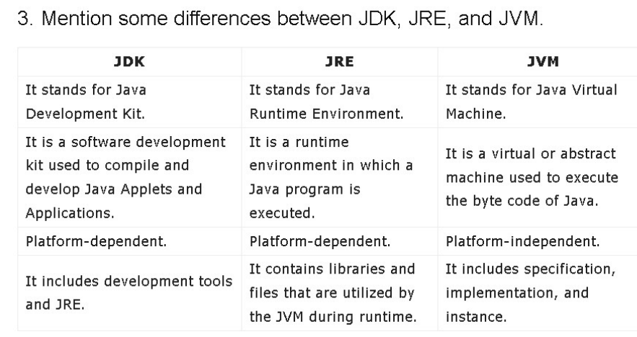

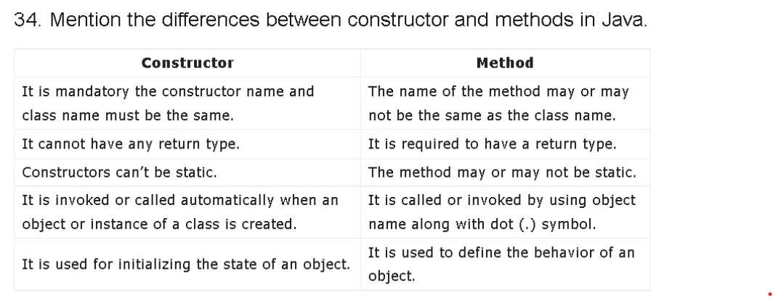



**19) Get department,total salary with respect to a department from employee table order by total salary descending**  
  
Select DEPARTMENT,sum(SALARY) Total_Salary from employee group by DEPARTMENT order by Total_Salary desc;  
  
Result:

[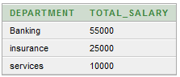](https://1.bp.blogspot.com/-rOg2oN4ubzE/WE5us6TeJqI/AAAAAAAACqs/_2zbcCQBw8kFAKfrwJnApf4-KIbzAa9pACLcB/s1600/emp1.png)

**20) Get department,no of employees in a department,total salary with respect to a department from employee table order by total salary descending**  
  
Select DEPARTMENT,count(FIRST_NAME),sum(SALARY) Total_Salary from employee group by DEPARTMENT order by Total_Salary desc;  
  
**Result:**

[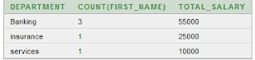](https://3.bp.blogspot.com/-iek5DOojmaw/WE5veY1yVFI/AAAAAAAACq0/5iFXW4p5cb0GIA6Y9xOrQLB-Yx39g_w4QCLcB/s1600/emp1.png)

**21) Get department wise average salary from employee table order by salary ascending**  
  
select DEPARTMENT,avg(SALARY) AvgSalary from employee group by DEPARTMENT order by AvgSalary asc;  
  
**Result:**

[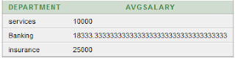](https://3.bp.blogspot.com/-tiPTAaKchcg/WE5v6nsXrEI/AAAAAAAACrA/6VN19fkE82oeNoBVVpNH7RlnaBOSYC5rgCLcB/s1600/emp2.png)

**22)  Get department wise maximum salary from employee table order by salary ascending**  
  
select DEPARTMENT,max(SALARY) MaxSalary from employee group by DEPARTMENT order by MaxSalary asc;  
  
  
  
Result:

[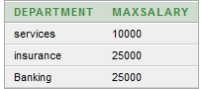](https://1.bp.blogspot.com/-dV7S0NtHXgU/WE5wOY8qE2I/AAAAAAAACrE/UYPMEpdxwYUNIIER6zXZQaC8hDDrBawogCLcB/s1600/emp2.png)

**23) Get department wise minimum salary from employee table order by salary ascending**  
  
**select DEPARTMENT,min(SALARY) MinSalary from employee group by DEPARTMENT order by MinSalary asc;**  
  
**24)select 20 % of salary from John , 10% of Salary for Roy and for other 15 % of salary from employee table**  
  
SELECT FIRST_NAME, CASE FIRST_NAME WHEN 'John' THEN SALARY * .2 WHEN 'Roy' THEN SALARY * .10 ELSE SALARY * .15 END "Deduced_Amount" FROM EMPLOYEE;  
  
**Explanation:** Here, we are using "SQL CASE" statement to achieve the desired results. After case statement, we had to specify the column on which filtering is applied. In our case it is "FIRST_NAME". And in then condition, specify the name of filter like John, Roy etc. To handle conditions outside our filter, use else block where every one other than John and Roy enters.  
  
**25) Delete employee data from employee table who got incentives in incentive table**  
  
**delete from EMPLOYEE where EMPLOYEE_ID in (select EMPLOYEE_REF_ID from INCENTIVES)**  
  
**Explanation :** Trick about this question is that we can't delete data from a table based on some condition in another table by joining them. Here to delete multiple entries from EMPLOYEE table, we need to use Subquery. Entries will get deleted based on the result of Subquery  
  
**26) Write a query to rank employees based on their incentives for a month**  
  
select FIRST_NAME,INCENTTIVE_AMOUNT,DENSE_RANK() OVER (PARTITION BY INCENTIVE_DATE ORDER BY INCENTTIVE_AMOUNT DESC) AS Rank from EMPLOYEE a, INCENTIVES b where a.EMP_ID=b.EMP_ID;  
  
Result:

[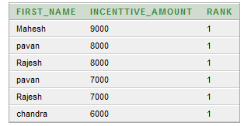](https://2.bp.blogspot.com/-xln0iAUXO2A/WE5xt6B45fI/AAAAAAAACrU/OHarK2R-IYIgwbTbOJYX9iAPuUxS2ydVACLcB/s1600/emp2.png)

   
  
  
  
  
  
  
  
  
Explanation: In order to rank employees based on their rank for a month, "DENSE_RANK" keyword is used. Here partition by keyword helps us to sort the column with which filtering is done. Rank is provided to the column specified in the order by statement. The above query ranks employees with respect to their incentives for a given month.  
 **27) Update incentive table where employee name is 'pavan'**  
  
update INCENTIVES set INCENTTIVE_AMOUNT='9000' where EMP_ID=(select EMP_ID from EMPLOYEE where FIRST_NAME='pavan' );  
  
  
Explanation : We need to join Employee and Incentive Table for updating the incentive amount. But for update statement joining query wont work. We need to use sub query to update the data in the incentive table.  
  
**28) select first_name, incentive amount from employee and incentives table for those employees who have incentives**  
  
Select FIRST_NAME,INCENTTIVE_AMOUNT from employee a inner join incentives B on A.EMP_ID=B.EMP_ID;  
  
Result:

[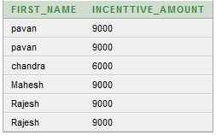](https://4.bp.blogspot.com/-735AtExOW_0/WE5y3ElkwoI/AAAAAAAACrg/_IZ3wdQ3o1s0K42O74mviQ40xuapwte_wCLcB/s1600/emp2.png)

**29) select first_name, incentive amount from employee and incentives table for those employees who have incentives and incentive amount greater than 5000**  
  
**Select FIRST_NAME,INCENTTIVE_AMOUNT from employee a inner join incentives B on A.EMP_ID=B.EMP_ID and INCENTTIVE_AMOUNT >5000;**  
  
**30) Select first_name, incentive amount from employee and incentives table for all employes even if they didn't get incentives**  
  
**Select FIRST_NAME,INCENTTIVE_AMOUNT from employee a left join incentives B on A.EMP_ID=B.EMP_ID;**  
 **31) Select first_name, incentive amount from employee and incentives table for all employees who got incentives using left join**  
  
**SQL Queries in Oracle:**  
    
Select FIRST_NAME,nvl(INCENTTIVE_AMOUNT,0) from employee a right join incentives B on A.EMP_ID=B.EMP_ID;  
  
**SQL Queries in SQL Server:**  
  
Select FIRST_NAME, isnull(INCENTTIVE_AMOUNT,0) from employee a right join incentives B on A.EMP_ID=B.EMP_ID;  
  
**SQL Queries in MySQL:**  
  
Select FIRST_NAME, IFNULL(INCENTTIVE_AMOUNT,0) from employee a right join incentives B on A.EMP_ID=B.EMP_ID;  
 **32) Select TOP 2 salary from employee table**  
  
**SQL Queries in Oracle:**  
  
select * from (select * from employee order by SALARY desc) where rownum <3;  
  
**Result:**

[](https://4.bp.blogspot.com/-WqtbW9wG86o/WE50TevsY8I/AAAAAAAACrs/cHsYtCgHDu0FR70EbMjF9goljTEjP8ZCACLcB/s1600/emp2.png)

   
  
  
**SQL Queries in SQL Server:**  
  
select top 2 * from employee order by salary desc;  
  
**SQL Queries in MySQL:**  
  
select * from employee order by salary desc limit 2;  
 **33) Select TOP N salary from employee table**  
  
**SQL Queries in Oracle:**  
  
 select * from (select * from employee order by SALARY desc) where rownum <N + 1;  
  
**SQL Queries in SQL Server:**  
  
 select top N * from employee;  
  
**SQL Queries in MySQL**:  
    
select * from employee order by salary desc limit N  
  
**34) Select 2nd Highest salary from employee table**  
  
  
**SQL Queries in MySQL:**  
  
select min(SALARY) from (select * from employee order by salary desc limit 2)a ;  
  
**35) Select Nth Highest salary from employee table**  
  
**SQL Queries in MySQL:**  
  
select min(SALARY) from (select * from employee order by salary desc limit N) a

**Q #12) What is Components**  
In Angular, components are the basic building blocks, which control a part of the UI for any application.  
A component is defined using the **@Component** decorator. Every component consists of three parts, the template which loads the view for the component, a stylesheet which defines the look and feel for the component, and a class that contains the business logic for the component.

We can create components the following command:

ng g c test

**Q #13) What is Module**

A module is a place where we can group components, directives, services, and pipes. Module decides whether the components, directives, etc can be used by other modules, by exporting or hiding these elements.

Every module is defined with a @NgModule decorator. By default, modules are :- Root Module

**Q #14) What is Services**

Services are objects which get instantiated only once during the lifetime of an application. The main objective of a service is to share data, functions with different components of an Angular application.

A service is defined using a **@Injectable** decorator. A function defined inside a service can be invoked from any component or directive.

To create a service, run the following command: -ng g s common

**Q #15)What is Observable**

Observable provides operators like map, forEach, filter, reduce, retry, retryWhen etc.

Can be cancelled by using the unsubscribe() method

It is lazy.

**Q #16)How to call the data from service to component?**

Through method (Has-A-Relationship).

**Q #17)What is NPM?**

NPM stands for Node Package Manager.

NPM is used to fetch any packages (JavaScript libraries) that an application needs for

development, testing, and/or production, and may also be used to run tests and tools used

in the development process.

NPM is 3rd party library or 3rd party package.

**Q #18) Difference between http and httpclient?**

Http: The HttpClient is used to perform HTTP requests and it imported from

@angular/common/http.

Httpclient: The HttpClient is more modern and easy to use the alternative of HTTP.

HttpClient is an improved replacement for Http.

**Q #19) What is data binding?**

In Angular, data binding is one of the most powerful and important features that allow you to

define the communication between the component and DOM (Document Object Model).

There are 4 type :-

a. String Interpolation:-{{}}

b. Property Binding:-[]

c. Event Binding:- ()

d. Two-Way Data Binding:-[(ngModel)]

**Q #19) What is pipe?**

It is use for currency,date ,percentage

**Q #20) Command for bootstrap and font awesome ?**

npm i bootstrap@4.4.1

npm I font-awesomeng g m Header --routing

**Q #21) What is FormBuilder?**

The FormBuilder provides syntactic sugar that shortens creating instances of

a FormControl, FormGroup, or FormArray. It reduces the amount of boilerplate needed to

build complex forms.

**Q #22) What is Routing?**

To handle the navigation from one view to the next, you use the Angular Router. The Router enables navigation by interpreting a browser URL as an instruction to change the view