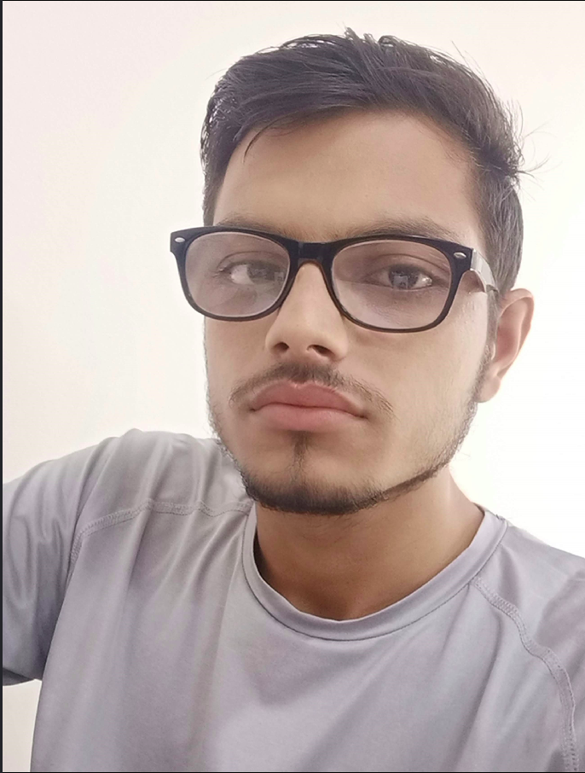

YOGESH GAHLAWAT
IT Graduate

ABOUT ME
Date of Birth: March 24, 1999
Age: 22
Gender: Male
Birth Place: Sonepat, Haryana

CONTACT
8708269245
yogeshgahlawat2425@gmail.com
https://www.linkedin.com/in/yogesh-gahlawat-48893116b/

SKILLS
Good Problem Solving Ability
Knowledge of Data Structure and Algorithms
Knowledge of C/C++, Java( Core java, JDBC, Servlet, JSP), Python, HTML, CSS, JavaScript, openCV
Knowledge about MySQL, oracle DB
Knowledge of git version control system
Knowledge about windows and unix operating systems

EXPERTISE
JDBC, Servlet, JSP, Python, openCV, MySQL
CAREER OBJECTIVES
Student with no experience aims to find and exciting and challenging entry level position in the field of information and technology industry alongside who continuously motivate and drive me to do my best and improve my skills and abilities in order to assist the company in achieving their goals.

ACADEMIC BACKGROUND
2019 – 2022PURSUING MASTER DEGREE
Amity University, Noida
2016 - 2019BACHELOR DEGREE
Hindu Institute of Management, affiliated by D.C.R.U.S.T. , Murthal, State university(Haryana)
2015 – 2016SENIOR SECONDARY(12th)
Board of School Education Haryana, State Board(Haryana)
2013 – 2014SECONDARY(10th)
Board of School Education Haryana, State Board(Haryana)

INTEREST
Eager to learn New Technologies, Programming,
Eager to face real time problems

