**Name:** Yogesh Balasaheb Kumbhar. **Roll No: 56**

**Class:** Final Year B. Tech CSE **Batch:** B2

**Title : Program to demonstrate Spinners, Touch Mode, Alerts, Popups, and Toasts with**

**their events handler**

**Android Spinner:**

**activity_main.xml**

*<?*xml version="1.0" encoding="utf-8"*?>*<RelativeLayout xmlns:android="http://schemas.android.com/apk/res/android"  
 android:layout_width="match_parent" android:layout_height="match_parent">  
 <TextView  
 android:id="@+id/txtVw"  
 android:layout_width="wrap_content"  
 android:layout_height="wrap_content"  
 android:layout_marginLeft="50dp"  
 android:layout_marginTop="150dp"  
 android:text="Select User:"  
 android:textStyle="bold"  
 android:textSize="15dp" />  
 <Spinner  
 android:id="@+id/spinner1"  
 android:layout_width="wrap_content"  
 android:layout_height="wrap_content"  
 android:layout_alignBottom="@+id/txtVw"  
 android:layout_toRightOf="@+id/txtVw" />  
</RelativeLayout>

**MainActivity.java**

package com.example.spinner;  
  
import androidx.appcompat.app.AppCompatActivity;  
import android.os.Bundle;  
import android.view.View;  
import android.widget.AdapterView;  
import android.widget.ArrayAdapter;  
import android.widget.Spinner;  
import android.widget.Toast;  
  
public class MainActivity extends AppCompatActivity implements AdapterView.OnItemSelectedListener {  
 String[] users = { "Yogesh Kumbhar", "Shubham Jangali", "Sandesh Shivare", "Mukund Patil", "Poonam Jangali" };  
 @Override  
 protected void onCreate(Bundle savedInstanceState) {  
 super.onCreate(savedInstanceState);  
 setContentView(R.layout.*activity_main*);  
  
 Spinner spin = (Spinner) findViewById(R.id.*spinner1*);  
  
 ArrayAdapter<String> adapter = new ArrayAdapter<String>(this, android.R.layout.*simple_spinner_item*, users);  
  
adapter.setDropDownViewResource(android.R.layout.*simple_spinner_dropdown_item*);  
  
 spin.setAdapter(adapter);  
 spin.setOnItemSelectedListener(this);  
 }  
 @Override  
 public void onItemSelected(AdapterView<?> arg0, View arg1, int position, long id) {  
 Toast.*makeText*(getApplicationContext(), "Selected User: "+users[position] , Toast.*LENGTH_SHORT*).show();  
 }  
 @Override  
 public void onNothingSelected(AdapterView<?> arg0) {  
 *// TODO - Custom Code* }  
}

**Output:**

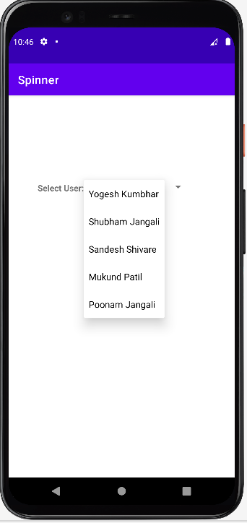 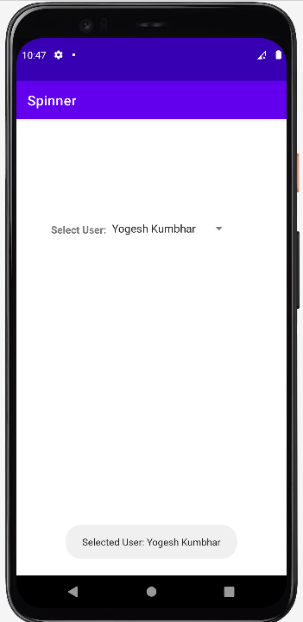

**Alert**

Activity_main.xml

<?xml version="1.0" encoding="utf-8"?>  
<RelativeLayoutxmlns:android="http://schemas.android.com/apk/res/android"  
android:layout_width="match_parent" android:layout_height="match_parent">  
<Button  
android:id="@+id/getBtn"  
android:layout_width="wrap_content"  
android:layout_height="wrap_content"  
android:layout_marginLeft="150dp"  
android:layout_marginTop="200dp"  
android:text="Show Alert" />  
</RelativeLayout>

MainActivity.java

package com.firstapp.alert;  
  
import androidx.appcompat.app.AlertDialog;  
import androidx.appcompat.app.AppCompatActivity;  
  
import android.content.DialogInterface;  
import android.os.Bundle;  
import android.view.View;  
import android.widget.Button;  
import android.widget.Toast;  
  
public class MainActivityextends AppCompatActivity{  
@Override  
protected void onCreate(Bundle savedInstanceState) {  
super.onCreate(savedInstanceState);  
setContentView(R.layout.*activity_main*);  
Button btn= (Button)findViewById(R.id.*getBtn*);  
btn.setOnClickListener(new View.OnClickListener() {  
@Override  
public void onClick(View v) {  
AlertDialog.Builder builder = new AlertDialog.Builder(MainActivity.this);  
builder.setTitle("Login Alert")  
 .setMessage("Are you sure, you want to continue ?")  
 .setCancelable(false)  
 .setPositiveButton("Yes", new DialogInterface.OnClickListener() {  
@Override  
public void onClick(DialogInterfacedialog, intwhich) {  
Toast.*makeText*(MainActivity.this,"Selected Option: YES",Toast.*LENGTH_SHORT*).show();  
 }  
 })  
 .setNegativeButton("No", new DialogInterface.OnClickListener() {  
@Override  
public void onClick(DialogInterfacedialog, intwhich) {  
Toast.*makeText*(MainActivity.this,"Selected Option: No",Toast.*LENGTH_SHORT*).show();  
 }  
 });  
*//Creating dialog box*AlertDialog dialog = builder.create();  
dialog.show();  
 }  
 });  
 }  
}

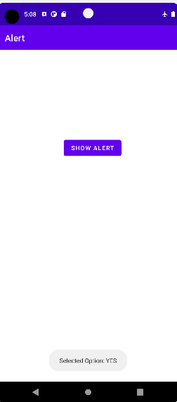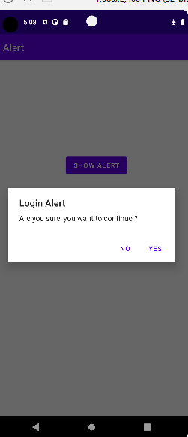

**Touch Mode**

**activity_main.xml**

*<?*xml version="1.0" encoding="utf-8"*?>*<LinearLayoutxmlns:android="http://schemas.android.com/apk/res/android"  
android:layout_width="match_parent"  
android:layout_height="match_parent"  
android:paddingLeft="10dp"  
android:paddingRight="10dp"  
android:orientation="vertical">  
<TextView  
android:layout_width="wrap_content"  
android:layout_height="wrap_content"  
android:layout_gravity="center_horizontal"  
android:autoLink="web"  
android:text="Touch Mode"  
android:textStyle="bold" />  
  
<ImageView  
android:id="@+id/imgvw"  
android:layout_width="411dp"  
android:layout_height="match_parent"  
android:scaleType="matrix"  
android:src="@drawable/nature" />  
</LinearLayout>

**MainActivity.java**

package com.example.touchmode;  
  
import androidx.appcompat.app.AppCompatActivity;  
  
import android.graphics.Matrix;  
import android.os.Bundle;  
import android.view.MotionEvent;  
import android.view.ScaleGestureDetector;  
import android.widget.ImageView;  
  
public class MainActivityextends AppCompatActivity {  
private ImageViewimg;  
private Matrix matrix= new Matrix();  
private float scale = 1f;  
private ScaleGestureDetectordetector;  
  
@Override  
protected void onCreate(Bundle savedInstanceState) {  
super.onCreate(savedInstanceState);  
setContentView(R.layout.*activity_main*);  
  
img= (ImageView)findViewById(R.id.*imgvw*);  
detector = new ScaleGestureDetector(MainActivity.this,newScaleListener());  
 }  
@Override  
public booleanonTouchEvent(MotionEvent event){  
detector.onTouchEvent(event);  
return true;  
 }  
private class ScaleListenerextends ScaleGestureDetector.SimpleOnScaleGestureListener{  
@Override  
public booleanonScale(ScaleGestureDetector detector) {  
scale *= detector.getScaleFactor();  
scale = Math.*max*(0.1f, Math.*min*(scale, 5.0f));  
matrix.setScale(scale, scale);  
img.setImageMatrix(matrix);  
return true;  
 }  
 }  
}

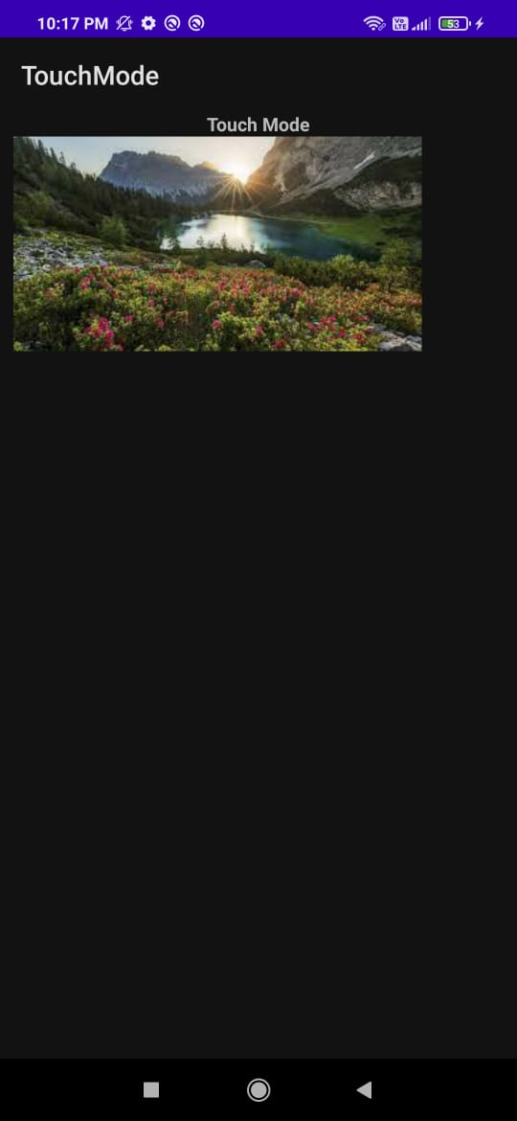 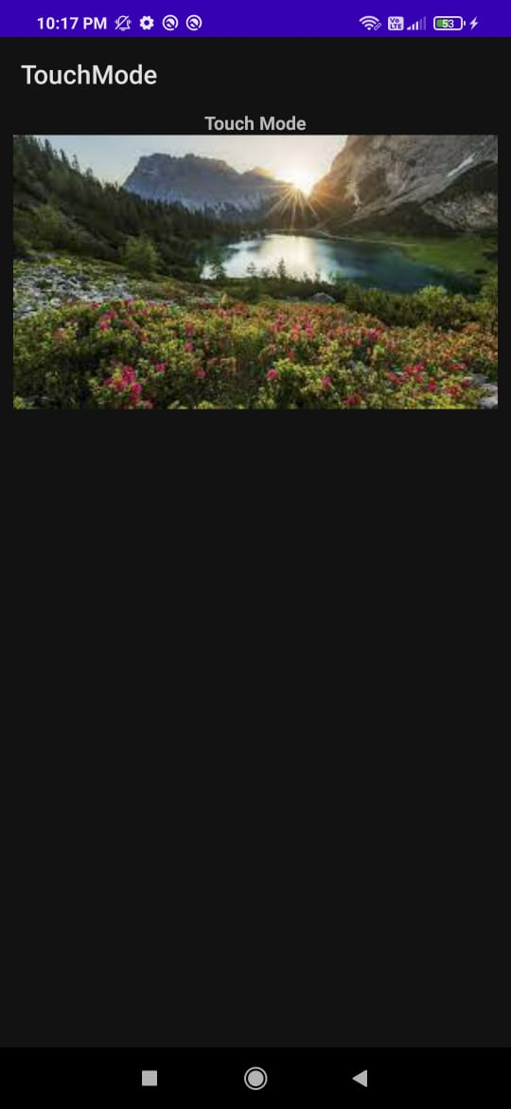

**Popup:**

**activity_main.xml**

*<?*xml version="1.0" encoding="utf-8"*?>*<LinearLayout xmlns:android="http://schemas.android.com/apk/res/android"  
 android:layout_width="match_parent"  
 android:layout_height="match_parent"  
 android:orientation="vertical" >  
  
 <Button  
 android:id="@+id/btnShow"  
 android:layout_width="wrap_content"  
 android:layout_height="wrap_content"  
 android:text="Show Popup Menu"  
 android:layout_marginTop="200dp" android:layout_marginLeft="100dp"/>  
</LinearLayout>

popup_menu.xml

*<?*xml version="1.0" encoding="utf-8"*?>*<menu xmlns:android="http://schemas.android.com/apk/res/android" >  
 <item android:id="@+id/search_item"  
 android:title="Search" />  
 <item android:id="@+id/upload_item"  
 android:title="Upload" />  
 <item android:id="@+id/copy_item"  
 android:title="Copy" />  
 <item android:id="@+id/print_item"  
 android:title="Print" />  
 <item android:id="@+id/share_item"  
 android:title="Share" />  
 <item android:id="@+id/bookmark_item"  
 android:title="BookMark" />  
</menu>

**MainActivity.java**

package com.example.popupmenu;  
  
import androidx.appcompat.app.AppCompatActivity;  
  
import android.os.Bundle;  
import android.view.MenuItem;  
import android.view.View;  
import android.widget.Button;  
import android.widget.PopupMenu;  
import android.widget.Toast;  
  
public class MainActivity extends AppCompatActivity implements PopupMenu.OnMenuItemClickListener {  
 @Override  
 protected void onCreate(Bundle savedInstanceState) {  
 super.onCreate(savedInstanceState);  
 setContentView(R.layout.*activity_main*);  
 Button btn = (Button) findViewById(R.id.*btnShow*);  
 btn.setOnClickListener(new View.OnClickListener() {  
 @Override  
 public void onClick(View v) {  
 PopupMenu popup = new PopupMenu(MainActivity.this, v);  
 popup.setOnMenuItemClickListener(MainActivity.this);  
 popup.inflate(R.menu.*popup_menu*);  
 popup.show();  
 }  
 });  
 }  
 @Override  
 public boolean onMenuItemClick(MenuItem item) {  
 Toast.*makeText*(this, "Selected Item: " +item.getTitle(), Toast.*LENGTH_SHORT*).show();  
 switch (item.getItemId()) {  
 case R.id.*search_item*:  
 *// do your code* return true;  
 case R.id.*upload_item*:  
 *// do your code* return true;  
 case R.id.*copy_item*:  
 *// do your code* return true;  
 case R.id.*print_item*:  
 *// do your code* return true;  
 case R.id.*share_item*:  
 *// do your code* return true;  
 case R.id.*bookmark_item*:  
 *// do your code* return true;  
 default:  
 return false;  
 }  
 }  
}

**Output:**

