**Name:** Yogesh Balasaheb Kumbhar. **Roll No: 56**

**Class:** Final Year B. Tech CSE **Batch:** B2

**Title: write a program to use of different Layouts.**

**Linear Layout:**

**activity_main.xml:**

*<?*xml version="1.0" encoding="utf-8"*?>*<LinearLayout xmlns:android="http://schemas.android.com/apk/res/android"  
 android:layout_width="match_parent"  
 android:layout_height="match_parent"  
 android:paddingLeft="20dp"  
 android:paddingRight="20dp"  
 android:orientation="vertical" >  
 <EditText  
 android:id="@+id/txtTo"  
 android:layout_width="match_parent"  
 android:layout_height="wrap_content"  
 android:hint="To"/>  
 <EditText  
 android:id="@+id/txtSub"  
 android:layout_width="match_parent"  
 android:layout_height="wrap_content"  
 android:hint="Subject"/>  
 <EditText  
 android:id="@+id/txtMsg"  
 android:layout_width="match_parent"  
 android:layout_height="0dp"  
 android:layout_weight="1"  
 android:gravity="top"  
 android:hint="Message"/>  
 <Button  
 android:layout_width="100dp"  
 android:layout_height="wrap_content"  
 android:layout_gravity="right"  
 android:text="Send"/>  
</LinearLayout>

**MainActivity.java:**

package com.example.linearlayout;  
  
import androidx.appcompat.app.AppCompatActivity;  
import android.os.Bundle;  
  
public class MainActivity extends AppCompatActivity {  
  
 @Override  
 protected void onCreate(Bundle savedInstanceState) {  
 super.onCreate(savedInstanceState);  
 setContentView(R.layout.*activity_main*);  
 }  
}

Output:

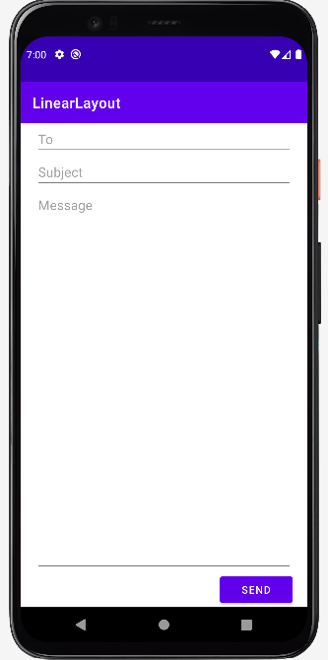

**Relative Layout:**

**activity_main.xml**

*<?*xml version="1.0" encoding="utf-8"*?>*<RelativeLayout xmlns:android="http://schemas.android.com/apk/res/android"  
 xmlns:app="http://schemas.android.com/apk/res-auto"  
 xmlns:tools="http://schemas.android.com/tools"  
 android:layout_width="match_parent"  
 android:layout_height="match_parent"  
 tools:context=".MainActivity">  
  
 <TextView  
 android:layout_width="wrap_content"  
 android:layout_height="wrap_content"  
 android:text="Hello World!"  
 app:layout_constraintBottom_toBottomOf="parent"  
 app:layout_constraintEnd_toEndOf="parent"  
 app:layout_constraintStart_toStartOf="parent"  
 app:layout_constraintTop_toTopOf="parent"  
 android:layout_centerVertical="true"  
 android:layout_centerHorizontal="true"  
 />  
 <androidx.appcompat.widget.AppCompatButton  
 android:id="@+id/btn1"  
 android:layout_width="wrap_content"  
 android:layout_height="wrap_content"  
 android:text="Button1"  
 android:layout_alignParentRight="true"  
 android:layout_centerVertical="true"  
 />  
 <androidx.appcompat.widget.AppCompatButton  
 android:id="@+id/btn2"  
 android:layout_width="match_parent"  
 android:layout_height="wrap_content"  
 android:text="Button2"  
 android:layout_alignParentBottom="true"  
 android:layout_centerHorizontal="true"  
 />  
 <androidx.appcompat.widget.AppCompatButton  
 android:id="@+id/btn3"  
 android:layout_width="wrap_content"  
 android:layout_height="wrap_content"  
 android:text="Button3"  
 android:layout_alignParentLeft="true"  
 android:layout_centerVertical="true"  
 />  
 <androidx.appcompat.widget.AppCompatButton  
 android:id="@+id/btn4"  
 android:layout_width="wrap_content"  
 android:layout_height="wrap_content"  
 android:text="Button4"  
 android:layout_above="@id/btn2"  
 android:layout_centerHorizontal="true"  
 />  
 <androidx.appcompat.widget.AppCompatButton  
 android:id="@+id/btn5"  
 android:layout_width="wrap_content"  
 android:layout_height="wrap_content"  
 android:text="Button5"  
 android:layout_centerHorizontal="true"  
 android:layout_alignParentTop="true"  
 />  
  
  
</RelativeLayout>

**MainActivity.java**

package com.example.relativelayout;  
  
import androidx.appcompat.app.AppCompatActivity;  
  
import android.os.Bundle;  
  
public class MainActivity extends AppCompatActivity {  
  
 @Override  
 protected void onCreate(Bundle savedInstanceState) {  
 super.onCreate(savedInstanceState);  
 setContentView(R.layout.activity_main);  
 }  
}

**Frame Layout:**

**activity_main.xml:**

*<?*xml version="1.0" encoding="utf-8"*?>*<FrameLayout xmlns:android="http://schemas.android.com/apk/res/android"  
 android:layout_width="match_parent"  
 android:layout_height="match_parent"  
 android:orientation="vertical">  
 <ImageView  
 android:id="@+id/imgvw1"  
 android:layout_width="match_parent"  
 android:layout_height="match_parent"  
 android:scaleType="centerCrop"  
 android:src="@drawable/wlp" />  
 <TextView  
 android:id="@+id/txtvw1"  
 android:layout_width="match_parent"  
 android:layout_height="wrap_content"  
 android:layout_marginTop="40dp"  
 android:background="#4C374A"  
 android:padding="10dp"  
 android:text="Grate wallpapers"  
 android:textColor="#FFFFFF"  
 android:textSize="20sp" />  
 <TextView  
 android:id="@+id/txtvw2"  
 android:layout_width="wrap_content"  
 android:layout_height="wrap_content"  
 android:layout_gravity="right|bottom"  
 android:background="#AA000000"  
 android:padding="10dp"  
 android:text="28/Mar/2023"  
 android:textColor="#FFFFFF"  
 android:textSize="18sp" />  
</FrameLayout>

**MainActivity.java**

package com.example.framelayout;  
  
import androidx.appcompat.app.AppCompatActivity;  
  
import android.os.Bundle;  
  
public class MainActivity extends AppCompatActivity {  
  
 @Override  
 protected void onCreate(Bundle savedInstanceState) {  
 super.onCreate(savedInstanceState);  
 setContentView(R.layout.*activity_main*);  
 }  
}

**Output:**

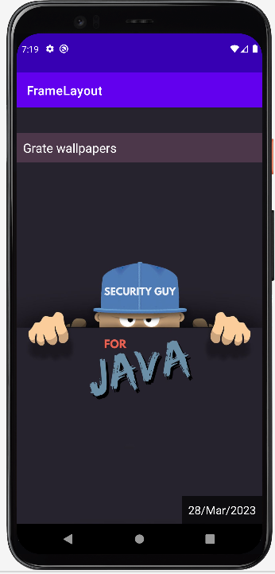

**Table Layout:**

**Activity_main.xml**

*<?*xml version="1.0" encoding="utf-8"*?>*<TableLayout xmlns:android="http://schemas.android.com/apk/res/android"  
 android:layout_width="match_parent"  
 android:layout_height="match_parent"  
 android:layout_marginTop="100dp"  
 android:paddingLeft="10dp"  
 android:paddingRight="10dp" >  
 <TableRow android:background="#0079D6" android:padding="5dp">  
 <TextView  
 android:layout_width="wrap_content"  
 android:layout_height="wrap_content"  
 android:layout_weight="1"  
 android:text="Roll No" />  
 <TextView  
 android:layout_width="wrap_content"  
 android:layout_height="wrap_content"  
 android:layout_weight="1"  
 android:text="First Name" />  
 <TextView  
 android:layout_width="wrap_content"  
 android:layout_height="wrap_content"  
 android:layout_weight="1"  
 android:text="Last Name" />  
 </TableRow>  
 <TableRow android:background="#DAE8FC" android:padding="5dp">  
 <TextView  
 android:layout_width="wrap_content"  
 android:layout_height="wrap_content"  
 android:layout_weight="1"  
 android:text="1" />  
 <TextView  
 android:layout_width="wrap_content"  
 android:layout_height="wrap_content"  
 android:layout_weight="1"  
 android:text="Yogesh" />  
 <TextView  
 android:layout_width="wrap_content"  
 android:layout_height="wrap_content"  
 android:layout_weight="1"  
 android:text="Kumbhar" />  
 </TableRow>  
 <TableRow android:background="#DAE8FC" android:padding="5dp">  
 <TextView  
 android:layout_width="wrap_content"  
 android:layout_height="wrap_content"  
 android:layout_weight="1"  
 android:text="2" />  
 <TextView  
 android:layout_width="wrap_content"  
 android:layout_height="wrap_content"  
 android:layout_weight="1"  
 android:text="Shubham" />  
 <TextView  
 android:layout_width="wrap_content"  
 android:layout_height="wrap_content"  
 android:layout_weight="1"  
 android:text="Jangali" />  
 </TableRow>  
 <TableRow android:background="#DAE8FC" android:padding="5dp">  
 <TextView  
 android:layout_width="wrap_content"  
 android:layout_height="wrap_content"  
 android:layout_weight="1"  
 android:text="3" />  
 <TextView  
 android:layout_width="wrap_content"  
 android:layout_height="wrap_content"  
 android:layout_weight="1"  
 android:text="Mukund" />  
 <TextView  
 android:layout_width="wrap_content"  
 android:layout_height="wrap_content"  
 android:layout_weight="1"  
 android:text="Patil" />  
 </TableRow>  
</TableLayout>

**MainActivity.java**

package com.example.tablelayout;  
  
import androidx.appcompat.app.AppCompatActivity;  
  
import android.os.Bundle;  
  
public class MainActivity extends AppCompatActivity {  
  
 @Override  
 protected void onCreate(Bundle savedInstanceState) {  
 super.onCreate(savedInstanceState);  
 setContentView(R.layout.*activity_main*);  
 }  
}

**Output:**

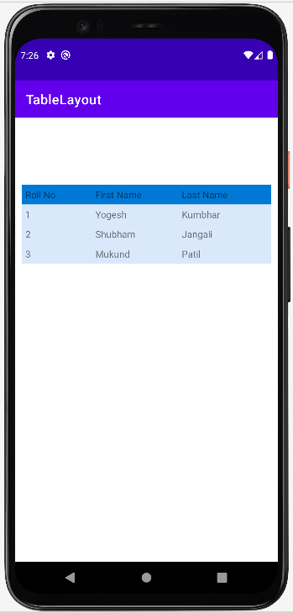

**Web View:**

**activity_main.xml:**

*<?*xml version="1.0" encoding="utf-8"*?>*<WebView xmlns:android="http://schemas.android.com/apk/res/android"  
 android:id="@+id/webview"  
 android:layout_width="fill_parent"  
 android:layout_height="fill_parent" />

**MainActivity.java:**

package com.example.webview;  
  
import androidx.appcompat.app.AppCompatActivity;  
  
import android.os.Bundle;  
import android.webkit.WebView;  
  
public class MainActivity extends AppCompatActivity {  
  
 @Override  
 protected void onCreate(Bundle savedInstanceState) {  
 super.onCreate(savedInstanceState);  
 setContentView(R.layout.*activity_main*);  
 WebView wv = (WebView) findViewById(R.id.*webview*);  
 String customHtml = "<html><body><h1>Welcome to Android</h1>" +  
 "<h2>Welcome to Android</h2><h3>Welcome to Android</h3>" +  
 "<p>It's a Static Web HTML Content.</p>" +  
 "</body></html>";  
 wv.loadData(customHtml, "text/html", "UTF-8");  
 }  
}

**Output:**

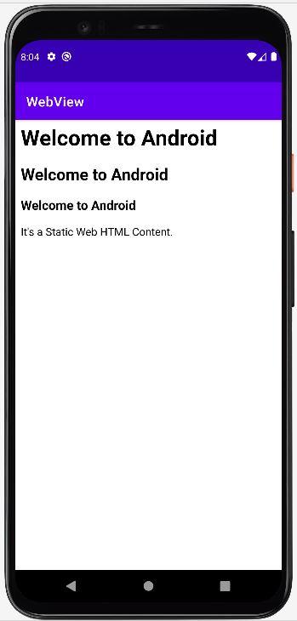

**List View:**

**Activity_main.xml:**

*<?*xml version="1.0" encoding="utf-8"*?>*<LinearLayout xmlns:android="http://schemas.android.com/apk/res/android"  
 xmlns:tools="http://schemas.android.com/tools"  
 android:layout_width="match_parent"  
 android:layout_height="match_parent"  
 android:orientation="vertical">  
 <ListView  
 android:id="@+id/userlist"  
 android:layout_width="match_parent"  
 android:layout_height="wrap_content" >  
 </ListView>  
</LinearLayout>

**MainActivity.java:**

package com.example.listview;  
  
import androidx.appcompat.app.AppCompatActivity;  
  
import android.os.Bundle;  
import android.widget.ArrayAdapter;  
import android.widget.ListView;  
  
public class MainActivity extends AppCompatActivity {  
 private ListView mListView;  
 private ArrayAdapter aAdapter;  
 private String[] users = { "Yogesh Kumbhar", "Shubham Jangali", "Mukund Patil", "Sandesh Shivare", "Poonam Jangali"};  
 @Override  
 protected void onCreate(Bundle savedInstanceState) {  
 super.onCreate(savedInstanceState);  
 setContentView(R.layout.*activity_main*);  
 mListView = (ListView) findViewById(R.id.*userlist*);  
 aAdapter = new ArrayAdapter(this, android.R.layout.*simple_list_item_1*, users);  
 mListView.setAdapter(aAdapter);  
 }  
}

**Output:**

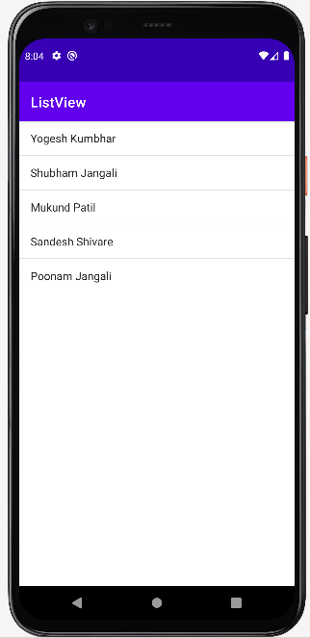

**Grid View:**

**activity_main.xml**

*<?*xml version="1.0" encoding="utf-8"*?>*<GridView xmlns:android="http://schemas.android.com/apk/res/android"  
 android:id="@+id/gridview"  
 android:layout_width="match_parent"  
 android:layout_height="match_parent"  
 android:columnWidth="110dp"  
 android:numColumns="auto_fit"  
 android:verticalSpacing="10dp"  
 android:horizontalSpacing="10dp"  
 android:stretchMode="columnWidth"  
 android:gravity="center" />

**MainActivity.java**

package com.example.gridview;  
  
import android.content.Context;  
import android.view.View;  
import android.view.ViewGroup;  
import android.widget.BaseAdapter;  
import android.widget.GridView;  
import android.widget.ImageView;  
  
public class ImageAdapter extends BaseAdapter {  
 private Context mContext;  
 public ImageAdapter(Context c) {  
 mContext = c;  
 }  
 public int getCount() {  
 return thumbImages.length;  
 }  
 public Object getItem(int position) {  
 return null;  
 }  
 public long getItemId(int position) {  
 return 0;  
 }  
 *// create a new ImageView for each item referenced by the Adapter* public View getView(int position, View convertView, ViewGroup parent) {  
 ImageView imageView = new ImageView(mContext);  
 imageView.setLayoutParams(new GridView.LayoutParams(200, 200));  
 imageView.setScaleType(ImageView.ScaleType.*CENTER_CROP*);  
 imageView.setPadding(8, 8, 8, 8);  
 imageView.setImageResource(thumbImages[position]);  
 return imageView;  
 }  
 *// Add all our images to arraylist* public Integer[] thumbImages = {  
 R.drawable.*img1*, R.drawable.*img2*,  
 R.drawable.*img3*, R.drawable.*img4*,  
 R.drawable.*img5*, R.drawable.*img6*,  
 R.drawable.*img7*, R.drawable.*img1*,  
 R.drawable.*img1*, R.drawable.*img2*,  
 R.drawable.*img3*, R.drawable.*img4*,  
 R.drawable.*img5*, R.drawable.*img6*,  
 R.drawable.*img7*, R.drawable.*img1*,  
 R.drawable.*img1*, R.drawable.*img2*,  
 R.drawable.*img3*, R.drawable.*img4*,  
 R.drawable.*img5* };  
}

**ImageAdapter.java**

package com.example.gridview;  
  
import androidx.appcompat.app.AppCompatActivity;  
  
import android.os.Bundle;  
import android.view.View;  
import android.widget.AdapterView;  
import android.widget.GridView;  
import android.widget.Toast;  
  
public class MainActivity extends AppCompatActivity {  
  
 @Override  
 protected void onCreate(Bundle savedInstanceState) {  
 super.onCreate(savedInstanceState);  
 setContentView(R.layout.*activity_main*);  
 GridView gv = (GridView) findViewById(R.id.*gridview*);  
 gv.setAdapter(new ImageAdapter(this));  
 gv.setOnItemClickListener(new AdapterView.OnItemClickListener() {  
 public void onItemClick(AdapterView<?> parent, View v, int position, long id) {  
 Toast.*makeText*(MainActivity.this, "Image Position: " + position, Toast.*LENGTH_SHORT*).show();  
 }  
 });  
 }  
}

**Output:**

