**Name:** Yogesh Balasaheb Kumbhar. **Roll No: 56**

**Class:** Final Year B. Tech CSE **Batch:** B2

**Title:** Program to demonstrate Touch Mode, Menus with their events handler.

**Context Menu:**

**activity_main.xml**

*<?*xml version="1.0" encoding="utf-8"*?>*<LinearLayout xmlns:android="http://schemas.android.com/apk/res/android"  
 android:layout_width="match_parent"  
 android:layout_height="match_parent"  
 android:orientation="vertical" >  
 <Button  
 android:id="@+id/btnShow"  
 android:layout_width="wrap_content"  
 android:layout_height="wrap_content"  
 android:text="Long press me"  
 android:layout_marginTop="200dp" android:layout_marginLeft="100dp"/>  
</LinearLayout>

**MainActivity.java**

package com.example.contextmenu;  
  
import androidx.appcompat.app.AppCompatActivity;  
  
import android.os.Bundle;  
import android.view.ContextMenu;  
import android.view.MenuItem;  
import android.view.View;  
import android.widget.Button;  
import android.widget.Toast;  
  
public class MainActivity extends AppCompatActivity {  
  
 protected void onCreate(Bundle savedInstanceState) {  
 super.onCreate(savedInstanceState);  
 setContentView(R.layout.*activity_main*);  
 Button btn = (Button) findViewById(R.id.*btnShow*);  
 registerForContextMenu(btn);  
 }  
 @Override  
 public void onCreateContextMenu(ContextMenu menu, View v, ContextMenu.ContextMenuInfo menuInfo) {  
 super.onCreateContextMenu(menu, v, menuInfo);  
 menu.setHeaderTitle("Context Menu");  
 menu.add(0, v.getId(), 0, "Upload");  
 menu.add(0, v.getId(), 0, "Search");  
 menu.add(0, v.getId(), 0, "Share");  
 menu.add(0, v.getId(), 0, "Bookmark");  
 }  
 @Override  
 public boolean onContextItemSelected(MenuItem item) {  
 Toast.*makeText*(this, "Selected Item: " +item.getTitle(), Toast.*LENGTH_SHORT*).show();  
 return true;  
 }  
}

**Output:**

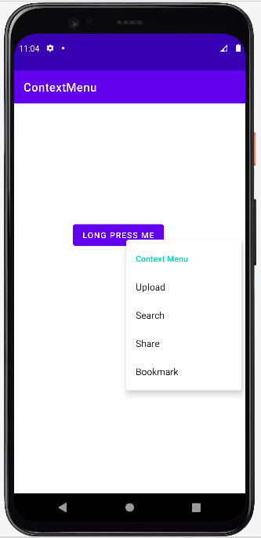 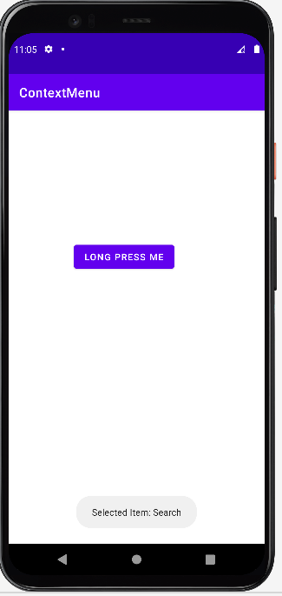

**Option Menu:**

**activity_main.xml**

*<?*xml version="1.0" encoding="utf-8"*?>*<androidx.constraintlayout.widget.ConstraintLayout xmlns:android="http://schemas.android.com/apk/res/android"  
 xmlns:app="http://schemas.android.com/apk/res-auto"  
 xmlns:tools="http://schemas.android.com/tools"  
 android:layout_width="match_parent"  
 android:layout_height="match_parent"  
 tools:context=".MainActivity">  
  
 <TextView  
 android:layout_width="wrap_content"  
 android:layout_height="wrap_content"  
 android:text="Option Menu"  
 app:layout_constraintBottom_toBottomOf="parent"  
 app:layout_constraintEnd_toEndOf="parent"  
 app:layout_constraintStart_toStartOf="parent"  
 app:layout_constraintTop_toTopOf="parent" />  
  
</androidx.constraintlayout.widget.ConstraintLayout>

**options_menu.xml**

*<?*xml version="1.0" encoding="utf-8"*?>*<menu xmlns:android="http://schemas.android.com/apk/res/android" >  
 <item android:id="@+id/search_item"  
 android:title="Search" />  
 <item android:id="@+id/upload_item"  
 android:title="Upload" />  
 <item android:id="@+id/copy_item"  
 android:title="Copy" />  
 <item android:id="@+id/print_item"  
 android:title="Print" />  
 <item android:id="@+id/share_item"  
 android:title="Share" />  
 <item android:id="@+id/bookmark_item"  
 android:title="BookMark" />  
</menu>

**MainActivity.java**

package com.example.optionmenu;  
  
import androidx.appcompat.app.AppCompatActivity;  
  
import android.os.Bundle;  
import android.view.Menu;  
import android.view.MenuItem;  
import android.widget.Toast;  
  
public class MainActivity extends AppCompatActivity {  
  
 @Override  
 protected void onCreate(Bundle savedInstanceState) {  
 super.onCreate(savedInstanceState);  
 setContentView(R.layout.*activity_main*);  
 }  
 public boolean onCreateOptionsMenu(Menu menu) {  
 getMenuInflater().inflate(R.menu.*options_menu*, menu);  
 return true;  
 }  
 @Override  
 public boolean onOptionsItemSelected(MenuItem item) {  
 Toast.*makeText*(this, "Selected Item: " +item.getTitle(), Toast.*LENGTH_SHORT*).show();  
 switch (item.getItemId()) {  
 case R.id.*search_item*:  
 *// do your code* return true;  
 case R.id.*upload_item*:  
 *// do your code* return true;  
 case R.id.*copy_item*:  
 *// do your code* return true;  
 case R.id.*print_item*:  
 *// do your code* return true;  
 case R.id.*share_item*:  
 *// do your code* return true;  
 case R.id.*bookmark_item*:  
 *// do your code* return true;  
 default:  
 return super.onOptionsItemSelected(item);  
 }  
 }  
}

**Output:**

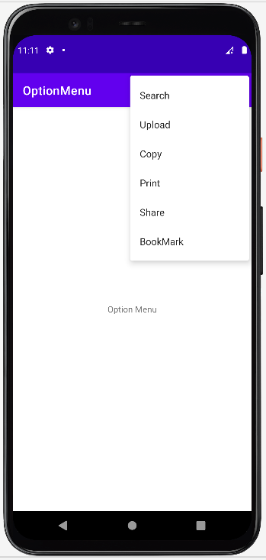 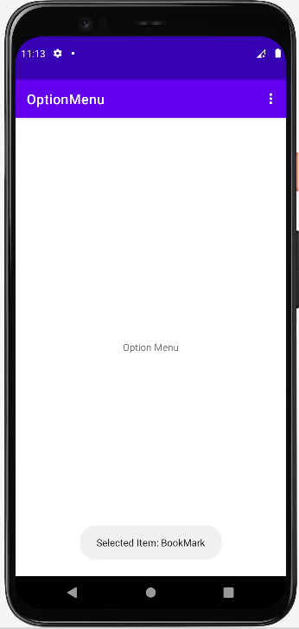

**Popup Menu:**

**activity_main.xml**

*<?*xml version="1.0" encoding="utf-8"*?>*<LinearLayout xmlns:android="http://schemas.android.com/apk/res/android"  
 android:layout_width="match_parent"  
 android:layout_height="match_parent"  
 android:orientation="vertical" >  
  
 <Button  
 android:id="@+id/btnShow"  
 android:layout_width="wrap_content"  
 android:layout_height="wrap_content"  
 android:text="Show Popup Menu"  
 android:layout_marginTop="200dp" android:layout_marginLeft="100dp"/>  
</LinearLayout>

**popup_menu.xml**

*<?*xml version="1.0" encoding="utf-8"*?>*<menu xmlns:android="http://schemas.android.com/apk/res/android" >  
 <item android:id="@+id/search_item"  
 android:title="Search" />  
 <item android:id="@+id/upload_item"  
 android:title="Upload" />  
 <item android:id="@+id/copy_item"  
 android:title="Copy" />  
 <item android:id="@+id/print_item"  
 android:title="Print" />  
 <item android:id="@+id/share_item"  
 android:title="Share" />  
 <item android:id="@+id/bookmark_item"  
 android:title="BookMark" />  
</menu>

**MainActivity.java**

package com.example.popupmenu;  
  
import androidx.appcompat.app.AppCompatActivity;  
  
import android.os.Bundle;  
import android.view.MenuItem;  
import android.view.View;  
import android.widget.Button;  
import android.widget.PopupMenu;  
import android.widget.Toast;  
  
public class MainActivity extends AppCompatActivity implements PopupMenu.OnMenuItemClickListener {  
 @Override  
 protected void onCreate(Bundle savedInstanceState) {  
 super.onCreate(savedInstanceState);  
 setContentView(R.layout.*activity_main*);  
 Button btn = (Button) findViewById(R.id.*btnShow*);  
 btn.setOnClickListener(new View.OnClickListener() {  
 @Override  
 public void onClick(View v) {  
 PopupMenu popup = new PopupMenu(MainActivity.this, v);  
 popup.setOnMenuItemClickListener(MainActivity.this);  
 popup.inflate(R.menu.*popup_menu*);  
 popup.show();  
 }  
 });  
 }  
 @Override  
 public boolean onMenuItemClick(MenuItem item) {  
 Toast.*makeText*(this, "Selected Item: " +item.getTitle(), Toast.*LENGTH_SHORT*).show();  
 switch (item.getItemId()) {  
 case R.id.*search_item*:  
 *// do your code* return true;  
 case R.id.*upload_item*:  
 *// do your code* return true;  
 case R.id.*copy_item*:  
 *// do your code* return true;  
 case R.id.*print_item*:  
 *// do your code* return true;  
 case R.id.*share_item*:  
 *// do your code* return true;  
 case R.id.*bookmark_item*:  
 *// do your code* return true;  
 default:  
 return false;  
 }  
 }  
}

