PROVIDER NEW IMPLEMENTATION

All the Provider new implementation contains full requirement in the CDG (Client Data Guide) which is prepared by onshore BA’s.

*Steps to start implementing a new provider:*

**Step 1: CDG Analysis**

Before working on Provider (new implementation or enhancement) first step of any new developer is to understand what the CDG is? and what type of data is contains?

CDG path is mentioned in the rally discussion of the US.

Following are the common tabs of CDG mentioned that a developer needs to analyze while implementing any new Provider:

* Revision Summary
* Loading & Integration
* Files
* CF-BI Account
* CF-BI Charge(If needed)
* CF-BI Insurance
* CF-BI Transaction
* BatchLoad
* LU-Post Codes
* BIRPlanCodeMapping
* Rule Execution
* Custom Rules

**Revision Summary:** This tab contains the short description about the requirement mentioned in the rally ticket also the tab name developer need to for understanding the complete requirement.



**Loading & Integration:** This tab contains the basic information about the provider like: coding suffix, project id, provider name, provider code, raw file path etc.

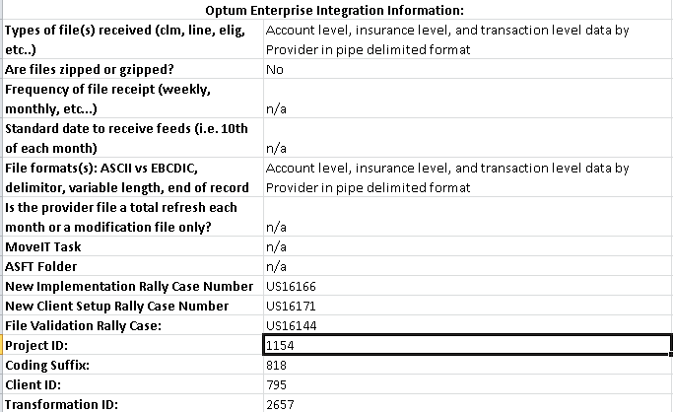

**Files:** This tab contains all the file names with their file type (delimiter) and file set (Account, Insurance, Transaction) information that a provider needs to process.

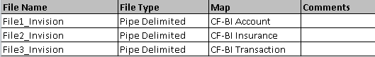

**CF-BI Account:** This tab contains all the mapping details of account file also the business logics related to the mapping of account file with C# objects if exists any.

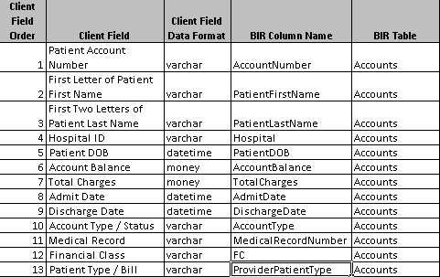

**CF-BI Insurance:** This tab contains all the mapping details of insurance file also the business logics related to the mapping of insurance file with C# objects if exists any.

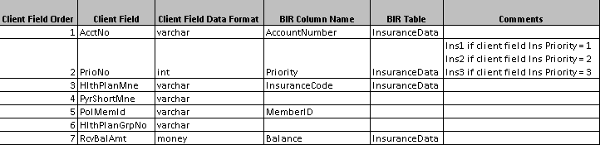

**CF-BI Transaction:** This tab contains all the mapping details of account details file also the business logics related to the mapping of account details file with C# objects if exists any.

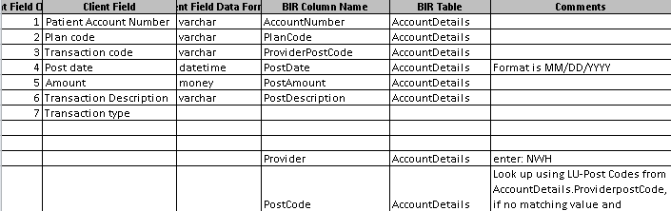

**BatchLoad:** This tab contains the blue print of direct connect batch load file which is generated internally by the base class.

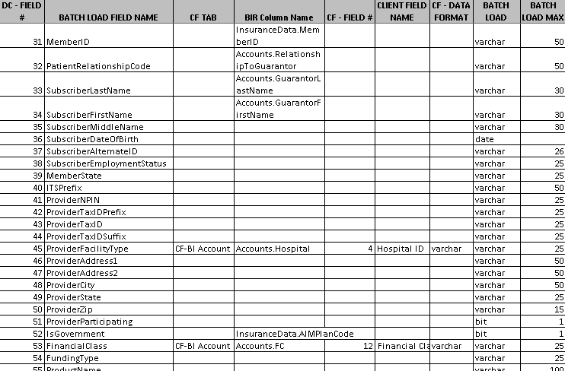

**LU-Post Codes:** This tab contains combination of all the post code and provider post code which is needed to generate the post code script for that provider.

**BIRPlanCodeMapping:** This tab contains all the plan code that is needed to generate the plan code script for that provider.

**Rule Execution:** This tab contains all the information of standard rules with their priorities which is needed to generate the Initial Setup script for that provider.

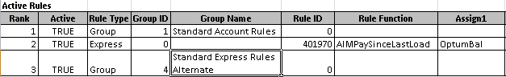

**Custom Rules:** This tab contains all the custom rules which are specific to that provider if the business wants to execute them too with standard rules. Priorities of all the custom rules are mentioned in Rule Execution tab.

**Step 2: Raw File Analysis**

After CDG analysis next step is to analyze raw file and for doing this developer has to take some sample records from each raw file and have to check whether the format of those records is matching with the format mentioned in the CDG(Account, Insurance, Transaction tabs).

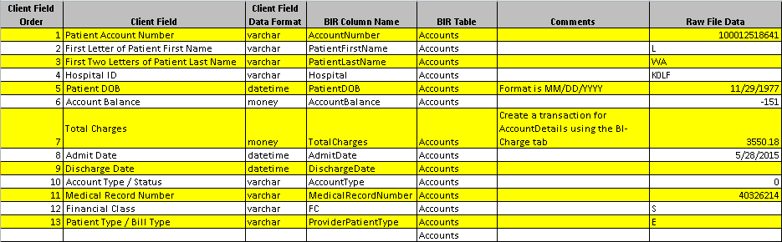

In the above example we have to compare two columns (i.e “Client Field Order” & “Raw File Data”) because first column contains the format of raw file and other column contains the sample records from raw file.

Extra things we need to verify in those columns:

1. Numeric field is in numeric format or not.
2. Date field is in date format or not.
3. Decimal field (amount field) is in decimal format or not.

By using same method we need to verify insurance and transaction files too.

**Step 3: Script Creation**

Next set comes after raw file analysis is script creation. Here we use a tool (Optum Rule Management) which takes the CDG as input and generates the scripts we needed for implementation. Well, for new implementation developer needs to create 3 script that are:

1. Initial Setup
2. BIR Plan Code Mapping
3. BIR Post Code Mapping

All these scripts can be easily generated by Optum Rule Management tool.

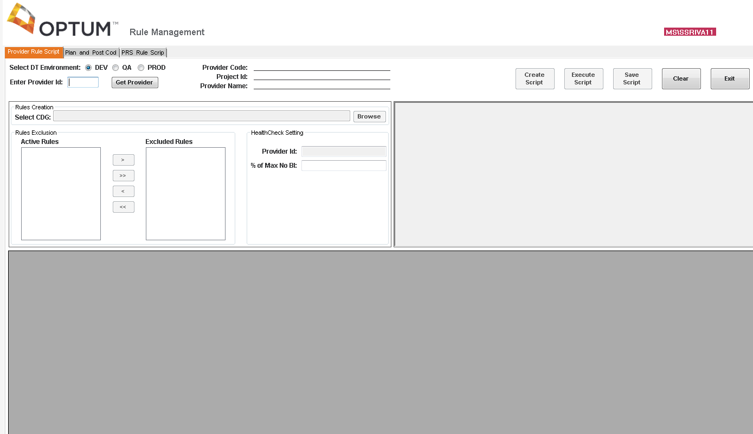

**How to generate initial script using Optum Rule Management tool?**

For generating initial set up scripts follow the below mentioned steps:

1. Open the tool => Go to Provider Rule Scripts tab.
2. Enter the coding suffix in the **Enter Provider ID** textbox.
3. Click on Get Provider button.
4. Click on Brows button and select the CDG.
5. Now click on Create script button. Initial set up script will be generated successfully.

**How to generate Plan code script using Optum Rule Management?**

For generating BIR Plan Code scripts follow the below mentioned steps:

1. Open the tool => Go to **Plan Code Post Code** tab.
2. Enter the coding suffix in Provider ID textbox.
3. Click on browse button and select the CDG.
4. Click on Plan code radio button.
5. Now click on Generate script button. Plan code script will be generated successfully.

**How to generate Post Code script using Optum Rule Management?**

For generating BIR Post Code scripts follow the below mentioned steps:

1. Open the tool => Go to **Plan Code Post Code** tab.
2. Enter the coding suffix in Provider ID textbox.
3. Click on browse button and select the CDG.
4. Click on Post code radio button.
5. Now click on Generate script button. Post code script will be generated successfully.

Now, all the scripts are created execute them in development environment and save them with their respective format as mentioned below:

1. Provider0XXX_InitialSetup
2. US16166_BIRPlanCodeMapping_Provider0XXX
3. US16166_BIRPostCodeMapping_Provider0XXX

Step 4: Coding

Before proceeding towards coding it is necessary to set up the coding environment in Visual Studio. For environment set up and coding follow the below mentioned steps:

1. Open Visual Studio => Select the Provider template from New Project dialog box.
2. Give the name of project as: Provider0XXX (XXX is coding suffix) and save it.
3. Project will open with solution name a: Provider0XXX.
4. Right click on solution => Click Add New Project.
5. Select TestProvider template and give that project name as TestProvider0XXX (XXX is coding suffix) and add it to the solution.
6. In TestProvider0XXX => Go to Form.cs => Got to BtnExecute_Click() method.
7. There change the directory name path as per the raw path mentioned in DEV DTMS for that provider.



Change only first line (raw path) as per the provider you are working.

1. In Provider0XXX there will be following 8 classes listed:

* Analyze0XXX.cs
* CleanUpLoad0XXX.cs
* CreateRacerLoadJob0XXX.cs
* ExpressClaimOutputFile0XXX.cs
* LoadProvider0XXX.cs
* PreProcessAccount0XXX.cs
* ProviderAccountAnalyzer0XXX.cs
* ProviderAccountExtended0XXX.cs

For a standard new implementation we need to deal with only 4 classes that are marked red.

1. Go to CreateRacerLoadJob0XXX.cs => PopulateJRFAList()
2. Add regex of the filenames in _jrfaList as mentioned in the CDG Files tab also the file groups as shown below:



1. Go to PreprocessAccount0XXX.cs => in this class re-write the raw files and sort them on the basis of account number.
2. Go to ProviderAccountExtended0XXX.cs=> in this class map the fields as mentioned in the CDG for all the files (i.e. Account, Insurance and Transaction).
3. Go to CleanUpLoad0XXX.cs => LoadRacerVariables()
4. Add business logic to delete the sort files from the raw path directory.

Now the coding is completed.

**Step 4: Execution in development environment**

After coding next step is execution in dev environment. In this step first run the code locally in visual studio, test it manually by running standard queries and then test the client code automatically in development environment using DEV DTMS(Data Transformation Management Solution).

Before testing the client through dev DTMS first you need to deploy the client code into development environment. For deployment follow the below mentioned steps:

1. Go to Anthill by using below mentioned link.

<http://anthill.optum.com>

1. Create the sandbox entry for the client.
2. Go to dashboard tab => Select your client under DT Sandbox.
3. Build you client and deploy it into DT DEV. Client will be deployed in development environment successfully.

**How to test provider through DTMS?**

1. Open DEV DTMS by using below mentioned link:

<http://apsed3771.aimhealth.com/DTManagementSolution>

1. Click on Administration tab => Go to Search box.

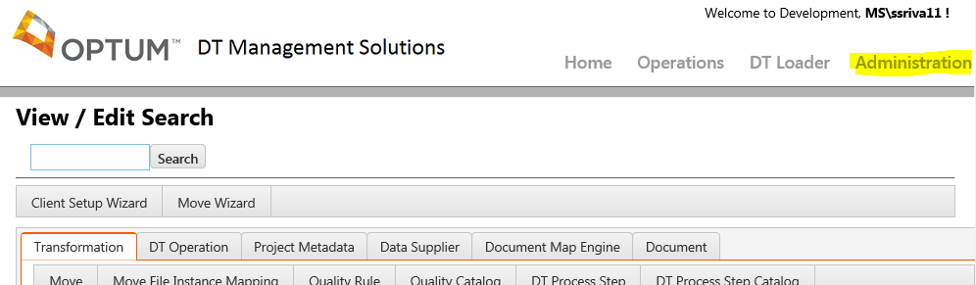

1. Search client name and click on Show Transformation image button in the extreme left side of the screen.

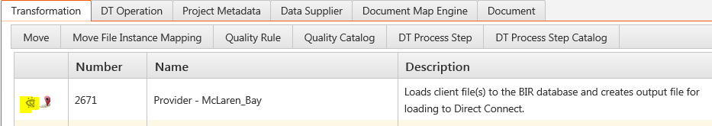

1. Now click on File Instance Mapping tab in the left middle section of the screen.

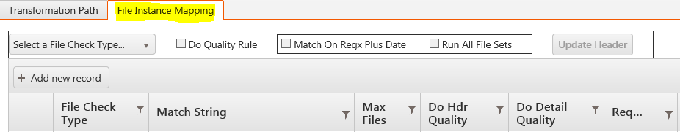

1. Here the file instance mapping details needs to be added. Click on the button Add New Record you will find that a new empty record is show in the below table.

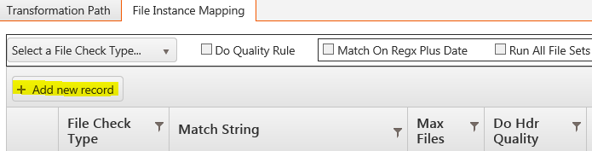

1. You will find File Check Type header is having one drop down which contains two values (i.e. Intake & Raw).
2. First select Intake from that drop down and give your file name regex under Match String section.

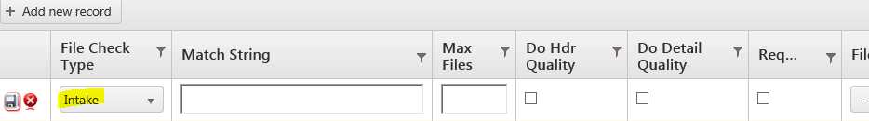

1. Now give the max file name number under Max Files section. For ex: if only one file is there for that regex give ‘1’.
2. Now click on the required checkbox under Required section.
3. Now click on Save image button in the left side of the screen.

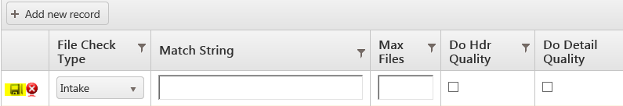

1. Now again click on Add New Record button and this time select Raw under File Check section drop down.
2. Enter the same file name regex as you have given for intake under Match String section.
3. Click on required checkbox under Required section.
4. Now select the file type under File type dropdown. For ex: for account file then select Account, for insurance file select Insurance for transaction file select Transaction.
5. Now enter the file group number under File Group section. For ex: if there are 2 accounts file the for first account file give file group number as 1 and for second one give file group number as 2.
6. Now enter File Instance mapping detail number under Details section. For this Go to SQL server=> Query for maximum file instance mapping details number from FileInstanceMappingDetails table in DataTransformation database. In the result just + 1 and enter that number in Details section.
7. Now for adding file instance mapping for insurance and transaction file repeat the steps from 5 to 16.
8. After adding all the file instance mapping details for the client go to the development intake path for that client and paste all the raw files
9. Again go to dev DTMS and click on Operations tab => now click on Intake Scanner Match tab.

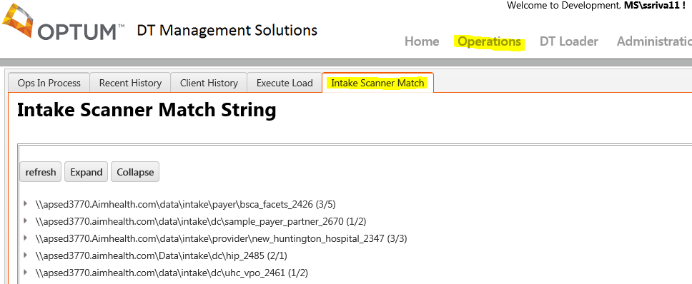

1. You will get the list of intake path for any clients under Intake Scanner Match String section. Check the intake path for your client and click on the arrow image on the left side of each client.
2. Check whether all the files are accepted or not. If accepted click on the intake path of your client => Now click on Execute button.

