**School of Engineering & Technology (CSE)**

**Project Based Learning**

**Semester-IV**



**SHARDA UNIVERSITY**

**LICENSE PLATE RECOGNITION**

**Submitted By: Submitted To:**

Section :E(Group 2)Mr. Ramesh Singh

Yogesh Pandey(2018016400)

MD Saif Ali(2018016003)

Shubham Pandey(2018016058)

(Signature)

**CONTENT**

1. Abstract
2. Scope
3. Problem statement
4. System study
5. Gantt Chart
6. Requirement
7. Flowchart
8. Snapshot
9. Future Scope
10. Conclusion
11. References

**Abstract**

Our main idea is recognition of license plate from picture. Firstly it will detect a plate in the whole picture then it will detect the alphanumeric value inside the number plate which can be used to check validity of documents

**Scope**

In our project, we are making a software which can scan alphanumeric value in the number plate. That can be used for license plate recognition, catching fraud license plate .It can also be used for checking the validity of the documents related to that license plate.

**Problem statement**

Currently we have software for detecting vehicle’s license plate that are not very precise. We can also linking this software to the database which can check automatically for the validity of the documents related to the license plate. Here we can detect multiple license plate at a time from a image.

**System study**

There’s no doubt that life and business have gotten more complex, even as certain tasks and activities have become easier due to artificial intelligence. The pace of change is quickening.Options of getting effective reports and graphical reports are either technically challenging or missing.

**OUTPUT SAMPLE**

**Snapshot**

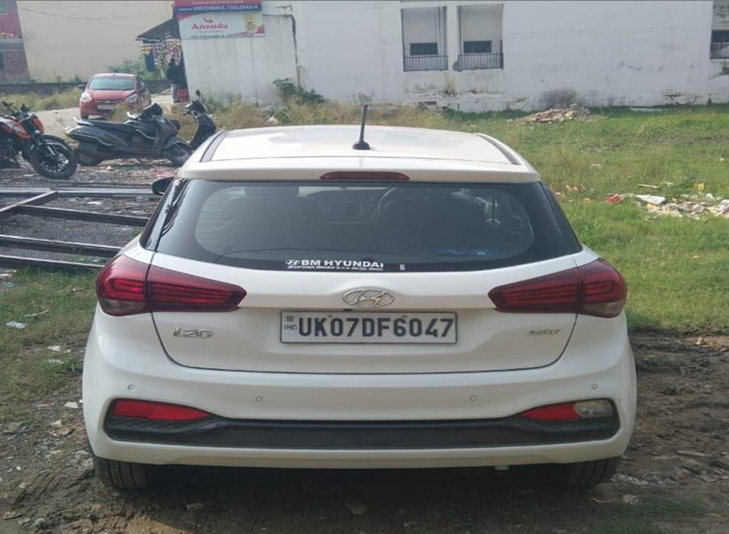

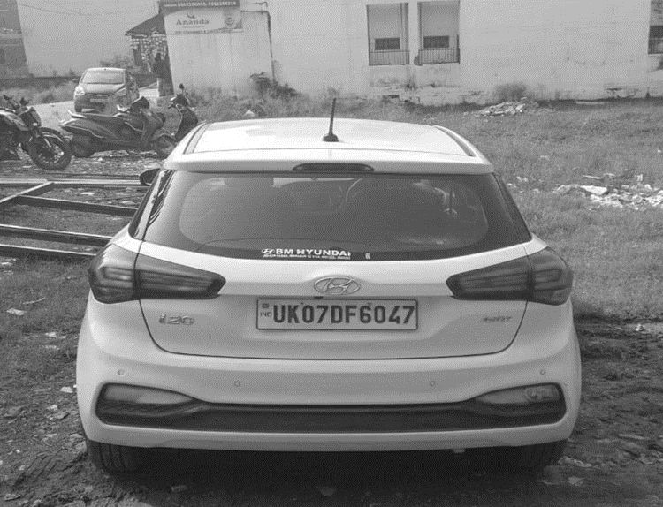

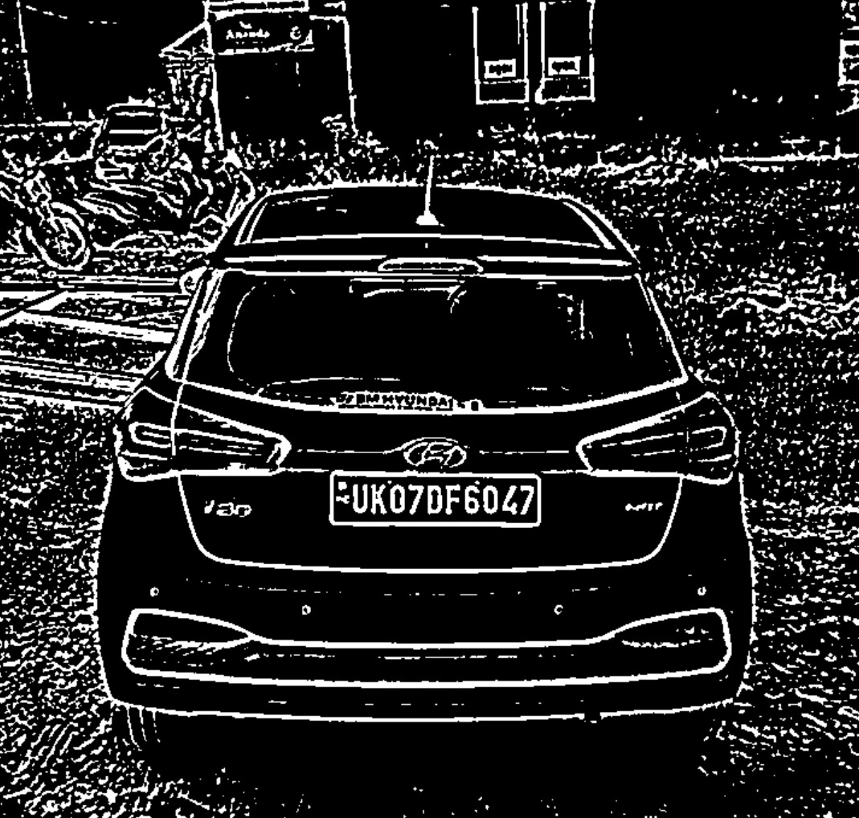

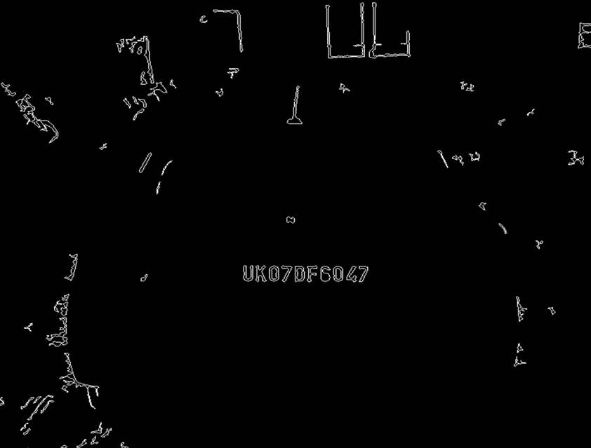





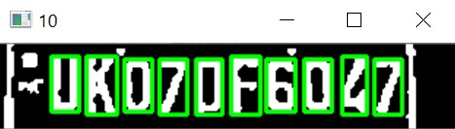

UK 07 DF6047

**Requirements**

* Computer
* Python
* Images
* Pandas
* Opencv
* KNN Classifier

**Future Scope**

This software can be further improved to recognizing plates from video frames which can be installed in camera in public which can detect for validation of any number plate and can keep track on thief escaping in vehicle

**Conclusion**

With billions of vehicles out there it’s almost impossible to check every vehicle individually.

Well!, license plate is one of the optimal solution to this which can scan through pic and extract alpha numeric value in it and it can check through database for validation of its documents.

**REFERENCES**

1. <https://doc.opencv.org>
2. <https://pandas.pydata.org>

Note: Code is attached in the given zipped file.