|  |
| --- |
| Peloton  Risk Scenarios |
| Avada Kedavra [Chunxiang Li](mailto:cl4143@columbia.edu)  [Xiaoyu Chen](mailto:xc2614@columbia.edu)  [Xiaoyue Xu](mailto:xx2398@columbia.edu)  [Yogesh Rohra](mailto:yar2115@columbia.edu)  [Zhuocheng Kong](mailto:zk2252@columbia.edu) |

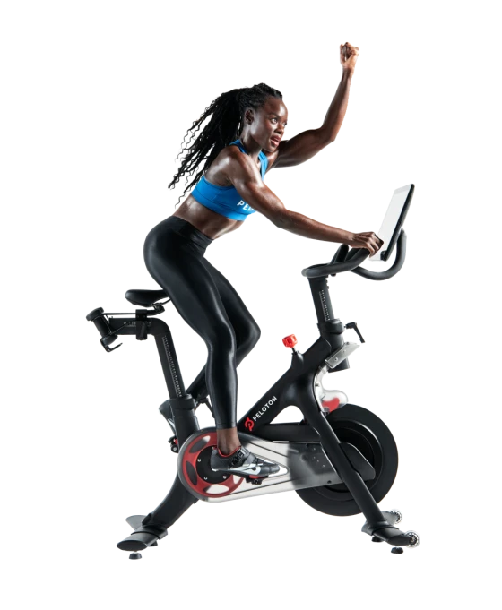

## Risk Scenarios

Based on the characteristics of Peloton, we selected 5 risks that Peloton needs to pay attention to from the 10 risks, and each was conducted with 3 Scenario tests.

### **Operational risk - Disasters - Pandemic**

Pandemic is a black swan event, which is unpredictable and with huge impacts. Therefore, it is difficult to use historical data as a guide. Most of our changes are speculative, we made the worst assumption and predicted the most severe implications for this time.

For the Very Pessimistic Scenario with 1% likelihood, we assumed a 15% increase in COGS and a 20% decrease in the Revenue. The manufacturing and supply chain of the company's products are significantly impacted. Moreover, the epidemic prevention will affect the closure of factories and the resumption of production, also respond to the secondary logistics, which will hit the company due to the supply of raw materials and labor shortage. Not only that, but the competitive landscape will also accelerate differentiation, and the offline business will be significantly squeezed.

For the Pessimistic Scenario with 2% likelihood, we assumed an 8% increase in COGS and a 10% decrease in Revenue. In this scenario, the company has reduced production capacity and is looking for alternative raw materials, which may face rising prices of some materials and cash flow difficulties. This action will result in a short-term shock to corporate liquidity, but there is still the possibility of subsequent recovery.

For the Moderate Scenario with 4% likelihood, we assumed a 5% increase in COGS and an 8% decrease in Revenue. The company is faced with increased competition. Although the price of raw materials will rise, it will not affect the overall operation, the company does not need to find substitutes for other raw materials. The sales volume drops slightly, but it is still acceptable.

### **Strategic - Competitor Risk**

For the Very Pessimistic Scenario, with 8% likelihood, considering the high growth of the Indoor Exercise market, financing is likely to happen. Domestic competitors or global competitors may use price war as a strategy to eliminate other players in the market. In this case, they can cut the price to rob the market share. Peloton, a medium-size company, will estimate a loss of 30% in revenue.

Nevertheless, the price war will not last very long. Once competitors start the price war, it will last for 1 year. Also, it is impossible to predict when competitors are starting a price war. Once a price war starts, the inventory for that year will increase by 18% and then recover in the next year (the supply chain can switch its estimation model to match the supply and demand). In general, the price war is a risky decision, but is not likely to happen.

For the Pessimistic Scenario, with 15% likelihood, location risk is likely to happen. When competitors find out Peloton is earning a lot in some locations, they will open a store around that area to share the benefit. However, considering the complexity of Peloton's products (not just indoor exercise equipment but also the teaching lesson and live stream app), we estimate that overall revenue will decline by 7% forever.

For the Moderate Scenario, with 25% likelihood, innovation is essential for all the firms in the Indoor Exercise market; thus, the problem is: can those competitors successfully design new products? Can they threaten Peloton's business model with those upcoming new products? It is highly likely to see new products launch in the market. New products may result in a revenue decline of 15% in the next 1 year while overall expenses increased 2% in one year due to R&D, and a 1% increase in R&D in Y2. Though finish the R&D stage, Peloton still need time for marketing and market needs time to react. Thus, revenue recovers one year later, then increases 3% annually.

### **Strategic - Economic Risk**

There are several possible scenarios for the economy. The most common scenario is that the economy is running smoothly, but scenarios like Stagflation, Economic Downturn, and Relatively High Inflation can also occur. Inflation above the 2% benchmark is often happening, such as the current U.S. is going through this phase; if the Fed makes a mistake in the coming year, such as raising interest rates too slowly, it will lead to Stagflation, while raising rates too quickly may lead to a hard landing and directly trigger a recession.

For the Very Pessimistic Scenario - Stagflation, inflation is very high, but the economy is not growing, the unemployment rate is high, and people have no desire to spend. Therefore, the company's products will sell less, but costs will rise due to cost increases in raw materials, human capital, etc. So, we assume CoGS will increase an additional 6% per year than the baseline scenario, and Average Revenue Growth will decrease an additional 10% per year.

For the Pessimistic Scenario - Economic Downturn (recession), people’s average income decreases, the unemployment rate increases, so people's desire to consume decreases. Therefore, Average Revenue Growth will decrease, which we assume an additional 10% decrease per year than the baseline scenario.

For the Moderate Scenario - Relatively high inflation, CoGS would be higher than target inflation rate. So, we assume CoGS will increase an additional 2% per year than the baseline scenario.

### **Strategic risk - Execution - Product quality**

As for the strategic risk of product quality, Peloton’s products and services may be subject to manufacturing and design defects from time to time. The probabilities for baseline, moderate, pessimistic, and very pessimistic scenarios are 40%,30%,20%, and 10% separately since the possibility for severe product quality problems occurring is low.

For Pessimistic and Very Pessimistic scenarios, product recalls and new product resolution would be required which will increase the costs of producing and innovating products along with reduced sales. In this case, the revenue growth rate would be -10% in the very pessimistic scenario and -8% in the pessimistic scenario, the cost of goods sold, R&D as a percent of revenue as well as SGA expense would also be significantly increased to 10% in the very pessimistic scenario and 8% in the pessimistic scenario.

For the Moderate Scenario, the revenue growth rate would be negative since there would be more concerns in the market related to the product quality which may impact sales revenue therefore the revenue growth and related expenses would be -5%.

### **Operation - Human Resources - Performance**

For human resources risk, Peloton is mainly concerned with the performance of employees hired. Hence, we considered a drop in the productivity and ethics of employees.

For the Very Pessimistic Scenario, with 7% likelihood, a significant drop in productivity of employees may cause a drastic revenue decline. Additionally, employees harm Peloton by stealing technology or compromising Peloton's infrastructure by involving it with competition, causing a rise in SGA expenses. We predict negative revenue growth of 15% starting 1st year with an additional 7% each year. The numbers considered here are since Peloton observed more than 100% growth for the past period compared to which -15% is a drastic decline in revenue. The additional 7% is less than half of 15%. Also, the SGA expenses will increase by 3% each year. The numbers here are for administration to deal with the employees who might potentially harm Peloton, 3% is slightly less than half of 7% hence it is assumed here.

For the Pessimistic Scenario, with 10% likelihood, shocks such as a significant drop in productivity of employees cause a drastic revenue decline. There will be a negative revenue growth of 10% starting 1st year with an additional 5% each year. The numbers here are sufficient to ascertain employee performance failure since Peloton observed more than 100% growth priorly. 5% additional each year is considered since it is half of 10%.

For the Moderate Scenario, with 18% likelihood, business as Usual with slight shocks such as drop-in productivity of employees. Since the productivity of employees decline, revenue will decrease 2.5% each year in addition to the previous year. A slight drop in productivity is acceptable and expected post and prior to the holiday season or long weekends. Hence a mere factor of 2.5% is considered a shock.