Ex.no:8 | MINI PROJECT – HOTEL BOOKINGS  DATA ANALYTICS

Aim:
To clean, transform, store, and analyze hotel booking data using Python, MySQL, Power BI and Tableau to derive meaningful insights into booking trends, cancellations, hotel performance, and customer/market segments.
Algorithm:
- Load the hotel booking dataset from the CSV file using Pandas.
- Clean the data by handling missing values, removing duplicate records, and eliminating unnecessary attributes.
- Transform the data by standardizing columns, creating arrival_date, and deriving useful fields such as total_nights and total_guests.
- Store the cleaned and transformed dataset in a MySQL database named hotel_analytics.
- Connect the MySQL database to Power BI for data analysis and reporting.
- Create DAX measures for key metrics such as total bookings, cancelled bookings, cancellation rate, and average ADR.
- Develop interactive visualizations to analyze booking trends, hotel performance, cancellations, and market segments.
- Generate business insights from the Power BI & Tableau dashboard.
- End the process.

Architecture:

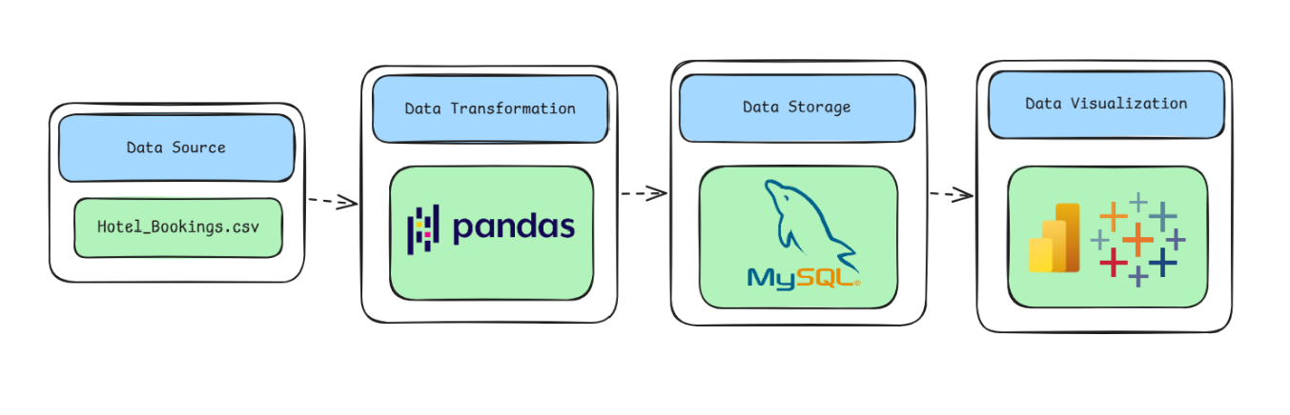

Program:
1. Python – Data Cleaning & Transformation
import pandas as pd
from sqlalchemy import create_engine, text

# Load dataset
df = pd.read_csv("hotel_bookings.csv")

# Create a copy for processing
hotel = df.copy()
# Remove unnecessary columns
hotel.drop(columns=["agent", "company"], inplace=True)

# Handle missing values
hotel["children"] = hotel["children"].fillna(0)
hotel["country"] = hotel["country"].fillna("Unknown")
# Remove duplicate records
hotel.drop_duplicates(inplace=True)

# Create arrival date
hotel["arrival_date"] = pd.to_datetime(
hotel["arrival_date_year"].astype(str) + "-" +
hotel["arrival_date_month"] + "-" +
hotel["arrival_date_day_of_month"].astype(str),
format="%Y-%B-%d"
)

# Create derived columns
hotel["total_nights"] = (
hotel["stays_in_weekend_nights"] +
hotel["stays_in_week_nights"]
)

hotel["total_guests"] = (
hotel["adults"] +
hotel["children"] +
hotel["babies"]
)

hotel["total_extra_requests"] = (
hotel["total_of_special_requests"] +
hotel["required_car_parking_spaces"]
)

# Standardize column names
hotel.columns = (
hotel.columns
.str.lower()
.str.strip()
.str.replace(" ", "_")
)
print("Original Shape:", df.shape)
print("Cleaned Shape:", hotel.shape)
hotel.head()
2. MySQL – Database and Data Loading
MySQL Command Prompt:
net start MySQL80
mysql -u root -p
MySQL:
CREATE DATABASE IF NOT EXISTS hotel_analytics;
Python/Jupyter:
username = "root"
password = "YOUR_MYSQL_PASSWORD"
host = "localhost"
port = 3306

# Connect to MySQL database
db_engine = create_engine(
f"mysql+pymysql://{username}:{password}@{host}:{port}/hotel_analytics"
)

# Load cleaned data into MySQL
hotel.to_sql(
"hotel_bookings",
con=db_engine,
if_exists="replace",
index=False,
chunksize=5000
)

print("Data loaded successfully into MySQL.")
Verify:
pd.read_sql(
"SELECT COUNT(*) AS total_rows FROM hotel_bookings",
db_engine
)
3. Power BI – DAX Measures
Total Bookings = COUNTROWS('hotel_analytics hotel_bookings')

Cancelled Bookings =
CALCULATE(
COUNTROWS('hotel_analytics hotel_bookings'),
'hotel_analytics hotel_bookings'[is_canceled] = 1
)

Cancellation Rate =
DIVIDE(
[Cancelled Bookings],
[Total Bookings]
)

Average ADR = AVERAGE('hotel_analytics hotel_bookings'[adr])

Average Stay = AVERAGE('hotel_analytics hotel_bookings'[total_nights])

4. Tableau Dashboard
Created visuals in tableau in separate sheets and created a dashboard

Output:
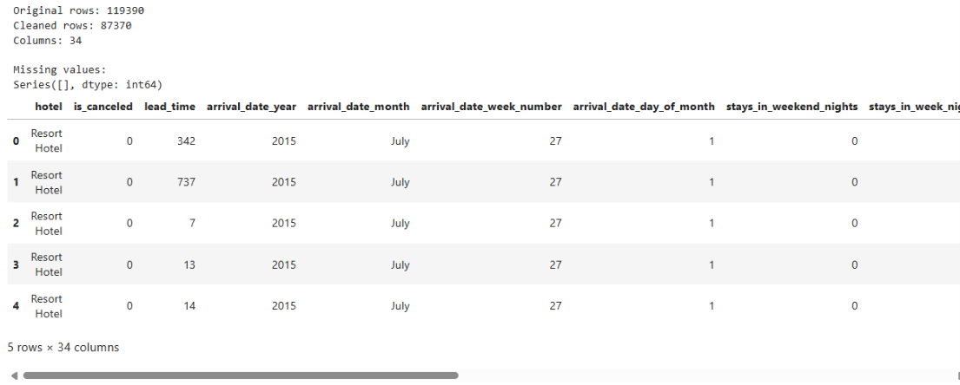

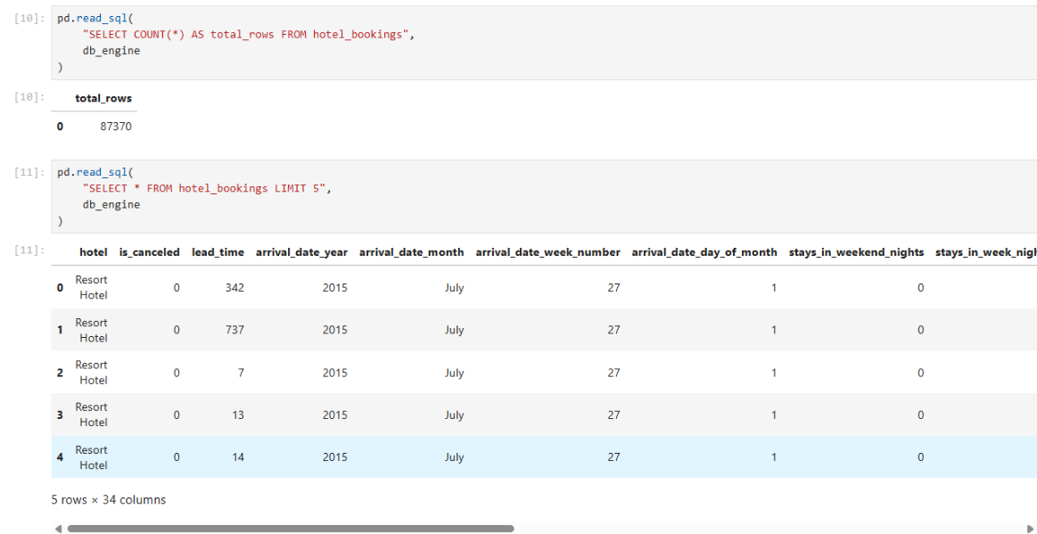

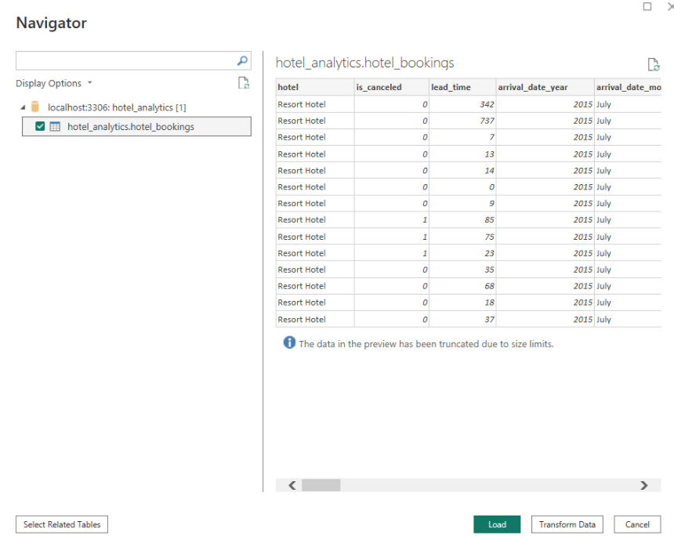

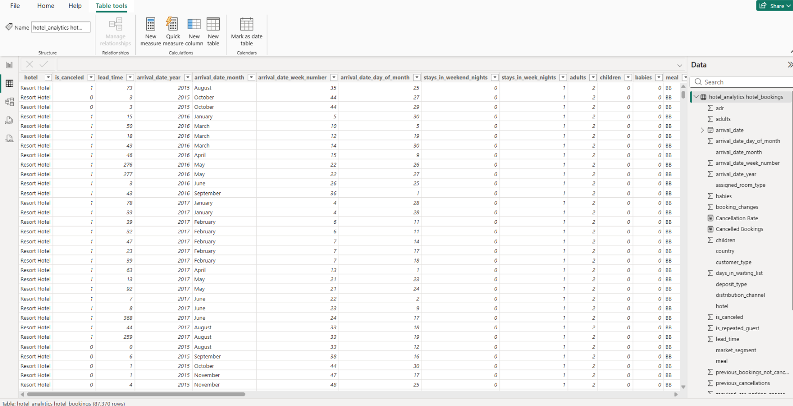

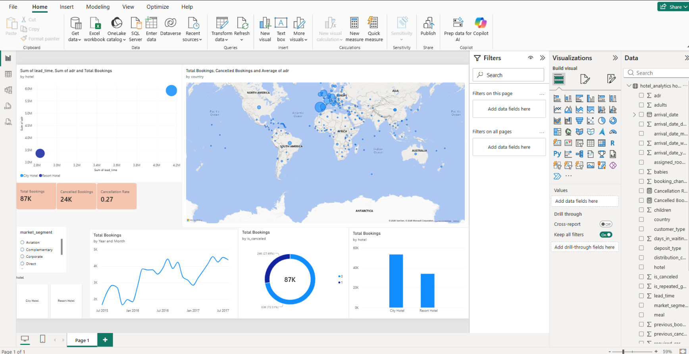

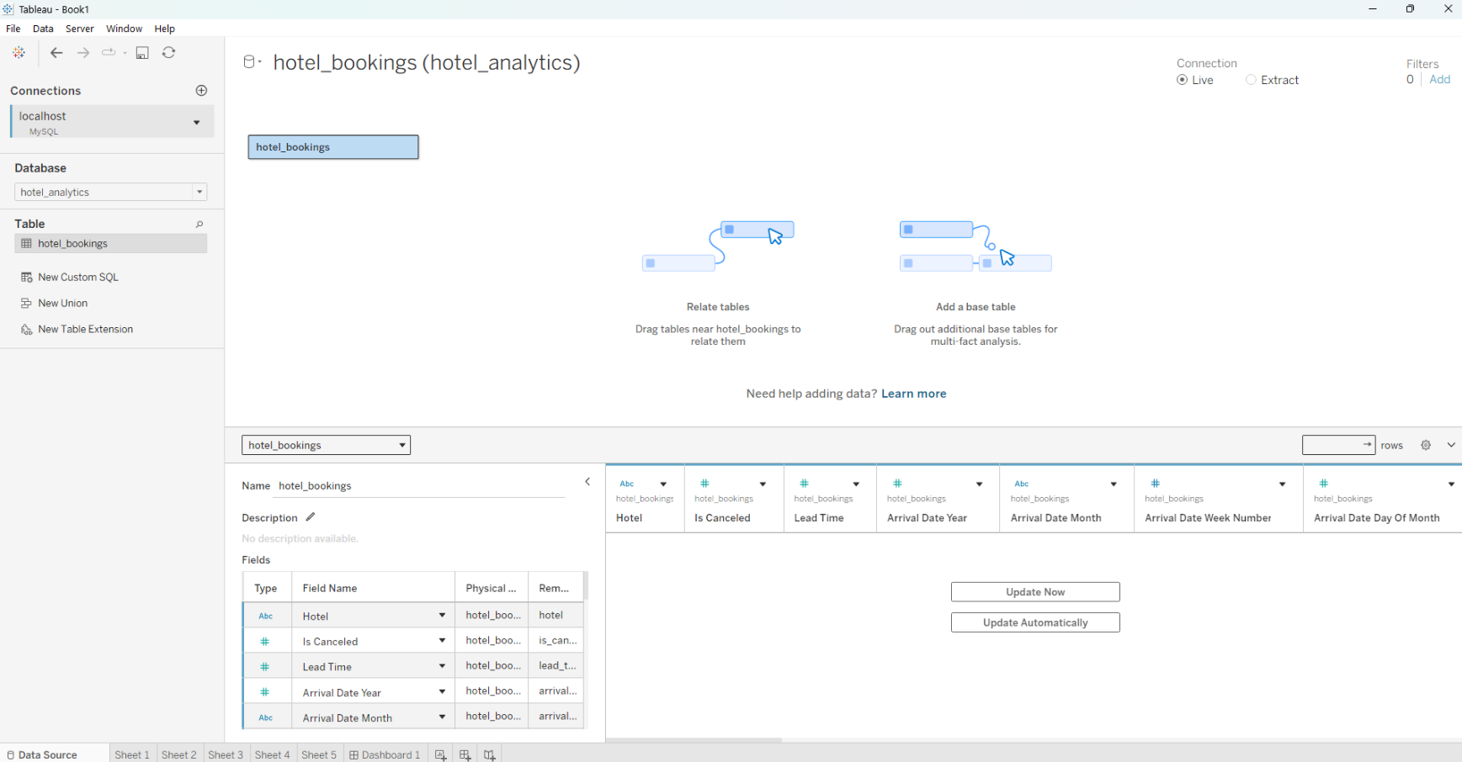

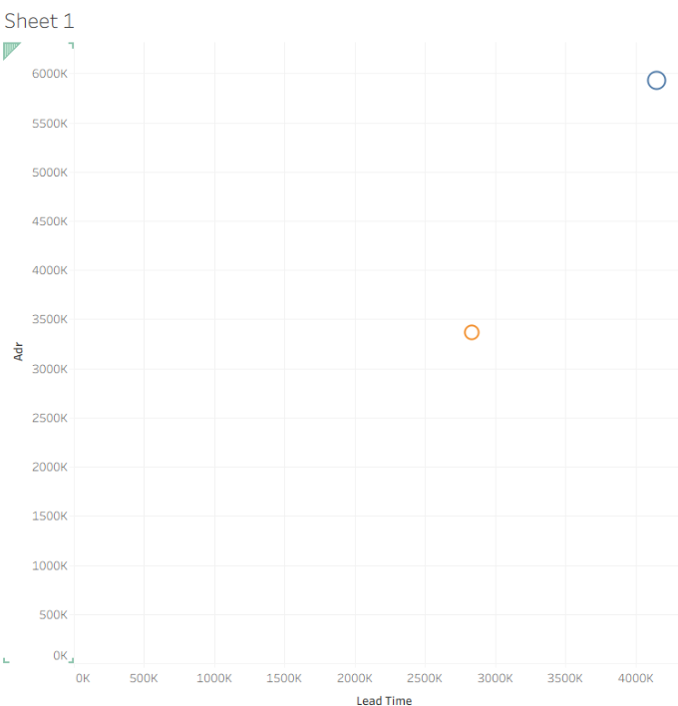

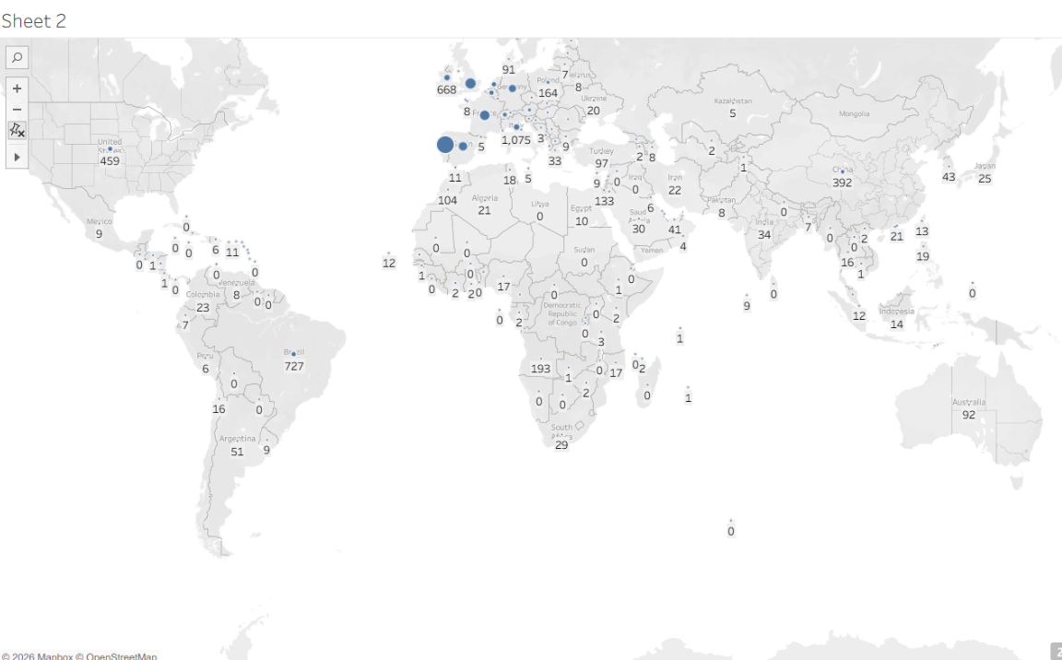

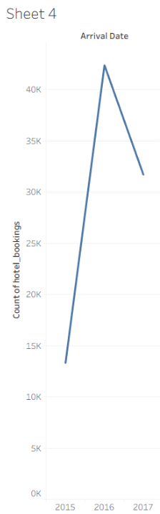
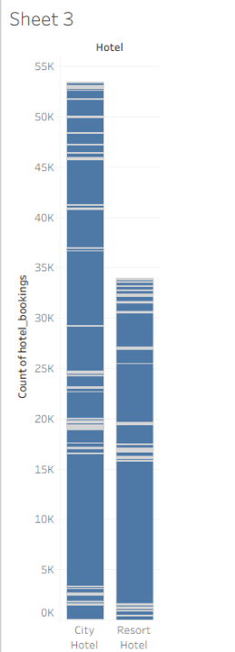

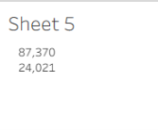

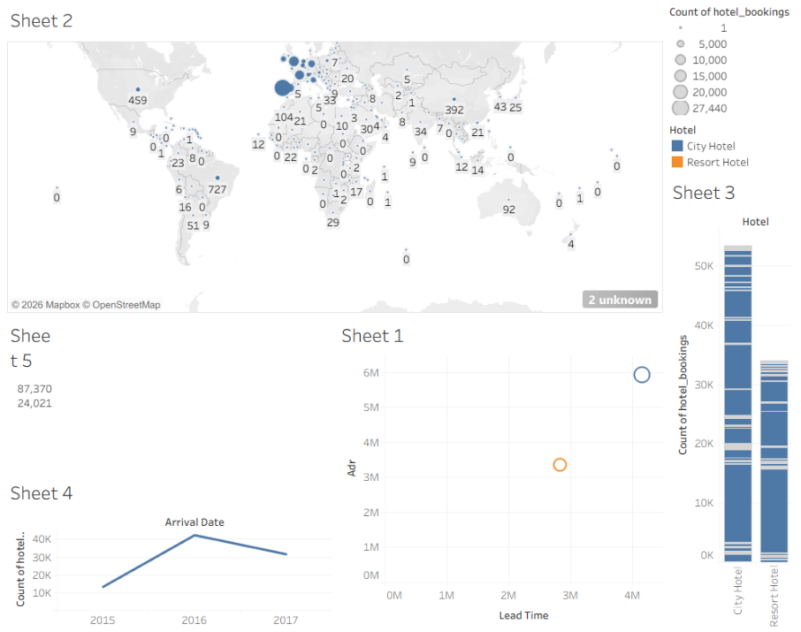

Result:

