Ex.no:7 | DATA VISUALIZATION USING TABLEAU

Aim:
To perform data analysis, data preparation, and visual exploration on the Healthcare Appointment dataset in Tableau Desktop to analyze appointment attendance, no-show rates, patient demographics, SMS reminders, waiting time, health conditions, and scholarship status for actionable healthcare insights.
Algorithm:
1. Data Ingestion & Connection
Connect Tableau Desktop to the HealthcareAnalytics SQL Server database and select the Appointments table.
Verify field data types (e.g., date formats for Scheduled Day and Appointment Day, integer values for Age and Waiting Days, and string values for Gender, Neighbourhood, SMS Status and Attendance Status).
2. Data Cleansing & Transformation
Handle invalid or inconsistent values across critical columns such as Age and Waiting Days.
Create calculated fields for key metrics (e.g., Total Appointments, Total Attended, Total No-Shows, No-Show Rate and Attendance Rate).
3. Exploratory Visual Analysis
4. Appointment Attendance Dynamics: Analyze waiting time groups against no-show rates to identify patterns in missed appointments.
5. Demographic & Patient Segmentation: Analyze age groups, gender, neighbourhood, scholarship status, and health conditions to identify differences in appointment attendance.
6. SMS Reminder & Health Trends: Compare no-show rates based on SMS reminder status and the number of health conditions such as hypertension, diabetes, and alcoholism.
7. Dashboard Assembly & Formatting
Combine key worksheets into an interactive healthcare appointment analysis dashboard.
Apply global interactive filters and parameters (e.g., Gender, Age Group, Neighbourhood, SMS Status, Waiting Time Group and Select Analysis Factor) across all dashboard components.

Output:

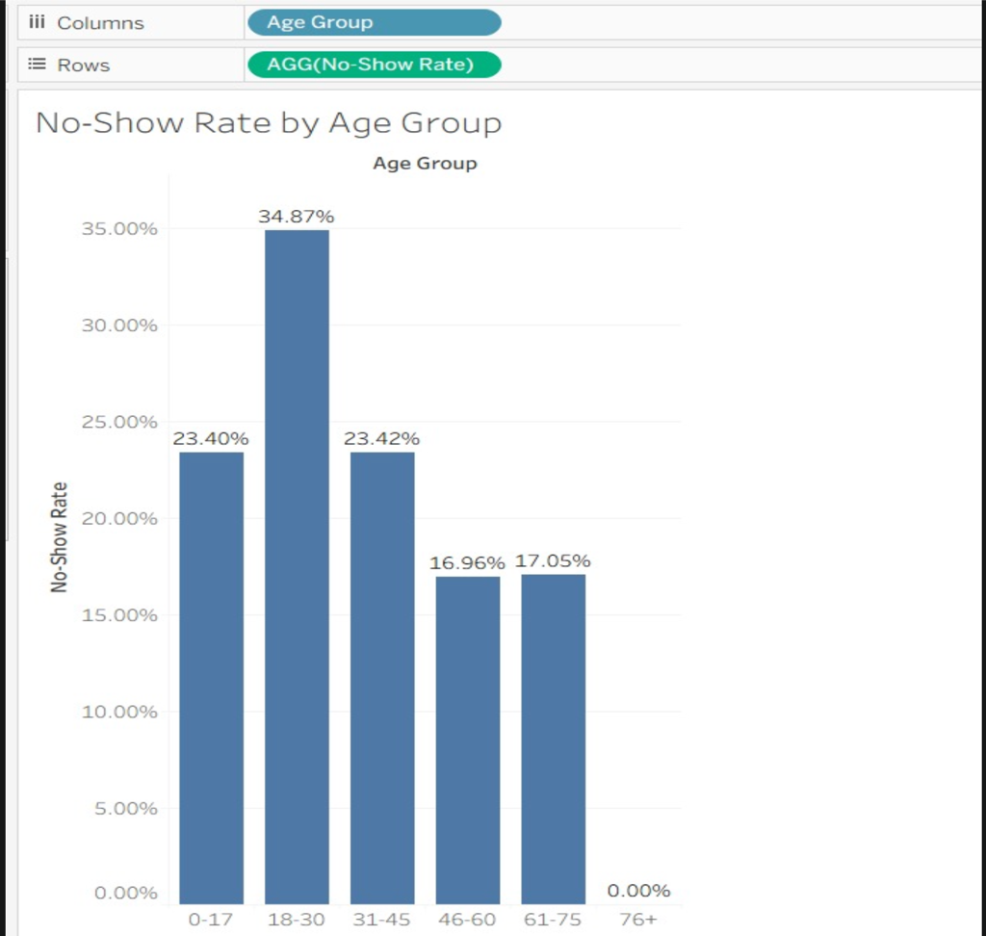

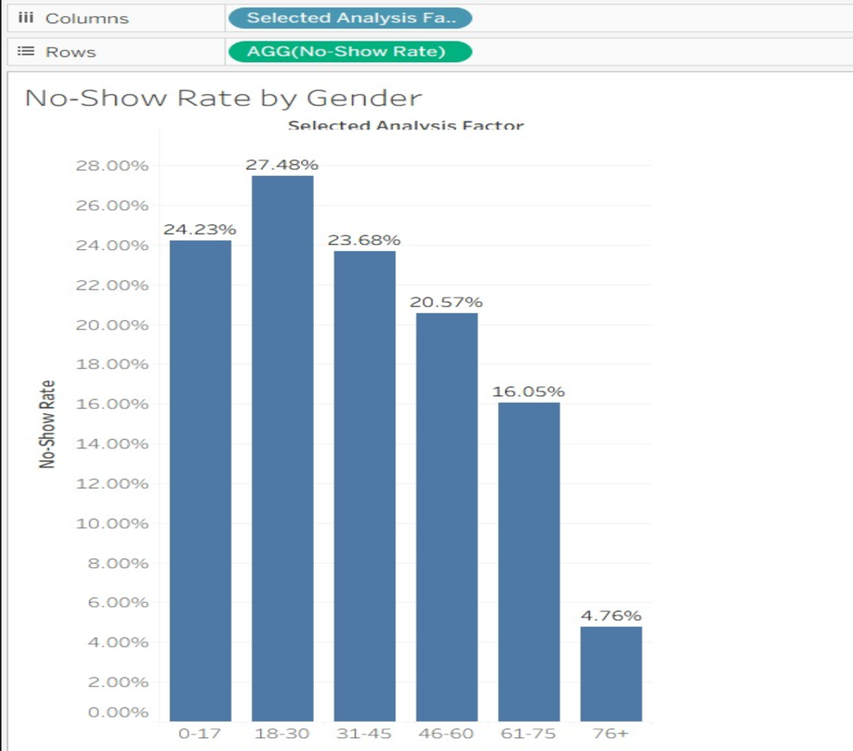

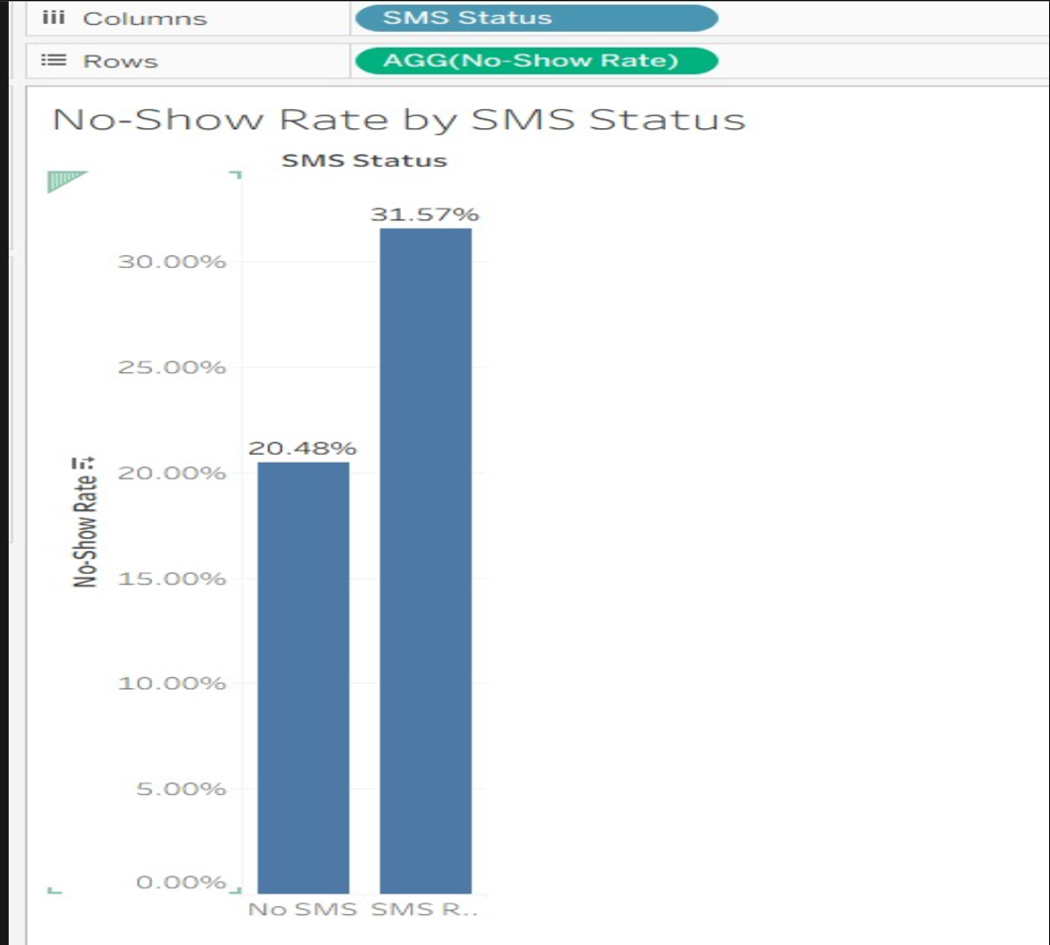
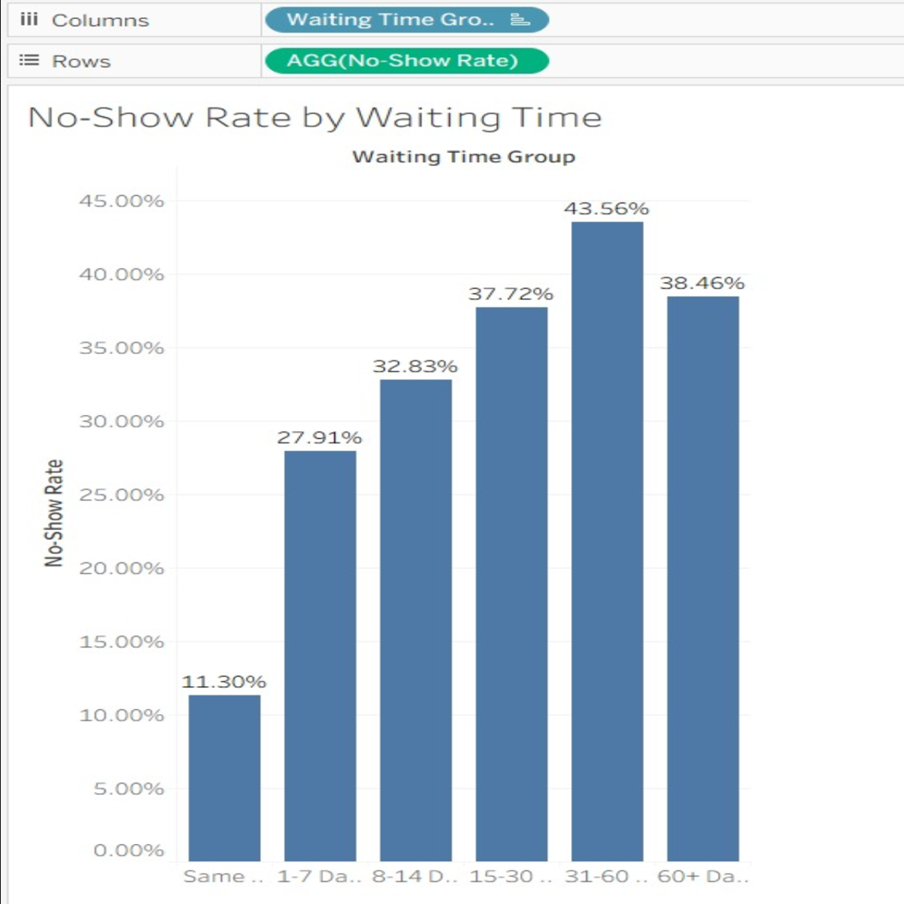

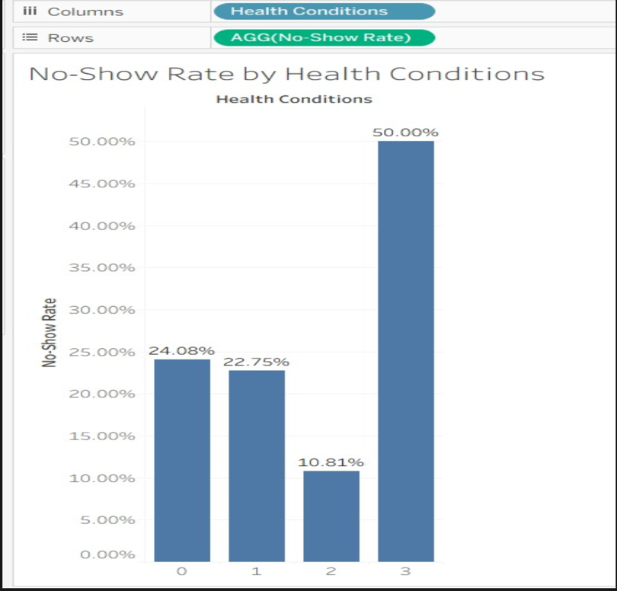
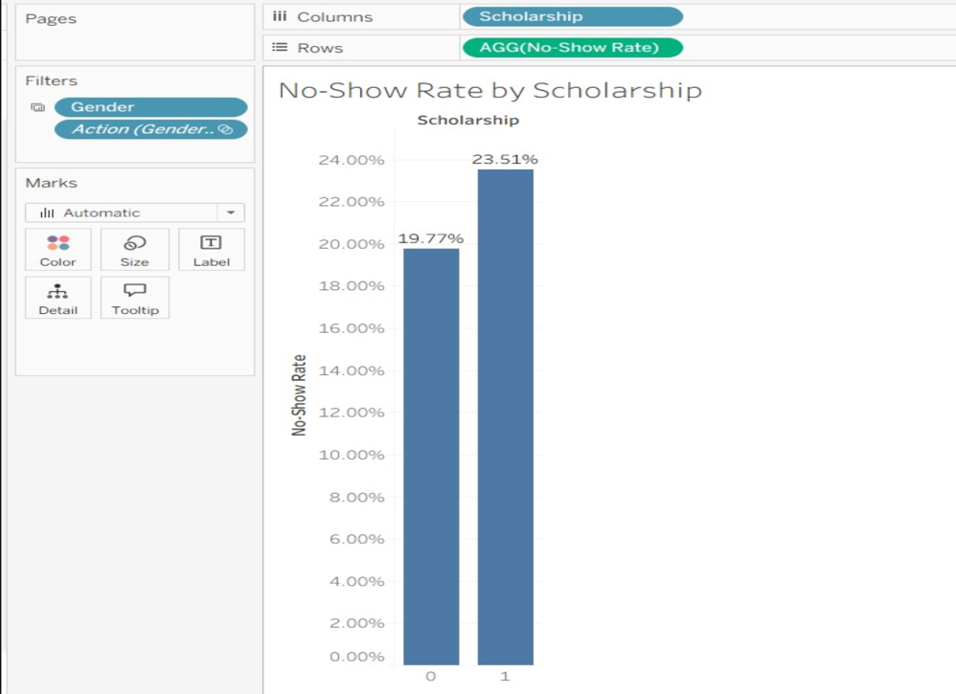
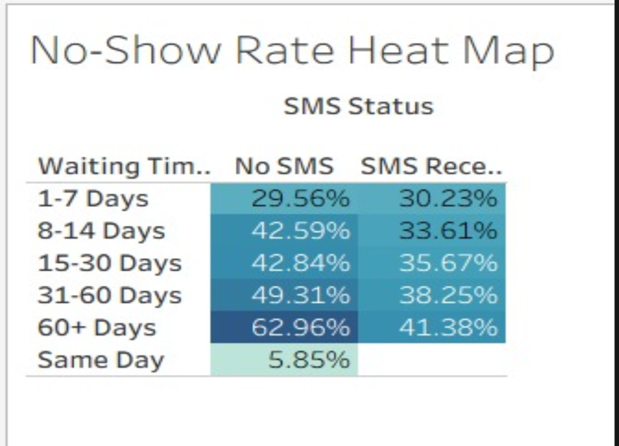

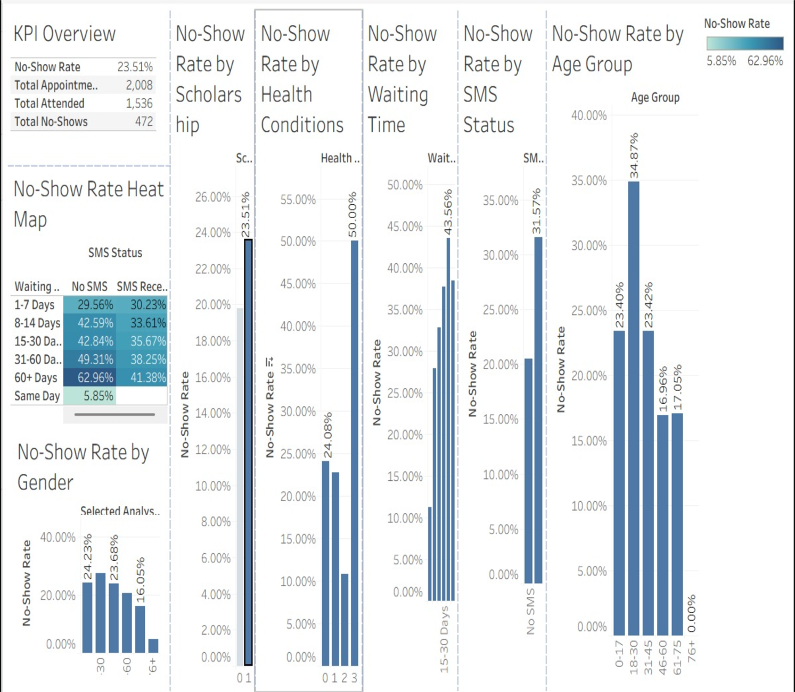

Result:

