Ex.no: 6

DATA VISUALIZATION USING POWER BI (KAGGLE V2 – MEDICAL APPOINTMENTS)

Aim:
To clean, preprocess, and transform the raw Kaggle V2 medical appointment dataset, load the cleaned data into Power BI, create DAX measures, and build an interactive dashboard to analyze appointment attendance, no-show patterns, patient demographics, SMS reminders, and health-condition factors.

Algorithm:
- Import Dataset: Load KaggleV2-May-2016.csv into Power BI using Get Data → Text/CSV.
- Clean Data: Open Power Query Editor, rename the required columns, check missing values, and set appropriate data types.
- Load Data: Click Close & Apply to load the cleaned dataset into Power BI.
- Create DAX Measures: Create Total Missed and No Show Rate measures to calculate missed appointments and their percentage.
- Create Visualizations: Build a Donut Chart, Card, Treemap, Clustered Column Charts, and Stacked Bar Chart using appointment, gender, SMS, health-condition, and no-show fields.
- Format Dashboard: Add suitable titles, labels, percentage formats, and consistent colors to the visuals.
- Analyze Results: Analyze appointment attendance, no-show patterns, SMS impact, gender distribution, and health-condition factors.

Output:

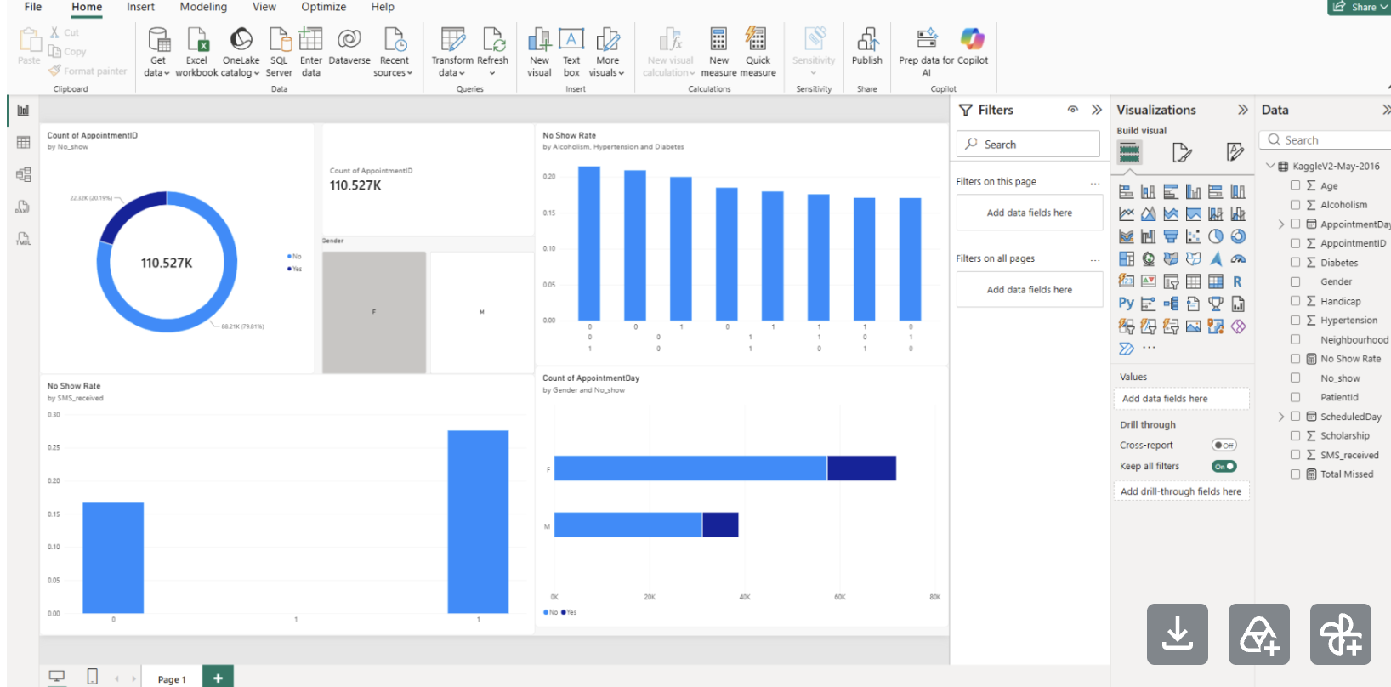

Result:
- Thus, the Kaggle V2 medical appointment dataset was successfully cleaned, transformed, and loaded into Power BI. DAX measures and multiple visualizations were created to analyze appointment attendance, no-show rates, gender distribution, SMS reminders, and health-condition-related appointment patterns.

