Ex.no:8 | MINI PROJECT – HEALTHCARE APPOINTMENT ANALYSIS

Domain and Problem Statement:
Domain: Healthcare Analytics & Appointment Management
Problem Statement: Healthcare organizations face challenges due to missed medical appointments, which can reduce healthcare service efficiency, waste available appointment slots, and affect patient management. This project addresses these challenges by analyzing medical appointment records to identify factors associated with appointment no-shows. The project transforms raw appointment data into meaningful business intelligence using Python, SQL Server, Power BI and Tableau to evaluate attendance patterns based on age, gender, SMS reminders, waiting time, scholarship status, health conditions and neighbourhood.
Dataset Description:
Dataset Name: Medical Appointment No-Show Dataset.
Granularity: Each row represents a single medical appointment record.
Timeframe Covered: May 2016.
Original Records: 110,527 appointment records.
Cleaned Records: 110,521 appointment records.
Key Entities and Attributes:
Patient Information:
- PatientId
- Gender
- Age
- Neighbourhood
Appointment Information:
- AppointmentID
- ScheduledDay
- AppointmentDay
- Waiting_Days
- Waiting_Time_Group

Health Information:
- Hipertension
- Diabetes
- Alcoholism
- Handcap
- Health_Conditions
Appointment Support Information:
- Scholarship
- SMS_received
- SMS_Status
Appointment Outcome:
- No_show
- Attendance_Status
Derived Attributes:
- Age_Group
- Waiting_Days
- Waiting_Time_Group
- Health_Conditions
- SMS_Status
- Attendance_Status

Data Source:
Primary Source: Kaggle Open Dataset – Medical Appointment No-Show Dataset.
Original File: KaggleV2-May-2016.csv
Data Processing: Python using Pandas.
Storage Infrastructure: Cleaned appointment records stored in a local Microsoft SQL Server database.
Database Name: HealthcareAnalytics
Table Name: dbo.Appointments
Visualization Tools:
- Microsoft Power BI
- Tableau Desktop
The project therefore follows the same source → transformation → database → visualization approach used in the reference document, but with the healthcare appointment dataset and SQL Server architecture.

Architecture:
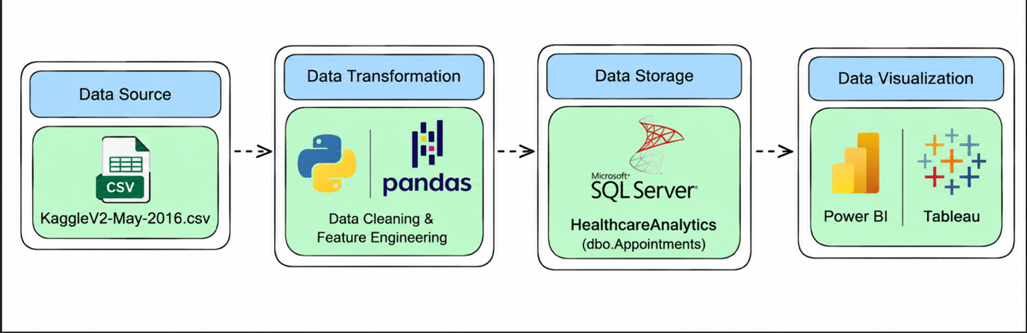

Program:
**1. Python – Data Cleaning & Transformation**

import pandas as pd

df = pd.read_csv("KaggleV2-May-2016.csv")

# Create a copy for processing
healthcare = df.copy()

# Handle missing values
healthcare["Gender"] = healthcare["Gender"].fillna("Unknown")
healthcare["Neighbourhood"] = healthcare["Neighbourhood"].fillna("Unknown")
healthcare["No-show"] = healthcare["No-show"].fillna("Unknown")

# Replace missing numerical values with 0
numeric_columns = [
"Age",
"Scholarship",
"Hipertension",
"Diabetes",
"Alcoholism",
"Handcap",
"SMS_received"
]

for column in numeric_columns:
healthcare[column] = healthcare[column].fillna(0)

# Remove duplicate records
healthcare.drop_duplicates(inplace=True)

# Convert date columns
healthcare["ScheduledDay"] = pd.to_datetime(
healthcare["ScheduledDay"], errors="coerce"
)

healthcare["AppointmentDay"] = pd.to_datetime(
healthcare["AppointmentDay"], errors="coerce"
)

# Create Waiting Days
healthcare["Waiting_Days"] = (
healthcare["AppointmentDay"].dt.normalize()
- healthcare["ScheduledDay"].dt.normalize()
).dt.days

# Create Attendance Status
healthcare["Attendance_Status"] = healthcare["No-show"].map({
"No": "Attended",
"Yes": "No-Show"
})

# Create SMS Status
healthcare["SMS_Status"] = healthcare["SMS_received"].map({
0: "No SMS",
1: "SMS Received"
})

# Create Health Conditions
healthcare["Health_Conditions"] = (
healthcare["Hipertension"]
+ healthcare["Diabetes"]
+ healthcare["Alcoholism"]
)

# Create Age Group
def age_group(age):
if age <= 17:
return "0-17"
elif age <= 30:
return "18-30"
elif age <= 45:
return "31-45"
elif age <= 60:
return "46-60"
elif age <= 75:
return "61-75"
else:
return "76+"

healthcare["Age_Group"] = healthcare["Age"].apply(age_group)

# Create Waiting Time Group
def waiting_time_group(days):
if days == 0:
return "Same Day"
elif days <= 7:
return "1-7 Days"
elif days <= 14:
return "8-14 Days"
elif days <= 30:
return "15-30 Days"
elif days <= 60:
return "31-60 Days"
else:
return "60+ Days"

healthcare["Waiting_Time_Group"] = healthcare["Waiting_Days"].apply(
waiting_time_group
)

# Standardize column names
healthcare.columns = (
healthcare.columns
.str.lower()
.str.strip()
.str.replace(" ", "_")
)

# Display dataset information
print("Original Shape:", df.shape)

print("Cleaned Shape:", healthcare.shape)

print("\nDataset Preview:")

print(healthcare.head())

print("\nDataset Information:")

print(healthcare.info())

2. SQL SERVER CONNECTIVITY

INSTALL SQL SERVER MANAGEMENT STUDIO

1) Create database named “dashboardDB”

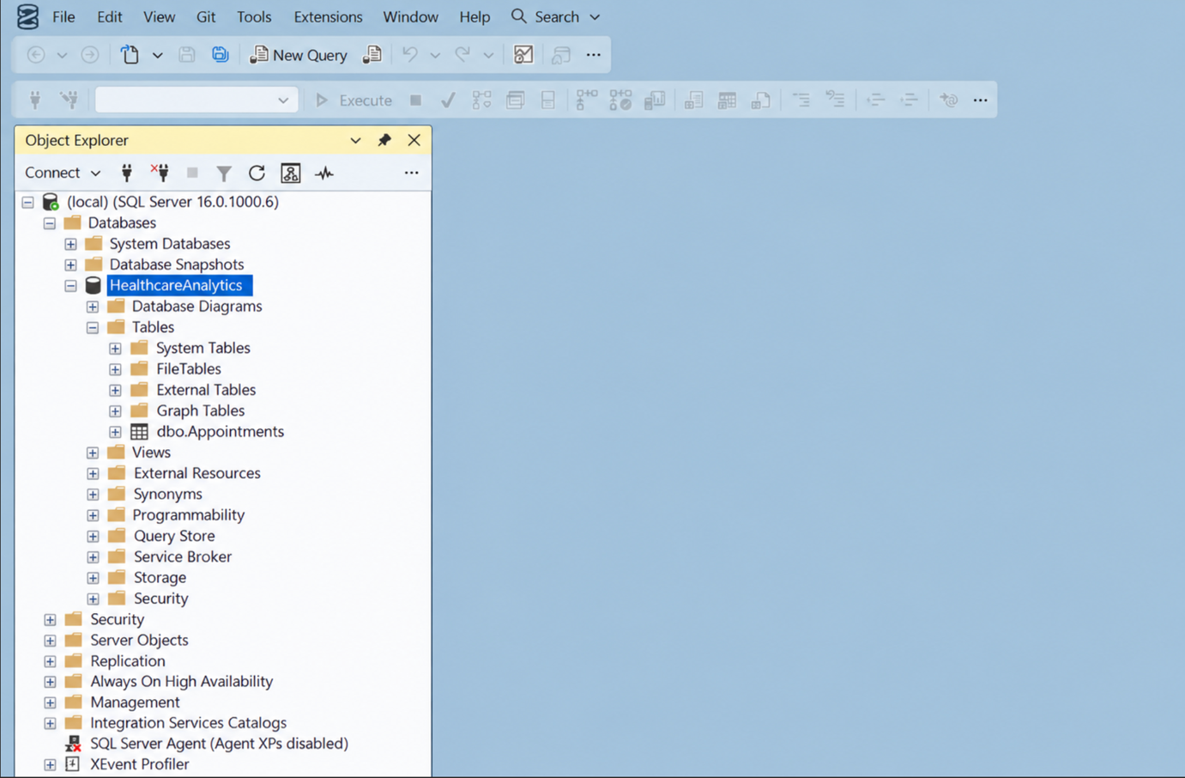

2) Import the csv file of the dataset

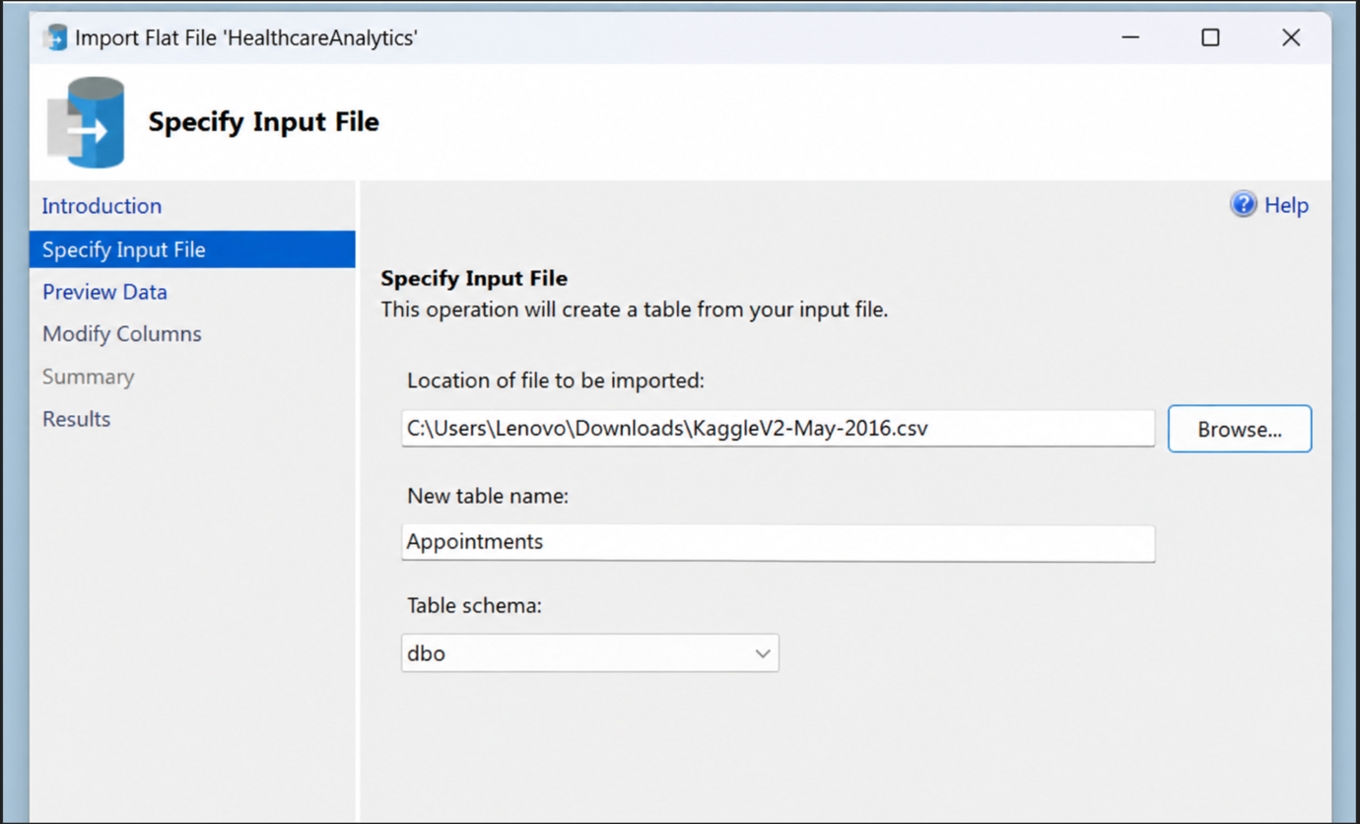

POWER BI

3) Now go to MICROSOFT POWER BI

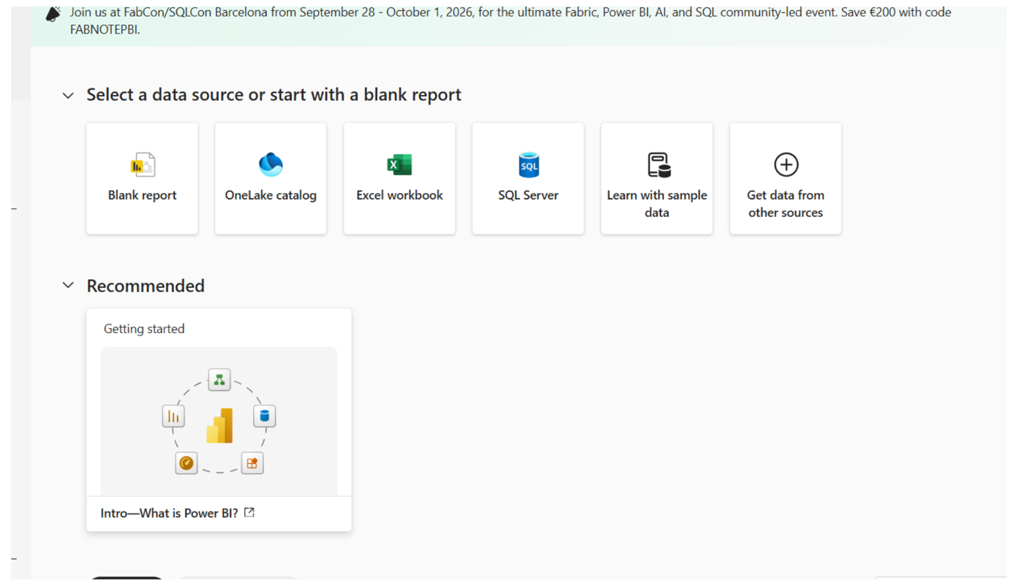

4) Click SQL SERVER

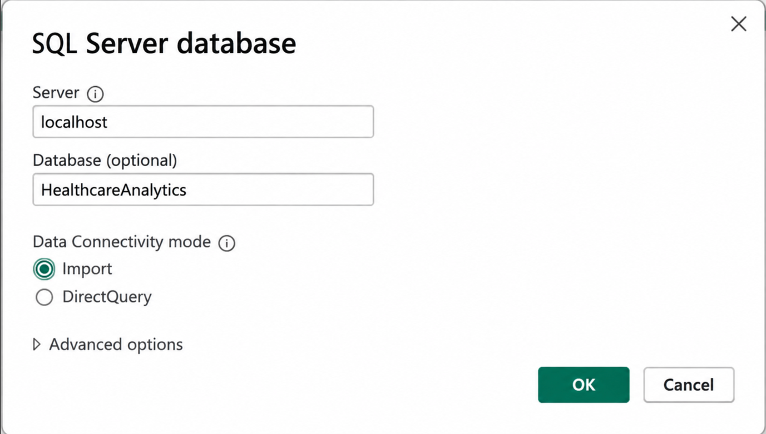

5) Click OK and click transform data

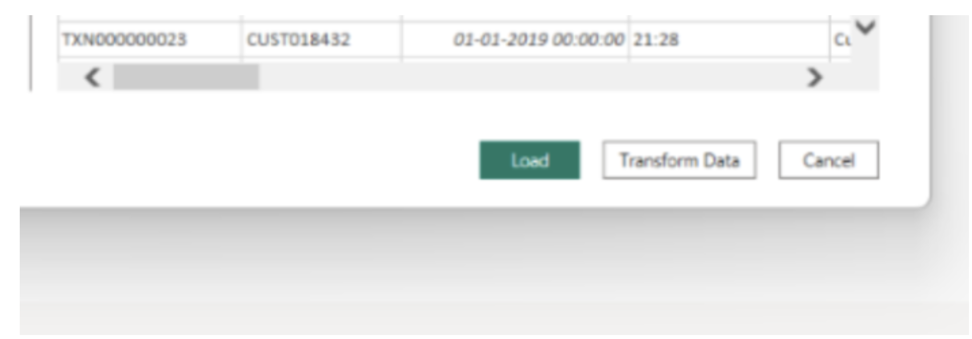

6) Create DAX measures

TOTAL APPOINTMENTS:

TOTAL ATTENDED :
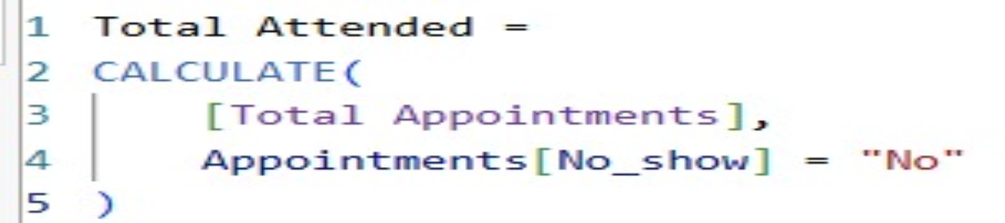

TOTAL NO-SHOWS:
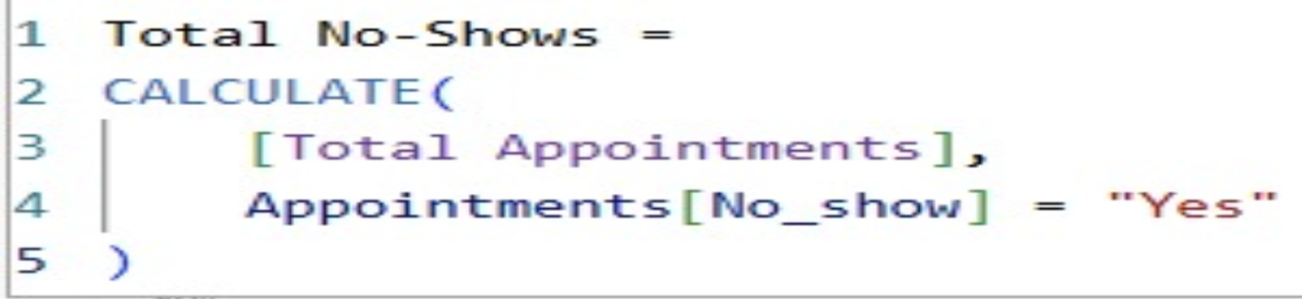

NO-SHOW RATE:

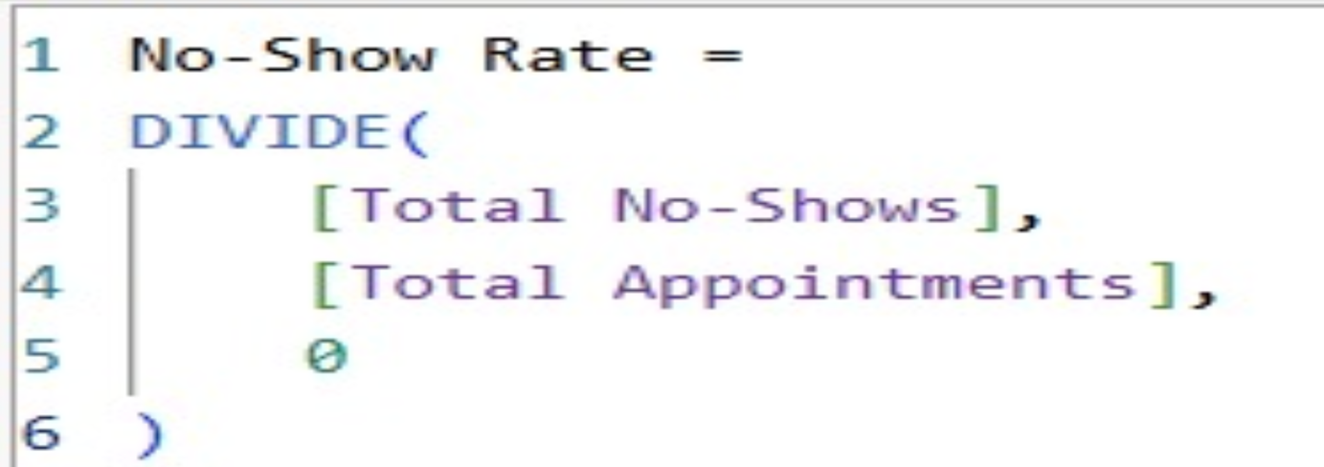

1.Healthcare Appointment Overview
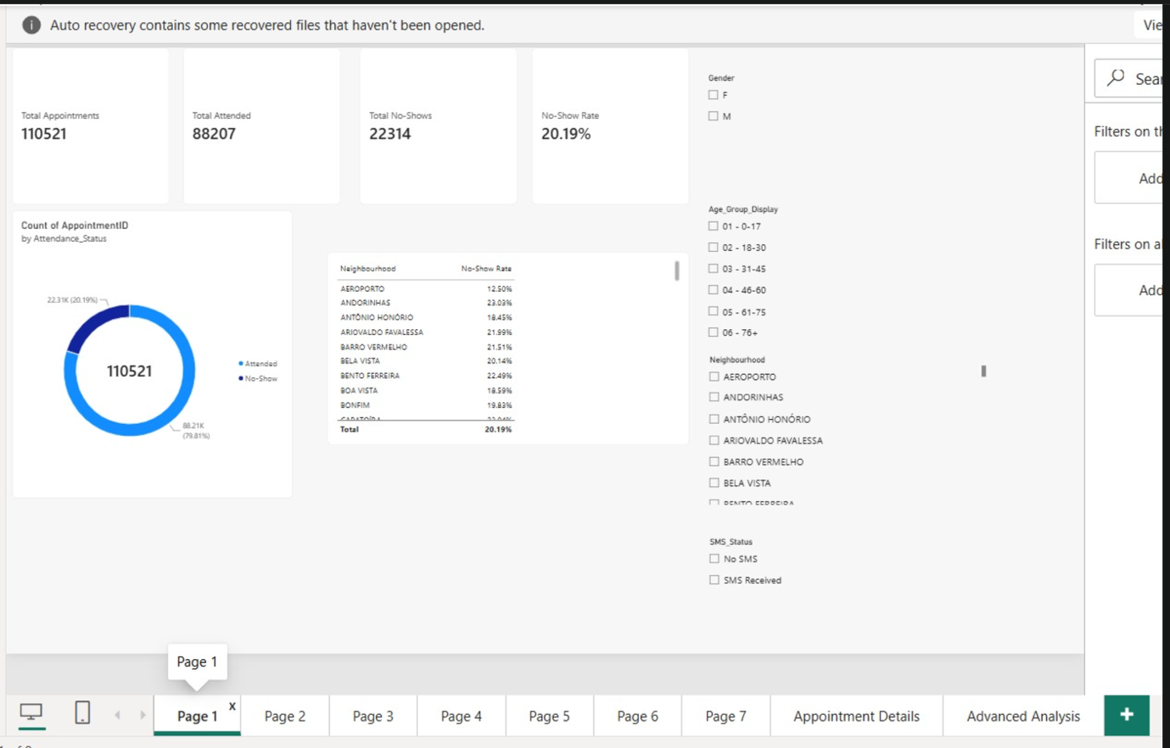
2. Appointment Analysis by Age Group
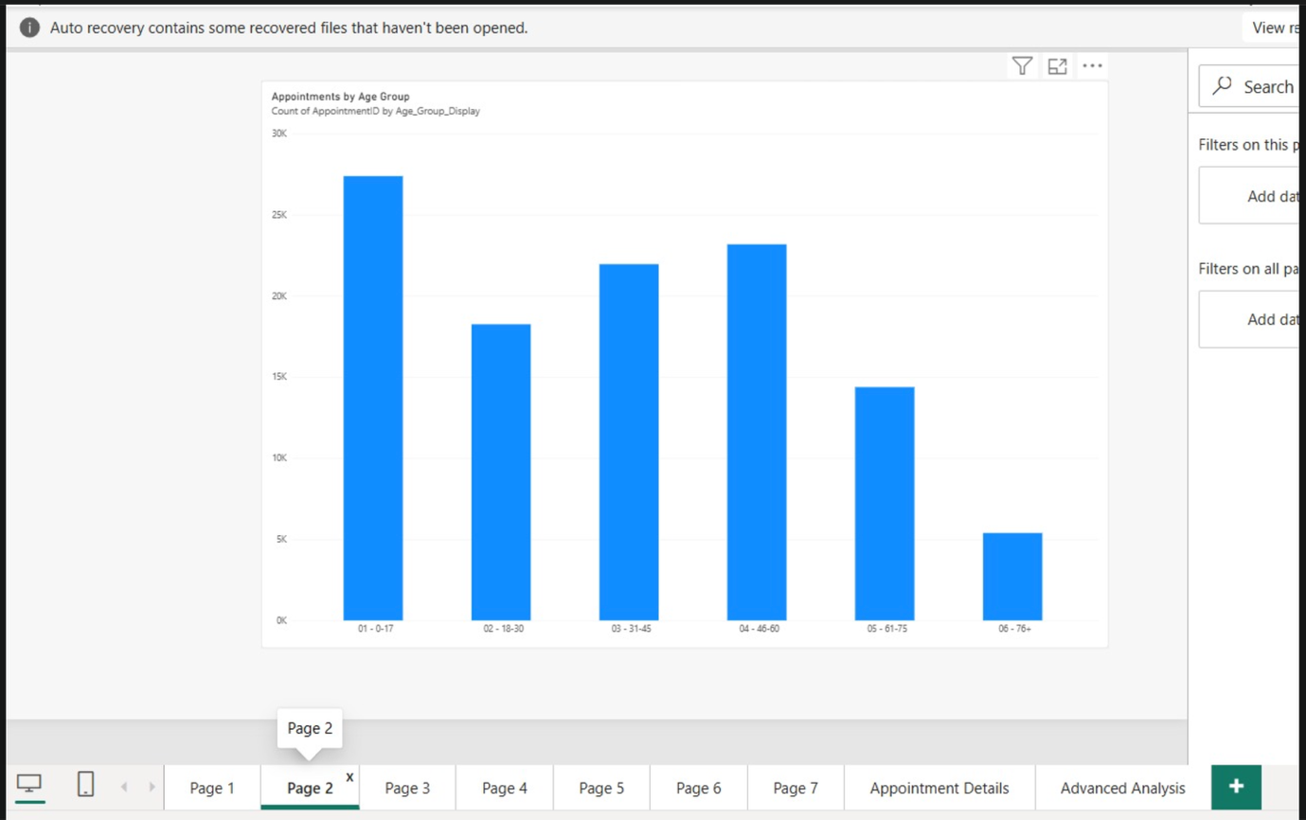

3. No-Show Rate by Gender
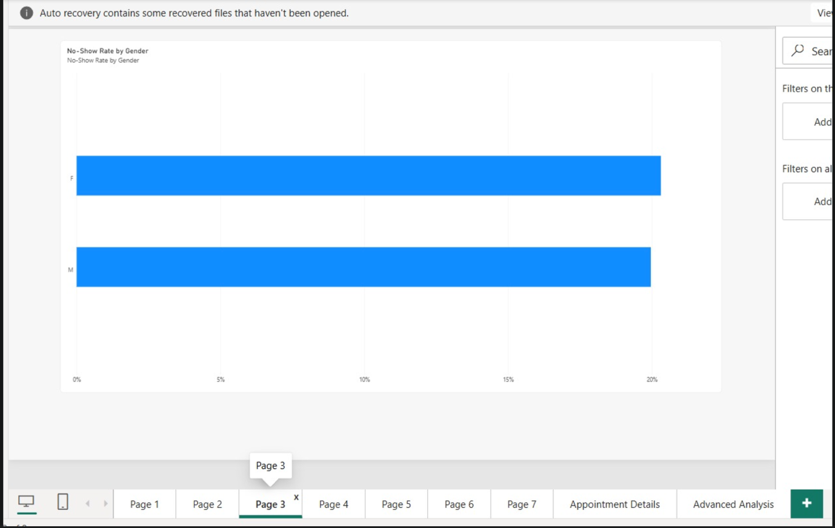

4. No-Show Rate by SMS Status
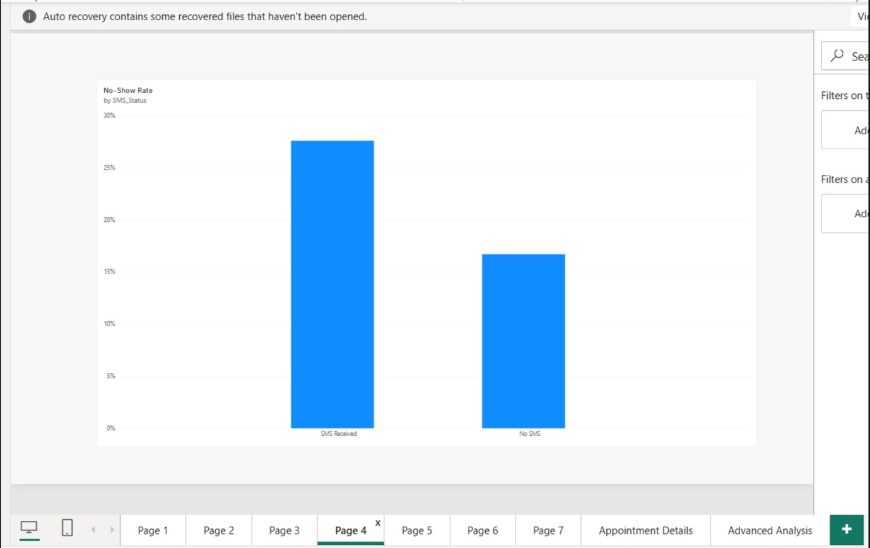

5. No-Show Rate by Waiting Time
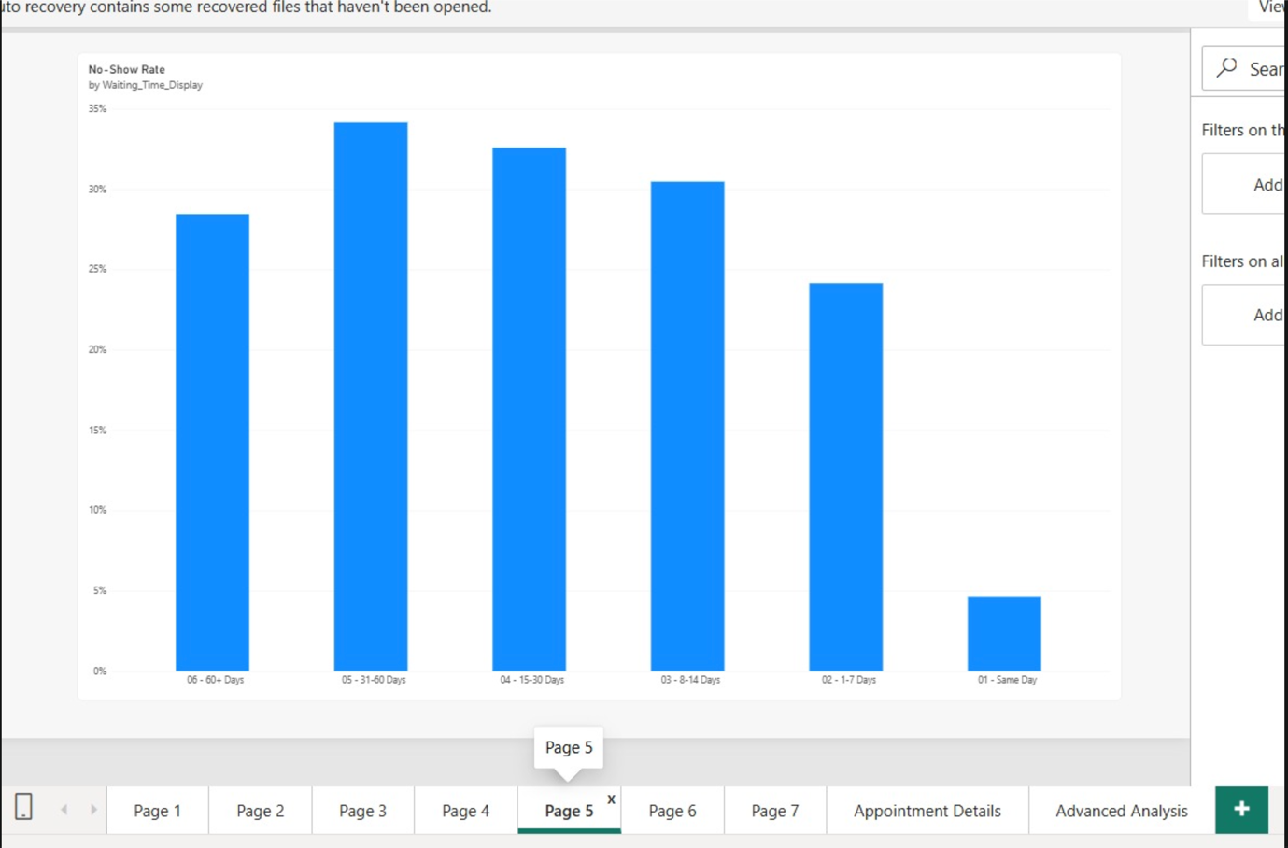

6. No-Show Rate by Health Conditions
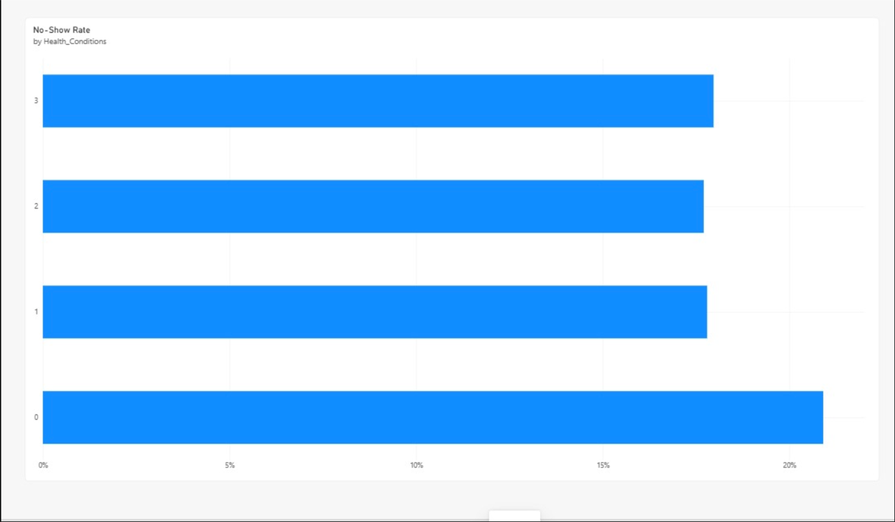

7. No-Show Rate by Scholarship
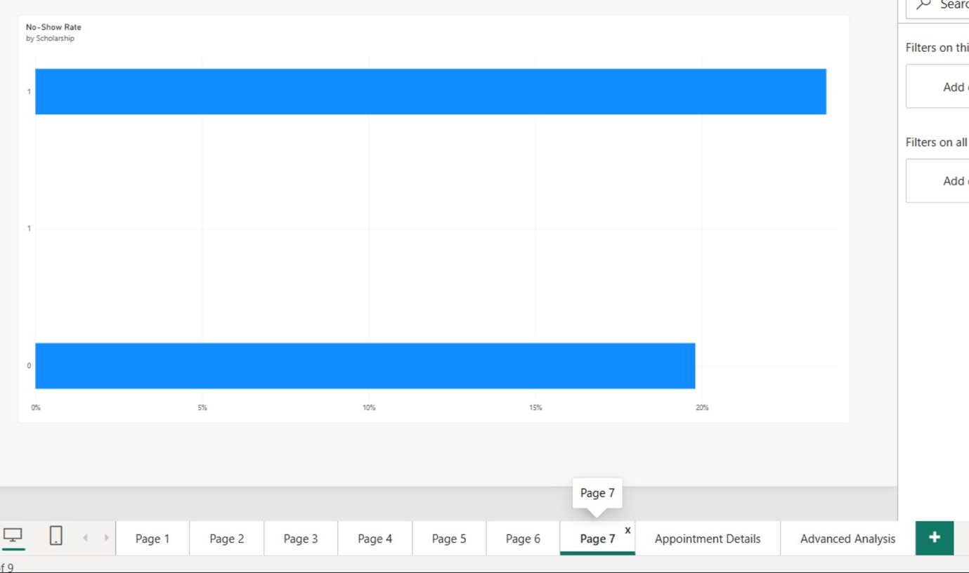

8. Appointment Details – Drill-Through Analysis
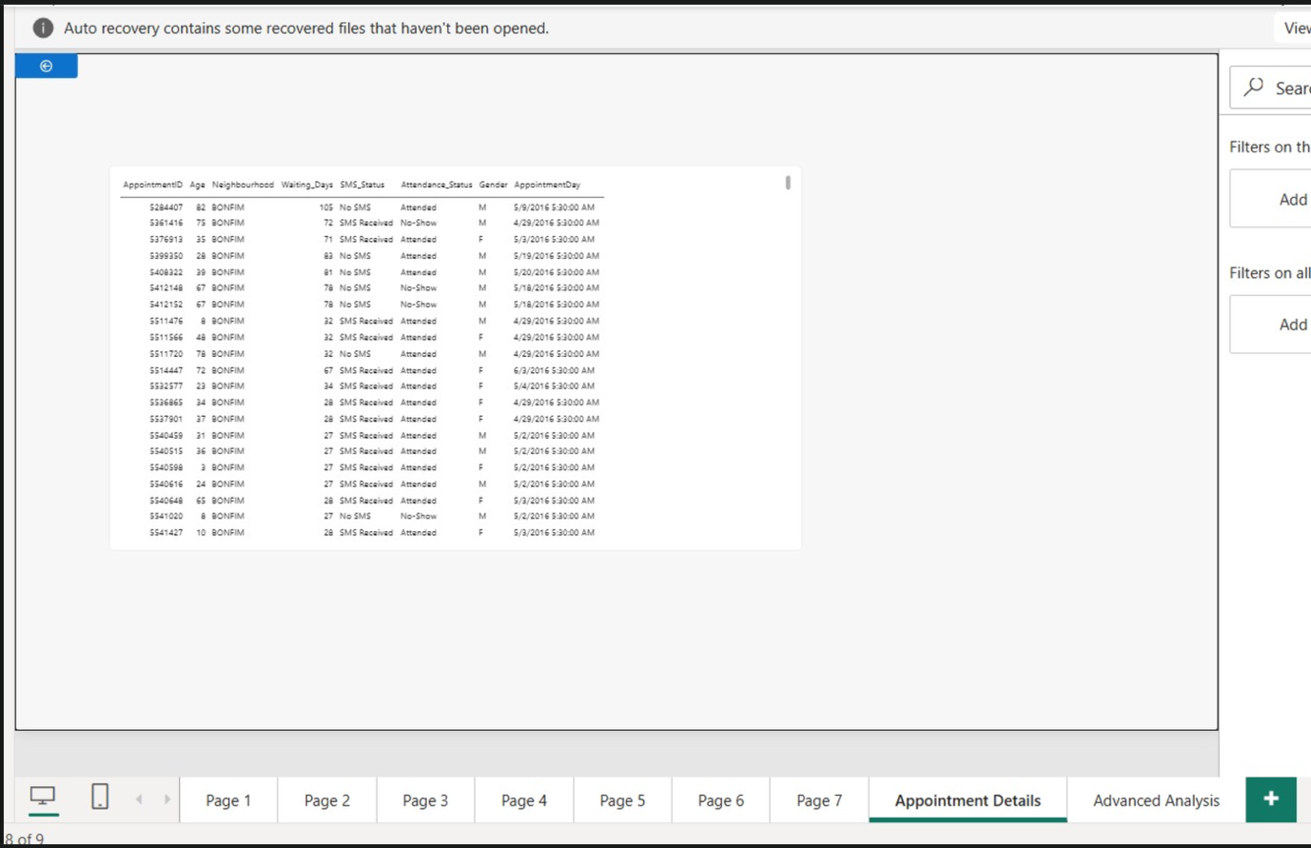

9. Advanced No-Show Rate Analysis
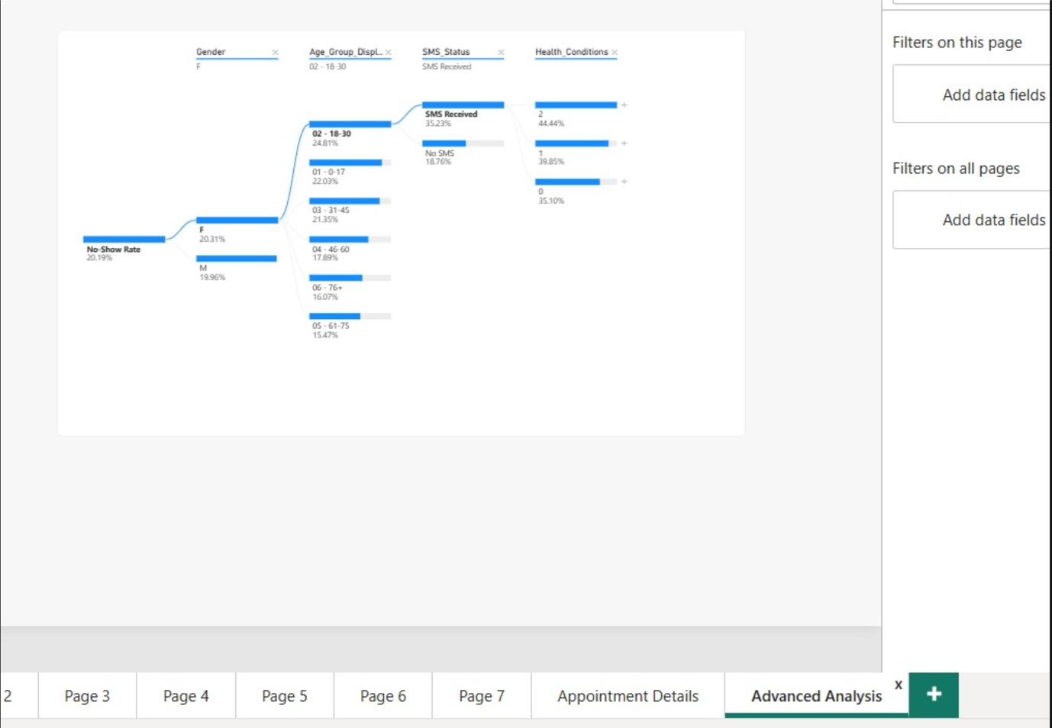

TABLEAU
Import the data from sql server
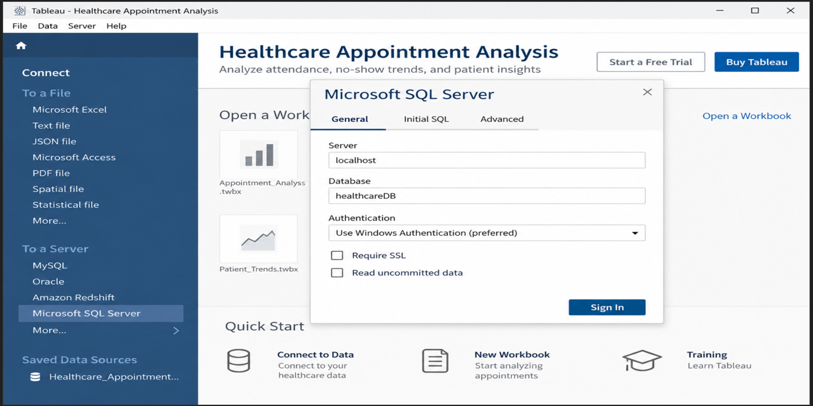

FINAL DASHBOARD:
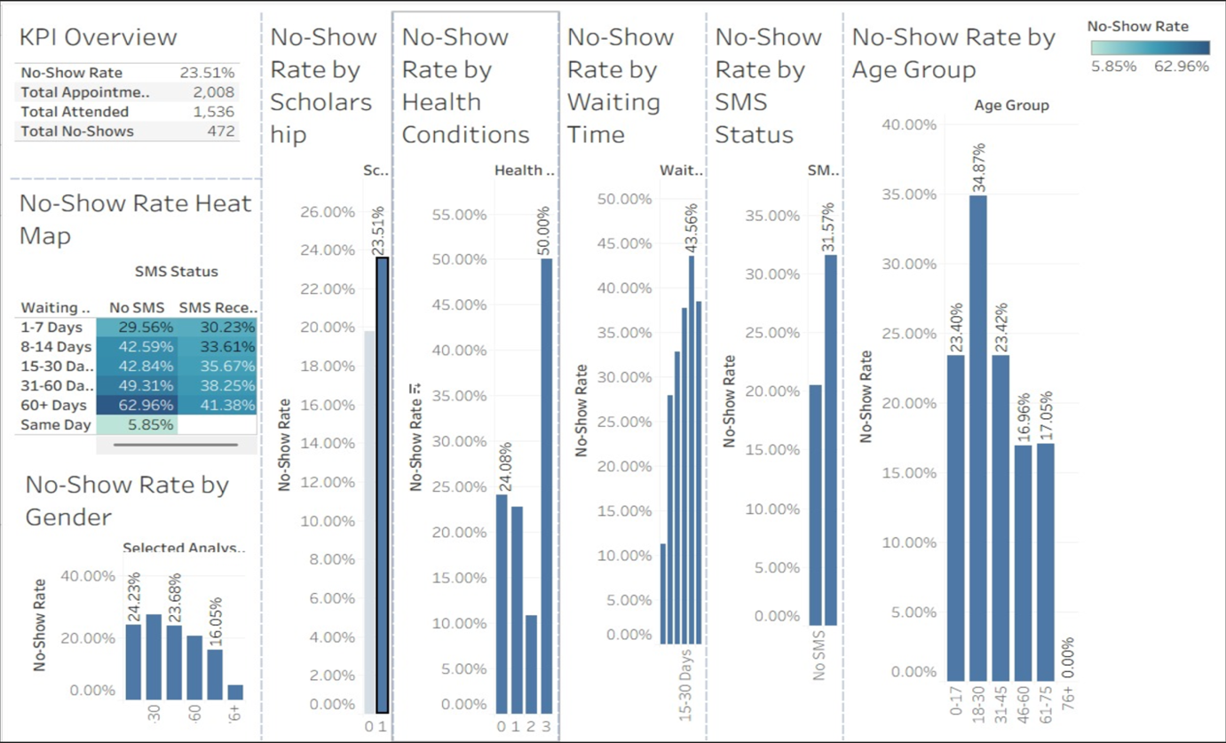

Build Parameters:
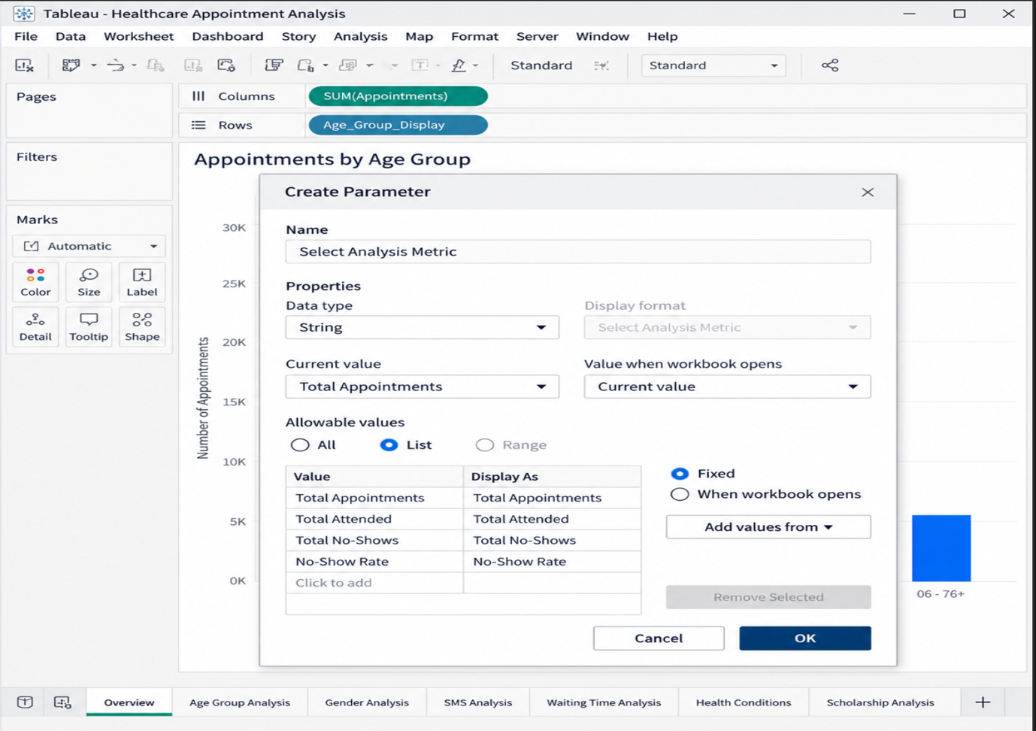

1.No-Show Rate by Age Group
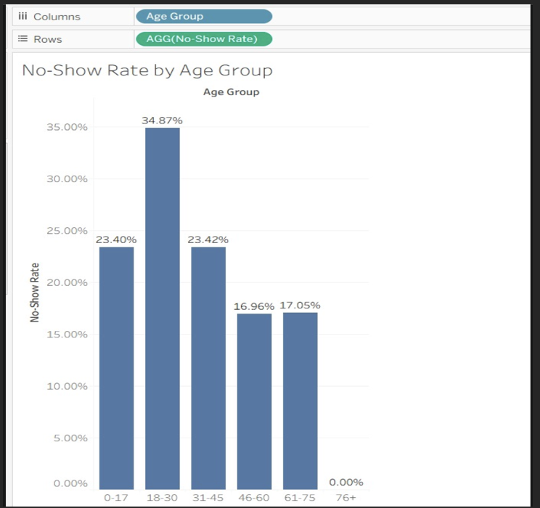

2.No-Show Rate by Selected Analysis Factor
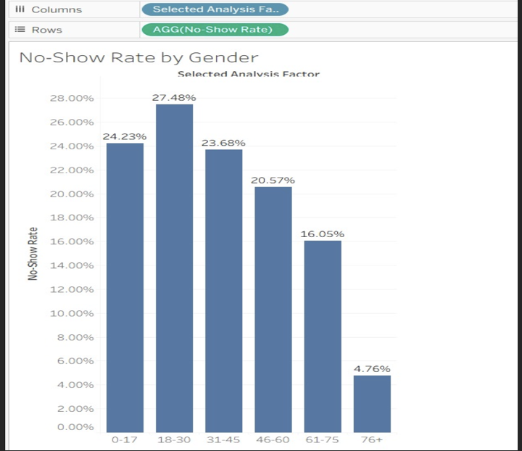

3.No-Show Rate by SMS Status
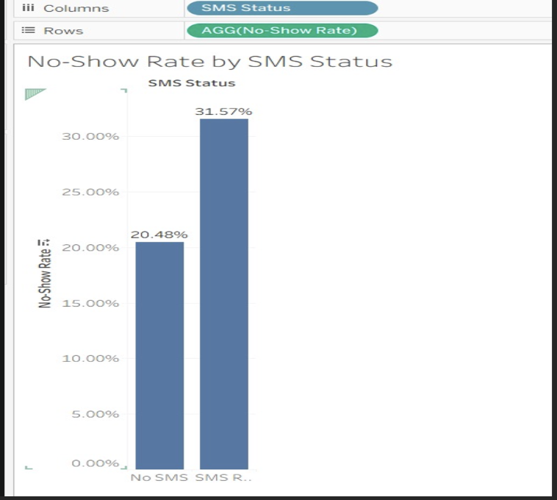
4.No-Show Rate by Waiting Time
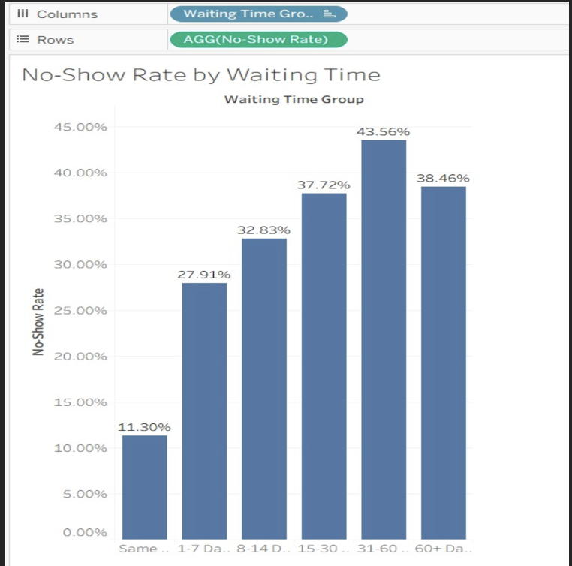

5.No-Show Rate by Health Conditions
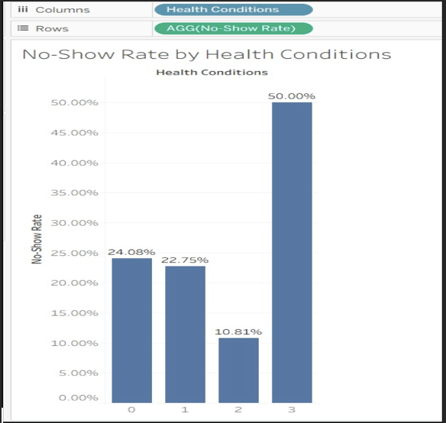

6.No-Show Rate by Scholarship
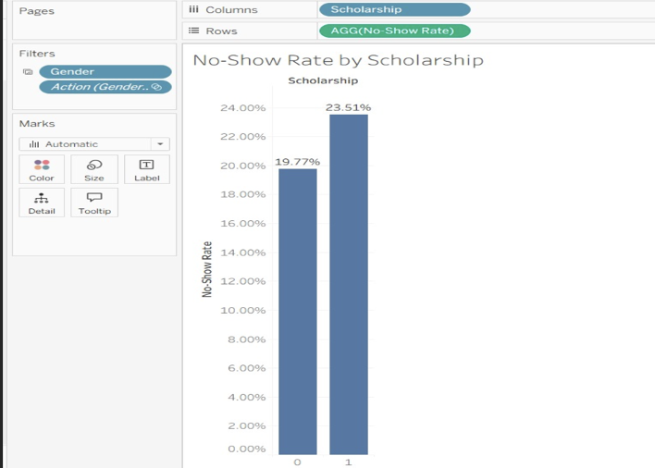

7.No-Show Rate Heat Map
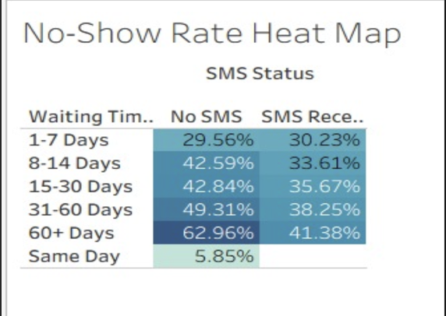

Observed Insights
- The dashboard contains 110,521 medical appointments, with 88,207 attended appointments and 22,314 no-shows.
The overall no-show rate is approximately 20.19%, while the attendance rate is about 79.81%.
This indicates that around one-fifth of the scheduled appointments were missed.
- No-show rates vary noticeably across age groups, with younger and middle-aged groups showing higher no-show levels.
The 18–30 age group records the highest no-show rate at approximately 24.61%, followed by 31–45 at 21.37% and 0–17 at 21.90%.
The 61–75 group shows a comparatively lower rate of about 14.86%, indicating differences in appointment attendance across age categories.
- Waiting time shows a strong relationship with appointment no-shows.
Same-day appointments have the lowest no-show rate at approximately 11.30%, while the rate increases to 27.91% for 1–7 days, 32.83% for 8–14 days, 37.72% for 15–30 days, and reaches about 43.56% for 31–60 days.
This indicates that appointments scheduled farther in advance tend to have higher observed no-show rates.
- SMS status and scholarship status also show differences in observed no-show rates.
Appointments marked SMS Received show a no-show rate of approximately 31.57%, compared with 20.48% for No SMS. Scholarship appointments show approximately 23.51%, compared with 19.77% for non-scholarship appointments.
These differences indicate that attendance patterns vary across support and reminder categories, although the dashboard shows association rather than causation.

